Supplementary file
miR397-LACs mediated cadmium stress tolerances in Arabidopsis thaliana

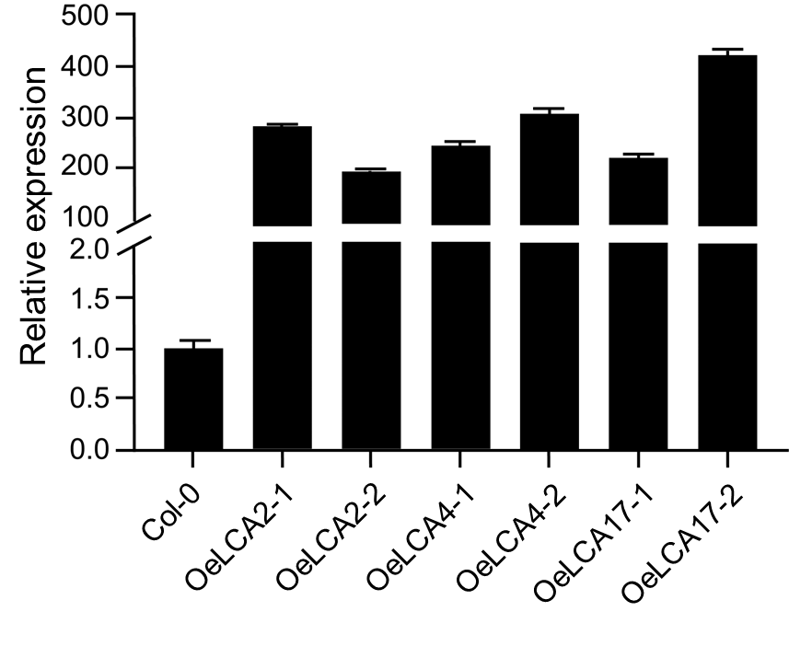
Figure S1: The transgenic plants with overexpression of LACs (OeLACs) showed higher LACs expression levels than wild-type plants.
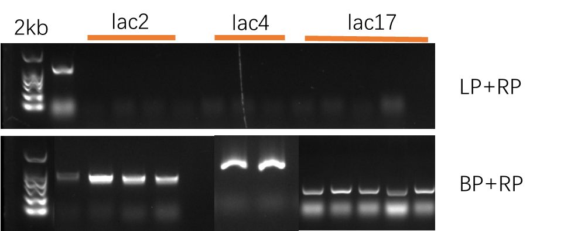
Figure S2: Specific primers confirmed the Lac mutants through ordinary PCR.

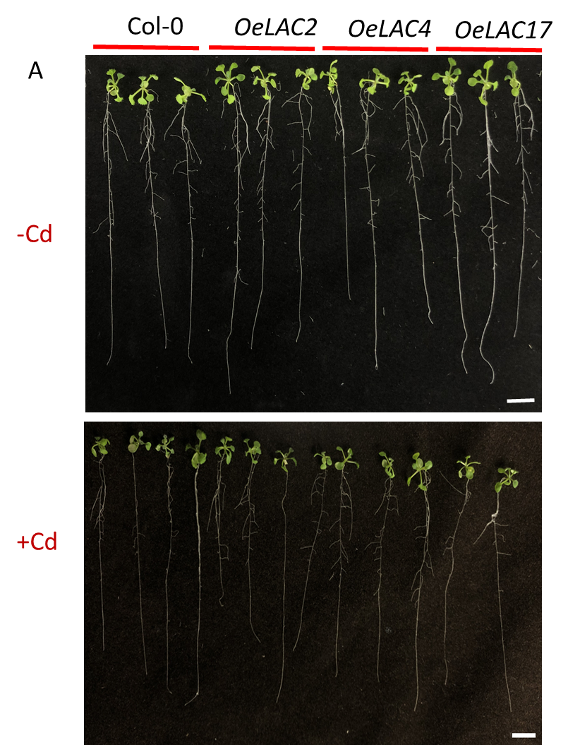
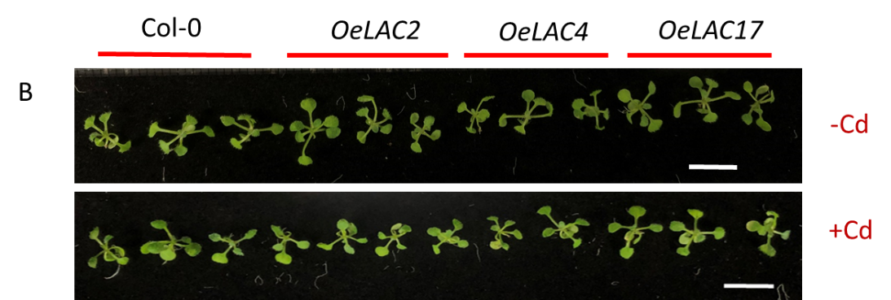

Figure S3: Morphology of OeLACs under Cd stress treatments; the lines of OeLAC have no morphological changes in root elongation (A) and leaves colour (B) under Cd stress. Scale bare = 1cm

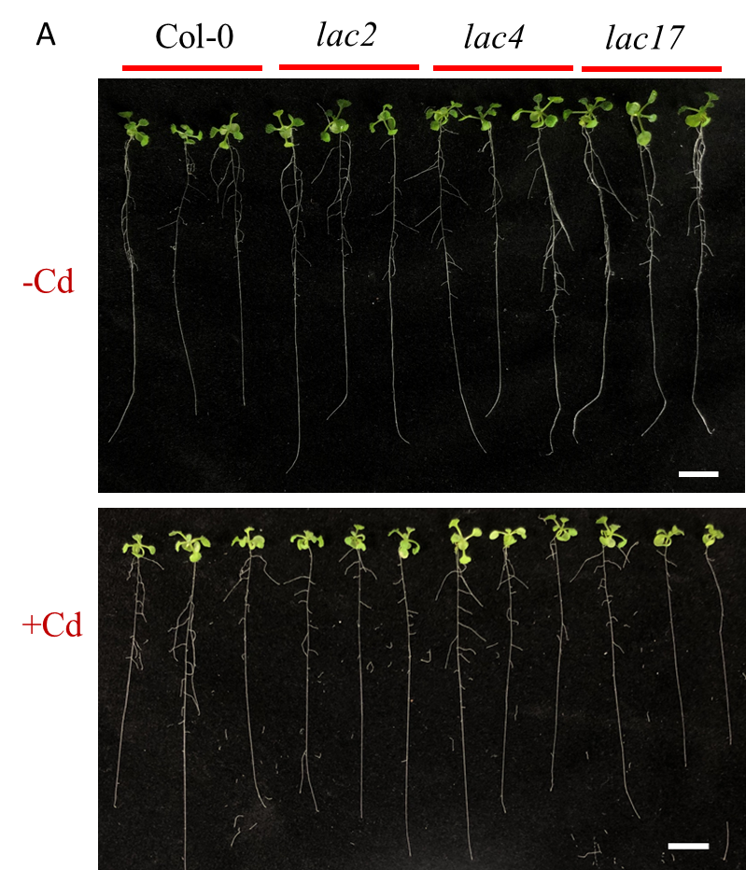
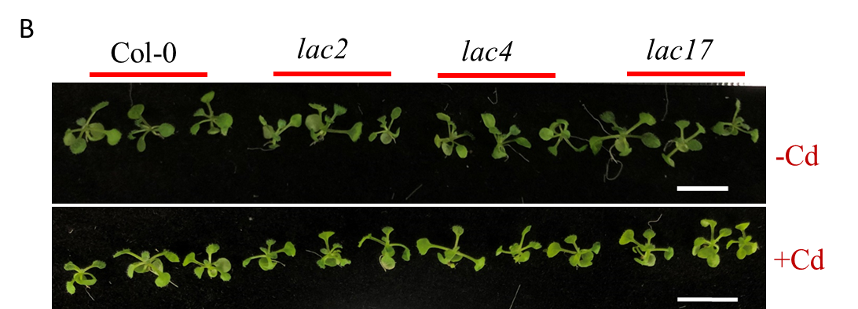
Figure S4: Morphology of lac mutants under Cd stress treatments; lac mutants have no morphological changes in root elongation (A) and leaves colour (B) under Cd stress. Scale bare = 1cm

Figure S5: Lignin content in OeLACs under Cd stress and normal conditions. There is no significant difference between different OeLACs and wild types.

Figure S6: Lignin content in lac mutants under Cd stress and normal conditions. There is no significant difference between different lac mutants and wild type.
Table S1: The primer sequences used for the constructions of vectors and miR397 expression analysis.
Primer names | Primer sequence
M₀-amiR397a-F | gccatttaaatgcagggattggcatcaacgcggcactcaatgt atcggatcctcgaggtgtaaaaaaactcg
M₀-amiR397a-R | gccatttaaatagccgaattggcatcaacgctgcactcaatga atccgagcccgatggtgagactttt
M₀-M₄-amiR397b-F | gccgtttaaacccagcgttagccatcaacgaggcactcaatgt atcggttgcccaagctgaataaaaaaa
M₀-M₄-amiR397b-R | gccgtttaaacaccccattagccatcaacgatgcactcaatga atccgtggcaccagctcacagtcat
STTM-miR397ab-F | gccatttaaatatggtctaaagaagaagaatcatcaacgatgctacactcaatgagaattcggtacgctgaaatcaccag
STTM-miR397ab-R | gccatttaaattagaccataacaacaacaactcattgagtgtagcagcgttgatgaagcttgggctgtcctctccaaatg
STTM-common-F | catttggagaggacagcccaag
STTM-common-R | ccaggtttagtcgtctcgtgtc
STTM397+35S-F | cttgcatgcctgcaggtcgacggcagatctgatcctactcca
STTM397+T35S-R | aattcgagctcggtacccgggctagagatcgcatgcgatccc
pMIR397a-F | ccctttcgtcttcaagaattccctcgatatacacttgtgt
pMIR397a-R | gacctgcaggcatgcaagcttatgttcattcaaacccagg
pMIR397b-F | ccctttcgtcttcaagaattcccttaagtgtgctcgaacc
pMIR397b-R | gacctgcaggcatgcaagcttaatgatgttcattcaaacc
GUS-F | tgctgcgtttcgatgcggtca
GUS-R | catgcgtcaccacggtgatat
SL-miR397-RT | gtcgtatccagtgcagggtccgaggtattcgcactggatacgaccatcaa
SL-U6-RT | agtgcagggtccgaggtatttttggaccatttctcgat
SL-397b-q-F | gcggcggtcattgagtgcatcg
SL-U6-q-F | ggaacgatacagagaagattagca
URP | agtgcagggtccgaggtatt
q-LAC2-F | cacgggccaaggaacaattg
q-LAC2-R | ccacgacttttggcacgttt
q-LAC4-F | tccttatagcccccggtcaa
q-LAC4-R | ggtgaggattgttggggagg
q-LAC17-F | gcactctgtggtaccatgct
q-LAC17-R | gacattgggaccacctcctg
UBQ10-F | accctccacttggtcctcag
UBQ10-R | aagagttctgccatcctccaac

Table S2: The list of primers used for the transporter genes expression.
Primer name | Primer sequences
AtHAM2-qF | TCCGTCAAGAACCGTCATCGTC
AtHAM2-qR | AACGATTTGGAACTGCGAGAGG
AtHAM4-qF | ATTCGTTGAGCTCGCAGTCGTC
AtHAM4-qR | ATGCGTATTGGCCACCGAATCC
AtABCC1-qF | AGAACGTGAAACTGGAGTTGTGAG
AtABCC1-qR | TCCAAGTGCATTCTGGTACCTCTC
AtABCC2-qF | CCTCTTGGTCTTGATGCTGAGGTC
AtABCC2-qR | CGTAACAGCGCACGTGAAAGAC
AtMRP7-qF | ATGGTACTGCTCCTAGACCAAGGG
AtMRP7-qR | GGACTTGTCTTCCAGCAATCTCG
AtPDR8-qF | ACTGCAGATGGGAACAGAAGAGG
AtPDR8-qR | TTCCTTTCTTATTGCCTGCACCAC

