Table 1. Information of primers used to amplify and sequence Pvmdr-1 gene
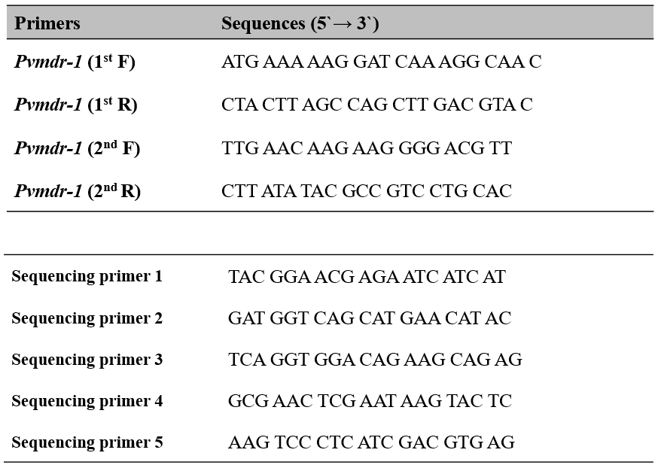
Pvmdr-1 primers set were adapted from Barnadas et al., 2008. Sequencing primers were newly designed for this study.

Table 2. List and frequency of Pvmdr-1 mutations in Republic of Korea from 2016 to 2017
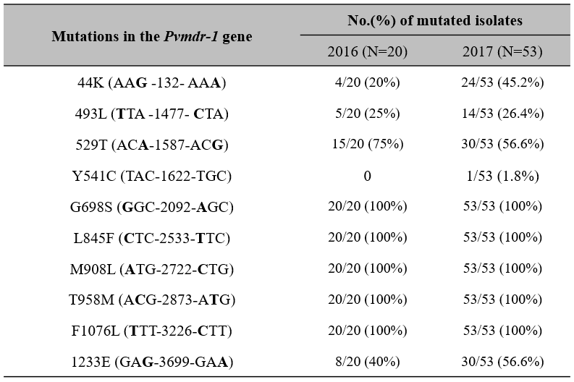
Quintuple non-synonymous mutations (G689S, L845F, M908L, T958M, and F1076L) and synonymous mutations (44K, 493L, 529T, and 1233E) were detected. Furthermore, a noble non-synonymous mutation was detected in 1 patient.

Table 3. Haplotypes of the Pvmdr-1 gene in Republic of Korea from 2016 to 2017
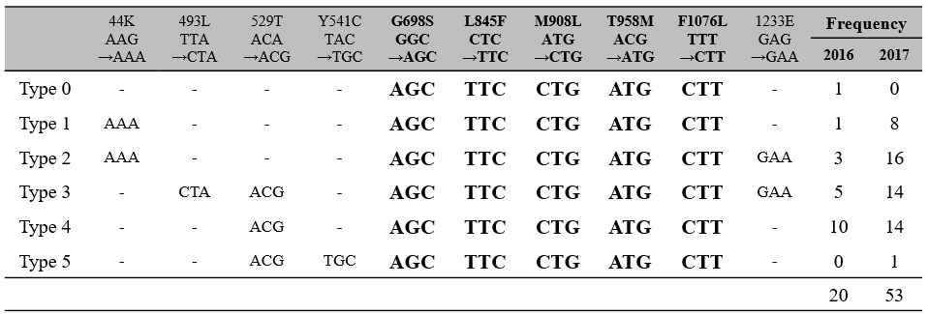
All haplotypes (Type 0 to Type 5) contains quintuple non-synonymous mutations (G689S, L845F, M908L, T958M and F1076L, marked in bold). The frequency of non-synonymous (Y541C) and synonymous mutations (44K, 493L, 529T and 1233E) from 2016 to 2017 was listed.

