Supplementary Information

Dysprosium-induced FeN_{x}-Dy₂O₃ sites for Efficient Bifunctional Oxygen Electrocatalytic Reactions
Ren Luo^{a,b}, Rui Wangª, Zihan Meng^{c}, Yannan Xia^{b}, Haolin Tang^{a,b∗}

ª State Key Laboratory of Advanced Technology for Materials Synthesis and Processing, Wuhan University of Technology, Wuhan 430070, China
^{b} Hubei Provincial Key Laboratory of Fuel Cells, Wuhan University of Technology, Wuhan 430070, China
^{c} Foshan Xianhu Laboratory of the Advanced Energy Science and Technology Guangdong Laboratory, Xianhu Hydrogen Valley, Foshan 528200, China
* Corresponding author.
Email: thln@whut.edu.cn (Haolin Tang)

Materials synthesis
2.97 g of Zn (NO₃)₃·6H₂O, 0.0808 g of Fe (NO₃)₃·6H₂O and 0.0913 g of Dy (NO₃)₃·6H₂O were dissolved in 40mL methanol, and ultrasonically dispersed for 5 min. In addition, 6.56 g of 2-methylimidazole was dissolved in 80 mL methanol. After the solution was completely clarified for 5 min, the former was quickly poured into the latter under intense stirring at room temperature for 24 h. After the reaction, FeDy-ZIF-8 was obtained by centrifugal washing and vacuum drying. Then, the obtained FeDy-ZIF-8 was mixed with a certain amount of dicyandiamide (2 g) and ground into powder. The powder was pyrolyzed at 950°C for 2h and then cooled naturally to obtain Dy₂O₃-Fe/NC.
The Fe/NC and Dy₂O₃/NC were prepared by the same method (just without Dy (NO₃)₃·6H₂O and Fe (NO₃)₃·9H₂O, respectively).

Materials Characterizations

Structural characterizations
X-ray diffraction (XRD) patterns were obtained using a Bruker D8 Advance with a Cu Kα X-ray as the excitation source. N₂ adsorption-desorption isotherms were performed at 77 K by using a Micrometrics ASAP 2020M. Raman spectra patterns were carried out on a Renishaw InVia Raman microscope with a 633 nm laser. Scanning electron microscopy (SEM) images were obtained on a Zeiss Ultra Plus. Transmission electron microscopy (TEM), high-angle annular dark-field scanning transmission electron microscopy (HAADF-STEM), and elemental mapping were collected on a Talos F200S. X-ray photoelectron spectra (XPS) were performed on an ESCALAB 250Xi with a monochromatic Al Kα X-ray as the excitation source, and the obtained XPS spectra were calibrated by shifting the C 1s peak to 284.8 eV.

Electrochemical characterizations
The electrocatalysts were characterized in a three-electrode system on a CHI 760E electrochemical workstation at room temperature in oxygen saturated 0.1 M KOH solution. A reversible hydrogen electrode (RHE), a graphite rod, and a catalyst-coated glass carbon electrode (5 mm in diameter) served as reference, counter, and working electrodes, respectively. Ultrasonically dispersed electrocatalyst ink was composed of 5 mg electrocatalyst, 900 μL isopropanol, 100 μL deionized water, and 20 μL Nafion (5 wt.%). During the electrochemical testing period,20 μL of the homogeneous ink was drop-casted on the glassy carbon substrate. Finally, the Koutecky-Levich (K-L) equation was employed to calculate the electron transfer numbers (n):
$\begin{aligned}\frac{1}{J}=\frac{1}{J_{L}}+\frac{1}{J_{K}}=\frac{1}{Bω^{1/2}}+\frac{1}{J_{K}}\#\left(1\right)\end{aligned}$
$$\begin{aligned}\text{B=0.62nF}{\text{C}}_{\text{0}}{{\text{D}}_{\text{0}}}^{\text{2/3}}{\text{ν}}^{\text{-1/6}}\#\left(2\right)\end{aligned}$$

where J, J_{K}, and J_{L} re the measured, kinetic, and limiting current densities, respectively. ω, n, and F are the angular velocity of the electrode, electron transfer number, and Faraday constant (96485 C mol⁻¹), respectively. C₀, D₀, and ν represent the bulk concentration of O₂ (1.2×10⁻⁶ mol cm⁻³), the diffusion coefficient of oxygen (1.9×10⁻⁵ cm² s⁻¹), and the kinematic viscosity of the electrolyte (0.01 cm² s⁻¹), respectively.

Zn-air battery tests
The liquid Zn-air batteries were assembled and tested under an ambient atmosphere. A carbon paper coated with Dy₂O₃-Fe/NC or 20 wt.% Pt/C+RuO₂ (1:1 mass ratio) electrocatalyst (loading of 1.0 mg cm⁻²) was applied as air cathodes, while a piece of polished zinc foil was acted as the anode, whereby a mixed solution of 6 M KOH with 0.2 M Zn (Ac)₂ served as the electrolyte. All the Zn-air battery tests were measured by a CHI 760E electrochemical workstation.

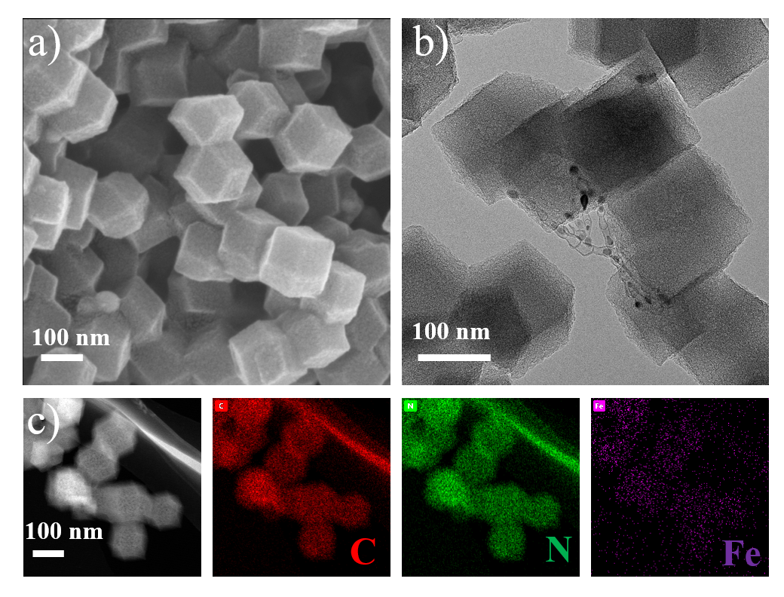
Figure S1. a) SEM, b) TEM, c) HAADF-STEM elemental mapping images of Fe/NC.
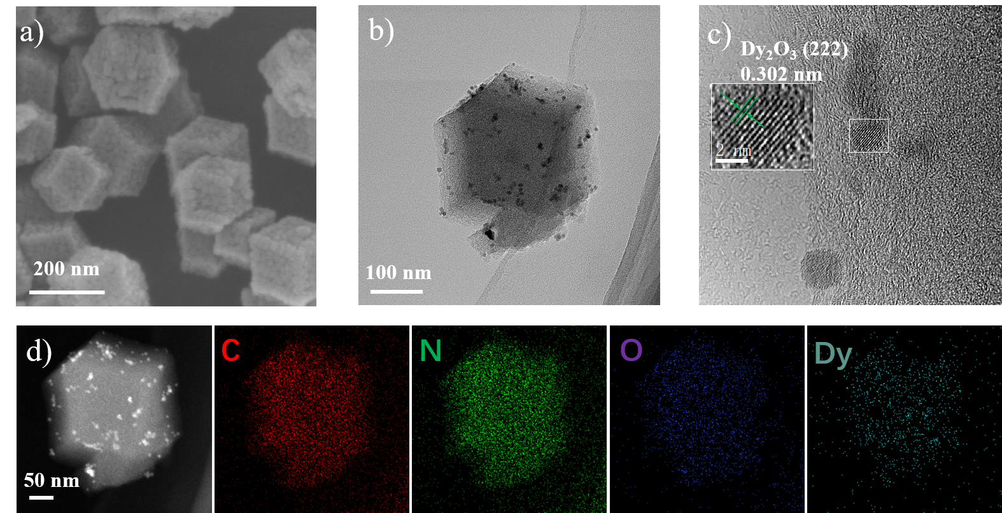
Figure S2. a) SEM, b) TEM, c) high-magnification TEM images and d) HAADF-STEM elemental mapping images of Dy₂O₃/NC.
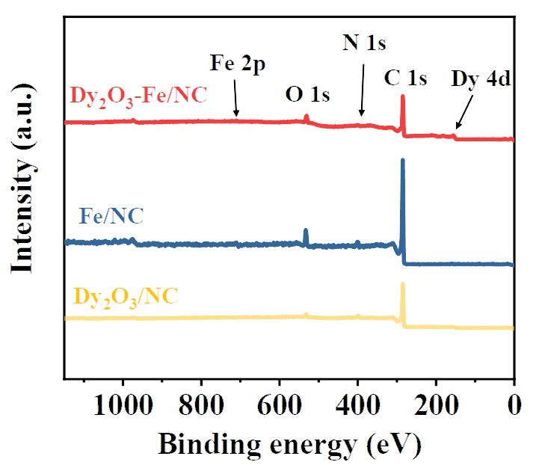
Figure S3. XPS survey of the C, N, O, Fe and Dy for three samples.
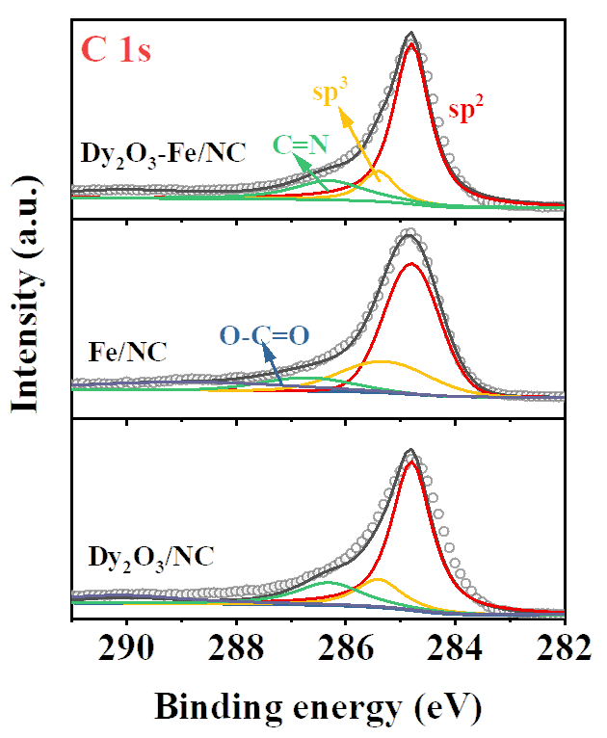
Figure S4. The C 1s spectra of three samples.
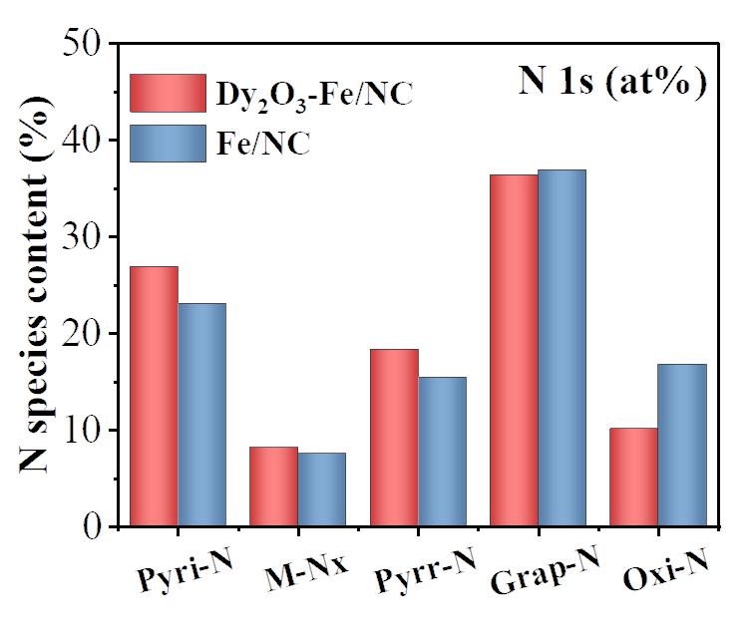
Figure S5. Contents comparison of the N species for Dy₂O₃-Fe/NC and Fe/NC.

∗Haolin Tang. E-mail address: thln@whut.edu.cn

