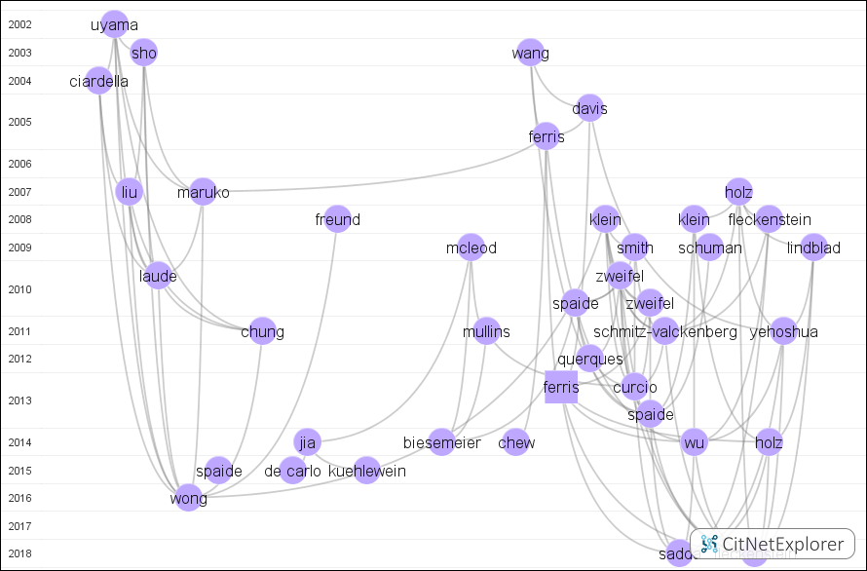
Supplementary Figure 5 | Cluster 3 represents the feature and classification of AMD. The vertical axis coordinates indicate the year of publication. Each point/square indicates a publication with the first author's last name. Squares represent the publications with the highest citation scores.

