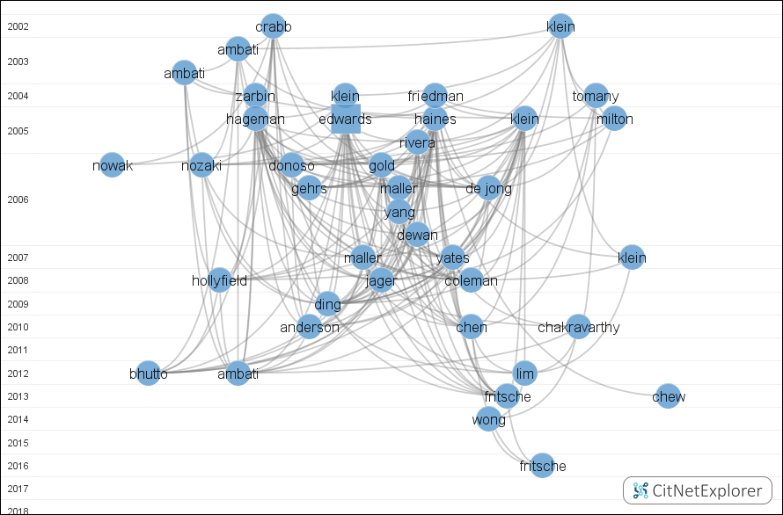
Supplementary Figure 3 | Cluster 1 represents the mechanism of AMD. The vertical axis coordinates indicate the year of publication. Each point/square indicates a publication with the first author's last name. Squares represent the publications with the highest citation scores.

