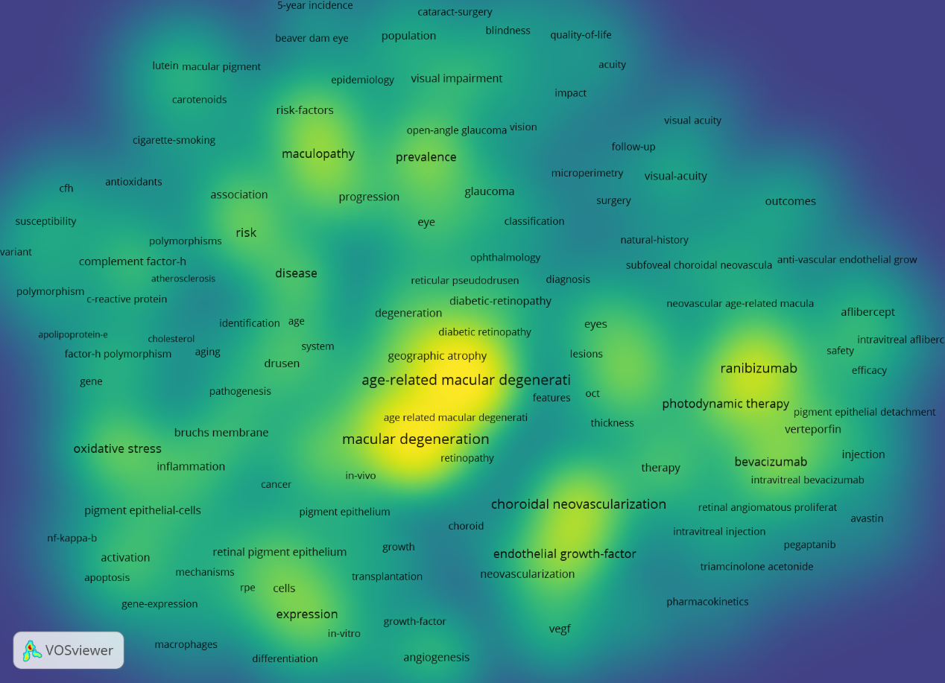
Supplementary Figure 2 | Density visualization for keywords in the co-occurrence network map. Each keyword in the density visualization has colors that indicate its appearance.
frequency. Keywords in yellow emerge more frequently, while green emerge in blue less frequently.

