Table S1. The search history on PubMed
Search number | Query | Results
#1 | "Polycystic Ovary Syndrome"[Mesh] | 17,025
#2 | (((((((((((((Ovary Syndrome, Polycystic[Title/Abstract])) OR (Syndrome, Polycystic Ovary[Title/Abstract])) OR (Stein-Leventhal Syndrome[Title/Abstract])) OR (Stein Leventhal Syndrome[Title/Abstract])) OR (Syndrome, Stein-Leventhal[Title/Abstract])) OR (Sclerocystic Ovarian Degeneration[Title/Abstract])) OR (Ovarian Degeneration, Sclerocystic[Title/Abstract])) OR (Sclerocystic Ovary Syndrome[Title/Abstract])) OR (Polycystic Ovarian Syndrome[Title/Abstract])) OR (Ovarian Syndrome, Polycystic[Title/Abstract])) OR (Polycystic Ovary Syndrome 1[Title/Abstract])) OR (Sclerocystic Ovaries[Title/Abstract])) OR (Sclerocystic Ovary[Title/Abstract]) | 4,305
#3 | ("Polycystic Ovary Syndrome"[Mesh]) OR ((((((((((((((Ovary Syndrome, Polycystic[Title/Abstract])) OR (Syndrome, Polycystic Ovary[Title/Abstract])) OR (Stein-Leventhal Syndrome[Title/Abstract])) OR (Stein Leventhal Syndrome[Title/Abstract])) OR (Syndrome, Stein-Leventhal[Title/Abstract])) OR (Sclerocystic Ovarian Degeneration[Title/Abstract])) OR (Ovarian Degeneration, Sclerocystic[Title/Abstract])) OR (Sclerocystic Ovary Syndrome[Title/Abstract])) OR (Polycystic Ovarian Syndrome[Title/Abstract])) OR (Ovarian Syndrome, Polycystic[Title/Abstract])) OR (Polycystic Ovary Syndrome 1[Title/Abstract])) OR (Sclerocystic Ovaries[Title/Abstract])) OR (Sclerocystic Ovary[Title/Abstract])) | 18,399
#4 | "Exenatide"[Mesh] | 2,801
#5 | (((((((((Bydureon[Title/Abstract])) OR (ITCA 650[Title/Abstract])) OR (AC 2993 LAR[Title/Abstract])) OR (Exendin-4[Title/Abstract])) OR (Ex4 Peptide[Title/Abstract])) OR (Peptide, Ex4[Title/Abstract])) OR (Exendin 4[Title/Abstract])) OR (Byetta[Title/Abstract])) OR (AC 2993[Title/Abstract]) | 1,991
#6 | ("Exenatide"[Mesh]) OR ((((((((((Bydureon[Title/Abstract])) OR (ITCA 650[Title/Abstract])) OR (AC 2993 LAR[Title/Abstract])) OR (Exendin-4[Title/Abstract])) OR (Ex4 Peptide[Title/Abstract])) OR (Peptide, Ex4[Title/Abstract])) OR (Exendin 4[Title/Abstract])) OR (Byetta[Title/Abstract])) OR (AC 2993[Title/Abstract])) | 3,495
#7 | (("Polycystic Ovary Syndrome"[Mesh]) OR ((((((((((((((Ovary Syndrome, Polycystic[Title/Abstract])) OR (Syndrome, Polycystic Ovary[Title/Abstract])) OR (Stein-Leventhal Syndrome[Title/Abstract])) OR (Stein Leventhal Syndrome[Title/Abstract])) OR (Syndrome, Stein-Leventhal[Title/Abstract])) OR (Sclerocystic Ovarian Degeneration[Title/Abstract])) OR (Ovarian Degeneration, Sclerocystic[Title/Abstract])) OR (Sclerocystic Ovary Syndrome[Title/Abstract])) OR (Polycystic Ovarian Syndrome[Title/Abstract])) OR (Ovarian Syndrome, Polycystic[Title/Abstract])) OR (Polycystic Ovary Syndrome 1[Title/Abstract])) OR (Sclerocystic Ovaries[Title/Abstract])) OR (Sclerocystic Ovary[Title/Abstract]))) AND (("Exenatide"[Mesh]) OR ((((((((((Bydureon[Title/Abstract])) OR (ITCA 650[Title/Abstract])) OR (AC 2993 LAR[Title/Abstract])) OR (Exendin-4[Title/Abstract])) OR (Ex4 Peptide[Title/Abstract])) OR (Peptide, Ex4[Title/Abstract])) OR (Exendin 4[Title/Abstract])) OR (Byetta[Title/Abstract])) OR (AC 2993[Title/Abstract]))) | 16
#8 | (((randomized controlled trial [Publication Type])) OR (randomized [Title/Abstract])) OR (placebo [Title/Abstract]) | 967,857
#9 | ((((randomized controlled trial[Publication Type])) OR (randomized[Title/Abstract])) OR (placebo[Title/Abstract])) AND ((("Polycystic Ovary Syndrome"[Mesh]) OR ((((((((((((((Ovary Syndrome, Polycystic[Title/Abstract])) OR (Syndrome, Polycystic Ovary[Title/Abstract])) OR (Stein-Leventhal Syndrome[Title/Abstract])) OR (Stein Leventhal Syndrome[Title/Abstract])) OR (Syndrome, Stein-Leventhal[Title/Abstract])) OR (Sclerocystic Ovarian Degeneration[Title/Abstract])) OR (Ovarian Degeneration, Sclerocystic[Title/Abstract])) OR (Sclerocystic Ovary Syndrome[Title/Abstract])) OR (Polycystic Ovarian Syndrome[Title/Abstract])) OR (Ovarian Syndrome, Polycystic[Title/Abstract])) OR (Polycystic Ovary Syndrome 1[Title/Abstract])) OR (Sclerocystic Ovaries[Title/Abstract])) OR (Sclerocystic Ovary[Title/Abstract]))) AND (("Exenatide"[Mesh]) OR ((((((((((Bydureon[Title/Abstract])) OR (ITCA 650[Title/Abstract])) OR (AC 2993 LAR[Title/Abstract])) OR (Exendin-4[Title/Abstract])) OR (Ex4 Peptide[Title/Abstract])) OR (Peptide, Ex4[Title/Abstract])) OR (Exendin 4[Title/Abstract])) OR (Byetta[Title/Abstract])) OR (AC 2993[Title/Abstract])))) | 7

Table S2. RCT Risk of Bias Assessment
Study | Random sequence generation | Allocation concealment | Blinding of participants and personnel | Blinding of outcome assessment | Incomplete outcome data | Optional report results | Other sources of bias
Elkind-Hirsch. K et al, 2008[21] | Patients were randomized through computer generated  Low Risk | Low Risk | No blinding  High Risk | NA  Unclear Risk | Drop-out rate (20%) Missing data with reasons given  Low Risk | A priori outcomes reported in main report Protocol available  Low Risk | No bias identified  Low Risk
Li. R.Y et at 2020[6] | Patients were randomized by a computer-generated system  Low Risk | Low Risk | NA  Unclear Risk | NA  Unclear Risk | NA  Unclear Risk | A priori outcomes reported in main report Protocol available  Low Risk | No bias identified  Low Risk
Li. R et al,2022[5] | Patients were randomized through A randomization list which was generated by using Statistics Analysis System  Low Risk | Low Risk | No blinding  High Risk | NA  Unclear Risk | Low drop-out rate (8%) Missing data with reasons given  Low Risk | A priori outcomes reported in main report Protocol available  Low Risk | No bias identified  Low Risk
Liu. X et al,2017 [7] | Patients were randomized through Computer generated  Low Risk | Low Risk | No blinding  High Risk | NA  Unclear Risk | Drop-out rate (10%) Missing data with reasons given  Low Risk | A priori outcomes reported in main report Protocol available  Low Risk | No bias identified  Low Risk
Ma. R. L et al, 2021[20] | The randomized codes were generated electronically using a two-block randomization technique to create a treatment allocation spreadsheet.  Low Risk | Low Risk | NA  Unclear Risk | NA  Unclear Risk | Drop-out rate (20%) Missing data with reasons given  Low Risk | A priori outcomes reported in main report Protocol available  Low Risk | No bias identified  Low Risk
Tao. T et al,2021 [27] | Patients were randomized by a computer-generated coding system.  Low Risk | Low Risk | No blinding High Risk | NA  Unclear Risk | Drop-out rate (18%) Missing data with reasons given  Low Risk | A priori outcomes reported in main report Protocol available  Low Risk | No bias identified  Low Risk
Wang. J et al, 2017[12] | Patients were randomized through Random number table  Low Risk | Low Risk | Blinding  Low Risk | No blinding  High Risk | No participants drop-out  Low Risk | A priori outcomes  reported in main report Protocol available  Low Risk | No bias identified  Low Risk
Zheng. S et al, 2017[2] | Patients were randomized by a computer-generated system  Low Risk | Low Risk | NA  Unclear Risk | NA  Unclear Risk | Drop-out rate (23%) Missing data with reasons given  Low Risk | A priori outcomes reported in main report Protocol available  Low Risk | No bias identified  Low Risk
Zheng. S et al, 2019[8] | Patients were randomized through randomizing software  Low Risk | Low Risk | NA  Unclear Risk | NA  Unclear Risk | Drop-out rate (23%) Missing data with reasons given  Low Risk | A priori outcomes reported in main report Protocol available  Low Risk | No bias identified  Low Risk
NA, Not Available
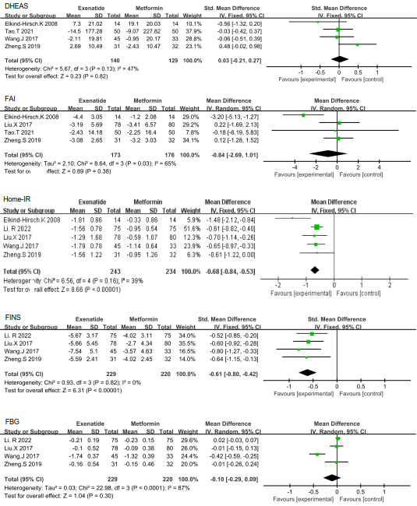
Fig S1 Effects on DHEAS, FAI, Homa-IR，FINS, FBG between exenatide and metformin
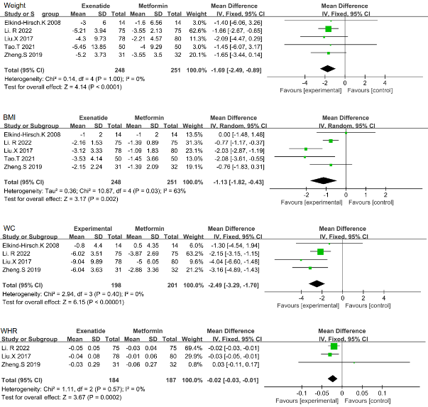
Fig S2 Effects on Weight, BMI, WC, WHR between exenatide and metformin

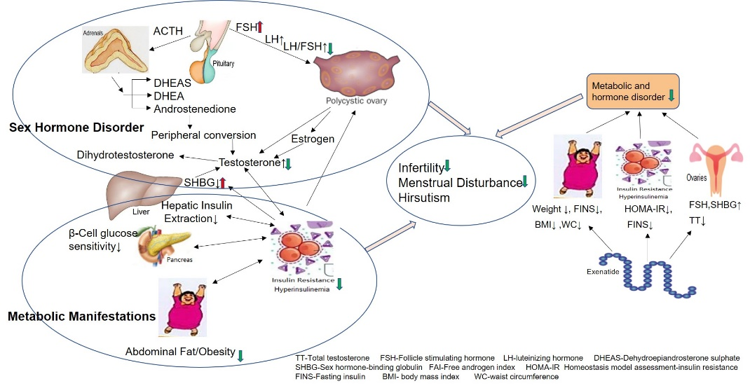
Fig S3 Putative mechanism of beneficial effects of exenatide

