Table 1
2-Dimensional structure and Name of compounds isolated from the oil of Garcinia kola
s/n | Compound Title | Compound Name | 2D-structure
1 | 6327366 | 1,1,1,3,5,5,5-Heptamethyltrisiloxane | 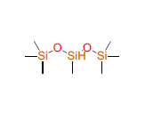
2 | 107852 | 1,2-Benzenediol, 3,5-bis(1,1-dimethylethyl)- | 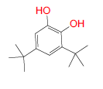
3 | 10408 | 2-Pentadecanone, 6,10,14-trimethyl- | 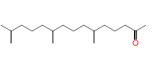
4 | 5366244 | 3,7,11,15-Tetramethyl-2-hexadecen-1-ol | 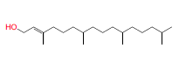
5 | 5367325 | 7,10,13-Hexadecatrienoic acid methyl ester | 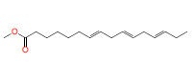
6 | 5319737 | 8,11-Octadecadienoic acid methyl ester | 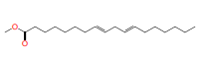
7 | 8203 | 9,12-Octadecadienoic acid (Z, Z)-, methyl ester | 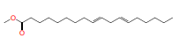
8 | 5367462 | 9,12,15-Octadecatrienoic acid, methyl ester, (9Z,12Z,15Z)- | 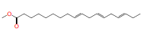
9 | 73170 | Alpha-Amyrin | 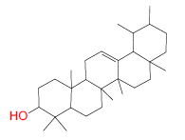
10 | 73145 | Beta-Amyrin | 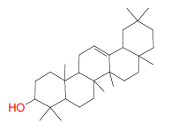
11 | 12314300 | Bicyclo[3.1.1]heptane, 2,6,6-trimethyl-, (1alpha,2beta,5alpha)- | 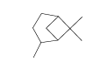
12 | 10914 | 2,2,4,4,6,6-hexamethyl-1,3,5,2,4,6-trioxatrisilinane | 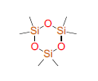
13 | 8181 | Methyl hexadecanoic acid | 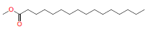
14 | 5460120 | Methyl 9-cis,11-trans-octadecadienoate | 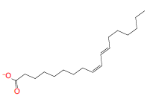
15 | 8201 | Methyl stearate | 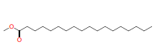
16 | 28838 | Methyl tris (trimethyl siloxy) silane | 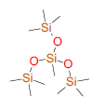
17 | 10446 | Neophytadiene | 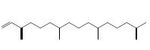
18 | 6428538 | Phytol acetate | 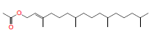
19 | 638072 | Squalene | 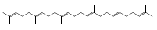
20 | 8852 | Decamethyltetrasiloxane | 