Supplementary

Appendix 1

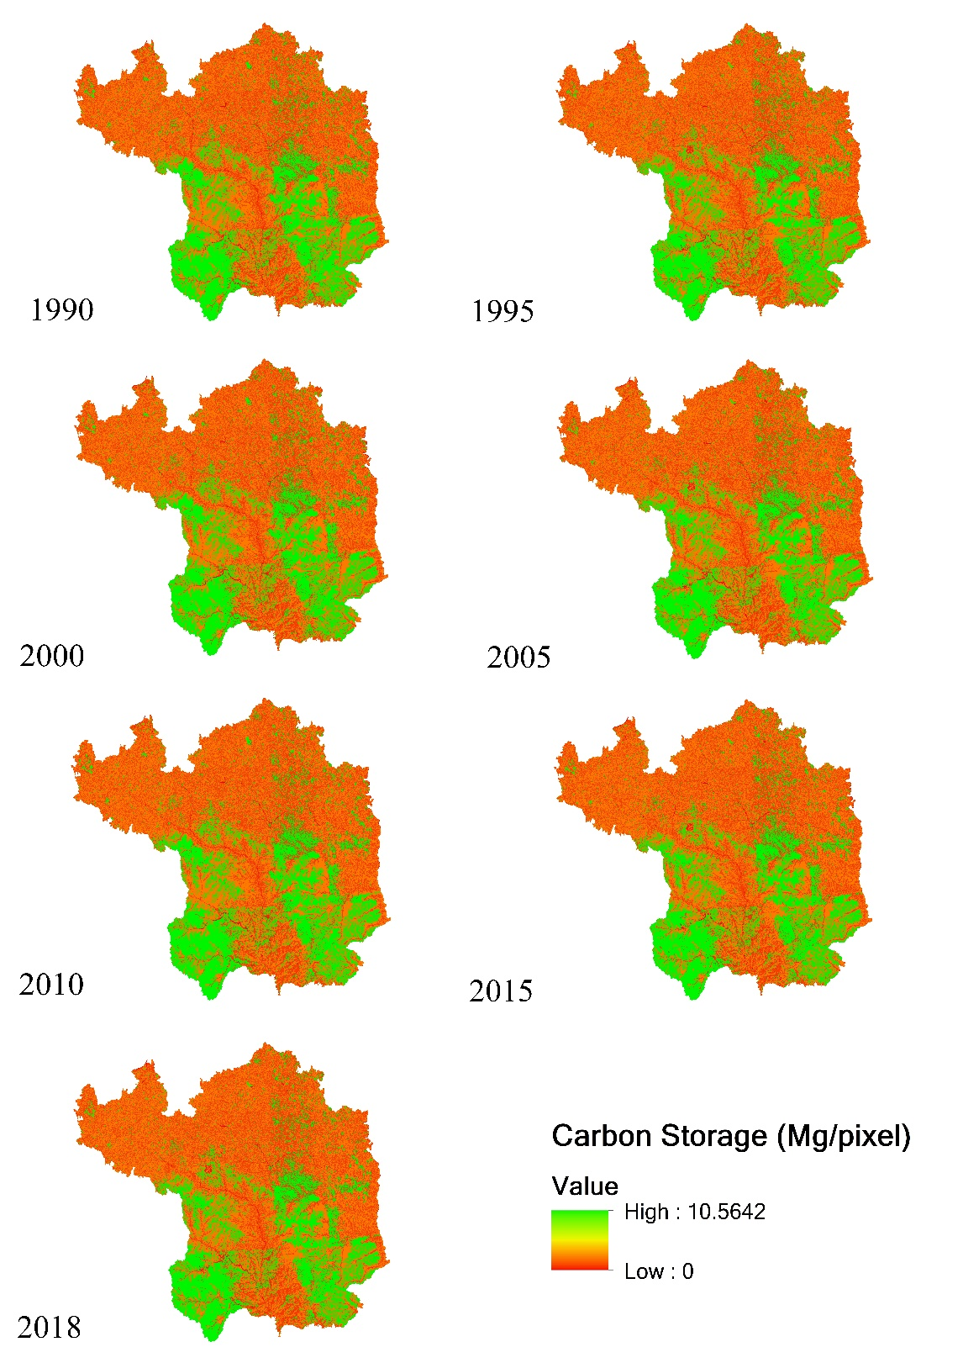

Figure. A1 Carbon storage map (Note: resolution of each pixel = 30m * 30m =900 m² , same as following)

Appendix 2

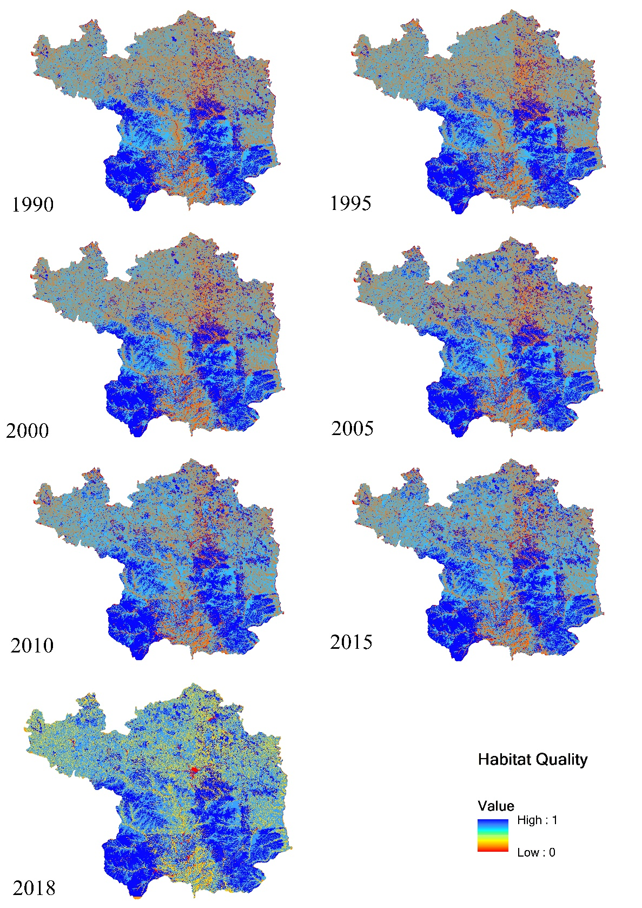

Figure. A2 Habitat quality map

Appendix 3

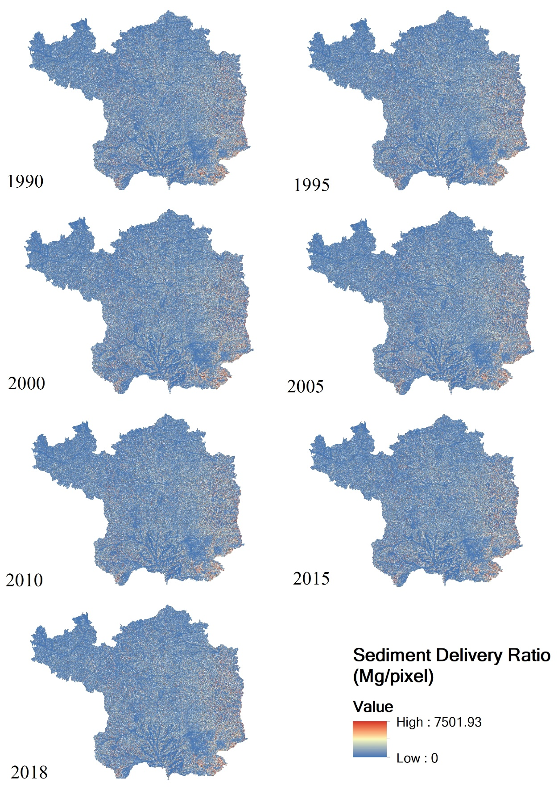

Figure. A3 Sediment delivery ratio map

Appendix 4

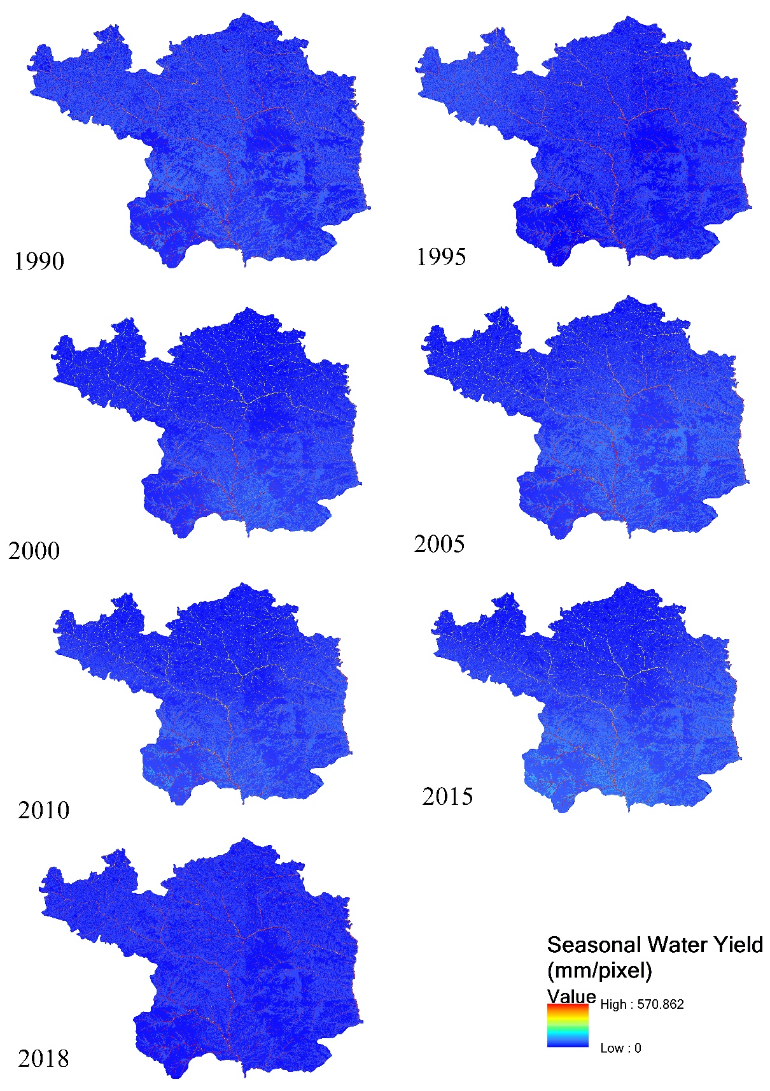

Figure. A4 Seasonal water yield map

Appendix 5

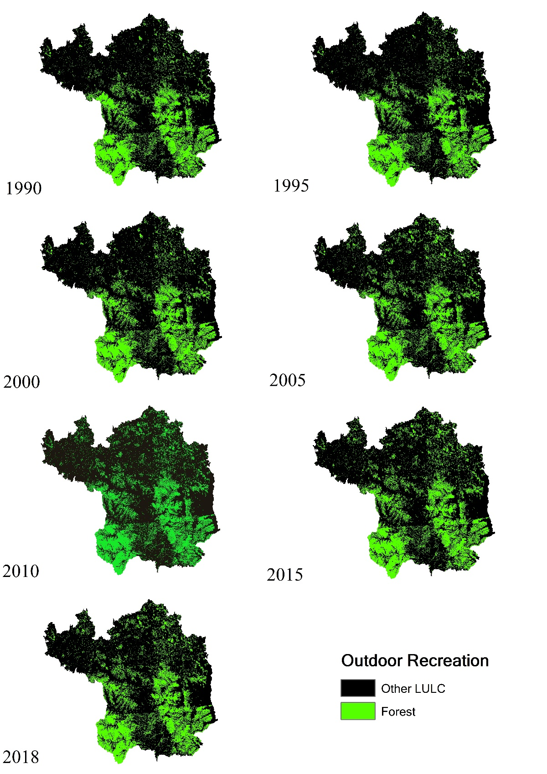

Figure. A5 Outdoor recreation map

Appendix 6

Table. A6 Area of six land use types in Yan’an area
Year  km² | 1990 | 1995 | 2000 | 2005 | 2010 | 2015 | 2018
Cropland | 11488.21 | 11761.71 | 11771.17 | 10935.54 | 9502.78 | 9498.11 | 9356.89
Forest | 9054.24 | 8659.35 | 9057.86 | 9790.82 | 9903.52 | 9899.23 | 9918.40
Grassland | 16227.41 | 16304.86 | 15925.34 | 16013.34 | 17290.54 | 17291.81 | 17301.05
Waterbody | 147.20 | 154.94 | 145.43 | 141.78 | 135.80 | 137.08 | 150.09
Urban | 117.30 | 153.21 | 134.57 | 152.88 | 202.14 | 206.26 | 281.52
Bareland | 2.64 | 2.93 | 2.64 | 2.63 | 2.22 | 4.52 | 31.29

Appendix 7

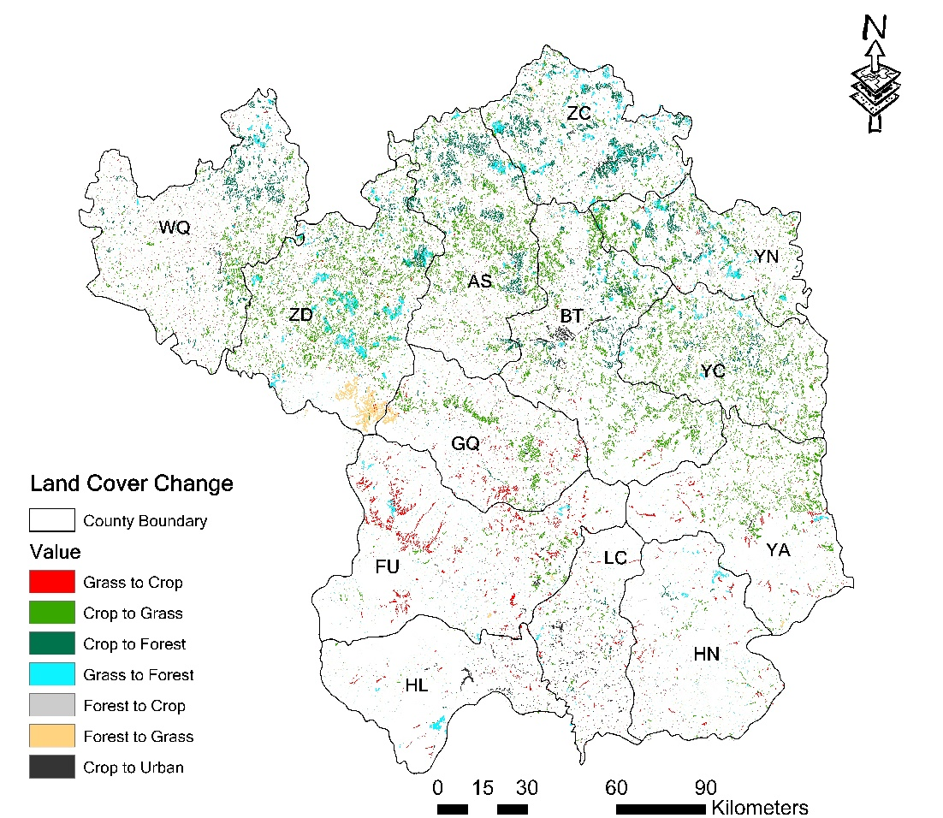

Figure A7. Land use change in the Yan’an area from 1990 to 2018.

Appendix 8

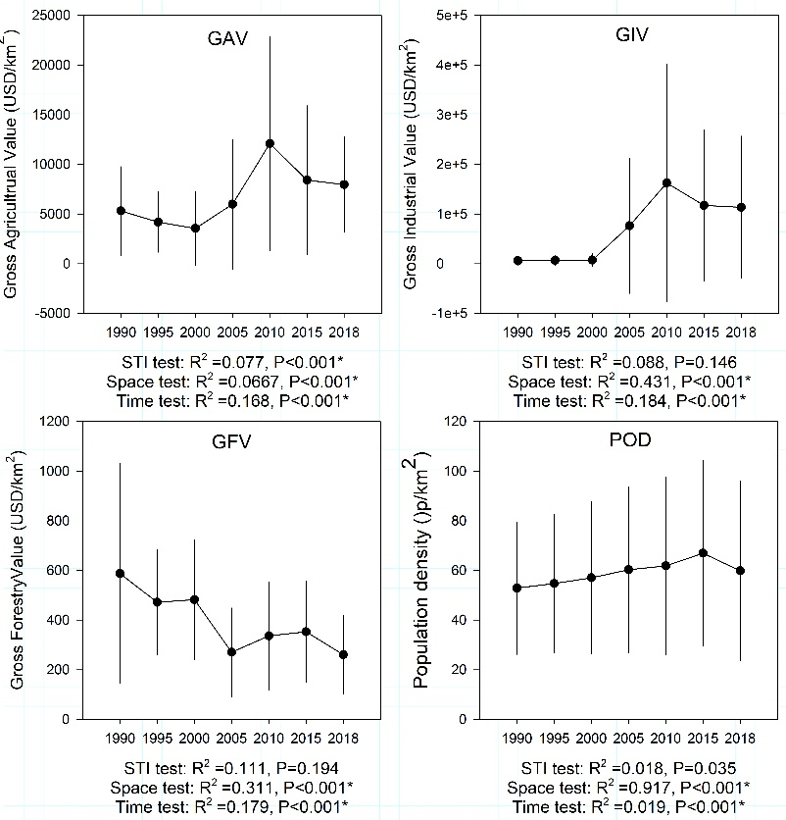

Figure A8. Change of economic factors and population density in Yan’an area.

