SUPPLEMENTARY MATERIALS
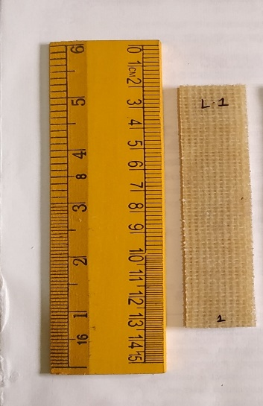  (a) | 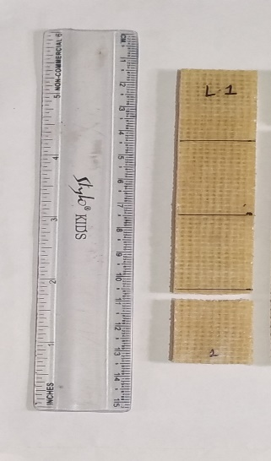  (b)
S1. Tensile specimens (a) before testing (b) after testing

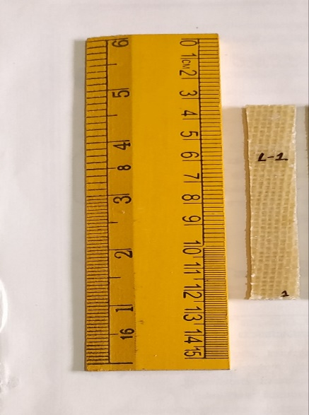  (a) | 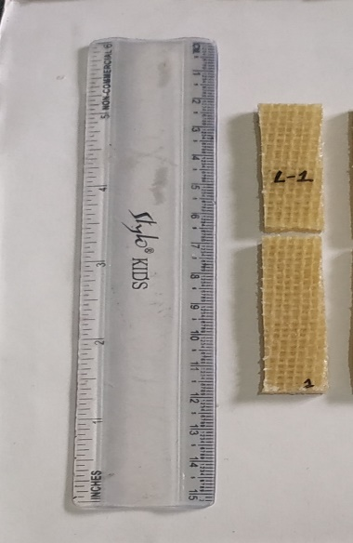  (b)
S2. Flexural specimens (a) before test (b) after test
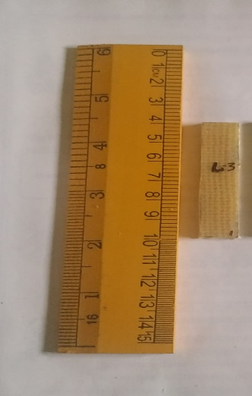  (a) | 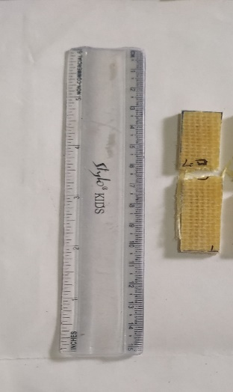  (b)
S3. Impact specimens (a) before testing (b) after testing
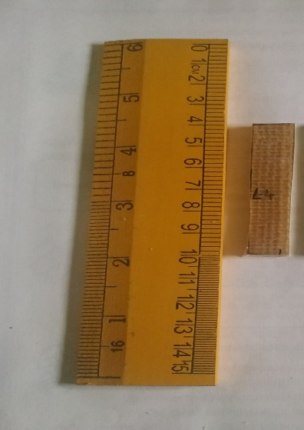  (a) | 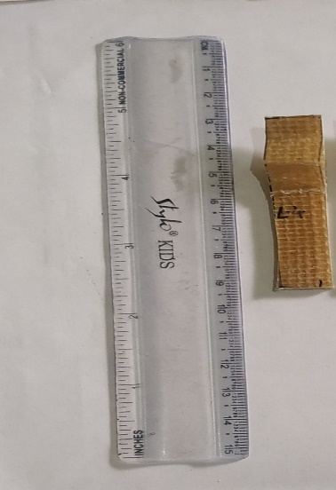  (b)
S4. ILSS specimens (a) before test (b) after test
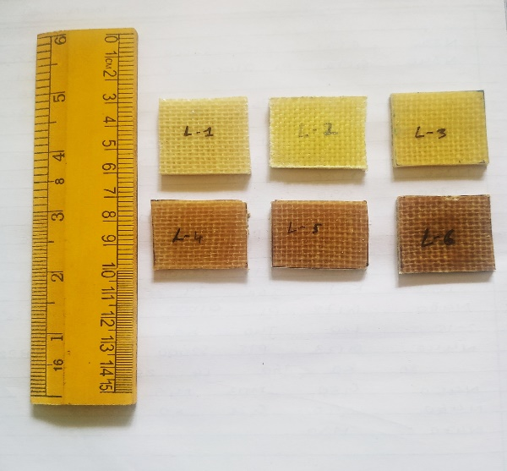
S5. Water absorption test specimens
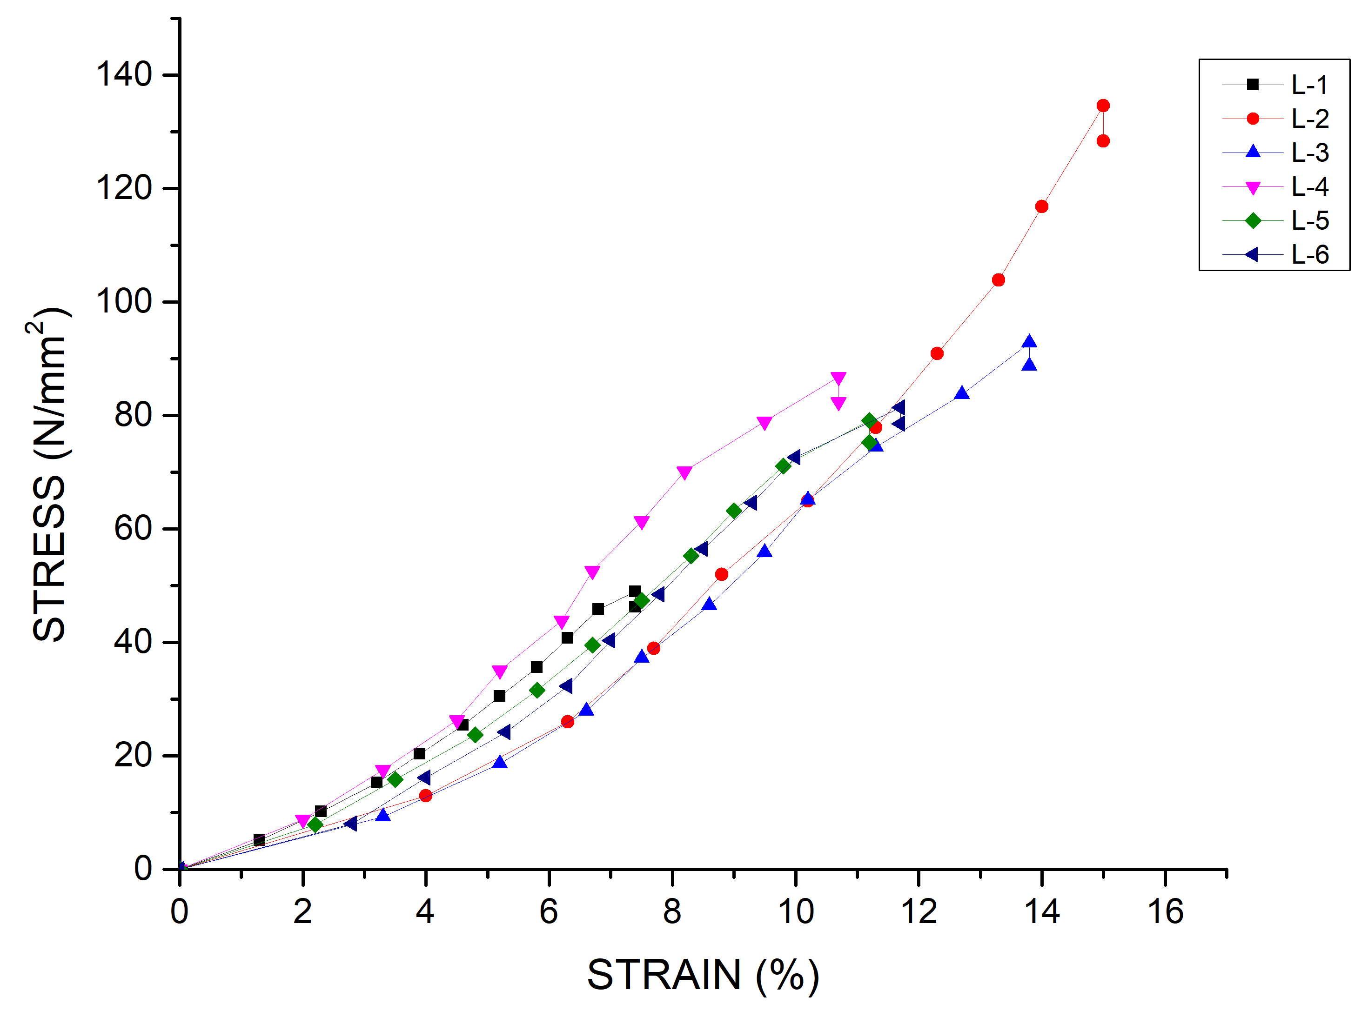
S6. Tensile stress-strain curves for different laminates
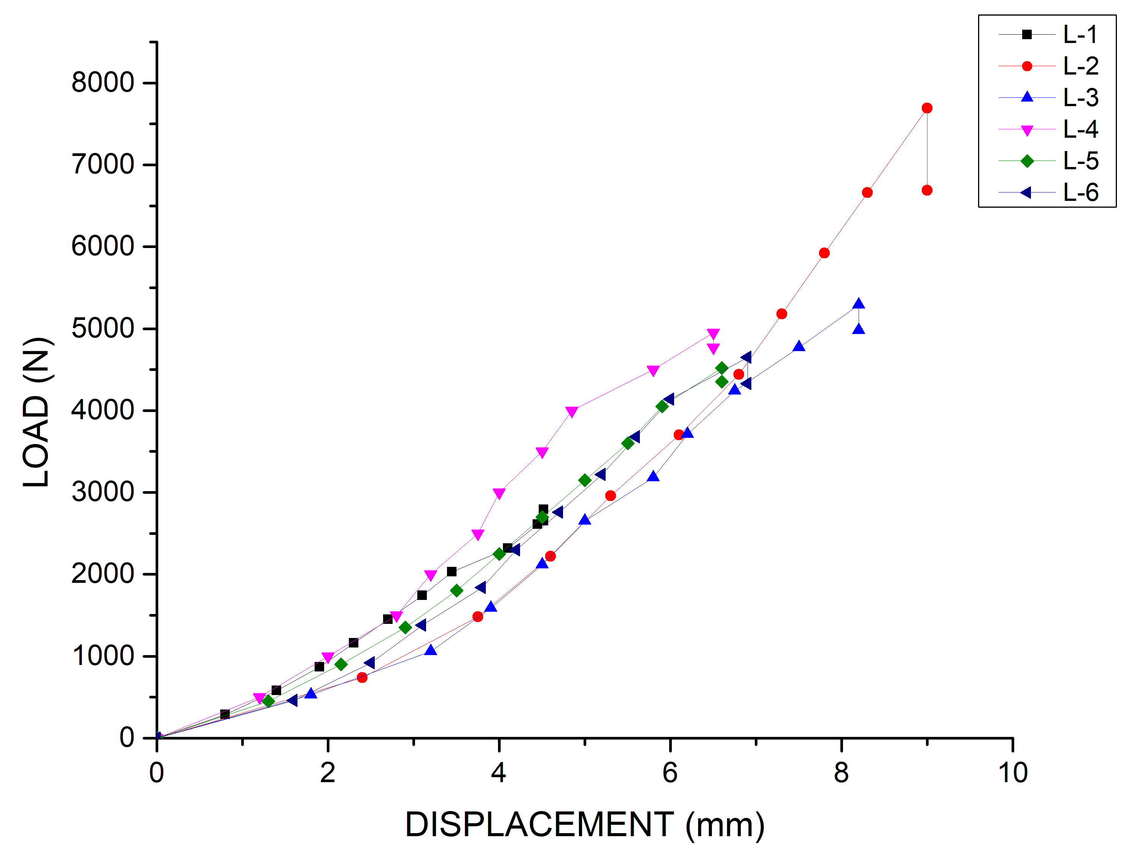
S7. Tensile load v/s displacement graphs for laminates
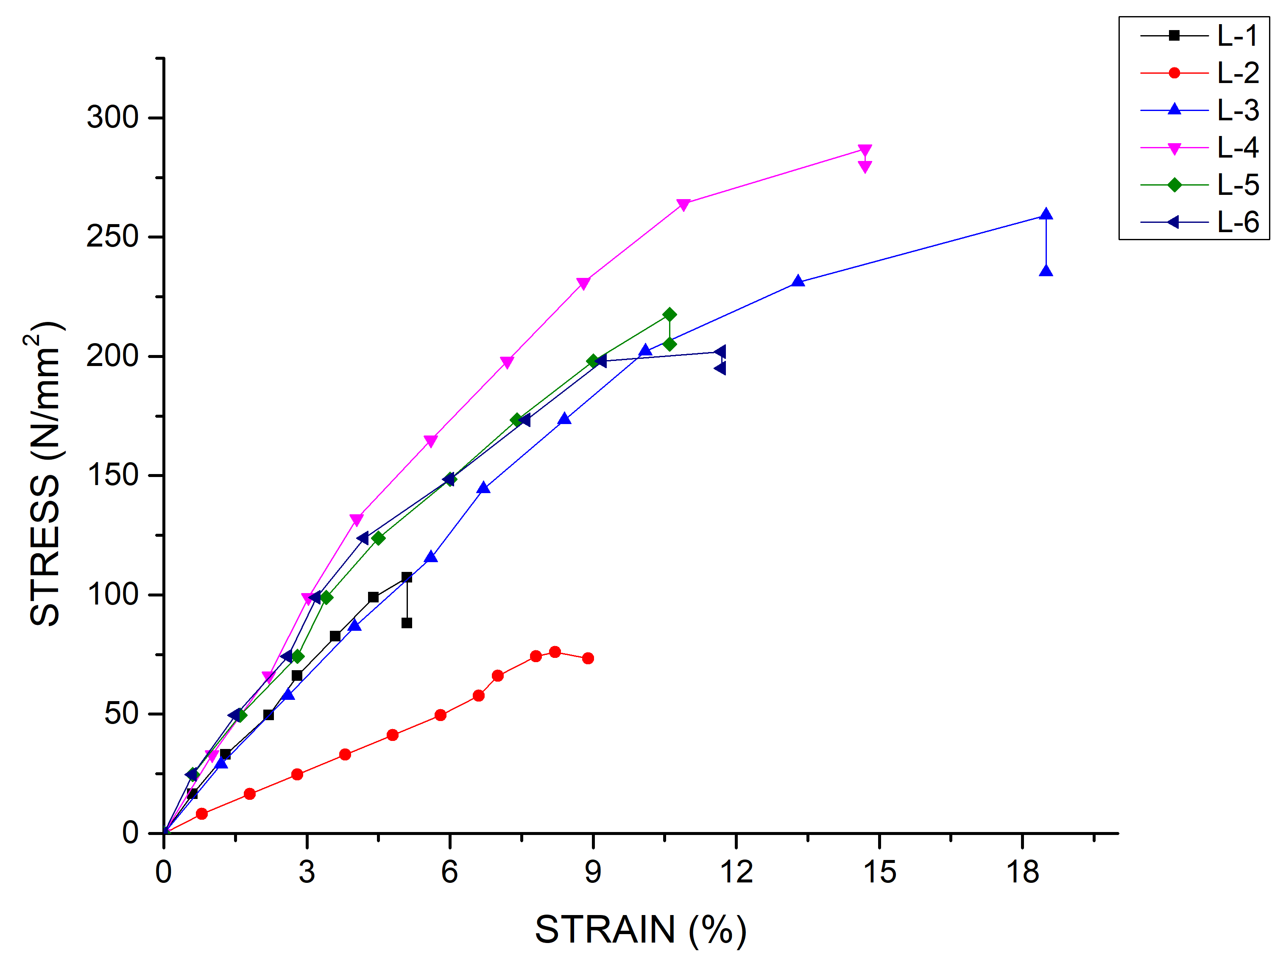
S8. Stress-strain graph for flexural specimen
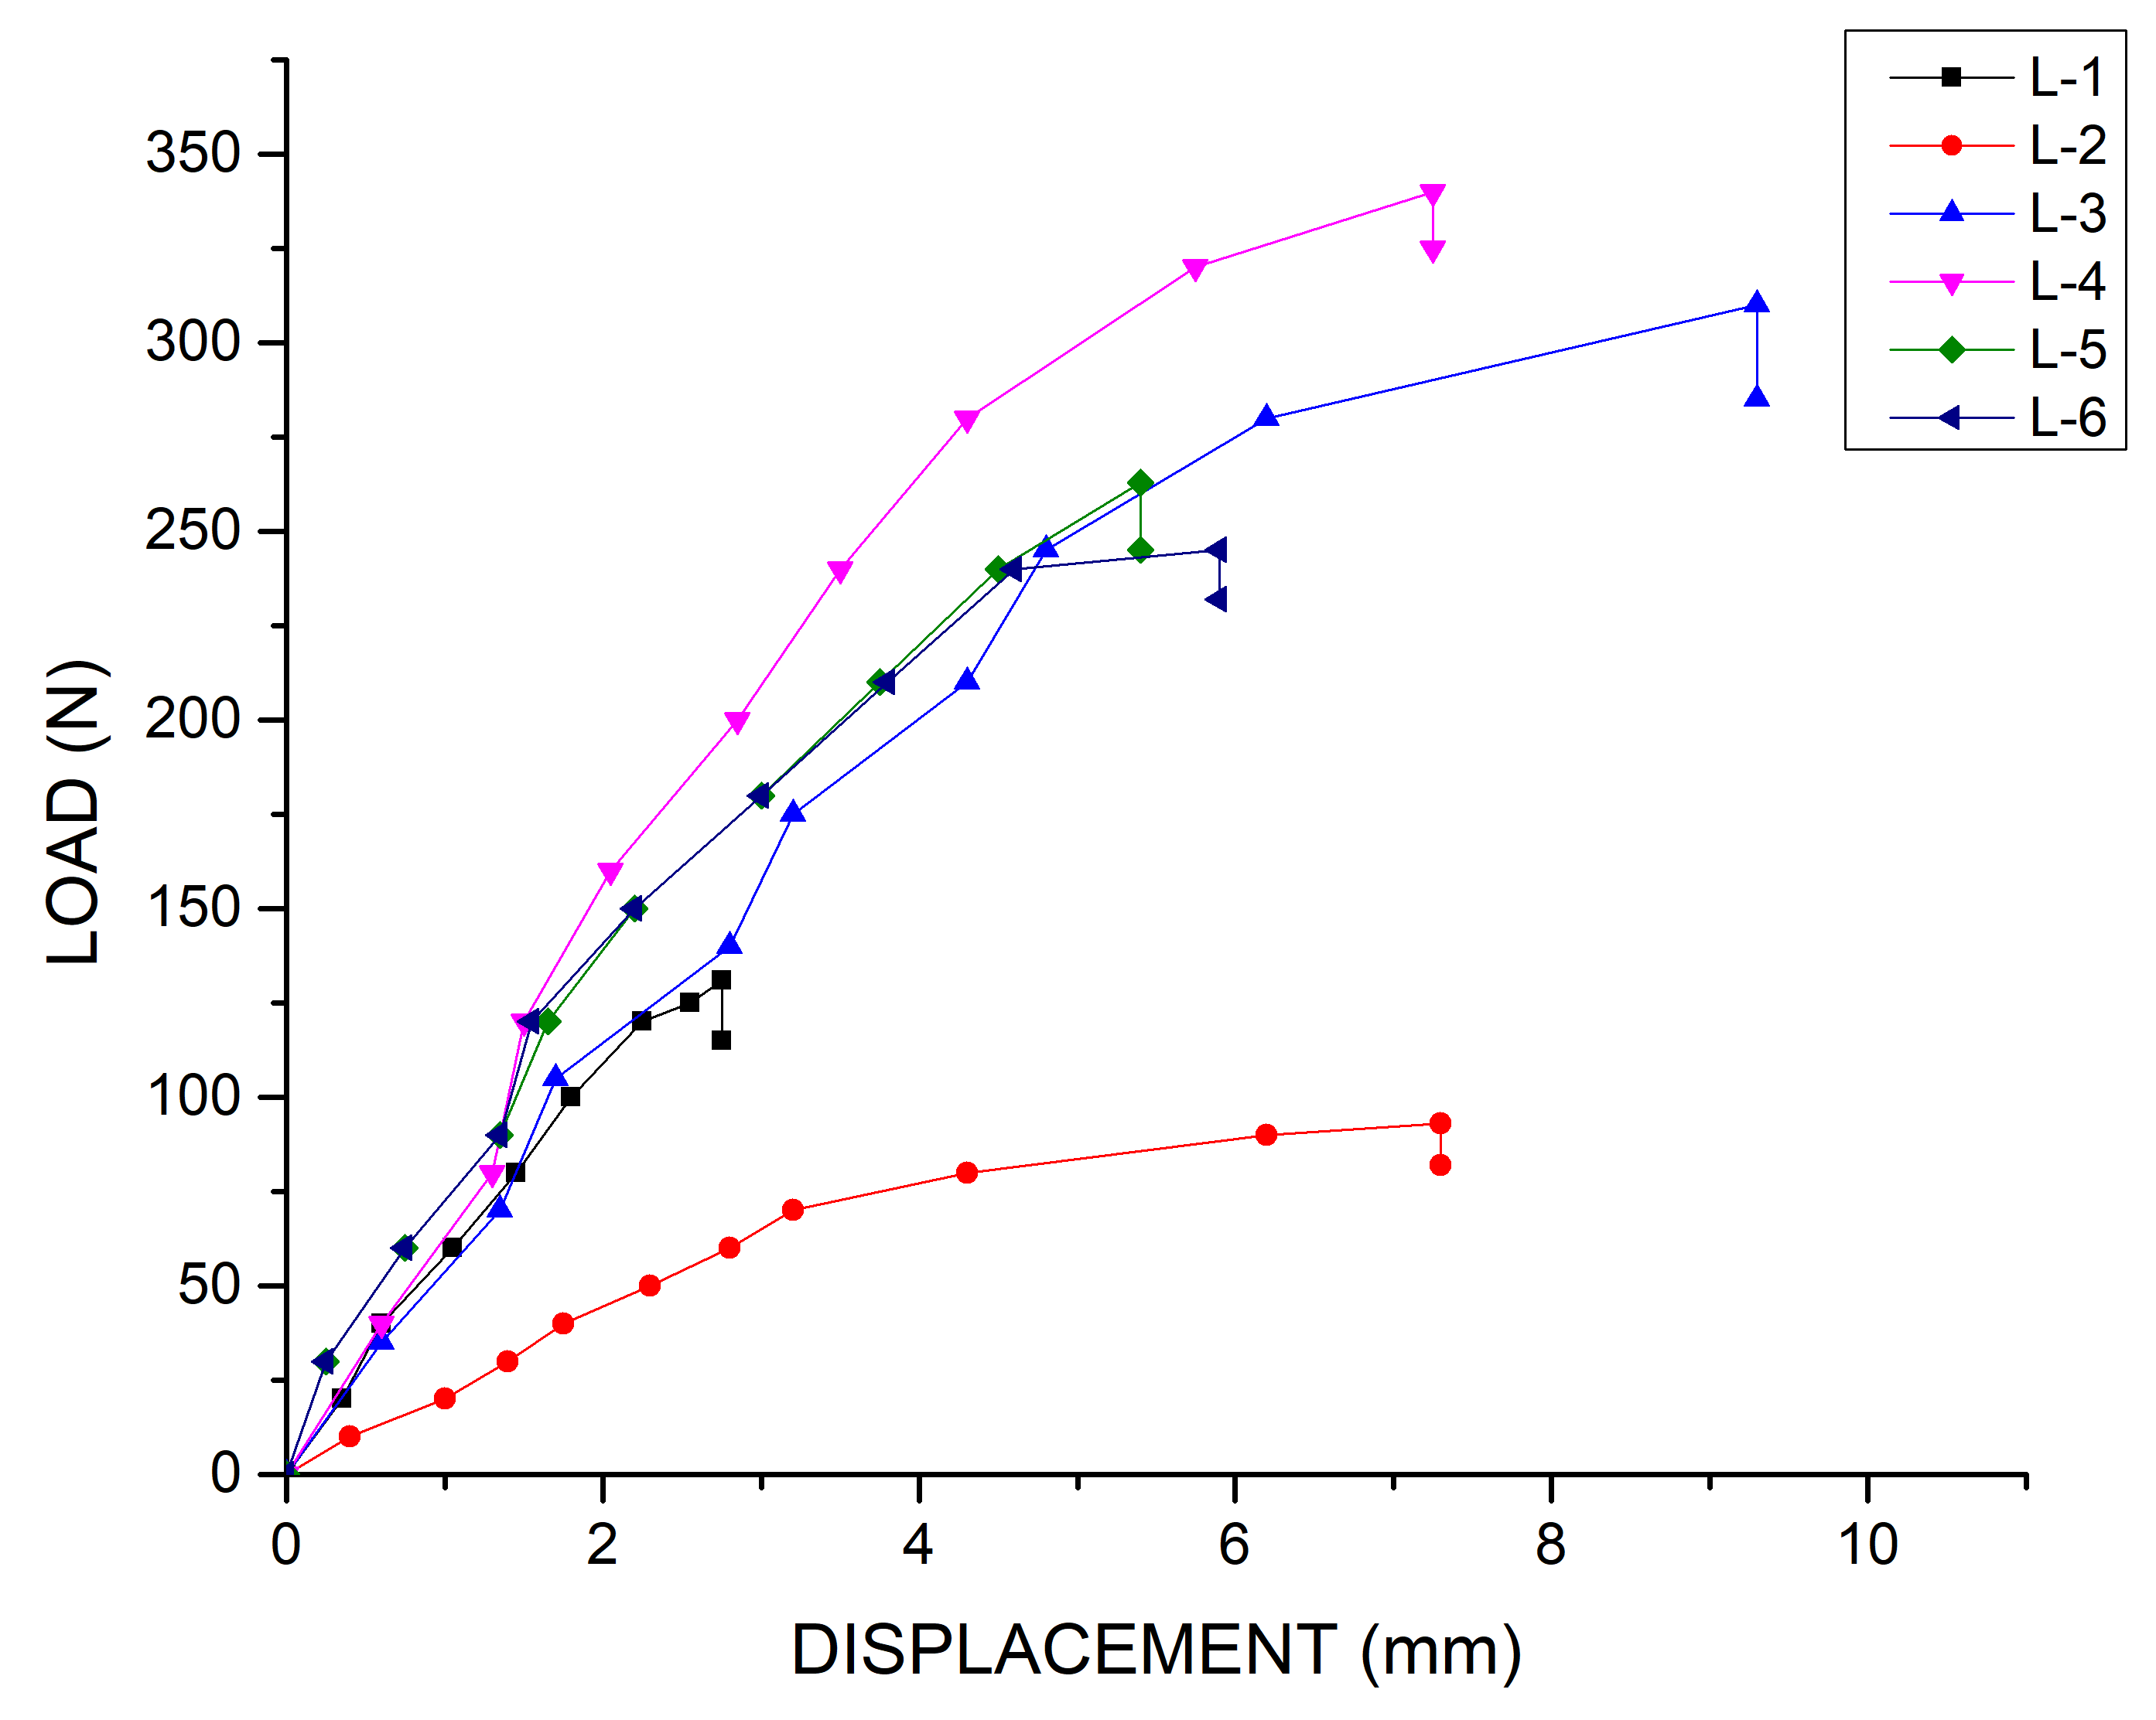
S9. Load-displacement graph for flexural specimen
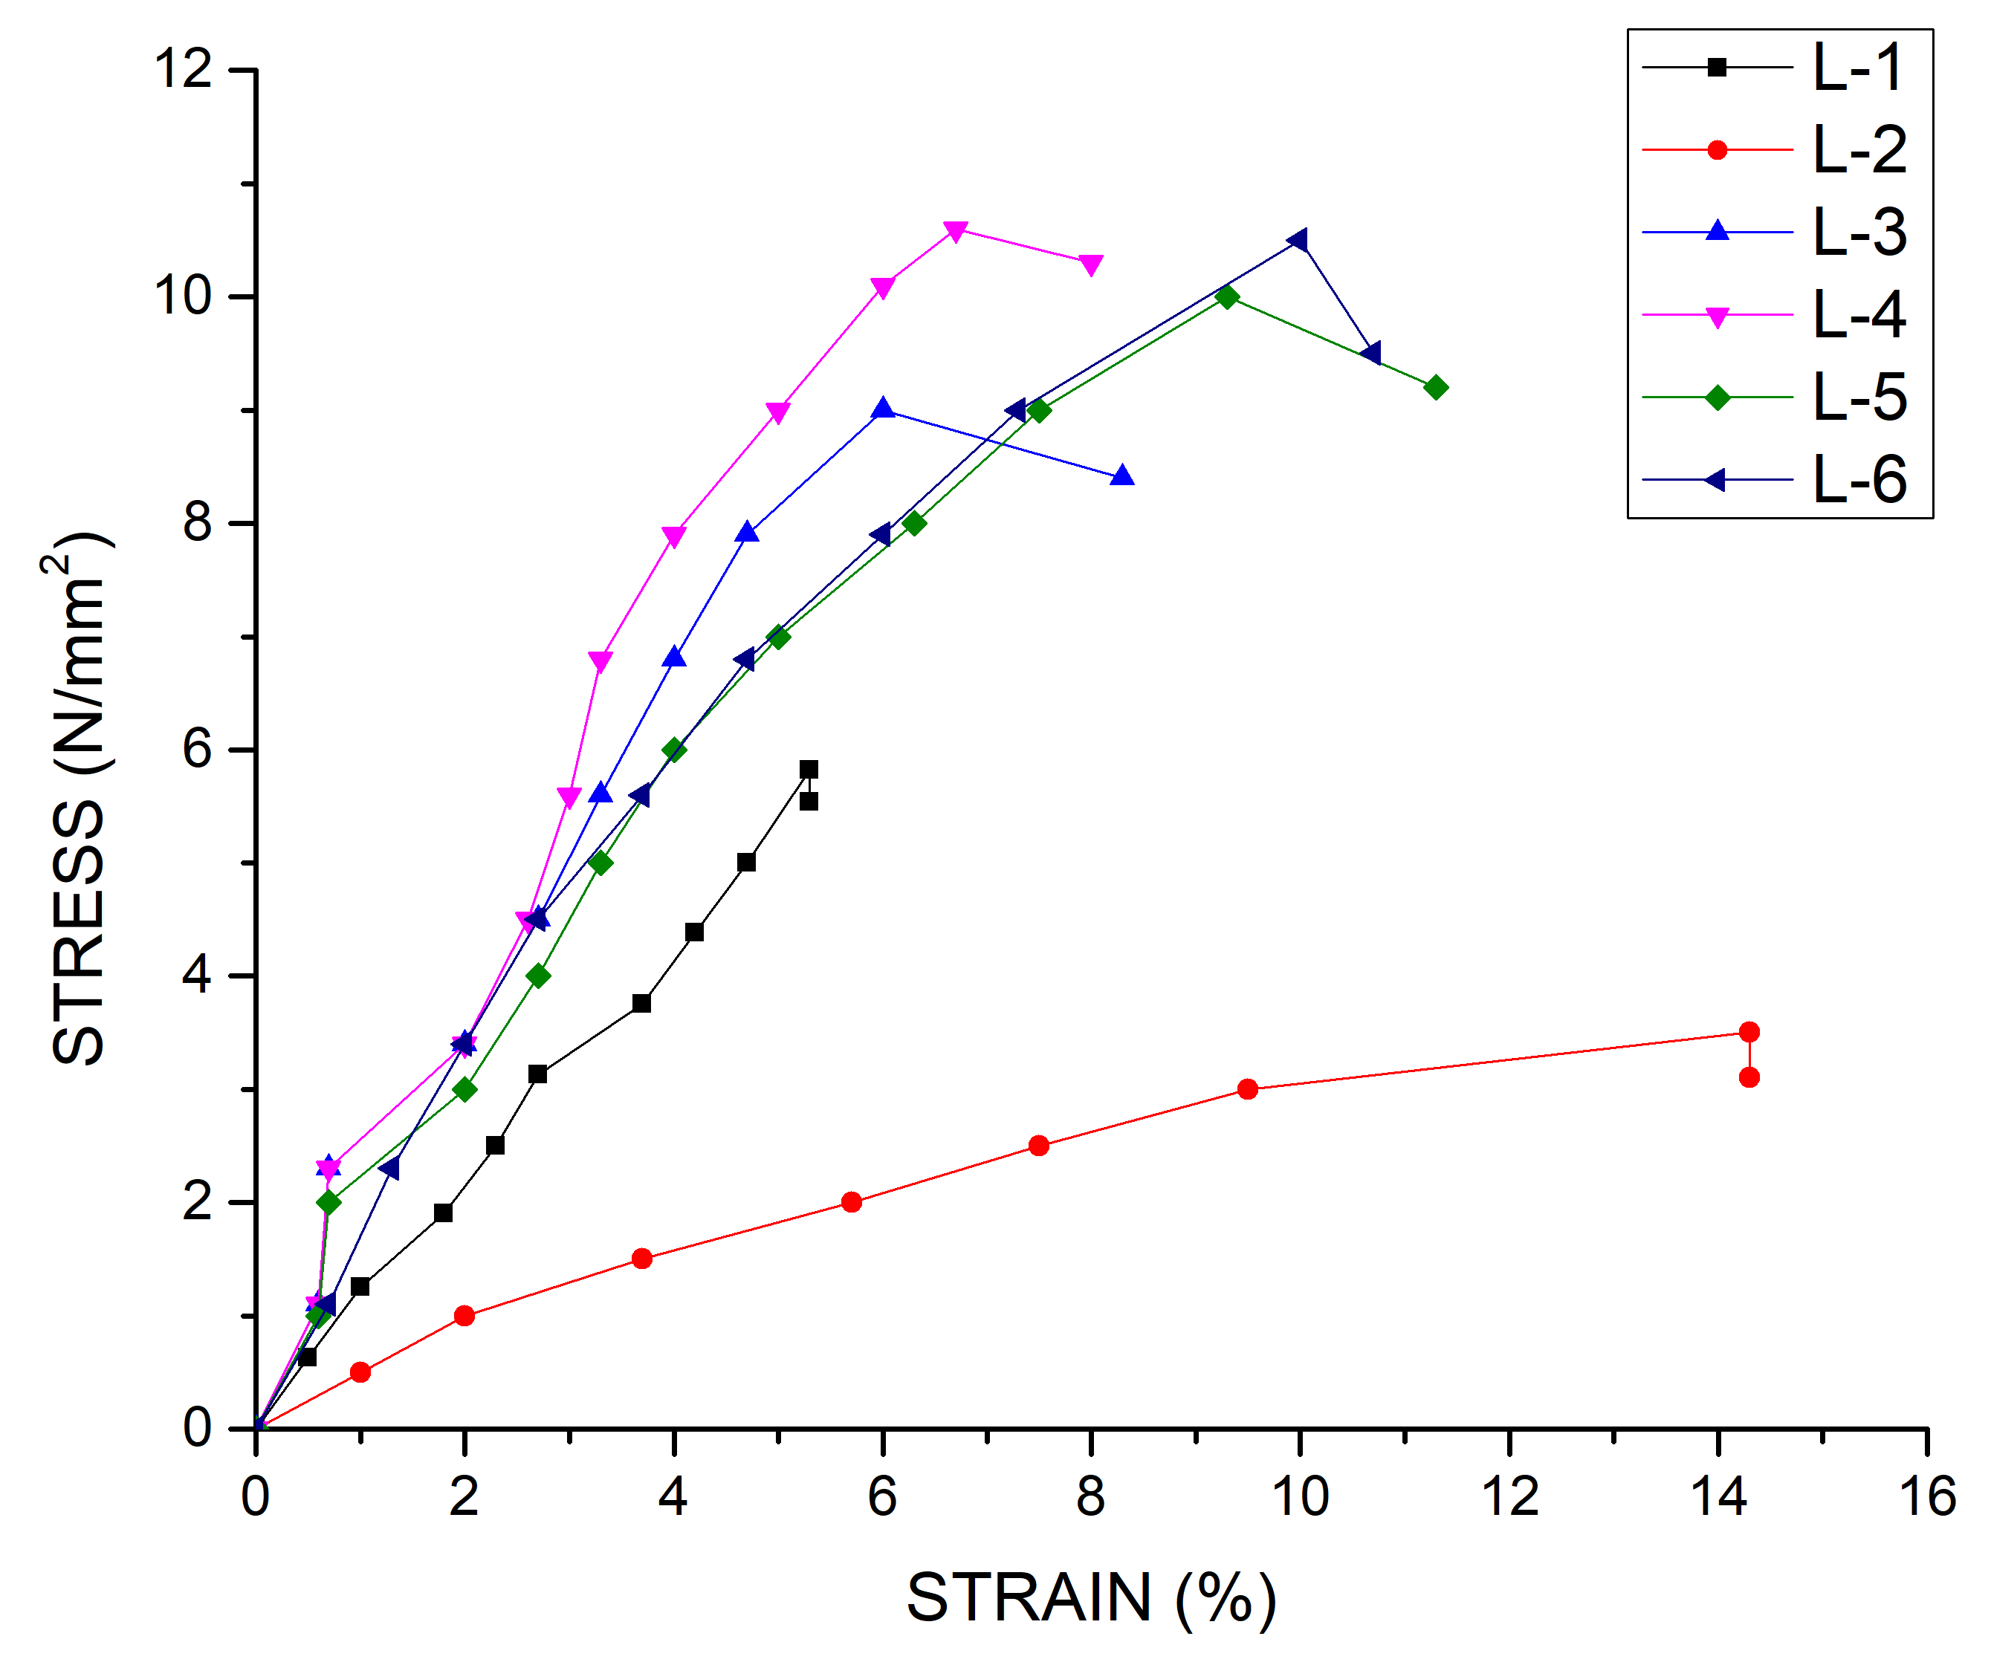
S10. Stress-strain graph for ILSS specimens

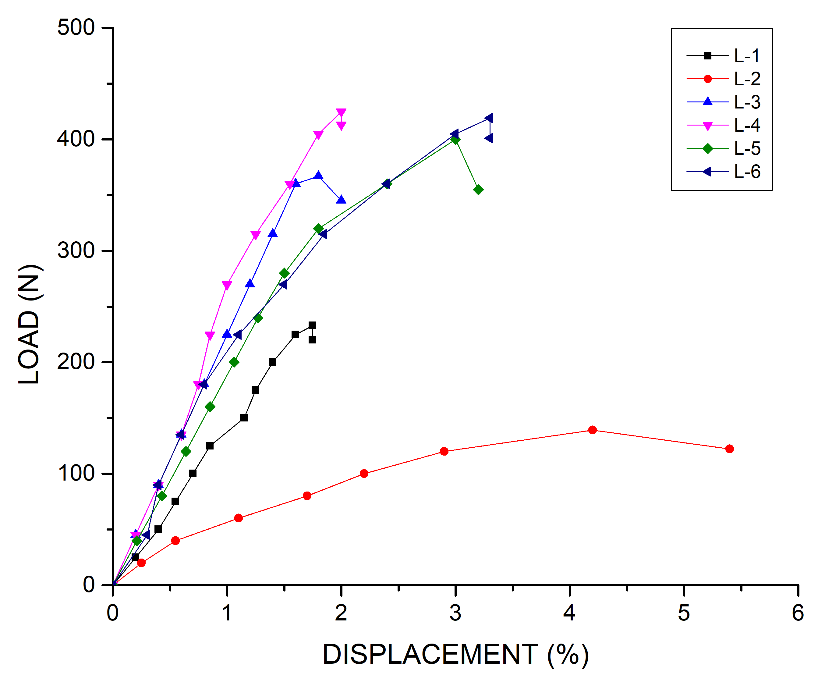
S11. Load-displacement graph for ILSS specimens

