Table S1: Datasets used in novel environment analyses.
Mouse | Date | Familiar Environment | Novel Environment | Area | Hemi-sphere | Depth (um) | Sex | Genotype | Age (days)
AZ2 | 6-30 | Sunset | Classroom Large | RSC | R | 155 | F | Thy-1 | 303
AZ2 | 7-12 | Sunset | Dot Room Fixed | RSC | R | 142 | F | Thy-1 | 315
AZ2 | 8-9 | Sunset | Paw Room | RSC | R | 150 | F | Thy-1 | 343
DB10 | 3-9 | Classroom | Paw Room Fixed | RSC | R | 187 | F | Niell | 145
DB12 | 3-18 | Classroom | Ornament Room | RSC | R | 162 | F | Niell | 154
DB13 | 3-30 | Classroom | Ornament Room | RSC | R | 494 | M | Niell | 166
DB15 | 5-24 | Classroom | Paw Room | RSC | R | 152 | M | Niell | 192
DB19 | 10-5 | Classroom | Sunset Large | RSC | L | 100 | M | Niell | 204
DB26 | 1-5 | Classroom | Dot Room Fixed | RSC | R | 170 | M | Niell | 117
DB27 | 1-24 | Classroom | Blue Room Fixed | RSC | R | 289 | F | Niell | 120
ZD32 | 6-12 | Landscape | Classroom | RSC | L | 210, 300 | M | Niell | 258
ZD40 | 8-17 | Classroom | Europa | RSC | R | 250, 177 | M | Thy-1 | 230
ZD46 | 3-18 | Europa | Classroom | RSC | R | 157 | F | Thy-1 | 297
ZD55 | 5-9 | Classroom | Europa | RSC | R | 71 | F | Niell | 219
ZD62 | 4-23 | Europa | Landscape | RSC | L,R | 236, 189 | M | Niell | 152
ZD63 | 6-3 | Classroom | Landscape Small | RSC | L,R | 174, 136 | F | Niell | 210
ZD66 | 5-28 | Classroom | Large Europa | RSC | L,R | 234, 157 | F | Niell | 173
ZD69 | 9-17 | Europa | Classroom | RSC | R | 209, 429 | M | Niell | 309
MOP14 | 4-15 | Classroom | Paw Room | CA1 | L |  | F | Thy-1 | 192
MOP16 | 5-28 | Classroom | Sunset Large | CA1 | L |  | M | Thy-1 | 235
MOP17 | 8-5 | Classroom | Paw Room | CA1 | L |  | M | Thy-1 | 304
MOP17 | 9-1 | Classroom | Sunset Large | CA1 | L |  | M | Thy-1 | 331
MOP17 | 9-6 | Classroom | Landscape | CA1 | L |  | M | Thy-1 | 336
MOP18 | 10-4 | Classroom | Ornament Room | CA1 | L |  | M | Thy-1 | 199
MOP18 | 10-18 | Classroom | Dot Room Fixed | CA1 | L |  | M | Thy-1 | 213
MOP22 | 4-6 | Classroom | Sunset Large | CA1 | L |  | M | Thy-1 | 218
MOP22 | 4-19 | Classroom | Dot Room Fixed | CA1 | L |  | M | Thy-1 | 231
MOP23 | 7-20 | Classroom | Dot Room Fixed | CA1 | L |  | M | Thy-1 | 323

Information about all datasets included in figures 1-4 and S1-S2 is displayed. All mice were trained in a “familiar” environment for 3 weeks or more, and then introduced to a novel environment during imaging. On the first day in the novel environment, the mouse ran for ~10 min (10-20 laps) in the familiar environment and then was “teleported” into the novel scene. Only the first day in the novel environment is analyzed here, even though mice ran for at least 2 additional days in each environment. In some cases, the same mouse was introduced to additional (fixed) novel environments (several days apart), and those sessions were also included.
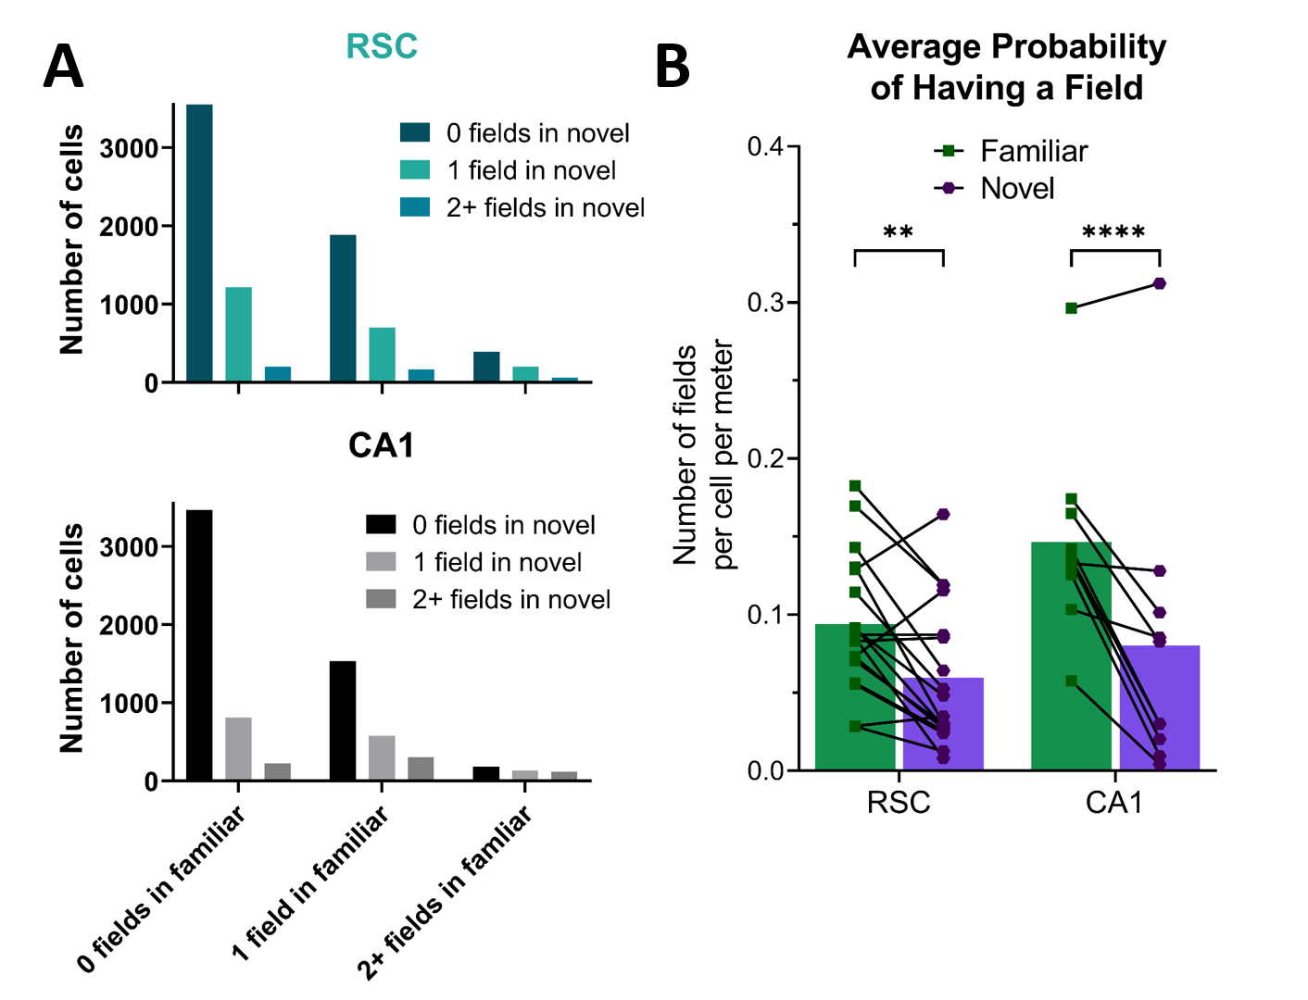
Figure S1: Probability of place field allocation.
In figure 2, we showed that the proportion of cells with fields in both environments is the same (in CA1) or almost the same (in RSC) as that predicted by random allocation with replacement (RAR). This assumption is incorrect in the hippocampus (Witharana et al., 2016), likely because pyramidal cells show something similar to a log normal distribution in propensity to fire (Rich et al., 2014; Lee et al., 2020). A.) Our data are consistent with the latter studies, because we also found that fields with one or more fields in one environment were more likely (than cells with no fields) to have one or more fields in the other environment (Chi square test; RSC: Χ²=349, df=4, p<0.0001; CA1: Χ²=428, df=4, p<0.0001). This may have partially been due to differences between mice (e.g. exact imaging location), but on the individual mouse level, 13/18 RSC recordings and 3/10 CA1 recordings showed a statistically significant disproportionate allocation of fields (Chi square test, df=1, p<0.05). However, these differences in propensity to fire were not large enough to significantly impact the proportion of cells in both environments (Fig. 2H), because only about half the cells had any fields in either environment, and very few had 2 or more fields in a single environment. The propensity of a cell to fire predicts how many fields a cell will have in a large environment, but not where those fields will be. Thus, in our relatively small environments compared to Lee et al., 2000, there was a low correlation between number of fields in familiar vs. novel (RSC: R=0.17, p<0.0001; CA1 R=0.24, p<0.0001), and thus a very low ability to predict if a cell was going to fire in the novel environment. B.) Witharana et al. also used small environments, but their analysis was a bit different than ours. They used the proportion of cells active in one familiar environment to predict the proportion of cells active in X (familiar and novel) environments, based on the RAR assumption, and found that this assumption largely overestimated the total number of active cells. Instead, we used the proportion of cells active in both the familiar and novel environments to predict the overlap. This may account for some of the difference in our results, since the number of fields per cell per meter is significantly lower in the novel than that in the familiar environment (64% of familiar in RSC, paired t-test, p<0.01 and 55% in CA1, p<0.01). Not all of their studies used novel environments, however, and thus more differences remain to be accounted for.

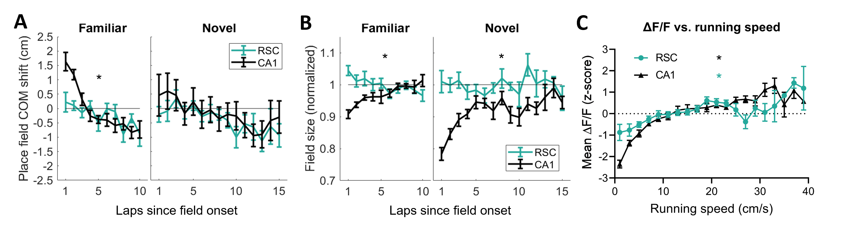
Figure S2: Place field backwards expansion and running speed analysis in all day 1 datasets.
A. The center of mass (COM) was calculated for each place field (each spatially-tuned cell could have one or more place fields) in the familiar and novel environments by weighting each position bin within the boundaries of the field with the mean activity in that bin. Then the COM was calculated for each lap with above threshold activity, and subtracted from the mean COM for that field. CA1 cells showed a COM shift similar to previously published data. RSC cells showed no such shift. In the novel environment, CA1 cells showed a lower COM shift, probably due to the sessions which never established stable spatial tuning (see Fig. 3D and 4E). B. Field size was calculated for each place field by calculating the number of bins within place field boundaries that had above-threshold activity (>50th percentile of all bins), and then normalized to the average across laps. Laps with mean activity below threshold were excluded from analysis, same as in A. CA1 fields increased in size across laps in both familiar and novel environments, while RSC cells did not. Asterisks indicate that repeated measures ANOVA showed a significant effect of laps for RSC (teal), or CA1 (black) datasets. C. The firing rates of CA1 and RSC neurons increased as the mice ran faster. To quantify the influence of running speed on neural activity, we found the running speed, and the mean activity across all cells in each lap (except lap 1) and bin of the track. We binned both the running speed and the z-scored activity in 2 cm/s running speed intervals. Any intervals with less than 10 instances were removed for that mouse. Not all mice ran >25 cm/s, and thus there is more variability those intervals. There was a main effect of running speed on ∆F/F in both RSC and CA1. There was no effect of environment novelty, and so both Novel and Familiar environment laps were combined. A mixed effects analysis showed a significant effect of running speed, and a significant interaction with imaging area. Therefore, there was a difference between the activity and firing rate relationship in RSC and CA1, but both regions individually also showed a main effect of laps. Asterisks indicate that a mixed effects model showed a significant effect of running speed for RSC (teal), and CA1 (black) datasets.

Table S2: Experiments completed by each mouse
Mice imaged in RSC | fixed day 1 | fixed day 3 | shifting day 1 | shifting day 3 | pre-destabilized | destabilized day 1
AZ2 | 12-Jul  9-Aug | 18-Jul  15-Aug | 27-Jul | 2-Aug | 18-Jul | 19-Jul
DB10 | 9-Mar
DB12 | 18-Mar | 23-Mar | 10-Mar | 15-Mar | 21-Apr | 22-Apr
DB13 | 30-Mar | 1-Apr | 22-Mar | 24-Mar
DB15 | 24-May | 27-May | 2-Jun | 4-Jun | 5-Jun | 6-Jun
DB26 | 5-Jan | 7-Jan | 18-Jan | 20-Jan | 10-Jan | 11-Jan
DB27 | 24-Jan | 26-Jan | 18-Jan | 20-Jan | 3-Mar | 4-Mar
DB4 |  |  | 12-Dec | 14-Dec
ZD40 | 17-Aug | 20-Aug |  |  | 23-Aug | 23-Aug
ZD46 |  |  |  |  | 14-Feb | 14-Feb
ZD55 | 9-May |  |  |  | 10-May | 16-May
ZD62 |  |  |  |  | 7-May | 7-May
ZD63 |  |  | 26-Jun | 2-Jul
ZD66 |  |  | 18-Jun | 20-Jun
ZD68 | 24-Jun | 26-Jun |  |  | 26-Jun | 26-Jun
ZD69 |  |  | 2-Oct | 4-Oct
MOP11 |  |  | 3-Feb | 6-Feb
number sessions passing criteria | 10 | 8 | 9 | 7 | 7 | 6
number sessions failing criteria | 0 | 0 | 2 | 4 | 3 | 4
Mice imaged in CA1
MOP14 | 15-Apr | 18-Apr | 19-Apr | 23-Apr | 1-May | 2-May
MOP16 |  |  | 12-Jun | 15-Jun
MOP17 | 5-Aug | 7-Aug | 14-Aug | 16-Aug | 17-Aug | 18-Aug
MOP18 | 4-Oct  18-Oct | 6-Oct  20-Oct | 12-Oct | 17-Oct | 30-Oct | 31-Oct
MOP22 | 19-Apr | 21-Apr | 23-May | 31-May | 29-Apr | 29-Apr
MOP8 |  |  | 20-Oct | 3-Nov
MOP23 | 20-Jul | 2-Aug | 19-Aug | 25-Aug | 2-Aug | 3-Aug
number sessions passing criteria | 6 | 5 | 7 | 7 | 4 | 4
number sessions failing criteria | 0 | 0 | 0 | 0 | 1 | 1

Many mice participated in multiple experiments (fixed: experiment two group one, shifting: experiment two group two, and destabilized: experiment three). Many of the same mice also participated in experiment one (Table S1), which is not included in this table. In each case, mice were exposed to different environments in the shifting and fixed experiments. Destabilized experiments were conducted following the fixed experiment, and used the same environment as the fixed experiment. The date each mouse ran in each experiment is recorded in the table. Empty boxes indicate the experiment was not run on that mouse. Mice with RSC cranial windows are at the top, and mice with CA1 windows are at the bottom. In two cases (AZ2, and MOP18) a mouse ran the same experiment twice, but using different environments. Some sessions failed our criteria for inclusion in the analysis (see methods), and are marked in orange. Figure 5 compares data from fixed day 1 and shifting day 1 sessions. Figures 6 and 7 and S3G compare data from pre-destabilized, destabilized day 1, and shifting day 1 sessions. Figure S3A-F is an analysis of only the datasets which included pre-destabilized and destabilized on the same day.

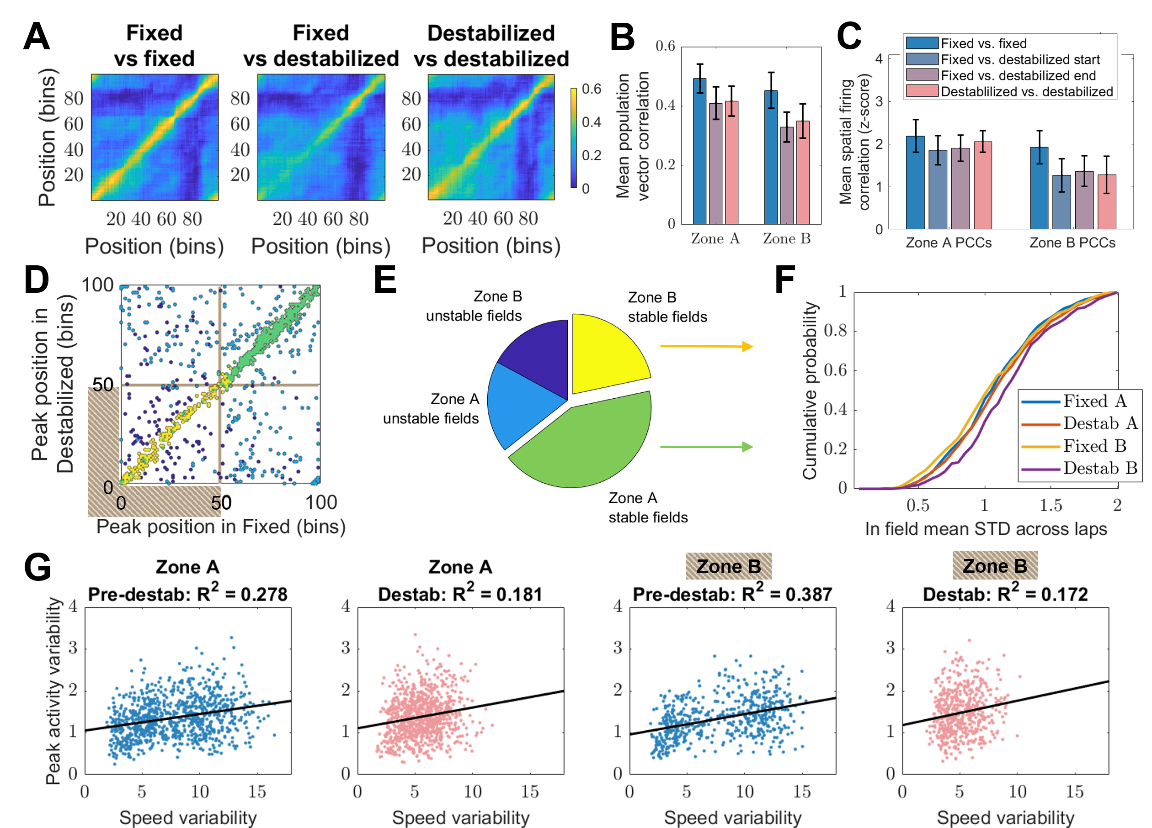
Figure S3: Stability and rate remapping in RSC PCCs recorded in both fixed and destabilized conditions.
In order to determine if neural activity maps were stable across the transition from a fixed to a destabilized configuration, we ran mice in both configurations in a single session (either on destabilized day 1 or 3; n=6). A. Population vectors for each position bin were calculated in 5 lap intervals in the fixed and destabilized configurations, and then correlated with all other bins in a different lap interval. B. The population vector correlations in the same bins across different laps was averaged across bins in each zone (along the diagonal in A), and then across mice (n=6). There was no difference between correlations between different lap intervals in fixed (blue), fixed vs. destabilized (purple), or destabilized (pink), in either zone A or zone B. C. Spatial activity maps were calculated for each cell in various 5-lap intervals, and correlated across intervals. Correlations were averaged across cells, z-scored against a shuffle control, and then averaged across mice. D. For the mice that ran in both the fixed and the destabilized environment on day 1 (n=4), the peak bin for each PCC in the fixed (x-axis) versus its peak bin in the destabilized (y-axis) is plotted. Bins 0-49 are in zone B, and 50-99 are in zone A (delineated by brown lines). In order to ensure the increase in peak activity variability (Fig 7E) was not due to fields shifting locations across laps, only fields from cells whose overall peak shifted by less than 25 cm were identified (yellow and green dots). E. The total number of fields is split into categories based on their location (zone A or B) and whether the cell’s peak location moved between fixed and destabilized. Only the stable fields are used for part F (70% of zone A fields and 56% of zone B fields). F. Mean in-field variability for all fields whose peak bins shifted by less than 25cm (n=4 mice; 717 fields in zone A, 364 fields in zone B). G. The peak activity variability for each PCC is plotted against the variability of the running speeds calculated at the same times (n=6 mice, same data as in Fig 7E and F). There is a correlation between activity variability and speed variability, but this correlation goes down in the destabilized configuration, and cannot account for the increased rate variability in destabilized zone B.

Supplementary videos SV1-SV4: Illustrations of the full VR environments.
Each video shows a view of the left, front, and right tablets, as the mouse would see them, along with a window containing the VR parameters and metrics, during two passes through a single environment. The parameter window contains an overhead schematic of the track, including the locations of each object (pink squares), hidden reward zones (cyan lines) and the position of the mouse (blue circle). Each video starts with blank tablets, which the mice saw at the beginning of each session, then the start of the first lap in the environment, followed by a second lap, and then a transition back into blank. The speed of the treadmill is set to a constant 20 cm/s, except just prior to each reward site, where the video simulates the mouse slowing down, licking, receiving a reward, and then running again. Videos contain four environments: three from experiment one (classroom, sunset, landscape), and one from experiments two and three (blue room), in which the shifting configuration of the environment is displayed. Note that four objects shift when the animal enters the second lap in blue room.

