Supplementary Information

Method

Constructing the cards’ expected values and teachers’ accuracy. The likelihood of each card leading to a reward changed throughout the duration of the experiment. The reward probability followed a stochastic distribution, as shown in Figure S1.
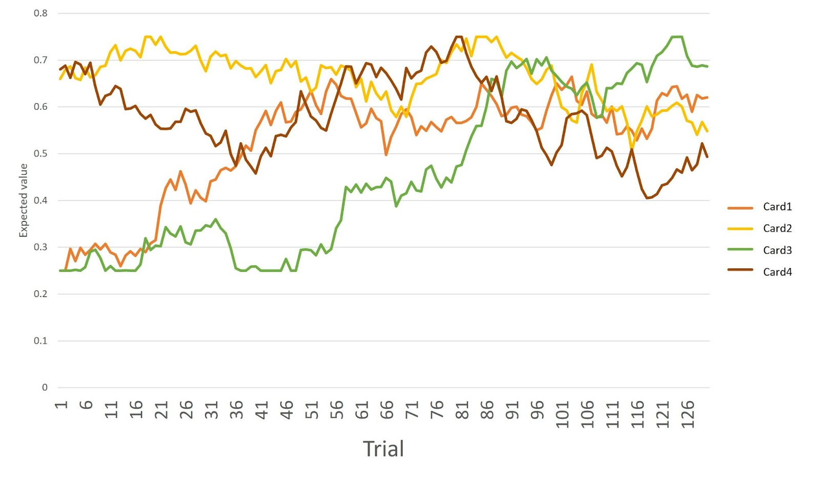
Figure S1. Drifting expected values for the cards across trials. The same random walk was used in each of the 6 blocks, and each card was randomly assigned to a random walk.

Teachers’ accuracy (i.e., chances for instructing the card with higher chances to gain a reward) also changed throughout the experiment. The teachers’ accuracy was based on the Softmax function, such that the 𝛽 component followed a stochastic distribution (see Figure S2 for teachers’ 𝛽). The Softmax for teacher accuracy is provided in Equation S1.

Eq. S1 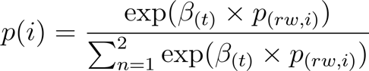

The probability of the teacher choosing card i is a function of the 𝛽 of the teacher on a certain trial t, and the true probability of that card i to lead to a reward.

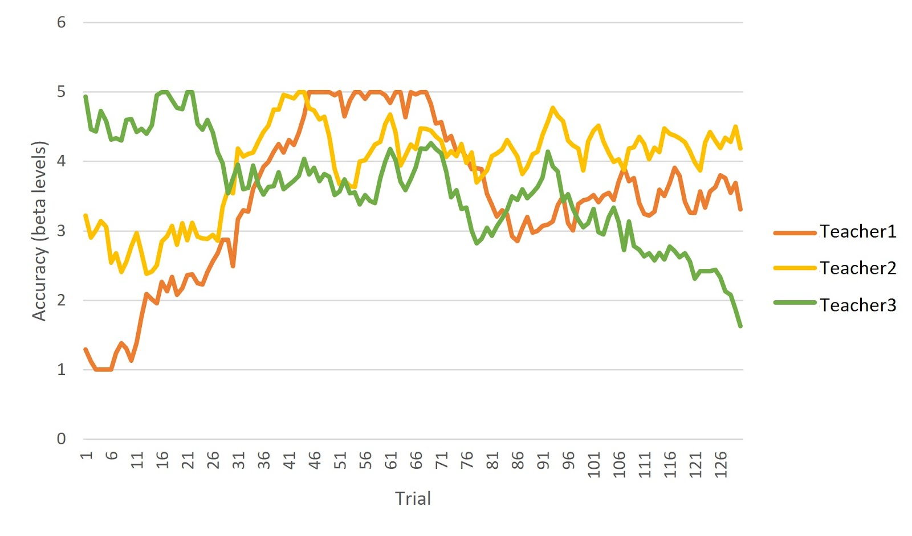

Figure S2. Drifting accuracy rates for advice accuracy of three teachers. The same random walk was employed in every session, such that the accuracy rate for each teacher avatar was randomly assigned.

Results

Regression analyses. In our analyes, we dummy coded the outcome of the previous offer (i.e., 0 vs. 1 for rewarded vs. unrewarded), and the advice condition (i.e., 0 vs.1 for concealed advice vs. revealed advice).

Priors robustness analysis. We used N(0,0.2) priors for all the effects described in the regression analysis section. We conducted a prior robustness analysis which indicated that the reported effects hold even when having narrower N(0,0.1) or wider N(0,0.4) priors for our predictors.
Parameter recovery. To ensure that our model was well specified, we simulated 200 agents using the full model (individual learning, informed and non-informed advice-taking). Individual parameters for each agent were sampled hierarchically. Learning rates were sampled from a normal distribution with a mean of 0.5 and a SD of 1, and were constrained between 0 and 1 using a logit link function. Decision noise parameters were sampled from a normal distribution with a mean of 2 and a SD of 0.5, and constrained to be positive using an exponential link function. Omega parameters were sampled from a normal distribution with a mean of 0.5 and a SD of 1, and were constrained between 0 and 1 using a logit link function. Bias parameters rates were sampled from a normal distribution with a mean of 0.75 and a SD of 1, and were constrained between -1 and 1 using a scaled logit link function. For each agent, we sampled 6 blocks, of 130 trials each, using the same random walk that was used for the empirical data collection. All other task aspects were exactly the same as the empirical task. We then sampled posterior parameter distributions using four chains with 1000 warmup iteration and 250 posterior samples each, leading to a total of 1000 posterior samples over 156000 artificial observations. We then inspected both the population and individual-level parameters against the true parameter estimates used to simulate behavior. We found an excellent recovery, with a full recovery of all parameters (see Figure S3).

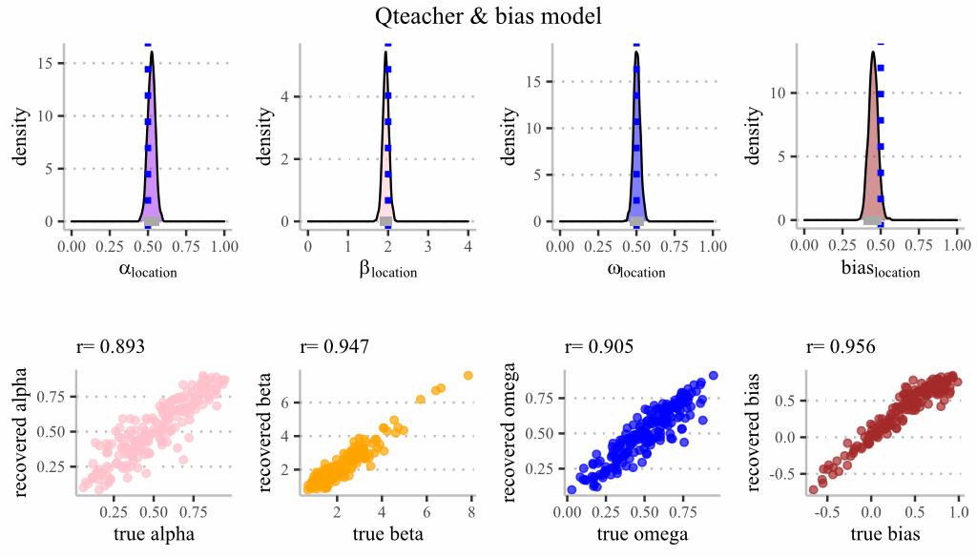

Figure S3. Parameter recovery for the full model. Model parameters included alpha (learning rate), beta (decision temperature), omega (informed advice-taking) and bias (non-informed advice-taking). We simulated 200 agents using a hierarchical parameter sample and estimated the parameter from simulated behavior. (A) Population-level parameters – dashed blue lines indicate the true parameter estimates used for behavior simulations. Parameters estimation from simulated data is indicated using the posterior distributions. (B) Individual-level parameters – we averaged to posterior distribution for each individual at each parameter, and plotted these recovered estimates against the true parameters. Overall, we found excellent recovery for population and individual-level parameters.

