Indigenous and local knowledge in the vulnerability of smallholder farmers to climate variability and change in Chiredzi, Zimbabwe
Supplementary Material (SM)
This file contains Supplemental Material of the following:
- The file also contains the November to April rainy season onset, cessation, length, and hot days for the sorghum crop and the additional monthly temperature and rainfall plots.
- Detailed explanations of the livelihood vulnerability assessment components and sub-components, including the questions used to investigate each sub-component and how this relates to vulnerability assessment in Chiredzi.
- Questionnaire survey guide used to collect socioeconomic data from the farmers. Dataset with survey information is found here: https://doi.org/10.17632/T87ZPHVS5X.1.

- Sorghum rainy onset, cessation, and length

Additional Methodology
It is important to assess the growing conditions of sorghum because it is a staple crop that is increasingly grown by rainfed smallholder farmers in the Chiredzi rural district. We used the following thresholds (SM Table 1) to calculate onset, cessation, and season length of the rainy season for sorghum grown in semi-arid regions.
SM Table 1: Definition of indices for rainfall requirements under semi-arid and arid conditions for sorghum crops.
Climate index | Description | Reference
Rainy season onset | Cumulative rainfall of ≥2 cm/ 20mm within 10 days in the sowing period (after 1 Aug for southern Africa) | (Wolf et al., 2015)
Rainy season cessation | The last day between 1 January and 30 June that accumulates 10 mm or more rainfall | (Mupangwa et al., 2011)
Rainy season length | The number of days between onset and cessation of rain dates | (Byakatonda et al., 2018)
Hot days | The number of days with maximum temperature above 38 ºC between November - April months of the growing season | (Huda et al., 1984)
Sorghum onset, cessation, length of rainy season and hot days
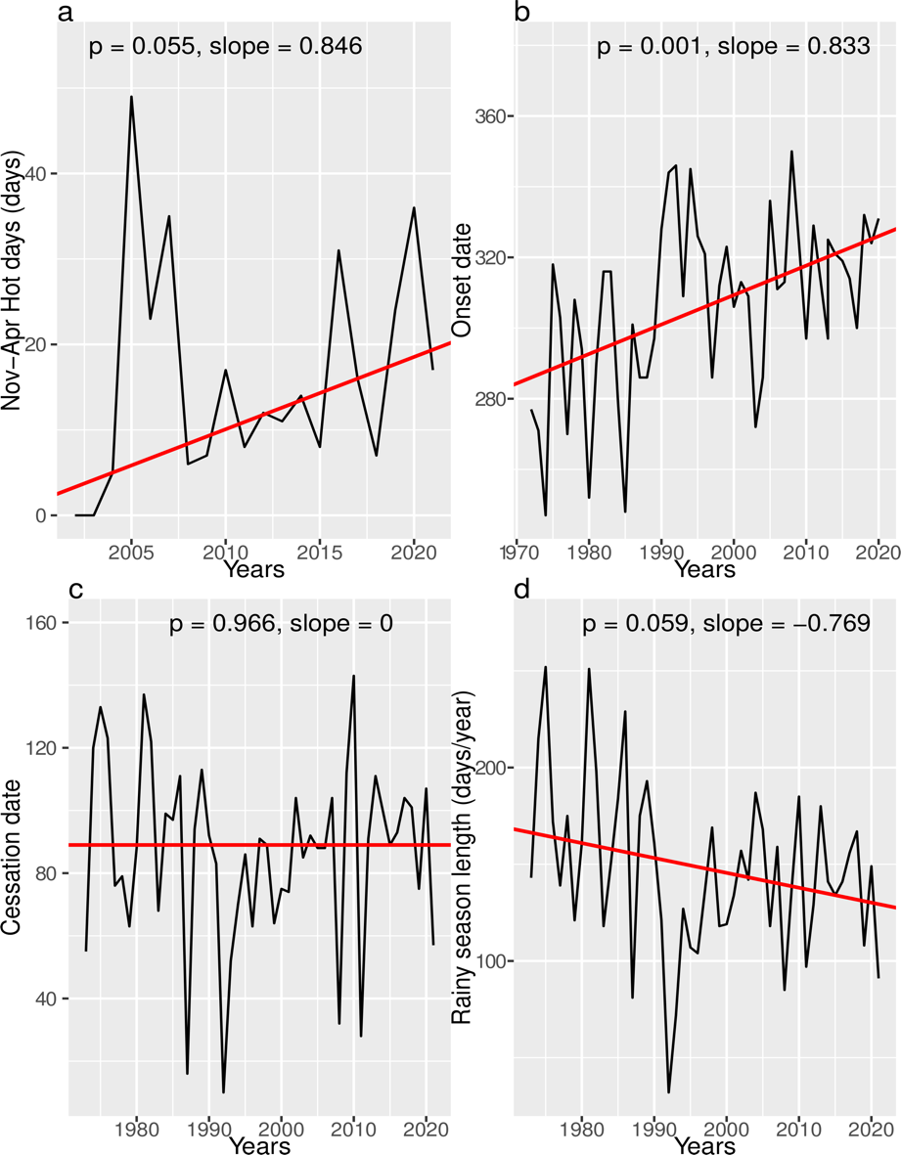
SM Figure 1: Inter-seasonal variability and trends in temperature and rainfall indices for sorghum in Chiredzi District between 1972–2021. The red line indicates the fitted trend line using the Mann–Kendall Sen’s slope estimate for a) number of hot days, b) onset of the rainy season (plotted in Julian days), c) cessation dates of the rainy season (also plotted in Julian days), and d) length of the rainy season. The slope and significance value (P-value) at the 5% significance level are presented for each index. The rainy season onset showed a statistically significant increasing trend (p = 0.001) to a delayed start, whereas cessation showed no trend. The combination of a significantly delayed rainy season onset and decreasing rainy season length strongly suggests shrinking of rainy season for sorghum. The hot days showed a statistically insignificant increasing trend, although we observed 0.846 days/year.
Monthly rainfall and temperature plots.
Monthly precipitation plots
Total monthly rainfall plots (1972–2021) for Chiredzi are presented in SM Figure 2.
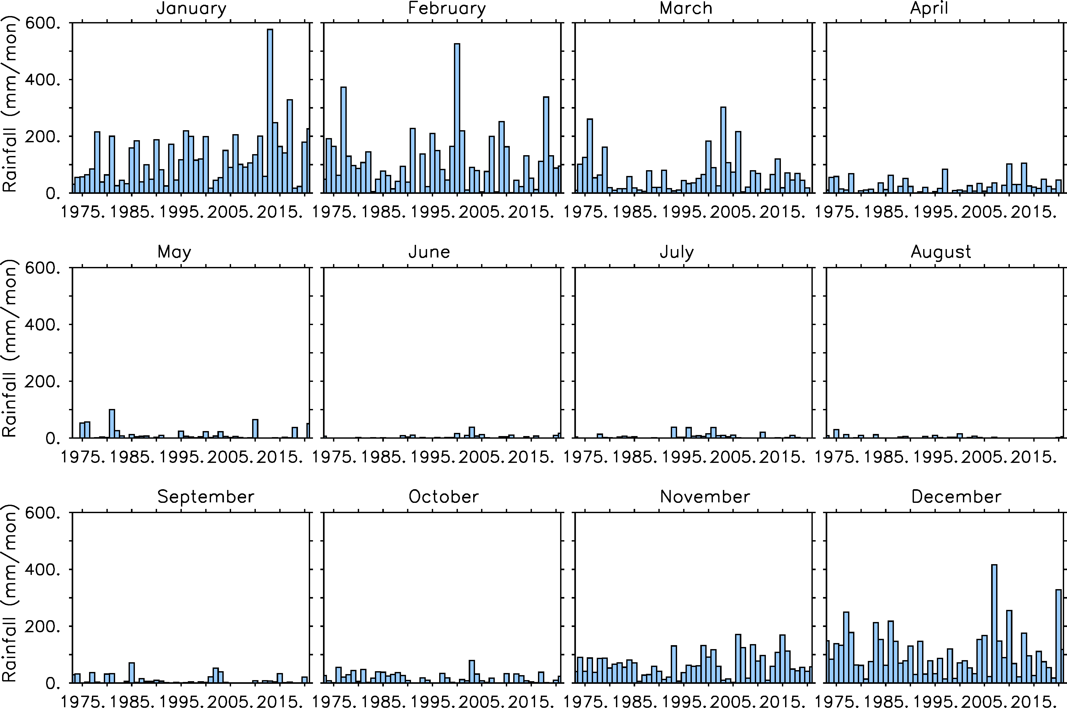
SM Figure 2: Total monthly rainfall for Chiredzi (1972–2021). Total monthly rainfall received in January has increased from 2000, while the February rainfall totals decreased simultaneously. This suggests a forward shift of the rainy season. This means that the dry spells traditionally experienced in January have now moved to February.
  - Monthly temperature analysis
Monthly mean minimum, average, and maximum temperature plots (2001–2021) for Chiredzi (SM Figure 3).
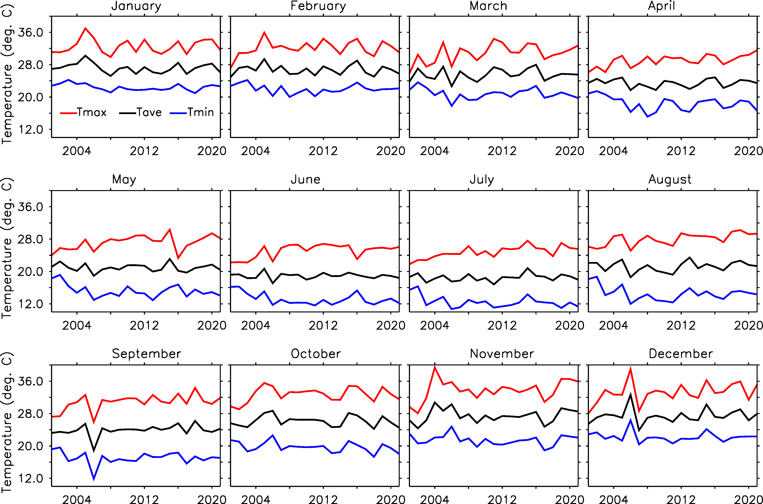
SM Figure 3: Mean monthly minimum, average, and maximum temperature trends for rainfall (2001–2021). The blue lines represents the mean monthly minimum temperature, the black lines represents the monthly average temperature, and the red lines are the mean monthly maximum temperature. the maximum temperature for April, July, and August is constantly increasing, while the minimum temperature for the same months is decreasing. Also, the minimum temperatures in June and May are constantly decreasing. This suggests that Chiredzi is increasingly warming with all winter months, showing that the minimum temperature is decreasing. The highest warming in October–February was observed between 2005-07.

- Details of livelihood vulnerability assessment for Chiredzi
SM Table 2: Expanded table of the LVI main and sub-components developed for Chiredzi and their link to vulnerability assessment of the smallholder farmers Chiredzi.
Capitals | Main | Sub-components | Explanation of sub-components | Status in LVI | Unit | Source | Survey question | Relationship with vulnerability to climate risk
Human | Food | - Percent of households dependent on family farm for food | Percentage of households that get their food primarily from their personal farms | Existing | Percent | (Hahn et al., 2009) | Where does your family get most of its food? | High dependence of family food on farm produce indicates high sensitivity to droughts and climate variability-related crop failure, and therefore, high vulnerability (Twongyirwe et al., 2019). The limited ability to save crops from preceding harvests reflects the sensitivity of the earlier season to unfavourable production conditions, including the climate. A higher inverse average crop diversity means fewer crops are grown, limiting the potential of the farmer to spread risk to climate-related crop failures, such as droughts (Lin, 2011). The higher the indicators for food, the more sensitive households are and the higher the vulnerability (Hahn et al., 2009; Williams et al., 2020).
Human | Food | - Average number of months households struggle to get food (range: 0–12) | Average number of months households struggle to obtain food for their family | Existing | Months | (Hahn et al., 2009) | Does your family have adequate food for the whole year or are there times during the year that your family does not have enough food? How many months a year does your family have trouble getting enough food?
Human | Food | - Percent of households who do not save crops | Percentage of households that do not save crops from each harvest | Existing | Percent | (Huong et al., 2019) | Does your family save some of the crops you harvest to eat during a different time of year?
Human | Food | - Average Crop Diversity Index (range: >0–1) | The inverse of (the number of food crops grown by a household +1). e.g., A household that grows pumpkin, maize, groundnuts, millet, beans, and Bambara buts will have a Crop Diversity Index = 1/ (6 + 1) = 0.14. | Modified | 1/no.  crops | (Hahn et al., 2009) | How many crops does your household grow? Please list.
Human | Food | - Percent of households that do not sell/ barter trade crops for other food supplies | Percentage of households unable to trade self-grown crops | Existing | Percent | (Shah et al., 2013) | Do you trade the food you grow with others for different food? Do you sell the crops you grow for money to buy other food goods?
Human | Livelihood  strategy | - Percent of households without family member working in a different community in Zimbabwe | Percentage of households that report at least 1 family member who works outside of the community for their primary work activity. | Modified | Percent | (Hahn et al., 2009) | How many people in your family go to a different community to work? | Households with members in the diaspora in Chiredzi are likely to receive remittances, which could lead to less dependence on agriculture for livelihood, and therefore, less vulnerable (FAO, 2017; Mupakati and Tanyanyiwa, 2017). The higher dependence on crops only for livelihoods indicates a household’s high sensitivity to climate risk. The diversification of income sources increases adaptive capacity and decreases the risk of loss. Practicing mixed farming for smallholder farmers in Africa reduces their vulnerability to climate hazards risks (Trisos et al., 2022). The higher the Average Agricultural Livelihood Diversification Index, the lower the livelihood diversification and, hence, the higher the vulnerability of the farmer to climate risk. Therefore, a higher value of the overall livelihood strategy indices reflects lower adaptive capacity, and hence, higher vulnerability.
Human | Livelihood  strategy | - Percent of households without family member working in diaspora | Percentage of households that report at least 1 family member working in diaspora | New | Percent | Developed for this study | Do you have any family member working in the diaspora? How often they send money back home? Under what circumstances do you usually sell your livestock?
Human | Livelihood  strategy | - Percent of households dependent solely on crops production as source of income | Percentage of households that report only crop production a source of income | Modified | Percent | (Hahn et al., 2009) | Do you or someone else in your household collect food from the bush, the forest, or lakes and rivers to sell?
Human | Livelihood  strategy | - Percent of households do not practice mixed farming | Percent of households that rely on mixed farming | New | Percent | Developed for this study | Do you or someone else in your household raise animals? How many cattle, goats, sheep, and chickens do you have? How often do you sell cattle?
Human | Livelihood  strategy | - Percent of households without non-agricultural livelihood income contribution | Percentage of households reporting livelihoods other than agriculture/  fishing/hunting as the main source of income | Existing | Percent | (Shah et al., 2013) | Obtained from the analysis of the survey
Human | Livelihood  strategy | - Average Agricultural Livelihood Diversification Index (range: 0.20 –1) | The inverse of (the number of agricultural livelihood activities +1) reported by a household, e.g., A household that farms, keep livestock, and utilises climate sensitive natural resources for livelihood will have a Livelihood Diversification Index = 1/(3 + 1) = 0.25. | Existing | 1/no.  livelihoods | (Hahn et al., 2009) | Integrate answers from 8, 9 and10
Human | Health | - Average distance to a health facility | Average distance households to get to the nearest health facility | Modified | Meters | (Hahn et al., 2009) | How long are you from a health facility? | The longer the distance to a health facility, the more families are ill or miss school/work, and the more sensitive and vulnerable they are (Hahn et al., 2009; Panthi et al., 2016). The indicators show how health impacts family and higher indices imply higher sensitivity.
Human | Health | - Percent of households with family member with chronic illness | Percentage of households that report at least 1 family member with chronic illness. Chronic illness was defined subjectively by respondent | Existing | Percent | (Hahn et al., 2009) | Is anybody in your family chronically ill (they get sick very often)?
Human | Health | - Percent of households where a family member had to miss work or school in the last 2 weeks due to illness | Percentage of households that report at least 1 family member who had to miss school of work due to illness in the last 2 weeks. | Existing | Percent | (Hahn et al., 2009) | Has anyone in your family been so sick in the past 2 weeks that they had to miss work or school?
 | Education and climate change training (modified) | - Percent of households where household head has not attended school | Percentage of households where the head of the household reports that they have attended 0 years of school | Existing | Percent | (Hahn et al., 2009) | Did you ever go to school? | Education improves awareness and the ability to adopt operational and crop management practices that increase adaptive capacity. Hence, they are less vulnerable to climate change. Education is the highest predictor of climate change literacy in Africa (Simpson et al., 2021). The higher the education level, the more likely it is to have climate change literacy which influence the urgency of farmers to act and likelihood to adapt (Simpson et al., 2021; Trisos et al., 2022), thus reducing their vulnerability. Therefore, the higher the education and climate change training the lower, the adaptive capacity and the higher the vulnerability of the farmer/ household.
 | Education and climate change training (modified) | - Percent of households where household head just passed primary school | Percentage of households where the head of the household reports that they have attended secondary school as their highest qualification | Existing | Percent | (Huong et al., 2019) | If yes, what is the highest education level?
 | Education and climate change training (modified) | - Percent of households where household head did not attend tertiary learning. | Percentage of households where the head failed to proceed to tertiary level | New | Percent | Developed for this study | If yes, what is the highest education level?
 | Education and climate change training (modified) | - Percent of households where a family member did not receive any training on climate change | Percent of households where a family member did not receive any training or information shared to them on climate change impacts and its causes.. | New | Percent | Developed for this study | Did you ever receive any training or information about climate change including its causes? Where did you receive the training? By who?
 | Indigenous and local knowledge (new) | - Percent of households do not use indigenous and local knowledge for weather forecasting | Percentage of households dot not use IK neither have access to scientific weather forecasts | New | Percent | Developed for this study | Do you forecast weather events and climate? If yes, how? | Having the indigenous and local knowledge of weather and seasonal forecasting means a farmer can make informed climate decisions in Chiredzi (Zvobgo et al., 2023), hence implemented several adaptation responses to adapt to the anticipated risk (Zvobgo et al., 2023), thus reducing the vulnerability and improves adaptive capacity. Lack of indigenous and local knowledge reverse all said above. Also, limited access to weather and climate forecasts means that uninformed decisions are made and there is less chance to adapt. The higher the indicator, the higher is the vulnerability of the farmer to climate risks.
 | Indigenous and local knowledge (new) | - Percent of farmers that do not implement planning and adaptation measures from indigenous knowledge. | Percentage of households that do not implement any IK measures to adapt to the climate risk. | New | Percent | Developed for this study | What practices (both management and operational) measures you implement because of the IK forecasts?
 | Indigenous and local knowledge (new) | - Average Crop Adaptation Response (CAR) Index (range: 0 –1) | The inverse of (the total number of adaptation responses implemented +1) reported by a household, e.g., A household that implement a total of 3 adaptation responses will have an AR Index = 1/(3 + 1) = 0.25. | New | Percent | Developed for this study | List the number of crop adaptation responses that you are implementing
 | Indigenous and local knowledge (new) | - Percent of households that do not have access to scientific weather forecasting | Percentage of households that have no access to scientific weather forecasts | New | Percent | Developed for this study | Do you have any access to scientific weather and climate forecasts? If yes, what device do you access with?
Social | Socio-demographic profile | - Dependency ratio | Ratio of the population under 18 and over 65 years of age to the population between19 and 60 years of age | Modified | Ratio | (Hahn et al., 2009) | Could you please list the ages and sexes of every person who eats and sleeps in this house? | The higher the number of dependents, the lower the capacity of the households to adapt. Women in Africa typically have a lower capacity to adapt (Trisos et al., 2022; Ayanlade et al., 2023). Fewer family members means limited capacity to adapt, as smallholder farmers depend on family labour to implement adaptation responses, most of which are labour intensive (FAO, 2015; Atube et al., 2021). The higher the number of members requiring dependent care, the fewer the members of the family that can be involved in agricultural production. Therefore, higher percentages of socio-demographic profile indicators reflect a lower capacity of households to adapt and higher the vulnerability.
Social | Socio-demographic profile | - Percent of female-headed households | Percentage of households where the primary adult is female. If a male head is away from home > 6 months per year the female is counted as the household head. | Existing | Percent | (Hahn et al., 2009) | Are you the head of the household?
Social | Socio-demographic profile | - Average number of family members in a household | Average number of family members in a household | Existing | Persons | (Huong et al., 2019) | Could you please list the ages and sexes of every person who eats and sleeps in this house?
Social | Socio-demographic profile | - Percent of households with members needing dependent care | Percentage of households with at least one member requiring daily care because of age, physical or mental condition, illness, or disability | Existing | Percent | (Shah et al., 2013) | Do any members of your household require daily care because of age?  physical or mental condition, illness, or disability?
Social | Social network | - Average Receive: Give ratio (range: 0–15) | Ratio of (the number of types of help received by a household in the past month + 1) to (the number of types of help given by a household to someone else in the past month + 1) | Existing | Ratio | (Hahn et al., 2009) | In the past month, did relatives or friends help you and your family:(e.g., Get medical care or medicines, sell animal products or other goods produced by family, Take care of children). In the past month, did you and your family help relatives or friends: (same choices as above) | High participation in farm-related community organisations/ groups and increased access to information through communication devices improves individuals’ awareness of impending hazards (Chaudhury et al., 2017; Dapilah et al., 2020). Access to social safety nets for farmers is crucial for improving adaptive capacity and is one of the adaptation responses available to smallholder farmers, which reduces their vulnerability (Hallegatte et al., 2016; Agrawal et al., 2019; Ulrichs et al., 2019; Scognamillo et al., 2022; Trisos et al., 2022). Strong social network indicators strengthen the capacity to adapt for farmers but higher constraints of this result in lower vulnerability (Chaudhury et al., 2017; Dapilah et al., 2020; Dumenu and Takam Tiamgne, 2020).
Social | Social network | - Percent of households not having access to government subsidies on agricultural production inputs in the past 12 months and other social welfare assistance including NGO support. | Percentage of households that reported that they have not received support from local government for any assistance in the past12 months with agricultural inputs, social welfare and other NGO support. | Modified | Percent | (Williams et al., 2020) | In the past 12 months, did your household received subsidies from the government on agricultural inputs, social welfare and other NGO support?
Social | Social network | - Percent of households not associated with any farmer-based organization (FBO) | Percentage of households that do not belong to any farmer-based group. | Existing | Percent | (Williams et al., 2020) | Are you a member of any farmer group or society?
Social | Social network | - Percent of households not having communication devices | Percentage of households that do not have a TV, radio or cellphone that can receive weather updates | Existing | Percent | (Williams et al., 2020) | Do you own any of the following: TV, radio or cellphone that connect FM radio?
Social | Social network | - Percent of households not associated with any community social group | Percentage of households that do not belong to any social excluding farmer-based groups. | Existing | Percent | (Williams et al., 2020) | Are you a member of any social group including WhatsApp group?
Natural | Natural  resources | - Percent of households that depend on (exploit) natural resources | Percentage of households that survive on natural resources either for food or selling products. | Existing | Percent | (Huong et al., 2019) | Do you exploit any natural resource for either selling or for consumption? | Higher percentages of farmers depend on exploiting natural resources for livelihood indicate greater reliance on climate-sensitive resources, which increases household vulnerability to negative climate impacts that affect the natural resource base (IPCC, 2023).
Natural | Natural  resources | - Percent of households using only Forest-based energy for cooking purpose | Percentage of households that use wood only for cooking and lighting. | Existing | Percent | (Huong et al., 2019) | What energy source do you use to cook at your house?
Natural | Land | - Percent of households with small farmland (0.1–0.5 ha) |  | Existing | Percent | (Huong et al., 2019) | What is the approximate size of your farmland? | Limited access to land hinders production, which reduces the capacity of smallholder farmers to adapt and increases their vulnerability (FAO, 2015; Bryceson, 2019). The higher the percentage of farmers who record signs of degradation, the less suitable the land is for agriculture, thus increasing the vulnerability of farmers (Webb et al., 2017; UN, 2018; Olsson et al., 2019). Thus, the higher the land component, the lower the farmer’s capacity to adapt hence high vulnerability.
Natural | Land | - Percentage of households reporting land degradation by climate-related extremes during past 20 years |  | Existing | Percent | (Huong et al., 2019) | Did you see any gully or land destruction related to climate hazards between 2000 and 2020?
Natural | Water | - Percent of household that collect water directly from natural water system | Percentage of households obtaining  water from wells, rainwater, pool, or hole as their primary source | Existing | Percent | (Shah et al., 2013) | Where do you collect your water from? | High reliance on households to natural water systems means reduced access to potable water during drought or flooding events. An increase in the distance to water sources for households means limited access to potable water and climate hazards can be a barrier to access potable water for households. The higher the percentage of water indicators, the higher the sensitivity of the water component to climate hazards and the more vulnerable households are.
Natural | Water | - Inverse of the average number of liters of water stored per household (range:>0–1) | The inverse of (the average number of liters of water stored by each household + 1) | Existing | 1/Litre | (Hahn et al., 2009) | What containers do you usually store water in? How many? How many liters are they?
Natural | Water | - Percent of household that do not collect water from a reliable source | Percentage of household that are using reliable and protected water source | New | Percent | Developed for this study | Depending on the answers provided in Q35, if it’s a well, the follow up question is: Is your well covered with a lid?
Natural | Water | - Average number of boreholes in a village | Average number of boreholes that are in a village | New | Count | Developed for this study | How many boreholes are in your village?
Natural | Water | - Average distance to water source | Average distance from households to primary water source. | Existing | Meters | (Williams et al., 2020) | How long does it take to get to your water source?
Natural | Climate hazards | - Average number of floods, drought, and cyclone events in the past 20 years (range: 0 –10) | Total number of floods, droughts, and cyclones that were reported by households in the past 20 years | Existing | Count | (Hahn et al., 2009) | How many times has this area been affected by a flood/ cyclone/ drought in 2010–2020? | The higher the number of climate hazards listed by the farmers, the higher the exposure of the farmers, and hence, the higher their vulnerability to climate variability and change. Lack of access to early warning systems for farmers means that they cannot prepare for the hazards, thereby increasing their vulnerability (Shiferaw et al., 2014). A higher percentage of households with members injured or died from climate hazards indicates high exposure of farmers to climate risk. Higher index values for climate hazards reflect higher exposure and increased vulnerability to climate hazards.
Natural | Climate hazards | - Percent of households that did not receive a warning about the about expected natural disasters/event | Percentage of households that did not receive a warning about the most severe flood, drought, and cyclone event in the past 20 years. | Existing | Percent | (Hahn et al., 2009) | Did you receive a warning about the flood/ cyclone/ drought before it happened?
Natural | Climate hazards | - Percent of households with an injury or death as a result of the most severe natural disaster in the past 20 years | Percentage of households that reported either an injury to or death of one of their family members as a result of the most severe flood, drought, or cyclone in the past 20 years. | Existing | Percent | (Hahn et al., 2009) | Was anyone in your family injured in the flood/cyclone drought? Did anyone in your family die due to flood/ cyclone/ drought?
Natural | Climate hazards | - Percent of households with losses to physical assets (house/ machinery) due to flooding and cyclones | Percentage of households that have suffered losses of physical assets that causes loss/damage of livelihood | Existing | Percent | (Shah et al., 2013) | In the last 10 years, what physical assets have you lost or been severely damaged due to flooding/  storm events?

- Questionnaire survey guide for farmers
Questionnaire survey guide for assessing livelihood vulnerability for smallholder farmers in Chiredzi, Zimbabwe
Demographic data
Ward
Village
Age of the house head (range)
Number of people below 18 and above 60: 19-59 years
Length of stay in the area
Education (of the household head)
Gender (of the household head)
Family size
Size of the farmland?

Food
Question | Responses
Where does your family get most of its food?
How many crops does your household grow? Please list.
Does your family have adequate food for the whole year or are there times during the year that your family does not have enough food?
If not, how many months you struggle to put food on the table
How much crop do you save?
Do you trade the food you grow with others for different food?
Do you trade the food you grow with others for different food?
Do you sell the crops you grow for money to buy other food goods?
Livelihood strategy
Question | Responses
Do you have livestock?
How many cattle, goats, sheep, and chickens that you have? Please list. | Cattle | Goats | Donkey | Sheep | Chickens | Others
How often do your sell livestock?
Under what circumstances do you usually sell your livestock?
How many people in your family go to a different community to work?
Do you have any family member working in the diaspora?
How often they send money back home?
Do you collect something from the bush, the forest, or lakes and rivers to sell?

Water
Question | Responses
Where do you collect your water from?
What containers do you usually store water in? How many? How many liters are they?
Depending on the answers provided in row 1, if it’s a well, the follow up question is: Is your well covered with a lid or protected?
How many boreholes are in your village?
How long does it take to get to your water source?

Natural resources
Question | Responses
Do you exploit any natural resource for either selling or consumption?
What energy source do you use to cook at your house?
Land
Question | Responses
Did you see any gully or land destruction related to climate hazards between 2010 and 2020?
What is the approximate size of your farmland?

Socio-demographic data
Question | Responses
Could you please list the ages and sexes of every person who eats and sleeps in this house?
Are you the head of the household?
Do any members of your household require daily care because of age? physical or mental condition, illness, or disability?

Social networks
Question | Responses
In the past month, did relatives or friends help you and your family:(e.g., Get medical care or medicines, sell animal products or other goods produced by family, Take care of children). In the past month, did you and your family help relatives or friends: (same choices as above)
In the past 12 months, have you or someone in your family gone to your community leader for help?
Are you a member of any farmer group or society?
Do you own any of the following: TV, radio or cellphone that connect FM radio?
Are you a member of any social group including a WhatsApp group?

Education and training
Question | Responses
Did you ever go to school?
If yes, what is the highest education level?
If yes, what is the highest education level?
Did you ever receive any training or information about climate change including its causes? Where did you receive the training? By who?
Indigenous and local knowledge
Question | Responses
Do you forecast weather events and climate? If yes, how?
What practices (both management and operational) do you implement because of the IK forecasts?
List the number of crop adaptation responses that you are implementing.
Do you have any access to other forecasts? If yes, what device do you access with?

Natural disasters
Question | Responses
How many times has this area been affected by a flood/ cyclone/ drought in 2000–2020?
Did you receive a warning about the flood/ cyclone/ drought before it happened?
Was anyone in your family injured in the flood/cyclone drought?
Did anyone in your family die due to flood/ cyclone/ drought?
In the last 10 years, what physical assets have you lost or been severely damaged due to flooding/
storm events?

Health
Question | Responses
How long are you from a health facility?
Is anybody in your family chronically ill (they get sick very often)?
Has anyone in your family been so sick in the past 2 weeks that they had to miss work or school?

Part B: Farmers’ perceptions of climate variability and change
How do you assess the weather and climate over the recent past years?

What evidence do you see that suggest any change or variability of the climate?

References
Agrawal, A. et al., 2019: Climate resilience through social protection. Background paper to the 2019 report of the Global Commission on Adaptation. Rotterdam and Washington, DC. Available at: www.gca.org. (accessed 10/08/2021).
Atube, F. et al., 2021: Determinants of smallholder farmers’ adaptation strategies to the effects of climate change: Evidence from northern Uganda. Agriculture & Food Security, 10(1), 6, doi:10.1186/s40066-020-00279-1.
Ayanlade, A. et al., 2023: Complex climate change risk and emerging directions for vulnerability research in Africa. Climate Risk Management, 40, 100497, doi:https://doi.org/10.1016/j.crm.2023.100497.
Bryceson, D. F., 2019: Gender and generational patterns of African deagrarianization: Evolving labour and land allocation in smallholder peasant household farming, 1980–2015. World Development, 113, 60–72, doi:10.1016/j.worlddev.2018.08.021.
Byakatonda, J., B. P. Parida, P. K. Kenabatho and D. B. Moalafhi, 2018: Influence of climate variability and length of rainy season on crop yields in semiarid Botswana. Agricultural and Forest Meteorology, 248, 130–144, doi:https://doi.org/10.1016/j.agrformet.2017.09.016.
Chaudhury, A. S. et al., 2017: Ties that bind: Local networks, communities and adaptive capacity in rural Ghana. Journal of Rural Studies, 53, 214–228, doi:https://doi.org/10.1016/j.jrurstud.2017.05.010.
Dapilah, F., J. Ø. Nielsen and C. Friis, 2020: The role of social networks in building adaptive capacity and resilience to climate change: a case study from northern Ghana. Climate and Development, 12(1), 42-56, doi:10.1080/17565529.2019.1596063.
Dumenu, W. K. and X. Takam Tiamgne, 2020: Social vulnerability of smallholder farmers to climate change in Zambia: the applicability of social vulnerability index. SN Applied Sciences, 2(3), 436, doi:10.1007/s42452-020-2227-0.
FAO, 2015: The economic lives of smallholder farmers: An analysis based on household data from nine countries [Rapsomanikis, G. (ed.)]. Nations, F. a. A. O. o. t. U., Rome, 48 pp. Available at: https://www.fao.org/3/i5251e/i5251e.pdf.
FAO, 2017: Migration, Agriculture and Climate Change: Reducing vulnerabilities and enhancing resilience. The Food and Agriculture Organization of the United Nations, FAO, Rome, 20 pp. Available at: https://knowledge.unccd.int/sites/default/files/inline-files/i8297en.pdf.
Hahn, M. B., A. M. Riederer and S. O. Foster, 2009: The Livelihood Vulnerability Index: A pragmatic approach to assessing risks from climate variability and change—A case study in Mozambique. Global Environmental Change, 19(1), 74–88, doi:https://doi.org/10.1016/j.gloenvcha.2008.11.002.
Hallegatte, S. et al., 2016: "Shock Waves" Managing the Impacts of Climate Change on Poverty. Climate Change and Development Series, The World Bank,, Washington, DC, 227 pp. ISBN 978-1-4648-0674-2.
Huda, A. K. S. et al., 1984: Modeling the effect of environmental factors on sorghum growth and development. In: Agrofnetsorology of Sorghum md Millet in the %mi-Arid Tro~ioa: Pmedinar of the International Symwsium, 15-20 Nov 1882, India, International Crop Research Institute lor the Semi-Arid Tropics, pp. 277-288.
Huong, N. T. L., S. Yao and S. Fahad, 2019: Assessing household livelihood vulnerability to climate change: The case of Northwest Vietnam. Human and Ecological Risk Assessment: An International Journal, 25(5), 1157–1175, doi:10.1080/10807039.2018.1460801.
IPCC, 2023: Synthesis Report of the Sixth Assessment Report: A Report of the Intergovernmental Panel on Climate Change. Cambridge University Press, Cambridge, UK and New York, NY, USA. Available at: https://www.ipcc.ch/report/ar6/syr/downloads/report/IPCC_AR6_SYR_LongerReport.pdf.
Lin, B. B., 2011: Resilience in Agriculture through Crop Diversification: Adaptive Management for Environmental Change. BioScience, 61(3), 183-193, doi:10.1525/bio.2011.61.3.4.
Mupakati, T. and V. I. Tanyanyiwa, 2017: Cassava production as a climate change adaptation strategy in Chilonga Ward, Chiredzi District, Zimbabwe. Jàmbá: Journal of Disaster Risk Studies, 9(1), 1–10, doi:10.4102/jamba.v9i1.348.
Mupangwa, W., S. Walker and S. Twomlow, 2011: Start, end and dry spells of the growing season in semi-arid southern Zimbabwe. Journal of Arid Environments, 75(11), 1097–1104, doi:10.1016/j.jaridenv.2011.05.011.
Olsson, L. et al., 2019: Land Degradation. In: Climate Change and Land: an IPCC special report on climate change, desertification, land degradation, sustainable land management, food security, and greenhouse gas fluxes in terrestrial ecosystems [P.R. Shukla, J. S., E. Calvo Buendia, V. Masson-Delmotte, H.-O. Pörtner, D. C. Roberts, P. Zhai, R. Slade, S. Connors, R. van Diemen, M. Ferrat, E. Haughey, S. Luz, S. Neogi, M. Pathak, J. Petzold, J. Portugal Pereira, P. Vyas, E. Huntley, K. Kissick, M. Belkacemi, J. Malley (ed.)]. Cambridge University Press, Cambridge, UK, 345-436 pp. Available at: https://doi.org/10.1017/9781009157988.006.
Panthi, J. et al., 2016: Livelihood vulnerability approach to assessing climate change impacts on mixed agro-livestock smallholders around the Gandaki River Basin in Nepal. Reg Environ Change, 16(4), 1121–1132, doi:10.1007/s10113-015-0833-y.
Scognamillo, A., M. Mastrorillo and A. Ignaciuk, 2022: Reducing vulnerability to weather shock through social protection – Evidence from the implementation of Productive Safety Net Programme (PSNP) in Ethiopia [Luca, R. (ed.)]. FAO Agricultural Development Economics Working Paper 22–02, FAO, Rome, 38 pp. Available at: https://doi.org/10.4060/cc0824en.
Shah, K. U., H. B. Dulal, C. Johnson and A. Baptiste, 2013: Understanding livelihood vulnerability to climate change: Applying the livelihood vulnerability index in Trinidad and Tobago. Geoforum, 47, 125–137, doi:https://doi.org/10.1016/j.geoforum.2013.04.004.
Shiferaw, B. et al., 2014: Managing vulnerability to drought and enhancing livelihood resilience in sub-Saharan Africa: Technological, institutional and policy options. Weather and Climate Extremes, 3, 67-79, doi:10.1016/j.wace.2014.04.004.
Simpson, N. P. et al., 2021: Climate change literacy in Africa. Nature Climate Change, 11(11), 937–944, doi:10.1038/s41558-021-01171-x.
Trisos, C. H. et al., 2022: Africa. In: Climate Change 2022: Impacts, Adaptation, and Vulnerability. Contribution of Working Group II to the Sixth Assessment Report of the Intergovernmental Panel on Climate Change [H.-O. Pörtner, D. C. R., M. Tignor, E.S. Poloczanska, K. Mintenbeck, A. Alegría, M. Craig, S. Langsdorf, S. Löschke, V. Möller, A. Okem, B. Rama (ed.)]. Cambridge University Press, Cambridge, UK and New York, NY, USA, 1285–1455 pp. Available at: https://www.ipcc.ch/report/ar6/wg2/downloads/report/IPCC_AR6_WGII_Chapter09.pdf.
Twongyirwe, R. et al., 2019: Perceived effects of drought on household food security in South-western Uganda: Coping responses and determinants. Weather and Climate Extremes, 24, 100201, doi:https://doi.org/10.1016/j.wace.2019.100201.
Ulrichs, M., R. Slater and C. Costella, 2019: Building resilience to climate risks through social protection: from individualised models to systemic transformation. Disasters, 43(Suppl 3), S368–s387, doi:10.1111/disa.12339.
UN, 2018: Devastating Impacts of Climate Change Threatening Farm Outputs, Increasing Global Hunger, Delegates Say as Second Committee Takes Up Agriculture, Food Security. UN, New York.
Webb, N. P. et al., 2017: Land degradation and climate change: building climate resilience in agriculture. Frontiers in Ecology and the Environment, 15(8), 450–459, doi:https://doi.org/10.1002/fee.1530.
Williams, P. A., O. Crespo and M. Abu, 2020: Assessing vulnerability of horticultural smallholders’ to climate variability in Ghana: applying the livelihood vulnerability approach. Environment, Development and Sustainability, 22(3), 2321–2342, doi:10.1007/s10668-018-0292-y.
Wolf, J., K. Ouattara and I. Supit, 2015: Sowing rules for estimating rainfed yield potential of sorghum and maize in Burkina Faso. Agricultural and Forest Meteorology, 214-215, 208-218, doi:https://doi.org/10.1016/j.agrformet.2015.08.262.
Zvobgo, L. et al., 2023: Role of Indigenous and local knowledge in seasonal forecasts and climate adaptation: A case study of smallholder farmers in Chiredzi, Zimbabwe. Environmental Science & Policy, 145, 13–28, doi:https://doi.org/10.1016/j.envsci.2023.03.017.

