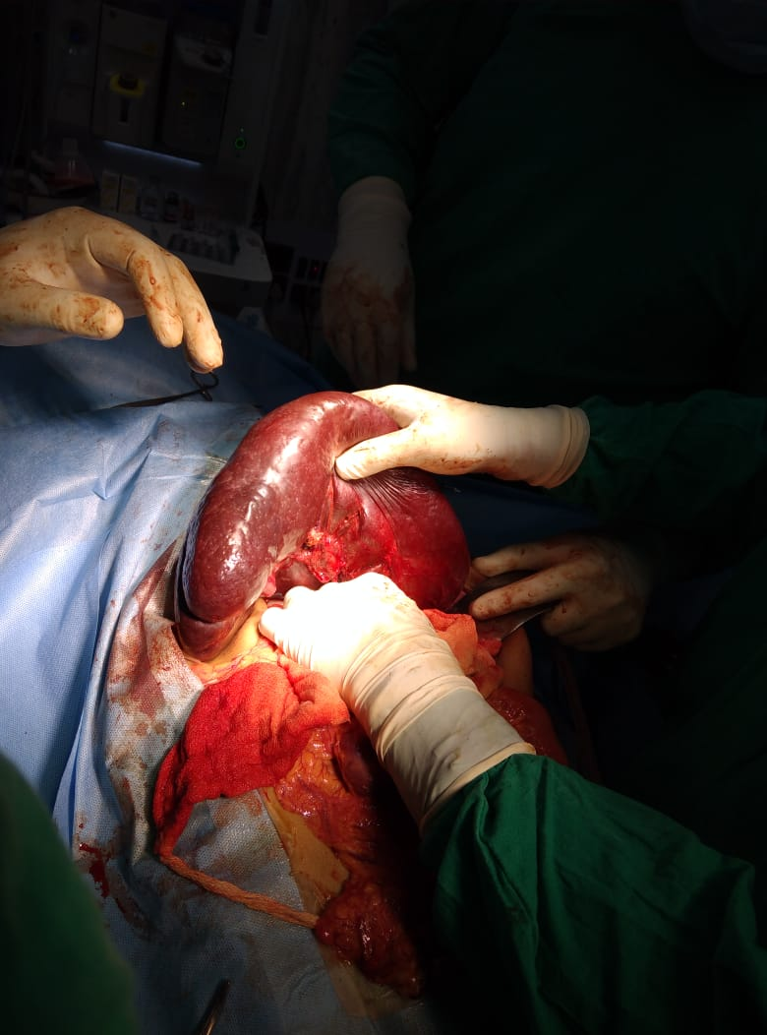

Picture 1 showing splenectomy for thalassemic patient

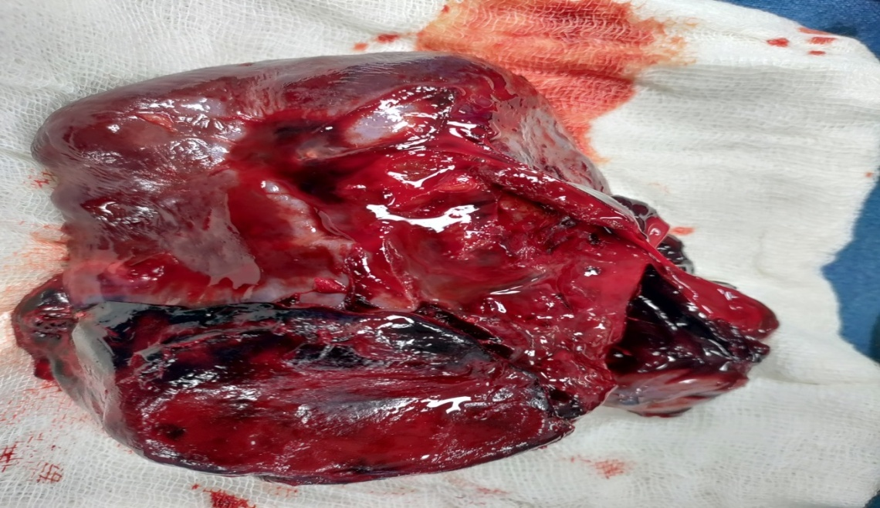
Picture 2- showing splenic trauma following RTA
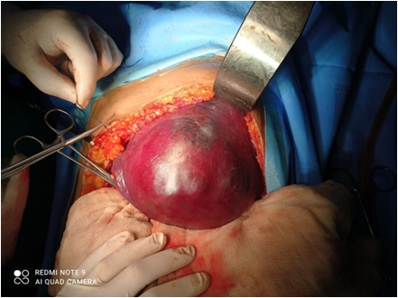

Picture 3 showing large splenic cyst
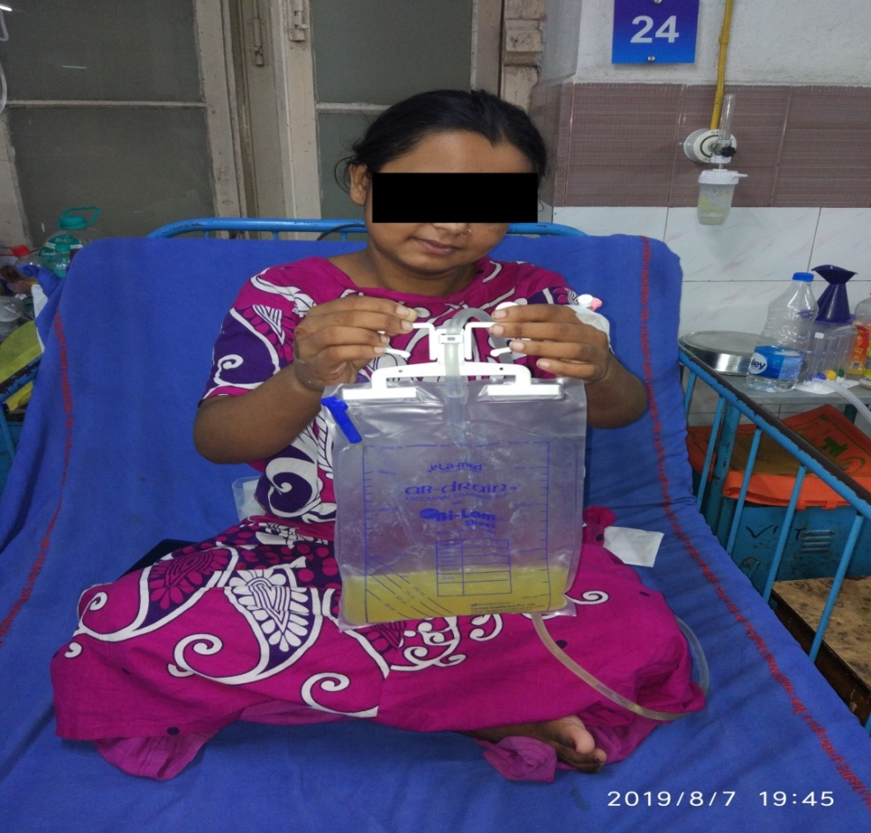

Picture 4 showing pancreatic fistula

