Supporting information
3D printing of flexible sensors based on polyvinyl alcohol/carboxylated chitosan/sodium alginate/silver nanowire high-strength hydrogels
Feiyue Hao Shuang Sun, Xieraili Maimaitiyiming*
State Key Laboratory of Chemistry and Utilization of Carbon Based Energy Resources, College of Chemistry, Xinjiang University, Urumqi, 830046, Xinjiang, PR China.
E-mail: 380731363@qq.com
Experimental
Materials
Polyvinyl alcohol (PVA), chitosan (CS, 90% deacetylation degree) were purchased from Beijing Bailingwei Technology Co., Ltd., and silver nanowire dispersion (AgNW, diameter 50 nm, concentration 10 mg, ml) was purchased from Nanjing Xianfeng Nano Materials Technology Co., Ltd., Glycerol Newport Chemical Co., Ltd., deionized water was prepared in the laboratory. All chemicals are used directly after purchase without additional treatment.
Preparation of polyvinyl alcohol hydrogel.
The mixed solvent is prepared according to a certain weight ratio of water and glycerol, a certain amount of polyvinyl alcohol is added to make the prepared polyethylene hydrogel content be 10%wt, stirred and heated to 98 ℃, and the stirring is stopped after heating for one hour. Turn off the heating when there are no bubbles in the solution, pour the solution into the dumbbell-shaped template after the solution has dropped to room temperature, put it in the refrigerator, freeze at -20°C for two hours, take out the sample, and thaw at room temperature to obtain a polyvinyl alcohol hydrogel.
Preparation of polyvinyl alcohol/carboxylated chitosan composite hydrogel.
In the above process of preparing polyvinyl alcohol, after the polyvinyl alcohol is completely dissolved, add a certain amount of carboxylated chitosan, so that the mass ratio of carboxylated chitosan and polyvinyl alcohol is 1:2, and then according to the above Process to prepare composite hydrogels.
Preparation of hydrogel ink.
In the system of the composite hydrogel solution, a certain amount of sodium alginate was added to prepare a 5wt% sodium alginate mixed system. When the system was evenly mixed, it was cooled to room temperature, and the hydrogel ink was centrifuged at 9000 rpm for 10 min. The bubbles inside the ink are removed, and finally a hydrogel ink that can be used for extrusion 3D printing is obtained.
Performance Testing.
Draw through CAD in advance, then import the designed graphics into the dispenser system, and select the required graphics to print. We choose to use a 0.7 mm needle, control the pressure at 0.16 MPa, and move the needle at a speed of 8 mm/s. Adjust the appropriate height to print complex three-dimensional structures layer by layer on a glass substrate. Dumbbell models, multi-layer rectangular squares and grid structures for motion sensing were printed. Load the prepared dumbbell-shaped model into the fixture of the rubber extensometer, input the actual width and thickness of the sample, adjust the gauge length to 20 mm, and set the stretching speed to 80 mm/min. For the cyclic tensile test, the strain was set to 100%, 200%, and 300%, respectively, and the tensile speed parameter was set to 50 mm/min. A conical three-dimensional structure with a diameter of 14 mm on the bottom surface was printed for the compression performance test, and the compression speed was 20mm/min. The compressive strain is 60%. The strain sensitivity (GF) of the hydrogel was calculated using the following equation. where ε is the applied strain of the hydrogel.
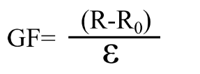
Tear tests were performed using a rubber tensile testing machine with a 20N sensor. The printed rectangular hydrogel samples were cut into a trouser shape with an initial cut length of 10 mm. The cut notch was split into two arms and the clamp was stretched at a constant speed (20 mm/min) until the crack penetrated the entire sample, while the other remained stationary. The tearing energy (Γ) is defined as the work required to tear a unit area and is calculated by the following formula.
$$Γ=\frac{2F}{W}$$
where w is the thickness of the sample and F is the peak force obtained from the steady state tear test. Three replicate measurements were performed on each sample.
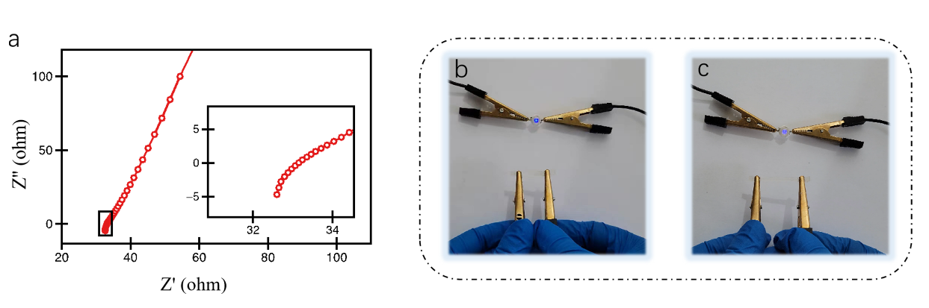
Figure S1. (a) electrical conductivity test of PVA/CCS/SA/AgNWs hydrogels; (b, c) effects of strain behavior on the electrical conductivity of hydrogels.
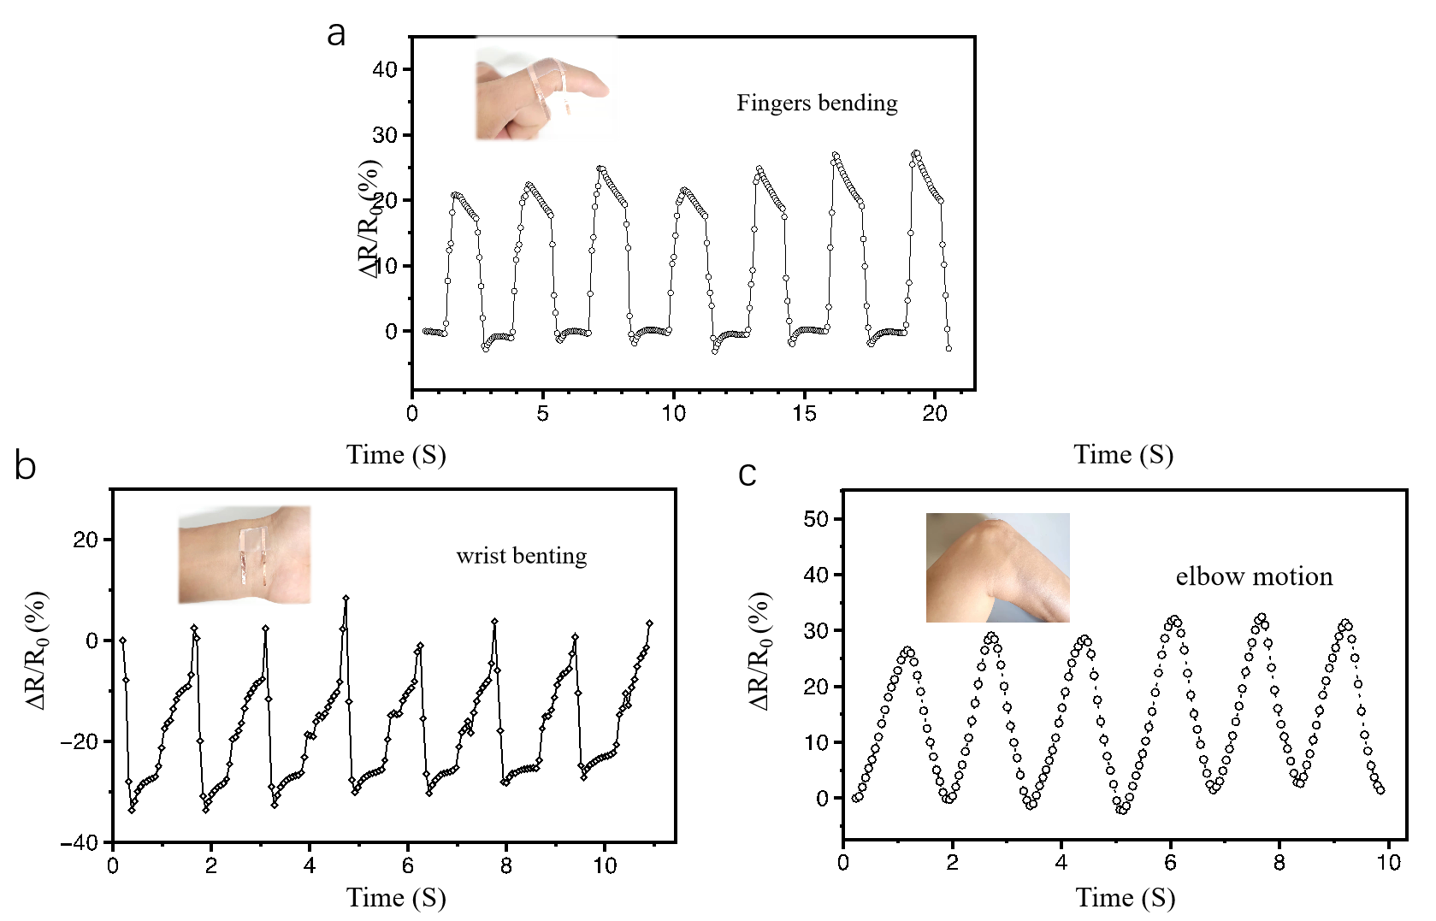
Figure S2. (a) Motion detection of fingers (b) Wrist flexion (d) Elbow flexion detection.

