Supplementary Information

Syntheses, optical properties, and bioimaging application of near-infrared aza-BODIPY dyes with electronic push-pull system
Yibiao Yao, Xiaodan Xiao, Shaojie Liu, Baozhu Tian * and Jinlong Zhang *
Shanghai Engineering Research Center for Multi-media Environmental Catalysis and Resource Utilization, Key Laboratory for Advanced Materials and Joint International Research Laboratory of Precision Chemistry and Molecular Engineering, Feringa Nobel Prize Scientist Joint Research Center, School of Chemistry and Molecular Engineering, East China University of Science and Technology, 130 Meilong Road, Shanghai 200237, PR China.
† Corresponding Author: Prof. B.Z. Tian, e-mail: baozhutian@ecust.edu.cn; Prof. J.L. Zhang, e-mail: jlzhang@ecust.edu.cn.

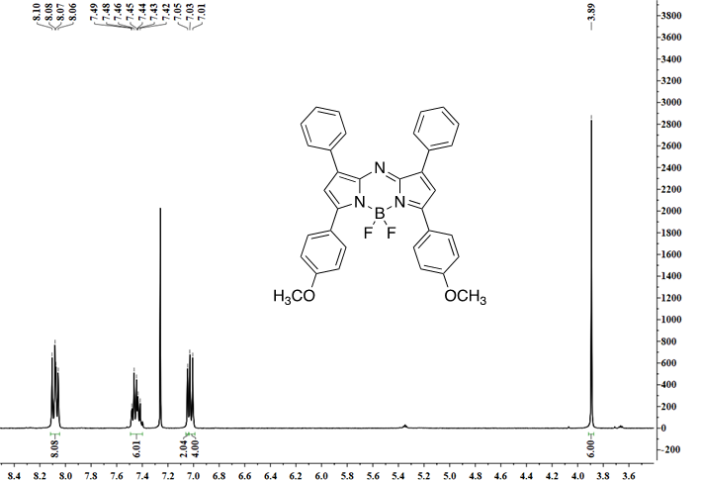
Fig. S1 ¹H NMR spectrum of H-OMe in CDCl₃

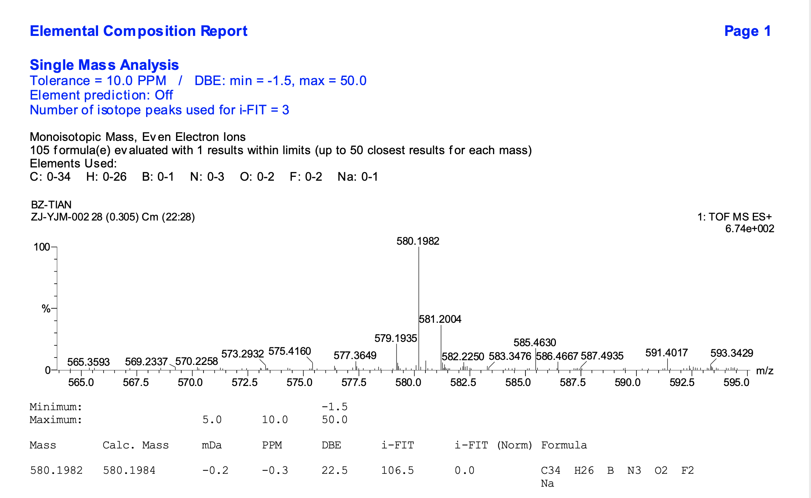
Fig. S2 HRMS spectrum of H-OMe

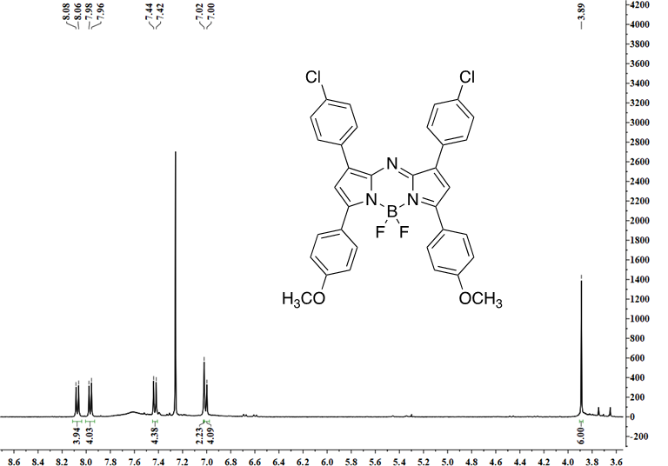
Fig. S3 ¹H NMR spectrum of Cl-OMe in CDCl₃

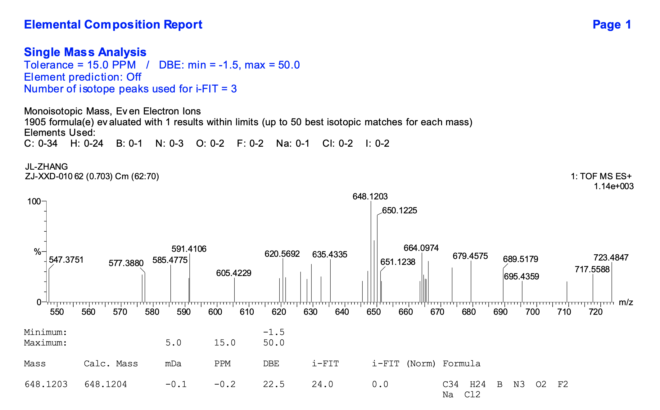
Fig. S4 HRMS spectrum of Cl-OMe

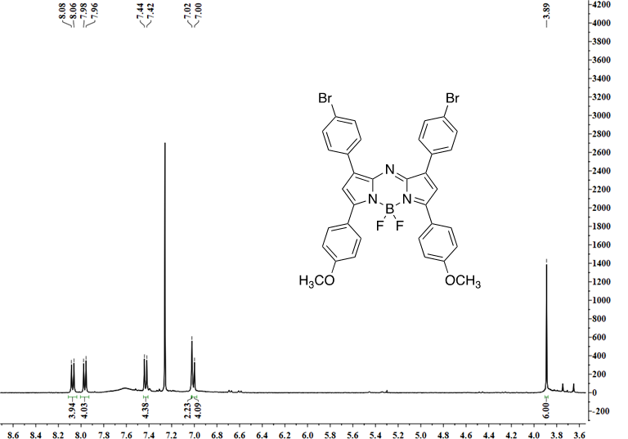
Fig. S5 ¹H NMR spectrum of Br-OMe in CDCl₃

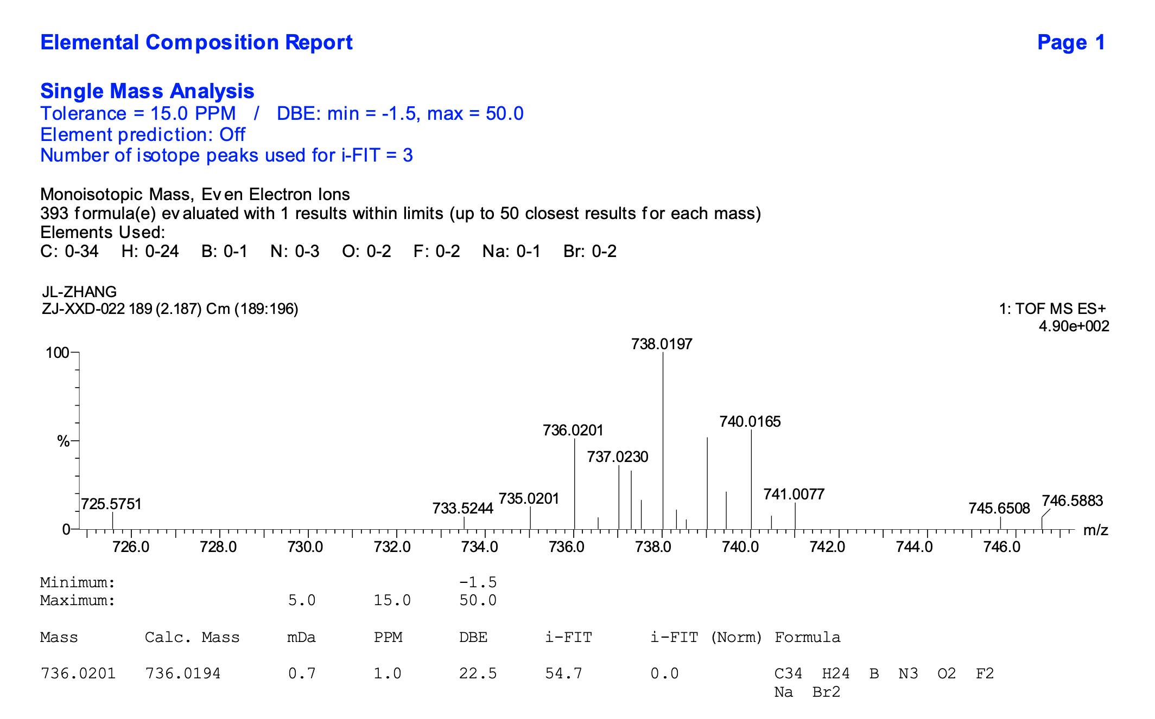
Fig. S6 HRMS spectrum of Br-OMe

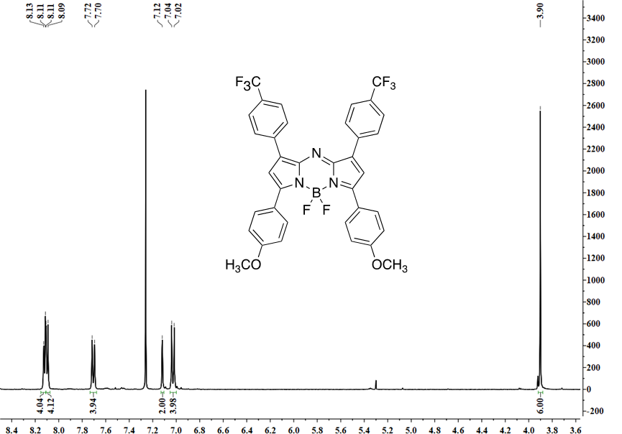
Fig. S7 ¹H NMR spectrum of CF₃-OMe in CDCl₃

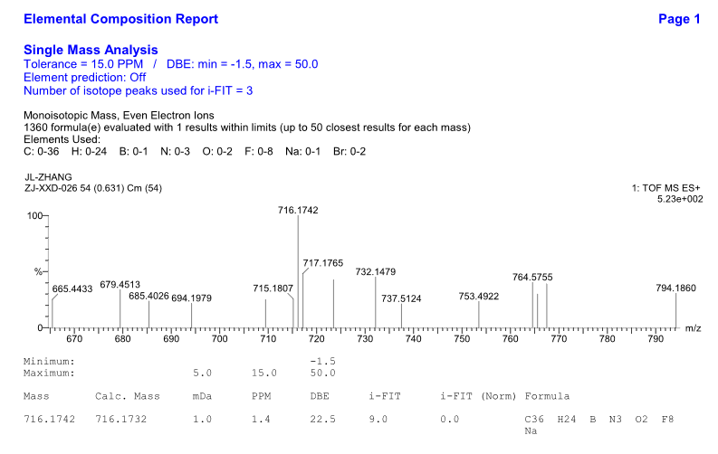
Fig. S8 HRMS spectrum of CF₃-OMe

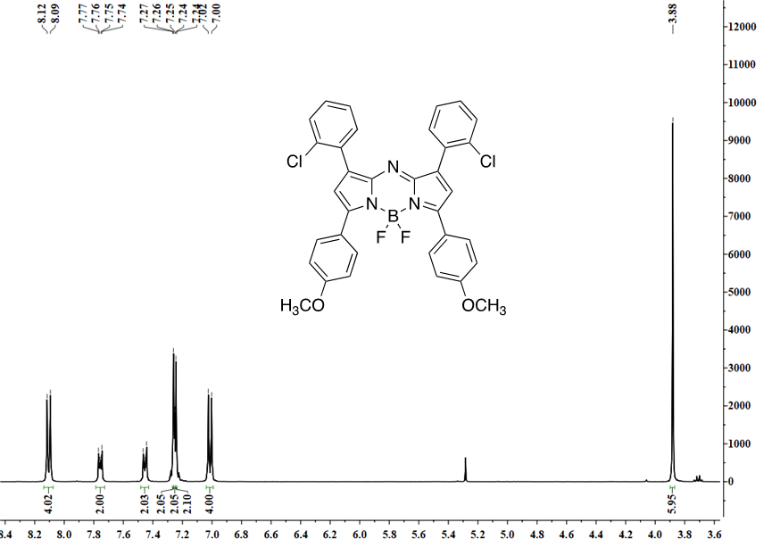
Fig. S9 ¹H NMR spectrum of o-Cl-OMe in DMSO

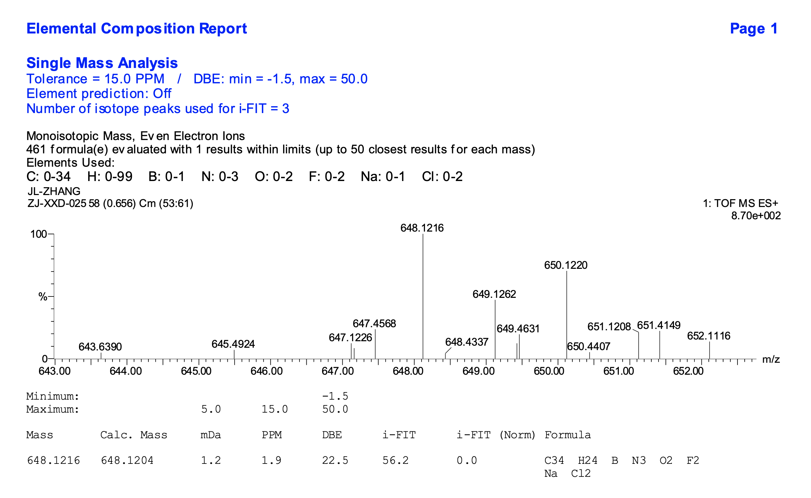
Fig. S10 HRMS spectrum of o-Cl-OMe

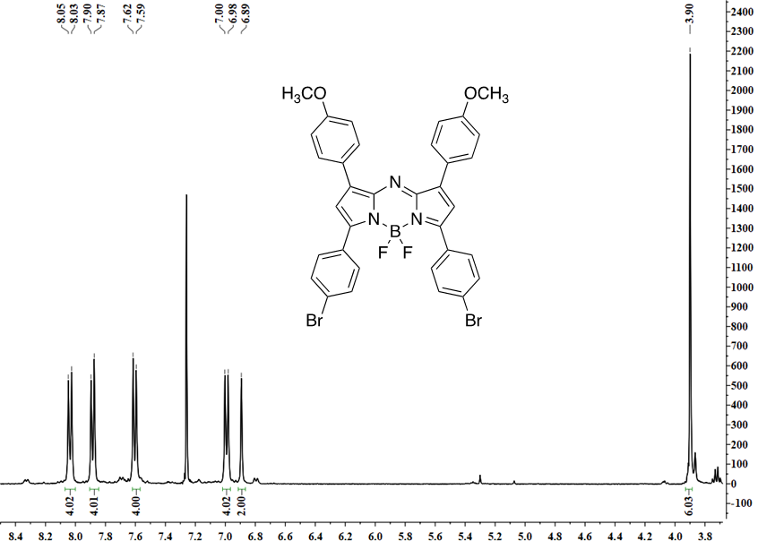
Fig. S11 ¹H NMR spectrum of OMe-Br in CDCl₃

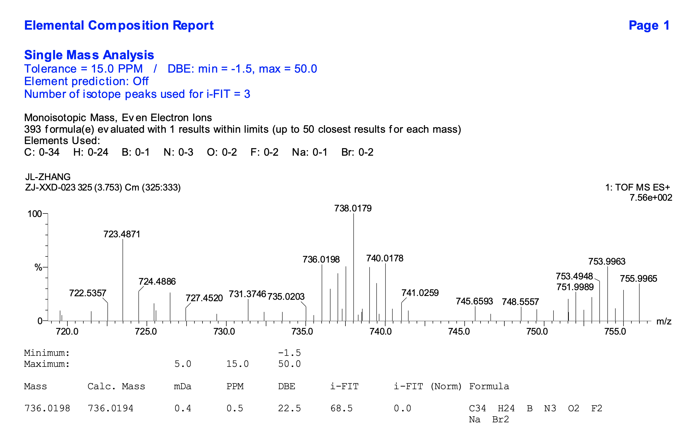
Fig. S12 HRMS spectrum of OMe-Br
Fig. S13 Absorption spectrum of dyes after 12 h of irradiation in EtOH
Fig. S14 Determination of H-OMe first cathodic peak potential
Fig. S15 Determination of Cl-OMe first cathodic peak potential

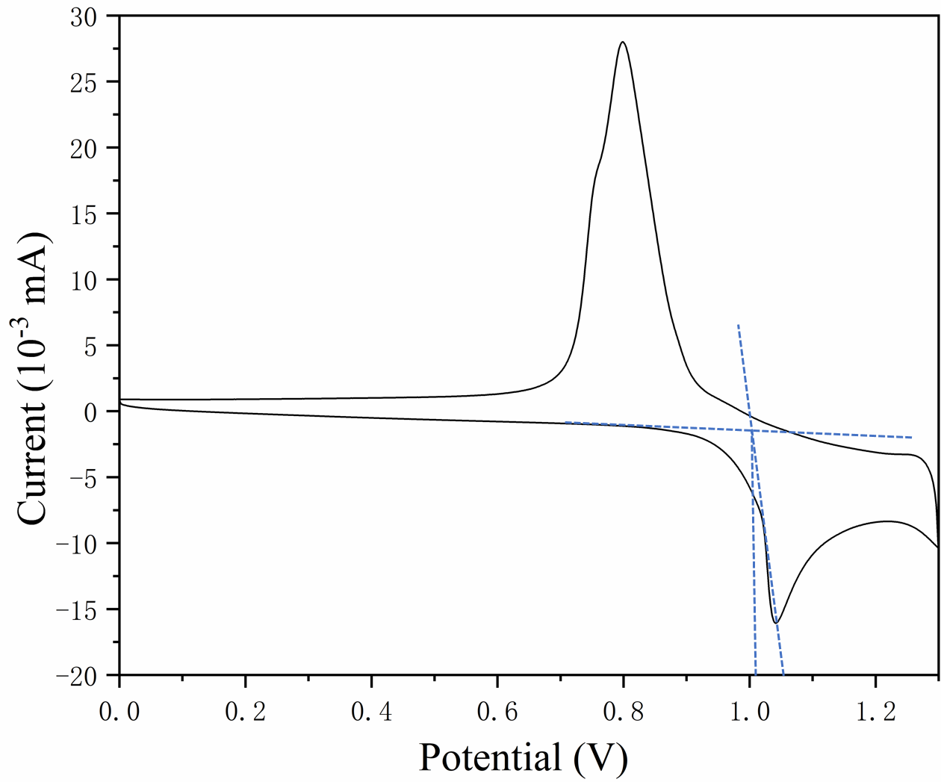
Fig. S16 Determination of Br-OMe first cathodic peak potential
Fig. S17 Determination of CF₃-OMe first cathodic peak potential

Fig. S18 Determination of o-Cl-OMe first cathodic peak potential

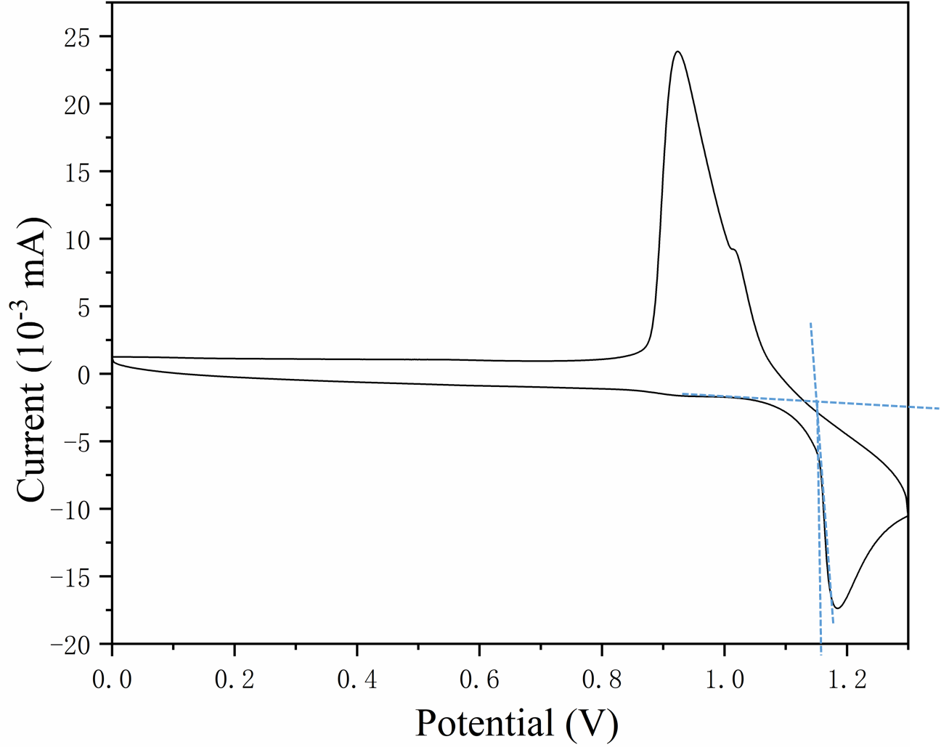
Fig. S19 Determination of OMe-Br first cathodic peak potential

