Appendix
1.To measure the Thail index.
$${Theil}_{it}=\sum_{j=1}^{2}{\left(\frac{Y_{ij,t}}{Y_{i,t}}\right)}ln\left({\frac{Y_{ij,t}}{Y_{i,t}}}/{\frac{P_{ij,t}}{P_{i,t}}}\right)$$
In the above equation,${Theil}_{it}$ represents the Thiel index in year t of city I,j=1 represents urban area，j=2 represents rural area,$Y_{ij}$ represents total income of residents in urban or rural areas of the city I,$Y_{i}$ is total income of residents,$P_{ij}$ is the total population of urban or rural areas in province i.
2.
Table A1：First-stage Regression of Lndif
Dependent Variables: | Lndif
 | (1)
Lninternet | 0.08***
 | (0.01)
Lnmobilephone | 0.066***  (0.019)
Controls | Yes
City FE | Yes
Year FE | Yes
N | 2682
Notes: Significance stars ***, **, and * indicate statistical significance at the 0.01, 0.05, and 0.10 levels, respectively. Standard errors are clustered at the city level.The independent variables are Lninternet and Lnmobilephone(instruments). Lninternet is defined as that the logarithm of the number of Internet users at the end of the year. Lnmobilephone is difined as that the logarithm of the number of mobile phone users at the end of the year. The dependent variable is Lndif same as equation (5).

Table A2：Robustness test:Drop Large Cities
Dependent Variables: | Lndpi |  |  |  |  |  |  |  |  |  |  |  | Incomegap
 | (1) |  |  | (2) | (3) |  |  |  |  |  |  | (4) |  |  | (5) | (6)
Samples: | Drop Jihuadanlie |  |  | Drop provincial capital | Drop Zhixiashi |  |  |  |  |  |  | Drop Jihuadanlie |  |  | Drop provincial capital | Drop Zhixiashi
Lndif | 0.128*** |  | 0.135*** |  | 0.130*** |  |  |  |  |  | -0.403*** |  |  |  | -0.379*** | -0.401***
 | (0.030) |  | (0.031) |  | (0.030) |  |  |  |  |  | (0.079) |  |  |  | (0.082) | (0.079)
Controls | Yes | Yes |  |  | Yes |  |  |  |  |  |  |  | Yes | Yes |  |  | Yes
City FE | Yes | Yes |  |  | Yes |  |  |  |  |  |  |  | Yes | Yes |  |  | Yes
Year FE | Yes | Yes |  |  | Yes |  |  |  |  |  |  |  | Yes | Yes |  |  | Yes
N | 2770 | 2510 |  |  | 2770 |  |  |  |  |  |  |  | 2770 | 2510 |  |  | 2770
R2 | 0.983 | 0.984 |  |  | 0.984 |  |  |  |  |  |  |  | 0.913 | 0.922 0.917
Notes: Significance stars ***, **, and * indicate statistical significance at the 0.01, 0.05, and 0.10 levels, respectively. Standard errors are clustered at the city level.Column (1) & (4) lists the effects of Lndif on Lndpi and Incomegap using the sample after dropping the Jihuadanlieshi respectly. Column (2) & (5) lists the effects of Lndif on Lndpi and Incomegap using the sample after dropping the provincial capital. Column (3) & (6) lists the effects of Lndif on Lndpi and Incomegap using the sample after dropping the Zhixiashi.

Table A3：Robustness test- Lag All Dependent Varibles
Dependent Variables: | Lnruralincome | Incomegap
 | (1) | (2)
L.lnindex | 0.124*** | -0.357***
 | (0.029) | (0.069)
Controls(lag) | Yes | Yes
City FE | Yes | Yes
Year FE | Yes | Yes
N | 2529 | 2529
AR2 | 0.9807 | 0.9109

Table A4：Robustness test- Substitute Independent and Dependent Varible
 | (1) | (2) | (3) | (4) | (5) | (6)
Dependent Variables: | Lndpi | Lndpi | Incomegap | Incomegap | Incomegap | Theil
Lndif | 0.135*** |  | -0.371*** |  | -0.354*** | -0.025**
 | (0.032) |  | (0.081) |  | (0.104) | (0.011)
Lndigitaleconomy |  | 0.019*** |  | -0.053***
 |  | (0.007) |  | (0.020)
Controls | Yes | Yes | Yes | Yes | Yes | Yes
City FE | Yes | Yes | Yes | Yes | Yes | Yes
Year FE | Yes | Yes | Yes | Yes | Yes | Yes
N | 2482 | 2482 | 2482 | 2482 | 1800 | 1800

Table A4：Robustness Test-Winsor
 | (1) | (2) | (3) | (4)
Dependent Variables: | Lndpi | Incomegap | Lndpi | Incomegap
Lnindex | 0.148*** | -0.482*** | 0.192*** | -0.450***
 | (0.037) | (0.098) | (0.045) | (0.106)
Controls | Yes | Yes | Yes | Yes
City FE | Yes | Yes | Yes | Yes
Year FE | Yes | Yes | Yes | Yes
N | 2810 | 2810 | 2810 | 2810
Within R2 | 0.206 | 0.095 | 0.197 | 0.088
The column(1) and column(2) report the estimators by winsoring in 1% level. The column(3) and column(4) report the estimators by winsoring in 2.5% level.

Fig. 1 The Changing Trend of Farmers’ Income
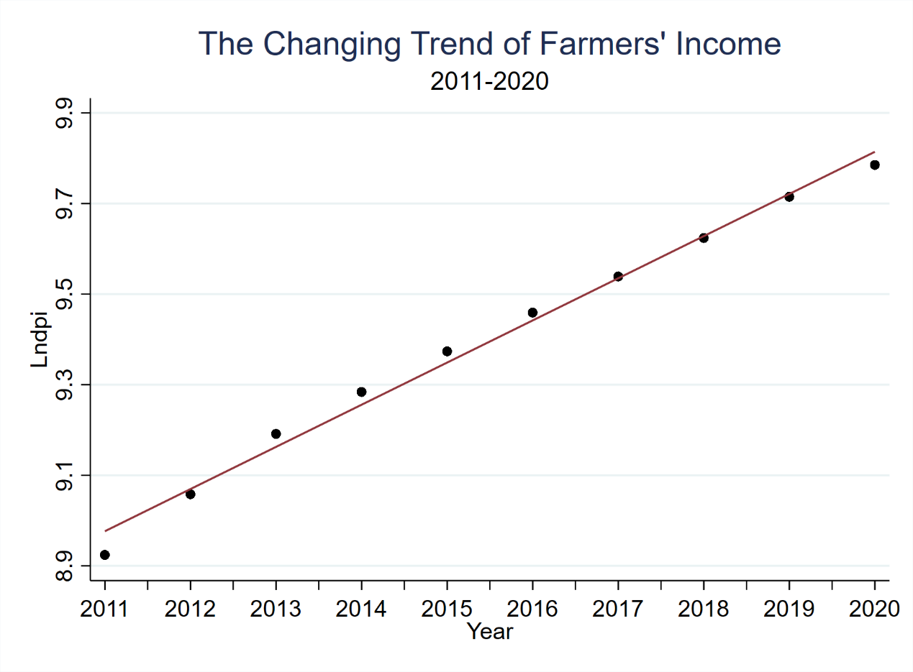

Fig. 2 The Changing Trend of Urban-Rural Incomegap
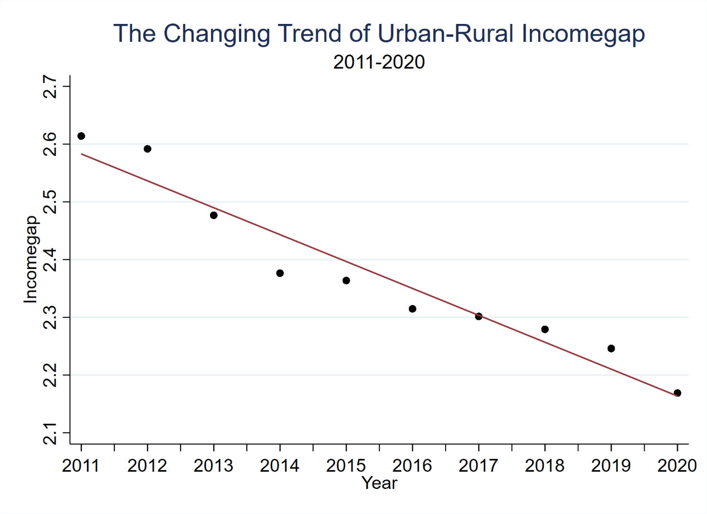
Fig. 3 The Changing Trend of Digital Financial Incusion
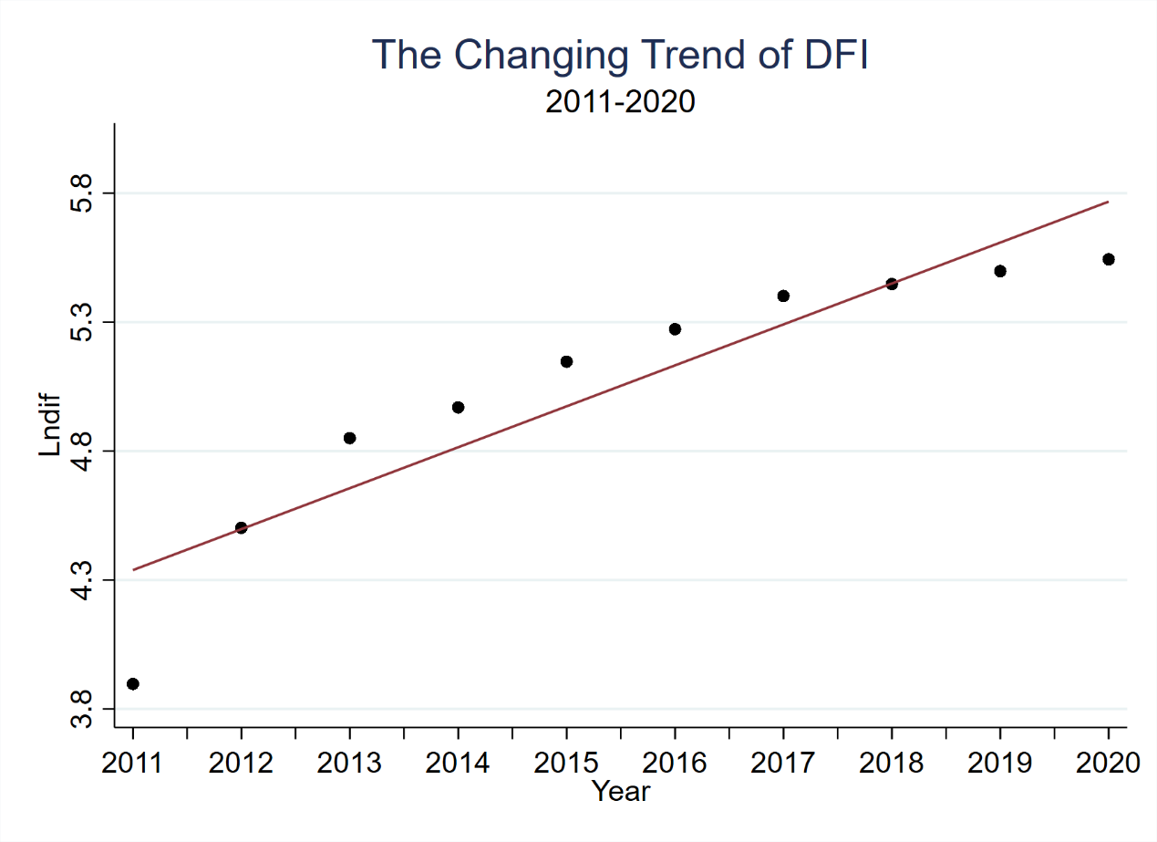
Fig. 4 The Changing Trend of ATFP
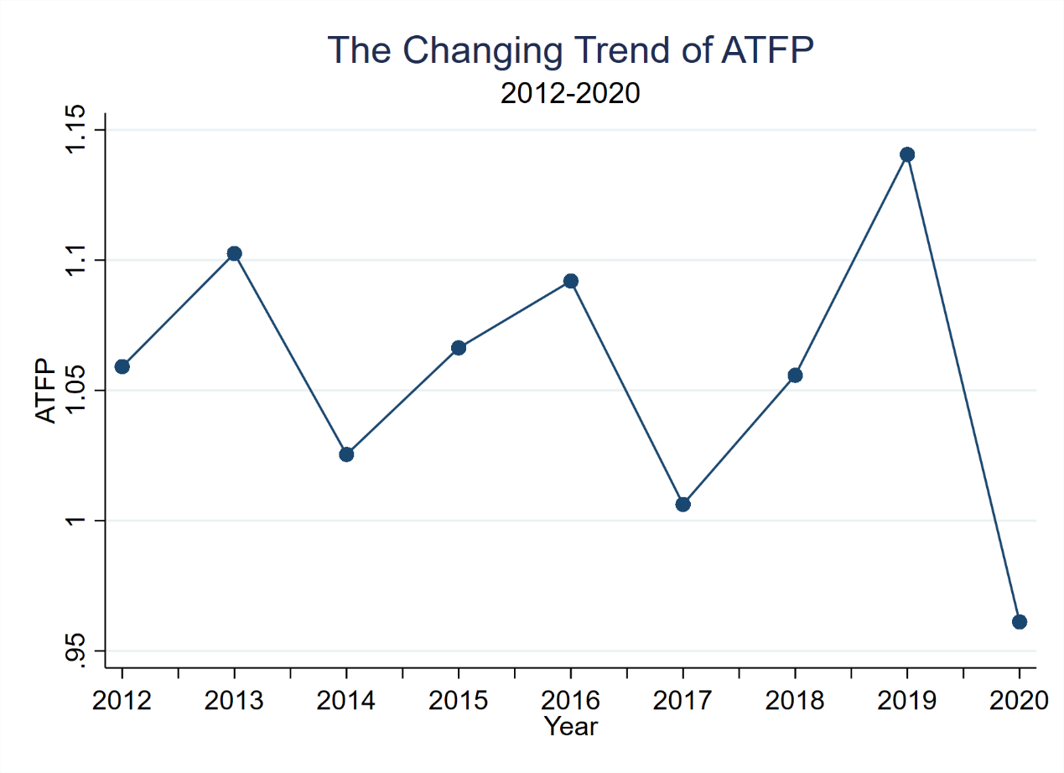

3. To measure agricultural TFP
In this paper, DEA-Malmqusit index method is used to measure agricultural total factor productivity. The specific formula is as follows:
Tfpch=$M_{i}(x^{t+1},y^{t+1};x^{t},y^{t})$=${[\frac{d_{i}^{t}(x^{t+1},y^{t+1})}{d_{i}^{t}(x^{t},y^{t})}×\frac{d_{i}^{t+1}(x^{t+1},y^{t+1})}{d_{i}^{t+1}(x^{t},y^{t})}]}^{\frac{1}{2}}$=$\frac{d_{i}^{t+1}(x^{t+1},y^{t+1})}{d_{i}^{t}(x^{t},y^{t})}×\left[\frac{d_{i}^{t}(x^{t+1},y^{t+1})}{d_{i}^{t+1}(x^{t+1},y^{t+1})}×\frac{d_{i}^{t}(x^{t},y^{t})}{d_{i}^{t+1}(x^{t},y^{t})}\right]$=Effch×Techch=Pech×Sech×Tech
In the above equation ,Tfpch is the rate of change of agriculture（relative to the previous year），which is equal to Malmquist index.Effch and Techch respectively represent technical efficiency change and technological change. Effch can be further decomposed into pure technical efficiency change(Pech) and Scale efficiency change(Sech).X is input factors,including crop sown area, employment in the first production and total power of agricultural machinery.Y is output factor，which is represented by Value added of first industry.

