Table S1. Measured and certified values of essential and toxic elements concentration, as mg/kg dry weight, in standard reference material of NMIJ CRM 7303-a lake sediment (n=3).
Metal | NMIJ CRM 7303-a lake sediment |  |  |  | INCT-CF-3– Corn flour
 | Certified value | Measured value (n=3) | Recovery (%) |  | Certified value | Measured value (n=3) | Recovery (%)
Cr | 39.1±2.8 | 39.5±2.18 | 101 |  | 0.137±0.03 | 0.138±0.042 | 101
Ni | 21.8±2.5 | 21.9±0.51 | 100 |  | 0.383±0.039 | 0.378±0.041 | 99
Cu | 23.1±3.1 | 23.3±2.16 | 101 |  | 1.63±0.13 | 1.64±0.035 | 101
As | 8.6±1.0 | 8.53±0.37 | 99 |  | 0.01 | 0.0099±0.001 | 99
Cd | 0.34±0.02 | 0.33±0.05 | 97 |  | 0.007 | 0.0068±0.001 | 97
Pb | 31.3±1.1 | 31.7±3.11 | 101 |  | 0.052 | 0.053±0.003 | 102
Fe | NA |  |  |  | 32.0 ±1.4 | 31.89±3.34 | 100
Mn | NA |  |  |  | 4.98±0.22 | 4.93±0.31 | 99
Zn | 108.2±1.0 | 105±5.28 | 99 |  | 20.09±0.76 | 20.47±2.26 | 102

Table S2. Mathematical expressions and physical significances of environmental and ecological indices.
Indices | Mathematical expressions | Classification | Contamination degree | References
Geo-accumulation index, I_{geo} | $I_{geo}= {Log}_{2}\left(\frac{C_{n}}{{1.5 ×B}_{n}}\right)$ Where, C_{n} is the measured elemental concentration in sediment and B_{n} is the background heavy metal concentrations | I_{geo} < 0 | Uncontaminated | Müller, (1981)
Geo-accumulation index, I_{geo} |  | 1 ≤ I_{geo} < 2 | Uncontaminated to moderately contaminated | Müller, (1981)
Geo-accumulation index, I_{geo} |  | 2 ≤ I_{geo} < 3 | Moderately to heavily contaminated | Müller, (1981)
Geo-accumulation index, I_{geo} |  | 3 ≤ I_{geo} < 4 | Heavily contaminated | Müller, (1981)
Geo-accumulation index, I_{geo} |  | 4 ≤ I_{geo} < 5 | Heavily to extremely contaminated | Müller, (1981)
Geo-accumulation index, I_{geo} |  | I_{geo} ≥ 5 | Extremely contaminated | Müller, (1981)
Contamination factor, CF | $CF= \frac{C_{n}}{B_{n}}$ Where, C_{n} and B_{n} are the measured and background elemental concentrations in sediment & water, respectively. | CF < 1 | Low contamination | Håkanson, (1980)
Contamination factor, CF |  | 1 ≤ CF < 3 | Moderate contamination | Håkanson, (1980)
Contamination factor, CF |  | 3 ≤ CF < 6 | Considerable contamination | Håkanson, (1980)
Contamination factor, CF |  | CF ≥ 6 | Very high contamination | Håkanson, (1980)
Modified degree of contamination, mC_{d} | ${mC}_{d}=\frac{1}{n}\sum_{i=1}^{n}{{CF}_{i}}$ where, CF is the contamination factor | mC_{d} < 1.5 | Uncontaminated | Håkanson, (1980); Abrahim, and Parker, (2008)
Modified degree of contamination, mC_{d} |  | 1.5 ≤ mC_{d} < 2 | Slightly contaminated | Håkanson, (1980); Abrahim, and Parker, (2008)
Modified degree of contamination, mC_{d} |  | 2 ≤ mC_{d} < 4 | Moderately contaminated | Håkanson, (1980); Abrahim, and Parker, (2008)
Modified degree of contamination, mC_{d} |  | 4 ≤ mC_{d} < 8 | Moderately to heavily contaminated | Håkanson, (1980); Abrahim, and Parker, (2008)
Modified degree of contamination, mC_{d} |  | 8 ≤ mC_{d} < 16 | Heavily contaminated | Håkanson, (1980); Abrahim, and Parker, (2008)
Modified degree of contamination, mC_{d} |  | 16 ≤ mC_{d} < 32 | Severely contaminated | Håkanson, (1980); Abrahim, and Parker, (2008)
Modified degree of contamination, mC_{d} |  | mC_{d} > 32 | Extremely contaminated | Håkanson, (1980); Abrahim, and Parker, (2008)
Degree of contamination, C_{d} | $C_{d}=\sum_{i=1}^{n}{{CF}_{i}}$ where, CF is the contamination factor | C_{d} < 8 | Low degree of contamination | Håkanson, (1980)
Degree of contamination, C_{d} |  | 8 ≤ C_{d} < 16 | Moderate degree of contamination | Håkanson, (1980)
Degree of contamination, C_{d} |  | 16 ≤ C_{d} < 32 | Considerable degree of contamination | Håkanson, (1980)
Degree of contamination, C_{d} |  | C_{d} > 32 | High degree of contamination | Håkanson, (1980)
Enrichment factor, EF | $EF= \frac{{(C_{n}/Fe)}_{Sample}}{{(B_{n}/Fe)}_{Background}}$ Where, C_{n} is the measured elemental concentration in sediment and B_{n} is the background heavy metal concentrations | EF < 1 | Elemental mobilization | (Birch & Olmos, 2008)
Enrichment factor, EF |  | EF = 1 | Baseline data | (Birch & Olmos, 2008)
Enrichment factor, EF |  | 1 ≤ EF < 1.5 | Possible anthropogenic origin | (Birch & Olmos, 2008)
Enrichment factor, EF |  | 1.5 ≤ EF < 3 | Minor enrichment | (Birch & Olmos, 2008)
Enrichment factor, EF |  | 3 ≤ EF < 5 | Moderate enrichment | (Birch & Olmos, 2008)
Enrichment factor, EF |  | 5 ≤ EF < 10 | Severe modification | (Birch & Olmos, 2008)
Enrichment factor, EF |  | EF > 10 | Very severe modification | (Birch & Olmos, 2008)
Pollution load index, PLI | $PLI={({CF}_{1}× {CF}_{2}×… {CF}_{n})}^{\frac{1}{n}}$ where, CF is the contamination factor | PLI = 0 | Perfection | Sadhu et al. (2012)
Pollution load index, PLI |  | PLI < 1 | Baseline level | Sadhu et al. (2012)
Pollution load index, PLI |  | PLI > 1 | Contaminated | Sadhu et al. (2012)
Potential ecological risk factor, Er^{i} | ${Er}^{i}={Tr}^{i}×{CF}^{i}$ where, Tr^{i} is the biological toxic metal response factor (Zn=1, Ni=5, Mn=1, Pb=5, Cu=5, Cr=2 and Cd=30; Islam et al., 2017) and CF is the contamination factor. | Er^{i} < 40 | Low risk | Håkanson, (1980)
Potential ecological risk factor, Er^{i} |  | 40 ≤ Er^{i} < 80 | Moderate risk | Håkanson, (1980)
Potential ecological risk factor, Er^{i} |  | 80 ≤ Er^{i} < 160 | Considerable risk | Håkanson, (1980)
Potential ecological risk factor, Er^{i} |  | 160 ≤ Er^{i} < 320 | High risk | Håkanson, (1980)
Potential ecological risk factor, Er^{i} |  | Er^{i} ≥ 320 | Very high risk | Håkanson, (1980)
Potential ecological risk index (RI) | $RI=\sum_{i=1}^{n}{{Er}^{i}}$ where Er^{i} is the potential ecological risk factor. | RI < 150 | Low risk | Håkanson, (1980)
Potential ecological risk index (RI) |  | 150 ≤ RI < 300 | Moderate risk | Håkanson, (1980)
Potential ecological risk index (RI) |  | 300 ≤ RI < 600 | Considerable risk | Håkanson, (1980)
Potential ecological risk index (RI) |  | RI ≥ 600 | High risk | Håkanson, (1980)
Mean effects range median quotient (MERM-Q) | MERM-Q=Cn/ERM, Where, Cn is metals concentration in sample, ERM for Cr, Ni, Cu, As, Cd, Pb, Fe, Mn and Zn are 370, 52, 270, 70, 10, 218, 15000, 550 and 410, respectively. | 0.11 ≤ M-ERM-Q < 0.5 | 21% probability of toxicity | Håkanson, (1980)
Mean effects range median quotient (MERM-Q) |  | 0.51 ≤ M-ERM-Q < 1.5 | 49% probability of toxicity | Håkanson, (1980)
Mean effects range median quotient (MERM-Q) |  | M-ERM-Q > 1.5 | 76% probability of toxicity | Håkanson, (1980)
Nemerow pollution index (P_{N}) | $$PN=\sqrt{{CF}^{2}+CFMax 2/2}$$  where CF is the average of contamination factors and CFmax is the maximum contamination factor found for an element in a sample. | P_{N} ≤ 1 | Unpolluted | Chen (2010)
Nemerow pollution index (P_{N}) |  | 1 < P_{N} ≤ 2.5 | Low pollution | Chen (2010)
Nemerow pollution index (P_{N}) |  | 2.5 < P_{N} ≤ 7 | moderate pollution | Chen (2010)
Nemerow pollution index (P_{N}) |  | P_{N} > 7 | High pollution | Chen (2010)

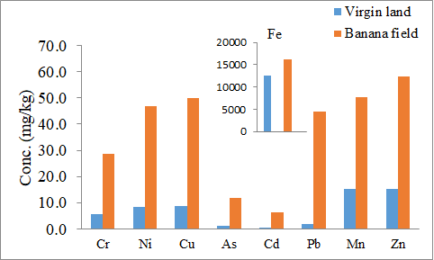
Fig. S1. Concentration of trace elements (mg/kg) in soil of banana field and virgin land located around the industrial area of the capital of ancient Pundranagar, Bangladesh
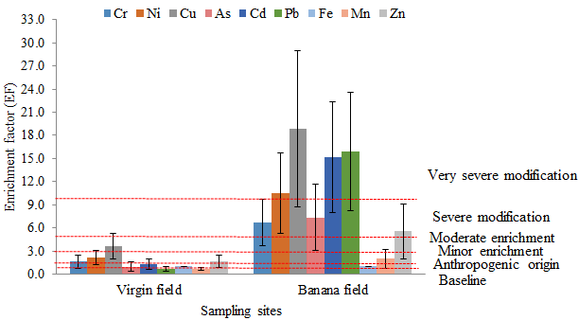
Fig. S2. Enrichment factor (EF) of trace elements in banana field’s soil around the capital of ancient Pundranagar, Bangladesh. Horizontal dot line indicates the class of metals enrichment in soil.
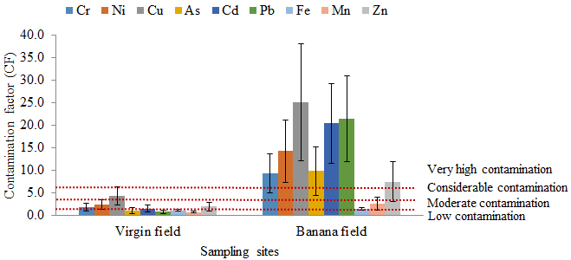
Fig. S3. Contamination factor (CF) of trace elements in banana field’s soil around the capital of ancient Pundranagar, Bangladesh. Horizontal dot line indicates the class of contamination degree.

