Abnormal Chromatin Remodeling Induced by ARID1A Loss Leads to Malformation of the Dentate Gyrus
Pei-Pei Liu^{1,3,4 *}, Shi-Ping Lu^{1*}, Xiao Li^{1,2,3,4*}, Gang-Bin Tang^{1,3,4,} Xiao Liu^{1, 2,3,4,} Shang-Kun Dai^{1,2,3,4}, Lin-Fei Jiao^{1,2,3,4}, Xi-Wen Lin^{1,3,4}, Xing-Guo Li⁵, Zhao-Qian Teng^{1,2.3,4, #}, Chun-Sheng Han^{1,2,3,4, #}, Chang-Mei Liu^{1,2,3,4, #}
1. State Key Laboratory of Stem Cell and Reproductive Biology, Institute of Zoology, Chinese Academy of Sciences, Beijing 100101, China.
2. Savaid Medical School, University of Chinese Academy of Sciences, Beijing 100049, China.
3. Institute for Stem Cell and Regeneration, Chinese Academy of Sciences, Beijing 100101, China.
4. Beijing Institute for Stem Cell and Regenerative Medicine, Beijing, China
5. Graduate Institute of Biomedical Sciences, China Medical University, No.91, Hsueh-Shih Road, Taichung, Taiwan 40402.
6.Correspondence authors: C-M. Liu (liuchm@ioz.ac.cn, 8610-82619690), C-S. Han (hancs@ioz.ac.cn, 8610-64807105) and Z-Q. Teng(tengzq@ioz.ac.cn, 8610-82619699)
*These authors contributed equally to this paper.

Running title: Arid1a Regulates Dentate Gyrus Development
Key Words: Arid1a, SWI/SNF, Neural stem cells, Dentate gyrus, Hippocampal development

Supplemental figure legends
Figure S1. Arid1a cKO mice exhibit early postnatal lethality
(A) Localization staining of Arid1a (red) in GFP-expressing (green)neural progenitor cells, neurons, and astrocytes within the dentate gyrus. Scale bars,10µm. (B) Relative Arid1a expression in mouse hippocampus development from P0 to P21. Extracts of hippocampus at different times were measured by Real-time PCR. GAPDH was used as a loading control. **p < 0.01. (C) Arid1a expression in mouse hippocampus decreased with development. Lysates of hippocampus at postnatal days 0-21 were measured by western blot. β-actin was used as a loading control. (D) Quantification of the density of the Arid1a(C) protein bands by normalization to the intensity of β-actin bands in F. * p<0.05, *** p <0.001, n=3 mice, mean ± SEM. (E)Schematic of the crosses to generate Arid1a knockout mice. Representative diagram for the generation of Emx1-cre mediated Arid1a knockout mice. A conditional Arid1a allele has loxP sites flanking exons 7 and 9 and results in an out-of-frame mutation upon Cre-mediated recombination. (F) Kaplan-Meier graph shows survival curves of the Arid1a cKO (n = 48 mice), WT (n = 82 mice). Mice in the homozygous Arid1a deletion group exhibited significantly decreased survival (dot) relative to the control group (Two-Tailed log-rank tests). * p<0.05, ** p <0.01, *** p <0.001.
Figure S2. Arid1a cKO mice lead to disorganized hippocampus
(A) Immunofluorescence for Nestin (green) and BLBP (red) in the DG from WT and Arid1a cKO mice at P0. DAPI, (blue). Scale bars, 50µm. (B) Quantification of the number of Nestin and BLBP positive cells per area in the dentate gyrus of WT and Arid1a cKO mice at P0. ***p < 0.001. (WT, n=3 mice; cKO, n=3 mice). (C) Representative images of calretinin (green) staining on P21 WT and Arid1a cKO hippocampus coronal sections. Scale bar, 20μm. (D) Quantification of calretinin⁺ cell in the DG of WT and Arid1a cKO mice at P21(WT, n=3 mice; cKO, n=3 mice). **p< 0.01. (E) Representative images of calbindin (green) staining on P21 WT and Arid1a cKO hippocampus coronal sections. Scale bar, 50μm. (F) Quantification of calbindin⁺ cell in the DG of WT and Arid1a cKO mice at P21(WT, n=3 mice; cKO, n=3 mice). ***p< 0.001.
Figure S3. Distinction at single cell level is observed between WT and Arid1a cKO mice
(A)Dotplot showing the expression of marker genes of astrocytes, blood, Cajal-Retzius cells, endothelial cells, ependymal cells, microglia, mural cells, neurons, OPCs, other and progenitor cells. (B) Heatmap of correlation between cell types. (C) Display of differentially expressed genes (DEGs) between WT and Arid1a cKO in each cell type. Down_Highly (avg_log2FC < -0.5, p_val_adj<0.01); Down_Lowly (avg_log2FC < -0.5, 0.01<=p_val_adj<0.05); Up_Highly (avg_log2FC > 0.5, p_val_adj<0.01); Up_Lowly (avg_log2FC > 0.5, 0.01<=p_val_adj<0.05).

Figure S4. Developmental trajectory analysis of neural cells at single-cell level
(A) Dotplot showing the expression of marker genes of DG and CA neurons. (B) Heatmap showing the changes of genes in the two branches in pseudo-time, with enriched Gene Ontology terms (right). (C) Scatterplot showing differentially expressed genes (DEGs) between WT and Arid1a cKO in DG neurons.

Figure S5. Loss of Arid1a results in profiling changes in histone modifications
(A) GO analysis of 47 commonly shared genes from H3K4me3 and H3K27ac down-regulated ChIP-seq peaks.

Figure S6. Arid1a regulates the expression of Prox1 in hippocampus NSPCs
(A) 3000 base pairs(bp) Prox1 promoter from transcription start site and cloned every 1000bp of the Prox1 promoter into luciferase reporter plasmid (Prox1 promoter-1(P-1), Prox1 promoter-2(P-2), Prox1 promoter-3(P-3). (B)The luciferase activity assay revealed that only Prox1 promoter-1(P-1) showed significantly increased luciferase activity after co-transfection with Arid1a overexpression plasmid (OE). Data are means ± s.e.m. of three independent experiments each performed in triplicate; *p < 0.05. (C) Western blot analysis of NSPCs from WT and Arid1a cKO postnatal pups infected with control, Prox1-OE virus.β-actin is a loading control.

Supplemental Figures
Figure S1. Arid1a cKO mice exhibit early postnatal lethality
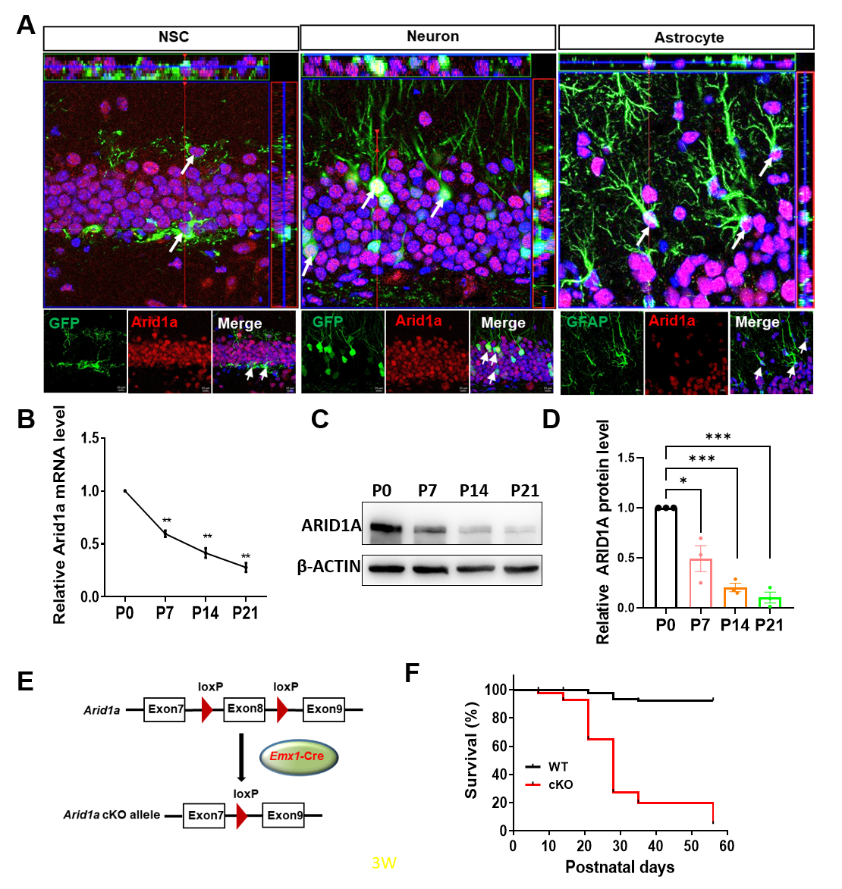

Figure S2. Arid1a cKO mice lead to disorganized hippocampus

Figure S3. Distinction in single-cell level is observed between WT and Arid1a cKO mice

Figure S4. Developmental trajectory analysis of neural cells at single-cell level

Figure S5. Loss of Arid1a results in profiling changes in histone modifications

Figure S6. Arid1a regulates the expression of Prox1 in hippocampus NSPCs
