Artificial Intelligence Enabled Cognitive Computer-Centered Digital Analysis Model for Examination of the Children’s Mental Health

Jyoti Agarwal^{1*} and Sachin Sharma^{1†}
^{1*}Department of Computer Science and Engineering, Graphic Era Deemed to be University, Dehradun, 248002, Uttarakhand, India.

*Corresponding author(s). E-mail(s): itsjyotiagarwal1@gmail.com; Contributing authors: sachin.cse@geu.ac.in;
†These authors contributed equally to this work.

Abstract
Mental health plays an important role for how a person act, think and feel. Specially in the case of students it’s become very crucial and they suffer from various kind of mental disorders due to educa- tional, emotional and societal pressure. This paper proposes a Artificial Intelligence enabled cognitive computer-centered digital analysis model for the examination of children’s mental health. The objective of chil- dren mental health analysis using vocal spectrogram, a pseudo scientific technology, is to deduce deceit from mental health that is detected in the voice. With excessive stress being viewed as an indication of deceit, the technology seeks to distinguish between good mental health and bad mental health outputs in response to stimuli. In this study, we provide a Convolutional Neural network (CNN) based cognitive computer based model for detecting children mental health based on speech cues and deep learning. Automatic children mental health detec- tion is developing into an intriguing study topic since communication between intelligent systems and humans is demanded to happen more frequently. Although the level of particular hormones, like as corti- sol, can be accurately measured to identify children’s mental health. Proposed CNN model validation is done using five different usability factors (learnability, efficiency, effectiveness, satisfaction and under- standability) to assess its utility and effectiveness and the results of

1

2 Artificial Intelligence Enabled Cognitive Computer-Centered Digital Analysis Model f

the initial tests indicate that the proposed model provides a promis- ing tool for the examination of children’s mental health. This paper also discusses about how Reinforcement Learning(RL) and CNN algo- rithms can be used for continuous improvement of the proposed model.

Keywords: mental, health, cognitive, children, usability, reinforcement, convolutional, neural

Introduction
Mental health is an important aspect of overall well-being and development, especially in children. First report in this regard given by Australian Child and Adolescent Mental Health Survey in 1998 mentioned that mental health prob- lems were common in approximate 14% of the children [15]. After that several studies are done in this area and the reports are collected across the world like Australia [5] and Student Mental Health Research Network [21]. In August 2019, University of Students, Ireland has also conducted a survey on student mental health, which focus on the increasing level of mental health issues of the students [12]. During COVID-19, students mental health disturbed a lot due to multiple changes in life, mode of education etc. Research shows that mental health implications of COVID-19 reflect a wide effect of uncertainty and health related fear among the students [26]. According to the Indian Jour- nal of Psychiatry [27], more than 50 million children in India were affected with mental health issues even before pandemic and out of them 80 to 90% of students were not having any kind of support. After pandemic, this number has been increased and problem has become very crucial. Mental health prob- lems can affect a student’s personal, academic and social life badly and they can be targeted to multiple disorders like depression, anxiety, bipolar disorder, even many students commit suicide. Early detection and treatment of mental health problems can prevent the development of more severe problems later in life, and help children achieve their full potential. Although many profes- sionals are there to help, but still there is a barrier among the children to seek help from these professionals due to the lack of communication with family and friends. Out of 5, at least 1 child is facing mental health problems but only 20% of them receive assistance [19]. The traditional methods of assessment, such as questionnaires and interviews, can be time-consuming, subjective, and prone to error. However, the evaluation of children’s mental health is a complex and challenging task, requiring the integration of multiple sources of informa- tion, including behavioural observations, cognitive assessments, and self-report measures.
The objective of this paper is to propose an Artificial Intelligence enabled cognitive computer-centered digital analysis model for examining the mental health of the children’s by considering multiple factors related to emotion, behaviour, social interaction, cognition etc. based on speech cues and deep

Artificial Intelligence Enabled Cognitive Computer-Centered Digital Analysis Model for Exa

learning. For this purpose, an online questionnaire was prepared and exper- iment was done among 400 children of different age group and different environmental areas. For experimental work, CNN algorithm is used where responses from children were collected as audio files and their spectrogram was plotted. This data was divided as training and testing data. After training the model, results were calculated for testing data for assessing children’s mental health. Validation of results obtained from the proposed model is done usabil- ity five different usability factors and also discuss how reinforcement learning can be used for continuous improvement of the model. The proposed model is designed to provide efficient assessment of mental health in children, which can contribute significant help for healthcare professionals, educators, and parents to monitor children’s, development and well-being.
This paper is divided into multiple sections to increase the readability of the paper. Background study related to existing work is given in section 2 and problem statement is discussed in section 3. Proposed CNN model is discussed in section 4 which is followed by experimental results and analysis in section
5. Conclusion and future scope of proposed work is given in section 6.

Background Study

Current research state on computer models for examining children’s mental health
The current state of research on computer models for examining children’s mental health is in its early stages, but rapidly evolving. While there has been a growing interest in using computer models for mental health assessments and treatments, there are still many challenges and limitations to overcome. Currently, there are a limited number of studies that have examined the use of computer models for diagnosing mental health conditions in children, and the results of these studies are mixed [4].Some studies have shown that com- puter models can be highly accurate in diagnosing mental health conditions in children, while others have shown that the accuracy of these models is limited and that more research is needed [10].One of the main challenges in devel- oping computer models for children’s mental health is the lack of large and diverse datasets that can be used to train the models. Additionally, there are many ethical and privacy concerns associated with using computer models for children’s mental health assessments, including the risk of misdiagnosis, the potential for biased algorithms, and the need to protect the privacy of children and families [8]. Despite these challenges, the potential benefits of using com- puter models for children’s mental health are significant, including improved accuracy and efficiency, increased accessibility, and the ability to provide more personalized and effective treatment plans [17].

4 Artificial Intelligence Enabled Cognitive Computer-Centered Digital Analysis Model f

Most commonly used Artificial Intelligence algorithms and methods for diagnosing mental health conditions in children
To identify mental health state, different machine learning algorithms are used. Srividya et al [22] have proposed the application of support vector machines, decision trees, na¨ıve bayes classifier, K-nearest neighbor classifier and logistic regression, Random Forest algorithms for this purpose from which Random Forest algorithm was giving most accurate results. A review of multiple ML algorithms along with its pros and cons is done to diagnose mental conditions of people and it was identified that all algorithms have different characteristics and can be used efficiently for diagnose mental health [6]. In 2019, different ML algorithms were examined for diagnosis of of mental illness using statistical methods on different data sets to find useful patterns [25]. A research was done for Malaysian student to identify responsible factors of mental illness [20].

Strengths and Limitations of computer models compared to traditional mental health assessments and treatments
In 2014, a review was done for learning application, strength and limitations of e-mental health system.Total 115 articles were reviewed and it was analyzed that computer models improve accessibility and reduced cost as well as increase the flexibility [14].A survey was done to compare traditional therapy meth- ods with new computer based methods to assess mental health of pregnant women and it was identified that 77.5% of women were interested in computer- based therapy [11]. Different Internet interventions are developed and tested for mental disorders which provide similar outcomes as offline treatment more effectively in terms of cost and time [2].

Ethical and privacy concerns associated with using computer models for children’s mental health assessments and treatment
The use of computer models for children’s mental health assessments and treatments raises several ethical and privacy concerns like data privacy, dis- crimination, lack of transparency, accountability, lack of technical knowledge. In 2017, such issues were identified and their solution were also discussed [3].

Outcomes and impact of using computer models in real-world
Use of computer Models or digital mental health service offers personalized care recommendations to promise more efficient and effective services. The outcomes and impact of using computer models in real-world settings are still being evaluated, but early studies suggest that they have the potential to

Artificial Intelligence Enabled Cognitive Computer-Centered Digital Analysis Model for Exa

improve diagnosis accuracy, enhance cost-effectiveness, personalized treatment and real time monitoring. Real world effectiveness of digital mental health services are also monitored during COVID-19 also [18].

Future directions and advancements in computer models for children’s mental health
The future directions and advancements in computer models for children’s mental health are likely to include improved accuracy and reliability, integra- tion with other technologies, development of new methods, addressing ethical and privacy concerns, expansion of applications etc [1].

Problem Statement
In past years, mental health problems are increasing rapidly among the stu- dents. One of the major reasons in most of the families is that both parents are working and they do not spend enough time with their children. Other rea- sons can be spending more time on mobile, TV, social media but lack of real friends. Communication gap among children with their parents and friends is also a major reason for mental health problems. A study of 415 parents shows that their children have emotional or behavioural problems, however only 2% of them took action against this problem [9]. Early diagnosis and treatment can help to overcome these issues and to prevent the development of more severe problems later in life.

Requirements
Considering these problems, following requirements are determined:
- Children should be educated about mental health.
- Parents should spend proper time along with their children.
- Efficient solution should be provided which can be helpful for children and their parents to monitor the mental health.

Solution
This research work is an attempt for providing a solution for the above addressed issues, where an Artificial Intelligence based cognitive computer model will be used to examine children’s mental health by recording their audio during submission of an online questionnaire.

Cognitive Computer-Centered Digital Analysis Model
The Cognitive model emphasizes psychological concepts, demonstrating how people approach problem solving and performing tasks. These models can be designed on paper or may be developed as computer program [7]. The cognitive

6 Artificial Intelligence Enabled Cognitive Computer-Centered Digital Analysis Model f
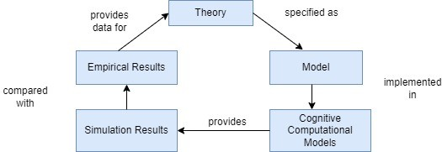
Fig. 1 Cognitive Modelling Process [10]
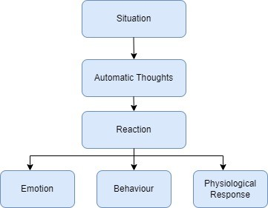
Fig. 2 Working of Cognitive Model [7]

model describes how people’s thoughts and perceptions influence their feelings and behavior. Cognitive Modelling process is shown in Fig. 1, which depicts that theory can be specified in a model which can be implemented in cognitive computational model. This model will provide simulation results which will be compared wit empirical results. Fig. 2 shows how results are generated using cognitive computational model.

Convolutional Neural Network
Convolutional Neural Network (CNN) are comprised of neurons which uses self-optimization approach through learning. Neurons receive input and per- form the operations. Basically CNN uses three layers: convolutional layers, pooling layers and fully-connected layers [16]. These three layers build CNN

Artificial Intelligence Enabled Cognitive Computer-Centered Digital Analysis Model for Exa
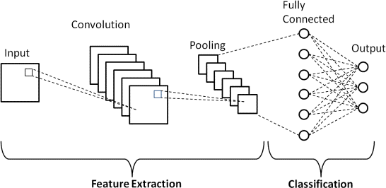

Fig. 3 Architecture of Convolutional Neural Network

architecture which is shown in Fig. 3. For computer vision and machine learn- ing problems, CNN has proved its excellence. CNNs is widely acceptable as deep learning techniques to solve crucial computational problems in current era of computer vision [13].

Proposed CNN Model
This research work aims to design a CNN based cognitive computer-centered digital analysis model to provide a more efficient and objective evaluation of children’s mental health. The model utilizes advanced computational methods and data analytic to analyze a variety of data sources, including behavioral observations, physiological data, and self-report measures. For this purpose, an online questionnaire was prepared and provided to 400 children’s between age group of 5 years to 25 years.Experiment was conducted in 5 different sessions and in each session 80 children were participated. Total duration for finish- ing the questionnaire in each session was 30 minutes. In each session data was collected in the form of audio during filling the questionnaire. The data is pro- cessed to generate a comprehensive evaluation of the child’s mental health, taking into account multiple factors, such as behavior, cognition, emotion, and social interaction. Proposed CNN model is also validated using five different usability factors (learnability, efficiency, effectiveness, satisfaction, and under- standability). The complete methodology of the proposed work is shown in Fig.4.

Experimental Results and Analysis
The experimental set up of proposed CNN based cognitive computer-centered digital analysis model for examination of children’s mental health typically involves the following steps:

8 Artificial Intelligence Enabled Cognitive Computer-Centered Digital Analysis Model f
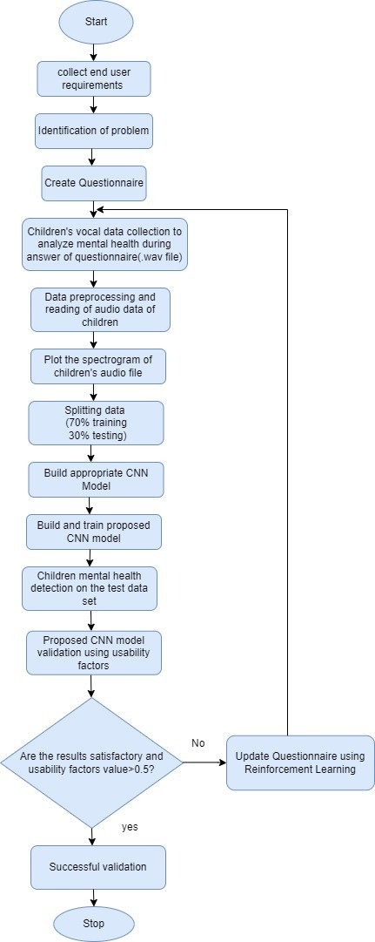
Fig. 4 Flow Chart of Proposed CNN Model

Artificial Intelligence Enabled Cognitive Computer-Centered Digital Analysis Model for Exa

Collect end-user requirements
The first step was to collect requirements of children and their parents. For this, we have interacted with many children (5 year to 25 years) and also with the parents and it was identified that main reason of mental health problem among the children are busy schedule of parents, increasing pressure of educa- tion, lack of mental health education, spending more time on social media etc. For communicating their issues, children do not have sufficient time of their parents. For which they want an efficient solution that can help to keep track on mental health of the children’s.

Identification of problem
After collecting user requirements, study has been done and it was identified that professionals are working in this area to provide consultancy but in our society, people still hesitate to seek professional help in case of mental illness. So, it was decided to develop an AI based cognitive computer model where children can communicate their thoughts in the form of a questionnaire. Data will be received from children in the form of audio.

Create Questionnaire
An online questionnaire was prepared considering behaviour, emotion, and social interaction aspects of the children. For preparing it, feedback was also collected from their parents.

Children’s vocal data collection to analyze mental health during answer of questionnaire(.wav file)
For Vocal data collection, 400 children were selected of different age group and different geographical locations. Children were divided between age group of 5-10 years, 10-15 years, 15-20 years and 20-25 years. In each session, 20 children of each group were selected and vocal data was recorded. Thus, in each session, 80 children were participating. Total 5 sessions were conducted where 400 children were participated.

Data preprocessing and reading of audio data of children
Cleaning and pre-processing the collected vocal data is done to remove any errors, outliers, or irrelevant information.

Plot the spectrogram of children’s audio file
Fig.5 illustrate the spectrogram of children’s audio file which is generated during the answer of questionnaire.

10 Artificial Intelligence Enabled Cognitive Computer-Centered Digital Analysis Model
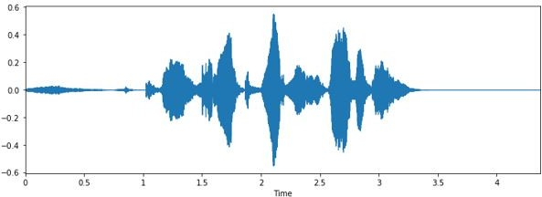
Fig. 5 Spectrogram of Children’s Audio File
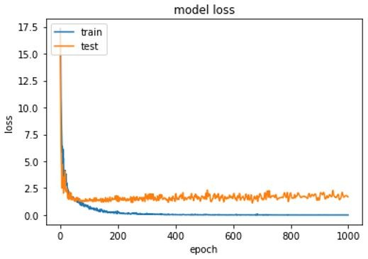
Fig. 6 Training of Proposed CNN Model

Splitting data
Collected data was divided into training and testing data. 70% of data is used as training data and rest 30% is used as testing data.

Build and train proposed CNN model
Proposed CNN model was build and trained using training data so that it can identify patterns and relationships between symptoms and mental health conditions. Results of proposed CNN model training is shown in Fig.6.

Children mental health detection on the test data set
After model training, results were generated for children’s mental health detec- tion using the test data. Results accuracy was 92.22% which is shown in Fig
7. Receiver Operating Characteristic (ROC) Curve is also generated which is shown in Fig.8. It is reflecting the performance of the purposed CNN model at threshold value. The calculated value was 0.692.

Artificial Intelligence Enabled Cognitive Computer-Centered Digital Analysis Model for Exa

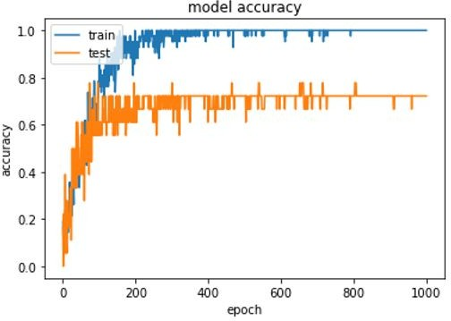
Fig. 7 Accuracy of Proposed CNN Model

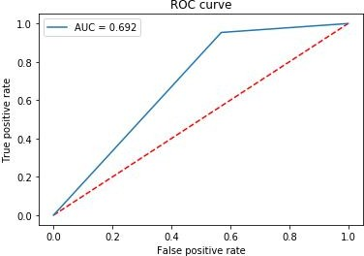

Fig. 8 ROC Curve of Proposed CNN Model

12 Artificial Intelligence Enabled Cognitive Computer-Centered Digital Analysis Model

Proposed CNN model validation using usability factors
Validating the computer model by comparing its predictions to the diagnoses made by human clinicians. For validation of the proposed model, usability test was performed using four different usability factors: learnability, efficiency, effectiveness and satisfaction.

Learnability
It can be measured as the ratio of number of achievable task and total num- ber of tasks. Experiment was performed on 400 children where 315 children have completed all the questions (100%) successfully whereas, 47 children have completed 94% of the questions, 21 children have completed 89% of ques- tions and rest 17 children have completed 81% of the questions. As an average learnability was calculated as 91% or 0.91.

Learnability = Number of achievable Tasks / Total Number of Tasks (1)

Efficiency
It can be measured as how much time is taken to complete the task by users. Total 30 minutes were given to the user to compete the task and it was analysed that among 400 children, 362 children have completed the task within given time, rest children have not completed the task within the time. So, efficiency of the proposed model is 90.5% or 0.95.

Effectiveness
Percentage of task completed by the user denotes the effectiveness. Experiment was conducted in 5 different sessions and in each session 80 children were participated. In first session, 74 children have completed the task, whereas 76, 78, 72 and 75 children have completed the task in session 2,3,4 and 5 respectively. Average effectiveness can be calculated as:

Σ_{U} Σ_{N}
E¯ = ^{j=1} ^{i=1} 100 (2)
UN

mij
∗

where N=5 (total number of sessions), U=80(total number of users in each session), mij is result of the session i by j number of users.

E = ((74 + 76 + 78 + 72 + 75)/(80 ∗ 5)) ∗ 100)
E = (375/400) ∗ 100
E = 93.75%
or
E = 0.93

Artificial Intelligence Enabled Cognitive Computer-Centered Digital Analysis Model for Exa

Satisfaction
How much users were satisfied with the developed model, denotes the satisfac- tion level. 95% of the children were satisfied from the proposed model, however 5% children were not fully satisfied due to poor Internet connection. Overall reaction of the children was satisfied where 72% commented it was excellent, 14% commented it was easy to understand and 9% commented that it was flexible. So, satisfaction level for the proposed model was 0.95.

Understandability
Understandability can be measures using given metrics:
(

EMI = 1, if meta data is available 0, otherwise

(3)

Meta data was available in the form of instructions with proper documen- tation for helping the children for completing the task. So, EMI value will be 1. Assessed values of usability factors are summarized in Table 1 and its graphical representation is shown in Fig.9.
Table1. Estimated Values of Usability Factors
S.No | Usability Factors | Estimated Values
1 | Learnability | 0.91
2 | Efficiency | 0.95
3 | Effectiveness | 0.93
4 | Satisfaction | 0.95
5 | Understandability | 1

Update Questionnaire using Reinforcement Learning
Continuously monitoring and updating the proposed model based on new data and feedback, to improve its performance over time using Reinforcement Learning.

Reinforcement Learning
A machine learning algorithm where intelligent agents take actions in an envi- ronment to maximize the cumulative reward. In our experimental work, agent are the children who are using the system and reward is the estimated values of usability factors and accuracy of the results. If the value of any usability factor is less than 0.5 or results are not satisfactory, then reinforcement learn- ing will be applied to maximize the reward by updating the model in terms of questionnaire. In this work, satisfactory results were generated and all usabil- ity factors were having values greater than 0.5 hence this algorithm is not applied. Otherwise following reinforcement learning can be used [23]:
A: Action to update model using reinforcement learning based on usability factors
CR: Current Results of student mental health and usability factors RP: Reward Points of successful validation of model

14 Artificial Intelligence Enabled Cognitive Computer-Centered Digital Analysis Model
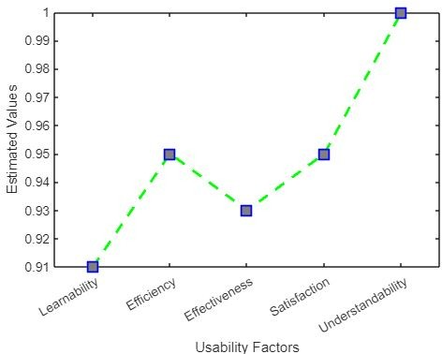
Fig. 9 Estimated Values of Usability Factors

P: Policy decided based on the RP
Q: Application to change the strategy to develop the questionnaire

Algorithm 1 Reinforcement Learning

Parameters: step size α ∈ (0, 1], small epsilon > 0
Initialize Q(cr, a), for all cr ∈ CR+, a ∈ A(cr), arbitrarily except that Q(t, ·) =
0
while True do
Initialize CR;
for each step of episode do A from CR from Q Apply action A, observe
RP , CR′
Q(CR, A) ← Q(CR, A) + α[RP + γ max_{a} Q(CR′, a) − Q(CR, A)]
CR ← CR′

Result shows that proposed CNN based cognitive computer model out- performs for examining children’s mental health and 92.22% of accuracy is achieved. For validation of the proposed CNN model, five different usability factors (learnability, efficiency, effectiveness, satisfaction and understandably) are used. Each factor was having the value greater than 0.5 which is summa- rized in Table 1. Both the aspects (accuracy level and usability factors value) ensures successful validation of the proposed model which shows that the pro- posed CNN model can be used efficiently to assess mental health of the children which can be useful for parents and professionals to keep track of children’s mental health status.

Artificial Intelligence Enabled Cognitive Computer-Centered Digital Analysis Model for Exa

6 Conclusion and Future Scope
In conclusion, Artificial Intelligence enabled cognitive computer-centered dig- ital analysis model provides a promising tool for the examination of children’s mental health. The model utilizes advanced computational methods and data analytic to provide a comprehensive and objective evaluation of mental health, taking into account multiple factors and provide high accuracy of results. Results given by testing of usability factors also indicate that the model is providing a valuable tool to monitor the development and well-being of chil- dren. Future of computer models for children’s mental health is likely to involve ongoing improvements in accuracy and reliability, integration with other technologies, development of new methods, addressing ethical and pri- vacy concerns, and expansion of applications.The field is rapidly evolving, and new advances are expected to emerge in the coming years.Further research is needed to fully assess the utility and effectiveness of the model in real-world applications.

Declarations

Ethical Approval
This material is the authors’ own original work, which has not been previously published elsewhere. The paper is not currently being considered for publica- tion elsewhere.The paper reflects the authors’ own research and analysis in a truthful and complete manner.

Competing interests
I declare that the authors have no competing interests as defined by Springer, or other interests that might be perceived to influence the results and discussion reported in this paper.

Authors’ contributions
Both authors have discussed to identify the problem and perform experiments to get the results. Their specific contribution for this research paper is as under: Jyoti Agarwal: completed abstract part of the paper along with section 1, 3, 5 and 6. Fig 1, Fig 2, Fig 3, Fig 9 and Table 1 are prepared by her.
Sachin Sharma: completed section 2 and section 4. Fig 4, Fig 5, Fig 6, Fig 7, Fig 8 are also prepared by him.
Both the authors reviewed the manuscript.

Funding
Funding not received from any organization.

16 Artificial Intelligence Enabled Cognitive Computer-Centered Digital Analysis Model

References
- Abbas, A., Schultebraucks, K., Galatzer-Levy, I. R. (2021). Digital measurement of mental health: challenges, promises, and future direc- tions. Psychiatric Annals, 51(1), 14-20.https://doi.org/10.3928/00485713- 20201207-01.

- Andersson, G., Titov, N. (2014). Advantages and limitations of Internet- based interventions for common mental disorders. World Psychiatry, 13(1), 4-11. https://doi.org/10.1002/wps.20083.

- Bauer, M., Glenn, T., Monteith, S., Bauer, R., Whybrow, P. C., Geddes,
J. (2017). Ethical perspectives on recommending digital technology for patients with mental illness. International journal of bipolar disorders, 5, 1-14.https://doi.org/10.1186/s40345-017-0073-9.

- Bauer, Michael, Scott Monteith, John Geddes, Michael J. Gitlin, Paul Grof, Peter C. Whybrow, and Tasha Glenn. ”Automation to optimise physician treatment of individual patients: examples in psychiatry.” The Lancet Psychiatry 6, no. 4 (2019): 338- 349.https://doi.org/10.1016/S2215-0366(19)30041-0.

- Browne, V., Munro, J., Cass, J. (2017). Under the radar: The mental health of Australian university students. JANZSSA-Journal of the Australian and New Zealand Student Services Association, 25(2).https://doi.org/10.30688/janzssa.2017.16.

- Cho, G., Yim, J., Choi, Y., Ko, J., Lee, S. H. (2019). Review of machine learning algorithms for diagnosing mental illness. Psychiatry investiga- tion, 16(4), 262.DOI: 10.30773/pi.2018.12.21.2

- Cognitive Modeling.https://rb.gy/gjiugl/Accessed: 2023-02-16

- Domfeh, E. A., Weyori, B., APPIAHENE, P., Mensah, J., Awarayi, N., Afrifa, S. (2022). Human-Centered Artificial Intelligence, a review. Authorea Preprints.10.22541/au.166013641.15972664/v1.

- Duxbury, L., Higgins, C., Lee, C. (1994). Work-family conflict: A com- parison by gender, family type, and perceived control. Journal of family Issues, 15(3), 449-466.https://doi.org/10.1177/019251394015003006.

- Emond, B., West, R. L. (2004). Using cognitive modelling simulations for user interface design decisions. In Innovations in Applied Artificial Intelligence: 17th International Conference on Industrial and Engineering Applications of Artificial Intelligence and Expert Systems, IEA/AIE 2004, Ottawa, Canada, May 17-20, 2004. Proceedings 17 (pp. 305-314). Springer Berlin Heidelberg.

Artificial Intelligence Enabled Cognitive Computer-Centered Digital Analysis Model for Exa

- Hantsoo, L., Podcasy, J., Sammel, M., Epperson, C. N., Kim, D. R. (2017). Pregnancy and the acceptability of computer-based versus tra- ditional mental health treatments. Journal of Women’s Health, 26(10), 1106-1113.https://doi.org/10.1089/jwh.2016.6255.

- Hill, M., Farrelly, N., Clarke, C., Cannon, M. (2020). Student mental health and well-being: overview and future directions. Irish Journal of Psychological Medicine, 1-8.https://doi.org/10.1017/ipm.2020.110.

- Ketkar, N., Moolayil, J., Ketkar, N., Moolayil, J. (2021). Con- volutional neural networks. Deep Learning with Python: Learn Best Practices of Deep Learning Models with PyTorch, 197- 242.https://doi.org/10.1007/978-1-4842-5364-9

- Lal, S., Adair, C. E. (2014). E-mental health: a rapid review of the literature. Psychiatric services, 65(1), 24- 32.https://doi.org/10.1176/appi.ps.201300009.

- Mahlous, A. R., Okkali, B. (2022). A Digital Mental Health Intervention for Children and Parents Using a User-Centred Design. Advances in Human-Computer Interaction, 2022. https://doi.org/10.1155/2022/4322177.

- O’Shea, K., Nash, R. (2015). An introduction to convolutional neural networks.https://doi.org/10.48550/arXiv.1511.08458.

- Papa, R., Jackson, K. M. (Eds.). (2021). Artificial Intelligence, Human Agency and the Educational Leader. Springer Nature.

- Prescott, M. R., Sagui-Henson, S. J., Welcome Chamberlain, C. E., Cas- tro Sweet, C., Altman, M. (2022). Real world effectiveness of digital mental health services during the COVID-19 pandemic. Plos one, 17(8). https://doi.org/10.1371/journal.pone.0272162

- Shanley, D. C., Reid, G. J., Evans, B. (2008). How parents seek help for children with mental health problems. Administration and Policy in Mental Health and Mental Health Services Research, 35, 135- 146.https://doi.org/10.1007/s10488-006-0107-6.

- Shafiee, N. S. M., Mutalib, S. (2020). Prediction of mental health problems among higher education student using machine learning. Inter- national Journal of Education and Management Engineering (IJEME), 10(6), 1-9.DOI: 10.5815/ijeme.2020.06.01.

- The Student Mental Health Research Network.Accessed: 2023-02-14 https://www.smarten.org.uk.

18 Artificial Intelligence Enabled Cognitive Computer-Centered Digital Analysis Model

- Srividya, M., Mohanavalli, S., Bhalaji, N. (2018). Behavioral modeling for mental health using machine learning algorithms. Journal of medical systems, 42, 1-12.https://doi.org/10.1007/s10916-018-0934-5.

- Sun, C. (2017, May). Fundamental Q-learning algorithm in finding opti- mal policy. In 2017 International Conference on Smart Grid and Electrical Automation (ICSGEA) (pp. 243-246). IEEE.10.1109/ICSGEA.2017.84.

- Understanding CBT https://beckinstitute.org/about/understanding- cbt/Accessed: 2023-02-16.

- Usta, M. B., Karabekiroglu, K., Sahin, B., Aydin, M., Bozkurt,

A., Karaosman, T.,
U¨ rer, E. (2019). Use of machine learning

methods in prediction of short-term outcome in autism spectrum disorders. Psychiatry and Clinical Psychopharmacology, 29(3), 320- 325.https://doi.org/10.1080/24750573.2018.1545334

- Wang, C., Pan, R., Wan, X., Tan, Y., Xu, L., Ho, C. S., Ho,
R. C. (2020). Immediate psychological responses and associated fac- tors during the initial stage of the 2019 coronavirus disease (COVID- 19) epidemic among the general population in China. Interna- tional journal of environmental research and public health, 17(5), 1729.https://doi.org/10.3390/ijerph17051729

- UNICEF report spotlights on the mental health impact of COVID-19 in children and young people. Accessed: 2023-02-15. https://rb.gy/gjiugl.

