Supplementary information for

The natural product co-evolved pyrroloquinoline quinone gene enhances their production when heterologously expressed in a variety of Streptomycetes

Xinran Wang^{1-3,#}, Ningxin Chen^{2, 3,#}, Pablo Cruz-Morales⁴, Biming Zhong^{2, 3,+}, Yangming Zhang^{2, 3,+}, Suneil Acharya⁵, Zhibo Li^{2, 3}, Huaxiang Deng^{2, 3}, Xiaozhou Luo^{1-3,6,*}, Jay D Keasling^{3,5,7,8,*}

¹Shenzhen Key Laboratory for the Intelligent Microbial Manufacturing of Medicines, Shenzhen Institute of Advanced Technology, Chinese Academy of Sciences, Shenzhen, 518055, China
²CAS Key Laboratory of Quantitative Engineering Biology, Shenzhen Institute of Synthetic Biology, Shenzhen Institute of Advanced Technology, Chinese Academy of Sciences, Shenzhen, 518055, CN
³Center for Synthetic Biochemistry, Shenzhen Institute of Synthetic Biology, Shenzhen Institutes of Advanced Technology, Chinese Academy of Sciences, Shenzhen 518055, CN
⁴Novo Nordisk Foundation Center for Biosustainability, Technical University of Denmark, 2800, Kgs. Lyngby, Denmark.
⁵Department of Chemical and Biomolecular Engineering & Department of Bioengineering, University of California, Berkeley, CA, 94720, USA.
⁶Shenzhen Infrastructure for Synthetic Biology, Shenzhen Institute of Synthetic Biology, Shenzhen Institute of Advanced Technology, Chinese Academy of Sciences, Shenzhen 518055, China
⁷Joint BioEnergy Institute, Emeryville, CA, 94608, USA.
⁸Biological Systems and Engineering Division, Lawrence Berkeley National Laboratory, Berkeley, CA, 94720, USA.
^{#,+} These authors contribute equally to this work.

*Corresponding author: Xiaozhou Luo (xz.luo@siat.ac.cn); Jay D. Keasling (keasling@berkeley.edu)
Table S1 Composition of the super matrix for the calculation of the Actinomycetota species tree
Partition | Annotation | Start-end | Model
1 | Peptide chain release factor 1 | 1-350 | LG+F+R9
2 | RNA polymerase sigma factor | 351-652 | LG+I+G4
3 | ribose-phosphate diphosphokinase | 653-973 | LG+R10
4 | 50S ribosomal protein L3 | 974-1181 | LG+R8
5 | 50S ribosomal protein L4 | 1182-1382 | LG+F+R9
6 | YebC/PmpR family DNA-binding transcriptional regulator | 1383-1635 | LG+F+R8
7 | 50S ribosomal protein L1 | 1636-1864 | LG+R7
8 | 50S ribosomal protein L5 | 1865-2017 | LG+R6
9 | glutamine-hydrolyzing GMP synthase | 2018-2525 | LG+F+R10
10 | Holliday junction branch migration DNA helicase RuvB | 2526-2840 | LG+F+I+G4
11 | 30S ribosomal protein S11 | 2841-2964 | LG+R6
12 | DNA-directed RNA polymerase subunit beta | 2965-4186 | LG+R10
13 | DNA translocase FtsK | 4187-4799 | LG+F+R10
14 | methionine adenosyltransferase | 4800-5172 | LG+F+R10
15 | F0F1 ATP synthase subunit beta | 5173-5616 | LG+I+G4
16 | polyribonucleotide nucleotidyltransferase | 5617-5883 | LG+R10
17 | DNA-directed RNA polymerase subunit alpha | 5884-6212 | LG+F+R7
18 | thioredoxin-disulfide reductase | 6213-6517 | LG+F+R10

Table S2 Distribution of metabolites detected in different increase ranges (shown by %).
Fold range | Among all metabolites | Among increased metabolites
<0 | 46.25 | -
0-2 | 13.35 | 24.84
2-10 | 15.65 | 29.12
10-100 | 2.13 | 3.96
100-1000 | 3.49 | 6.49
1000-10000 | 6.92 | 12.87
10000-100000 | 9.61 | 17.88
100000-1000000 | 2.39 | 4.45
1000000-10000000 | 0.20 | 0.37
10000000-100000000 | 0.01 | 0.02
>0 | 53.75

Table S3 Distribution of increased metabolites in different increase ranges (shown by %) in different streptomyces strains.
Strains | 0-2 | 2-10 | 10-100 | 100-1000 | 1000-10000 | 10000-100000 | >100000
Streptomyces coelicolor | 61.58 | 22.81 | 0.42 | 7.49 | 5.88 | 1.75 | 0.07
Streptomyces avermitilis | 48.74 | 36.74 | 2.81 | 6.37 | 4.30 | 1.04 | 0.00
Streptomyces albus | 18.22 | 23.31 | 2.72 | 4.33 | 13.71 | 24.51 | 13.20
Streptomyces griseus | 44.03 | 37.43 | 2.50 | 3.19 | 4.78 | 5.92 | 2.16
Streptomyces cinnamonensis | 16.69 | 32.08 | 6.43 | 9.35 | 17.52 | 15.92 | 2.01
Streptomyces sp NP10 | 24.81 | 39.52 | 2.33 | 5.05 | 16.02 | 9.95 | 2.33
Streptomyces venezulae | 26.91 | 34.08 | 2.02 | 17.49 | 16.14 | 2.91 | 0.45
Streptomyces clavuligerus | 61.44 | 27.90 | 1.57 | 5.02 | 2.51 | 1.25 | 0.31
Streptomyces noursei | 63.10 | 28.88 | 2.14 | 2.14 | 2.14 | 1.60 | 0.00
Streptomyces rapamycinicus | 11.14 | 36.62 | 9.26 | 9.14 | 10.59 | 19.31 | 3.93
Streptomyces cattleya | 7.72 | 9.63 | 4.21 | 3.91 | 14.54 | 50.85 | 9.13

Table S4 Natural products increased by PQQ gene cluster in our study (n = 3, three independent samples).
No | Compound Name | BGC | FC (abs) ([PQQ] vs [152]) | Producer | Bioactivity
1 | L-681,217 | L 681217 | 39.03 ± 2.98 | S. cattleya | Antibacterial
2 | Alteramide A | SGR-PTM | 18.74 ± 6.71 | S.albus | Antifungal
3 | 1,3,6,8-Tetrahydroxynaphthalene | THN | 2.25 ± 0.46 | S. coelicolor
4 | Actinorhodin | Actinorhodin | 2.63 ± 0.22 | S. coelicolor | Antibacterial
5 | Actinorhodinic acid | Actinorhodin | 2.47 ± 0.16 | S. coelicolor | Antibacterial
6 | CDA | CDA | 1.3 ± 0.10 | S. coelicolor
7 | CDA3A | CDA | 1.18 ± 0.12 | S. coelicolor
8 | epsilon-Actinorhodin | Actinorhodin | 2.2 ± 0.09 | S. coelicolor | Antibacterial
9 | Germicidin L | Germicidin | 1.95 ± 0.36 | S. coelicolor | Radical scavenger
10 | Germicidin N | Germicidin | 1.15 ± 0.16 | S. coelicolor | Radical scavenger
11 | Efomycin G | Elaiophylin | 1.69 ± 0.08 | S. rapamycinicus | Antifungal
12 | Elaiophylin | Elaiophylin | 1.08 ± 0.01 | S. rapamycinicus | Antifungal
13 | Efomycin A | Elaiophylin | 3.38 ± 0.36 | S. rapamycinicus | Antifungal
14 | Actinoplanic acid A | Actinoplanic acid | 1.87 ± 0.06 | S. rapamycinicus
15 | Nigericin | Nigericin | 31.55 ± 2.80 | S. rapamycinicus | Antibacterial
16 | Rapamycin | Rapamycin | 12.5 ± 0.48 | S. rapamycinicus | Immune suppressant
17 | Ectoine | Ectonine | 4.87 ± 0.47 | S. sp. NP10 | Osmoprotectant
18 | Hydroxyectoine | Ectonine | 6.54 ± 0.10 | S. sp. NP10 | Osmoprotectant
19 | 1-Deoxychloramphenicol | Chloramphenicol | 2.8 ± 0.98 | S. venezulae | Antibacterial
20 | Antimycin A1 | antimycin | 19.85 ± 1.20 | S.albus | Antifungal
21 | Antimycin A3 | antimycin | 2.99 ± 1.67 | S.albus | Antifungal
22 | Surugamide A | Surugamide | 38.37 ± 9.62 | S.albus | Antibacterial
23 | Surugamide E | Surugamide | 36.71 ± 8.23 | S.albus | Antibacterial
24 | Antimycin A2 | antimycin | 13.65 ± 1.67 | S.albus | Antifungal
25 | Alteramide B | SGR-PTM | 6.59 ± 1.13 | S.albus
26 | Nocardamin | Nocardamin | 1.39 ± 0.19 | S.avermitilis
27 | Oligomycin A | Oligomycin | 1.14 ± 0.06 | S.avermitilis | Anticancer
28 | Oligomycin D | Oligomycin | 1.39 ± 0.19 | S.avermitilis | Anticancer
29 | Monensin A | Monensin | 3.43 ± 1.00 | S.cinnamonas | Antibacterial
30 | Monensin B | Monensin | 2.47 ± 0.62 | S.cinnamonas | Antibacterial
31 | Premonensin | Monensin | 4.36 ± 1.07 | S.cinnamonas | Antibacterial
32 | A factor | γ-butyrolactone | 1.56 ± 0.18 | S.griseus | Quorum sensing

Table S5 Studies on engineering rapamycin production.
Studies | Engineering step | Fold change
Tian et.al., 2020, Nucleic Acids Res | Integrating an endogenous QS system with CRISPRi | ∼660%
Liu et.al., 2020, Appl Microbiol Biotechnol | "Superplasmid" which including global regulatory factors afsR, cyclic adenosine receptor protein (CRP), RNA polymerase beta subunits (rpoB) with point mutation and acetyl coenzyme A carboxylase gene (accA2BE) | 110%
Geng et.al., 2017, World J Microbiol Biotechnol | UV+precursor supplement+metabolic engineering | 4.8 folds
Dutta et.al., 2017, World J Microbiol Biotechnol | Random mutagenesis + medium optimization | 67%+72%
Dang et.al., 2016, World J Microbiol Biotechnol | Metabolic engineering based on genome-scale metabolic model | 142.30%
Kim et.al., 2014, J Microbiol Biotechnol | Random mutagenesis + medium optimization | 588%
Dutta et.al., 2014, 3 Biotech | Medium optimization | 52%
Zhao et.al., 2013, Appl Microbiol Biotechnol | Medium optimization | 57%
Jung et.al., 2011, Appl Microbiol Biotechnol | Mutagenesis + metabolic engineering | 3-4 folds
Yoo et.al., 2015, J Ind Microbiol Biotechnol | deletion of negative regulator | 4.6-6.7

Table S6 Studies of single step genetic engineering on monensin production.
Reference | Engineering step | Fold Change
(文莹 等,2001) | Expressing Vhb | 1.34
(Tang et.al, 2017) | Overexpressing MonH | 1.29
(Tang et.al, 2017) | Overexpressing MonRI | 1.49
(Tang et.al, 2017) | Overexpressing MonRII | 1.51
(Zhang et.al, 2016) | Overexpressing DasR | 1.68
(Zhang et.al, 2016) | Combine 4 regulators | 2.25
(KaXivcovX et al, 1984) | Radiation | 1.7

Table S7 The ScbB homologous in S. griesus.

Query id | Subject id | % Identity | Alignment length | Mismatches | Gap opens | Query start | Query end | Subject start | Subject end | Evalue | Bit score
ScbB: SCO6264 | WP_042498103.1 | 43.27 | 245 | 131 | 4 | 15 | 259 | 12 | 248 | 3.00E-47 | 159
ScbB: SCO6264 | WP_012381071.1 | 42.57 | 249 | 133 | 4 | 12 | 259 | 4 | 243 | 2.00E-41 | 143
ScbB: SCO6264 | WP_012378432.1 | 43.9 | 246 | 128 | 4 | 15 | 259 | 20 | 256 | 1.00E-38 | 136
ScbB: SCO6264 | WP_003970533.1 | 36.33 | 256 | 148 | 6 | 13 | 261 | 5 | 252 | 4.00E-36 | 129
ScbB: SCO6264 | WP_012378412.1 | 38.65 | 251 | 143 | 5 | 12 | 259 | 13 | 255 | 2.00E-34 | 125
ScbB: SCO6264 | WP_012378765.1 | 34.63 | 257 | 150 | 6 | 12 | 262 | 8 | 252 | 2.00E-29 | 111
ScbB: SCO6264 | WP_012378123.1 | 33.46 | 263 | 150 | 7 | 12 | 262 | 6 | 255 | 5.00E-28 | 107
ScbB: SCO6264 | WP_012381985.1 | 32.95 | 258 | 156 | 7 | 12 | 262 | 4 | 251 | 3.00E-27 | 105
ScbB: SCO6264 | WP_003969985.1 | 34.27 | 248 | 144 | 8 | 15 | 259 | 3 | 234 | 4.00E-27 | 104
ScbB: SCO6264 | WP_003967366.1 | 34.5 | 258 | 149 | 8 | 10 | 262 | 5 | 247 | 1.00E-26 | 103

Table S8 The compounds with fold change>10⁵ list in S. rapamycinicus.
Formula | Mass | Retention Time | FC ([sg-PQQ] vs [sg-152]) | Predicted Compound
 | 289.9443 | 0.9829999 | 31407.44
 | 404.0706 | 0.9829999 | 24460.8
C6 H11 O8 P | 242.0192 | 0.98800004 | 34139.55 | Inositol cyclic phosphate
C15 H12 O6 | 288.06 | 0.998 | 57890.66 | Isofuranonaphthoquinone D
 | 159.9863 | 1.005 | 35568.06
C14 H10 O6 | 274.0449 | 1.052 | 48607.19 | Isofuranonaphthoquinone B
 | 259.19 | 1.5559999 | 25730.46
 | 334.0365 | 1.6970003 | 24677.16
 | 208.0049 | 1.717 | 162272.4
C16 H18 N2 O2 | 270.133 | 1.9010001 | 45049.96 | Bohemamine I
 | 369.0748 | 3.108 | 284975.8
 | 767.1157 | 3.1679997 | 311274.8
 | 393.1215 | 3.267 | 29879.99
 | 350.0315 | 3.4529996 | 106934.8
C15 H20 O2 | 232.1432 | 3.5770001 | 36624.53 | Anmindenol B
C30 H48 N O10 P | 613.3078 | 3.758 | 58484.62 | Phoslactomycin C
C13 H12 O6 | 264.0676 | 3.791 | 11792.27 | Indanostatin
C7 H14 O2 | 130.1005 | 3.8250003 | 202034.9 | Heptanoic acid
 | 514.2764 | 3.8600001 | 44401.57
 | 301.0271 | 3.9260004 | 72853.75
C29 H48 O9 | 540.3293 | 3.9270003 | 108698 | D-Quinovosyl-tylactone
 | 765.347 | 4.0229993 | 53399.73
 | 827.4061 | 4.0429997 | 109079.2
 | 270.0393 | 4.076 | 27294.53
 | 417.1717 | 4.1059995 | 17675.95
 | 787.2803 | 4.1409993 | 199810.5
C17 H25 N3 O2 | 303.1966 | 4.205 | 17727.47 | N-Methyl-L-valyl-L-tryptophanol
 | 1192.616 | 4.348 | 66434.27
C12 H22 O3 | 214.1587 | 4.358 | 129334.3 | (1beta,4beta,4abeta,7alpha,8aalpha)-4,8a-Dimethyloctahydronaphthalene-1,4a,7(2H)-triol
 | 938.268 | 4.399 | 22877.89
C40 H42 O21 S | 890.1953 | 4.464 | 47903.9 | Naquihexcin H
 | 735.3836 | 4.4809995 | 93588.51
 | 685.3934 | 4.4910007 | 208265.2
C31 H52 O10 | 584.3554 | 4.532 | 298394.4 | (11E,13E)??,16??iethyl??,6??ihydroxy??5??[(5??hydroxy??,4??imethoxy????ethyloxan????yl)oxy]methyl}??,9,13??rimethyl????xacyclohexadeca??11,13??iene??,10??ione
C12 H22 O3 | 214.1587 | 4.5470004 | 187515.6 | (1beta,4beta,4abeta,7alpha,8aalpha)-4,8a-Dimethyloctahydronaphthalene-1,4a,7(2H)-triol
 | 257.128 | 4.548 | 116064.4
C15 H22 N2 O3 | 278.1647 | 4.576 | 37425.26 | N1-Acetyl-N7-O-hydroxyphenylacetyl cadaverine
C13 H15 N O2 | 217.112 | 4.649 | 58478.51 | (Z)-6-(4-Hydroxy-3-methylbut-2-en-1-yl)indolin-2-one
 | 1015.524 | 4.6580005 | 74542.02
 | 414.2863 | 4.702 | 98318.19
 | 317.2363 | 4.7270007 | 30320.05
 | 132.091 | 4.7379994 | 83953.77
C14 H28 O5 | 276.1955 | 4.83 | 497083.3 | LMA-P3
 | 779.2108 | 4.838 | 10018.35
C28 H48 O7 | 496.3396 | 4.905 | 114379 | Pladienolide
C13 H17 N O4 | 251.1174 | 4.907 | 38887.99 | 7-[(4-Methoxyphenyl)methyl]-4,5,6,7-tetrahydro-1,3-oxazepine-5,6-diol
 | 1350.765 | 4.9459996 | 79769.54
C19 H14 O7 | 354.0715 | 4.973 | 32163.91 | 11-Hydroxyrabelomycin
 | 515.3343 | 4.999 | 141138
C20 H30 O5 | 350.2112 | 5.055 | 259522.6 | Streptenol H
C20 H32 O5 | 352.2271 | 5.084 | 17880.7 | Narbonolide
 | 1164.681 | 5.114 | 121342.7
C34 H50 O8 | 586.3536 | 5.126 | 72176.82 | Tetronomycin
 | 174.1015 | 5.2099996 | 112491.4
C20 H26 O5 | 346.1798 | 5.225 | 111272.7 | Hydroxy marilone C
C29 H26 Cl2 O8 | 572.1016 | 5.347 | 108754 | Formicamycin B
 | 193.039 | 5.4010005 | 42623.35
C38 H50 N8 O12 S | 842.3186 | 5.4049997 | 10172.8 | Mureidomycin B
C14 H13 N O4 | 259.086 | 5.501 | 51911.31 | Albidopyrone
C28 H33 N O10 | 543.2124 | 5.5029993 | 13402.6 | Alldimycin C
 | 527.3702 | 5.514 | 92863.91
C44 H67 N5 O21 S | 1033.399 | 5.5429997 | 61393.33 | Liposidomycin A
 | 640.4548 | 5.5460005 | 60789.19
 | 406.2009 | 5.5639997 | 61504.3
C17 H22 N2 O9 S | 430.1052 | 5.654 | 115731 | 7-(5-Carboxyvaleramido)-7-methoxycephalosporanic acid
 | 299.1173 | 5.6889997 | 49505.29
 | 522.1756 | 5.712 | 50029.74
 | 184.1265 | 5.7179995 | 94458.27
 | 406.2009 | 5.7449994 | 61488.69
 | 950.6197 | 5.764 | 74151.41
C38 H48 N8 O11 S | 824.3071 | 5.791 | 30383.03 | ((1-(((3S)-3-((R)-2-amino-3-(3-hydroxyphenyl)-N-methylpropanamido)-1-(((Z)-((4R,5R)-5-(2,4-dioxo-3,4-dihydropyrimidin-1(2H)-yl)-4-hydroxydihydrofuran-2(3H)-ylidene)methyl)amino)-1-oxobutan-2-yl)amino)-4-(methylthio)-1-oxobutan-2-yl)carbamoyl)phenylalanine
 | 484.0879 | 5.8349996 | 274958.7
 | 522.1577 | 5.9000006 | 219265.5
 | 533.2177 | 5.9389997 | 126291.7
 | 378.2058 | 5.9560003 | 12535.68
C29 H27 N5 O4 | 509.2065 | 6.027 | 134192.9 | 1-[(2R,4R,5R,6S)-5-Methoxy-6-methyl-18-oxo-29-oxa-1,7,17-triazaoctacyclo[12.12.2.1?,??0?????0????.0??????0??????0??,???nonacosa-8,10,12,14(28),15(19),20(27),21(26),22,24-nonaen-4-yl]-1-methylurea
 | 578.2014 | 6.029 | 681833.9
C22 H22 N4 O4 | 406.164 | 6.0649996 | 65956.44 | Thaxtomin D
 | 625.3238 | 6.087 | 11672.73
C9 H11 N O2 | 165.0801 | 6.1230006 | 61896.45 | 4-Methoxyacetanilide
 | 299.1168 | 6.1269994 | 177154.5
 | 865.4248 | 6.147 | 86214.63
 | 268.1323 | 6.166 | 89123.94
C13 H20 O3 | 224.1424 | 6.1689997 | 215354.6 | Violapyrone I
C29 H30 N4 O8 | 562.2067 | 6.1850004 | 44580.75 | Saframycin A
 | 729.3393 | 6.1930003 | 312695
C28 H41 N3 O7 | 531.2979 | 6.229 | 26028.54 | 18??mino??,5??ehydro??7??emethylreblastatin
 | 261.0654 | 6.233 | 36261.8
 | 631.3596 | 6.2379994 | 438451.5
 | 578.2378 | 6.2869997 | 70032.28
C18 H28 O3 | 292.205 | 6.3079996 | 96066.41 | 3E,6E,8E,10R,11R,12E)-11-Hydroxy-4,8,10,12-tetramethyltetradeca-3,6,8,12-tetraenoic acid
C43 H46 O15 | 802.2818 | 6.4119997 | 347189.8 | Grincamycin G
C32 H55 N O14 | 677.365 | 6.419999 | 12232.56 | Fumonisin B
C21 H22 O7 | 386.1372 | 6.4360003 | 90959.98 | Ruthmycin
 | 278.1316 | 6.458 | 46782.75
 | 776.343 | 6.458 | 316649.2
 | 284.1426 | 6.4599996 | 211697.5
C22 H20 N4 O2 | 372.1593 | 6.4609995 | 7728075 | 3,6-bis(1H-Indol-3-ylmethyl)piperazine-2,5-dione
C13 H15 N | 185.1216 | 6.4609995 | 38408.69 | 6-Prenylindole
 | 404.1851 | 6.4609995 | 1946872
C25 H28 O9 | 472.1719 | 6.461999 | 427472.2 | Naphthopyranomycin
C21 H22 O5 | 354.1479 | 6.464 | 122162.1 | NSC640155
 | 252.1164 | 6.464 | 62501.72
 | 296.1423 | 6.464 | 71606.16
 | 373.2041 | 6.464 | 58833.41
 | 310.158 | 6.469001 | 138256.9
 | 554.4191 | 6.487 | 61367.68
C20 H23 Cl N4 O7 | 466.1314 | 6.5250006 | 55785.33 | JBIR-35
C30 H31 N O10 | 565.1991 | 6.6409993 | 294803.4 | A 51493A
C62 H97 N O18 S | 1175.647 | 6.6479993 | 276395.8 | Mediomycin A
 | 1239.653 | 6.725999 | 15201.98
 | 344.1636 | 6.7379994 | 78818.72
C20 H32 O6 | 368.2218 | 6.7389994 | 27128.94 | Platenolide I
C22 H20 N4 O2 | 372.1587 | 6.742 | 109022.5 | 3,6-bis(1H-Indol-3-ylmethyl)piperazine-2,5-dione
C14 H28 O2 | 228.2103 | 6.8009996 | 110386.4 | Methyl-4,8-dimethylundecanate
C27 H35 N O8 | 501.2375 | 6.8380003 | 155212.1 | Sedecamycin
C30 H31 N O10 | 565.1996 | 6.896 | 165555.6 | A 51493A
C20 H32 O5 | 352.2261 | 6.911 | 92043.75 | Narbonolide
 | 698.2708 | 6.9539995 | 241949.4
 | 850.261 | 6.961999 | 103696.1
C24 H27 N O6 S | 457.1569 | 6.9770007 | 14605.69 | Platensimycin S1
 | 560.2613 | 6.9889994 | 39224.02
 | 1089.698 | 7.0429997 | 112616.8
 | 547.1889 | 7.069 | 543968.5
 | 418.1461 | 7.0719995 | 182517.6
 | 530.1802 | 7.1220007 | 1366577
C30 H29 Cl O8 | 552.1619 | 7.125 | 122000.6 | Formicamycin A
C13 H26 O | 198.1996 | 7.1260004 | 272349.1 | 6,10-Dimethylundecan-2-one
 | 993.4119 | 7.1260004 | 41987.43
C21 H22 O5 | 354.1478 | 7.131 | 65061.62 | NSC640155
C21 H26 O6 | 374.174 | 7.1339993 | 38316.15 | Cochleamycin A
C29 H33 N O11 | 571.2071 | 7.1969995 | 170129.1 | Desmethyldescarbamoyl-5-hydroxynovobiocin
 | 546.2114 | 7.2090006 | 16625.22
C35 H54 O8 | 602.3829 | 7.248 | 267551.8 | Tetronasin
C15 H30 O2 | 242.2258 | 7.2589993 | 33450.89 | Pentadecanoic acid
 | 498.103 | 7.262 | 66961.6
 | 476.1514 | 7.2970004 | 110421.6
 | 609.1952 | 7.304 | 27261.88
 | 483.1907 | 7.3779993 | 140341.2
C22 H26 O7 | 402.169 | 7.397 | 201532.8 | Furaquinocin A
 | 1160.407 | 7.4669995 | 308255.4
 | 340.1686 | 7.530999 | 46265.35
 | 710.4624 | 7.563 | 283723.5
 | 1451.835 | 7.563 | 171691.3
 | 386.1198 | 7.5670004 | 94158.78
 | 474.136 | 7.5719995 | 389944.8
C61 H109 N O21 | 1191.745 | 7.5859995 | 165368.3 | Desertomycin
C5 H12 N O5 P | 197.0464 | 7.589 | 88553.59 | Antibiotic FR-900098
C25 H41 N O5 S | 467.2663 | 7.6099997 | 207019.2 | Cyslabdan
 | 1276.797 | 7.6300006 | 117204.4
C21 H23 N O4 | 353.1645 | 7.647 | 341369.8 | Ketomemicin B6
 | 857.508 | 7.6889997 | 376381.3
 | 476.1514 | 7.742 | 66440.24
 | 1152.441 | 7.7709994 | 89270.05
 | 526.1282 | 7.79 | 116907.9
 | 504.1948 | 7.796 | 29676.71
C28 H24 O9 | 504.1469 | 7.798 | 1999775 | Bequinostatin A
 | 2645.44 | 7.838 | 25004.26
C27 H35 N O8 | 501.2372 | 7.855 | 405502.9 | Sedecamycin
C29 H27 N5 O4 | 509.2063 | 7.8620005 | 127173.1 | 1-[(2R,4R,5R,6S)-5-Methoxy-6-methyl-18-oxo-29-oxa-1,7,17-triazaoctacyclo[12.12.2.1?,??0?????0????.0??????0??????0??,???nonacosa-8,10,12,14(28),15(19),20(27),21(26),22,24-nonaen-4-yl]-1-methylurea
 | 1824.902 | 7.952 | 23230.59
 | 386.1203 | 7.954 | 44680.37
C20 H18 N4 O7 | 426.115 | 7.964 | 324932.4 | Pitucamycin
C22 H26 O6 | 386.1742 | 7.9929996 | 32308.15 | Furaquinocin D
 | 444.1255 | 8.005 | 24731.02
C14 H25 N3 O6 S | 363.1507 | 8.019 | 56628.95 | N-[(5S)-5-Amino-5-carboxypentanoyl]-L-cysteinyl-D-valine
C27 H35 N O8 | 501.2373 | 8.072 | 186938.6 | Sedecamycin
 | 1345.81 | 8.096 | 118332.4
C15 H30 O | 226.2312 | 8.114999 | 345751.9 | 2-Pentadecanone
C16 H25 N7 O8 | 443.1786 | 8.302001 | 73869.12 | Asteromycin
 | 1499.769 | 8.302001 | 142212
C24 H27 N O5 S | 441.1631 | 8.308 | 79611.72 | Platencin S1
 | 509.1496 | 8.312 | 83497.61
 | 1533.753 | 8.313 | 167238.7
 | 538.1646 | 8.315 | 69684.06
C27 H25 N O7 | 475.1679 | 8.319 | 117218.3 | Lugdunomycin
 | 541.2331 | 8.329001 | 164299.8
C24 H27 N O6 S | 457.1577 | 8.352 | 184354.7 | Platensimycin S1
 | 1392.768 | 8.352 | 138251.4
C15 H24 N2 O7 S | 376.1302 | 8.374 | 189115 | Lactacystin
 | 310.1575 | 8.383 | 11659.44
 | 1248.687 | 8.427001 | 133594.4
 | 470.2656 | 9.002 | 348716.6
 | 918.5747 | 9.080001 | 90035.02
 | 850.3151 | 9.481 | 19719.92
C18 H34 O2 | 282.2573 | 9.554 | 97603.03 | 6-Octadecenoic acid
 | 946.6051 | 9.562 | 40112
 | 378.2626 | 9.845 | 199817.6
 | 956.5864 | 9.861 | 18405.02
C25 H41 N O5 S | 467.2733 | 9.866 | 16211.87 | Cyslabdan
C25 H38 N2 O6 | 462.2754 | 9.89 | 12580.76 | 1,19-bis(3-Hydroxyazetidin-1-yl)nonadeca-5,14-diene-1,8,12,19-tetraone
 | 486.3353 | 10.034 | 92090.25
C30 H50 O7 | 522.3563 | 10.330001 | 26842.17 | Nahuoic acid A
 | 1008.617 | 10.599999 | 256060.9
 | 494.3674 | 10.607001 | 56595.01
 | 1008.543 | 10.612 | 524207.6
 | 561.3546 | 10.62 | 23459.04
C40 H68 O12 | 740.4717 | 10.775001 | 14421.87 | Phthoramycin
 | 481.364 | 10.782999 | 19700.06
 | 549.3043 | 10.79 | 249333.2
 | 802.3031 | 11.092001 | 102854.7
C27 H42 O4 | 430.3084 | 11.141999 | 200789.2 | 2-(3-Acetoxy-4,4,14-trimethylandrost-8-en-17-yl)-propanoic acid
 | 682.4655 | 11.159 | 10347.54
 | 538.314 | 11.240999 | 271012.6
 | 498.2831 | 11.252 | 115302.6
 | 428.2927 | 11.334 | 157039
C36 H60 O13 | 700.3994 | 11.403 | 98692.34 | Aldgamycin L
 | 630.5391 | 11.403 | 27157.21
C36 H60 O12 | 684.4054 | 11.41 | 11776.96 | Fungichromin B
 | 644.5565 | 11.757 | 33455.15
C28 H34 N2 O7 | 510.2427 | 12.266999 | 52617.68 | Manumycin B
 | 456.3236 | 12.267999 | 209242.2
 | 570.2643 | 12.498 | 10987.26
C12 H16 O4 | 224.1053 | 12.5 | 112954.4 | Olivetolic acid
 | 292.168 | 12.502 | 42309.23
 | 324.0301 | 12.503999 | 51519.71
C43 H62 N2 O11 | 782.4345 | 12.619001 | 238202 | 30-Deoxy-kirromycin
 | 824.4011 | 12.627999 | 753398.8
 | 840.396 | 12.633001 | 281649.3
 | 364.1696 | 12.972 | 15628.33
C48 H79 N O18 | 957.5383 | 13.001 | 51841.28 | 3-Acetyltylosin
 | 694.537 | 13.5339985 | 75059.81
C18 H30 N4 O6 | 398.2113 | 13.763 | 83192.16 | Cytosamine
 | 498.2949 | 14.495 | 33271.92
C14 H26 F2 N4 O5 | 368.1862 | 14.665 | 16771.23 | dDesferrioxamine-F2[11-]
 | 600.3266 | 16.443 | 12465.27

Table S9 Compounds with fold change>10⁵ list in S. griseus.
Formula | Mass | Retention Time | FC ([sg-PQQ] vs [sg-152]) | Predicted Compounds
 | 979.2613 | 1.621 | 16199.8
 | 443.2706 | 3.228 | 10760.65
 | 925.4967 | 3.463 | 18626.79
 | 504.1171 | 3.487999 | 15907.8
C27 H39 N O7 | 489.2765 | 3.652 | 13010.81 | Isomigrastatin
C28 H21 N O8 | 499.1265 | 3.671 | 18796.02 | Eriamycin
 | 443.2705 | 3.707 | 13132.54
 | 739.4184 | 3.778 | 15110.04
 | 866.4811 | 3.791 | 42002.98
 | 433.0807 | 3.802 | 39112.38
 | 951.4581 | 3.824 | 28094.09
 | 867.4515 | 3.978 | 20098
C15 H21 N3 O2 | 275.1618 | 4 | 24502.59 | Physostigmine
 | 308.1814 | 4.304 | 37628
 | 590.2717 | 4.459 | 23299.74
C13 H15 N O6 | 281.0885 | 4.494 | 17626.82 | A58365B
C14 H28 O5 | 276.192 | 4.609001 | 23379.78 | LMA-P3
 | 825.4958 | 4.705 | 164198.9
 | 260.079 | 4.726 | 278530.3
 | 509.3188 | 4.754 | 29750.26
C63 H111 N3 O20 | 1229.772 | 4.901001 | 27329.92 | Malolactomycin A
 | 458.3078 | 4.965 | 24289.51
 | 706.2053 | 5.095 | 49337.07
 | 320.218 | 5.124 | 25649.05
C18 H15 N3 O6 S | 401.0721 | 5.16 | 19733.66 | 2-Acetamido-3-(2-amino-8-formyl-3-oxo-phenoxazin-1-yl)sulfanyl-propanoic acid
 | 248.1615 | 5.309 | 44286.87
C24 H25 N O10 S | 519.1168 | 5.491001 | 27719.68 | WS 009A
C9 H12 N2 O2 S2 | 244.0358 | 5.546001 | 37643.21 | (1Z)-SS'-dimethyldihydroholomycin
C22 H27 N9 O4 | 481.2186 | 5.619999 | 31376.63 | Distamycin A
 | 278.1717 | 5.632 | 79165.95
 | 296.127 | 5.782001 | 17919.17
 | 330.9987 | 5.807 | 23766.6
 | 351.065 | 5.819 | 64105.46
C14 H20 O3 | 236.1431 | 5.874 | 72085.46 | 2-Methyl-8-hydroxybenzeneheptanoic acid
C18 H22 N2 O5 | 346.1506 | 5.993 | 43342.16 | Foxicin A
C8 H13 N3 O4 | 215.0926 | 6.095 | 47600.83 | FK409
 | 292.1867 | 6.099999 | 223921.4
C12 H14 O3 | 206.0928 | 6.196 | 24502.88 | 5-(2-Methylphenyl)-5-oxovaleric acid
 | 572.2084 | 6.231 | 46129.03
C20 H27 N5 O7 | 449.1917 | 6.237999 | 244456.7 | Nikkomycin Px
 | 1754.657 | 6.284 | 468343.6
 | 344.179 | 6.312 | 33520.34
 | 342.1486 | 6.372001 | 36116.4
 | 1788.661 | 6.474 | 387267
 | 1756.67 | 6.556 | 193280.3
 | 1772.667 | 6.558999 | 164328.2
 | 1773.795 | 6.564 | 51276.57
 | 1532.553 | 6.686 | 94459.9
 | 1510.573 | 6.694 | 582330.2
 | 1468.598 | 6.699 | 190437.2
 | 1470.611 | 6.716 | 149366
 | 1452.604 | 6.760001 | 138079.7
C21 H24 O5 | 356.1624 | 6.769001 | 88503.15 | Cuevaene A
 | 1494.578 | 6.832 | 13536.72
 | 1516.558 | 6.833 | 165372.5
 | 1478.584 | 6.867 | 206571.3
 | 1510.573 | 6.882 | 97557.88
 | 1736.645 | 7.103 | 126206
 | 1508.595 | 7.155999 | 93462.02
C14 H26 O4 | 258.1807 | 7.331 | 157963.1 | SCB3
C15 H22 N2 O4 | 294.1579 | 7.335 | 46636.92 | CHEMBL3251687
 | 1645.619 | 7.592 | 387194.3
 | 1403.549 | 7.61 | 105282.7
C17 H26 O5 | 310.1757 | 7.957 | 31311.96 | Albocycline D
C22 H22 N4 O5 | 422.16 | 7.999 | 49178.5 | Thaxtomine B
C15 H24 N4 O7 | 372.167 | 8.005 | 119731.6 | Clavamycin F
 | 449.1783 | 8.014 | 24734.29
C13 H22 O3 | 226.1555 | 8.280999 | 58837.96 | 4S,10-Dihydroxy-10-methyl-dodec-2-en-1,4-olide
C28 H37 N O4 | 451.2728 | 10.335 | 71169.28 | Cytochalasin J
 | 435.2776 | 12.392 | 23240.93
C22 H30 O6 | 390.2029 | 16.355 | 37934.97 | 3-(4-(2-(4-(2-Hydroxy-3-methoxypropoxy)phenyl)propan-2-yl)phenoxy)propane-1,2-diol

Table S10 Information of BGCs in S. rapamycinicus.
Region | Type | From | To | Most similar known cluster | Similarity
Region 1 | T3PKS,NRPS-like,NRPS,betalactone,T1PKS | 1 | 106,876 | lobophorin A | 36%
Region 2 | NRPS | 491,617 | 540,884 | coelichelin | 100%
Region 3 | butyrolactone | 859,144 | 868,463 | cyphomycin | 9%
Region 4 | T1PKS | 1,024,465 | 1,112,648 | azalomycin F3a | 100%
Region 5 | T1PKS | 1,298,486 | 1,437,158 | nigericin | 100%
Region 6 | T1PKS | 1,439,806 | 1,483,779 | salinomycin | 8%
Region 7 | T1PKS | 1,585,031 | 1,663,130 | elaiophylin | 87%
Region 8 | redox-cofactor | 1,690,280 | 1,712,398 | lankacidin C | 13%
Region 9 | hserlactone | 1,836,607 | 1,857,362 | daptomycin | 4%
Region 10 | butyrolactone | 1,867,930 | 1,878,862
Region 11 | NRPS,T1PKS | 2,083,936 | 2,136,122 | meilingmycin | 4%
Region 12 | NRPS,T3PKS,other | 2,194,053 | 2,294,639 | feglymycin | 84%
Region 13 | T1PKS,NRPS | 2,376,523 | 2,596,226 | thiazostatin / watasemycin A / watasemycin B / 2-hydroxyphenylthiazoline enantiopyochelin / isopyochelin | 86%
Region 14 | lanthipeptide-class-i | 2,599,171 | 2,623,572 | steffimycin D | 16%
Region 15 | lassopeptide | 2,763,243 | 2,785,685
Region 16 | terpene | 2,825,088 | 2,847,488 | hopene | 76%
Region 17 | T2PKS | 3,223,797 | 3,296,312 | spore pigment | 83%
Region 18 | T1PKS | 3,440,208 | 3,501,621 | s56-p1 | 11%
Region 19 | RiPP-like | 3,566,936 | 3,576,136
Region 20 | siderophore | 3,744,643 | 3,755,156
Region 21 | NRPS-like | 4,330,901 | 4,372,987 | echoside A / echoside B / echoside C / echoside D / echoside E | 100%
Region 22 | siderophore | 4,931,246 | 4,942,037 | desferrioxamin B | 100%
Region 23 | T1PKS,NRPS | 5,234,705 | 5,353,578 | lydicamycin | 40%
Region 24 | terpene | 6,279,853 | 6,301,507 | geosmin | 100%
Region 25 | ladderane,arylpolyene,NRPS | 6,595,547 | 6,698,033 | atratumycin | 57%
Region 26 | indole | 6,995,321 | 7,016,463 | 5-isoprenylindole-3-carboxylate β-D-glycosyl ester | 61%
Region 27 | NRPS | 7,233,050 | 7,275,286 | ochronotic pigment | 75%
Region 28 | ladderane,arylpolyene | 7,325,972 | 7,367,065 | atratumycin | 34%
Region 29 | RRE-containing | 7,378,794 | 7,401,202 | granaticin | 10%
Region 30 | T1PKS | 7,536,753 | 7,718,885 | mediomycin A | 68%
Region 31 | terpene | 8,222,414 | 8,242,984
Region 32 | ectoine | 8,900,244 | 8,910,648 | ectoine | 100%
Region 33 | siderophore,T1PKS | 9,081,916 | 9,139,461 | apoptolidin | 20%
Region 34 | terpene | 9,152,238 | 9,168,506 | BE-43547A1 / BE-43547A2 / BE-43547B1 / BE-43547B2 / BE-43547B3 / BE-43547C1 / BE-43547C2 | 20%
Region 35 | T1PKS | 9,476,760 | 9,606,190 | akaeolide | 20%
Region 36 | NRPS-like | 9,680,021 | 9,720,124 | BD-12 | 71%
Region 37 | T1PKS,NRPS-like,nucleoside,NRPS | 9,758,976 | 10,004,255 | rapamycin | 100%
Region 38 | PKS-like | 10,085,595 | 10,126,623 | rustmicin | 20%
Region 39 | terpene | 10,130,161 | 10,149,631 | 2-methylisoborneol | 100%
Region 40 | terpene | 10,565,677 | 10,585,422 | pristinol | 100%
Region 41 | T1PKS,ladderane,arylpolyene | 10,679,301 | 10,730,137 | atratumycin | 28%
Region 42 | NRPS,T1PKS | 10,976,611 | 11,092,238 | meridamycin | 76%
Region 43 | T1PKS,NRPS-like | 11,099,441 | 11,181,894 | hygrocin A / hygrocin B | 93%
Region 44 | T1PKS,hglE-KS | 11,336,115 | 11,459,137 | bafilomycin B1 | 50%
Region 45 | RiPP-like | 11,461,501 | 11,471,719
Region 46 | NRPS | 11,477,449 | 11,554,061 | dechlorocuracomycin | 8%
Region 47 | terpene | 11,606,908 | 11,627,280 | brasilicardin A | 38%
Region 48 | terpene | 11,765,022 | 11,785,930
Region 49 | NRPS-like | 11,835,848 | 11,877,612 | echoside A / echoside B / echoside C / echoside D / echoside E | 11%
Region 50 | betalactone | 11,969,269 | 11,998,132 | Sch-47554 / Sch-47555 | 7%
Region 51 | T1PKS | 12,036,351 | 12,099,769 | hitachimycin | 22%
Region 52 | NRPS | 12,222,724 | 12,274,150
Region 53 | T1PKS | 12,289,607 | 12,332,240 | geldanamycin | 39%

Table S11 Information of BGCs in S. griesus.
Region | Type | From | To | Most similar known cluster | Similarity
Region 1 | terpene | 47,703 | 70,765 | isorenieratene | 100%
Region 2 | lanthipeptide-class-iv | 149,896 | 172,595
Region 3 | T1PKS,NRPS | 275,486 | 326,653 | A-47934 | 8%
Region 4 | NRPS,T3PKS | 464,992 | 570,745 | CDA1b/CDA2a/CDA2b/CDA3a/CDA3b/CDA4a/CDA4b | 7%
Region 5 | melanin | 604,068 | 611,793 | istamycin | 4%
Region 6 | RiPP-like | 616,318 | 624,815 | streptamidine | 58%
Region 7 | NRPS,NRPS-like,LAP,T1PKS,other | 641,140 | 792,830 | lidamycin | 41%
Region 8 | RiPP-like | 900,351 | 910,398 | tetronasin | 3%
Region 9 | NRPS,T1PKS | 937,505 | 985,289 | SGR PTMs/SGR PTM Compound b/SGR PTM Compound c/SGR PTM Compound d | 100%
Region 10 | NRPS,NRPS-like | 1,040,889 | 1,089,517 | nucleocidin | 47%
Region 11 | terpene | 1,127,348 | 1,153,611 | hopene | 69%
Region 12 | terpene | 1,482,239 | 1,501,955 | 2-methylisoborneol | 100%
Region 13 | linaridin | 1,768,290 | 1,786,697 | pentostatine/vidarabine | 9%
Region 14 | NRPS-independent-siderophore | 2,026,431 | 2,039,870 | schizokinen | 20%
Region 15 | terpene | 2,452,552 | 2,470,816
Region 16 | lanthipeptide-class-iii | 2,817,532 | 2,838,618 | AmfS | 100%
Region 17 | melanin | 2,880,853 | 2,889,385 | melanin | 100%
Region 18 | T1PKS,NRPS-like | 2,908,041 | 2,960,292 | enduracidin | 10%
Region 19 | NRPS | 3,029,854 | 3,093,422 | atratumycin | 15%
Region 20 | NRPS-like,arylpolyene,ladderane,NRPS | 3,747,947 | 3,871,878 | kitacinnamycin A/kitacinnamycin B/kitacinnamycin C/kitacinnamycin D/kitacinnamycin E/kitacinnamycin F | 61%
Region 21 | betalactone | 4,064,846 | 4,092,758 | divergolide A/divergolide B/divergolide C/divergolide D | 6%
Region 22 | lanthipeptide-class-i | 4,495,428 | 4,520,684
Region 23 | melanin | 4,960,838 | 4,971,221 | grixazone A | 61%
Region 24 | LAP,thiopeptide | 5,142,038 | 5,174,689
Region 25 | NRPS-independent-siderophore | 5,573,822 | 5,585,600 | desferrioxamin B | 100%
Region 26 | lanthipeptide-class-iii,lanthipeptide-class-ii | 5,637,061 | 5,668,505
Region 27 | PKS-like | 6,220,925 | 6,256,545 | malacidin A/malacidin B | 5%
Region 28 | ectoine | 6,603,626 | 6,614,024 | ectoine | 100%
Region 29 | amglyccycl,RRE-containing | 6,935,101 | 6,971,131 | streptomycin | 55%
Region 30 | terpene,T1PKS | 7,080,060 | 7,191,361 | griseochelin | 100%
Region 31 | T1PKS | 7,271,755 | 7,372,510 | stambomycin A/stambomycin B/stambomycin C/stambomycin D | 40%
Region 32 | linaridin,T1PKS | 7,562,138 | 7,638,706 | iminimycin A/iminimycin B | 100%
Region 33 | T3PKS | 7,888,518 | 7,929,636 | naringenin | 100%
Region 34 | NRP-metallophore | 7,988,318 | 8,182,236 | griseobactin | 100%
Region 35 | terpene | 8,196,628 | 8,236,630 | carotenoid | 100%
Region 36 | butyrolactone | 8,268,444 | 8,279,388 | coelimycin P1 | 8%
Region 37 | terpene | 8,473,224 | 8,498,798 | isorenieratene | 100%
Table S12 Strains and primers used in this study.
Strains or plasmids | Features | Sources
E.coli
DH10B | F´ (traΔ36 proAB lacIq lacZΔM15) rpsL (strR) thr leu endA thi-1 lacY galK galT ara tonA tsx dam dcm supE44 Δ(lac-proAB) Δ(mcrC-mrr)102::Tn10 (tetR) | GIBCO-BRL
ET12567(pUZ8002) | RecE, dam, dcm, hsds, cm, str, tet, km
Streptomyces
SCO-PQQ | Streptomyces coelicolor M145::pLQ646-shxm1453-57 | This study
SCO-152 | Streptomyces coelicolor M145::pSET152 | This study
SMA-PQQ | Streptomyces avermitilis NRRL8165::pLQ646-shxm1453-57 | This study
SMA-152 | Streptomyces avermitilis NRRL8165::pSET152 | This study
SA-PQQ | Streptomyces albus J1074::pLQ646-shxm1453-57 | This study
SA-152 | Streptomyces albus J1074::pSET152 | This study
SLA-PQQ | Streptomyces lasaliensis ATCC 31180::pLQ646-shxm1453-57 | This study
SLA-152 | Streptomyces lasaliensis ATCC 31180::pSET152 | This study
S2130-PQQ | Streptomyces sp. CB02130::pLQ646-shxm1453-57 | This study
S2130-152 | Streptomyces sp. CB02130::pSET152 | This study
SCN-PQQ | Streptomyces cinnamonensis ATCC 15413::pLQ646-shxm1453-57 | This study
SCN-152 | Streptomyces cinnamonensis ATCC 15413::pSET152 | This study
SNP10-PQQ | Streptomyces sp. NP10::pLQ646-shxm1453-57 | This study
SNP10-152 | Streptomyces sp. NP10::pSET152 | This study
SVE-PQQ | Streptomyces venezulaeISP 5230::pLQ646-shxm1453-57 | This study
SVE-152 | Streptomyces venezulaeISP 5230::pSET152 | This study
SCLA-PQQ | Streptomyces clavuligerus ATCC 27064::pLQ646-shxm1453-57 | This study
SCLA-152 | Streptomyces clavuligerus ATCC 27064::pSET152 | This study
SNO-PQQ | Streptomyces noursei A-150::pLQ646-shxm1453-57 | This study
SNO-152 | Streptomyces noursei A-150::pSET152 | This study
SRA-PQQ | Streptomyces rapamycinicus A-001::pLQ646-shxm1453-57 | This study
SRA-152 | Streptomyces rapamycinicus A-001::pSET152 | This study
SHX-PQQ | Streptomyces hygroscopicusXM201::pLQ646-shxm1453-57 | This study
SHX-152 | Streptomyces hygroscopicusXM201::pSET152 | This study
SCA-PQQ | Streptomyces cattleya NRRL8057::pLQ646-shxm1453-57 | This study
SCA-152 | Streptomyces cattleya NRRL8057::pSET152 | This study
Plasmids
pLQ646 | pSET152::kasOp*
pXR-1 | pSET152::kasOp*-shxm1453-57 | This study
Primers
1453-646-F | TGAGTTGAAGAGGTGACGTCCATATGATGAACGACACCACACCGC
1453-646-R | AACAGCTATGACATGATTACGAATTCTCACCCTCCTCCGGGCTT

Figure S1 Oxidized and reduced form of PQQ and its relationship with redox modulation. .

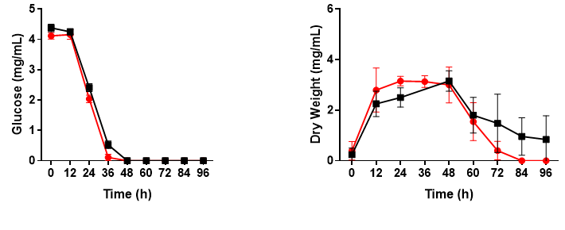
Figure S2 Glucose consumption curve and growth curve of streptomyces coelicolor with (red) and without (black) PQQ.

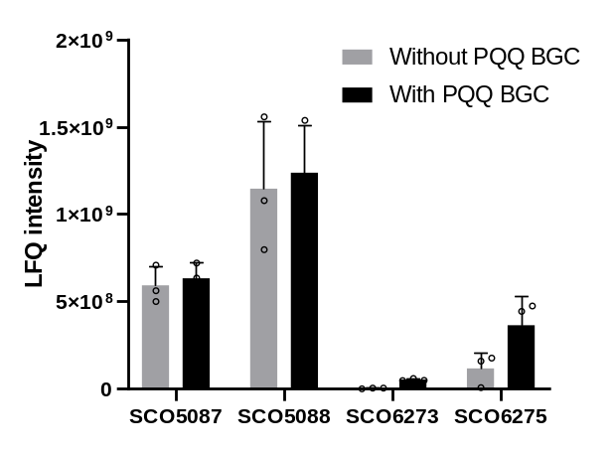
Figure S3 Intensities of PKS proteins involved in actinorhodin biosynthesis (SCO5087 and SCO5088) and coelimycin P1 biosynthesis (SCO6273 and SCO6275).

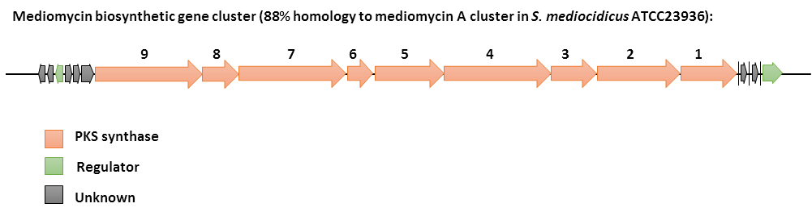
Figure S4 Biosynthetic genes cluster of Mediomycin in S. rapamycinicus.

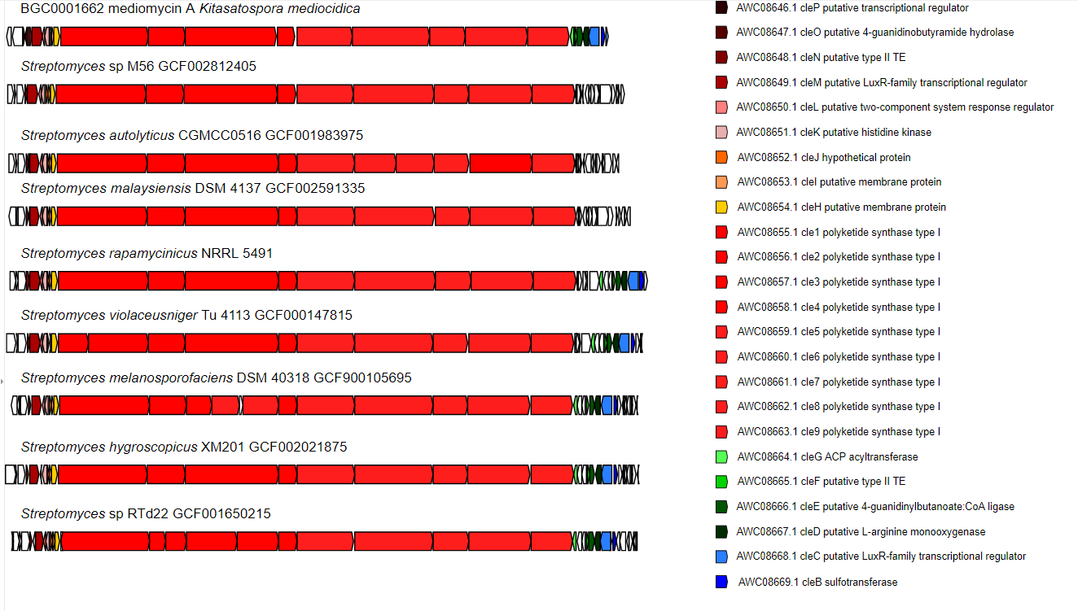
Figure S5 Distribution of Mediomycin BGC in streptomyces.

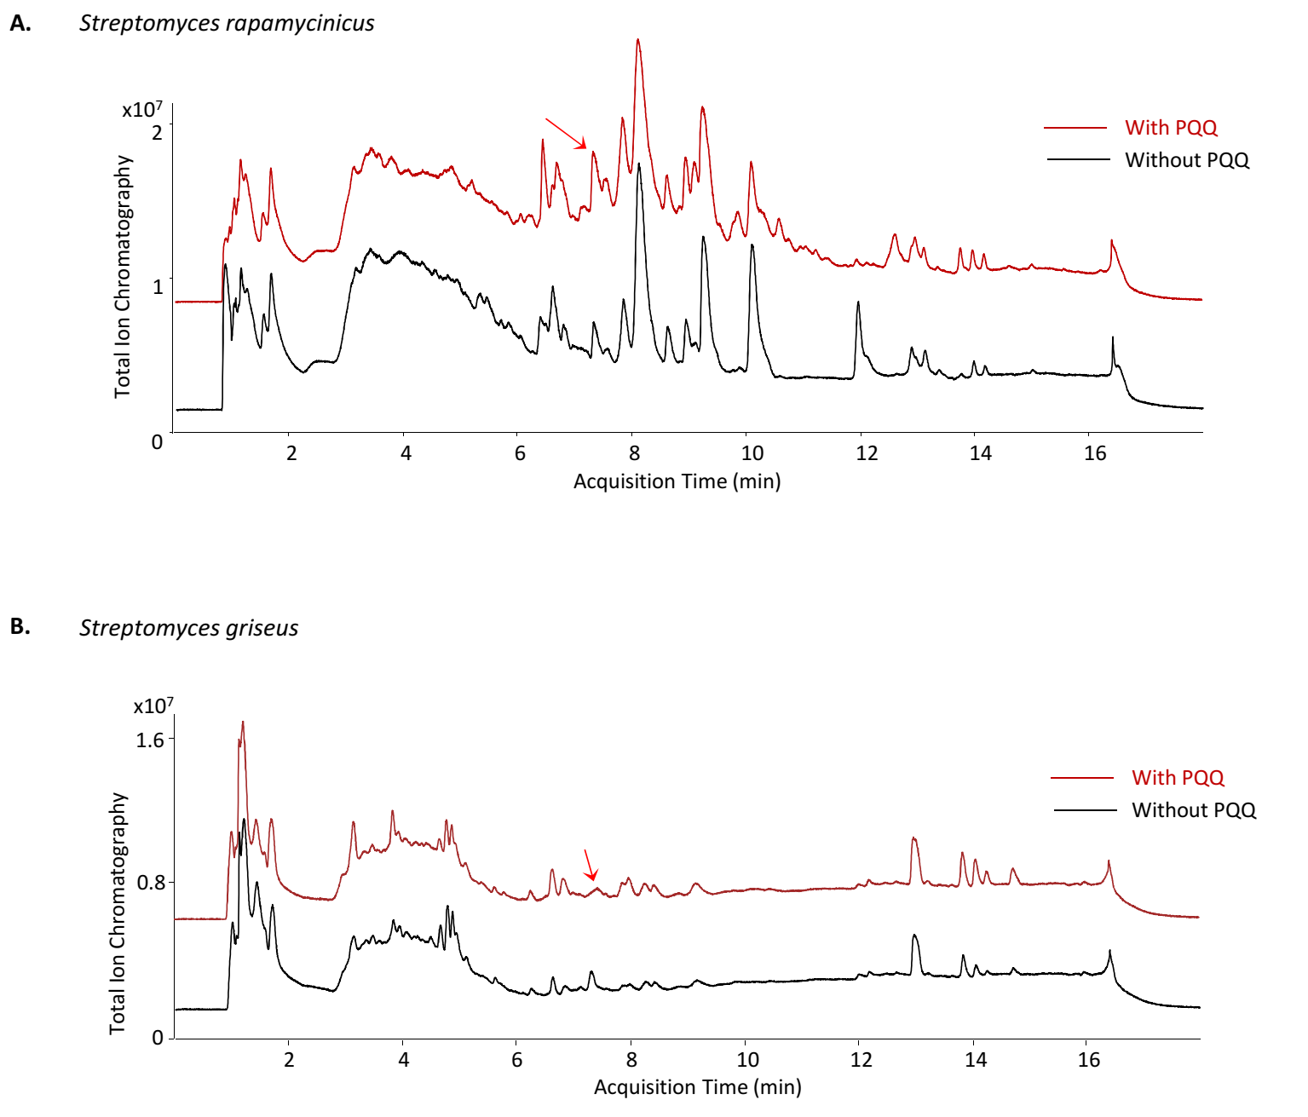
Figure S6 Total ion chromatography (TIC) changes revealed generation of new metabolites in S. rapamycinicus (A) and S. griseus (B).

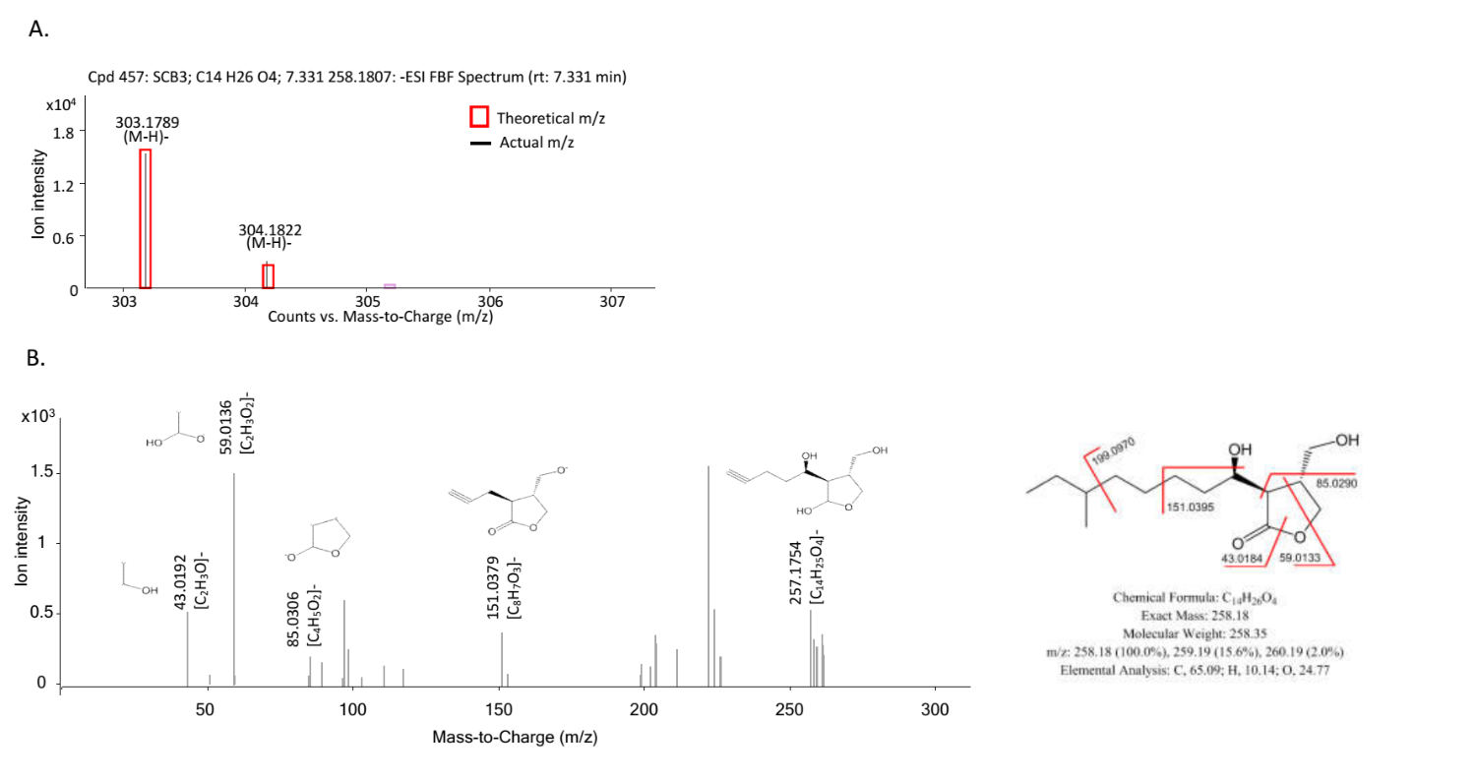
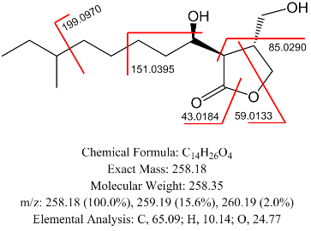
Figure S7 Structural prediction of SCB3 according to MS1 alignment with database (A) and MS 2 fragmentation (B).

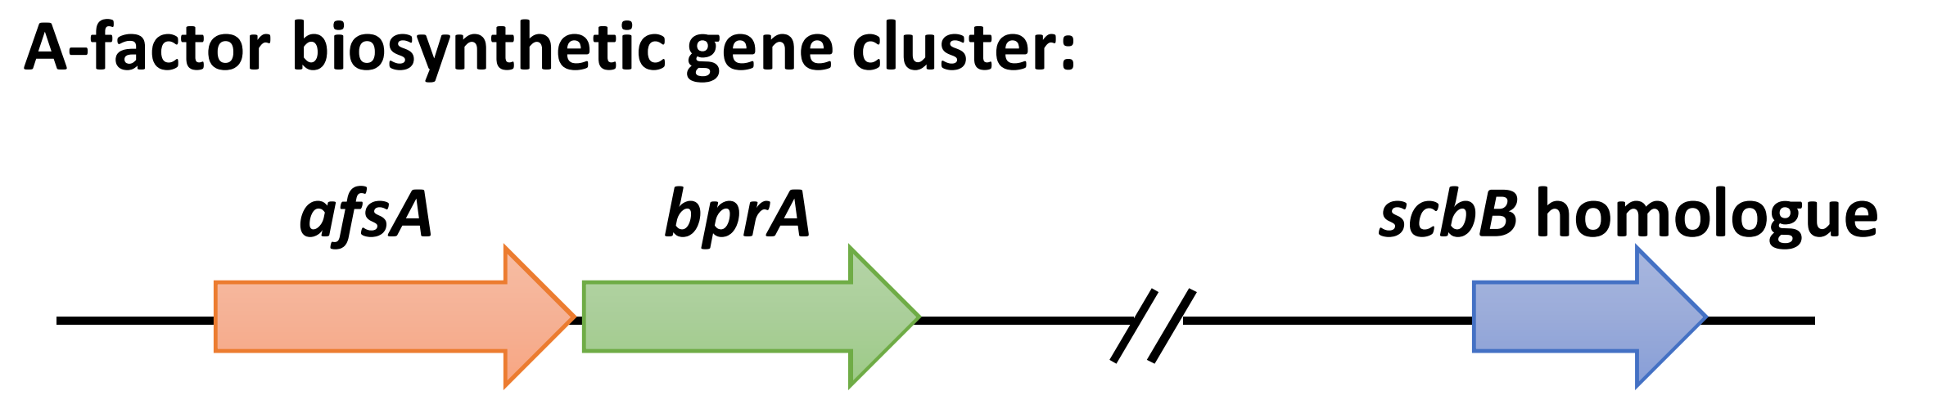
Figure S8 Proposed biosynthetic genes for SCB3-like molecule in S. griseus, including the biosynthetic genes cluster of A-factor and scbB homologue outside the cluster.

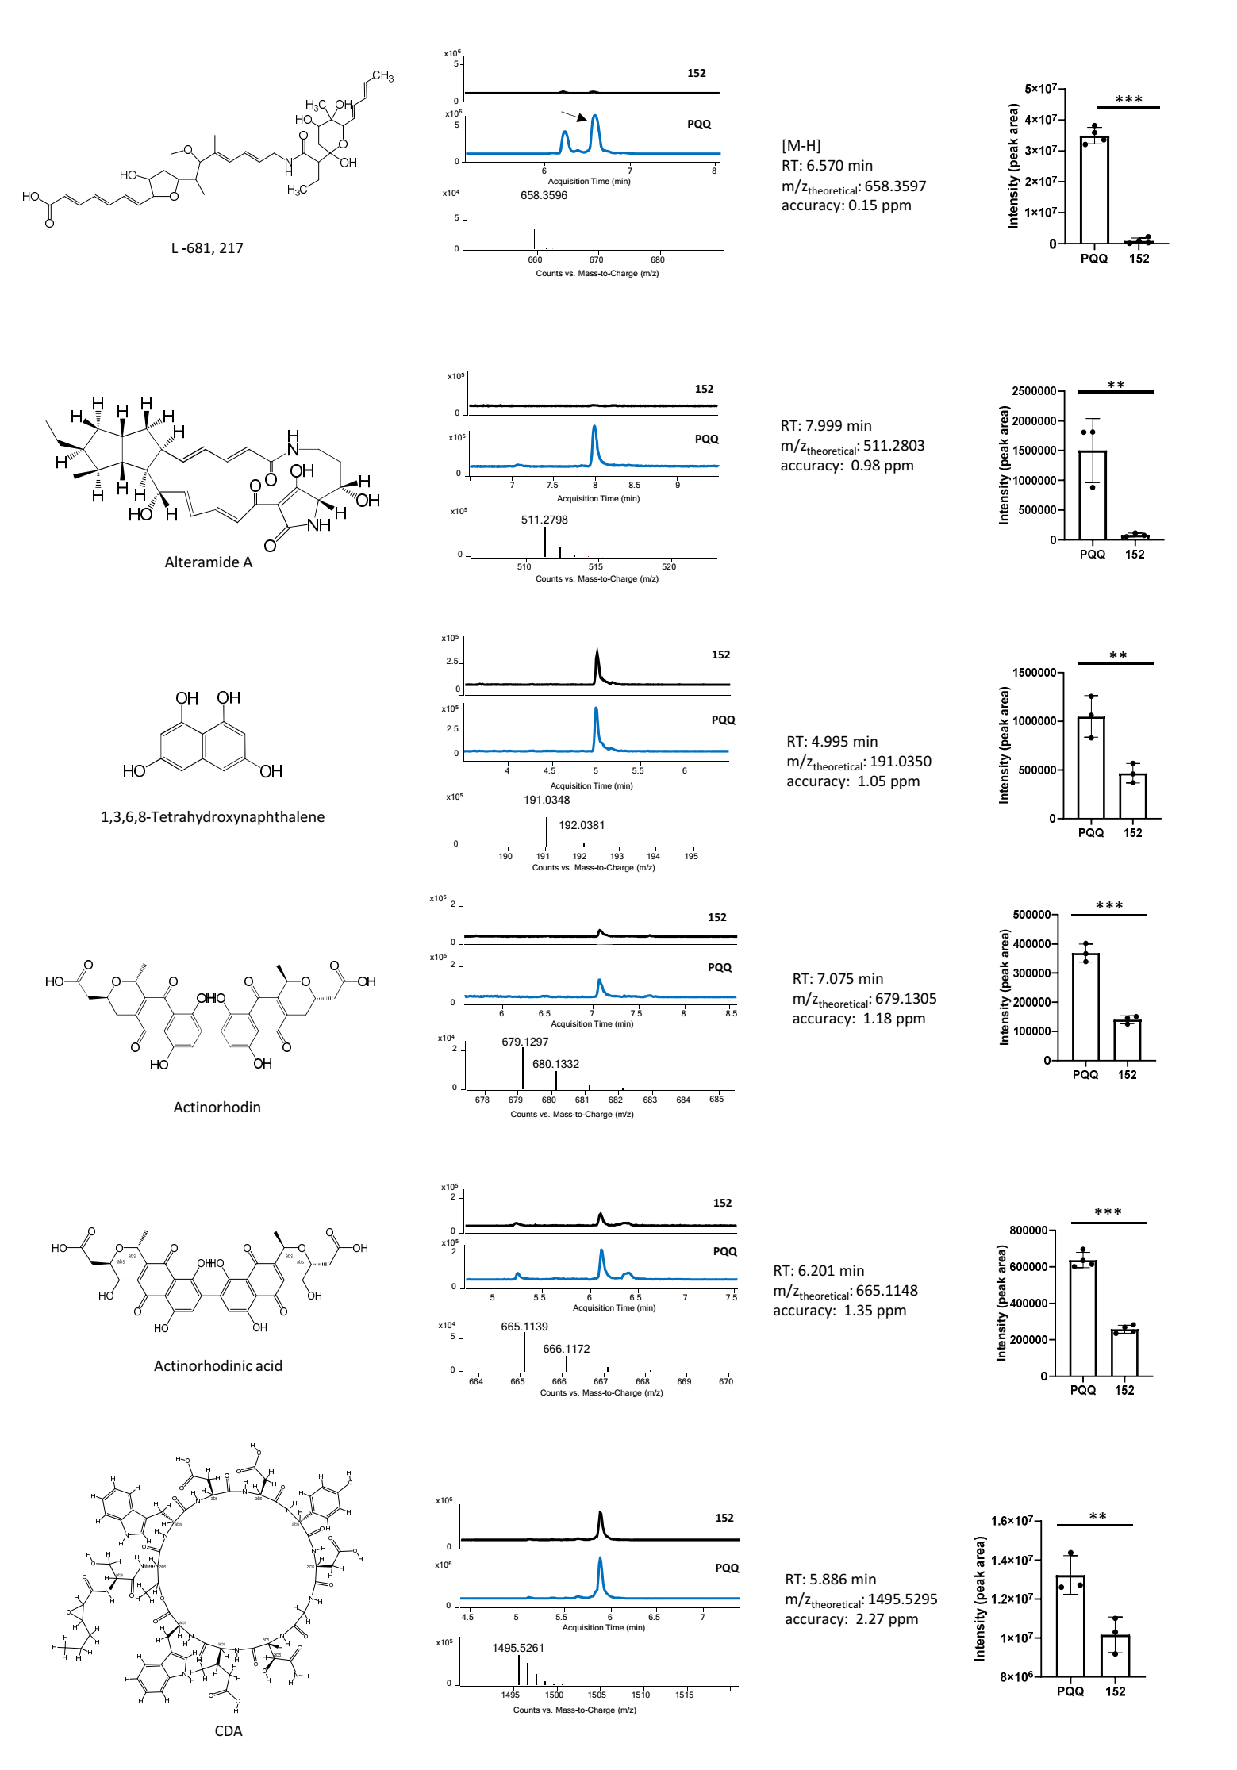
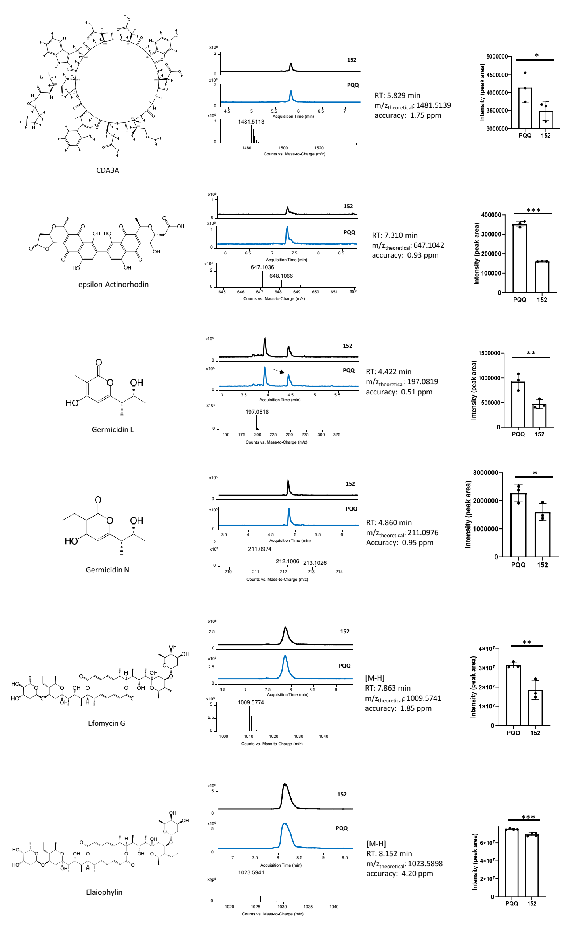
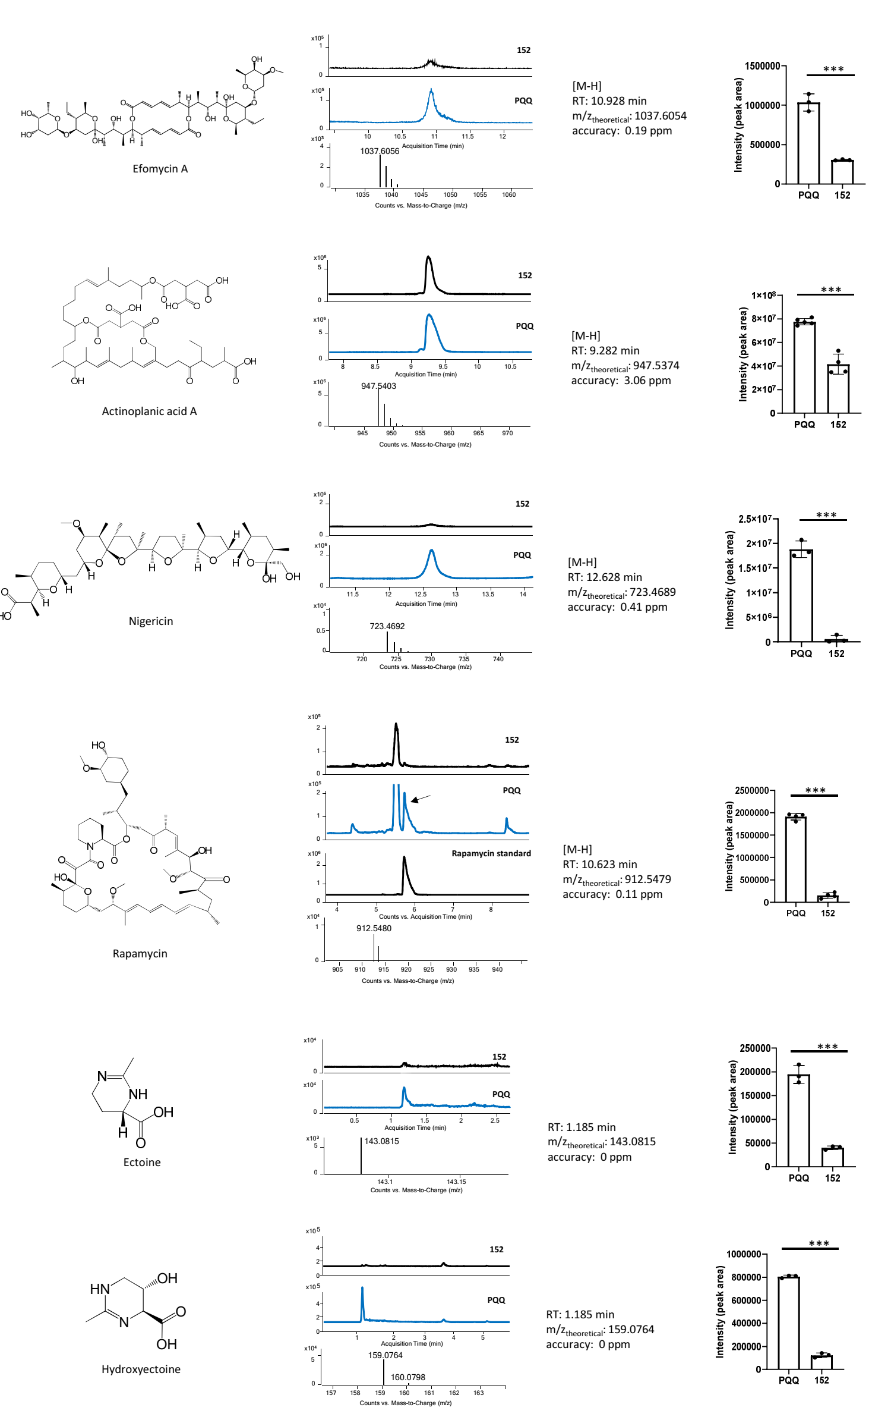

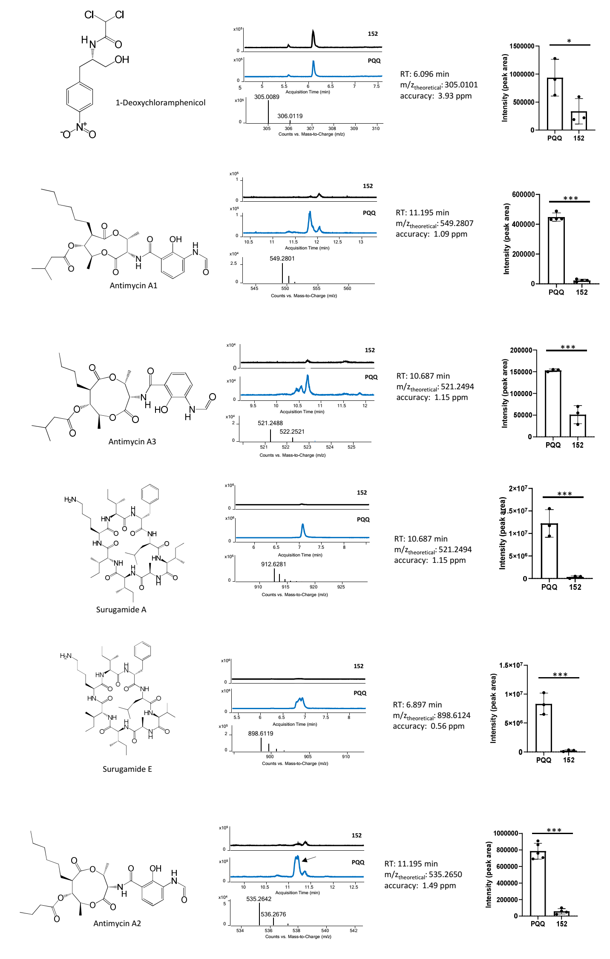

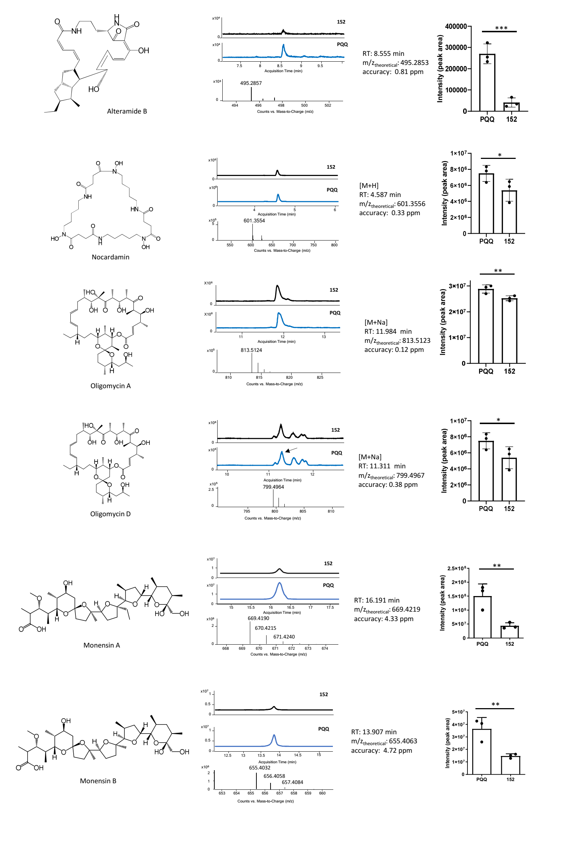

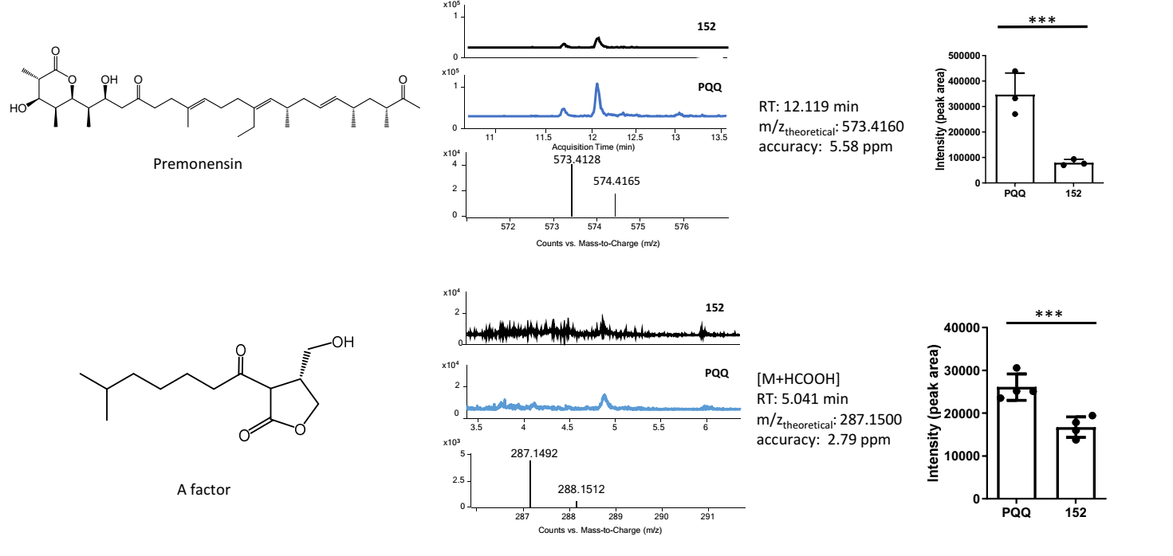
Figure S9 Detailed annotation information and yield changes of known natural products. For rapamycin, the elution program was modified for separation with the previous peak at 10.0 min, a standard with 10 mg/L of rapamycin was also analyzed for peak confirmation. For yield changes, ‘PQQ’ represents for strain with PQQ gene cluster, ‘152’ represents for strain without PQQ gene cluster. Mean with error bars showing s.d. is plotted (n = 3, at least three independent samples). Multiple comparison significance was tested to *p<0.1, **p < 0.05, ***p<0.01 by an unpaired two-sided Student’s t-test.

