Supplementary figures

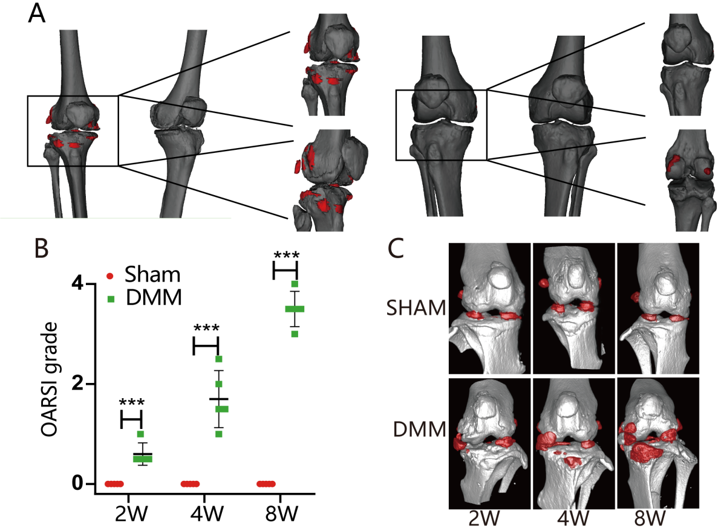
S1. A. Examination and assessment of knee osteoarthrosis in KOA patients and NC patients. B. Mice selected for execution at weeks 2, 4, and 8 after modeling were assessed for OA severity in the knee using OARSI. A blinded method was used to evaluate two sections of each mouse for OARSI scores. C. Micro CT imaging of a mouse knee joint at weeks 2, 4, and 8 after modeling with Mimics 5.0 indicating the presence of osteophytes as red.
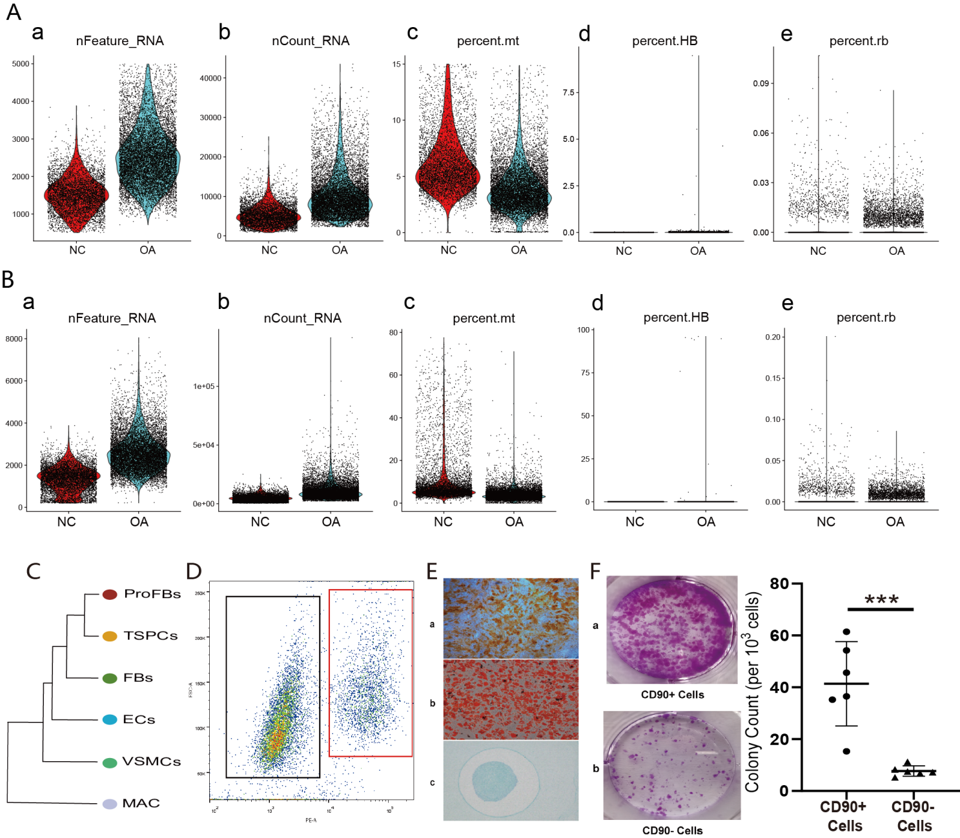
S2. Gene expression analysis of normal ACL- and OA-ACL-derived cells: A. pre-cell filtration and B. post-cell filtration. C. Phylogenetic relationships among the various subpopulations. D. Flow cytometry sorting results for TSPCs. E. Osteogenic, adipogenic, and chondrogenic trilinear differentiation of TSPCs. F. Demonstration of the clonogenic ability of TSPCs cells compared to other ACL cells.

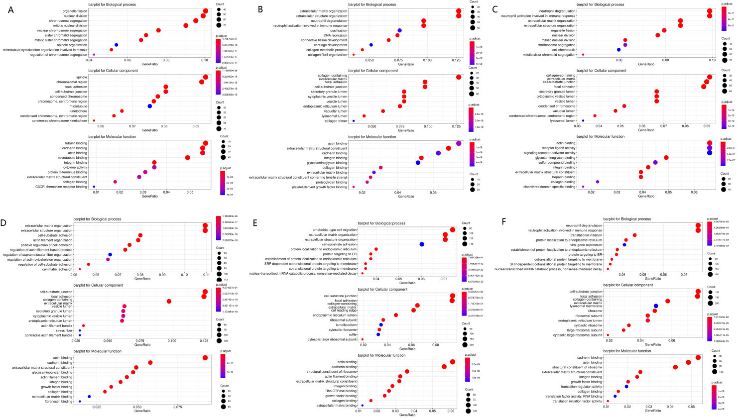

S3. GO analysis demonstrates the enrichment of gene expression in each subgroup, including TSPCs(A), ProFBs(B), FBs(C), VSMCs(D), ECs(E), and MAC (F).

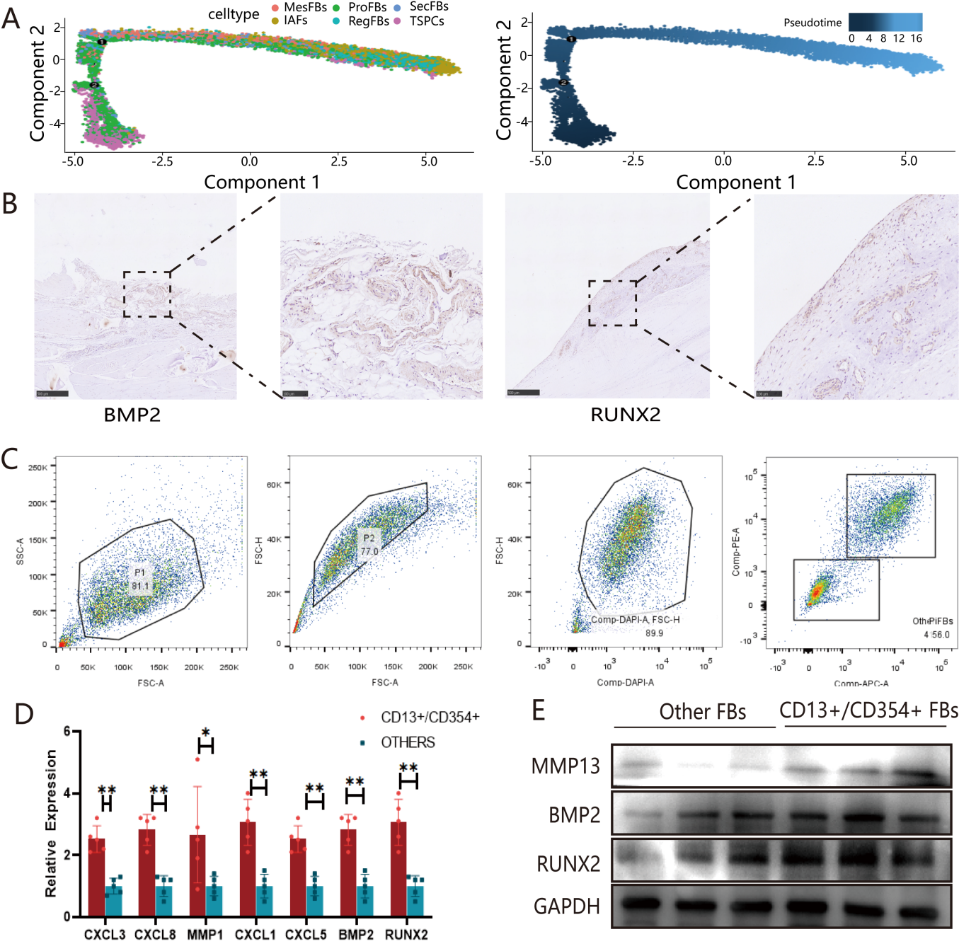
S4. Phenotype identification and gene expression validation of the IAF subpopulations. A. pseudotime analysis of the origin and differentiation of IAF cell subpopulations. B. Immunohistochemical staining showing the localization of IAFs presence in the ACL. C. Flow sorting demonstration of IAFs. D. qRT-PCR to detect gene expression differences between CD13+/CD354+ cells and other types of IAFs. E. Western blot to verify protein expression differences between the two subpopulations of IAFs.

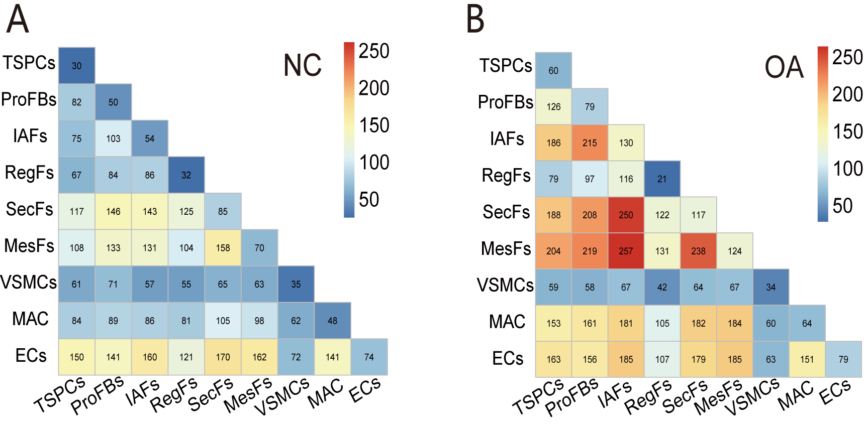
S5. A. Heat map of intercellular communication in normal ACL, which shows that TSPCs exhibit the most abundant interactions with other cells. B. Heat map of cellular communication in OA-ACL, which shows that IAFs exhibit the highest number of communications with other cells.

