Supplementary information
For the article

Socio-political cost of accelerating coal phase-out
Lola Nackeª, Vadim Vinichenkoª, Aleh Cherp^{b,c}, Avi Jakhmolaª, Jessica Jewell^{a,d,e}

Table of Contents
Supplementary Figures 1
Supplementary Tables 5
Supplementary Notes 12
Supplementary Note 1. Just Energy Transition Partnerships 12
Supplementary Note 2. Regression analysis 13
Supplementary Note 3. Calculating Value Added of coal power generation and coal mining 16
References 18

Supplementary Figures
Supplementary Figure 1. Methods. We use Vinichenko et al¹ to identify all countries with coal phase-out commitment which used coal for power production at the time of making such a commitment (43 countries). Out of these 43 countries, 21 also have a compensation scheme based on our systematic review and expert consultations (Methods). South Africa also receives international compensation through their JETP but does not have a coal phase-out commitment.
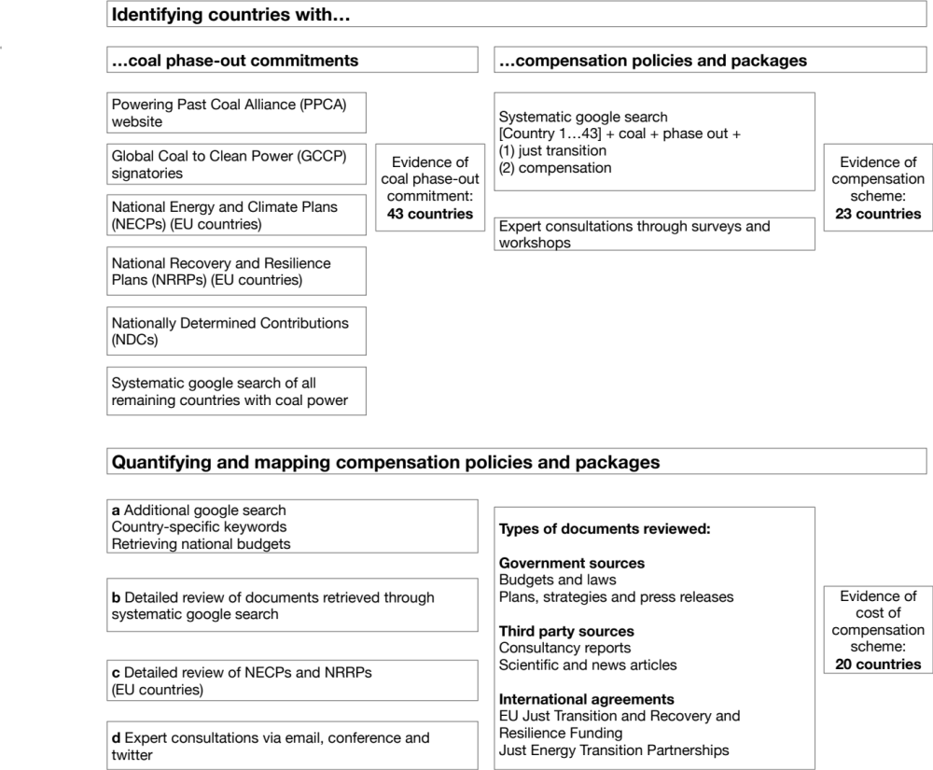
Supplementary Figure 2. Compensation cost per GW coal. Installed coal capacity at the time of the coal phase-out commitment from Ember². Cost of constructing one GW coal power in Europe compiled through a systematic google search (see Methods, Supplementary Table 4).
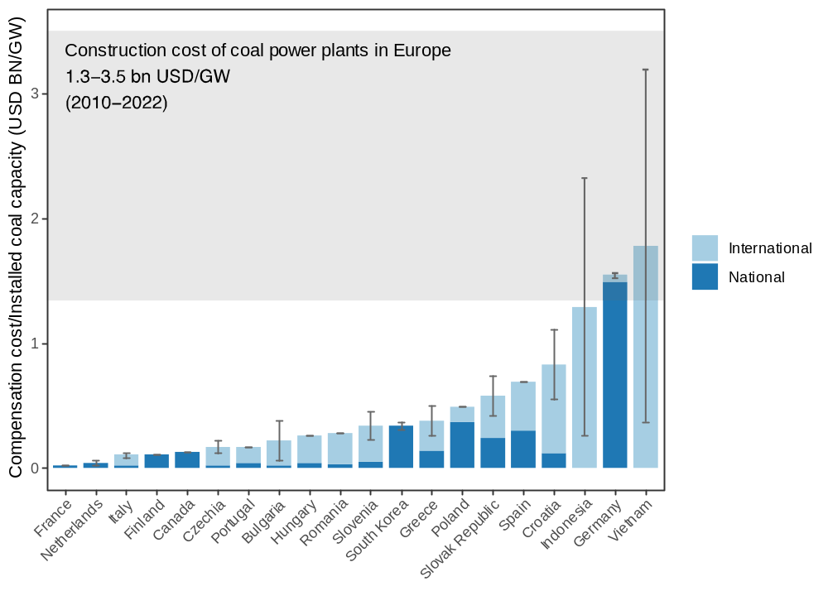
Supplementary Figure 3. Average annual compensation compared to coal production subsidies. Coal production subsidy data compiled from the OECD³ and from IISD⁴ respectively. In our main estimate we exclude investment in state-owned companies (also in Figure 3) since in contrast to compensation payments and other subsidies, governments expect a return to an investment. We could not identify subsidy data for Vietnam, Bulgaria, Croatia and Romania.
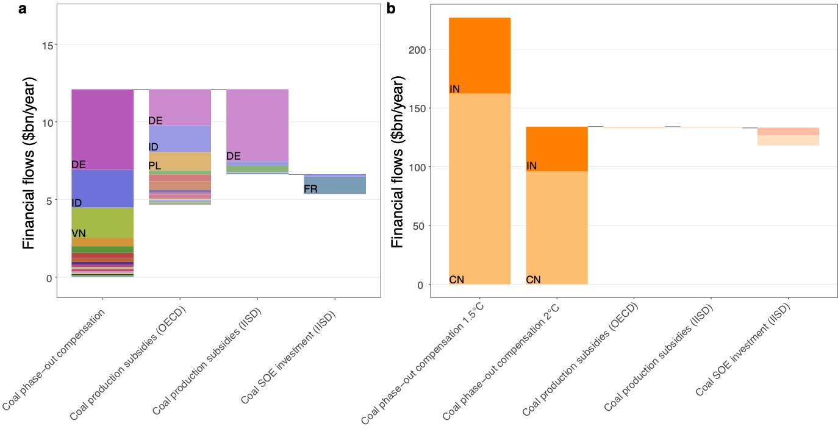

Supplementary Figure 4. Total compensation in international context. Compensation estimates represent our central estimate (Table 1, Supplementary Table 1, Methods). Projected financial flows for Official Development Assistance (ODA), coal production subsidies, and the COP climate pledge are calculated as the average between the minimum and maximum duration of coal phase-out. See (Supplementary Table 3 for a description of and sources for each financial flow).
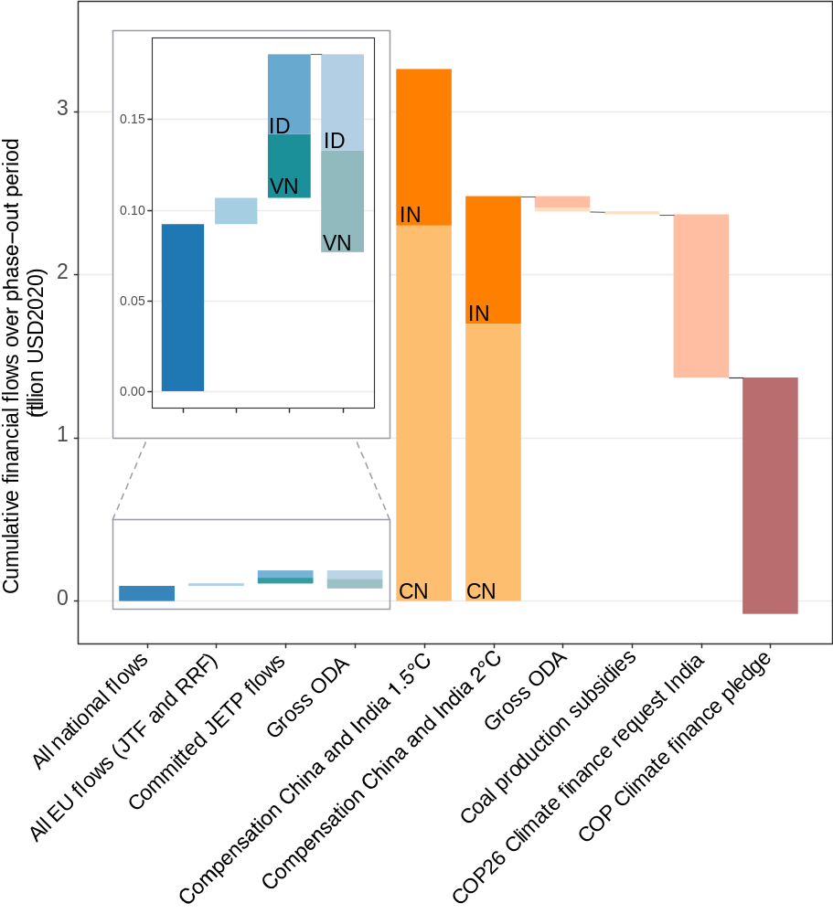

Supplementary Tables

Supplementary Table 1. Detailed compensation estimates and sources.
Country | Upper/lower estimate | Summary estimate (USD₂₀₂₀ mln) | Individual estimates  (USD₂₀₂₀ mln) | Beneficiary and purpose
Bulgaria | Lower estimate | 260 | 260 | Transfer to “design, build and commission infrastructure adequate for transmission of hydrogen and low-carbon gaseous fuels”. Pledge confirmed in Recovery and Resilience Facility.⁵
Bulgaria | Upper estimate | 1,480 | 1,480 | EU transfer to coal regions to support structural development. Dependent on approval of Territorial Just transition Plan^{6–8}.
Canada | Estimate | 1,200 | 30 | Transfer to coal regions, focusing on skills development and economic diversification. Pledge confirmed in national budget.⁹
Canada | Estimate | 1,200 | 110 | Transfer to coal regions, to invest in infrastructure. Pledge confirmed in national budget.⁹
Canada | Estimate | 1,200 | 2 | Transfer to coal regions to invest in clean energy and transmission/integration projects and to help territories to identify options to reduce reliance on coal-fired electricity. Allocation may also benefit non-coal regions.¹⁰
Canada | Estimate | 1,200 | 870 | Transfer to TransAlta, ATCO, and Capital Power, the major coal utilities in Alberta, for foregone profits. Regional phase-out in Alberta ahead of national phase-out¹¹.
Canada | Estimate | 1,200 | 4 | Transfer to municipalities, for economic diversification plans and feasibility studies. Regional phase-out in Alberta ahead of national phase-out.¹¹
Canada | Estimate | 1,200 | 30 | Transfer to laid-off workers. Regional phase-out in Alberta ahead of national phase-out.¹¹
Canada | Estimate | 1,200 | 150 | Transfer to help coal and indigenous communities adjust to coal phase-out. Regional phase-out in Alberta ahead of national phase-out.¹²
Croatia | Lower estimate | 110 | 90 | EU transfer to support regions negatively affected by climate transition measures¹³. The original eligibility analysis describes that one eligible region hosts a coal power plant⁷. Since the exact flows allocated to each region and purpose are not specified, we assume that half of the overall EU funding is directed at the coal phase-out as the lower estimate¹⁴.
Croatia | Lower estimate | 110 | 20 | Share of national co-financing to the EU JTF¹⁴.
Croatia | Upper estimate | 220 | 190 | Since the exact flows allocated to each region and purpose are not specified, we assume that all EU funding is directed at the coal phase-out as the upper estimate¹⁴.
Croatia | Upper estimate | 220 | 30 | Share of national co-financing to the EU JTF¹⁴.
Czechia | Lower estimate | 1,230 | 210 | Transfer to increase installed capacity of sources of photovoltaic energy. Pledge confirmed in Recovery and Resilience Facility.¹⁵
Czechia | Lower estimate | 1,230 | 70 | Transfer to modernize heat distribution. Pledge confirmed in Recovery and Resilience Facility.¹⁵
Czechia | Lower estimate | 1,230 | 810 | EU transfer to support regions negatively affected by climate transition measures^{16–18}. This includes three regions that host coal but also other carbon-intensive industries¹⁶. Since the exact flows allocated to each region and purpose are not specified, we assume that half of the overall EU funding is directed at the coal phase-out as the lower estimate.¹⁴
Czechia | Lower estimate | 1,230 | 140 | Share of national co-financing to the EU JTF¹⁴.
Czechia | Upper estimate | 1,890 | 1,600 | Since the exact flows allocated to each region and purpose are not specified, we assume that all EU funding is directed at the coal phase-out as the upper estimate^{14,16,18}.
Czechia | Upper estimate | 1,890 | 290 | Share of national co-financing to the EU JTF¹⁴.
Finland | Estimate | 280 | 180 | Transfer to companies for investments in alternatives to coal. Pledge from national budget.¹⁹
Finland | Estimate | 280 | 100 | Transfer to companies to promote renewables and improve energy efficiency. Pledge from government website.²⁰
France | Estimate | 80 | 30 | Transfer to support laid-off workers. Pledge confirmed in national budget²¹.
France | Estimate | 80 | 50 | Transfer to regions to support with the costs of coal plant closure. Pledge confirmed in coal phase-out plan.²¹
Germany | Lower estimate | 65,540 | 640 | Transfer to hard coal companies to compensation for closure of power plants (through auctions). Pledge confirmed in coal phase-out law²², lower estimate based on empirical data for first five auctions from²³.
Germany | Lower estimate | 65,540 | 2,000 | Transfer to Lausitz Energie Kraftwerk AG for costs of mine closures (negotiated amount of compensation). Pledge confirmed in coal phase-out law.²²
Germany | Lower estimate | 65,540 | 2,970 | Transfer to RWE AG for costs of mine closures (negotiated amount of compensation). Pledge confirmed in coal phase-out law. ²²
Germany | Lower estimate | 65,540 | 3,430 | Transfer to Combined Heat and Power (CHP) plant operators, to support coal alternatives. Pledge confirmed in coal phase-out law. ²²
Germany | Lower estimate | 65,540 | 5,710 | Transfer to laid-off workers. Pledge confirmed in coal phase-out law.²²
Germany | Lower estimate | 65,540 | 15,990 | Transfer to brown coal regions for structural development. Pledge confirmed in structural development law.²⁴
Germany | Lower estimate | 65,540 | 29,700 | Transfer to hard and brown coal regions for structural development Pledge confirmed in structural development law.²⁴
Germany | Lower estimate | 65,540 | 1,250 | Transfer to hard coal and former brown coal mining regions for structural development. Pledge confirmed in structural development law²⁴.
Germany | Lower estimate | 65,540 | 2,370 | EU transfer to support affected regions of the climate transition^{7,25}. This includes four regions affected by the coal phase-out²⁵. We exclude transfers to support the phase-out of an oil refinery¹⁴.
Germany | Lower estimate | 65,540 | 1,480 | Share of national co-financing to the EU JTF¹⁴.
Germany | Upper estimate | 2,280 | 2,280 | Transfer to hard coal companies to compensation for closure of power plants (through auctions). Pledge confirmed in coal phase-out law²², upper estimate based on maximum amount reported in non-governmental source²⁶.
Germany | Excluded |  |  | Potential future transfer to energy intensive industries to compensate for rising electricity costs due to the coal phase-out²². We were not able to retrieve the announced legislation (Förderrichtlinie) or estimate a specific amount of such compensation.
Greece | Lower estimate | 1,200 | 340 | National transfer to coal regions for investments in infrastructure. Pledge confirmed in national Just Transition Plan²⁷.
Greece | Lower estimate | 1,200 | 730 | EU transfer to support regions negatively affected by climate transition measures⁷. This includes two regions that host coal industries, as well as oil-powered plants²⁸. Since the exact flows allocated to each region and purpose are not specified, we assume that half of the overall EU funding is directed at the coal phase-out as the lower estimate.¹⁴
Greece | Lower estimate | 1,200 | 130 | Share of national co-financing to the EU JTF¹⁴.
Greece | Upper estimate | 1,960 | 230 | National transfer to coal regions for structural development. From non-governmental report, not confirmed in national budget, law or plan.²⁹
Greece | Upper estimate | 1,960 | 1,460 | Since the exact flows allocated to each region and purpose are not specified, we assume that all EU funding is directed at the coal phase-out as the upper estimate.^{14,28}
Greece | Upper estimate | 1,960 | 270 | Share of national co-financing to the EU JTF¹⁴.
Hungary | Estimate | 320 | 270 | EU transfer to support regions negatively affected by climate transition measures^{17,30}. Since the original eligibility analysis and the final allocation news release only mention coal, we assume all EU JTF funding is paid in relation to the coal phase-out^{7,14,30}.
Hungary | Estimate | 320 | 50 | Share of national co-financing to the EU JTF¹⁴.
Indonesia | Lower estimate | 9,100 | 9,100 | International transfer to Indonesia to support coal phase-out and decarbonization in line with just transition. Pledge confirmed in international agreement.³¹
Indonesia | Upper estimate | 78,900 | 78,900 | Own extrapolation of original pledge over the maximum duration of phase-out in line with the GCCP (2023-2049). Not confirmed in national documents (Methods, Supplementary Note 1).
Italy | Lower estimate | 870 | 740 | EU transfer to support regions negatively affected by climate transition measures^{7,32}. Since the news report documenting the final allocation describes that funding supports coal phase-out in the region of Sulcis Iglesiente, we include this funding in the lower estimate^{7,14,32}.
Italy | Lower estimate | 870 | 130 | Share of national co-financing to the EU JTF¹⁴.
Italy | Upper estimate | 1330 | 1130 | Since the original eligibility analysis mentions that the region of Taranto also hosts coal industry, we include this funding in the upper estimate^{7,14,32}.
Italy | Upper estimate | 1330 | 200 | Share of national co-financing to the EU JTF¹⁴.
Netherlands | Lower estimate | 60 | 60 | Transfer to Vattenfall to compensate for the early closure of the Hemweg plant. Confirmed in EU State Aid case. ³³
Netherlands | Upper estimate | 240 | 240 | Transfer to Riverstone to compensate for early closure of the Onyx power plant. Not confirmed in national documents.³⁴
Netherlands | Excluded | 3,350 | 2,230 | Transfer requested by RWE AG to compensate for early closure of power plants, but claim has been denied by The Hague District Court.³⁵
Netherlands | Excluded | 3,350 | 1,120 | Transfer requested by Uniper to compensate for early closure of power plants, but claim has been denied by The Hague District Court.³⁵
Poland | Estimate | 15,330 | 8,200 | Transfer to energy company EDM to cover costs of running and decommissioning coal plants. Confirmed in national coal phase-out plan.³⁶
Poland | Estimate | 15,330 | 1,280 | Transfer to company PGG for support of coal plant closure. Confirmed in national coal phase-out plan.³⁶
Poland | Estimate | 15,330 | 2,050 | Transfer to coal mining company SRK to compensate for costs of coal mine closure. Confirmed in EU State Aid case.³⁷
Poland | Estimate | 15,330 | -920 | Estimated gain from operation of coal power plants until closure. Confirmed in coal phase-out plan.³⁶
Poland | Estimate | 15,330 | 3,800 | EU transfer to support regions negatively affected by climate transition measures^{7,38}. Since the original eligibility analysis and the final allocation news release only mention coal, we assume all EU JTF funding is paid in relation to the coal phase-out.^{7,14,38}
Poland | Estimate | 15,330 | 920 | Share of national co-financing to the EU JTF¹⁴.
Portugal | Estimate | 260 | 180 | EU transfer to support regions negatively affected by climate transition measures^{7,39}. This includes two regions with coal-fired power plants, and one city with an oil refinery³⁹. We exclude funding to the oil refinery¹⁴.
Portugal | Estimate | 260 | 80 | Share of national co-financing to the EU JTF¹⁴.
Slovakia | Lower estimate | 460 | 110 | Transfer to coal mining company HBP to alleviate social and environmental consequences of coal mine closure. Confirmed in EU state aid cases.⁴⁰
Slovakia | Lower estimate | 460 | 250 | EU transfer to support regions negatively affected by climate transition measures^{7,41}. This includes one region that hosts coal industries, as well as regions that host chemicals and metals industries^{7,41}. Since the exact flows allocated to each region and purpose are not specified, we assume that half of the overall EU funding is directed at the coal phase-out as the lower estimate^{14,41}.
Slovakia | Lower estimate | 460 | 100 | Share of national co-financing to the EU JTF¹⁴.
Slovakia | Upper estimate | 690 | 490 | Since the exact flows allocated to each region and purpose are not specified, we assume that all EU funding is directed at the coal phase-out as the upper estimate^{14,41}.
Slovakia | Upper estimate | 690 | 200 | Share of national co-financing to the EU JTF¹⁴.
Slovenia | Lower estimate | 150 | 130 | EU transfer to support regions negatively affected by climate transition measures^{7,42}. This includes one region with an active coal industry, and one region with a former coal industry^{7,42}. Since the exact flows and their purposes are not specified, we assume that half of the overall EU funding is directed at the coal phase-out as the lower estimate¹⁴.
Slovenia | Lower estimate | 150 | 20 | Share of national co-financing to the EU JTF¹⁴.
Slovenia | Upper estimate | 320 | 270 | Since the exact flows and their purposes are not specified, we assume that all EU funding is directed at the coal phase-out as the upper estimate^{14,42}.
Slovenia | Upper estimate | 320 | 50 | Share of national co-financing to the EU JTF¹⁴.
Spain | Estimate | 2,130 | 170 | Transfer to regional governments to support environmental restoration of mining areas. Confirmed in national just transition plan. ^{43,44}
Spain | Estimate | 2,130 | 110 | Transfer to municipalities to support building of digital, social and environmental infrastructures. Confirmed in national just transition plan.⁴⁴
Spain | Estimate | 2,130 | 20 | Transfer to coal workers for professional training and support in finding employment. Confirmed in national just transition plan.⁴⁴
Spain | Estimate | 2,130 | 30 | Transfer to the energy city foundation to support alternative energy infrastructure (e.g. hydrogen). Confirmed in national just transition plan.⁴⁴
Spain | Estimate | 2,130 | 30 | Transfer to support business and small investment projects to generate employment in coal mining regions. Confirmed in national just transition plan.⁴⁴
Spain | Estimate | 2,130 | 10 | Transfers to local businesses affected by coal plant and mine closures. Confirmed in national just transition plan.⁴⁴
Spain | Estimate | 2,130 | 120 | Transfers to support economic recovery in coal mining regions. Confirmed in national just transition plan.⁴⁴
Spain | Estimate | 2,130 | 360 | Transfers to support renewable energy infrastructures in coal mining regions. Confirmed in national just transition plan.⁴⁴
Spain |  |  | 890 | EU transfer to support regions negatively affected by climate transition measures^{7,45}. Since the original eligibility analysis and the final allocation news release only mention coal, we assume all EU JTF funding is paid in relation to the coal phase-out^{14,45}.
Spain |  |  | 390 | Share of national co-financing to the EU JTF¹⁴.
Romania | Estimate | 1,550 | 500 | Transfer to companies in the coal and renewables sectors to support alternative energy infrastructures. Pledge confirmed in Recovery and Resilience Facility.⁴⁶
Romania | Estimate | 1,550 | 890 | EU transfer to support regions negatively affected by climate transition measures^{7,47}. In total, the EU JTF benefits six Romanian regions, out of which two regions host active coal mining. Here, we include funding to these two regions^{14,47}.
Romania | Estimate | 1,550 | 160 | Share of national co-financing to the EU JTF¹⁴.
South Korea | Lower estimate | 10,940 | 10,940 | Transfer to coal regions to support renewable energy infrastructure and create new jobs. Pledge confirmed in Korean New Deal to be paid from treasury.⁴⁸
South Korea | Upper estimate | 2,440 | 2,440 | Transfer to coal regions to support renewable energy infrastructure and create new jobs. Additional to pledge from treasury.⁴⁸
Vietnam | Lower estimate | 7,260 | 7,260 | International transfer to Vietnam to support coal phase-out and decarbonization in line with just transition. Pledge confirmed in international agreement.⁴⁹
Vietnam | Upper estimate | 62,930 | 62,930 | Own extrapolation of original pledge over the maximum duration of phase-out in line with the GCCP (2023-2049). Not confirmed in national documents. (Methods, Supplementary Note 1).

Supplementary Table 2. Overview of countries with coal phase-out commitments. Data on coal phase-out commitments is based on Vinichenko et al¹. Avoided emissions for countries with coal phase-out commitments have been calculated vis-a-visa a reference scenario under which cumulative emissions for all operating and planned power plants are retired at a nationally-specific average retirement age. *Countries which are included in the EU Just Transition Fund, but where we could not find evidence of national just transition plan or policy in relation to coal. See Supplementary Table 1 for compensation estimates and sources.
Country | Year of phase-out pledge | Type of pledge | Current (earlier) phase-out commitment | Number & (GWe) of operating coal | Avoided emissions  (Mt CO2) |  | Pledged compensation  (USD bln)
Countries with coal phase-out commitment and compensation policy
Germany | 2019 | PPCA | 2030 (2035-2038) | 172 (43) | 1489 (1207-1770) |  | 66.4 (65.5-67.2)
Viet Nam | 2021 | GCCP | 2040s | 64 (19.7) | 542 (191-1234) |  | 35.1 (7.3-62.9)
South Korea | 2021 | GCCP | 2050 | 104 (35.7) | 540 |  | 12.2 (10.9-13.4)
Indonesia | 2021 | GCCP | 2040s | 268 (34) | 509 (179-1227) |  | 44 (9.1-78.9)
Italy | 2017 | PPCA | 2025 | 34 (10.5) | 468 |  | 1.1 (0.9-1.3)
Czechia | 2022 | National | 2033 | 182 (10) | 447 |  | 1.7 (1.2-2.2)
Chile | 2021 | PPCA | 2040 or earlier | 25 (5) | 390 (262-517) |  | NA
Poland | 2021 | GCCP | 2049 | 292 (31.3) | 389 |  | 15.3
Netherlands | 2017 | PPCA | 2029 (2030) | 6 (4.8) | 346 |  | 0.18 (0.06-0.29)
Greece | 2019 | PPCA | 2028 (2023) | 16 (4.6) | 148 (121-176) |  | 1.8 (1.2-2.3)
Canada | 2017 | PPCA | 2030 | 33 (9.1) | 143 |  | 1.2
Slovenia | 2021 | PPCA | 2033 | 6 (0.7) | 80 |  | 0.24 (0.16-0.32)
France | 2017 | PPCA | 2022 | 51 (3.3) | 57 |  | 0.1
Bulgaria | 2021 | EU | 2038 or earlier | 38 (4.6) | 50 (45-55) |  | 1 (0.26-1.74)
Ukraine | 2021 | PPCA | 2040 or earlier | 125 (24.7) | 44 (36-52) |  | NA
North Macedonia | 2021 | PPCA | 2030 | 3 (0.7) | 29 |  | NA
Slovakia | 2019 | PPCA | 2025 | 32 (1.1) | 28 |  | 0.6 (0.5-0.8)
Finland | 2017 | PPCA | mid-2029 (2030) | 20 (2.6) | 26 |  | 0.28
Portugal | 2017 | PPCA | 2021 (2030) | 6 (1.9) | 26 |  | 0.3
Spain | 2021 | PPCA | 2030 or earlier | 14 (3.1) | 15 |  | 2.1
Croatia | 2021 | PPCA | 2033 or earlier | 3 (0.2) | 15 |  | 0.17 (0.11-0.22)
Romania | 2021 | EU | 2032 | 29 (5.5) | 9 |  | 1.6
Hungary | 2021 | PPCA | 2029 | 13 (1.2) | 0.1 |  | 0.3
Total | - | - | - | 1536 (258) | 5790 (4660-7650) |  | 186 (118-253)
Countries with coal phase-out commitments and no compensation policy
Israel | 2018 | PPCA | 2025 (2030) | 13 (4.9) | 169
Philippines | 2021 | GCCP | 2040s | 64 (10.6) | 158
Kazakhstan | 2021 | GCCP | 2050 | 124 (12.2) | 109
United Kingdom | 2017 | PPCA | 2024 (2025) | 45 (15.3) | 45
Panama | 2021 | National | 2023 | 5 (0.4) | 45
Ireland | 2018 | PPCA | 2025 | 3 (0.9) | 30
Mauritius | 2021 | PPCA | 2030 | 5 (0.2) | 22
Denmark | 2017 | PPCA | 2028-2030 (2030) | 9 (2.5) | 18
Senegal | 2018 | PPCA | No phase-out plan (2050) | 3 (0.2) | 18
Sri Lanka | 2021 | GCCP | 2040s | 3 (0.9) | 13
Peru | 2020 | PPCA | 2022 | 1 (0.1) | 10
Sweden | 2017 | PPCA | 2020 (2022) | 3 (0.1) | 8
Brunei Darussalam | 2021 | GCCP | 2040s | 4 (0.2) | 5
Austria | 2017 | PPCA | 2020 (2022) | 9 (0.8) | 4
Zambia | 2021 | GCCP | 2040s | 3 (0.3) | 3
New Zealand | 2017 | PPCA | 2030 | 9 (0.5) | 0.1
Montenegro | 2021 | PPCA | 2035 | 1 (0.2) | 0
Botswana | 2021 | GCCP | 2040s | 9 (0.8) | 0
Myanmar | 2021 | NDC | 2050 | 5 (0.2) | 0
Singapore | 2021 | PPCA | 2050 | 2 (0.1) | 0
Total | - | - | - | 320 (51) | 657 |  | -
Countries with coal phase-out pledge but no coal power: Albania, Angola, Azerbaijan, Belgium, Costa Rica, Côte d'Ivoire, Cyprus, El Salvador, Egypt, Estonia, Ethiopia, Fiji, Latvia, Lithuania, Lichtenstein, Luxembourg, Maldives, Marshall Islands, Mauritania, Niue, Nepal, Somalia, Switzerland, Tuvalu, Uruguay, Vanuatu

Supplementary Table 3. Detailed annual and cumulative compensation flows. In order to compare different financial flows, we calculate the annual amount implied by each compensation package and the cumulative amounts implied by relevant financial flows. Purely empirical data are shown in plain text, calculated amounts in italics.
Financial flow |  | Annual amount  ($billion/year) | Cumulative amount  ($billion) | Notes
Compensation plans
All national flows |  | 6.4  (4.7-8) | 92  (89-95) | Cumulative amount compiled from policy documents and other reports (see Supplementary Table 1 for all references).  Annual amount calculated over the number of years between the coal phase-out commitment and the pledged coal phase-out date.
All EU flows  (JTF and RRF) |  | 1.1  (1-1.7) | 14  (13-16) | Cumulative amount compiled from policy documents and other reports (see Supplementary Table 1 for all references).  Annual amount calculated over the number of years between the coal phase-out commitment and the pledged coal phase-out date.
JETP flows | South Africa | 2.3  (1.7-2.8) | NA | Currently pledged annual flows retrieved from JETPs with South Africa⁵⁰, Vietnam⁴⁹ and Indonesia³¹ respectively.  Cumulative amount calculated by extrapolating currently pledged JETP flows until the latest coal phase-out date (2049) under the GCCP. The central estimate is the mean of that which is already pledged (shown in bold) and our maximum estimate (see also Supplementary Note 1). Extrapolation is not possible for South Africa which does not have an explicit coal phase-out commitment.
JETP flows | Vietnam | 2.1  (1.5-2.4) | 35  (7-63)
JETP flows | Indonesia | 2.7  (1.8-3) | 44  (9-79)
Projected compensation for India and China in line with climate targets
Compensation 1.5℃ | China | 184  (89-326) | 2,300  (1,700-2,600) | Compensation estimates in line with 1.5℃ scenarios. Total amount calculated by applying our best performing regression models to avoided emissions under IPCC AR6 scenarios and calculating the central estimate as the median out of all estimates.  Annual amount calculated by dividing total compensation by the amount of years between 2022 and the coal phase-out for each scenario, and calculating the central estimate as the median out of all estimates. (See Methods).
Compensation 1.5℃ | India | 65  (40-82) | 1,000  (800-1,100)
Compensation 2℃ | China | 106  (63-155) | 1,700  (1,500-2,200)
Compensation 2℃ | India | 38  (26-50) | 800  (600-900)
Existing financial flows to understand level of compensation plans and projections
Gross ODA | Indonesia | 2.5  (1.4-3.3) | 59  (47-70) | Annual gross ODA compiled from OECD.⁵¹  Cumulative gross ODA for Indonesia and Vietnam calculated by extrapolating historical ODA flows until the earliest and latest coal phase-out dates (2040-2049) under the GCCP respectively and calculating the central estimate as the mean (see also Supplementary Note 1). Extrapolation is not possible for South Africa which does not have an explicit coal phase-out commitment. For China and India, ODA is extrapolated over the amount of years between 2022 and the coal phase-out for each scenario, and calculating the central estimate as the median out of all estimates.
Gross ODA | Vietnam | 2.6  (1.4-3.8) | 61  (49-73)
Gross ODA | South Africa | 1.3  (0.8-1.7) | NA
Gross ODA | India | 4.1  (3.4-4.9) | 78  (64-87)
Gross ODA | China | 1.6  (1.2-2.8) | 25  (17-33)
Coal production subsidies | India | 0.1  (0.08-0.2) | 2  (2-3) | Annual coal production subsidies compiled from the OECD³ for Figure 3. Same approach applied to data from IISD⁴ in Supplementary Figure 3.  Cumulative subsidies are extrapolated over the amount of years between 2022 and the coal phase-out for each scenario, and calculating the central estimate as the median out of all estimates.
Coal production subsidies | China | 1.1  (0.01-2) | 16  (8-24)
COP26 Climate finance request | India | 56.1  (45.5-66.7) | 1,000 | Total climate finance of request $1 trillion by India’s prime minister at COP26.⁵² Annual amount is calculated by dividing the request by the median duration of coal phase-out in line with 1.5°C and 2°C consistent pathways (see Methods).
COP Climate finance pledge |  | 100 | 1,450  (700-2,200) | Annual COP Climate finance pledge to all developing countries retrieved from OECD report ⁵³. Cumulative amount is calculated by extrapolating the pledge ($1 billion per year) over the earliest coal phase-out scenario under 1.5°C consistent pathways for India and China (phase-out by 2030) for the lower estimate, and over the latest phase-out scenario under 2°C consistent pathways (phase-out by 2045) for the upper estimate and calculating the central estimate as the mean.

Supplementary Table 4. Construction cost of new coal plants. We retrieve a list of coal power plants built in European countries between 2010 and 2022 from the S&P World Electric Power Plants database⁵⁴ and then conduct a systematic google search to retrieve costs of building these power plants (see Methods). Currencies differ depending on the respective source. We convert values to USD using the average annual exchange rate for the year in which each report was published, which we retrieve from the OECD⁵⁵.
Country | Name of power plant  (Year of construction) | MW capacity | Cost  (USD2020 bln)
Bulgaria | AES Galabovo (2011) | 670 | USD 1.7bn⁵⁶
Czechia | Prunerov (2016) | 750 | USD 1.3bn⁵⁷
Czechia | Kladno (2014) | 135 | NA
Czechia | Ledvice (2020) | 660 | USD 2.3bn⁵⁸
Germany | Boxberg (2012) | 675 | USD 1bn⁵⁹
Germany | Datteln (2020) | 1100 | USD 1.7bn⁶⁰
Germany | GKM (2015) | 911 | USD 1.7bn⁶¹
Germany | Lunen-4 (2013) | 800 | USD 1.9bn⁶²
Germany | Moorburg (2015) | 1730 | USD 3.3bn⁶³
Germany | Neurath (2012) | 2240 | USD 4.7bn⁶⁴
Germany | RDK (Karlsruhe) (2014) | 912 | USD 2bn⁶⁵
Germany | Walsum-10 (2013) | 790 | USD 1.5bn⁶⁶
Germany | Westfalen (2014) | 820 | USD 1.1bn⁶⁷
Germany | Wilhelmshaven-C (2015) | 800 | USD 1.8bn⁶⁸
Italy | Torrevaldaliga Nord (2010) | 1320 | NA
Netherlands | Centrale Rotterdam (2014) | 800 | NA
Netherlands | Eemshaven (2015) | 1600 | USD 3.4bn⁶⁹
Netherlands | Maasvlakte (2016) | 1116 | USD 1.9bn⁷⁰
Poland | Belchatow (2011) | 858 | USD 2.4bn⁷¹
Poland | Jawrozno-III (2020) | 910 | USD 1.8bn⁷²
Poland | Opole (2019) | 1800 | USD 3.6bn⁷³
Poland | Turow (2021) | 496 | USD 1.1bn⁷⁴
Slovenia | Sostanj 6 (2015) | 600 | USD 1.6bn⁷⁵

Supplementary Notes

Just Energy Transition Partnerships
Just Energy Transition Partnerships (JETPs) are a new mechanism to support coal-dependent countries in decarbonisation and climate mitigation^{76,77}. The first JETP was established at COP26 between France, Germany, the United Kingdom, the United States, and the European Union as donors, and South Africa as recipient^{50,78}. Since then, JETPs have also been established with Vietnam and Indonesia as recipients, and an expanded group of donor countries (known as the International Partners Group which now also includes Denmark, Italy, Canada, Japan and Norway^{31,49}). Just Energy Transition Partnerships are also in discussion with Senegal and India^{77,79}.
Each JETP pledges a certain amount of funding (currently between USD8.5 bn - USD20 bn respectively over 3 to 5 years) and administrative and technical assistance^{31,49,50}. Usually, half of these funds are provided by donor countries, and the other half is mobilized from private finance, for example from the “Glasgow Financial Alliance for Net Zero” - a working group including several large banks (for example Bank of America, Deutsche Bank, HSBC)^{31,49,50}. In our analysis, we only include compensation to be paid by donor countries (see Methods).
Recipient countries of JETPs lead the development of a transition plan, to be endorsed by donor countries and ensure the constructive use of funds⁷⁷. Conditional upon the plan being endorsed and followed, the JETPs provide opportunities for further financial flows to support decarbonisation in the longer term^{31,49,50}. For example, the JETP for considers “policy reforms aimed at facilitating great levels of investment”³¹ (Table 2 in the main text). Given that the vision of JETPs is to be renewed and extended, we estimate an upper boundary for compensation by extrapolating currently pledged annual transfer rates until the latest possible date of coal phase-out (2049) for both Indonesia and Vietnam. For South Africa, such an extrapolation is not possible because there is no phase-out date specified. The central estimate we report is the average between already-committed funding and our upper estimate.
The JETPs also includes estimates of emission reductions compared to the countries’ current pathways to be achieved through the partnerships. The JETP for Vietnam envisions a “cumulative reduction of around 200 megatons of greenhouse gas emissions by 2030, and a further 300 megatons by 2035”⁴⁹ – roughly comparable to our median estimate of avoided emissions of coal phase-out. The JETP for Indonesia foresees a “cumulative reduction of more than 300 megatons in greenhouse gas emissions through 2030 and a reduction of well above 2 gigatons through 2060 from Indonesia's current trajectory”³¹. This is roughly in the same order of magnitude as our estimates for avoided emissions from coal phase-out (Supplementary Table 2). The JETP for South Africa “is expected to prevent up to 1-1.5 gigatons of emissions over the next 20 years”⁵⁰ though there so far there is no definite coal phase-out plan or commitment.

Regression analysis
Variable selection and mechanisms
To better understand the variation between coal phase-out compensation paid in different countries, we conduct a multiple variable regression analysis. We select variables based on different mechanisms that may plausibly affect compensation for coal phase-out. Compensation is paid to those actors that are negatively affected by coal phase-out decision to address resistance and enhance the feasibility of coal phase-out as well as to make transitions more just and equitable^{80–82}.
Resistance to coal phase-out which can arise due to the premature retirement of infrastructure such as power plants, for which investors and companies would otherwise have retained further profits leads to coal lock-in. This resistance is likely to be stronger in the case of a stronger coal sector with the presence of domestic mining and more ambitious national pledges which lead to higher stranded capacity^{83,84}. Resistance is also likely to be affected by whether there is also domestic coal mining in a country as evidenced by the fact that in several countries, such as Spain, Poland and Germany, workers and companies associated with the coal mining industry protested against coal phase-out^{85–87} .
Government capacity to overcome resistance against coal phase-out and the overall national context is also likely to affect the amount of compensation paid. Government capacity includes the extent to which governments are able to formulate and implement certain policies. Those with more accountability, and thus higher levels of democracy, are likely better able to balance interests of the broader public, rather than responding to certain vested interests (such as the coal industry). We expect that states with higher levels of accountability are less captured by vested interests and thus have lower compensation. Scholars typically operationalize this through examining the presence of free and fair elections, existence of an independent media, freedom of opinion⁸⁸. Additionally, governments with higher economic capacity are likely to be able to bear the costs of policy measures and in the case of coal-phase to mobilize funds for compensation policies. This may be captured by the size of a country’s economy as larger countries simply have more resources (measured by GDP) or GDP per capita, however the latter correlates with the strength of democracy so it may be difficult to disentangle the interplay between accountability and economic capacity embedded in GDP/capita.
Based on these mechanisms, we identify the following eight variables which may affect coal phase-out compensation:

Ambition of national coal phase-out and characteristics of coal sector:

- Higher avoided emissions of the coal phase-out is expected to be associated with higher compensation, because it indicates that younger coal power plants are retired, which indicates larger stranded assets and thus more resistance to coal phase-out.
- A large coal power plant fleet is expected to be associated with higher compensation cost due to the larger the amount of infrastructure that needs to be retired, and the resistance of actors dependent on this infrastructure (plant workers and owners, and regions where power plants are centered).
- Higher generation of coal power is expected to be associated with higher compensation, since it is associated with the strength of the coal industry and replacing more coal power requires stronger (financial) effort.
- Higher levels of domestic coal mining is expected to be associated with higher compensation, because domestic coal is important for national energy security and is likely to induce resistance from actors dependent on this industry (mining workers and companies as well as regions rich in coal reserves).
- Higher value added (VA) of coal power and mining is expected to be associated with higher compensation, because it indicates the role of the coal industry for national economic development, and is thus also associated with the strength of the coal industry.
Coal sector and national pledge variables:
- Higher GDP is expected to be associated with higher compensation, because larger economies are more likely to mobilize larger funds for compensation.
- Stronger democracy is expected to be associated with lower compensation. We use the variable Polyarchy from the Electoral Democracy Index from V-Dem⁸⁸. This Index captures the extent to which governments are responsive to their citizens, by combining measures of the fairness of elections, the freedom of association and expression, the extensiveness of suffrage and the effect elections have on the composition of a country’s chief electorate. Governments that are more responsive to an extensive electorate are less likely to prioritise the interests of a small group of constituents over the interest of the larger electorate (the taxpayers).
- Higher GDP per capita (PPP) is expected to be associated with higher compensation because it indicates the wealth of a country and wellbeing of its citizens. However, GDP per capita also correlates with the level of democracy, which is expected to decrease the amount of compensation paid. GDP per capita may thus conflate two conflicting mechanisms.
There are additional variables that cand indicate mechanisms operating within complex socio-political systems and can affect the amount of compensation governments pay for coal phase-out. However, many of these variables are not suitable for systematic comparison across countries. For example, the coal workers (measured by the number of workers in the coal power and mining industry) could indicate the extent to which coal phase-out may lead to employment losses which may need to be addressed by a national government. It may also help capture varying levels of automatization of the coal industry in different countries. However, there is no comparable data coverage of all countries included in our study. While some countries capture both the number of coal power and coal mining workers, others only capture one of these industries. Some countries account for both direct and indirect employees in the same metric, while others cover both separately or only one of the two measures. We thus exclude this variable based on a lack of data coverage. Another potential variable is public opposition to coal, however again there is no comparable systematic data on such opposition.
Regression analysis and results
Because we have a small number of cases (15 countries), we test models with a maximum of three independent variables. We first test collinearity between the variables (see Supplementary Figure 5) and exclude any combination of variables with a collinearity larger than 0.7. This means that we exclude the following combinations of variables:
- Size of the coal power plant fleet and Avoided emissions
- Size of the coal power plant fleet and Coal power generation
- Size of the coal power plant fleet and VA of coal
- Amount of domestic coal mining and VA of coal
- Coal power generation and Avoided emissions
- Coal power generation and VA of coal
- Avoided emissions and VA of coal

Supplementary Figure 5. Regression correlation plot.
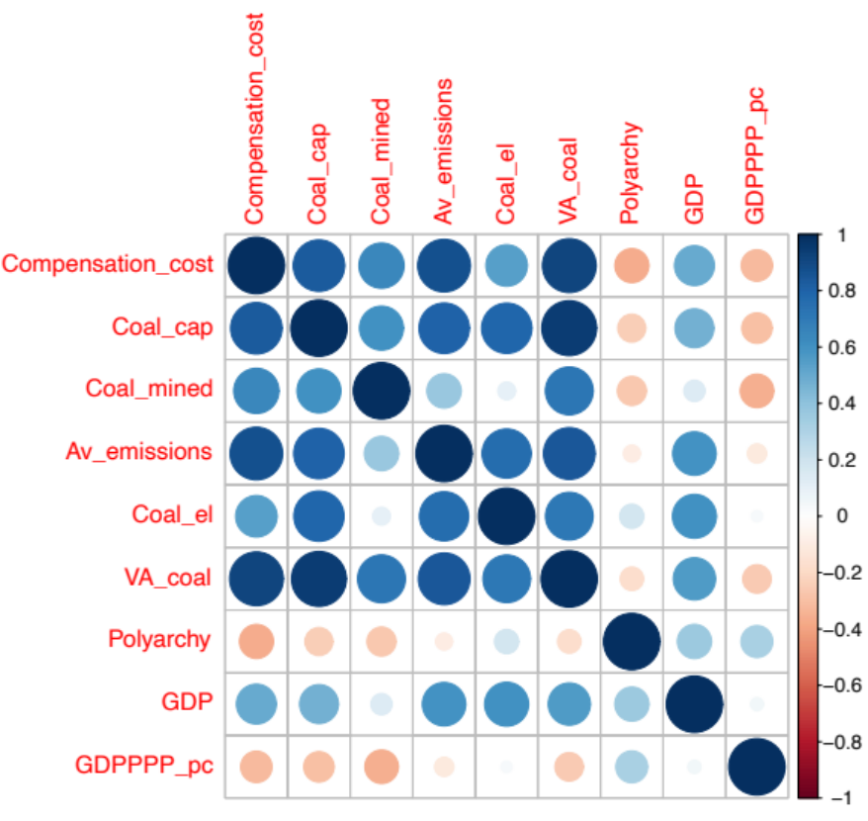
Since the value-added of the coal sector is correlated to all other variables in our model, we exclude it from the regression. We also exclude models that combine two variables related to government capacity.
Running all three-variable combinations (excluding pairs of collinear variables) results in 9 models which we rank according to Aikaike Information Criterion (AIC) and Adjusted R² (Supplementary Table 5). In our three best performing models, avoided emissions is found significant at the 0.1% level, and coal and lignite mining is found significant at the 1% level. Additionally, our best performing model controls for Polyarchy. In contrast to avoided emissions, size of the coal power plant fleet is first found significant at 1% in the model ranked fourth by AIC, and generation of coal power is first found significant at 0.1% in the model ranked sixth.
The models including GDP/capita exhibit paradoxical results, in that GDP/capita is negatively correlated with compensation. This may reflect the fact that GDP/capita captures the wellbeing and wealth of citizens in a country⁸⁹ and is also associated with the overall level of democracy. GDP/capita thus conflates two conflicting mechanisms, namely wealth of the country (which leads to higher compensation) and strength of democracy (which leads to lower compensation). Since our sample is not big enough to control for this interaction, we exclude GDP/capita from further analysis.
Based on this analysis, we conclude that avoided emissions, controlled by amount of domestic coal mining and government capacity, best predicts the amount of coal phase-out compensation that is paid. While we based the selection of variables on plausible causal mechanisms that may explain coal phase-out compensation, our regression analysis identifies correlation rather than causation. In-depth case studies of the countries studied may help to validate the results of such a regression analysis.

Supplementary Table 5. Coefficients from all regression models. “***” indicates that variables are found significant at the 0.1% level. “**” Indicates that variables are found significant at the 1% level. “*” Indicates that variables are found significant at the 5% level. “.” Indicates that variables are found significant at above 5% levels.
Variable | Model A | [Excl] | Model B | Model C | Model D | Model E | [Excl] | Model F |  | [Excl]
Avoided emissions  (Gt CO2) | 36.9***  (4.5) | 36.5***  (5.1) | 33.9***  (6.5)
Installed coal capacity (GW) |  |  |  | 712**  (229) | 853***  (196.3) |  | 859***  (202)
Coal-fired electricity generation (GWh) |  |  |  |  |  | 0.03***  (0.007) |  | 0.02.  (0.01) |  | 0.03**  (0.01)
Coal and lignite mined (Mt) | 49**  (13.7) | 52**  (15.8) | 57.4**  (15.5) | 37.4  (24.3) | 28.2  (24.5) | 75**  (20.3) | 30.4  (25.6) | 82.8**  (21.5) |  | 79.8**  (22.5)
Polyarchy | -21,949*  (8,984) |  |  |  | -13,680  (13,755) | -29,060.  (14,400)
GDP  ($2020 mln) |  |  | 0.001  (0.002) | 0.003  (0.003) |  |  |  | 0.004  (0.004)
GDP /capita (PPP) ($2020) |  | -0.09  (0.09) |  |  |  |  | -0.03  (0.1) |  |  | -0.1  (0.1)
AIC | 413 | 417.9 | 419 | 429.6 | 430.2 | 431.1 | 431.3 | 434.4 |  | 434.7
Adj R2 | 0.87 | 0.84 | 0.83 | 0.71 | 0.7 | 0.7 | 0.69 | 0.63 |  | 0.63

Calculating Value Added of coal power generation and coal mining
To calculate the value added (VA) of the coal sector, we calculate VA of coal power generation and of coal mining separately for each country, and then sum up both values.
Calculating value added for coal mining
For Bulgaria, Czechia, Germany, Greece, Spain, Poland and Romania, VA for coal mining is available from Eurostat⁹⁰. Data is not available for the same years for all countries, so we use the average over the most recent available five years, or if data over less years is available for less years, we use average data for those years. For missing years in the middle of the data series, we interpolate the average of the preceding and following year. We convert all values to USD2020 before calculating the average, using average annual exchange rates for the relevant years from OECD⁵⁵ and the GDP deflator from IMF⁹¹.
For Slovakia, we could not find national statistics on VA for coal mining, so we estimated VA based on data from the surrounding countries (Czechia, Poland, and Hungary). We assume that geographical conditions are similar for countries in close proximity to each other, which affects VA of coal mined. For each of these three countries we calculate annual VA/Mt coal and then an average of the three countries. Finally, we multiply Mt coal mined in Slovakia for the given year with annual average VA/Mt coal mined for that particular year of the three countries. Economic and political conditions might affect VA as well, but the exact effect of these conditions is not possible to estimate.
For Canada, we use national statistics on VA of coal mining^{92,93} (average VA over the available years – 2014-2018). About half of coal mined in Canada is metallurgical, and half is thermal⁹². There is no available data on how high the VA is for metallurgical coal compared to thermal coal, so we roughly approximate VA of thermal coal by dividing value added in half.
For Vietnam, Indonesia, South Korea, China, and India, data on VA for coal mining was not available so we use the median value from our sampled countries and apply it to Mt coal mined for each country in 2017 and 2019, to calculate a range for potential VA from coal in these years. We then calculate the median out of both estimates. We use data for 2017 and 2019 for comparability with value added for coal power generation, for which we have data for 2017 and 2019.
France, Netherlands and Finland did not have any operational coal mines at the time of committing to coal phase-out.
Calculating value added for coal power generation
We retrieve data on VA for Electricity, gas, steam and air conditioning supply from Eurostat for all EU countries⁹⁰. For Canada, Indonesia, South Korea, Vietnam, India and China, we retrieve data from national statistics[ref]. For Vietnam, VA is also reported for Electricity, gas, steam and air conditioning supply⁹⁴. For China, VA is reported for Production and Supply of Electricity, Heat, Gas and Water⁹⁵. For India, VA is reported for Electricity, gas, water supply & other utility services⁹⁶. For Canada, Indonesia and South Korea, VA is reported for Electric power generation, transmission and distribution specifically^{93,97,98}. For China and Indonesia, data is available for 2017, for India data is available for 2016-2017, and for Vietnam, data is available for 2019.
For countries where VA is bundled with other utilities, we normalize this value to the share of electricity in household consumption of energy⁹⁹ multiplied by the share of coal power in electricity to approximate VA of coal power generation⁹⁹.

References
1. Vinichenko, V., Vetier, M., Jewell, J., Nacke, L. & Cherp, A. Phasing out coal for 2 °C target requires worldwide replication of most ambitious national plans despite security and fairness concerns. Environ Res Lett 18, 014031 (2023).
2. Ember. Data Explorer | Open Source Global Electricity Data | Ember. https://ember-climate.org/data/data-tools/data-explorer/ (2023).
3. OECD. OECD Inventory of Support Measures for Fossil Fuels. https://www.oecd.org/fossil-fuels/countrydata/ (2021).
4. Gençsü, I. & Roberts, L. G20 coal subsidies: tracking government support to a fading industry | ODI: Think change. https://odi.org/en/publications/g20-coal-subsidies-tracking-government-support-to-a-fading-industry/ (2019).
5. Council of Ministers of the Republic of Bulgaria. National Recovery and Resilience Plan of the Republic of Bulgaria. Preprint at https://nextgeneration.bg/14 (2021).
6. The European Parliament & The Council. Regulation of the European Parliament and of the Council establishing the Just Transition Fund. Preprint at https://data.consilium.europa.eu/doc/document/PE-5-2021-INIT/en/pdf (2021).
7. European Commission. European Semester 2020 Overview of Investment Guidance on the Just Transition Fund 2021-2027 per Member State (Annex D). https://ec.europa.eu/info/sites/default/files/annex_d_crs_2020_en.pdf (2020).
8. Kojouharova, V. What is the current state of the just transition processes in Bulgaria? - Bankwatch. https://bankwatch.org/publication/what-is-the-current-state-of-the-just-transition-processes-in-bulgaria (2023).
9. Government of Canada. People-centred just transition: Discussion paper. https://www.rncanengagenrcan.ca/sites/default/files/pictures/home/just_transition_discussion_paper_-_en_-_july_15.pdf (2021).
10. Audit and Evaluation Branch Natural Resources Canada. Evaluation of the Regional Electricity Cooperation and Strategic Infrastructure (RECSI) Initiative. Government of Canada https://www.nrcan.gc.ca/transparency/reporting-and-accountability/plans-and-performance-reports/strategic-evaluation-division/reports-and-plans-year/evaluation-the-regional-electricity-cooperation-and-strategic (2019).
11. Task Force on Just Transition for Canadian Coal Power Workers and Communities. A just and fair transition for Canadian coal power workers and communities. https://publications.gc.ca/collections/collection_2019/eccc/En4-361-2019-eng.pdf (2018).
12. Newfoundland Labrador et al. Pan-Canadian framework on clean growth and climate change: Canada’s plan to address climate change and grow the economy. https://publications.gc.ca/collections/collection_2017/eccc/En4-294-2016-eng.pdf (2016).
13. European Commission. Investing in skills and jobs for the green transition in Croatia | European Social Fund Plus. https://ec.europa.eu/european-social-fund-plus/en/news/skills-and-jobs-green-transition-croatia (2022).
14. European Commission. 2021-2027 JTF Finances Details | Data | European Structural and Investment Funds. https://cohesiondata.ec.europa.eu/2021-2027-Categorisation/2021-2027-JTF-Finances-Details/dy7j-i7p6 (2023).
15. Ministry of Industry and Trade. Dokumenty | Národní plán obnovy. https://www.planobnovycr.cz/dokumenty (2021).
16. European Commission. EU Cohesion Policy: €1.64 billion for Czechia. https://ec.europa.eu/commission/presscorner/detail/en/IP_22_5702 (2022).
17. European Commission. European Semester 2020: Overview of Investment Guidance on the Just Transition Fund 2021-2027 per Member State (Annex D). Preprint at https://commission.europa.eu/system/files/2020-02/annex_d_crs_2020_en.pdf (2020).
18. Ministry of the Environment of the Czech Republic. Operational programme Just Transition (OPJT) 2021-2027. https://www.mzp.cz/en/operational_programme_just_transition (2023).
19. Ministry of Economic Affairs and Employment. Investment incentives to promote rapid phase-out of coal in energy production. https://valtioneuvosto.fi/en/-/1410877/investment-incentives-to-promote-rapid-phase-out-of-coal-in-energy-production (2020).
20. Ministry of Economic Affairs and Employment. Draft Budget of Ministry of Economic Affairs and Employment for 2021: building new growth pathways. https://valtioneuvosto.fi/en/-/1410877/draft-budget-of-ministry-of-economic-affairs-and-employment-for-2021-building-new-growth-pathways (2020).
21. Ministère de l’économie des finances et de la souveraineté industrielle et numérique. Budget Général Mission ministérielle Projects annuels de performances Annexe au projet de loi de finances pour 2021: Programme 174 Énergie, climat et après-mines. Preprint at https://www.budget.gouv.fr/documentation/documents-budgetaires/exercice-2021/projet-de-loi-de-finances/budget-general/ecologie-developpement-et-mobilite-durables (2021).
22. Bundestag. Gesetz zur Reduzierung und zur Beendigung der Kohleverstromung und zur Anderung weiterer Gesetze. (2020).
23. Tiedemann, S. & Müller-Hansen, F. Auctions to phase out coal power: Lessons learned from Germany. Energ Policy 174, 113387 (2023).
24. Bundesregierung. Investitionsgesetz Kohleregionen vom 8. August 2020 (BGBl. I S. 1795). Preprint at https://www.gesetze-im-internet.de/invkg/InvKG.pdf (2020).
25. European Commission. EU Cohesion Policy: €2.5 billion for Germany. https://ec.europa.eu/commission/presscorner/detail/en/ip_22_6275 (2022).
26. ZEIT Online. Gesetz zum Kohleausstieg: Kabinett beschließt Kohleausstieg bis 2038 | ZEIT ONLINE. DIE ZEIT (2020).
27. Ministry of Environment and Energy. Just transition development plan of lignite areas. https://www.sdam.gr/sites/default/files/consultation/Master_Plan_Public_Consultation_ENG.pdf (2020).
28. European Commission. EU cohesion policy: €1.63 billion for TJTP in Greece. https://ec.europa.eu/commission/presscorner/detail/en/ip_22_3711 (2022).
29. OECD. OECD Environmental Performance Reviews: Greece 2020. Oecd Environ Perform Rev (2020) doi:10.1787/cec20289-en.
30. European Commission. EU Cohesion Policy 2021-2027: Hungary. https://ec.europa.eu/commission/presscorner/detail/en/ip_22_7801 (2022).
31. European Commission. Just Energy Transition Partnership with Indonesia. https://ec.europa.eu/commission/presscorner/detail/en/IP_22_6926 (2022).
32. European Commission. EU Cohesion Policy: €1 billion for Italy. https://ec.europa.eu/commission/presscorner/detail/en/ip_22_7800 (2022).
33. European Commission. State Aid SA.54537 (2020/NN) - Netherlands Prohibition of coal for the production of electricity in the Netherlands. Preprint at https://ec.europa.eu/competition/state_aid/cases1/202025/284556_2165085_151_2.pdf (2020).
34. S&P Global Commodity Insights. Dutch government agrees on closure compensation for 731-MW Rotterdam coal plant. S&P Global Commodity Insights https://www.spglobal.com/commodityinsights/en/market-insights/latest-news/electric-power/120121-dutch-government-agrees-on-closure-compensation-for-731-mw-rotterdam-coal-plant (2021).
35. Meijer, B. & Potter, M. Dutch court denies RWE and Uniper compensation for closure of coal plants | Reuters. Reuters (2022).
36. Czyżak, P. et al. Poland’s planned coal monopoly – who pays the price? https://instrat.pl/wp-content/uploads/2020/12/CE_Instrat_Coal-Monopoly_3.12.2020.pdf (2020).
37. European Commission. State Aid SA.41161 (2015/N) – Poland State aid to Polish coal mining in the period 2015-2018. Preprint at https://ec.europa.eu/competition/state_aid/cases/257337/257337_1866791_407_2.pdf (2016).
38. European Commission. €3.85 billion for a just transition in five Polish regions. https://ec.europa.eu/commission/presscorner/detail/en/ip_22_7413 (2022).
39. European Commission. €223.8 million for a just climate transition in Portugal. https://ec.europa.eu/commission/presscorner/detail/en/ip_22_7718 (2022).
40. European Commission. State Aid SA.55038 (2019/N) – Slovakia – Aid to cover the exceptional costs of Hornonitrianske bane Prievidza (HBP) related to the closure of its mining operations. Preprint at https://ec.europa.eu/competition/state_aid/cases1/20205/281626_2128088_142_2.pdf (2019).
41. European Commission. €459 million for a just climate transition in Slovakia. https://ec.europa.eu/commission/presscorner/detail/en/ip_22_7086 (2022).
42. European Commission. Cohesion Policy: More than €258 million for Slovenia. https://ec.europa.eu/commission/presscorner/detail/en/ip_22_7744 (2022).
43. Council of Ministers. Government of Spain is taking the necessary measures to protect the integrity of its borders [Government/Activity of the Council of Ministers]. https://www.lamoncloa.gob.es/lang/en/gobierno/councilministers/paginas/2021/20210518council.aspx (2021).
44. El Instituto para la Reestructuración de la Minería del Carbón y Desarrollo Alternativo de las Comarcas Mineras. Just Transition Agreements Update September 2021. https://www.transicionjusta.gob.es/Convenios_transicion_justa/common/Folleto_Convenios_Transicion_Justa_EN_uv.pdf (2021).
45. European Commission. EU Cohesion policy: €869 million for Spain. https://ec.europa.eu/commission/presscorner/detail/en/ip_22_7868 (2022).
46. European Commission. Commission Staff Working Document Analysis of the recovery and resilience plan of Romania. Preprint at https://eur-lex.europa.eu/legal-content/EN/TXT/PDF/?uri=CELEX:52021SC0276&;from=EN (2021).
47. European Commission. Inforegio - EU Cohesion Policy: €2.14 billion for a just climate transition in Romania. https://ec.europa.eu/regional_policy/whats-new/newsroom/12-09-2022-eu-cohesion-policy-eur2-14-billion-for-a-just-climate-transition-in-romania_en (2022).
48. Government of the Republic of Korea. Korean New Deal. Preprint at https://english.moef.go.kr/pc/selectTbPressCenterDtl.do?boardCd=N0001&;seq=4948 (2020).
49. Foreign & Commonwealth and Development Office. Political declaration on establishing the Just Energy Transition Partnership with Viet Nam - GOV.UK. https://www.gov.uk/government/publications/vietnams-just-energy-transition-partnership-political-declaration/political-declaration-on-establishing-the-just-energy-transition-partnership-with-viet-nam (2022).
50. European Commission. South Africa Just Energy Transition Investment Plan. https://ec.europa.eu/commission/presscorner/detail/en/STATEMENT_22_6664 (2022).
51. OECD. Total official flows by country and region (ODA + OOF). (2022).
52. Rathi, A. & Chaurdhary, A. India Wants $1 Trillion Before It Raises Targets to Cut Emissions. Bloomberg https://www.bloomberg.com/news/articles/2021-11-10/india-holds-back-on-climate-pledge-until-rich-nations-pay-1-trillion (2021).
53. OECD. Climate Finance Provided and Mobilised by Developed Countries in 2016-2020. Clim Finance Usd 100 Billion Goal (2022) doi:10.1787/286dae5d-en.
54. S&P Global. World Electric Power Plants Database. (2021).
55. International Monetary Fund & International Financial Statistics. Official exchange rate (LCU per US$, period average) | Data. https://data.worldbank.org/indicator/PA.NUS.FCRF (2022).
56. Novinite. American AES Launches Bulgaria’s Galabovo TPP - Novinite.com - Sofia News Agency. https://www.novinite.com/articles/128908/American+AES+Launches+Bulgaria’s+Galabovo+TPP (2011).
57. Mizzy, S. The launch of the modernized Prunéřov is hampered by the insolvency of the main suppliers – europe-cities.com. https://europe-cities.com/2016/11/13/the-launch-of-the-modernized-prunerov-is-hampered-by-the-insolvency-of-the-main-suppliers/ (2016).
58. Power Technology. Ledvice Power Station Expansion, Czech Republic. https://www.power-technology.com/marketdata/ledvice-power-station-expansion-czech-republic/ (2022).
59. Vattenfall. Vattenfall’s investments 2000 – 2016. From fossil fuel to wind - The history and heritage of Vattenfall. https://history.vattenfall.com/stories/from-hydro-power-to-solar-cells/vattenfalls-investments-2000-2016-from-fossil-fuel-to-wind.
60. Enerdata. Germany rules that approval for Datteln-4 coal-fired plant was invalid | Enerdata. https://www.enerdata.net/publications/daily-energy-news/germany-rules-approval-datteln-4-coal-fired-plant-was-invalid.html (2021).
61. Power Technology. GKM Power Plant Unit 9, Germany. https://www.power-technology.com/marketdata/gkm-power-plant-unit-9-germany/ (2021).
62. Eckert, V. Trianel calls for German power market reform | Reuters. Reuters https://www.reuters.com/article/germany-power-trianel-idINL5N0B588P20130205 (2013).
63. Beyond Coal. Vattenfall requests closure of Germany’s second-youngest coal power plant - Europe Beyond Coal : Europe Beyond Coal. https://beyond-coal.eu/2020/09/04/vattenfall-requests-closure-of-germanys-second-youngest-coal-power-plant/ (2020).
64. Power Technology. Neurath F&G (BoA 2&3) Power Plant, Germany. https://www.power-technology.com/marketdata/neurath-fg-boa-23-power-plant-germany/ (2021).
65. Power Technology. Rheinhafen Karlsruhe RDK 8 Power Station, Germany. https://www.power-technology.com/marketdata/rheinhafen-karlsruhe-rdk-8-power-station-germany/ (2021).
66. Die Presse. EVN enthält für Mängel bei “Walsum 10” Entschädigung | DiePresse.com. https://www.diepresse.com/5123426/evn-enthaelt-fuer-maengel-bei-walsum-10-entschaedigung (2016).
67. Andresen, T. & Zha, W. This €1 Billion Power Plant May Never Be Switched on - Bloomberg. https://www.bloomberg.com/news/articles/2015-12-23/brand-new-rwe-plant-is-latest-victim-of-merkel-s-energy-shift#xj4y7vzkg (2015).
68. Power Technology. Wilhelmshaven Coal Fired Power Plant, Germany. https://www.power-technology.com/marketdata/wilhelmshaven-coal-fired-power-plant-germany/ (2021).
69. Wynn, G. The big Dutch coal power mistake and what it means for Europe. Energy Post https://energypost.eu/big-dutch-coal-mistake-future-coal-europe-2/ (2016).
70. Darby, M. Dutch coal plant lost €800m in value last year. https://www.climatechangenews.com/2017/04/10/dutch-coal-plant-lost-e800m-value-one-year/ (2017).
71. Modern Power Systems. 858 MWe supercritical extension for Belchatow - Modern Power Systems. https://www.modernpowersystems.com/features/feature858-mwe-supercritical-extension-for-belchatow/ (2007).
72. Power Technology. PKE Jaworzno III Power Plant II, Poland. https://www.power-technology.com/marketdata/pke-jaworzno-iii-power-plant-ii-poland/ (2021).
73. NS Energy. Opole Power Plant- Europe’s biggest coal power project completed in 2019. https://www.nsenergybusiness.com/projects/opole-power-plant-expansion/.
74. Power Technology. PGE Turow Power Plant (Expansion), Poland. https://www.power-technology.com/marketdata/pge-turow-power-plant-expansion-poland/ (2022).
75. CEE Bankwatch Network. Sostanj lignite thermal power plant unit 6, Slovenia - Bankwatch. https://bankwatch.org/project/sostanj-lignite-thermal-power-plant-unit-6-slovenia.
76. Sarr, S. & Fall, S. Just energy transitions and partnerships in Africa: A Senegal case study | IDDRI. https://www.iddri.org/en/publications-and-events/report/just-energy-transitions-and-partnerships-africa-senegal-case-study (2022).
77. Kramer, K. Just Energy Transition Partnerships: An opportunity to leapfrog from coal to clean energy | International Institute for Sustainable Development. https://www.iisd.org/articles/insight/just-energy-transition-partnerships (2022).
78. UK COP 26. Political declaration on the just energy transition in South Africa. https://ukcop26.org/political-declaration-on-the-just-energy-transition-in-south-africa/ (2021).
79. Mathiesen, K. & Barigazzi, J. G7 offered Vietnam and Indonesia $15B to drop coal. They said ‘maybe’ – POLITICO. POLITICO (2022).
80. International Energy Agency. Coal in Net Zero Transitions: Strategies for rapid, secure and people-centred change. https://iea.blob.core.windows.net/assets/08119e54-73ce-4207-b6ce-fbe75c241191/CoalinNetZeroTransitions.pdf (2022).
81. Skjølsvold, T. M. & Coenen, L. Are rapid and inclusive energy and climate transitions oxymorons? Towards principles of responsible acceleration. Energy Res Soc Sci 79, 102164 (2021).
82. Diluiso, F. et al. Coal transitions—part 1: a systematic map and review of case study learnings from regional, national, and local coal phase-out experiences. Environ Res Lett 16, 113003 (2021).
83. Erickson, P., Kartha, S., Lazarus, M. & Tempest, K. Assessing carbon lock-in. Environ Res Lett 10, 084023 (2015).
84. Malik, A. et al. Reducing stranded assets through early action in the Indian power sector. Environ Res Lett 15, 094091 (2020).
85. Rentier, G., Lelieveldt, H. & Kramer, G. J. Varieties of coal-fired power phase-out across Europe. Energ Policy 132, 620–632 (2019).
86. Brauers, H., Oei, P.-Y. & Walk, P. Comparing coal phase-out pathways: The United Kingdom’s and Germany’s diverging transitions. Environ Innovation Soc Transitions 37, 238–253 (2020).
87. Brauers, H. & Oei, P.-Y. The political economy of coal in Poland: Drivers and barriers for a shift away from fossil fuels. Energ Policy 144, 111621 (2020).
88. Coppedge et al. V-Dem [Country-Year/Country-Date] Dataset v12 Varieties of Democracy (C-Dem) Project. (2022) doi:https://doi.org/10.23696/vdemds22.
89. Feenstra, R. C., Inklaar, R. & Timmer, M. P. The Next Generation of the Penn World Table. American Economic Review 10, 3150–3182.
90. Eurostat. Database. https://ec.europa.eu/eurostat/web/main/data/database (2022).
91. IMF. World Economic Outlook Database, October 2022. https://www.imf.org/en/Publications/WEO/weo-database/2022/October (2022).
92. Government of Canada. Coal facts. https://www.nrcan.gc.ca/our-natural-resources/minerals-mining/minerals-metals-facts/coal-facts/20071 (2022).
93. Statistics Canada. Table 36-10-0402-01 Gross domestic product (GDP) at basic prices, by industry, provinces and territories (x 1,000,000). https://www150.statcan.gc.ca/t1/tbl1/en/tv.action?pid=3610040201 (2021).
94. General Statistics Office. Statistical Yearbook of Vietnam 2021. https://www.gso.gov.vn/wp-content/uploads/2022/08/Sach-Nien-giam-TK-2021.pdf (2021).
95. National Bureau of Statistics of China. China Statistical Yearbook 2019. http://www.stats.gov.cn/tjsj/ndsj/2019/indexeh.htm (2019).
96. Ministry of Statistics and Programme Implementation. National accounts data 12. Annual and Quarterly estimates of GDP at constant prices. https://www.mospi.gov.in/web/mospi/download-tables-data/-/reports/view/templateOne/16701?q=TBDCAT (2022).
97. Statistics Indonesia. [2010 Version] GDP at 2010 Version (Billion Rupiahs), 2021. https://www.bps.go.id/indicator/11/65/2/-2010-version-gdp-at-2010-version.html (2021).
98. Bank of Korea. GDP and GNI by Economic Activities (not seasonally adjusted, current prices, quarterly & annual). https://kosis.kr/statHtml/statHtml.do?orgId=301&;tblId=DT_111Y010&language=en&conn_path=I3 (2021).
99. IEA. World energy balances. IEA World Energy Statistics and Balances (database) (2020).

