Additional file 4:
Table S1. Analysing the effects of normalisation techniques in the quantification of Eimeria. Comparison of two overlapping Pearson correlations based on dependent groups. Reference correlation is between Eimeria genome copies and Eimeria merged ASV abundance not normalised. rarefaction: random resampling of the OTU table to the minimum library depth. In green are the significantly improved and in red are significantly worsened correlations in relation to the overlapping correlation between Eimeria genome copies per gram of faeces and Eimeria ASV counts. P-adj: P-values corrected for multiple testing with Benjamini-Hochberg.
 | Standard PCR | Microfluidics PCR
Total sum scaling | Rho difference= -0.0040  df= 152  z= -0.986  p-adj= 0.376 | Rho difference= -0.0437  df= 128  z= -2.833,  p-adj= 0.009
Trimmed mean by M-values | Rho difference= -0.0055  df= 152  z= -1.625  p-adj= 0.208 | Rho difference= 0.0000  df= 128  z= 0.070,  p-adj= 0.945
Centered log ratio | Rho difference= 0.0625  df= 152  z= 5.203,  p-adj<0.001 | Rho difference= -0.0065  df= 128  z= -0.350  p-adj= 0.945
Rarefied read counts | Rho difference= -0.0092  df= 118  z= -0.886,  p-adj= 0.376 | Rho difference= -0.0934  df= 110  z= -3.322  p-adj= 0.004

Figure S1. Comparison of normalisation methods for quantification of Eimeria with amplicon sequencing (18S rRNA gene) using a standard PCR. dpi= days post infection, df= degree of freedom.
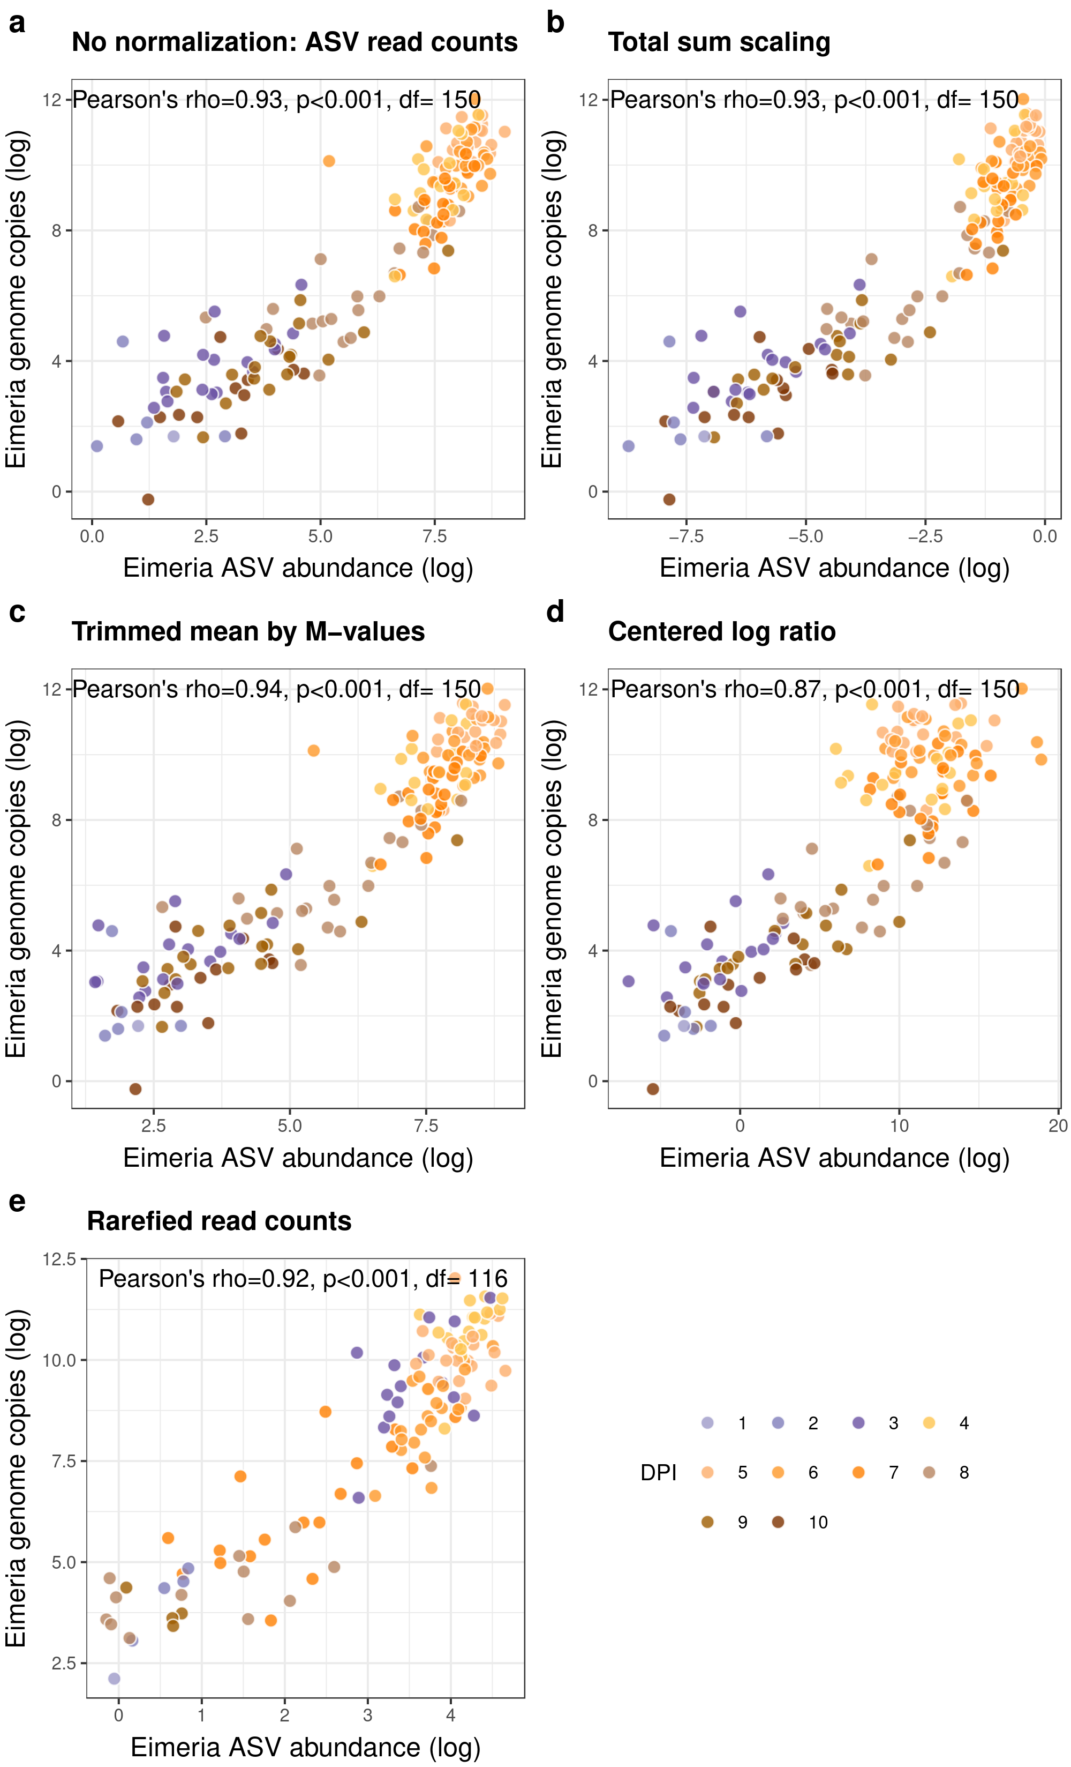
Figure S2. Comparison of normalisation methods for quantification of Eimeria with amplicon sequencing (18S rRNA gene) using microfluidics PCR. dpi= days post infection, df= degree of freedom.
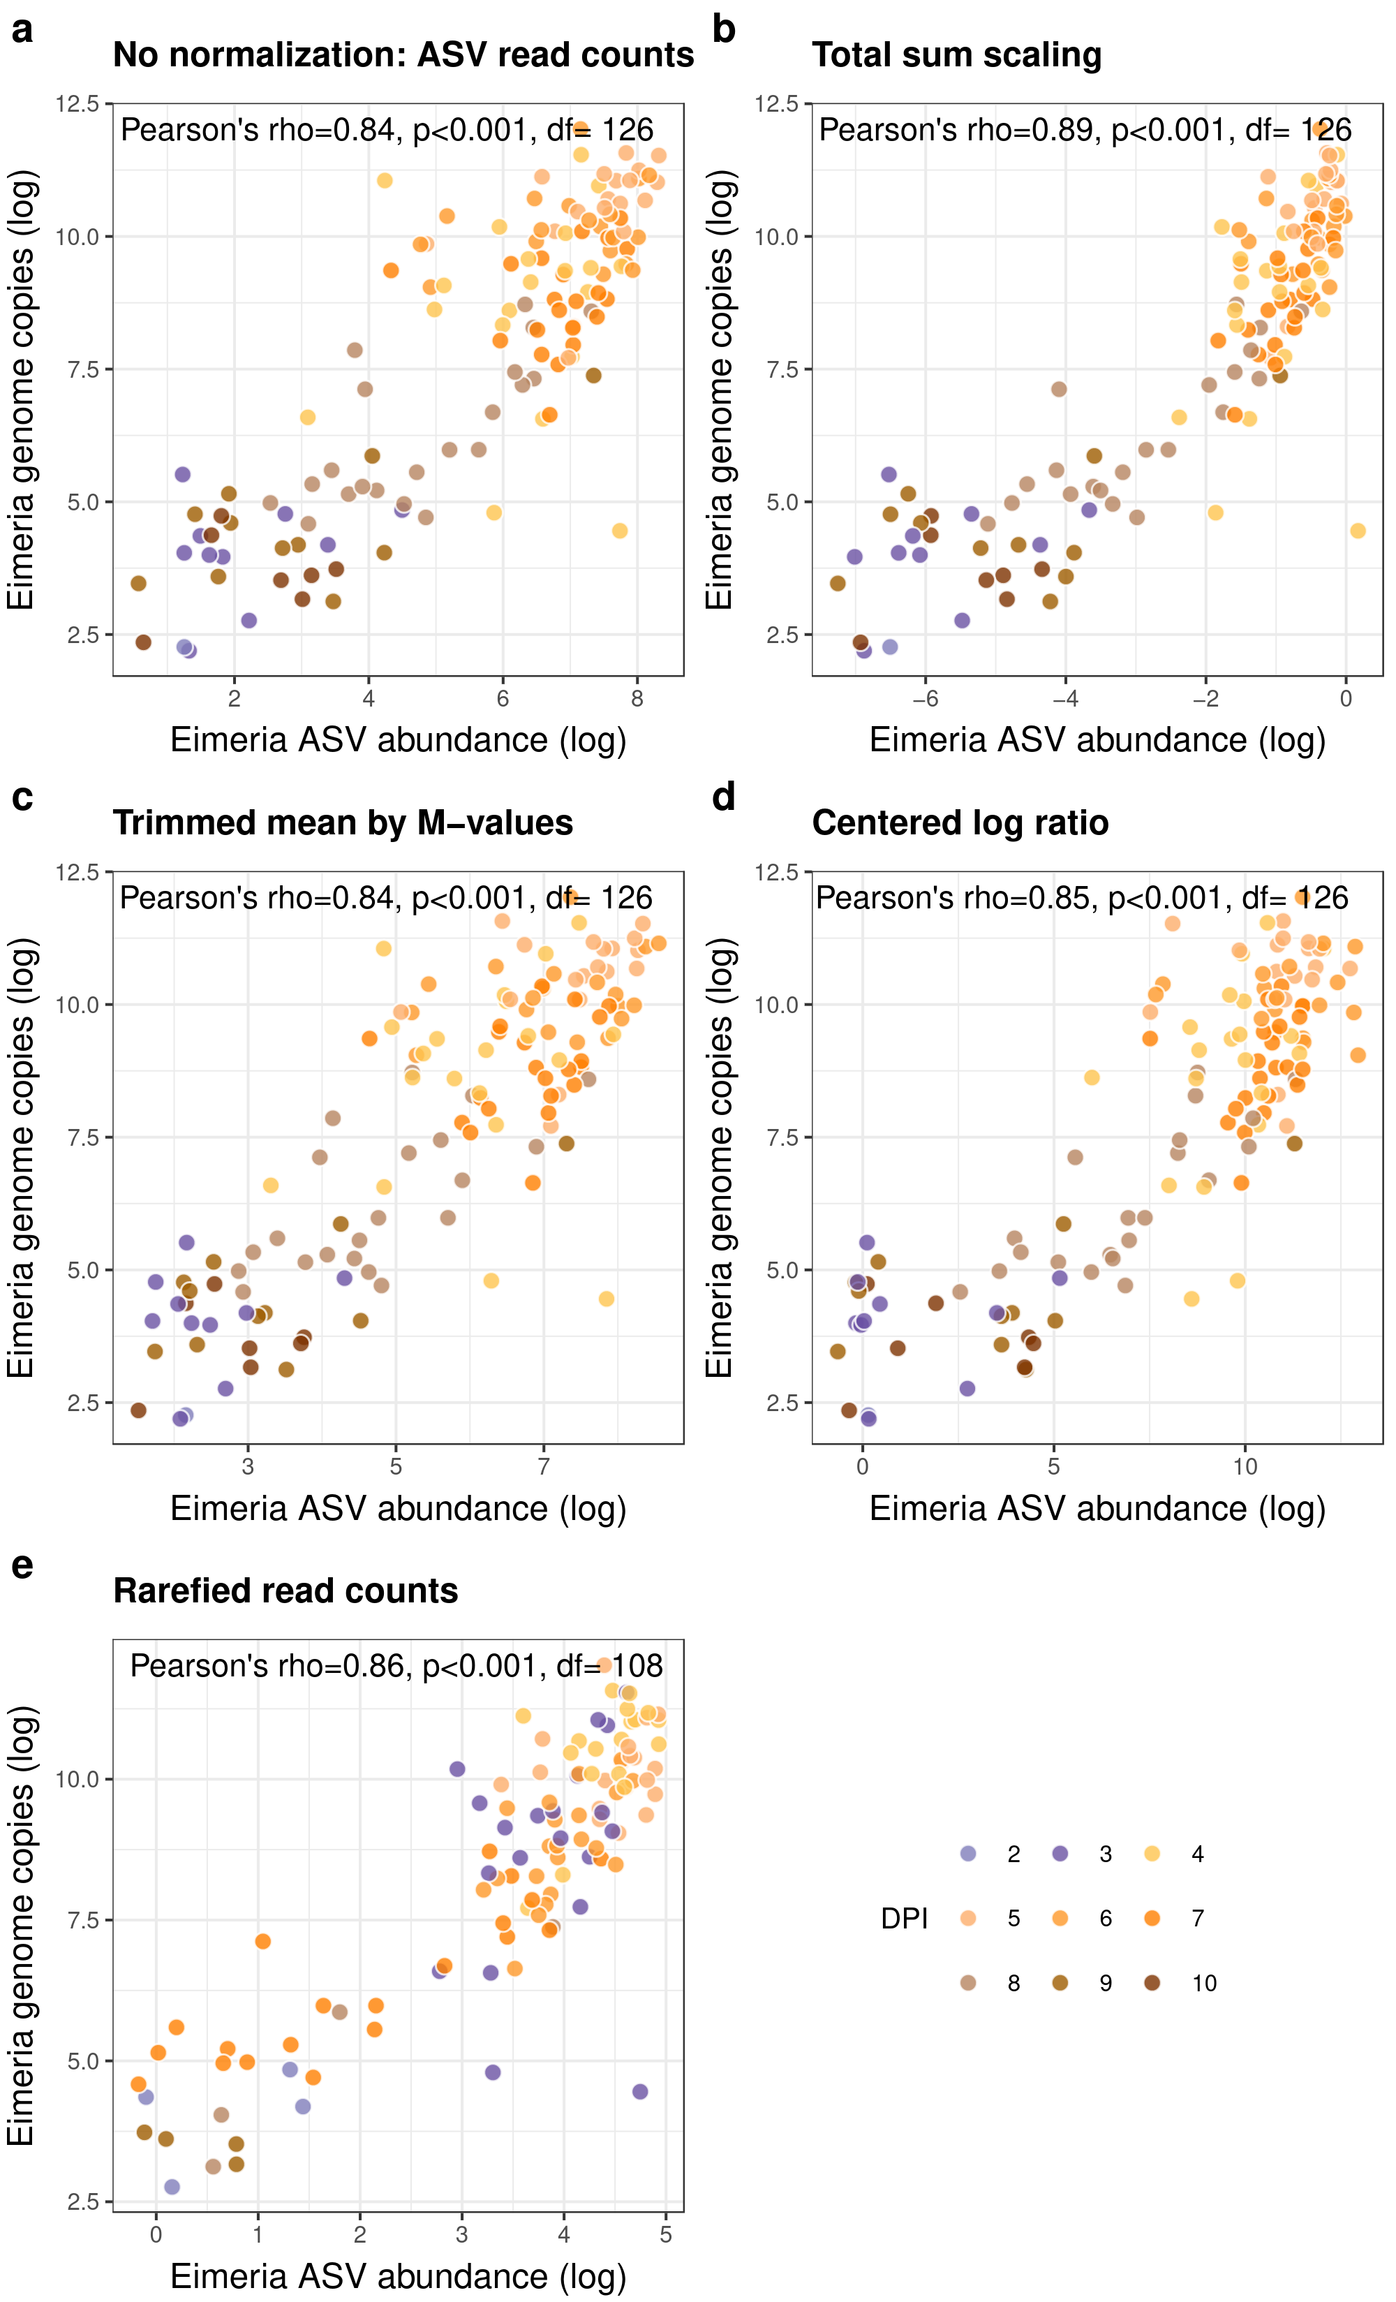
Figure S3. The different amplified Eimeria ASVs consistently reflect infection dynamics. Eimeria ASV abundances throughout days post infection measured as a) ASV1 sequenced from standard PCR amplification; b) ASV2 sequenced from standard PCR amplification; c) ASV1 sequenced from microfluidics PCR amplification; d) ASV1 sequenced from microfluidics PCR amplification. Abundances are measured as relative abundances after a total sum scaling normalisation, within the respective amplicon. Each dot represents one sample, samples from the same individual are connected with gray lines. The mean for each day post infection is depicted as a diamond. Colours represent the different days post infection. Note the difference in the scale of the y-axis in a) and c) vs b) and d).
