Supplementary Information for:

A novel application of bubble-eye strain of Carassius auratus for ex vivo fish immunological studies
Hiroto Nakajima^{1,2}, Atsushi Miyashita¹, Hiroshi Hamamoto¹, and Kazuhisa Sekimizu^{1,2,*}.

1. Institute of Medical Mycology, Teikyo University, Tokyo, Japan.
2. Genome Pharmaceuticals Institute Co., Ltd., Tokyo, Japan.
* sekimizu@main.teikyo-u.ac.jp

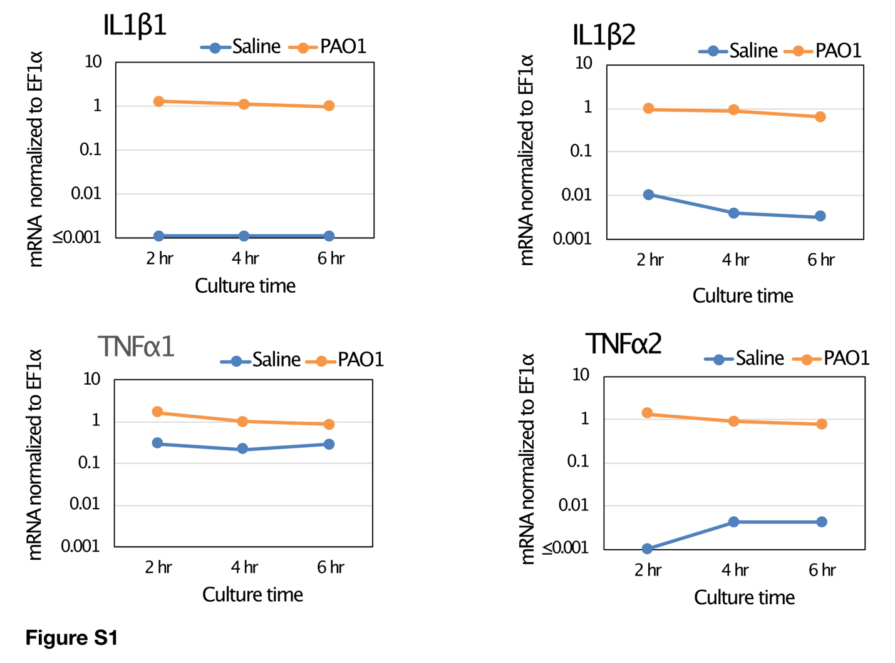
Figure S1. Stable expression of pro-inflammatory cytokines in ex vivo eye-sac cell culture. Eye-sac cells collected from bubble-eye goldfish were cultured with heat-killed P. aeruginosa (PAO1) or saline at 25℃ (8 x 10⁴/0.8 mL/well). Gene expressions of pro-inflammatory cytokines at 2, 4, and 6 hours after the adding of heat-killed P. aeruginosa cells or saline into the media are shown in the figure. The values were normalized to EF1α.

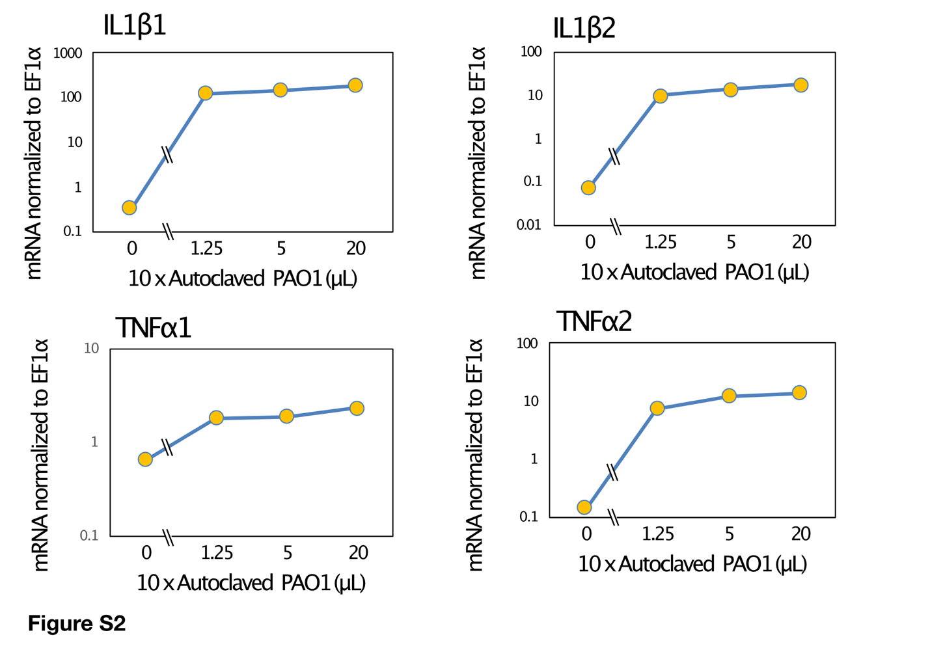
Figure S2. Dose-dependent ex vivo induction of pro-inflammatory cytokines in the eye-sac cells. Eye-sac cells collected from bubble-eye goldfish were cultured with heat-killed P. aeruginosa (PAO1; three doses in the figure) or saline (0µL in the figure) at 25℃ (8 x 10⁴/0.8 mL/well). Gene expressions of pro-inflammatory cytokines are shown in the figure. The values were normalized to EF1α.

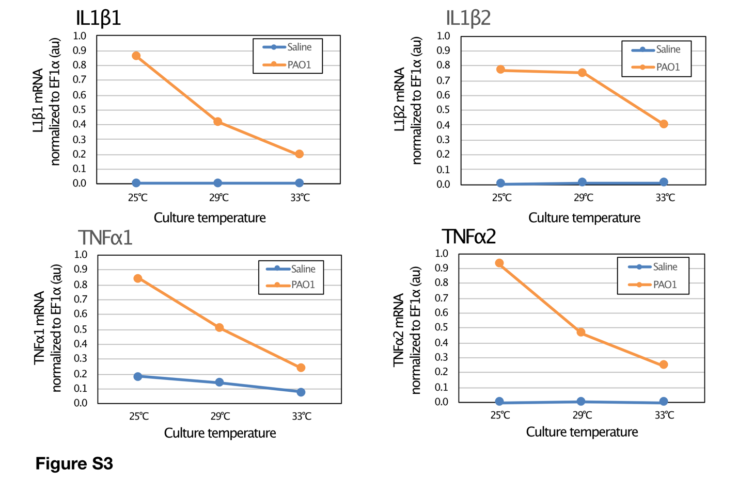
Figure S3. Temperature-dependent suppression of pro-inflammatory cytokine induction of the eye-sac cells. Eye-sac cells collected from untreated bubble-eye goldfish were cultured with heat-killed P. aeruginosa or saline at 25ºC, 29ºC, or 33ºC as indicated in the figure for four hours (8 x 10⁴/0.8 mL/well). Gene expressions of pro-inflammatory cytokines are shown in the figure. The values were normalized to EF1α.

