Supplementary figures

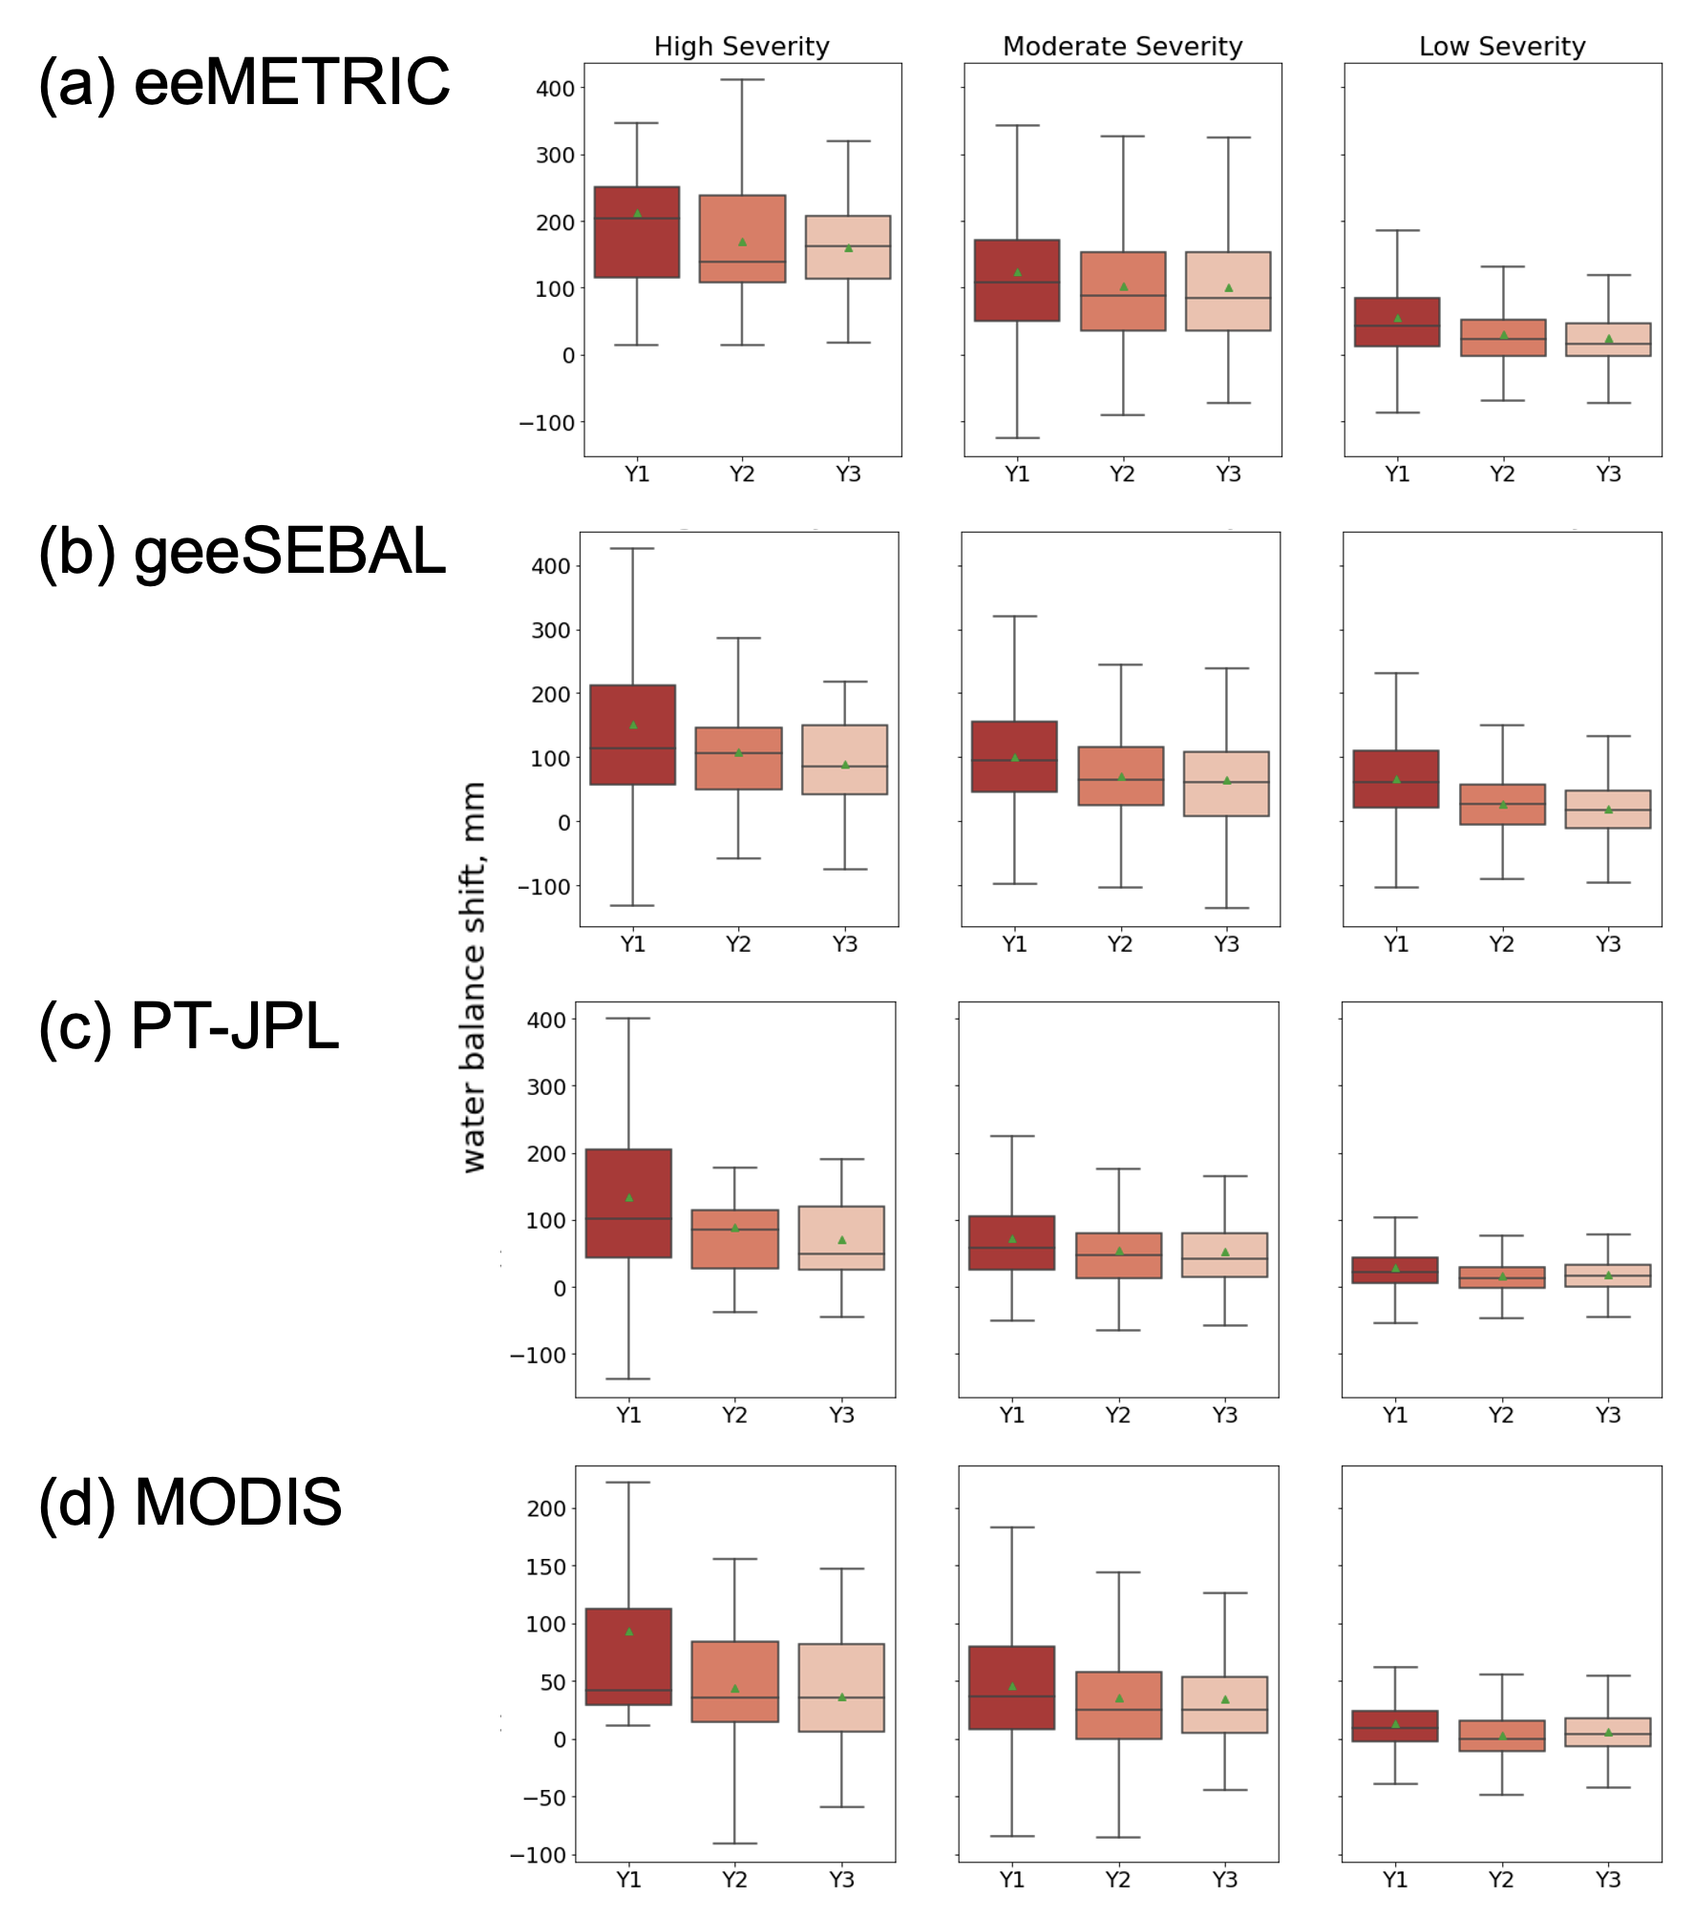
Figure S1. Water balance shift caused by fires during 2016-18 in three post-fire water years (Y1, Y2, and Y3) characterized by burn severity, obtained using remaining four ET sources (DisALEXI is shown in main text). Average values are shown with green markers. Whiskers represent 1.5 times the interquartile range.

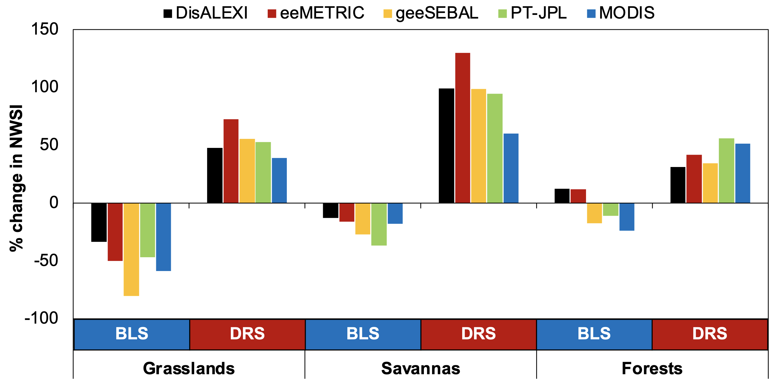

Figure S2. Change in NWSI in post-fire year Y3 compared to Y1 for high and moderate severity fires of 2016-18. Two scenarios of BLS (baseline) and DRS (drought) are compared using five sources of ET observations across the three landcovers. Positive change denotes increase in suppression while negative values denote recovery of ET.

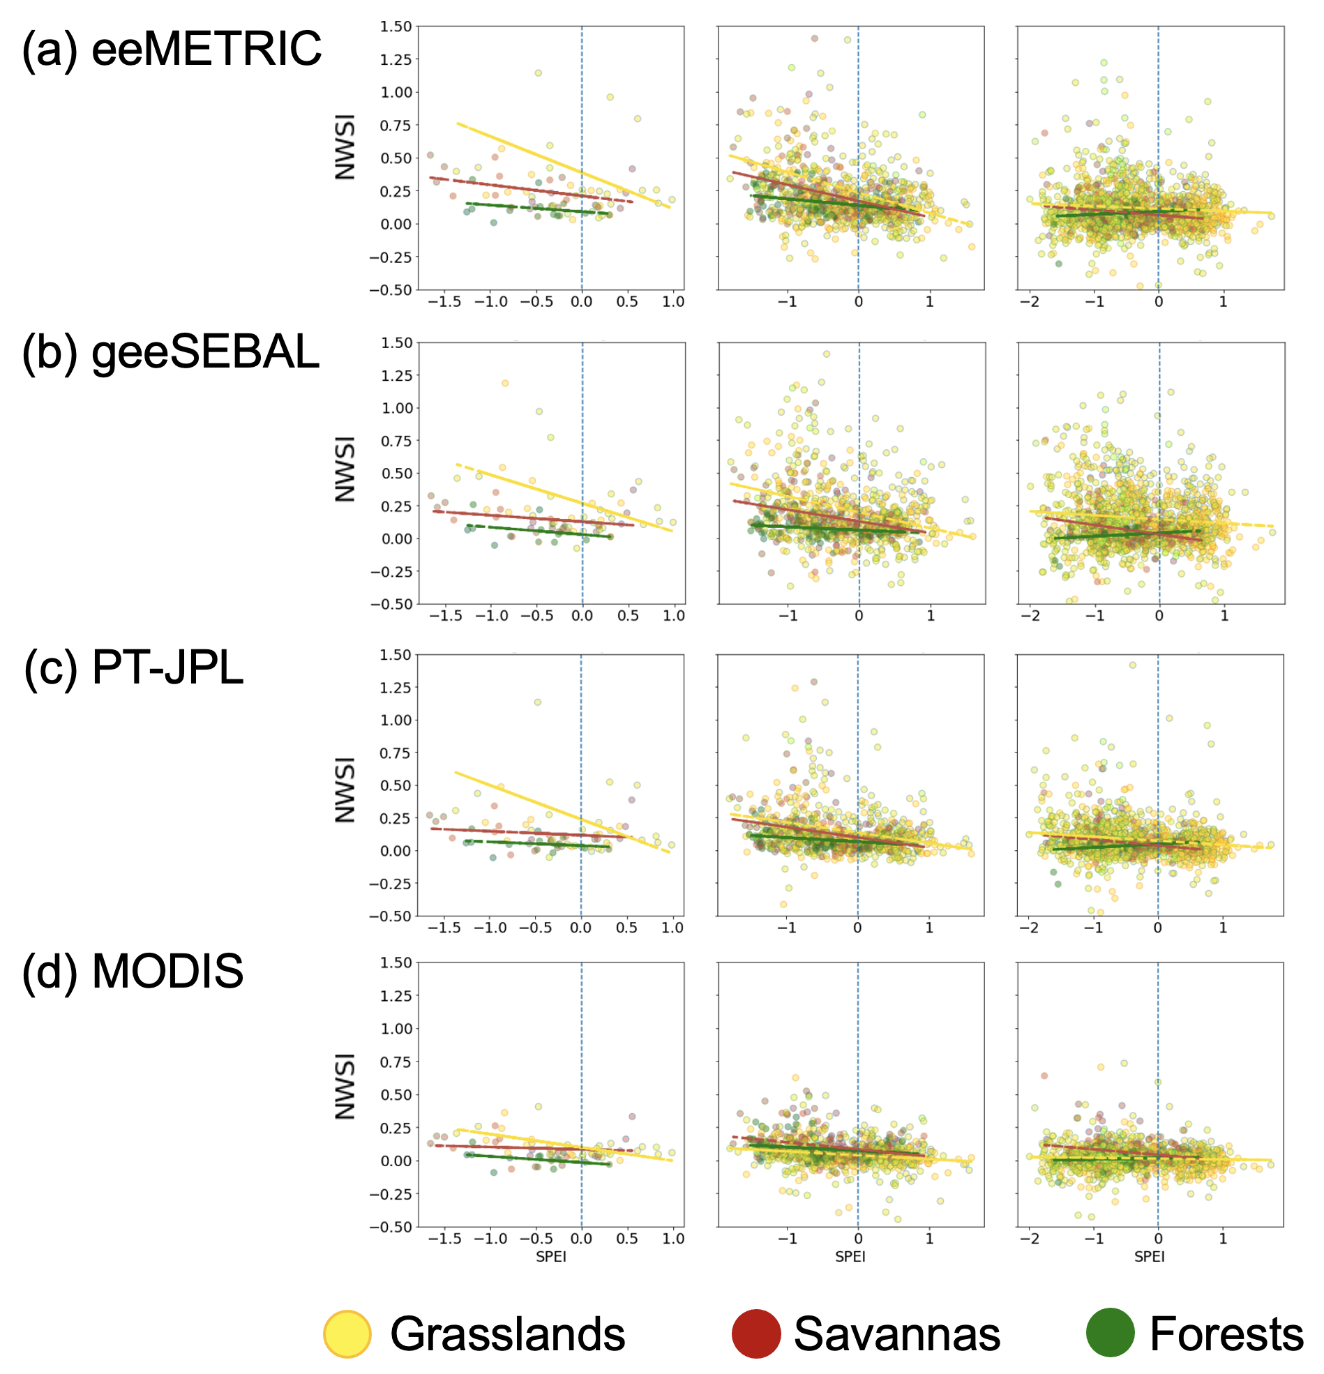

Figure S3. Scatter plots between NWSI and SPEI-90 for 2016 to 2018 fires, characterized by burn severity, where NWSI is obtained using five different sources of ET. Trends for each landcover are shown with respective colors.
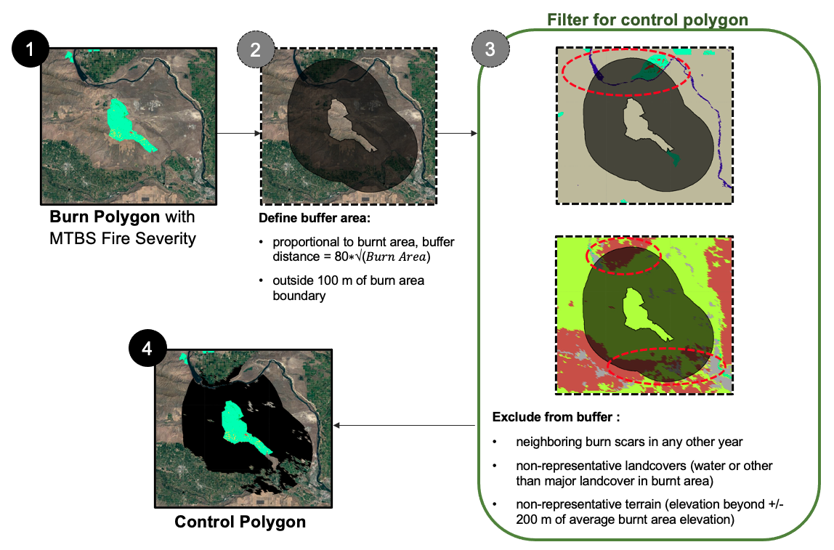

Figure S4. Steps to identify control polygon using MTBS burn polygons, burn severity, MODIS landcover, SRTM digital elevation model, and MODIS water mask product.

