TABLES
Table S1. Experiments performed for Box Behnken Experimental Design, including results for tetracycline (TC) removal and TIPI, were obtained by the Electrocoagulation process.
Run | q₁: initial pH | q₂: electric current density (Am⁻²) | q₃: time (min) | TC removal 1 (%) | TC removal 2 (%) | TC removal 3 (%) | TIPI 1 (V⁻¹) | TIPI 2 (V⁻¹) | TIPI 3 (V⁻¹)
1 | 6 | 67 | 20 | 95.79 | 95.96 | 96.37 | 0.23 | 0.25 | 0.26
2 | 6 | 94 | 30 | 98.35 | 98.16 | 98.37 | 0.21 | 0.23 | 0.22
3 | 6 | 94 | 10 | 97.40 | 97.29 | 97.83 | 0.20 | 0.22 | 0.21
4 | 6 | 40 | 30 | 96.71 | 93.60 | 94.27 | 0.38 | 0.36 | 0.37
5 | 6 | 40 | 10 | 73.62 | 71.94 | 71.95 | 0.17 | 0.15 | 0.16
6 | 6 | 67 | 20 | 95.40 | 94.66 | 95.92 | 0.26 | 0.24 | 0.25
7 | 8 | 67 | 30 | 97.77 | 97.99 | 97.35 | 0.28 | 0.29 | 0.27
8 | 8 | 67 | 10 | 94.56 | 95.37 | 96.45 | 0.27 | 0.27 | 0.26
9 | 4 | 67 | 30 | 98.45 | 97.42 | 98.44 | 0.28 | 0.28 | 0.28
10 | 4 | 67 | 10 | 90.52 | 88.60 | 89.78 | 0.22 | 0.22 | 0.23
11 | 6 | 67 | 20 | 96.79 | 97.16 | 96.27 | 0.27 | 0.27 | 0.26
12 | 8 | 94 | 20 | 96.60 | 98.16 | 98.57 | 0.21 | 0.22 | 0.23
13 | 8 | 40 | 20 | 95.21 | 92.80 | 94.10 | 0.38 | 0.36 | 0.42
14 | 4 | 94 | 20 | 96.77 | 97.53 | 98.20 | 0.21 | 0.24 | 0.23
15 | 4 | 40 | 20 | 93.82 | 93.48 | 92.27 | 0.38 | 0.40 | 0.41
16 | 6 | 67 | 20 | 96.37 | 98.37 | 96.56 | 0.28 | 0.28 | 0.28

Table S2. ANOVA results for the validation of the TIPI model by the EC treatment of tetracycline.
Factors | Degrees of freedom | Sum of squares | Mean squares | F | p-value
q₁ | 1 | 0.01 | 0.01 | 85 | <10⁻⁶
q₂ | 2 | 0.09 | 0.05 | 261 | <10⁻⁶
q₃ | 2 | 0.03 | 0.02 | 98 | <10⁻⁶
q₁:q₂ | 2 | 0.02 | 0.01 | 62 | <10⁻⁶
q₁:q₃ | 2 | 0.01 | 5x10⁻³ | 27 | <10⁻⁶
q₂:q₃ | 1 | 0.03 | 0.03 | 172 | <10⁻⁶
Regression | 10 | 0.20 | 0.02 | 118 | <10⁻⁶
Lack of fit | 2 | 4x10⁻⁵ | 2x10⁻⁵ | 0.11 | 0.90
Pure error | 35 | 6x10⁻³ | 2x10⁻⁴
Residues | 37 | 6x10⁻³ | 2x10⁻⁴
Total | 47 | 0.20 | 4x10⁻³
R² = 0.9696; R_{adj}=0.9614; F calculated (118) > F tabulated (2.10)

FIGURE
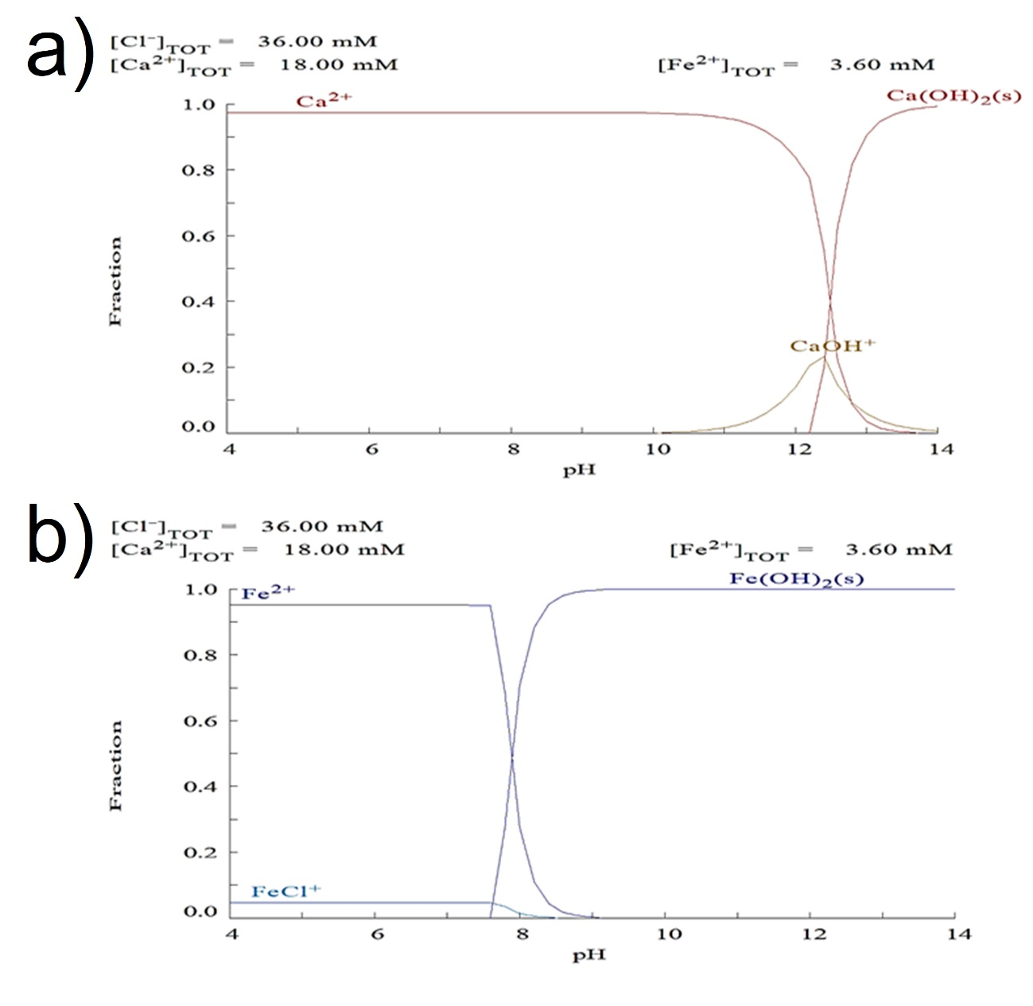

Figure S1. Simulated behaviour of the molar concentration fraction over pH for (a) Ca and (b) Fe species modelled using the Medusa software.

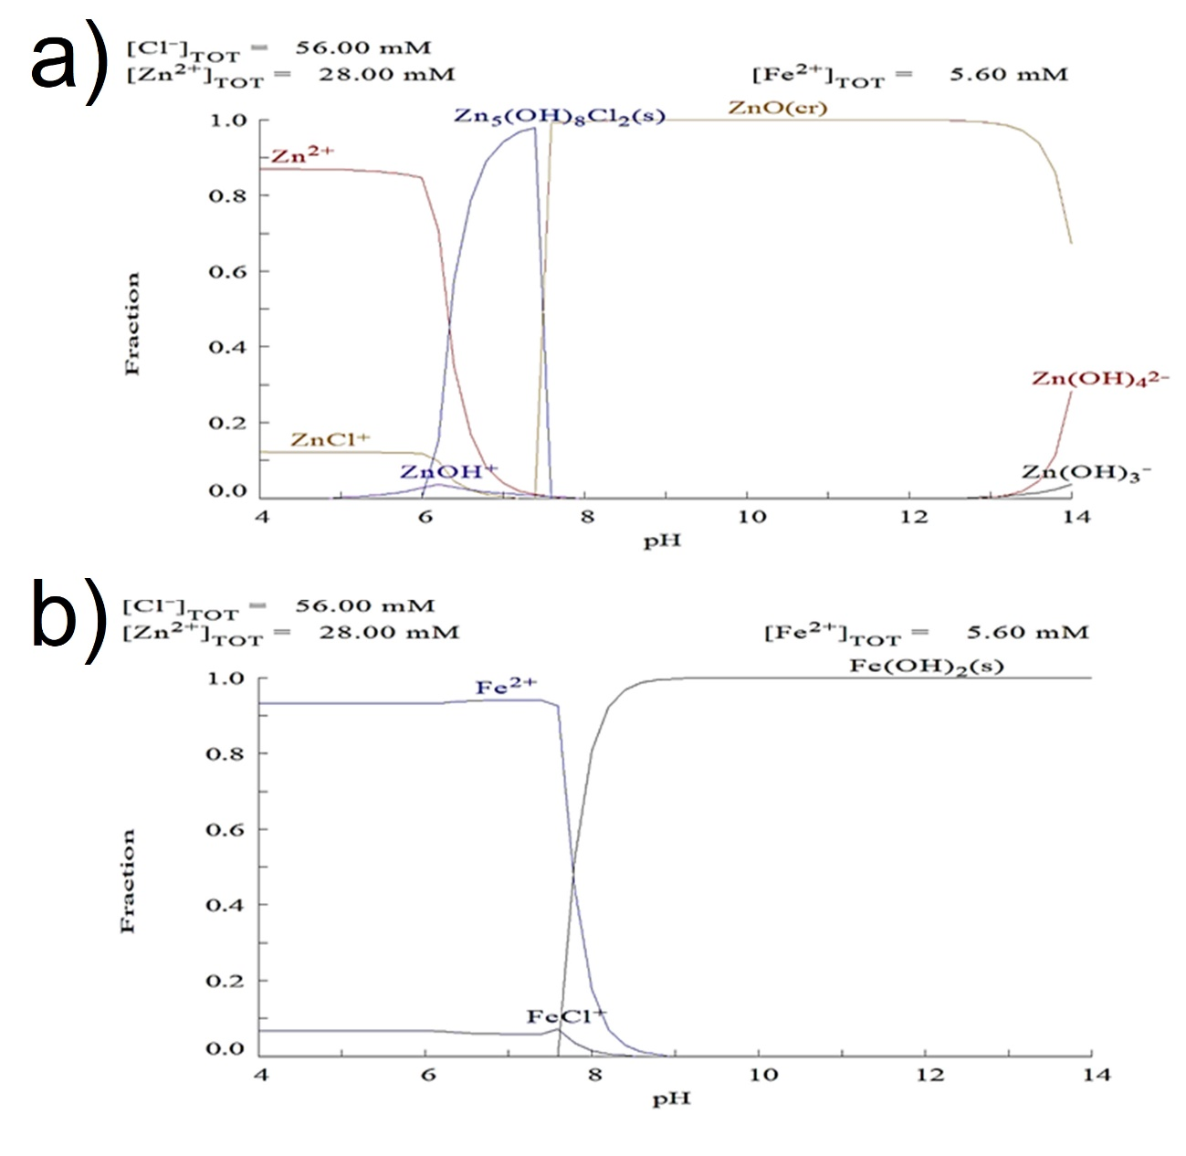
Figure S2. Simulated behaviour of the molar concentration fraction over pH for (a) K and (b) Fe species modelled using the Medusa software.

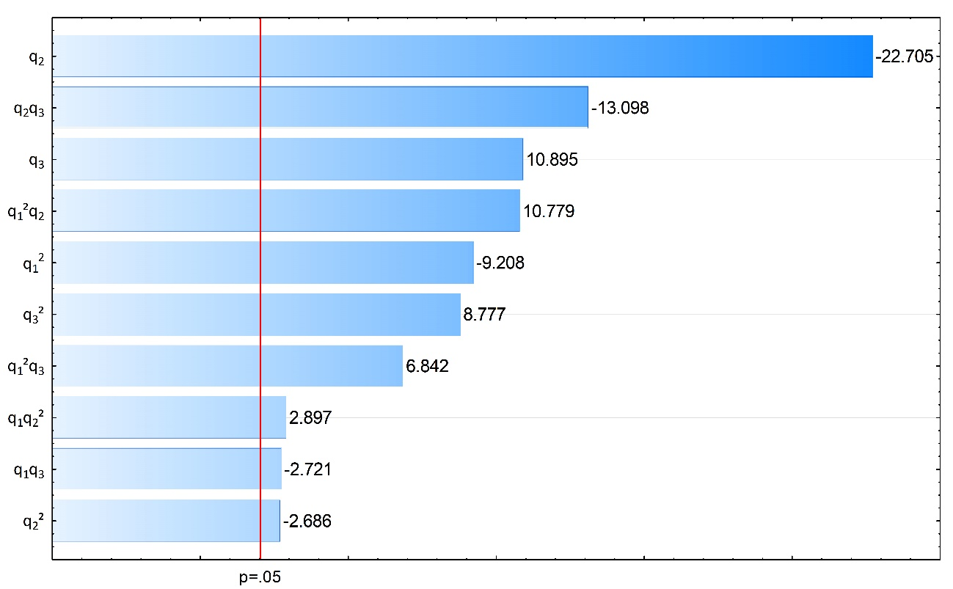
Figure S3. Pareto analysis of EC-based tetracycline removal data in the Box-Behnken design context with the time-integrated performance index (TIPI) as the response variable.

