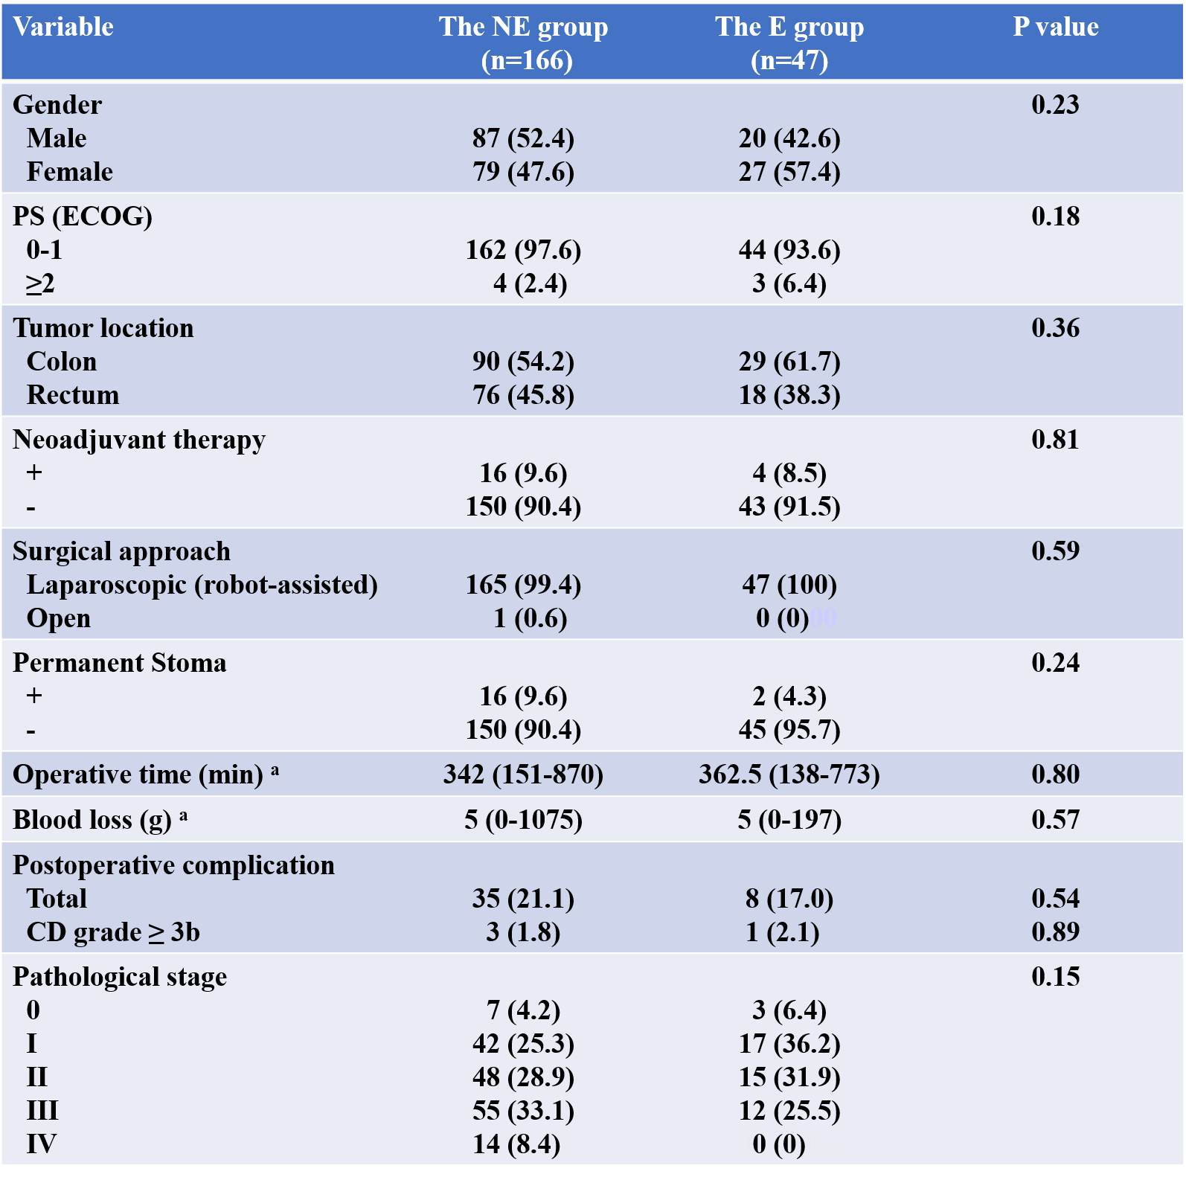

Table 1 Clinicopathological characteristics and surgical outcome of the NE and E groups
Values in parentheses are percentages, unless indicated otherwise. a; Values are median (minimum - maximum).
Abbreviations: CD, Clavien-Dindo classification; E, elderly; ECOG, Eastern Cooperative Oncology Group; n, number of patients; NE, non-elderly; PS, performance status

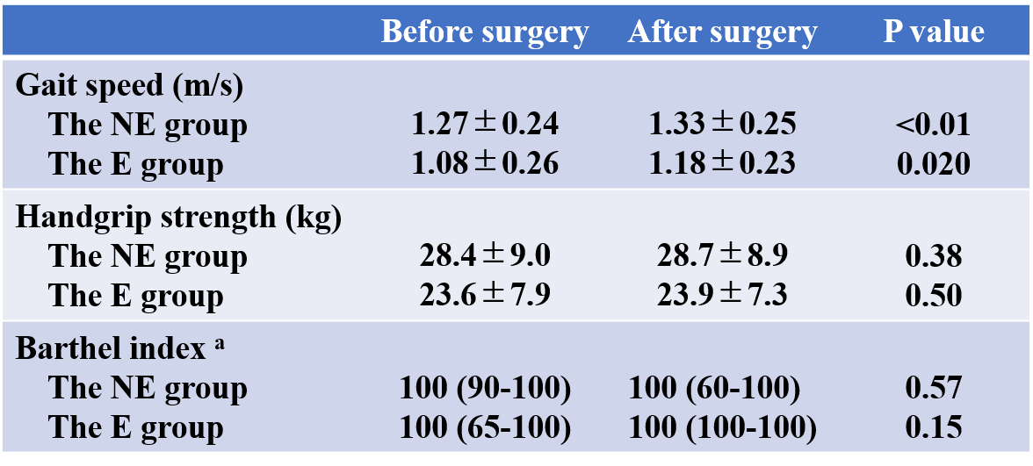

Table 2 The indicators of physical function
Values are presented as mean ± standard deviation, unless indicated otherwise. a; Values are median (minimum - maximum).
Abbreviations: E, elderly; NE, non-elderly

