Figure S1
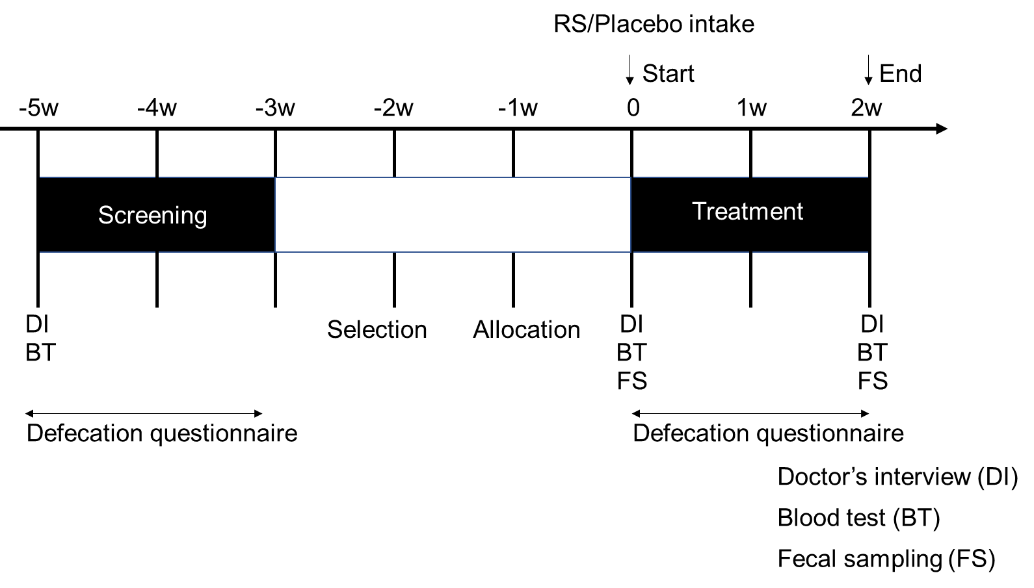
Figure S1. Test schedule for human trial.

Figure S2
Figure S2. Flow chart of participant selection.

Figure S3
Figure S3. RS increases excretion days per week. **p < 0.01. n = 19, error bars indicate SD.

Figure S4
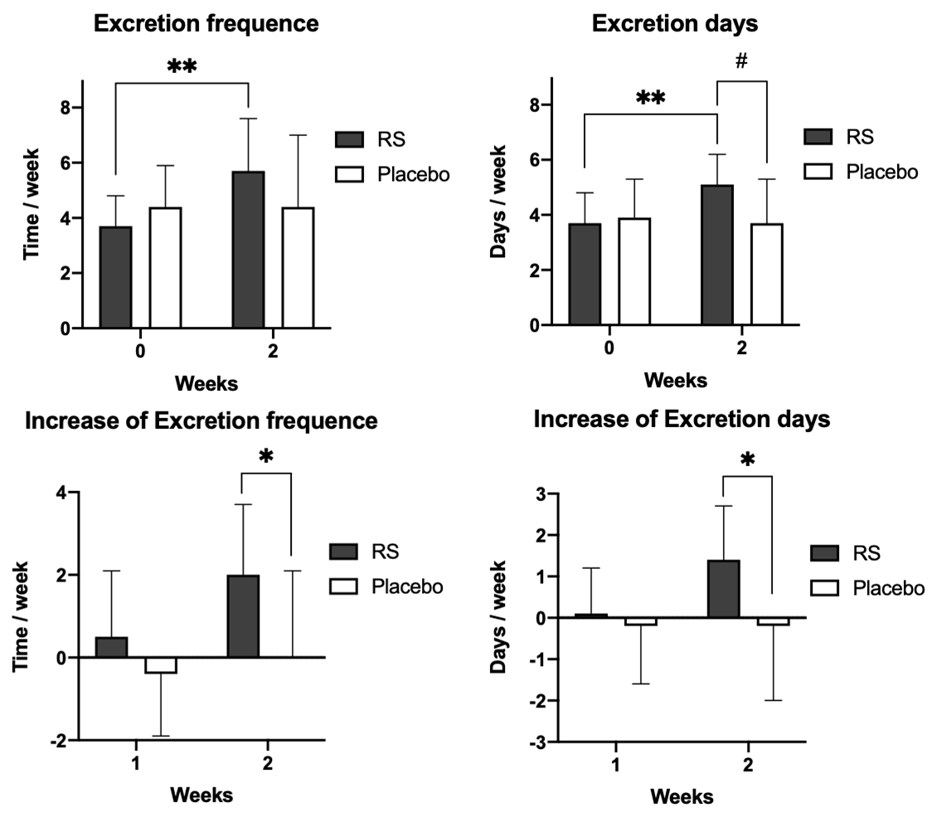
Figure S4. Re-analysis of constipated phenotypes in high-diversity subjects, *p < 0.05, **p < 0.01 and #p < 0.05. n = 9–10, error bars indicate SD.

