Supplementary Table 1. Land use history, including the crops grown and liming timeline from 2002 to 2019.

Growing season |  | Crops | Liming
2002/2003 | Nov. | Oriza sativa | 2000 kg ha⁻¹ of dolomitic lime (71% ECCE†)
2002/2003 | Apr. | Avena strigosa | 2000 kg ha⁻¹ of dolomitic lime (71% ECCE†)
2003/2004 | Jan. | Phaseolus vulgaris | -
2003/2004 | Apr. | Avena strigosa | -
2004/2005 | Nov. | Arachis hypogaea | -
2004/2005 | Apr. | Avena sativa | -
2005/2006 | Nov. | Arachis hypogaea | -
2005/2006 | May | Avena sativa | -
2006/2007 | Feb. | Zea mays | -
2006/2007 | Jun. | Avena strigosa | -
2007/2008 | Dec. | Zea mays | 2500 kg ha⁻¹ of dolomitic lime (76% ECCE†)
2007/2008 | Jun. | Avena sativa | 2500 kg ha⁻¹ of dolomitic lime (76% ECCE†)
2008/2009 | Dec. | Glycine max | -
2008/2009 | Mar. | Zea mays | -
2009/2010 | Oct. | Glycine max | -
2009/2010 | Mar. | Sorghum vulgare | -
2010/2011 | Oct. | Glycine max | -
2010/2011 | Mar. | Zea mays | -
2011/2012 | Oct. | Glycine max | -
2011/2012 | Mar. | Zea mays | -
2012/2013 | Oct. | Glycine max | 3000 kg ha⁻¹ of dolomitic lime (88% ECCE†)
2012/2013 | Mar. | Zea mays | 3000 kg ha⁻¹ of dolomitic lime (88% ECCE†)
2013/2014 | Oct. | Glycine max | -
2013/2014 | Mar. | Zea mays | -
2014/2015 | Oct. | Glycine max | -
2014/2015 | Mar. | Zea mays | -
2015/2016 | Oct. | Glycine max | -
2015/2016 | Mar. | Zea mays | -
2016/2017 | Oct. | Glycine max | 5000 kg ha⁻¹ of dolomitic lime (69% ECCE)
2016/2017 | Mar. | Zea mays | 5000 kg ha⁻¹ of dolomitic lime (69% ECCE)
2017/2018 | Oct. | Glycine max | -
2017/2018 | Mar. | Zea mays | -
2018/2019 | Ago. | Fallow | -
2018/2019 | Jan. | Brachiaria varieties* | -
Lime reapplication was performed when base saturation reached ≤ 50%.
†ECCE: effective calcium carbonate equivalents
*Beginning of the experiment

Supplementary Table 2. Soil texture characteristics before the experiment implementation.
Soil Texture
Clay | Silt | Total Sand
(g/ Kg)
309 | 35 | 656

Supplementary Table 3. Characteristics of the varieties of Brachiaria selected in this study.
Varieties/ Characteristics | BR  Brachiaria ruziziensis | BP  Brachiaria brizantha cv. BRS Paiaguás | BM  Brachiaria brizantha cv. Marandu | BI  Brachiaria spp. cv. Ipyporã - BRS RB331
Usage | Grazing and hay | Grazing and hay | Grazing and hay | Grazing and hay
Intercropping | All legumes | All legumes | All legumes | All legumes
Life cycle | Perennial | Perennial | Perennial | Perennial
Drought tolerance | Good | Tolerant | Good | Good
Leafhopper tolerance | Medium | Medium | High | High
Waterlogging tolerance | Medium | Medium | Low | Low
Tolerance to cold | Medium | Medium | Good | Good
Digestibility | High | High | High | Super High
Palatability | Good | Good | Good | Good
Altitude | Up to 2000m | Up to 2000m | Up to 2000m | Up to 2000m
Annual precipitation | Over 1000m | Over 800m | Over 1000m | Over 1000m
Growth habit | Clumping | Tufted | Tufted | Tufted
Germination | 7 to 21 days | 7 to 21 days | 7 to 21 days | 7 to 21 days
Planting depth | 2 to 3 cm | 2 to 3 cm | 2 to 3 cm | 2 to 6 cm
Breeding goals | Resistance to pasture plague insects (Notozulia entreriana and Deois flavopicta) | High productivity and resistance to drought and pests | High productivity and adaptation to different soils | Resistance to pasture plague insects (Notozulia entreriana and Deois flavopicta)
Source: <https://www.pasoita.com.br/en/> and <https://www.embrapa.br/>
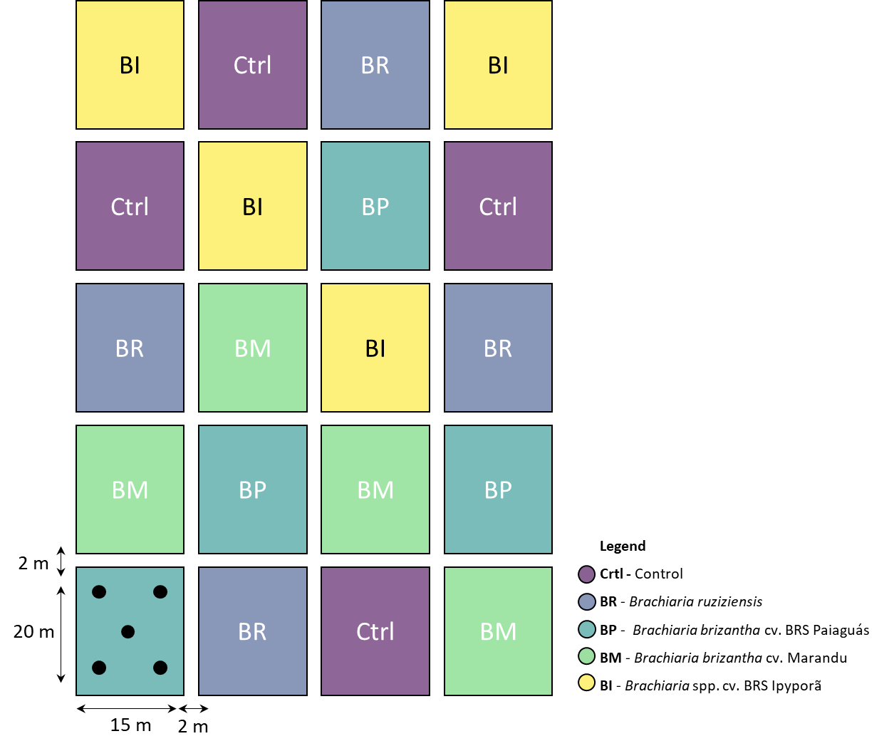
Supplementary Figure 1. Schematic graphic representing the experimental study design, size, and distribution of each plot. Black dots represent the points sampled within each plot and mixed to form a composite sample per plot.

Supplementary Table 4. Description of primers used in qPCR and amplicon sequencing analysis.
Target genes |  | *DSMZ  code | Primers | Sequences  (5’- 3’) | Fragment length  (pb) | References | Amplification condition
qPCR | 16S rRNA of Bacteria | 11192  (Gordonia sp.) | Eub 338f  Eub 518r | ACTCCTACGGGAGGCAGCAG  ATTACCGCGGCTGCTGG | 180 | Bakke et al. (2011) | qPCR: 95°C-10 min, 40 cycles, 95°C-40s, 54°C-40s, 72°C-40s; Melting: 95°C-15s, 55°C-1 min, 95°C-15s
qPCR | 16S rRNA of Archaea | 23604  (Methanolinea mesophile) | 519F  915R | CAGCCGCCGCGGTAA  GTGCTCCCCCGCCAATTCCT | 397 | Coolen et al. (2004);  Stahl, Amann (1991) | qPCR: 95°C-10 min; 40 cycles, 95°C-30s, 57°C-30s, 72°C-50s; Melting: 95°C-15s, 57°C-1 min, 95°C-15s
qPCR | ITS | Fragment isolated from Rhizoctonia solani | ITS1f  5.8S | CTTGGTCATTTAGAGGAAGTAA  CGCTGCGTTCTTCATCG | 300 | Fierer at al. (2005) | qPCR: 94°C-15 min; 40 cycles, 94°C-1min, 53°C-30s, 72°C-1min; Melting: 95°C-15s, 72°C-1 min, 96°C-15s
qPCR | amoA of Bacteria | 28437  (Nitrosomonas europaea) | amoB 1F  amoB 2R | GGG GTT TCT ACT GGT GGT  CCC CTC KGS AAA GCC TTC TTC | 491 | Rotthauwe et al. (1997) | qPCR: 95ºC-10 min; 40 cycles, 95ºC-45s, 60ºC-45s, 72ºC-45s; Melting: 95ºC-15s, 60ºC-1 min, 95ºC-15s
qPCR | amoA of Archaea | Environmental DNA | amoA1F  amoA 2R | STA ATG GTC TGG CTT AGA CG  GCG GCC ATC CAT CTG TAT GT | 635 | Francis et al. (2005) | qPCR: 95ºC-5 min, 40 cycles, 95ºC-40s, 56ºC-30s, 72ºC-1 min; Melting: 95ºC-15s, 57ºC-1 min, 95ºC-15s
 | nifH | 17167 | F | AAA GGY GGW ATC GGY AAR TCC ACC AC | 457 | Wallenstein and Vilgalys (2005) | 95°C-10 min; 40 cycles, 95°C-1 min, 55°C-27s, 95°C-15s, 55°C-1 min, 95°C-15s
 |  |  | R | TTG TTS GCS GCR TAC ATS GCC ATC AT |  | Wallenstein and Vilgalys (2005)
Amplicon sequencing | 16S rRNA  (v4 region) | - | 515F | GTGYCAGCMGCCGCGGTAA | 300 | Caporaso et al. (2011) | PCR: 25μl, Roche FastStart High Fi Taq, 58°C, 26 cycles
Amplicon sequencing | 16S rRNA  (v4 region) | - | 806R | GGACTACNVGGGTWTCTAAT | 300 | Caporaso et al. (2011) | PCR: 25μl, Roche FastStart High Fi Taq, 58°C, 26 cycles
Amplicon sequencing | 16S rRNA  (v4 region) | - | 1132r | CCGTCAATTHCTTYAART | 300 | Caporaso et al. (2011) | PCR: 25μl, Roche FastStart High Fi Taq, 58°C, 26 cycles
Amplicon sequencing | ITS | - | ITS1F | CTTGGTCATTTAGAGGAAGTAA | Variable | Gardes, Bruns (1993);  Smith, Peavy (2014) | PCR: 25μl, Qiagen HotStar Taq, 52°C, 33 cycles
Amplicon sequencing | ITS | - | ITS2 | GCTGCGTTCTTCATCGATGC | Variable | Gardes, Bruns (1993);  Smith, Peavy (2014) | PCR: 25μl, Qiagen HotStar Taq, 52°C, 33 cycles

*Reference code of the cell catalog of the Leibniz Institute DSMZ (Deutsche Sammlung von Mikroorganismen und Zellkulturen GmbH), used in the construction of the standard curves for qPCR analysis

Supplementary Table 5. Count sequences from 16S rRNA and ITS after-processing step (which includes filtering, denoise, merging, and removal of chimerical sequences) and after rarefaction.
Sample_ID | ITS |  | 16S
 | After processing | After rarefaction | After processing | After rarefaction
BR_1 | 38640 | 22687 | 41388 | 27585
BR_2 | 49775 | 22687 | 42734 | 27585
BR_3 | 53181 | 22687 | 44098 | 27585
BR_4 | 28702 | 22687 | 42407 | 27585
BP_1 | 44935 | 22687 | 38990 | 27585
BP_2 | 28808 | 22687 | 47004 | 27585
BP_3 | 22798 | 22687 | 38414 | 27585
BP_4 | 26671 | 22687 | 37135 | 27585
BM_1 | 38299 | 22687 | 41576 | 27585
BM_2 | 37814 | 22687 | 44197 | 27585
BM_3 | 22687 | 22687 | 36267 | 27585
BM_4 | 52041 | 22687 | 46263 | 27585
BI_1 | 28869 | 22687 | 40776 | 27585
BI_2 | 27214 | 22687 | 49721 | 27585
BI_3 | 35133 | 22687 | 45691 | 27585
BI_4 | 28593 | 22687 | 60923 | 27585
Ctrl_1 | 43864 | 22687 | 32637 | 27585
Ctrl_2 | 40237 | 22687 | 27598 | 27585
Ctrl_3 | 38460 | 22687 | 40114 | 27585
Ctrl_4 | 40561 | 22687 | 57308 | 27585
Total | 727282 | 453740 | 855241 | 551700
Ctrl – Control; BR - Brachiaria ruziziensis; BP - Brachiaria brizantha cv. BRS Paiaguás; BM - Brachiaria brizantha cv. Marandu; BI - Brachiaria spp. cv. BRS Ipyporã.
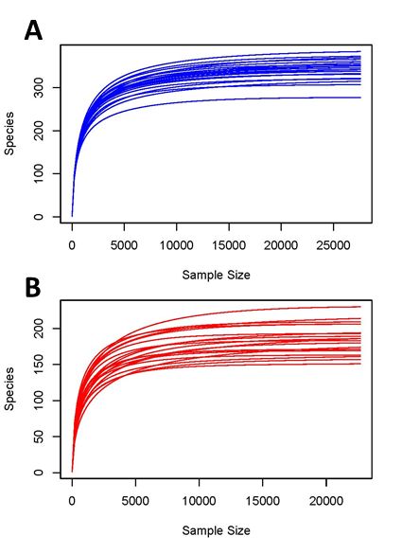
Supplementary Figure 2. Rarefaction curve from 16S rRNA (A) and ITS (B) after-processing step (which includes filtering, denoise, merge and, removal of chimerical sequences).

Supplementary Table 6. Inertia values from the distance-based redundancy analysis (db-RDA).
 | Prokaryotes |  | Fungi
 | Inertia | Proportion (%) | Inertia | Proportion (%)
Total | 0.6026 | 100 | 2.9187 | 100
Constrained | 0.3465 | 57.51 | 1.8350 | 62.87
Unconstrained | 0.2560 | 42.49 | 1.0836 | 37.13

Supplementary Table 7. Adonis test result for the bacterial and fungal soil communities. The analysis was based on the Bray-Custis distance with 999 permutations. The analysis model considered the block as an aleatory factor and the varieties of Brachiaria as a fixed factor.
 | Prokaryotes | Fungi
Model R² (%) | 57.5 | 62.9%
F-Value | 5.07 | 6.35
P-Value | <0.01 | <0.01

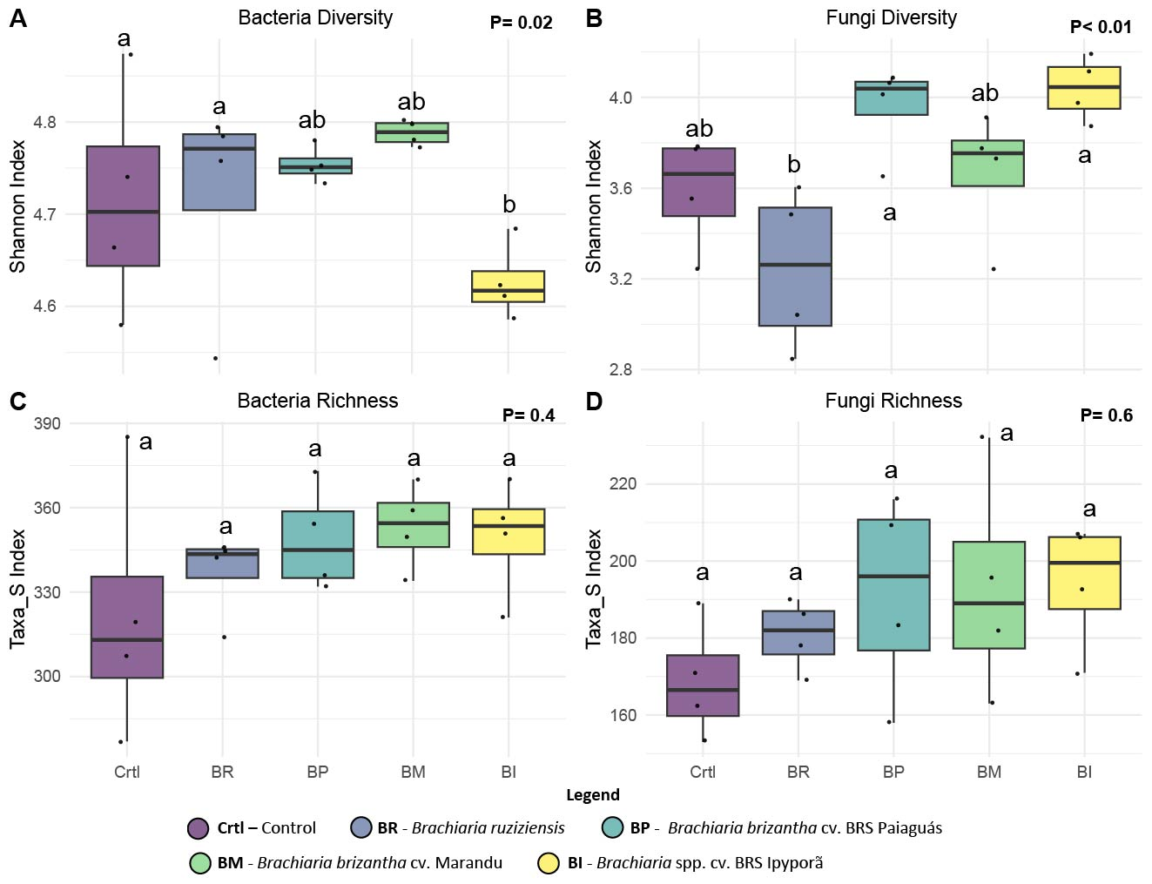
Supplementary Figure 3. Box-plot representing the prokaryotic diversity (A) and richness (C) and fungal diversity (B) and richness (D). Prokaryotic data was based on 16S rRNA sequencing classification at the genera level, and fungal data was based on ITS sequencing classification at the specie level. Lower case letters indicate statistical differences based on the One-Way ANOVA test, followed by the LSD test to compare groups (P<0.05) with p-value adjusted by Bonferroni correction.

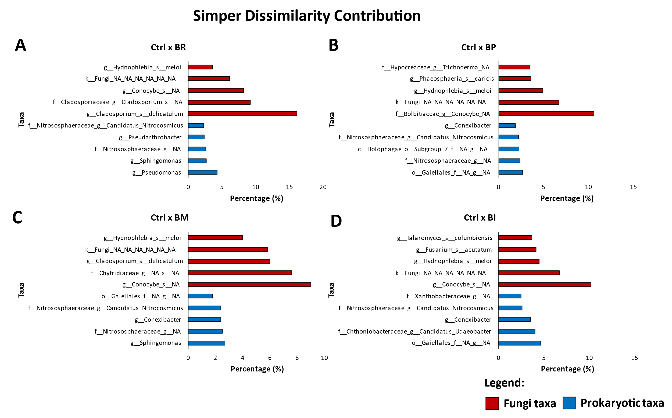
Supplementary Figure 4. Top 5 Fungi and Prokaryotic taxa that contributed (in %) to Simper dissimilarity analysis between the Control and each variety of Brachiaria. Ctrl – Control; BR - Brachiaria ruziziensis; BP - Brachiaria brizantha cv. BRS Paiaguás; BM - Brachiaria brizantha cv. Marandu; BI - Brachiaria spp. cv. BRS Ipyporã.

Supplementary Table 8. Potential predicted functions results (%) according to the FAPROTAX database (for prokaryotic communities).
Potential Functions | Ctrl | BR | BP | BM | BI | Average
chemoheterotrophy | 26.02 | 32.59 | 28.85 | 29.73 | 26.69 | 28.78
aerobic_chemoheterotrophy | 25.77 | 32.37 | 28.48 | 29.17 | 26.43 | 28.44
nitrification | 9.00 | 3.96 | 5.56 | 5.83 | 7.45 | 6.36
aerobic_ammonia_oxidation | 9.00 | 3.96 | 5.52 | 5.83 | 7.45 | 6.35
nitrate_reduction | 2.24 | 2.51 | 2.14 | 1.89 | 2.31 | 2.22
nitrogen_fixation | 1.55 | 2.6 | 2.25 | 1.95 | 2.58 | 2.19
nitrate_respiration | 1.74 | 1.5 | 1.78 | 1.59 | 1.92 | 1.7
nitrogen_respiration | 1.74 | 1.5 | 1.78 | 1.59 | 1.92 | 1.7
phototrophy | 1.80 | 1.17 | 1.74 | 1.57 | 1.86 | 1.63
photoheterotrophy | 1.71 | 1.17 | 1.73 | 1.57 | 1.85 | 1.61
photoautotrophy | 1.80 | 1.14 | 1.68 | 1.52 | 1.85 | 1.6
nitrate_denitrification | 1.71 | 1.14 | 1.69 | 1.55 | 1.84 | 1.58
nitrite_denitrification | 1.71 | 1.14 | 1.69 | 1.55 | 1.84 | 1.58
nitrous_oxide_denitrification | 1.71 | 1.14 | 1.69 | 1.55 | 1.84 | 1.58
denitrification | 1.71 | 1.14 | 1.69 | 1.55 | 1.84 | 1.58
nitrite_respiration | 1.71 | 1.14 | 1.69 | 1.55 | 1.84 | 1.58
anoxygenic_photoautotrophy_S_oxidizing | 1.71 | 1.14 | 1.68 | 1.52 | 1.84 | 1.58
anoxygenic_photoautotrophy | 1.71 | 1.14 | 1.68 | 1.52 | 1.84 | 1.58
aromatic_compound_degradation | 1.12 | 1.06 | 1.51 | 1.59 | 1.09 | 1.27
cellulolysis | 1.32 | 1 | 1.48 | 1.14 | 0.89 | 1.16
ureolysis | 0.94 | 1.64 | 0.99 | 1.03 | 0.83 | 1.08
*Rare | 2.26 | 3.91 | 2.78 | 3.21 | 2.01 | 2.83
predatory_or_exoparasitic | 0.72 | 1.06 | 1.06 | 0.72 | 0.76 | 0.86
intracellular_parasites | 0.38 | 0.5 | 0.44 | 0.53 | 0.47 | 0.46
fermentation | 0.32 | 0.78 | 0.32 | 0.32 | 0.27 | 0.4
manganese_oxidation | 0.32 | 0.42 | 0.34 | 0.35 | 0.12 | 0.31
nonphotosynthetic_cyanobacteria | 0.24 | 0.16 | 0.2 | 0.18 | 0.17 | 0.19
animal_parasites_or_symbionts | 0.04 | 0.66 | 0.03 | 0.04 | 0.05 | 0.16
aromatic_hydrocarbon_degradation | 0.00 | 0.06 | 0.08 | 0.27 | 0.01 | 0.08
aliphatic_non_methane_hydrocarbon_degradation | 0.00 | 0.06 | 0.08 | 0.27 | 0.01 | 0.08
hydrocarbon_degradation | 0.00 | 0.06 | 0.08 | 0.27 | 0.01 | 0.08
chloroplasts | 0.05 | 0.04 | 0.05 | 0.06 | 0.08 | 0.05
dark_oxidation_of_sulfur_compounds | 0.01 | 0.09 | 0.05 | 0.08 | 0.04 | 0.05
photosynthetic_cyanobacteria | 0.09 | 0 | 0 | 0 | 0.01 | 0.02
oxygenic_photoautotrophy | 0.09 | 0 | 0 | 0 | 0.01 | 0.02
chitinolysis | 0.00 | 0.01 | 0 | 0.05 | 0.02 | 0.02
methanol_oxidation | 0.00 | 0 | 0.01 | 0.03 | 0 | 0.01
methylotrophy | 0.00 | 0 | 0.01 | 0.03 | 0 | 0.01
dark_hydrogen_oxidation | 0.00 | 0 | 0.01 | 0.03 | 0 | 0.01
aerobic_nitrite_oxidation | 0.00 | 0 | 0.04 | 0 | 0 | 0.01
iron_respiration | 0.01 | 0 | 0 | 0 | 0 | 0
*The “Rare” function is based on the sum of functions that represents less than 1%.

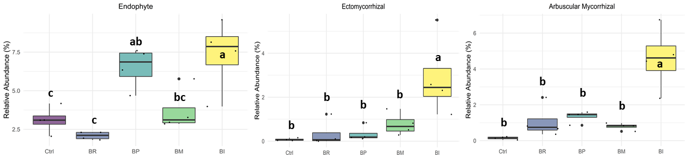
Supplementary Figure 5. Box-plot representing differences in the abundance (%) of fungal functional groups (Guild classification) according to the FUNGuild database (based on ITS sequencing). Low case letters in the box-plot represent functional groups with a statistical difference based on the One-Way ANOVA, followed by the post-hoc Tukey-Kramer test (P < 0.05) and after Benjamini-Hochberg FDR correction. Ctrl – Control; BR - Brachiaria ruziziensis; BP - Brachiaria brizantha cv. BRS Paiaguás; BM - Brachiaria brizantha cv. Marandu; BI - Brachiaria spp. cv. BRS Ipyporã.

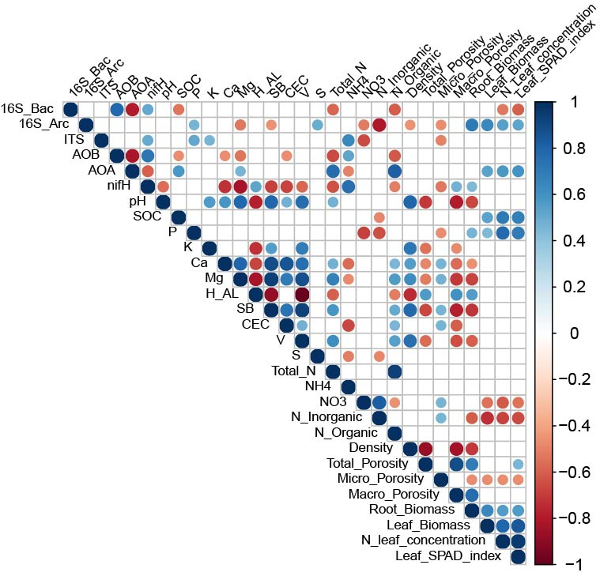
Supplementary Figure 6. Spearman rank correlogram between genes abundance with plant and soil characteristics. The correlation’s p-value was adjusted by Bonferroni correction. Only the significant correlations were plotted.

References
Bakke I, De Schryver P, Boon N, Vadstein O (2011) PCR-based community structure studies of bacteria associated with eukaryotic organisms: a simple PCR strategy to avoid co-amplification of eukaryotic DNA. Journal of microbiological methods 84:349–351
Caporaso JG, Lauber CL, Walters WA, et al (2011) Global patterns of 16S rRNA diversity at a depth of millions of sequences per sample. Proceedings of the national academy of sciences 108:4516–4522
Coolen MJ, Hopmans EC, Rijpstra WIC, et al (2004) Evolution of the methane cycle in Ace Lake (Antarctica) during the Holocene: response of methanogens and methanotrophs to environmental change. Organic Geochemistry 35:1151–1167
Fierer N, Jackson JA, Vilgalys R, Jackson RB (2005) Assessment of soil microbial community structure by use of taxon-specific quantitative PCR assays. Applied and environmental microbiology 71:4117–4120
Francis CA, Roberts KJ, Beman JM, et al (2005) Ubiquity and diversity of ammonia-oxidizing archaea in water columns and sediments of the ocean. Proceedings of the National Academy of Sciences 102:14683–14688
Gardes M, Bruns TD (1993) ITS primers with enhanced specificity for basidiomycetes‐application to the identification of mycorrhizae and rusts. Molecular ecology 2:113–118
Rotthauwe J-H, Witzel K-P, Liesack W (1997) The ammonia monooxygenase structural gene amoA as a functional marker: molecular fine-scale analysis of natural ammonia-oxidizing populations. Applied and environmental microbiology 63:4704–4712
Smith DP, Peay KG (2014) Sequence depth, not PCR replication, improves ecological inference from next generation DNA sequencing. PloS one 9:e90234
Stahl DA (1991) Development and application of nucleic acid probes in bacterial systematics. Nucleic acid techniques in bacterial systematics 205–248
Wallenstein MD, Vilgalys RJ (2005) Quantitative analyses of nitrogen cycling genes in soils. Pedobiologia 49:665–672

