Supplementary Material File

Enhanced electrocatalytic activity of Fluorine Doped Tin Oxide (FTO) by Trimetallic spinel ZnMnFeO₄/CoMnFeO₄ nanoparticles as a novel electrochemical sensor

Jalal Niazi Saei¹, Karim Asadpour-Zeynali^{1,2∗}
¹Department of Analytical Chemistry, Faculty of Chemistry, University of Tabriz, Tabriz 51666-16471, Iran
²Pharmaceutical Analysis Research Center, Faculty of Pharmacy, Tabriz University of Medical Sciences, Tabriz 51664, Iran

  - Apparatus and software
All electrochemical experiments were conducted without eliminating dissolved O₂ at room temperature. In order to measure the pH, a digital pH meter (model Metrohm 827 pH meter) was employed. A three-electrode system has been applied for electrochemical measurements containing modified fluorine doped tin oxide (FTO) with ZnMnFeO4/CoMnFeO4 nanoparticles (FTO) as the working electrode. FTO glass substrate has been bought from Nano Gostar Company of Iran, Isfahan. the saturated calomel (SCE) as the reference electrode and as an auxiliary electrode, a Pt wire which is Immersed Directly in solution has been used respectively. All potentials are reported comparative to the reference electrode. Electrochemical measurements were carried out by employing a Metrohm 757 VA processed computer electrochemical workstation that has been equipped with a three-electrode cell.
With the aim of verification of the associated bands' identification, the Fourier-transform infrared (FT-IR) spectra were recorded on a Bruker Optics TENSOR 27 spectrometer. The structure of crystalline and the purity of the spinel oxides phase were discerned by making use of the X-ray diffraction (XRD) technique its patterns were recorded with Phillips PW 1730 instrument (Eindhoven, Netherlands) with Cu-Kα radiation (λ = 0.154056 nm). Field emission scanning electron microscopy (FESEM) equipped with energy-dispersive X-ray spectroscopy (EDX) enforced on Tescan Mira 3 FESEM with the gold coating system to examine the morphological observation and elemental composition of the developed and prepared sample. Moreover, the transmission electron microscopy (TEM) method is enforced on the Zeiss EM-10C microscope (Germany) at an accelerating voltage of 100 kV was operated to analyze the particle size and textural features. Besides, an ultrasonic bath (FALC, Italy) was utilized to clean the electrode surface.
  - Reagents and solutions
Hydrazine (HZ), Iron (III) nitrate nonahydrate (Fe(NO₃)₃.9H₂O), Manganese dinitrate tetrahydrate (Mn(NO₃)₂.4H2O), zinc dinitrate tetrahydrate (Zn(NO₃)₂.4H₂O), Cobalt dinitrate hexahydrate (Co(NO₃)₂.6H2O) and ammonia solution (25% v/v) were procured from Merck. Ammonia, phosphate, and Britton-Robinson buffers with a concentration of 0.1 M have been utilized. In order to prepare all of the solutions, deionized water was brought into use. 0.1 M Ammonia buffer (pH 9.0) was used as a carrier electrolyte for HZ. All compounds were used in the absence of any further purification.
  - Electrochemical measurements
In accordance with the conditions of the device, the calibration curves for HZ have been schemed by the DPV technique employment. The parameters including step potential = 0.005 V, modulation time = 0.05 s, modulation amplitude = 0.025 V, quiet time = 5 s, and interval time = 0.5 s are the optimized DPV parameters.
Aiming to indicate the application of a modified electrode, the suggested sensor has been appraised with no pretreatment by using cigarettes that were the real sample for HZ in this study. These cigarettes were purchased from a local supermarket and were chosen from three famous brands. In the first place, the tobacco content from the cigarette was removed in order to prepare the real sample. The sample was initially weighed and then, leached in 0.1 M, pH 9.0 ammonia buffer and after all, ultrasonication of the sample was done which took 10 min. Finally, for the purpose of analyzing the real sample, the filtrated solution was diluted properly. In 5 mM [Fe(CN)₆]^{-3/-4} containing 0.1 M KCl, all measurements of electrochemical impedance spectroscopy were carried out accurately. The amplitude of the applied sine wave potential was 5 mV. The total EIS measurements were recorded and registered at open circuit potential (OCP) in the (frequency) range of 100 kHz to 0.01 Hz.
  - Characterization of the ZnMnFeO₄ and CoMnFeO₄ nanoparticles
The spinel ferrites are used in electrochemical sensors in the wake of some features including their superlative electrical and photoelectrochemical performance, high chemical stability, magnetic properties, low price, and good conductivity. Briefly, the modifier used in the present study causes HZ response enhancement and oxidation potential reduction considerably which is by cause of its exceptional conductivity, high adsorption, and high electrochemical surface area of ZnMnFeO₄/CoMnFeO₄/FTO. By means of the FT-IR spectra presented in Fig. S1, the structural formation and functional groups that are provided in the as-synthesized samples together with their metal-oxide vibrational modes are acknowledged explicitly. In the IR spectra of all the ferrite samples, there are generally two metal-oxide bands observed which both pertain to the nature of octahedral M-O stretching vibration and the nature of tetrahedral M-O stretching vibration ¹. In the spectrum of ZnMnFeO₄ (Fig. S1a), the band with greater wave number viewed at 584 cm⁻¹, ascribed to intrinsic stretching vibrations of the metal ions (Zn-O and Fe-O) exist at the tetrahedral site, while the other band viewed at 456 cm⁻¹, correlate to the bending vibrations of the metal ions (Zn-O, Mn-O, and Fe-O) bond in the octahedral site ¹. In the FT-IR spectrum of CoMnFeO₄ (Fig. S1b), the absorption band emerges at 589 cm⁻¹ as a result of the intrinsic stretching vibrations of metal ions (Co-O and Fe-O) bond in the tetrahedral site ². The absorption peak that can be seen at 1630 and 3440 cm⁻¹ corresponds to water molecules ³. The CoMnFeO₄ and ZnMnFeO₄ ferrite samples are synthesized by the hydrothermal route and in Fig. S1c and d, the patterns of X-ray diffraction for these samples can be clearly seen. For both samples which have proper crystallinity and well-defined diffraction lines, a single-phase spinel structure was perceived without any unfavourable phase. There is not any obvious peak detected for both sample. This bears witness that there is a high purity of the synthesized nanostructures. In Fig. S1c Appearing diffraction peaks for synthesized ZnMnFeO₄ nanoparticles at planes of (111), (220), (311), (400), (422), (511), and (440) adapted well with the standard pattern reported in the JCPDS card no. 01-074-2400. And in Fig. S1d the relevant peaks of CoMnFeO₄ at planes of (220), (311), (222), (400), (422), (511), and (440) in the XRD pattern could be indexed to the standard pattern reported in the JCPDS card no. 00-001-1121. Grounded on the XRD diffractograms of both nanoparticles, it can be seen that every one of the peaks is either all even or all odd. This indicates that the samples are spinel in phase ⁴.
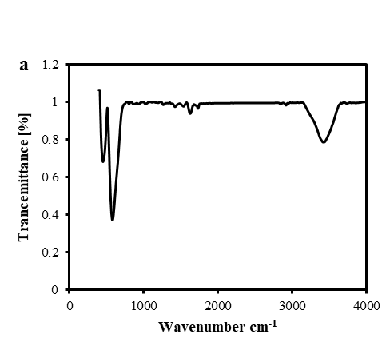 | 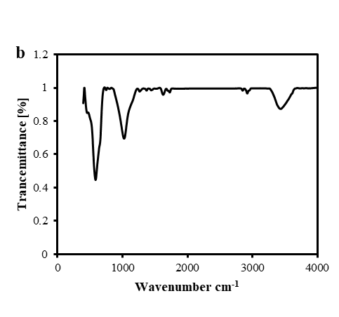
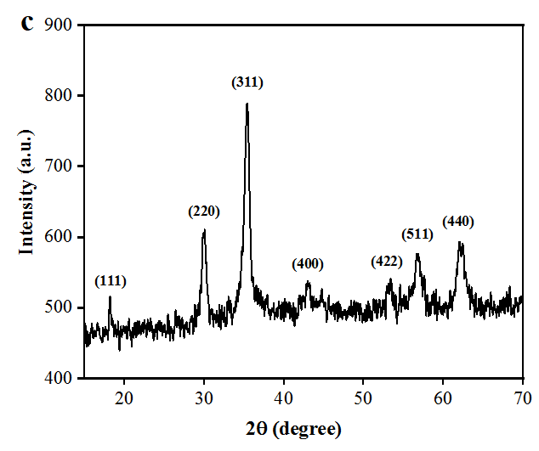 | 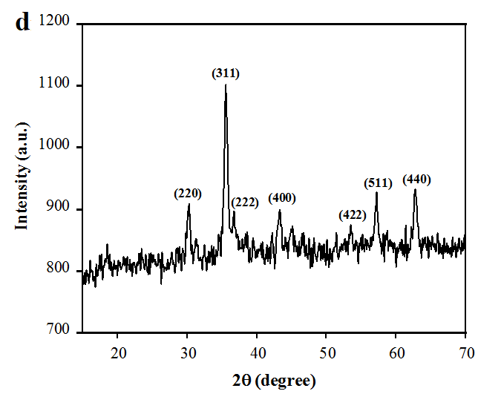
Fig. S1. FT-IR spectrum and XRD pattern of synthesized (a, c) ZnMnFeO₄ NPs and (b, d) CoMnFeO₄ NPs.
  - Electrochemical characterization of the HZ sensor
In order to modify the FTO substrate, the ZnMnFeO₄/CoMnFeO₄ NPs has been used as a modifier, and to control the tests, the FTO substrate was also modified with CoMnFeO₄ and ZnMnFeO₄ and then was defined as CoMnFeO₄/FTO, and ZnMnFeO₄/FTO. The electrochemical behavior of the three freshly modified electrodes including ZnMnFeO₄/CoMnFeO₄/FTO, CoMnFeO₄/FTO, and ZnMnFeO₄/FTO in 0.1 M KCl as a carrier electrolyte, and in 5 mM [Fe(CN)₆]⁻³/[Fe(CN)₆]⁻⁴ as a redox probe at a scan rate of 50 mV.s⁻¹ were evaluated by using the cyclic voltammetry technique significantly and were compared to each other (Fig. S2a). According to the results, the modification of electrodes with ZnMnFeO₄/CoMnFeO₄ created a reduction in the peak-to-peak separation and had higher peak currents compared to the others. In point of fact, the features of the modified electrode such as higher electrical conductivity and the large electroactive surface area make these significant differences between the bare electrode and the ZnMnFeO₄/CoMnFeO₄/FTO electrode.
The electrical conductivity and electron transition resistance of the modified electrode surface has been checked by electrochemical impedance spectroscopy. The EIS spectrum record of the bare FTO electrode and the three modified electrodes cited above is shown in Fig. S2b. Studying the process of charge transfer on the surface of the modified electrode is a practical way. The reason is that there is a double-layer capacitance and also a resistance to interfacial charge transfer change after the modification on the electrode surface. The EIS Nyquist spectra involve a semicircular region and a linear region. The semicircular diameter in the high-frequency region indicates the resistance of the interface charge transfer (Rct) that is shown in Fig. S2b. The Warburg element represents the diffusion process and is associated with the low-frequency region linear section. The transition resistance of the electrodes is characterized by employing a semicircular diameter in the Nyquist designs.
In Fig. S2b, it can be observed that the resistance in charge transfer for the modified CoMnFeO₄/FTO electrode is less than that of the bare electrode. It undoubtedly shows that the CoMnFeO₄ nanoparticles act as a stimulus and speed up the interfacial charge transfer. The diameter of the semicircle in the curve corresponding to the ZnMnFeO₄/FTO electrode is decreased in proportion to the CoMnFeO₄/FTO electrode which represents the high electrical conductivity of the ZnMnFeO₄ compared to the CoMnFeO₄ NPs. In the curve related to ZnMnFeO₄/CoMnFeO₄/FTO, a decrease in charge transfer resistance can be seen after coating of the ZnMnFeO₄ on the CoMnFeO₄/FTO which is a result of a higher electrochemical active surface area and the enhanced charge transfer rate of ZnMnFeO₄/CoMnFeO₄/FTO compared to the other modified electrodes. The Warburg element is also seen in the impedance spectrum (Fig. S2b), indicating the electrolyte diffusion into the coating and showing the porosity of the modifier. This is an essential and critical parameter in the properties of catalysts. It indicates that these two NPs together are being used successfully and they have a positive effect on each other.
  - Study of the active surface area of the HZ sensor
In order to check the electrocatalytic activity of a modified electrode, it is extremely important to recognize the real active surface area of that electrode. For calculating the microscopic surface area of the ZnMnFeO₄/CoMnFeO₄/FTO electrode, the cyclic Voltammetric method was applied in a 0.1 M KCl solution containing 5 mM of [Fe(CN)₆]^{-3/-4} as a redox probe at different scan rates which can be seen in Fig. S2c and the record of I_{p}-ν^{1/2} diagram is presented in Fig. S2d.
The electrochemical active surface area of an electrode was estimated from the slope value of the peak current diagram’s opposing to the diverse scan rates in the Randall-Sevcik equation [1]: I_{p} = (2.69 × 10⁵) n^{3/2} AD^{1/2} ʋ^{1/2} C (1). In this equation, I_{p} refers to peak current (A), C is the concentration [Fe(CN)₆]^{-3/-4} (mol.cm⁻³), υ is scan rate (V.s⁻¹), the number of electrons exchanged is presented with n, D refers to diffusion coefficient (cm².s⁻¹) and A refers to the microscopic surface area of the electrode (cm²). In the KCl solution, the coefficient of diffusion for the required probe is 0.2 M equal to 7.6 × 10⁻⁶ (cm².s⁻¹).
The effective electrochemical surface area was computed at 1.72 cm² for ZnMnFeO₄/CoMnFeO₄ NPs. This implies the fact that the modifier has enhanced the effective electrochemical surface of the FTO glass substrate and qualified this sensor for electrochemical sensing.
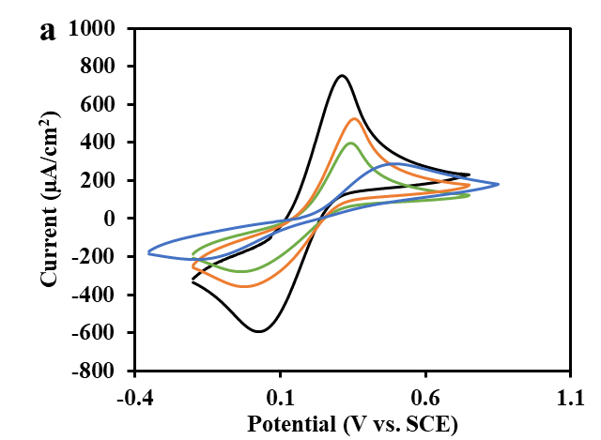 | 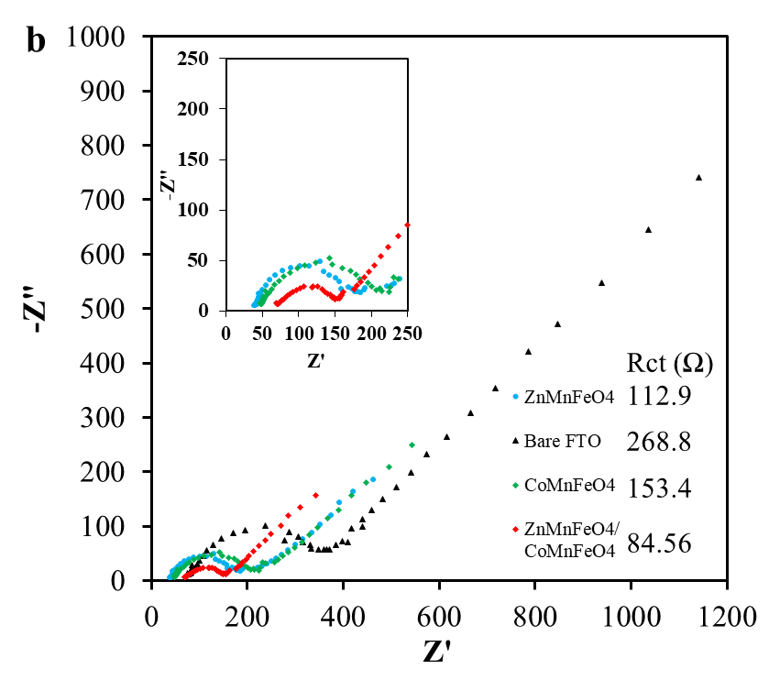  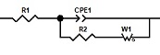
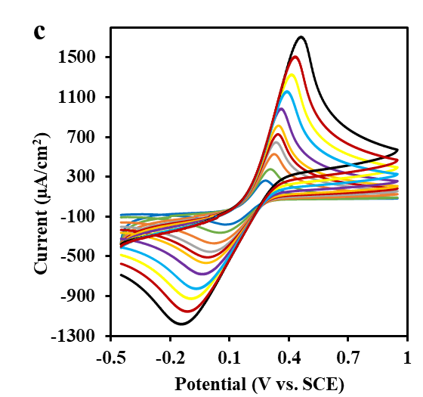 | 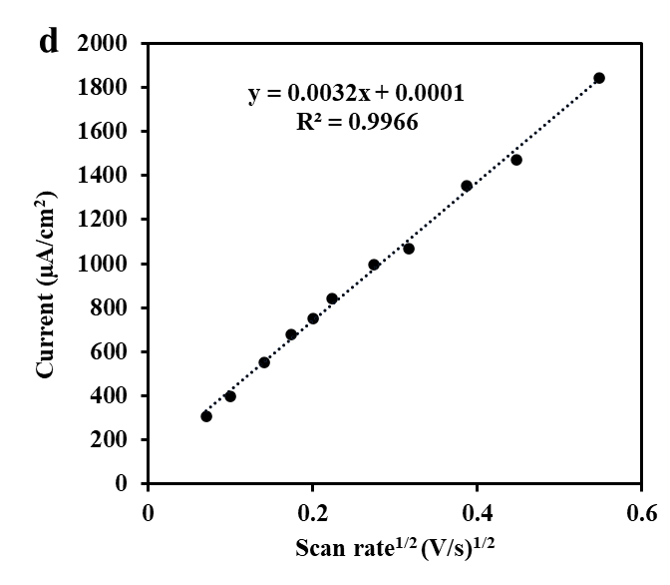
Fig. S2. (a) Cyclic Voltammograms for varied electrodes in 5mM [Fe(CN)₆]⁻³/[Fe(CN)₆]⁻⁴ with KCl 0.1M as supporting electrolyte at the scan rate of 50 mV.s⁻¹. (a) Bare FTO; (b) CoMnFeO₄/FTO; (c) ZnMnFeO₄/FTO; (d) ZnMnFeO₄/CoMnFeO₄/FTO; (b) Electrochemical impedance spectroscopy (EIS) of Bare FTO and the other modified electrodes in 5mM [Fe(CN)₆]⁻³/[Fe(CN)₆]⁻⁴ with KCl 0.1M, (c) CV responses of the ZnMnFeO₄/CoMnFeO₄/FTO in 5mM [Fe(CN)₆]⁻³/[Fe(CN)₆]⁻⁴ containing 0.1 M KCl at the scan rates of 5, 10, 20, 30, 40, 50, 75, 100, 150, 200, 300 mV.s⁻¹ (inner to outer), (d) Diagram of peak current against square root of the scan rates.

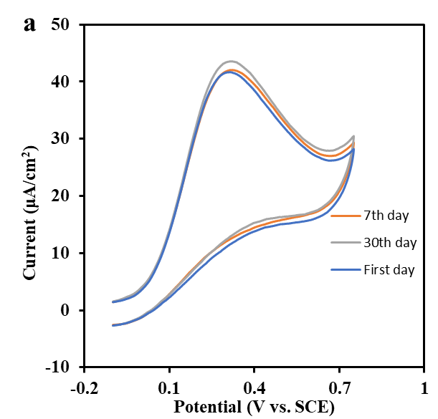 | 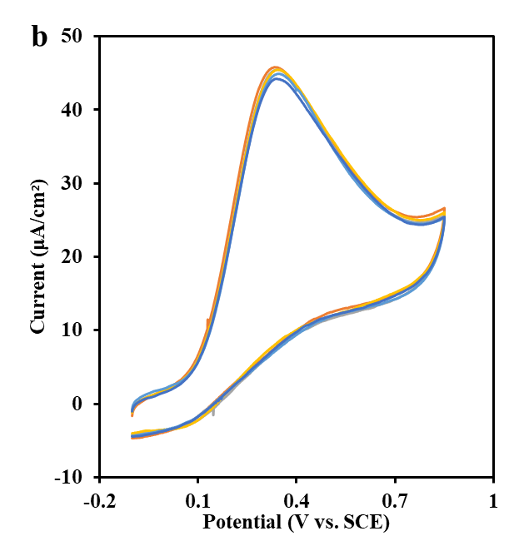
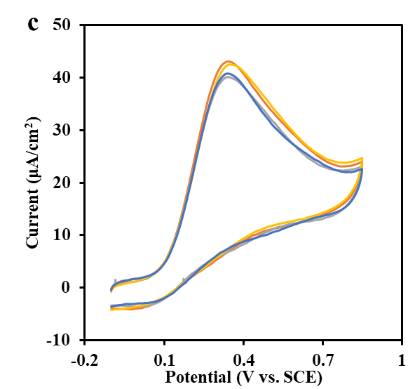
Fig. S3. (a) stability of the ZnMnFeO₄/CoMnFeO₄/FTO electrode at the first, 7th and 30th days, (b) is repeatability and (c) is the reproducibility of the ZnMnFeO₄/CoMnFeO₄/FTO electrode.

References
1. Patil, R., Delekar, S., Mane, D. & Hankare, P. Synthesis, structural and magnetic properties of different metal ion substituted nanocrystalline zinc ferrite. Results in Physics 3, 129-133 (2013).
2. Ghadimi, L. S., Arsalani, N., Ahadzadeh, I., Hajalilou, A. & Abouzari-Lotf, E. Effect of synthesis route on the electrochemical performance of CoMnFeO4 nanoparticles as a novel supercapacitor electrode material. Applied Surface Science 494, 440-451 (2019).
3. Baby, J. N., Sriram, B., Wang, S.-F. & George, M. Effect of various deep eutectic solvents on the sustainable synthesis of MgFe2O4 nanoparticles for simultaneous electrochemical determination of nitrofurantoin and 4-nitrophenol. ACS Sustainable Chemistry & Engineering 8, 1479-1486 (2020).
4. Hajalilou, A., Hashim, M., Ebrahimi-Kahrizsangi, R. & Sarami, N. Influence of CaO and SiO2 co-doping on the magnetic, electrical properties and microstructure of a Ni–Zn ferrite. Journal of Physics D: Applied Physics 48, 145001 (2015).

∗ Corresponding author: K. Asadpour-Zeynali Tel.: +98 413 3393113; Fax: +98 413 3340191. E-mail address: asadpour@tabrizu.ac.ir; k.zeynali@gmail.com

