Supplementary File 4. Additional photographic images of priapulid teeth generated for this study.
Geometric morphometrics of macro- and meiofaunal priapulid pharyngeal teeth provides a proxy for studying Cambrian “tooth taxa”. Zoomorphology.
Joel Vikberg Wernström¹, Ben J. Slater², Martin V. Sørensen³, Denise Crampton⁴ & Andreas Altenburger^{1*}
^{1.} The Arctic University Museum of Norway (UMAK) – UiT The Arctic University of Norway, Lars Thørings veg 10, 9006 Tromsø, Norway
^{2.} Department of Earth Sciences, Palaeobiology, Uppsala University, Geocentrum, Villavägen 16, 75236 Uppsala, Sweden
^{3.} Natural History Museum of Denmark, University of Copenhagen, 2100, Copenhagen, Denmark
^{4.} School of Natural Sciences, Bangor University, Bangor, Gwynedd LL57 2UW, United Kingdom & Research Centre in Evolutionary Anthropology and Palaeoecology, School of Biological Environmental Sciences, Liverpool John Moores University, Liverpool, L3 3AF UK
* Corresponding author (andreas.altenburger@uit.no)

Priapulus caudatus, UiT The Arctic University of Norway, The Arctic University Museum of Norway. Museum specimen. UMAK specimen TSZY-106.
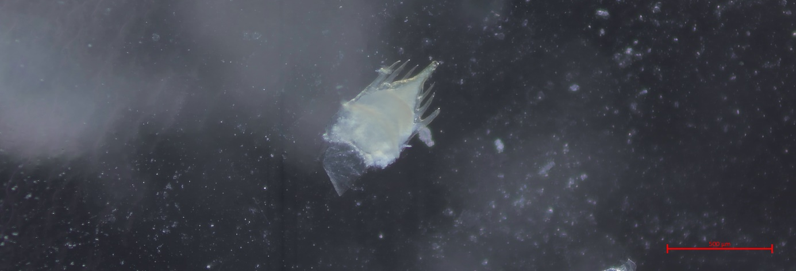
Fig. 1.
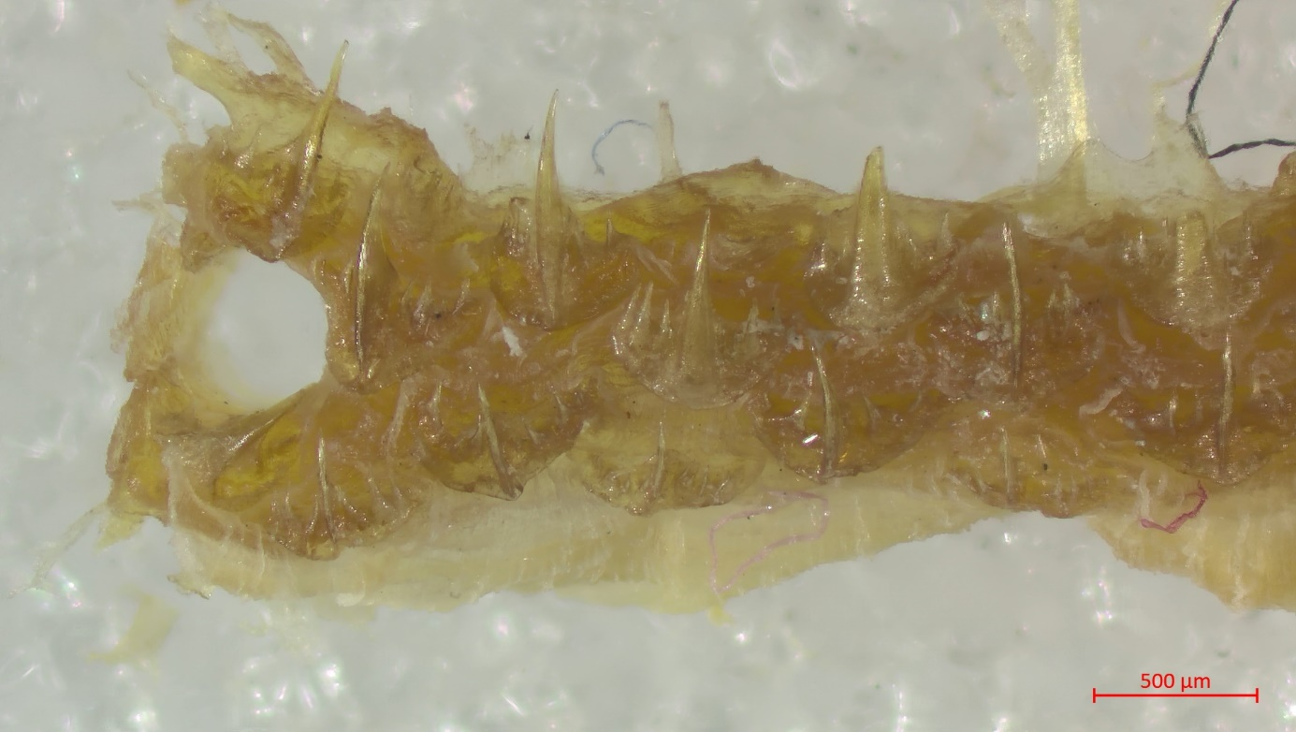
Fig. 2.
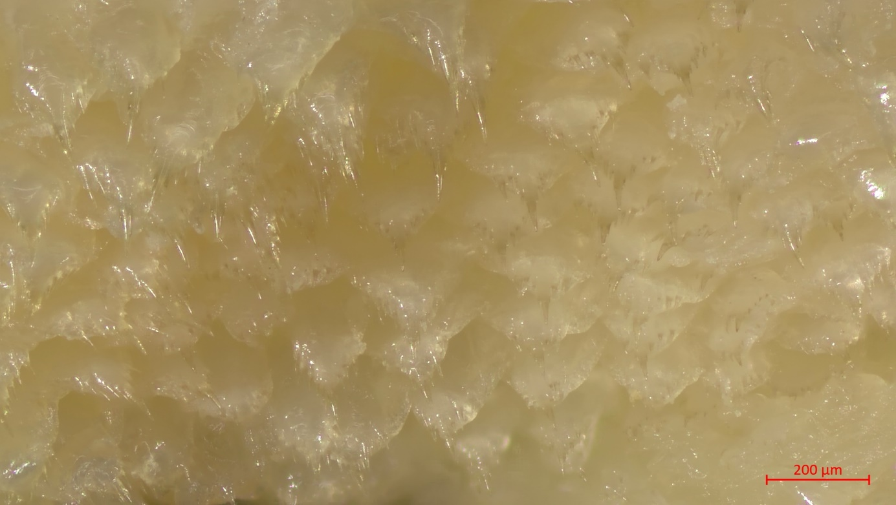
Fig. 3.
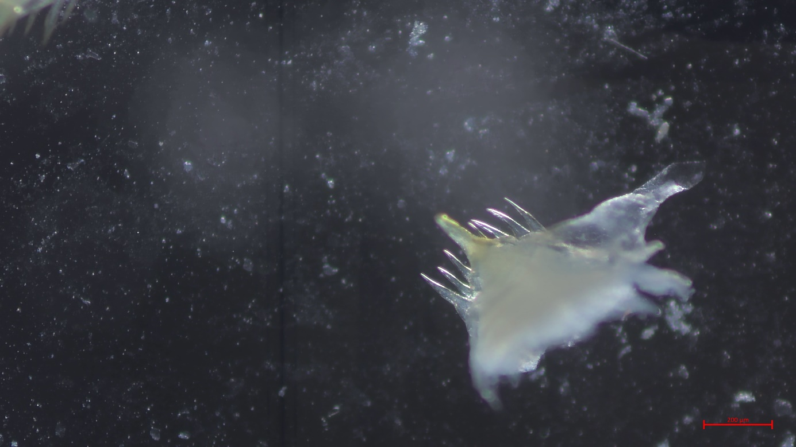
Fig. 4.
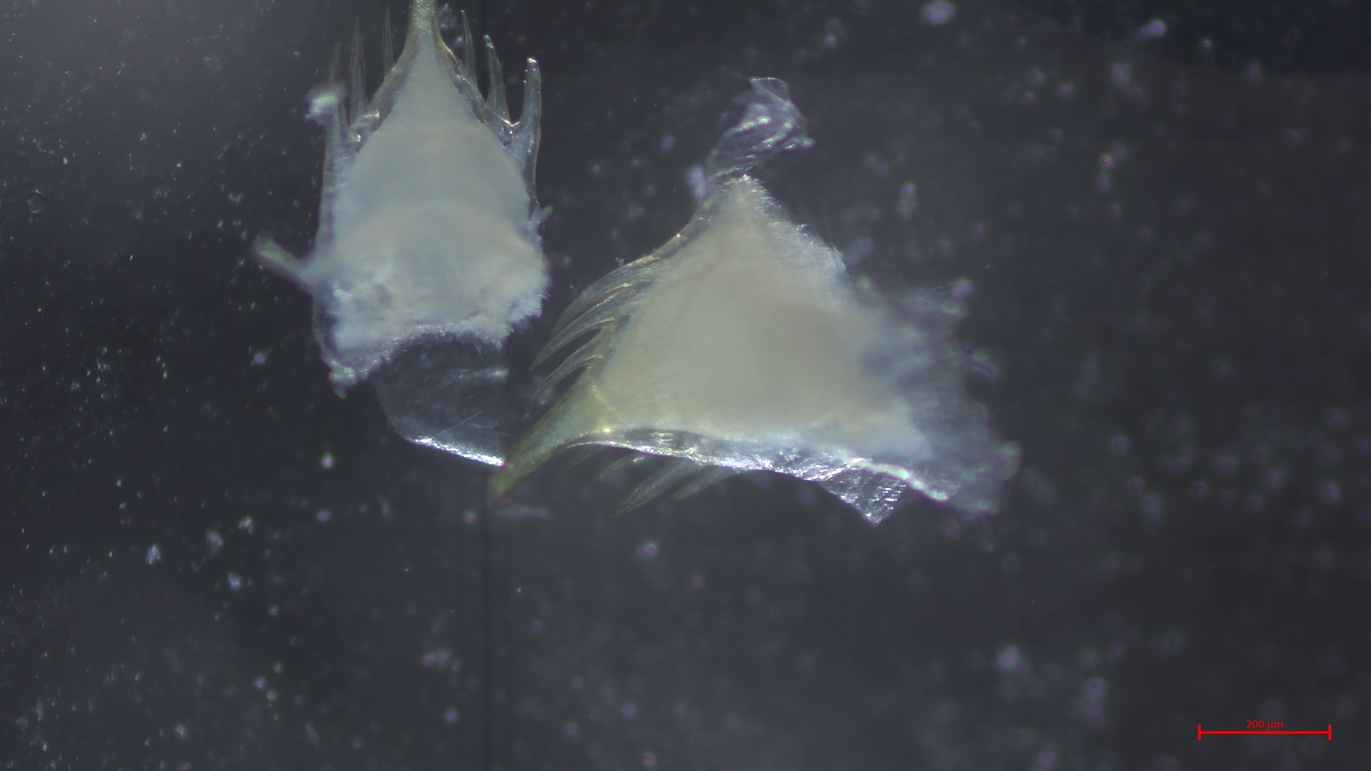
Fig. 5.
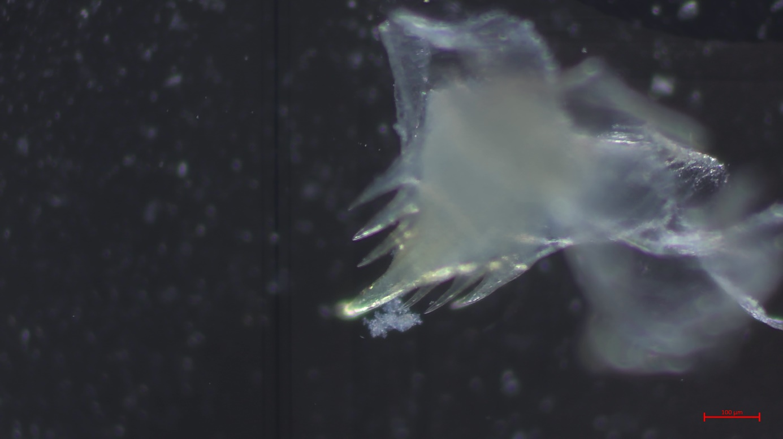
Fig. 6.
Fig. 7.
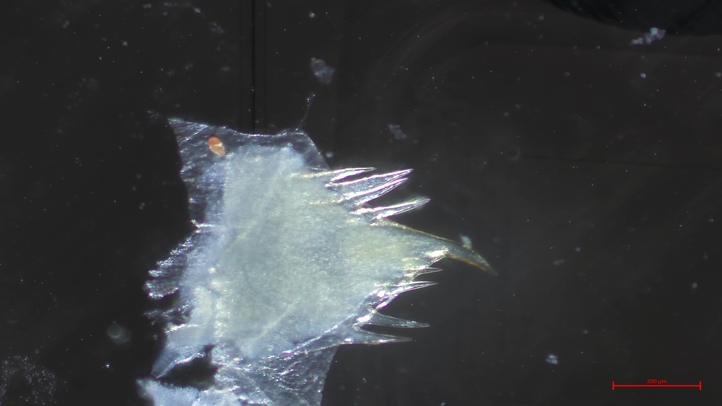
Fig. 8.
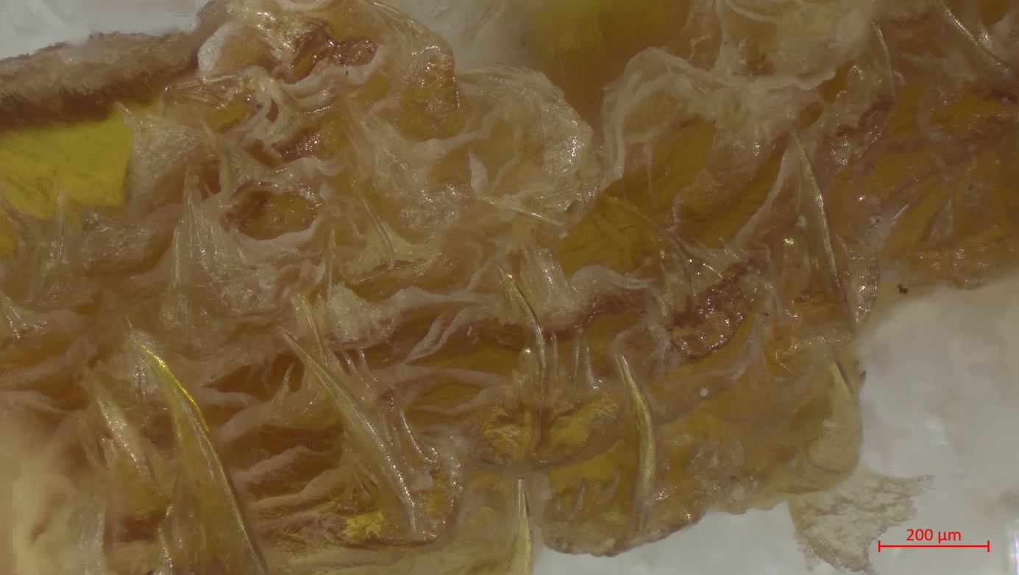
Fig. 9.
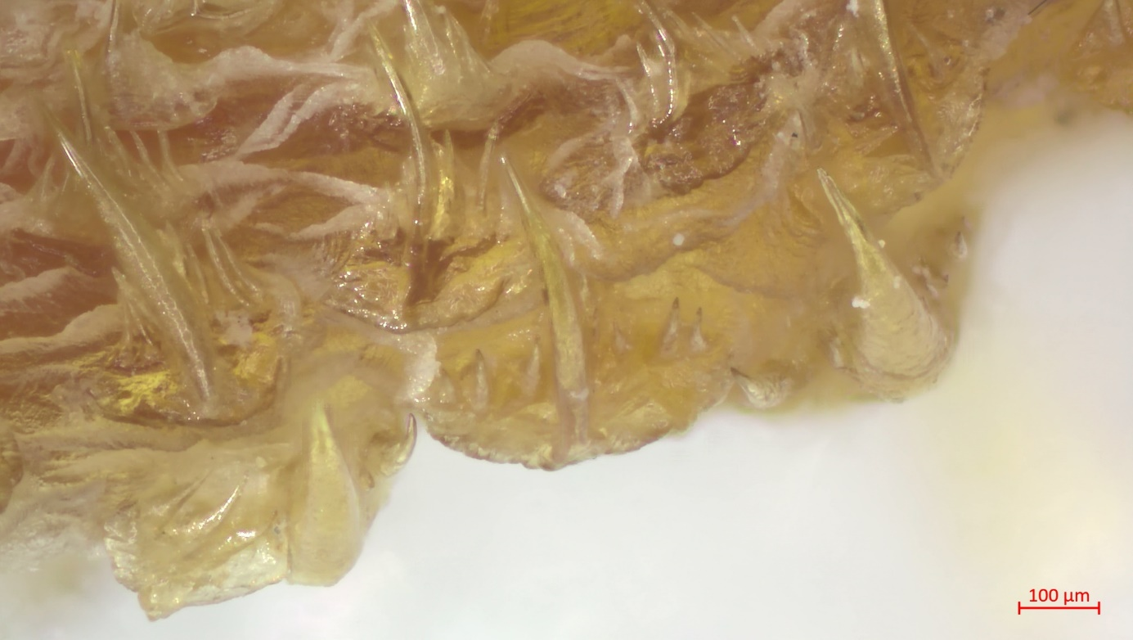
Fig. 10.

Halicryptus spinulosus, UiT The Arctic University of Norway, The Arctic University Museum of Norway. Museum specimen. UMAK specimen TSZY-131.
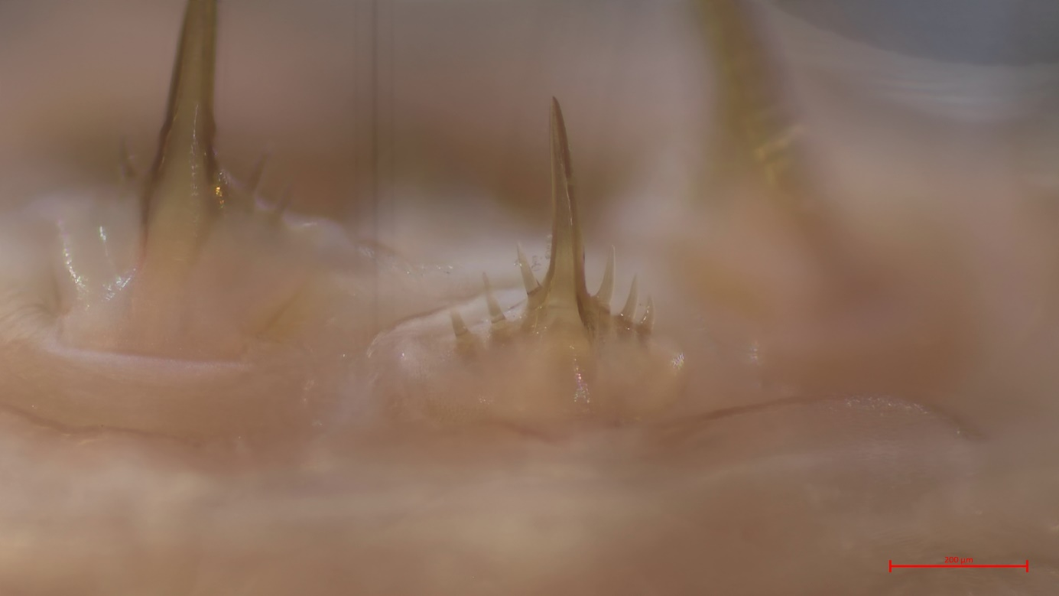
Fig. 11.
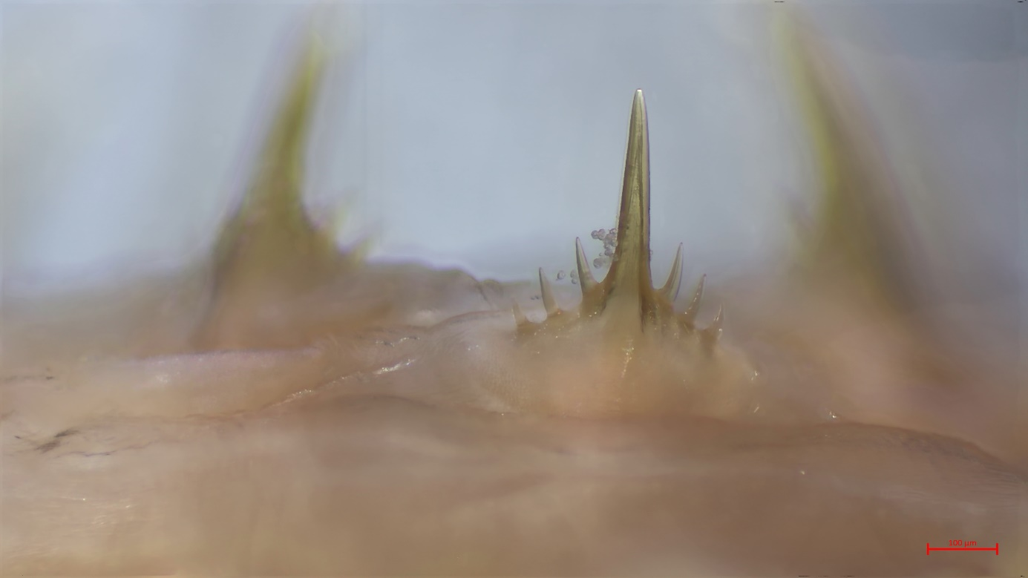
Fig. 12.
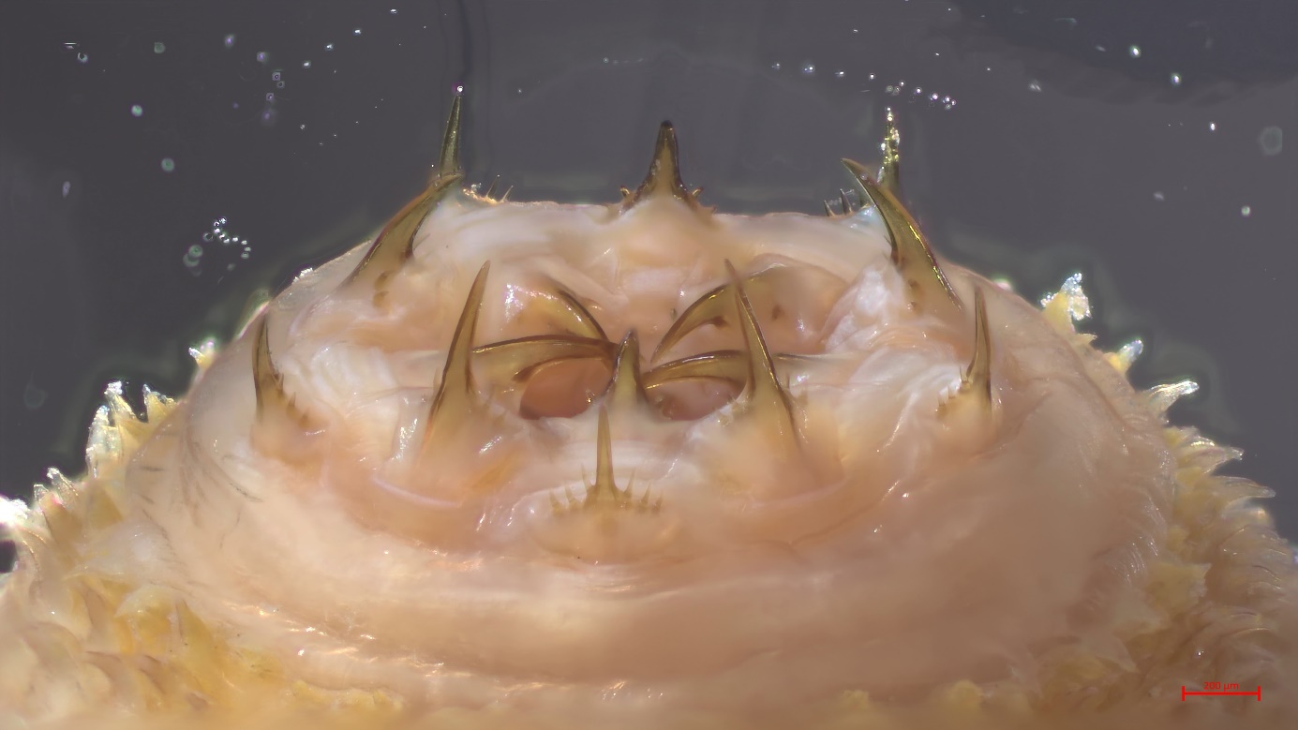
Fig. 13.
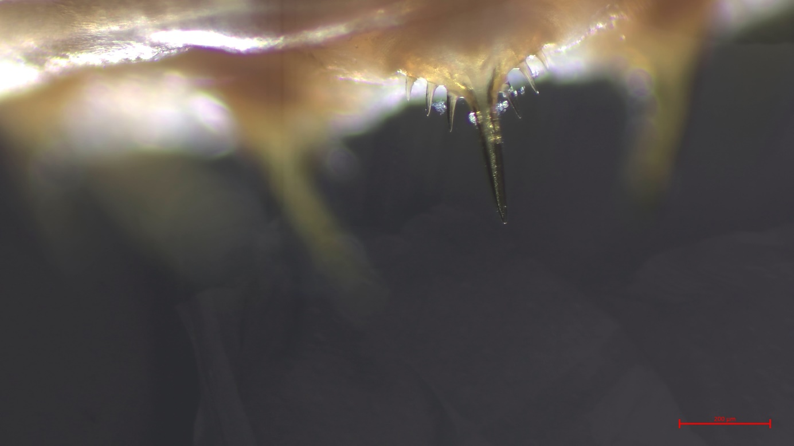
Fig. 14.

Incertae sedis, Early Cambrian priapulid teeth from Sweden preserved as carbonaceous microfossils (Ben Slater, Uppsala University, Sweden) (scale bar 20 µm).
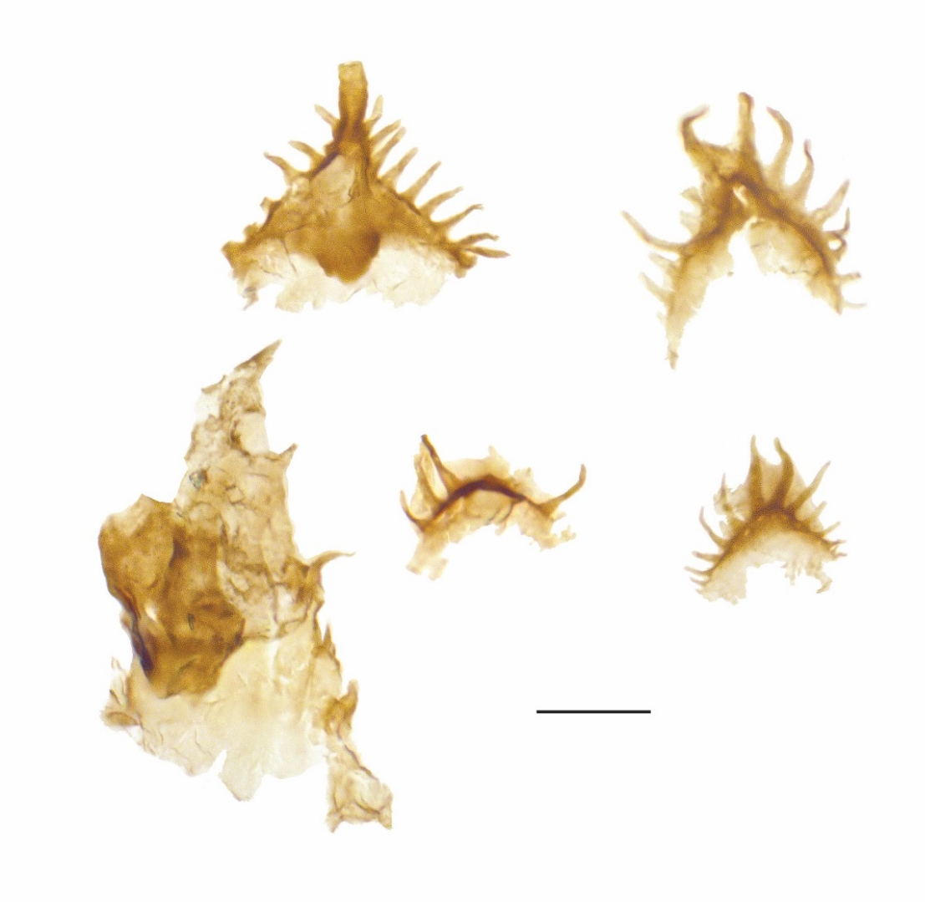
Fig. 15.

Meiopriapulus, Martin Sørensen, Natural History Museum of Denmark.
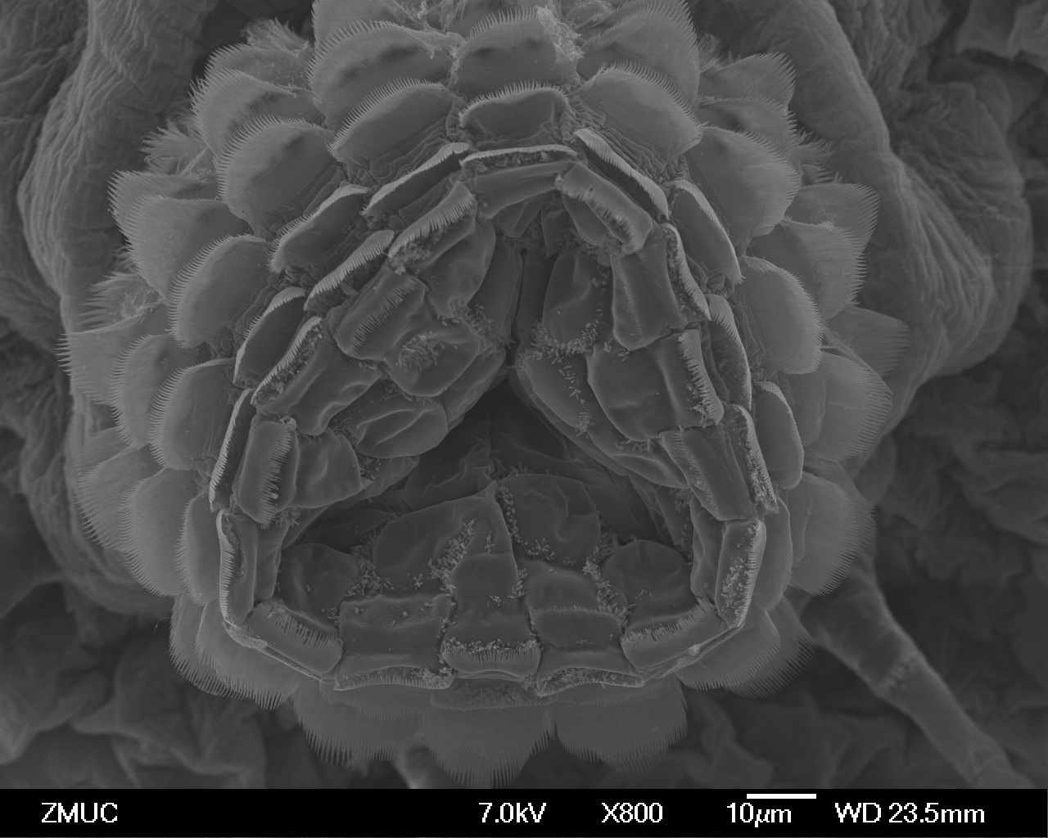
Fig. 16.
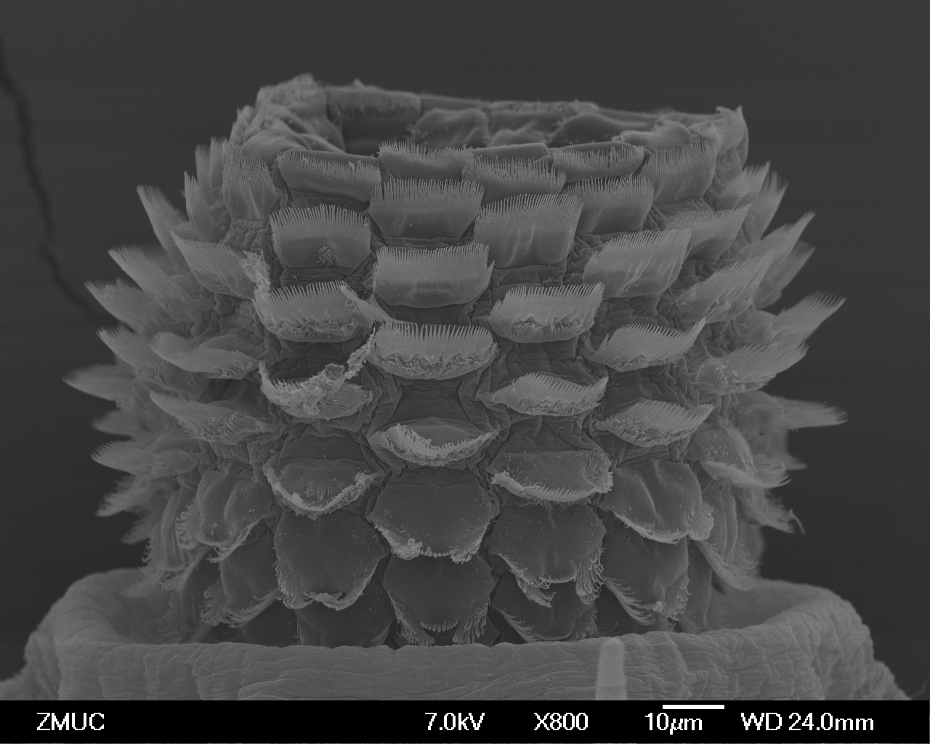
Fig. 17.
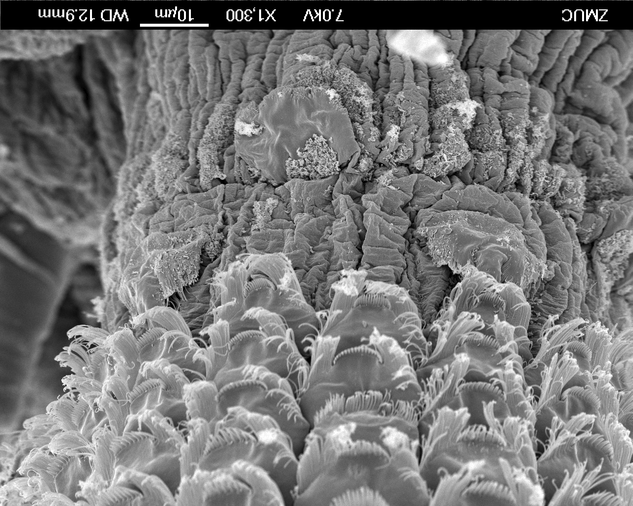
Fig. 18.

Tubiluchus, Martin Sørensen, Natural History Museum of Denmark.
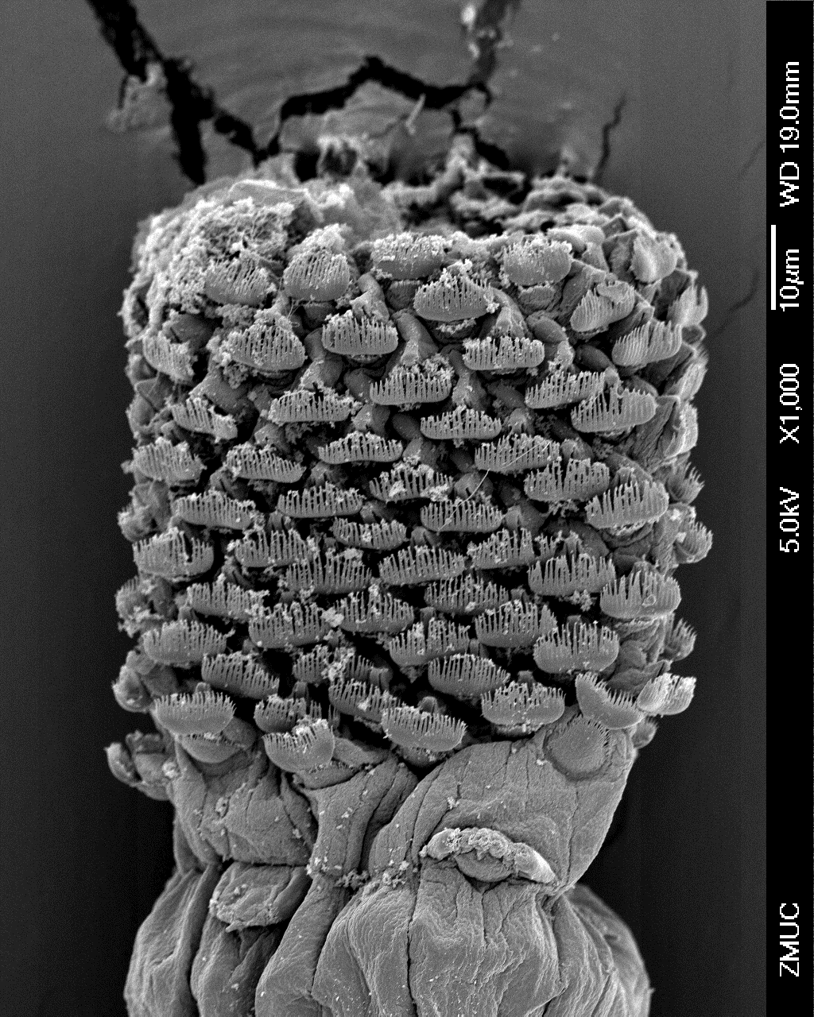
Fig. 19.

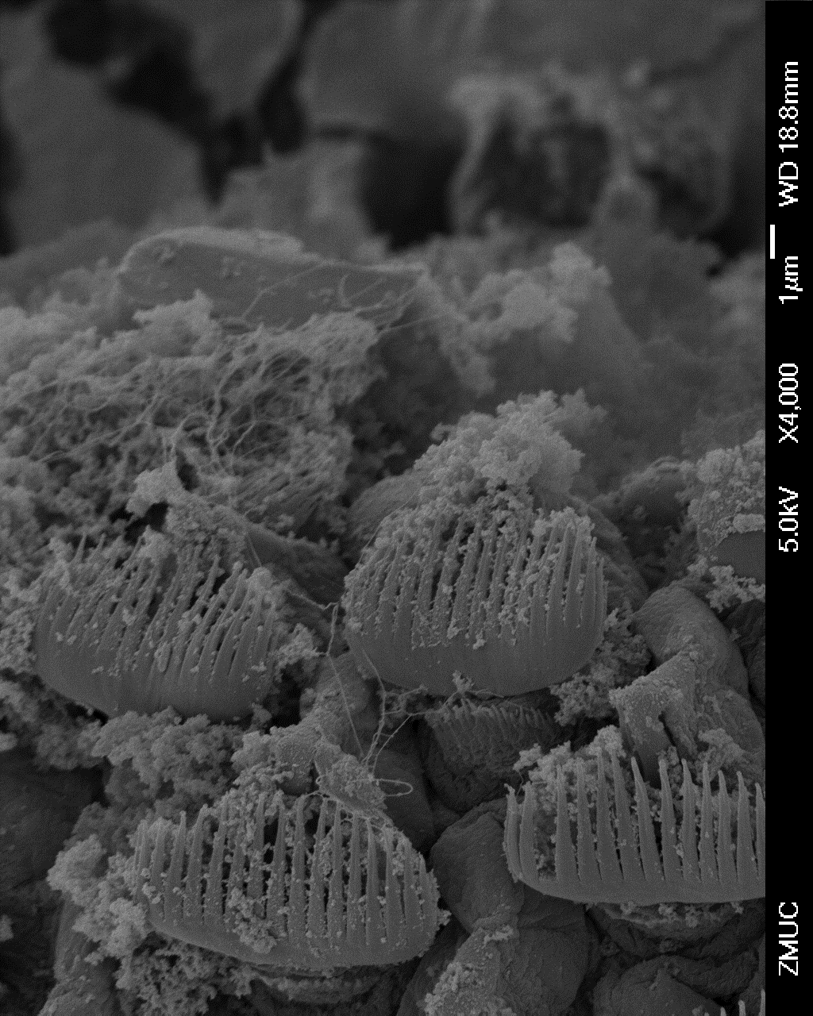
Fig. 20.
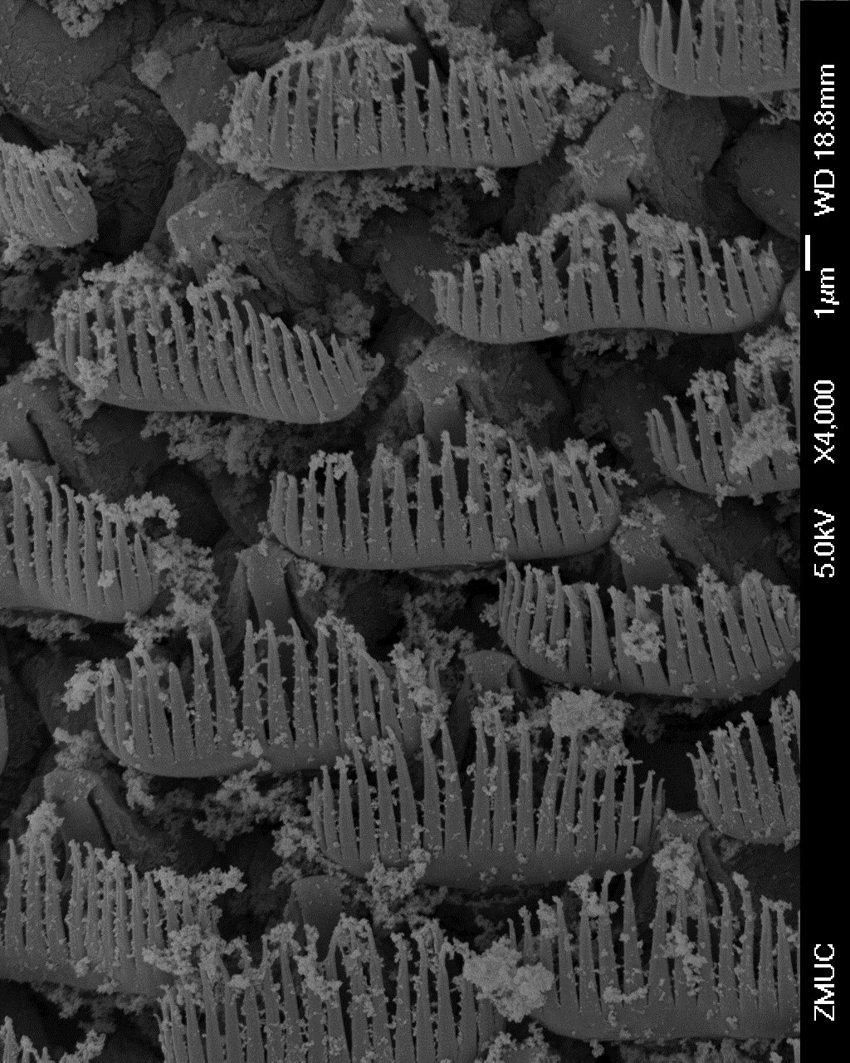
Fig. 21.

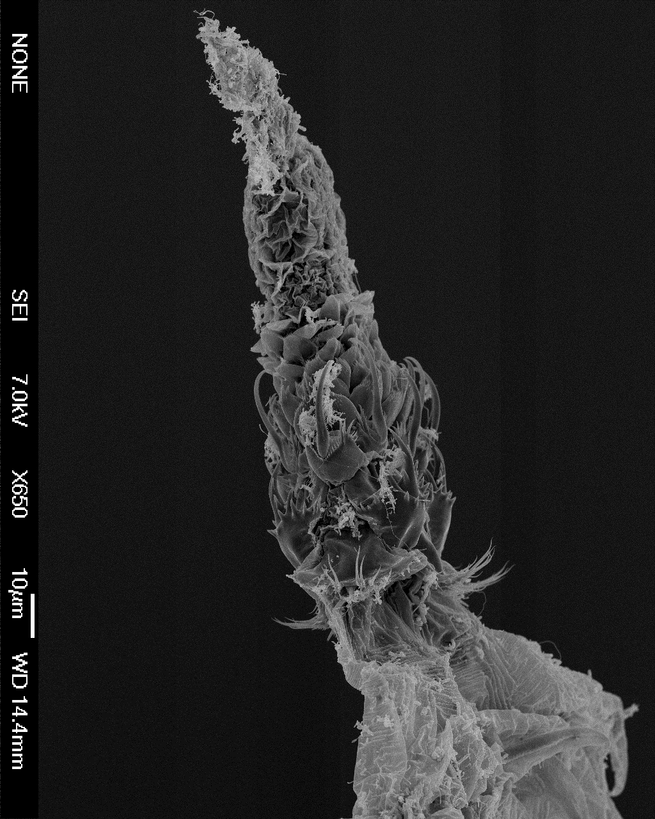
Fig. 22.

