Supplemental Materials for
Molecular Mimicry and Assemblies of Asymmetric Organic Semiconductors
Craig P. Yu¹, Shohei Kumagai¹, Michitsuna Tsutsumi¹, Tadanori Kurosawa¹, Hiroyuki Ishii², Go Watanabe³, Daisuke Hashizume⁴, Hiroki Sugiura⁵, Yukio Tani⁵, Toshihiro Ise⁵, Tetsuya Watanabe⁵, Hiroyasu Sato⁶, Jun Takeya^{1,7,8}, and Toshihiro Okamoto^{1,7,9}
¹Material Innovation Research Center (MIRC) and Department of Advanced Materials Science, Graduate School of Frontier Sciences, The University of Tokyo, 5-1-5 Kashiwanoha, Kashiwa, Chiba 277-8561, Japan
²Department of Applied Physics, Faculty of Pure and Applied Sciences, University of Tsukuba, 1-1-1 Tennodai, Tsukuba, Ibaraki 305-8573, Japan
³Department of Physics, School of Science, Kitasato University, 1-15-1 Kitasato, Minami-ku, Sagamihara, Kanagawa 252-0373, Japan.
⁴RIKEN Center for Emergent Matter Science (CEMS), 2-1 Hirosawa, Wako, Saitama 351-0198, Japan
⁵FUJIFILM Corp., 577 Ushijima, Kaisei-machi, Ashigarakami-gun, Kanagawa 258-8577, Japan
⁶Rigaku Corp., 3-9-12 Matsubara-cho, Akishima, Tokyo 196-8666, Japan
⁷National Institute of Advanced Industrial Science and Technology (AIST)-University of Tokyo Advanced Operando-Measurement Technology Open Innovation Laboratory (OPERANDO-OIL), AIST, 5-1-5 Kashiwanoha, Kashiwa, Chiba 277-8561, Japan
⁸International Center for Materials Nanoarchitectonics (MANA), National Institute for Materials Science (NIMS), 1-1 Namiki, Tsukuba 205-0044, Japan
⁹PRESTO, JST, 4-1-8 Honcho, Kawaguchi, Saitama 332-0012, Japan
*Corresponding Author:
Toshihiro Okamoto, tokamoto@k.u-tokyo.ac.jp

Table of Contents
1. ¹H and ¹³C NMR Spectra 3
2. Fundamental Properties 8
Thermal Properties 8
Electrochemical Measurements 9
Solubility 10
3. X-Ray Crystallography 11
Temperature-Variant Powder X-Ray Diffractions (PXRD) 12
X-Ray Diffraction of Edge-Casted Thin-Films 13
4. OFET Performance Evaluations 15
5. Single-Crystalline Thin-Films 16
6. Large-Area Single-Crystalline Thin Film 17

¹H and ¹³C NMR Spectra
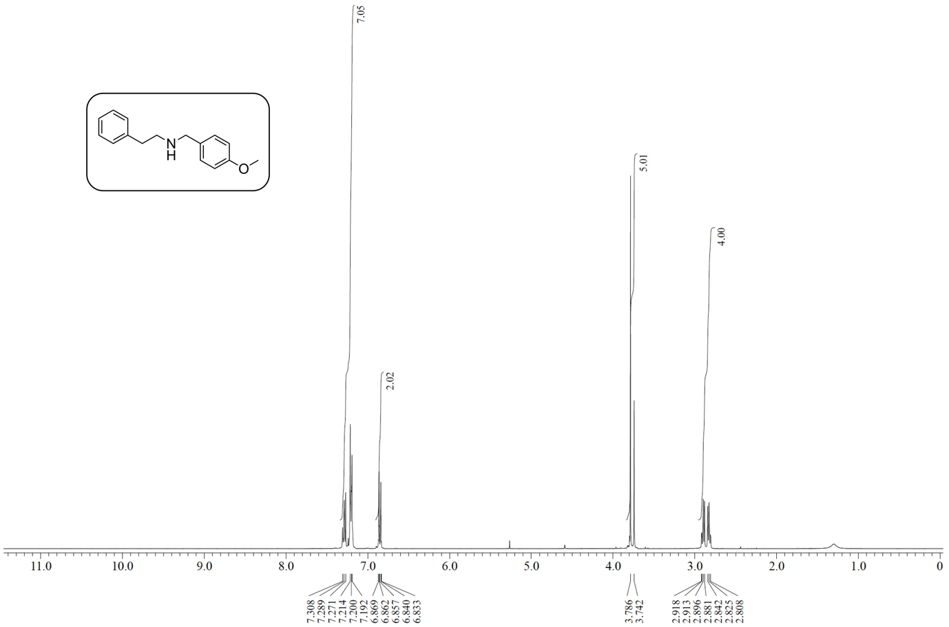
Supplementary Fig. 1 ¹H NMR of N-(4-methoxybenzyl)-2-phenylethan-1-amine in CDCl₃.

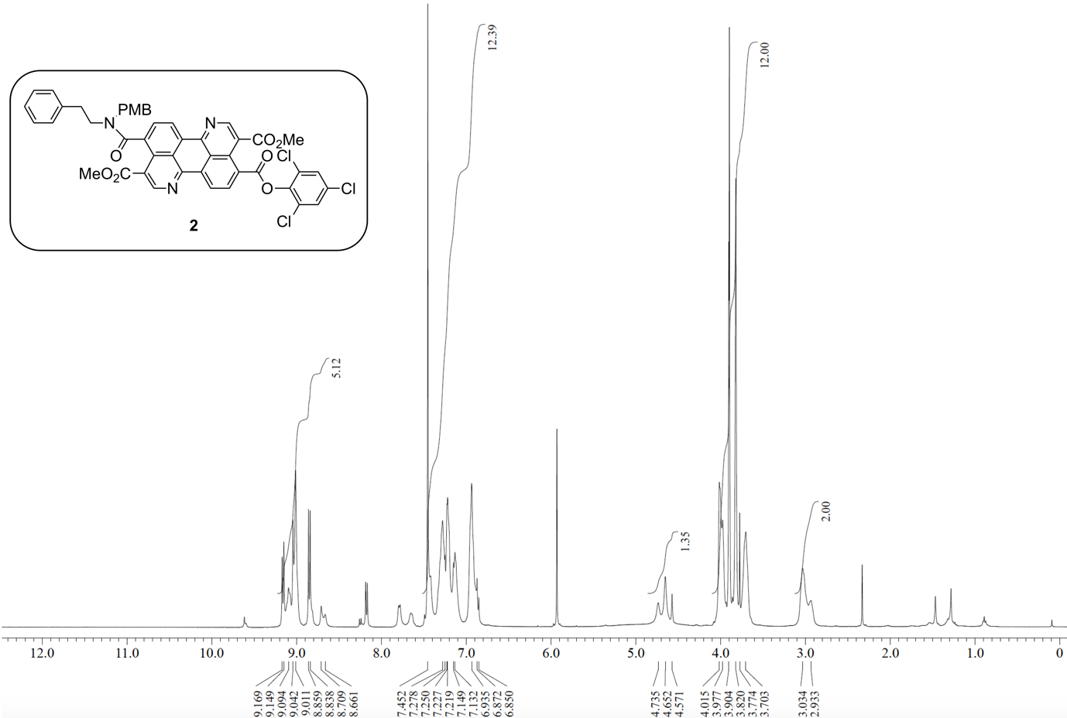
Supplementary Fig. 2 ¹H NMR of compound 2 in TCE-d₂ at 100 ˚C.

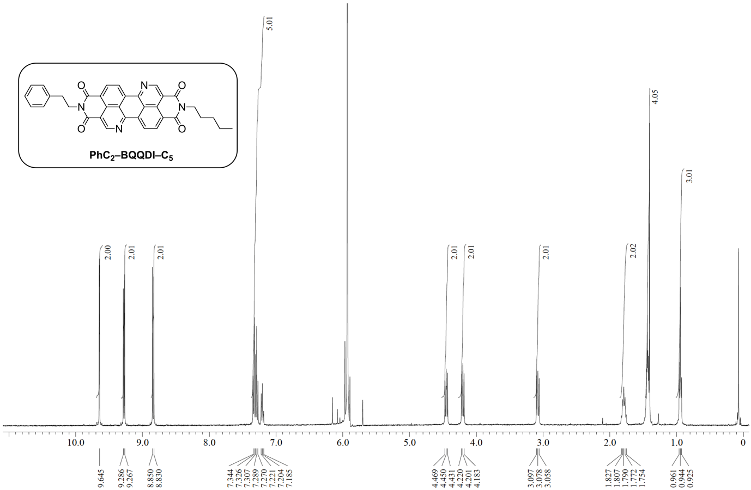
Supplementary Fig. 3 ¹H NMR of compound PhC₂–BQQDI–C₅ in TCE-d₂ at 100 ˚C.

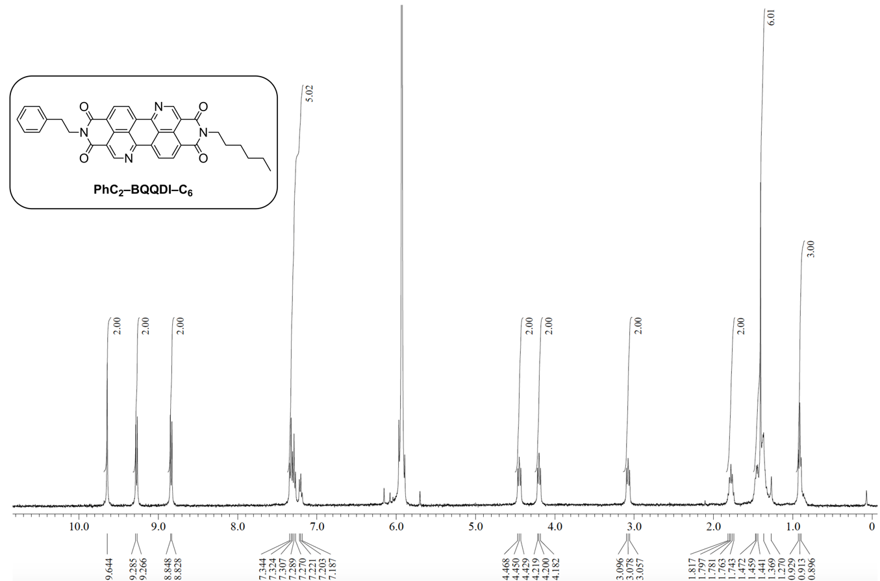
Supplementary Fig. 6 ¹H NMR of compound PhC₂–BQQDI–C₆ in TCE-d₂ at 100 ˚C.

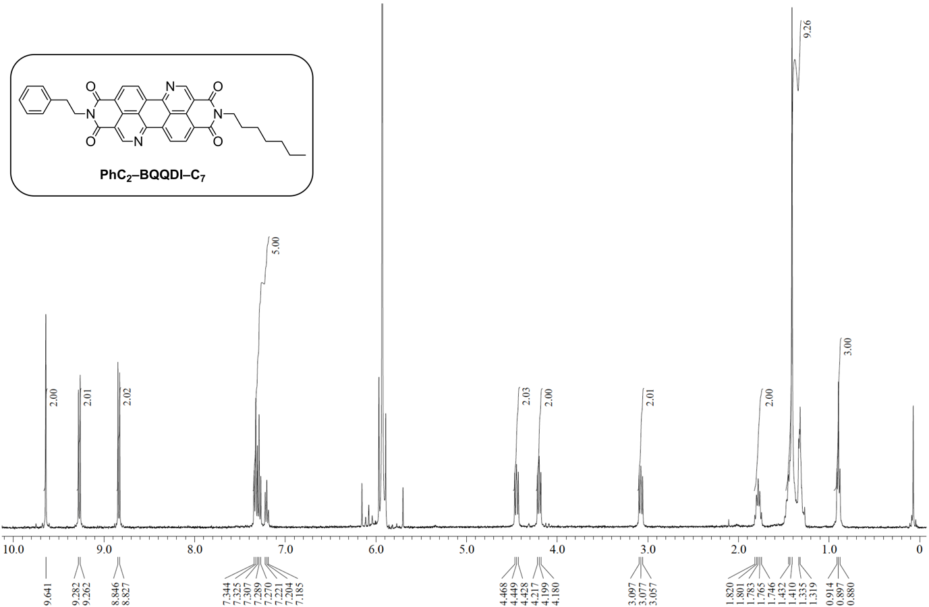
Supplementary Fig. 7 ¹H NMR of compound PhC₂–BQQDI–C₇ in TCE-d₂ at 100 ˚C.

Fundamental Properties

Thermal Properties
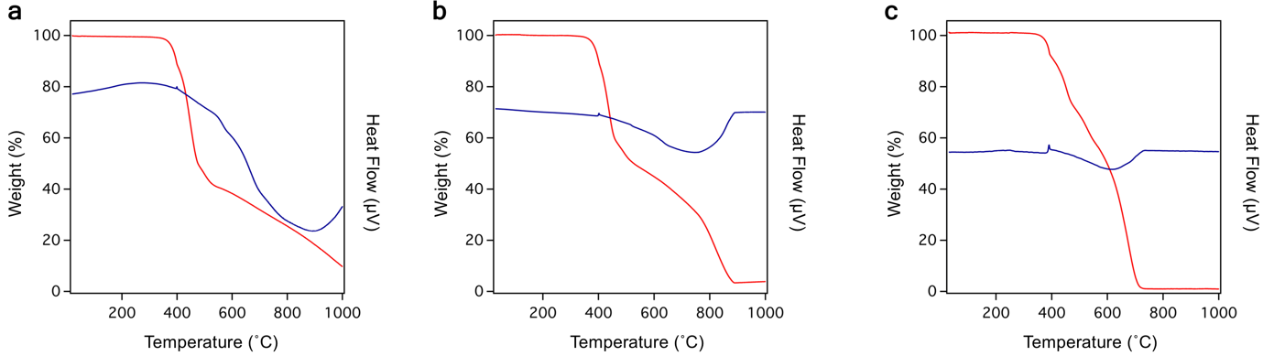
Supplementary Fig. 8 TG-DTA plots of a PhC₂–BQQDI–C₅, b PhC₂–BQQDI–C₆, and c PhC₂–BQQDI–C₇.
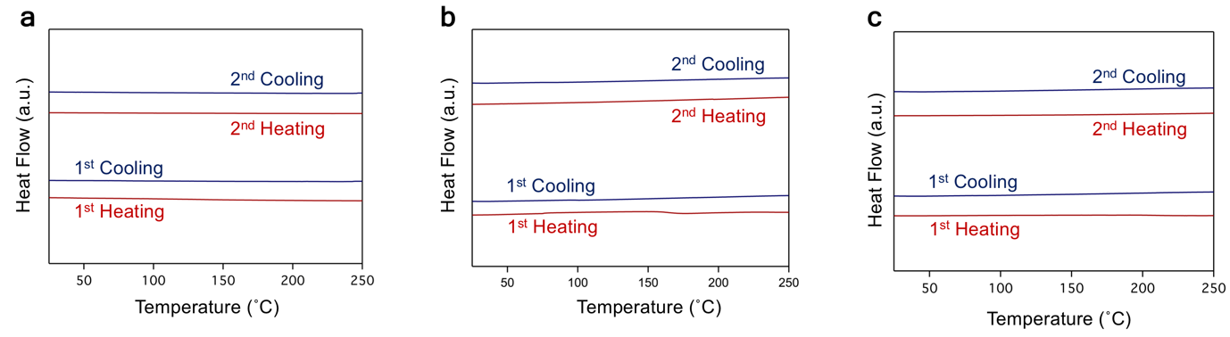
Supplementary Fig. 9 DSC plots of a PhC₂–BQQDI–C₅, b PhC₂–BQQDI–C₆, and c PhC₂–BQQDI–C₇.

Electrochemical Measurements
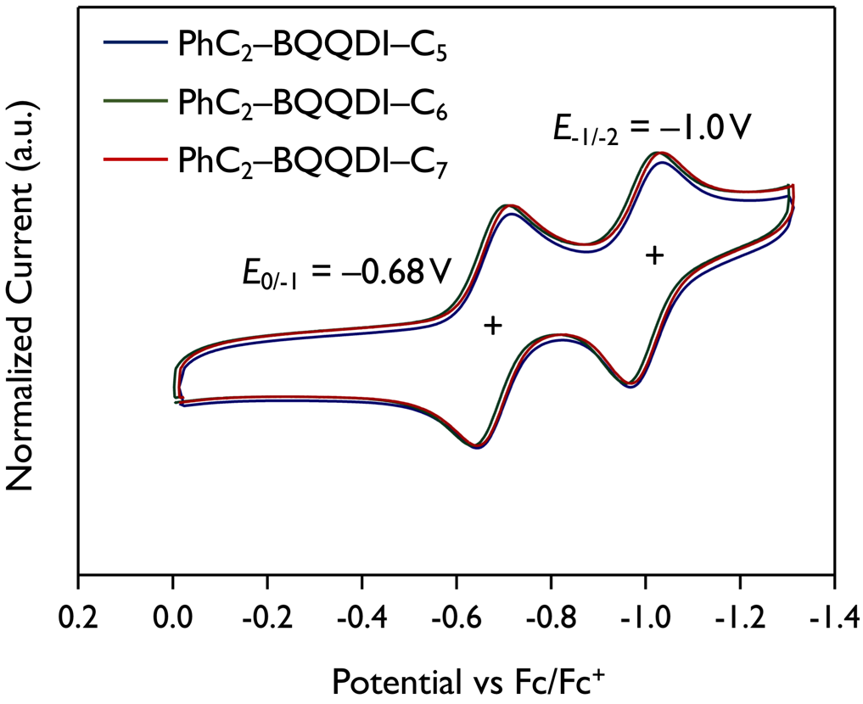
Supplementary Fig. 10 Cyclic voltammograms of PhC₂–BQQDI–C_{n}, where E_{0/−1} and E_{−1/−2} attribute to the half-wave reduction potentials corresponding to the first and second redox reactions, respectively (vs. Fc/Fc⁺). E_{LUMO} (vs. vacuum level) is estimated from E_{0/−1}: E_{LUMO} = −4.8 – E_{0/−1}.

Solubility
Supplementary Table 1 Solubility of PhC₂–BQQDI, C₈–BQQDI, and PhC₂–BQQDI–C_{n}.
Compound | Solubility (wt%)
PhC₂–BQQDI | < 0.0007
C₈–BQQDI | 0.019
PhC₂–BQQDI–C₅ | 0.0015
PhC₂–BQQDI–C₆ | 0.0016
PhC₂–BQQDI–C₇ | 0.0023

X-Ray Crystallography
Supplementary Table 2 Single-crystal data of PhC₂–BQQDI–C_{n}
 | PhC₂–BQQDI–C₅ | PhC₂–BQQDI–C₆ | PhC₂–BQQDI–C₇
Formula | C₃₅H₂₆N₄O₄ | C₃₆H₂₈N₄O₄ | C₃₇H₃₀N₄O₄
MW | 566.60 | 580.62 | 594.65
Temperature (K) | 298 | 298 | 293
Crystal System | Monoclinic | Monoclinic | Monoclinic
Space Group | Pn | Pn | Pn
a (Å) | 7.7195(2) | 7.8191(2) | 7.8265(5)
b (Å) | 4.98810(10) | 4.96240(10) | 4.9428(4)
c (Å) | 35.0076(10) | 35.6599(11) | 35.626(3)
α (˚) | 90 | 90 | 90
β (˚) | 91.243(6) | 92.408(7) | 92.355(7)
γ (˚) | 90 | 90 | 90
V (Å³) | 1347.67(6) | 1382.44(6) | 1377.01(18)
Z | 2 | 2 | 2
D_{x} (g cm⁻³) | 1.396 | 1.395 | 1.434
µ (mm) | 0.753 | 0.747 | 0.763
Refined Parameters | 389 | 397 | 452
GOF on F² | 1.196 | 1.013 | 1.593
R1 [I > 2σ(I)] | 0.0642 | 0.0643 | 0.1282
wR2 (all data) | 0.1888 | 0.1823 | 0.3751
Δρ_{min}, _{max} (e Å^{–3}) | -0.47, 0.74 | -0.25, -0.25 | -0.56, 0.48

Temperature-Variant Powder X-Ray Diffractions (PXRD)
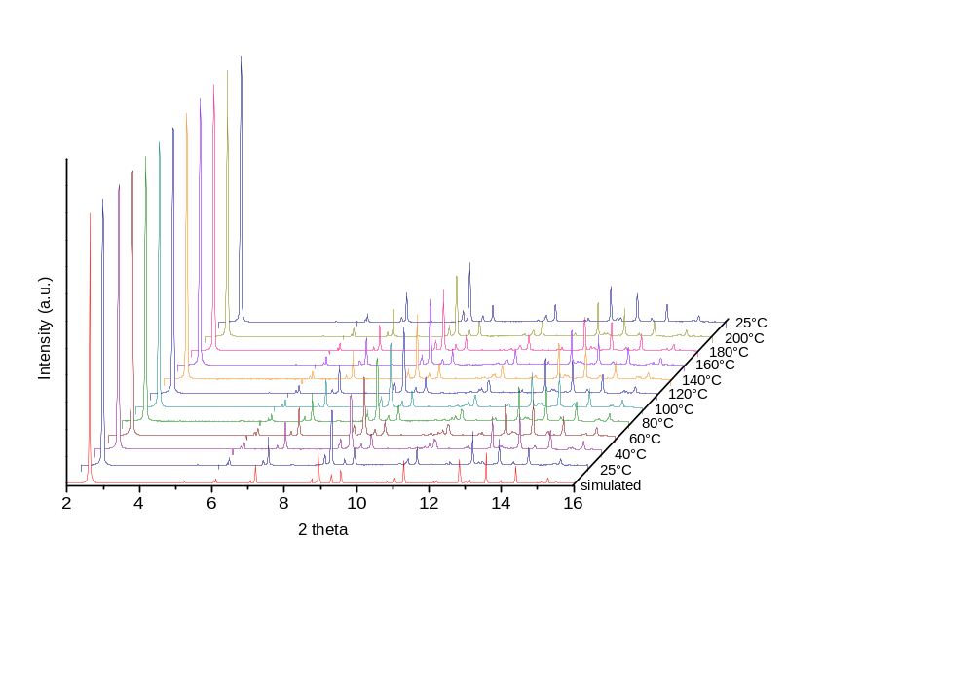
Supplementary Fig. 11 Temperature-variant PXRD plots of PhC₂–BQQDI–C₅.

X-Ray Diffraction of Edge-Casted Thin-Films
The X-ray irradiation was set perpendicular and parallel to the thin film for in-plane and out-of-plane diffractions, respectively.
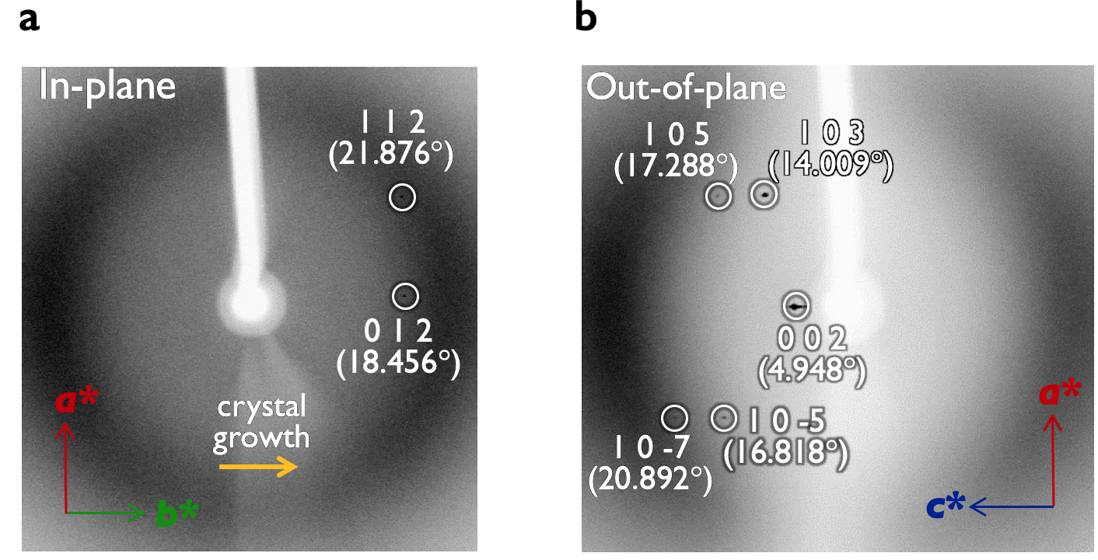
Supplementary Fig. 12 In-plane and out-of-plane thin-film XRD of PhC₂–BQQDI–C₅.
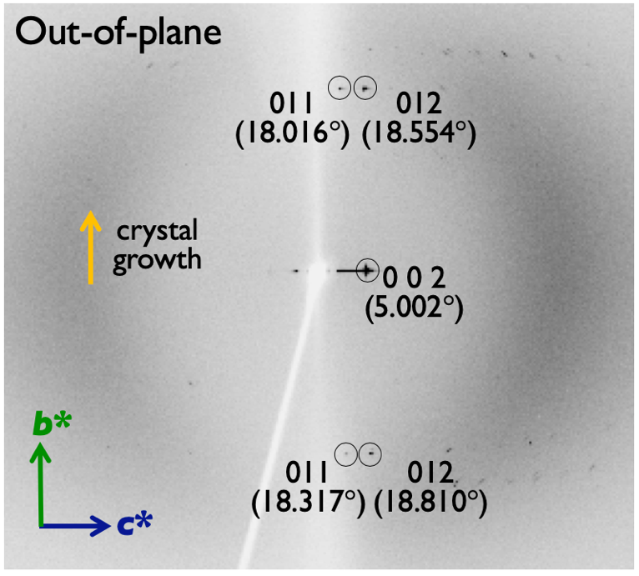
Supplementary Fig. 13 Out-of-plane thin-film XRD of PhC₂–BQQDI–C₆.
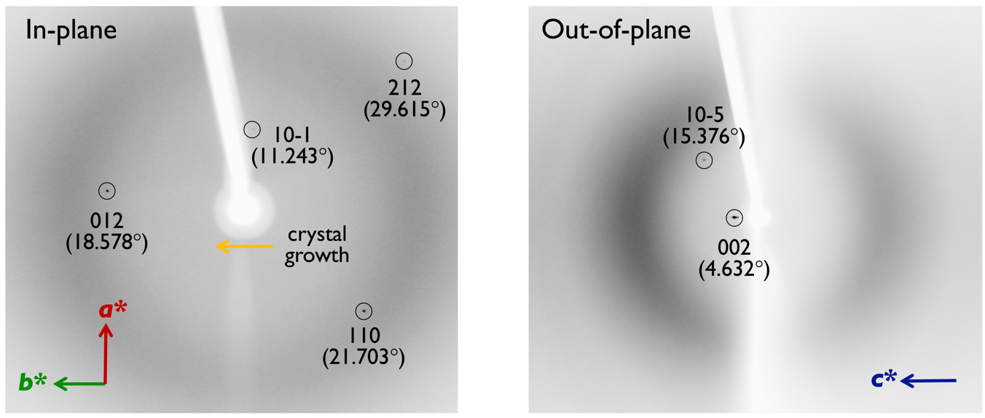
Supplementary Fig. 14 In-plane and out-of-plane thin-film XRD of PhC₂–BQQDI–C₇.

OFET Performance Evaluations
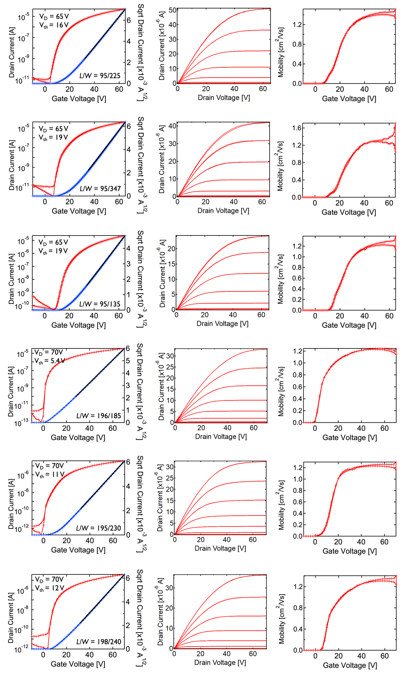
Supplementary Fig. 15 Transfer characteristics, output curves, and gate voltage-dependent µ_{e} of PhC₂–BQQDI–C₅ in six different devices.

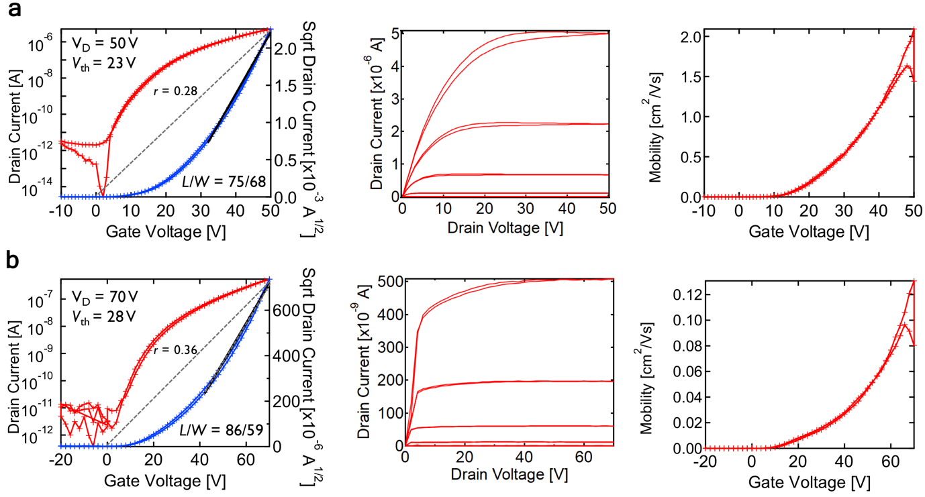
Supplementary Fig. 16 Transfer characteristics, output curves, and gate voltage-dependent µ_{e} of a PhC₂–BQQDI–C₆, and b PhC₂–BQQDI–C₆.

Single-Crystalline Thin-Films
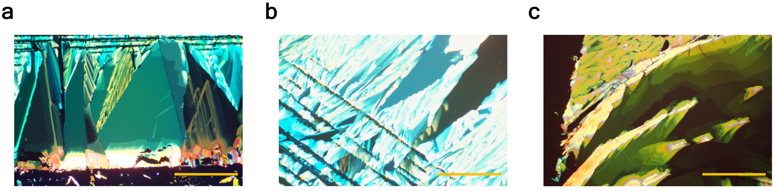
Supplementary Fig. 17 Polarized optical microscopic images of single-crystalline thin films of a PhC₂–BQQDI–C₅, b PhC₂–BQQDI–C₆, and c PhC₂–BQQDI–C₇, fabricated at the best temperatures of 115˚C, 110˚C, and 90˚C, respectively (scale bar = 0.5 mm).

Large-Area Single-Crystalline Thin Film
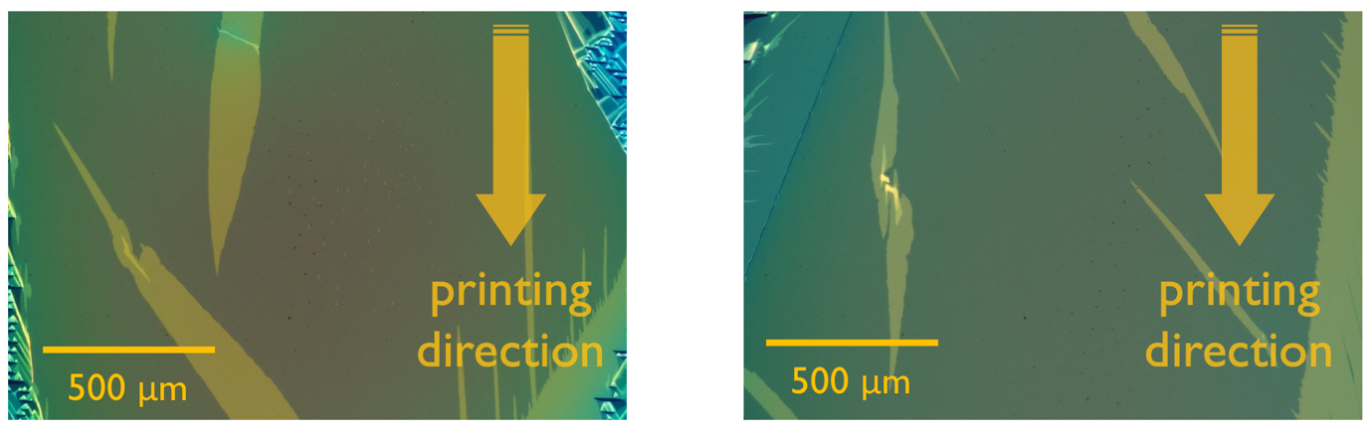
Supplementary Fig. 18 Polarized optical microscopic images of large-area single-crystalline thin films of PhC₂–BQQDI–C₅.
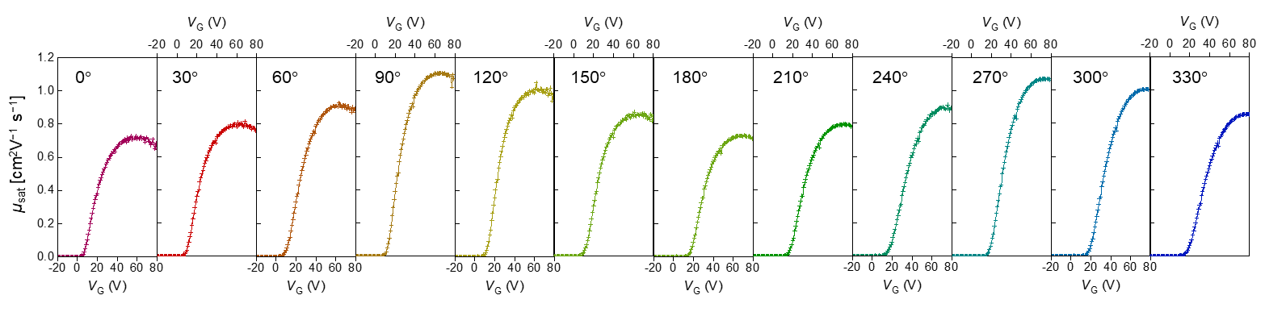
Supplementary Fig. 19 Gate voltage (V_{G}) dependent saturated µ_{e} (µ_{sat}) of large-area single-crystalline thin film of PhC₂–BQQDI–C₅ with their corresponding angle (˚) relative to the printing direction.

