Supporting Information

Screening and Analysis for Inhibitors of SHMT2 Enzyme Protein
Bojin Chen^{1,2}
¹Shanghai Engineering Research Center of Molecular Therapeutics & New Drug Development, School of Chemistry and Molecular Engineering, East China Normal University, Shanghai, 200062, China
²NYU-ECNU Center for Computational Chemistry at NYU Shanghai, Shanghai, 200062, China

Email: chenbojin135@163.com

Table S1. Structures and their ChemDiv IDs of the 20 representative compounds have the same skeleton.

Compound | ChemDiv_ID | R1 | R2 | R3
M1 | 8010-8303 | 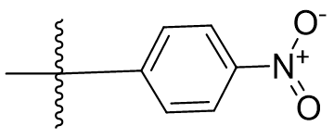 | 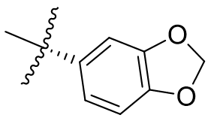 | 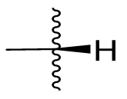
M2 | 8012-5183 | 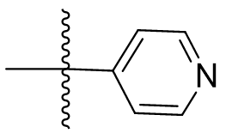 | 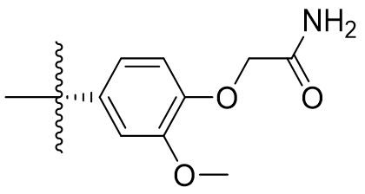
M3 | 3629-0287 | 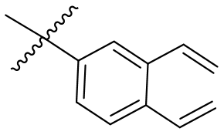 | 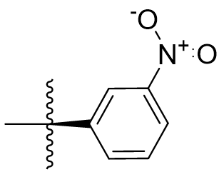 | 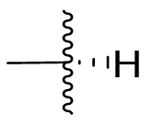
M4 | 3629-0311 | 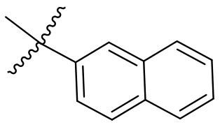 | 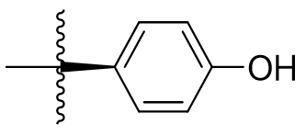
M5 | 3448-5845 | 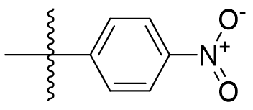 | 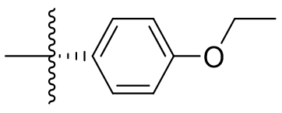
M6 | 8010-8305 | 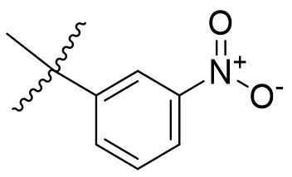 | 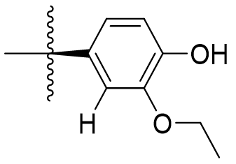
M7 | 3543-0016 | 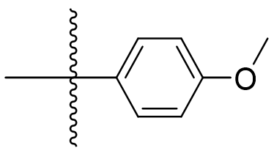 | 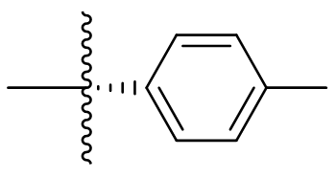
Compound | ChemDiv_ID | R1 | R2 | R3
M8 | 8012-3540 | 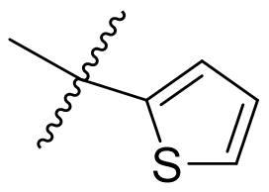 | 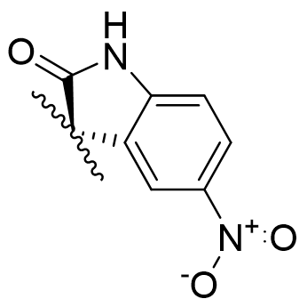
M9 | 8010-8306 | 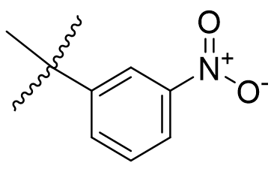 | 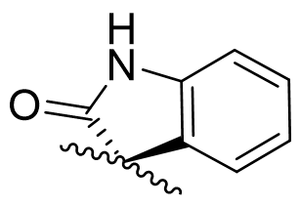
M10 | 3448-6597 | 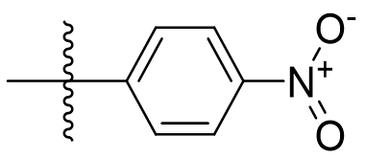 | 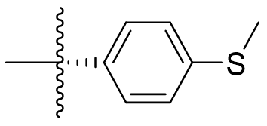
M11 | 3629-0271 | 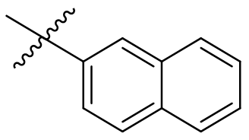 | 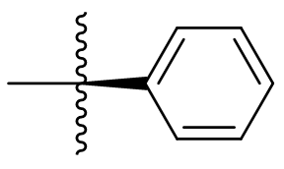
M12 | 8012-4430 | 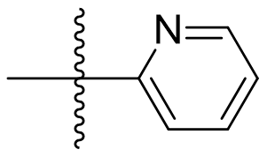 | 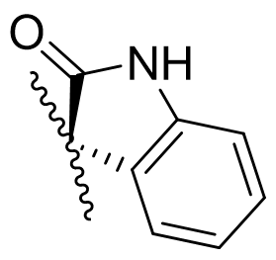
M13 | 3394-0195 | 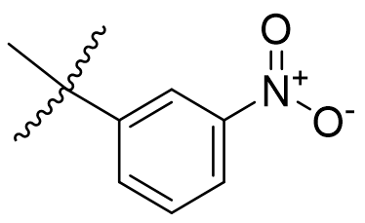 | 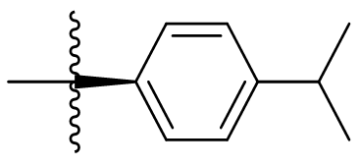
Compound | ChemDiv_ID | R1 | R2 | R3
M14 | 4333-3946 | 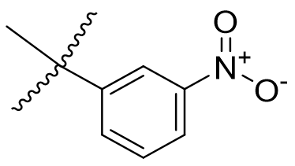 | 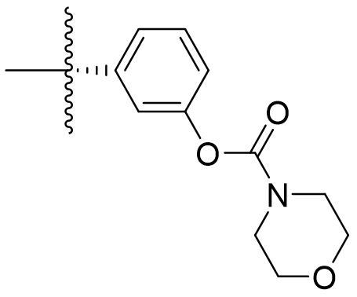
M15 | 3394-0367 | 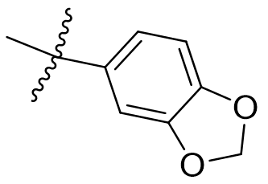 | 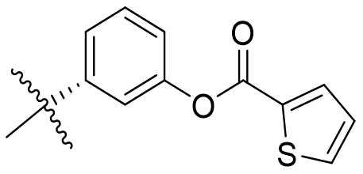
M16 | 3394-0352 | 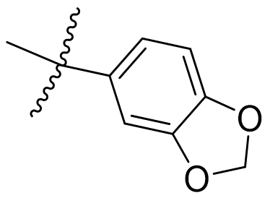 | 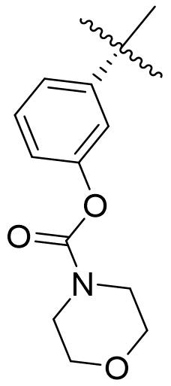
M17 | 8015-0700 | 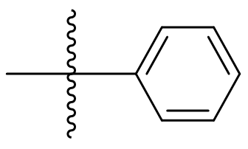 | 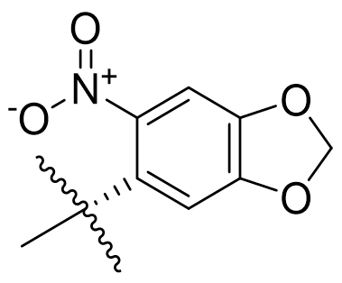
M18 | 3629-0318 | 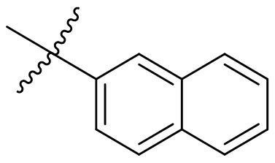 | 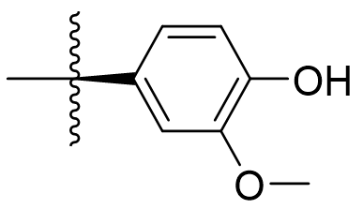
M19 | 8019-9096 | 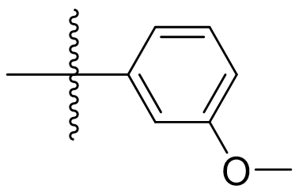 | 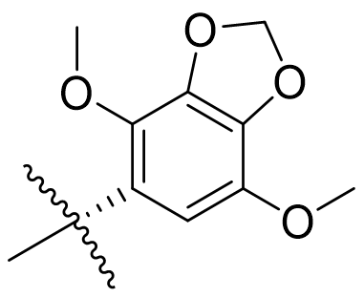
M20 | 4036-0469 | 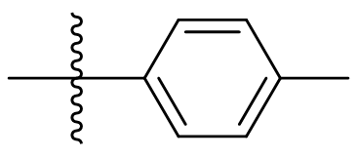 | 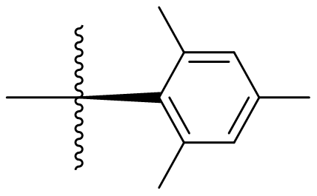

Table S2. Structures and their ChemDiv IDs of the 2 representative compounds in GlideScore and AAScore top ranking.
Compound | Chemdiv_ID | Structure
M21 | D135-0017 | 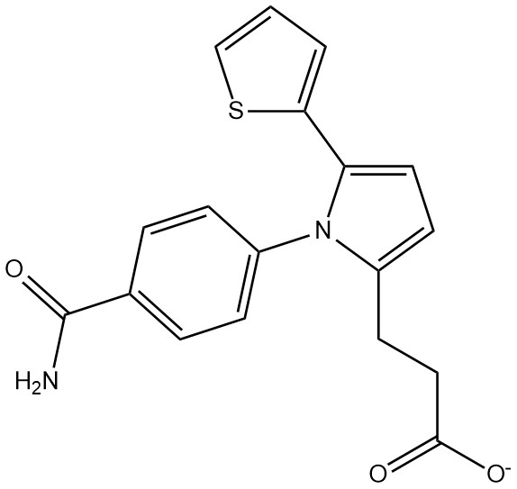
M22 | E989-1016 | 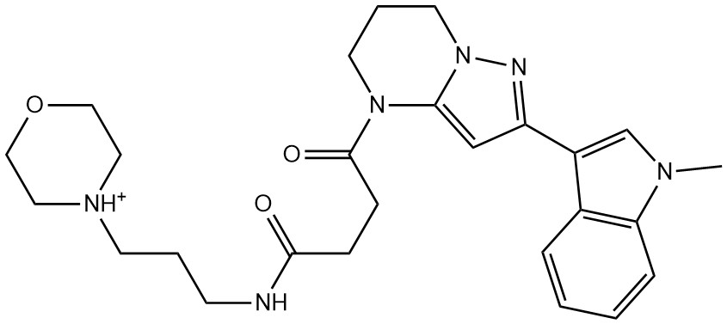

Table S3. The energy of the complex system M14-SHMT2 at different simulation time periods. The 100 ns simulation duration was divided into ten equal parts and the numbering of the times is the ordinal number of the time period.
M14-SHMT2
Time/ns | ΔH(kcal/mol) | IE (kcal/mol) | ΔG(kcal/mol)
1 | 26.7721 | -4.3786 | 22.3935
2 | 25.8252 | -3.651 | 22.1742
3 | 24.4142 | -3.707 | 20.7072
4 | 24.2283 | -4.0392 | 20.1891
5 | 24.9699 | -3.9488 | 21.0211
6 | 25.2962 | -3.723 | 21.5732
7 | 25.1875 | -3.8013 | 21.3862
8 | 25.1524 | -4.3379 | 20.8145
9 | 24.0632 | -3.2036 | 20.8596
10 | 24.2937 | -3.6455 | 20.6482

Table S4. The energy of the complex system M17-SHMT2 at different simulation time periods. The 100 ns simulation duration was divided into ten equal parts and the numbering of the times is the ordinal number of the time period.
M17-SHMT2
Time/ns | ΔH(kcal/mol) | IE(kcal/mol) | ΔG(kcal/mol)
1 | 27.6393 | -4.7071 | 22.9322
2 | 27.5403 | -3.6837 | 23.8566
3 | 27.8237 | -3.4999 | 24.3238
4 | 27.8651 | -3.5198 | 24.3453
5 | 27.4373 | -3.9608 | 23.4765
6 | 26.6812 | -3.798 | 22.8832
7 | 25.9853 | -3.9373 | 22.048
8 | 25.164 | -3.8176 | 21.3464
9 | 25.6127 | -3.956 | 21.6567
10 | 25.8425 | -3.6116 | 22.2309

Table S5: Average energy values for each hot spot residue in the M14-SHMT2 complex system.
M14-SHMT2
Residue | ΔEvdW | ΔEele | ΔGgb | ΔGnp | ΔH
LEU166 | 4.3523 | 0.0647 | -0.2099 | 0.184 | 4.3911
TYR105 | 3.8175 | 0.4087 | -0.9119 | 0.3535 | 3.6677
ARG425 | 3.0276 | 0.1312 | -0.0144 | 0.1228 | 3.2671
TYR176 | 2.5516 | 0.0295 | -0.3667 | 0.2411 | 2.4554
LYS409 | 2.0911 | 0.239 | -0.2751 | 0.1841 | 2.2391
TYR106 | 1.9169 | -0.0049 | 0.0164 | 0.1060 | 2.0344

Table S6 Average energy values for each hot spot residue in the M22-SHMT2 complex system.
M22-SHMT2
Residue | ΔEvdW | ΔEele | ΔGgb | ΔGnp | ΔH
TYR105 | 6.5056 | 0.1319 | -1.0195 | 0.3452 | 5.9632
TYR106 | 2.8552 | 0.0426 | 0.1892 | 0.0436 | 3.1306
ARG425 | 3.2399 | -5.1148 | 4.7564 | 0.1869 | 3.0685
LEU166 | 3.2253 | -0.0703 | -0.6361 | 0.2122 | 2.7312
TYR176 | 2.1918 | 0.0592 | -0.4515 | 0.238 | 2.0375

Table S7: Average energy values for each hot spot residue in the M1-SHMT2 complex system.
M1-SHMT2
Residue | ΔEvdW | ΔEele | ΔGgb | ΔGnp | ΔH
TYR106 | 3.8217 | 0.575 | -0.8307 | 0.2653 | 3.8313
TYR105 | 3.4255 | 0.1514 | -0.5367 | 0.2934 | 3.3336
LEU166 | 2.7389 | 0.0516 | -0.1862 | 0.1887 | 2.7931
ARG425 | 2.4053 | -0.0199 | -0.0237 | 0.1605 | 2.5222

Table S8: Average energy values for each hot spot residue in the M19-SHMT2 complex system.
M19-SHMT2
Residue | ΔEvdW | ΔEele | ΔGgb | ΔGnp | ΔH
TYR105 | 5.2661 | 0.1311 | -0.8768 | 0.3946 | 4.9151
LEU166 | 3.2921 | 0.0039 | -0.3696 | 0.1592 | 3.0857
LEU172 | 2.1571 | 0.157 | -0.407 | 0.1819 | 2.0889

Table S9: Average energy values for each hot spot residue in the M15-SHMT2 complex system.
M15-SHMT2
Residue | ΔEvdW | ΔEele | ΔGgb | ΔGnp | ΔH
TYR106 | 3.5847 | -0.0208 | -0.22 | 0.2253 | 3.5694
LEU166 | 2.9562 | -0.1048 | -0.2823 | 0.1891 | 2.7582
TYR105 | 2.6781 | 0.0846 | -0.5455 | 0.2684 | 2.4856
ARG425 | 1.956 | 0.7041 | -0.3208 | 0.0832 | 2.4225

