SQU Hospital Pediatric Handover Sheet
(Please don’t fill this form, you can copy the file and re-use it)

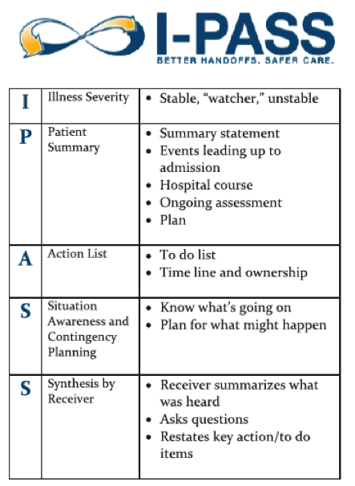
03:00 - 03:10 pm
HD handover

03:10 - 03:45 pm
Acute Teams Handover
Subspecialty Handover
03:45 – 04:00 pm

CanMEDSKey Competency 3.2 states:Demonstrate safe transfer of care, using both verbal and written communication, during a patient transition to a different health care professional, setting, or stage of care.*CanMEDS 2015 Competency Framework

I | Illness severity  (stable, watcher, unstable) | P | Patient Summery | A  S | Action List  Situation awareness
P3
Stable  Name:  Age:  Diagnosis:  Admit Date:  Weight:  Allergies:  POST:  Location:  Services: |  | HPI:  Relevant PMHx:  Active issues:  IVF/TFI:  Diet:  O2: -  Meds: |  | Daytime action list: -  Pending Ix/consults:  Night action list:  Situational awareness:
P4
Stable  Name:  Age:  Diagnosis:  Admit Date:  Weight:  Allergies:  POST:  Location:  Services: |  | HPI:  Relevant PMHx:  Active issues:  IVF/TFI:  Diet:  O2: -  Meds: |  | Daytime action list: -  Pending Ix/consults:  Night action list:  Situational awareness:
P1
Stable  Name:  Age:  Diagnosis:  Admit Date:  Weight:  Allergies:  POST:  Location:  Services: |  | HPI:  Relevant PMHx:  Active issues:  IVF/TFI:  Diet:  O2: -  Meds: |  | Daytime action list: -  Pending Ix/consults:  Night action list:  Situational awareness:
Pending admissions:
Stable  Name:  Age:  Diagnosis:  Admit Date:  Weight:  Allergies:  POST:  Location:  Services: |  | HPI:  Relevant PMHx:  Active issues:  IVF/TFI:  Diet:  O2: -  Meds:= |  | Daytime action list: -  Pending Ix/consults:  Night action list:  Situational awareness:

