Supplementary data:

Table S1
Details of the physicochemical conditions recorded on site in different hot springs.

Sr. no. | Location | pH  (±0.2) | Temp. (°C; ±2)
1 | Chopda 1 | 8.8 | 40
2 | Chopda 2 | 7.8 | 50
3 | Chumathang | 8.3 | 75
4 | Puga | 8.8 | 80
5 | Rajawadi | 8.0 | 50
6 | Tattapani | 8.2 | 75
7 | Tural | 7.9 | 65
8 | Unhavare | 7.8 | 60
9 | Unkeshwar | 7.7 | 40

Table S2
Summary of positive enrichments obtained from different hot springs grown under different culture conditions.

Medium | Substrate | Temperature in ℃ | Location of hot springs
Medium | Substrate | Temperature in ℃ | Chumatang | Puga | Chopda 1 | Chopda 2 | Unkeshwar | Unhavare | Rajawadi | Tural | Tattapani
BY | H₂:CO₂ | 40 | + | - | + | - | + | + | + | + | -
BY | H₂:CO₂ | 55 | - | - | - | - | - | + | + | + | -
BY | H₂:CO₂ | 70 | - | - | - | - | - | + | - | + | -
BY | H₂:CO₂ | 85 | - | - | - | - | - | - | - | - | -
BY | Sodium acetate | 40 | - | - | - | + | - | - | + | - | -
BY | Sodium acetate | 55 | - | - | - | - | - | + | - | + | -
BY | Sodium acetate | 70 | - | - | - | - | - | - | - | - | -
BY | Sodium acetate | 85 | - | - | - | - | - | - | - | - | -
BY | TMA+ME | 40 | - | - | + | - | + | + | + | - | -
BY | TMA+ME | 55 | - | - | - | - | - | + | + | + | -
BY | TMA+ME | 70 | - | - | - | - | - | - | - | - | -
BY | TMA+ME | 85 | - | - | - | - | - | - | - | - | -
BCYT | H₂:CO₂ | 40 | + | + | + | + | + | + | + | + | -
BCYT | H₂:CO₂ | 55 | + | + | - | + | - | + | + | + | -
BCYT | H₂:CO₂ | 70 | - | - | - | - | - | + | - | - | -
BCYT | H₂:CO₂ | 85 | - | - | - | - | - | - | - | - | -
BCYT | Sodium acetate | 40 | - | - | - | + | + | - | + | - | -
BCYT | Sodium acetate | 55 | - | - | - | + | - | - | + | + | -
BCYT | Sodium acetate | 70 | - | - | - | - | - | + | - | + | -
BCYT | Sodium acetate | 85 | - | - | - | - | - | - | - | - | -
BCYT | TMA+ME | 40 | - | - | + | + | + | + | + | - | -
BCYT | TMA+ME | 55 | + | - | - | + | - | - | + | + | -
BCYT | TMA+ME | 70 | - | - | - | - | - | + | - | + | -
BCYT | TMA+ME | 85 | - | - | - | - | - | - | - | - | -

Table S3
Fragment sizes predicted after in silico restriction digestion of the 16S rRNA gene of different methanogens with different restriction enzymes

Sr. No. | Methanogens | Alu I | BamH I | Cla I | EcoR 1 | Hind III | Hinf I | Sma I | Xho1
1. | Methanocaldococcus jannaschii strain JCM 1004 | 580, 459, 419 | 1458 | 1458 | 1458 | 1458 | 856,248,182,67,60,45 | 730,728 | 1458
2. | Methanobacterium formicicum strain DSM 1535 | 384,307,274,168,137,41,28,22,15 | 1030,346 | 1376 | 1376 | 994,382 | 867,249,246,14 | 680,580,89,27 | 1376
3. | Methanothermobacter marburgensis strain Marburg | 428, 276, 196, 168, 123, 79, 75, 56, 31, 28, 22 | 1482 | 1482 | 1482 | 1056,426 | 593,319,251,246,73 | 741,608,133 | 887,595
4. | Methanobacterium bryantii strain MOH | 338, 274, 232, 168, 75, 67, 41, 28, 22, 15 | 984,276 | 1260 | 1260 | 924,336 | 821,249,190 | 650,610 | 1260
5. | Methanothermobacter thermautotrophicus strain delta H | 340, 276, 168, 123, 110, 75, 67, 56, 28, 22 | 1265 | 1265 | 1265 | 927,338 | 505,319,251,190 | 612,607,46 | 758,507
6. | Methanomethylovorans thermophila strain L2FAW | 516, 323, 248, 168, 85, 23 | 1363 | 1363 | 1363 | 1363 | 596,214,184,164,127,65,13 | 603,428,283,49 | 1363
7. | Methanosarcina thermophila TM-1 | 709, 571, 147 | 1427 | 1427 | 1427 | 1427 | 972,245,143,54,13 | 606,428,262,131 | 1427
8. | Methanobrevibacter filiformis strain RFM-3 | 281, 276, 254, 168, 148, 78, 42, 40, 33, 28, 15 | 1363 | 1363 | 1363 | 1006,357 | 841,251,246,25 | 693,670 | 1363
9. | Methanocaldococcus vulcanius M7 | 580, 467, 231, 192 | 1470 | 1470 | 1470 | 1470 | 852,248,190,67,60,53 | 736,734 | 1470
10. | Methanothermus fervidus DSM 2088 | 450, 427, 196, 163, 131, 113 | 1480 | 1480 | 1480 | 1480 | 910,497,73 | 430,311,304,187,132,89,27 | 785,695
11. | Methanoculleus hydrogenitrophicus strain HC1459 | 512,302,215,186,165,54 | 1434 | 1434 | 1434 | 1434 | 470,321,240,122,118,55,52,43,13 | 726,708 | 798,373,165,98
12. | Methanocorpusculum aggregans strain DSM 3027 | 514,490,232,164,37,22 | 1459 | 1459 | 1459 | 1459 | 592,369,240,94,54,50,24,16,13,7 | 1330,129 | 821,473,165
13. | Methanosarcina mazei strain S-6 | 553,323,248,153,143 | 1420 | 1420 | 1420 | 1420 | 596,184,139,135,127,107,65,54,13 | 606,428,258,128 | 1420

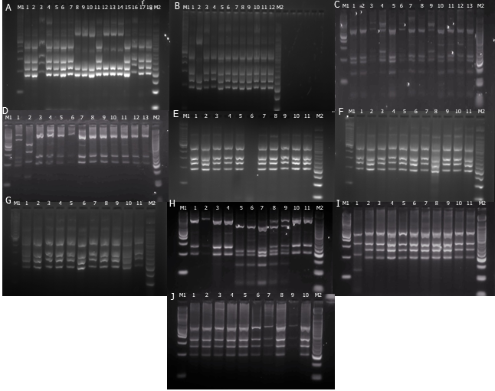
Fig. S1 PCR-RFLP based differentiation of various strains of methanogens (A-J) obtained from different hot springs digested using Hinf I. A, Lane 1-18 (R40N1, R40N2, R40N3, R40N4, R40N5, R40N6, R40N7, R40H8, R40H9, R40H10, R40N13, R40H12, R40H13, R40H14, R40N8, R40N9, R40N10, R40N11); B, Lane 1-12 (R40N12, R40H20, T40N1, T40N2, T40N3, T40N4, T40N5, T40N6, T40N7, T40N8, T40N9, T40N10); C, Lane 1-13 (UCB40M1, UCB40M5, T40UC2, T40UC9, UCB55M1, UCB55M2, UCB55M7, UCB55N2, T40UC5, T40UC1, T40UC3, T40UC4, UCB40N1); D, Lane 1-13 (UCB40T3, UCB40T10, UCB40H6, UCB40H4, UCB40T6, UCB40H1, T40UC1, UC40H1, UC40H4, UP40H1, UP40H2, UP40H5, UP40H6); E, Lane 1-11 (T40H9, T40H8, T55H12, T55H10, T55H15, BLANK, T55H21, T70H10, T70H15, T70H16, U40H1); F, Lane 1-11 (U40H3, U40H8, U40H13, U55H21, U55H7, U55H15, U55H5, U55H18, U55H19, U55H20, U55H22); G, Lane 1-11 (P55H1, P55H2, P55H3, P55H4, P55H5, P55H6, P55H7, P55H8, P55H9, P55H10, P55H11); H, Lane 1-11 (T40H1, T40H4, T40H3, T40H2, UCB40T1, UCB40T3, UCB40T2, T40UC6, T40UC7, R40H5, R40H4); I, Lane 1-11 (UCB40T9, R40H16, R55H1, R55H2, R55H3, R55H4, R55H6, R55H7, R55H8, R55H9, R55H10); J, Lane 1-10 (C55H1, C55H9, C55H7, C55H2, C55H3, C70H1, C70H2, C70H5, C70H6, C70H7); M1, 100 bp marker; M2, 50 bp marker

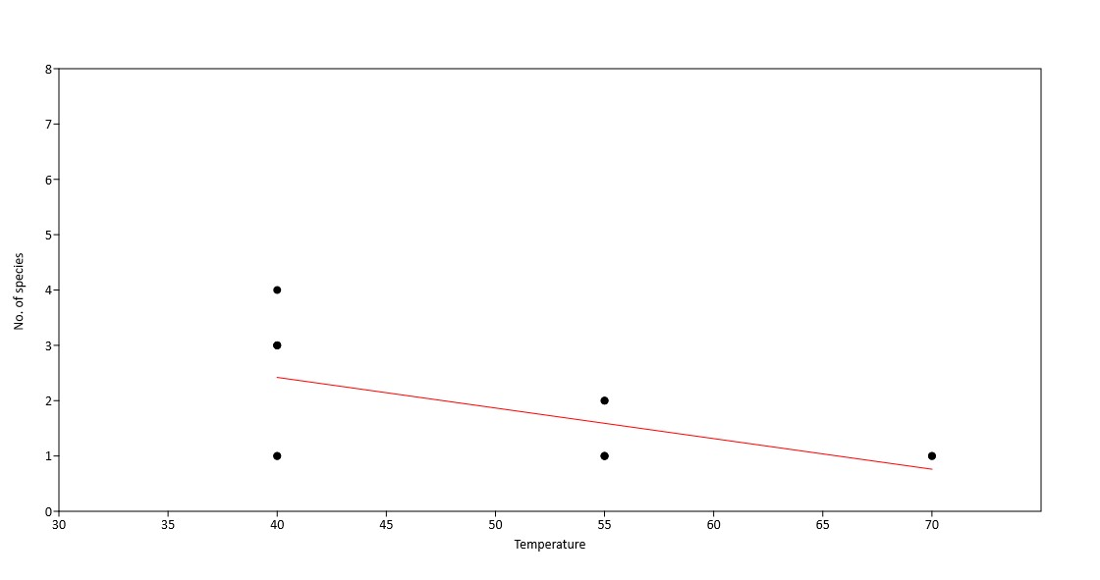

Fig. S2 The plot of linear regression implicating the decrease in diversity with an increase in temperature

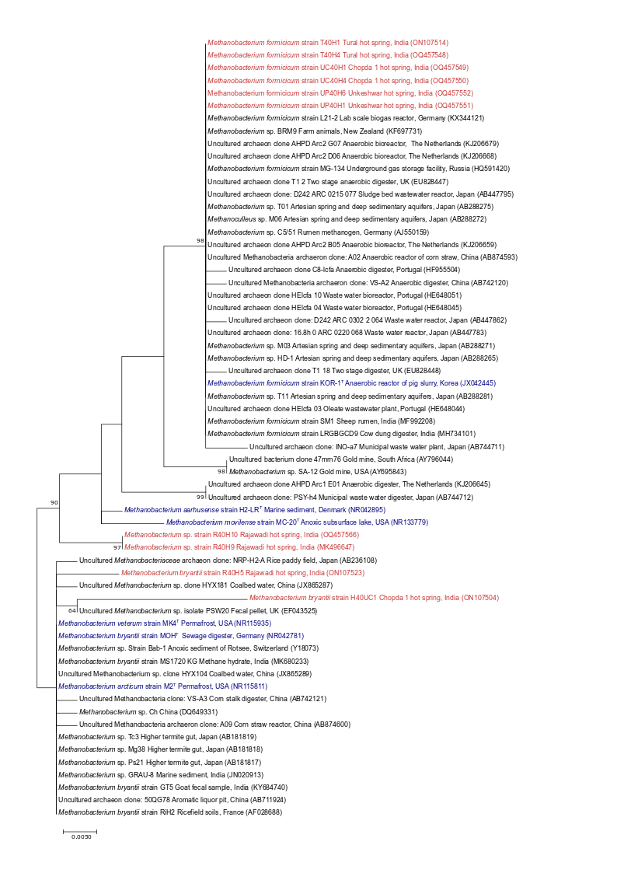
Fig. S3 A 16S rRNA gene based maximum-likelihood tree of genus Methanobacterium using Kimura 2-parameter model showing the phylogenetic position of obtained strains (in red) with nearest cultured (type strains in blue) and uncultured matches. Bootstrap values (>50%) based on 500 replicates are indicated at branching points. The GenBank accession number of each strain is listed in parentheses. Scale bar: 0.005 substitutions per site
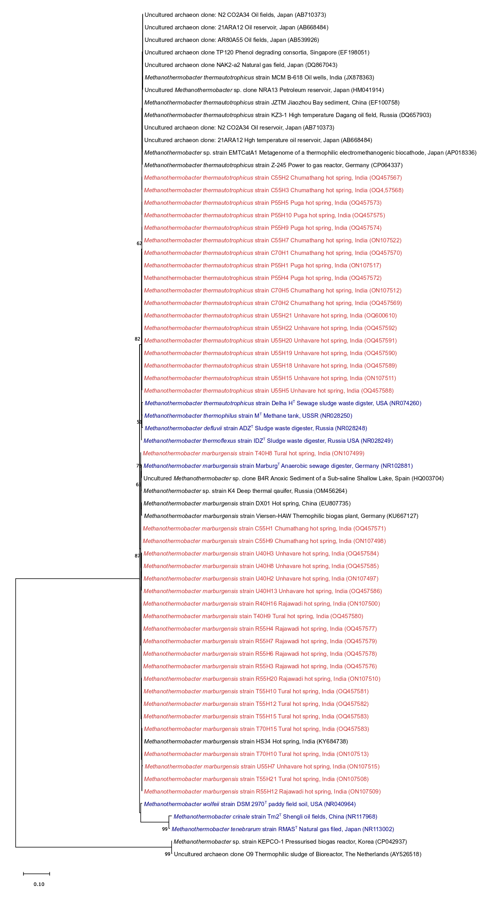

Fig. S4 A 16S rRNA gene based maximum-likelihood tree of genus Methanothermobacter using General time reversal parameter model showing the phylogenetic position of obtained strains (in red) with nearest cultured (type strains in blue) and uncultured matches. Bootstrap values (>50%) based on 500 replicates are indicated at branching points. The GenBank accession number of each strain is listed in parentheses. Scale bar: 0.1 substitutions per site
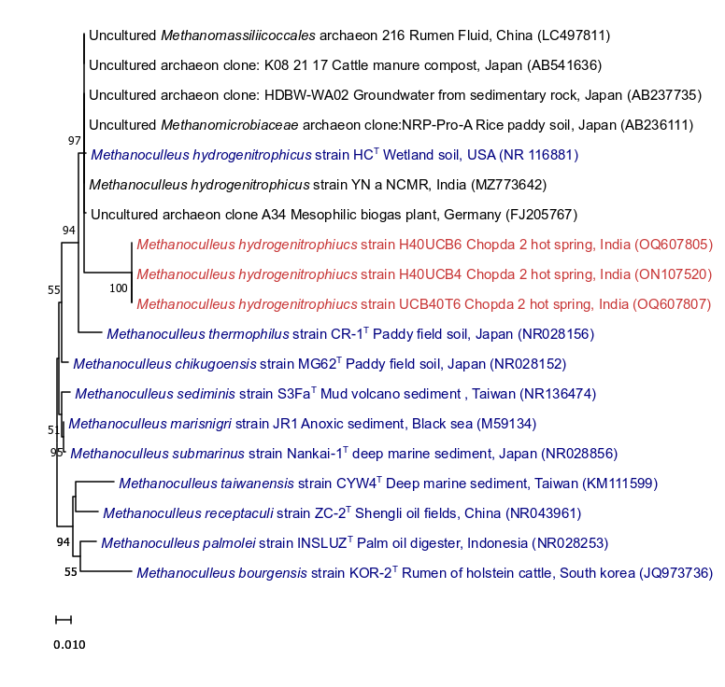
Fig. S5 A 16S rRNA gene based maximum-likelihood tree of genus Methanoculleus using Tamura 3 parameter model showing the phylogenetic position of obtained strains (in red) with nearest cultured (type strains in blue) and uncultured matches. Bootstrap values (>50%) based on 500 replicates are indicated at branching points. The GenBank accession number of each strain is listed in parentheses. Scale bar: 0.01 substitutions per site

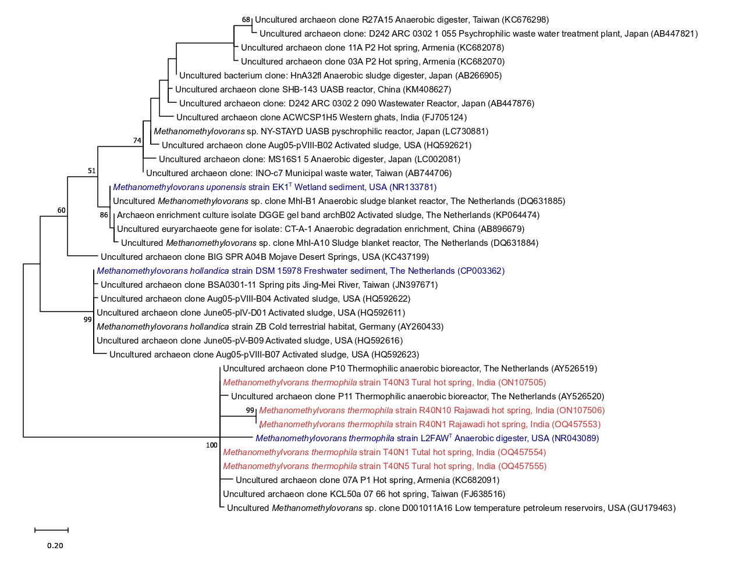

Fig. S6 A 16S rRNA gene based maximum-likelihood tree of genus Methanomethylovorans using Hasegawa-Kishino-Yano parameter model showing the phylogenetic position of obtained strains (in red) with nearest cultured (type strains in blue) and uncultured matches. Bootstrap values (>50%) based on 500 replicates are indicated at branching points. The GenBank accession number of each strain is listed in parentheses. Scale bar: 0.2 substitutions per site

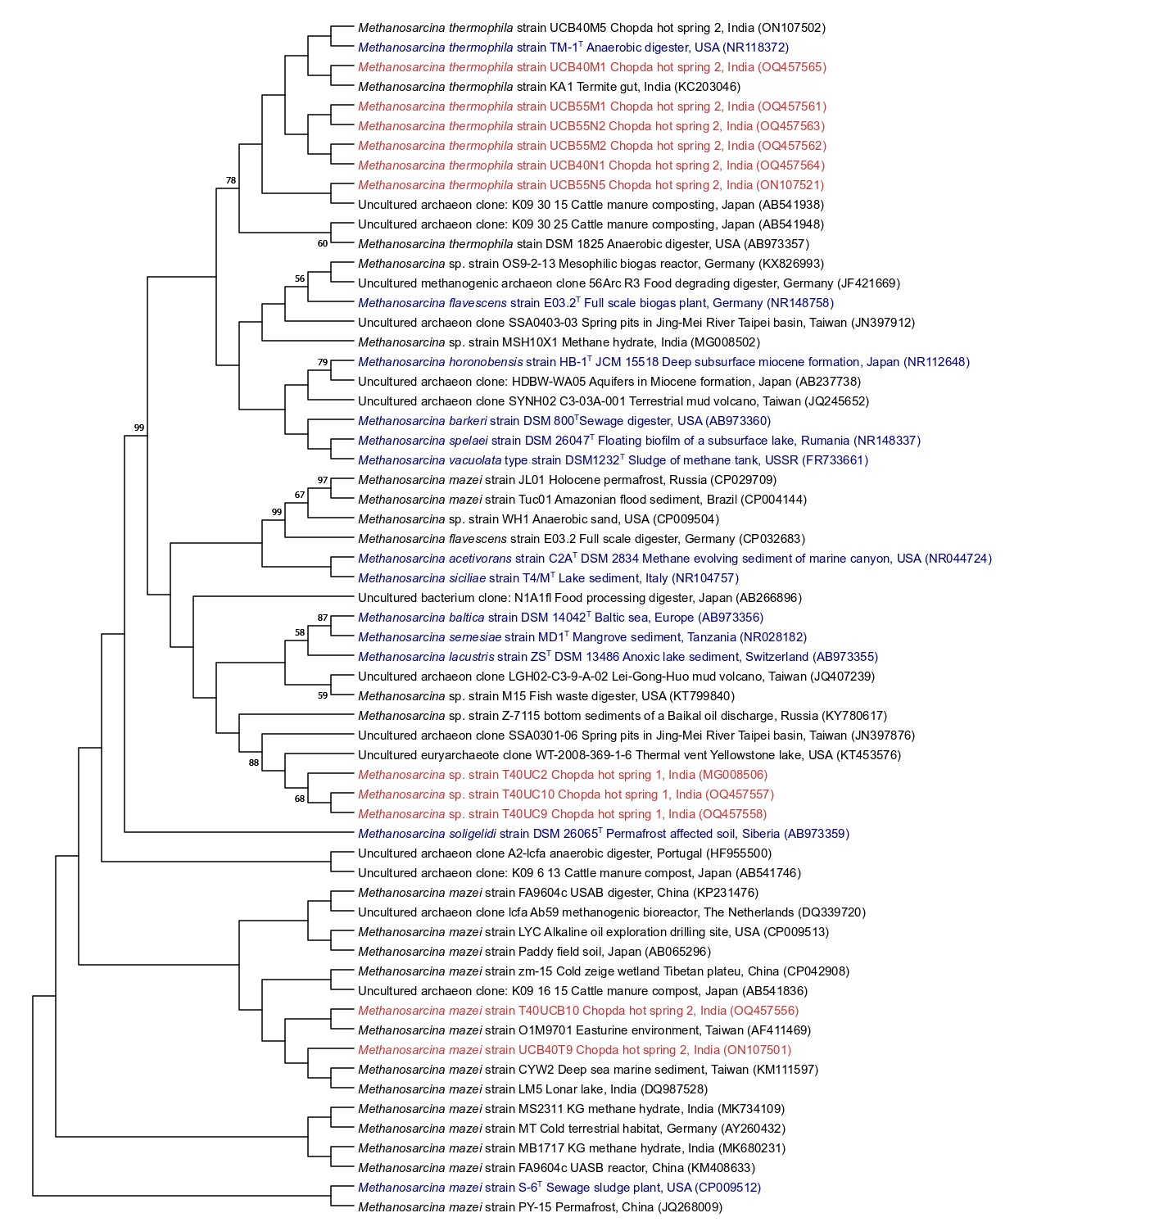

Fig. S7 A 16S rRNA gene based maximum-likelihood tree of genus Methanosarcina using Tamura Nei parameter model showing the phylogenetic position of obtained strains (in red) with nearest cultured (type strains in blue) and uncultured matches. Bootstrap values (>50%) based on 500 replicates are indicated at branching points. The GenBank accession number of each strain is listed in parentheses. Scale bar: 0.1 substitutions per site

