Assessing Efficacy of Plastic-free Alternative Ties For Coral Propagation in Reef Restoration.
Paige Strudwick¹* (ORC ID: 0000-0003-3053-5041), Emma F. Camp¹ (ORC ID: 0000-0003-1962-1336), Justin Seymour¹ (ORC ID: 0000-0002-3745-6541), Christine Roper¹ (ORC ID:
0000-0001-6128-9387), John Edmondson² (ORC ID: 0000-0001-8328-5600), Lorna Howlett¹ (ORC ID: 0000-0001-8095-1647), David J Suggett³ (ORC ID: 0000-0001-5326-2520)
¹ University of Technology Sydney, Climate Change Cluster, Faculty of Science, Ultimo, NSW, 2007, Australia
² Wavelength Reef Cruises, 6/43 Macrossan St., Port Douglas, QLD, 4877, Australia
³ King Abdullah University of Science and Technology (KAUST), Thuwal 23955-6900, Kingdom of Saudi Arabia
*Correspondence: paige.strudwick@uts.edu.au

Supplementary methods
All samples were held at 4 °C for four to six days during transportation from the study site to the laboratory. Once in the laboratory, RNAlater was thoroughly removed and samples were preserved at –80 °C for up to six months until DNA was extracted. Prior to DNA extraction, samples were thawed and rinsed with autoclaved phosphate-buffered saline (PBS) (3X, pH 7.4), and coral tissue was removed from the skeleton via air brushing into 4 mL of PBS. The tissue slurry was divided across two 2 mL micro centrifuge tubes and centrifuged at 8000 rpm for 5 min. The supernatant was removed, and the tissue pellet was stored at –80°C for one to two weeks until DNA extraction. DNA was extracted from approximately 200 µl of the coral tissue pellet using a DNeasy Blood and Tissue kit (Qiagen) following the Manufacturer’s protocol (July 2020 version) with a total elution volume of 40 µL. Kit “blank” samples were included in DNA extractions to identify any laboratory contaminants. Extracted DNA was quality checked and the concentration was quantified using a NanoDrop spectrophotometer.

Supplementary Figures
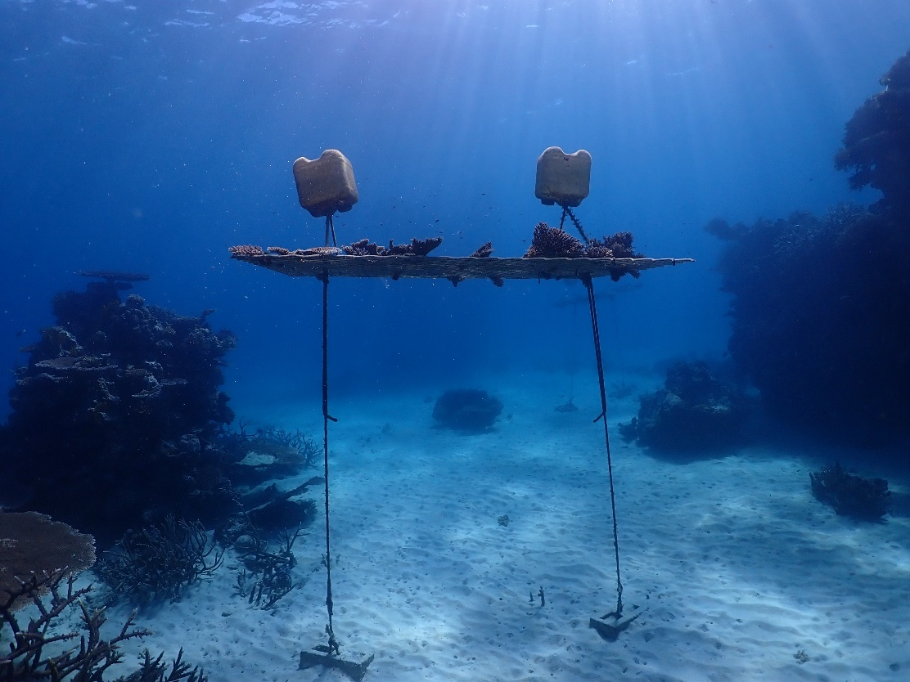
Fig. S1. Example of coral nursery at Opal Reef, photo: John Edmondson.
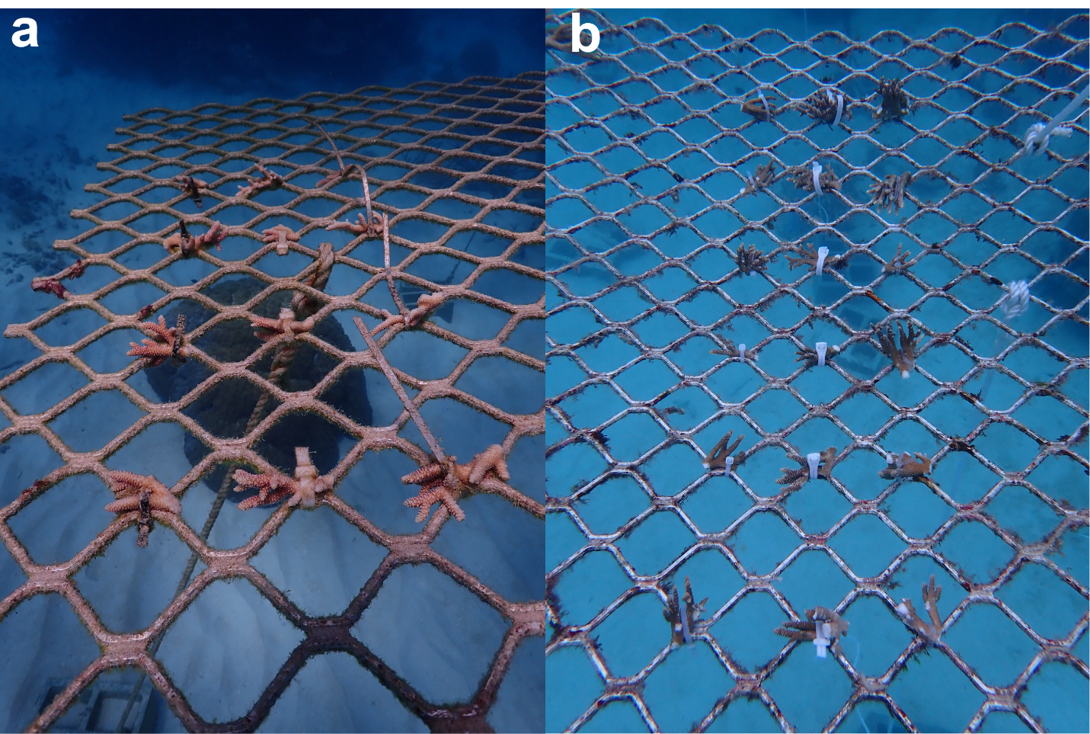 Fig. S2. Fragments of A. millepora in coral nurseries at Opal Reef, northern GBR. Coral fragments are secured with (from left to right) (a) plastic, biodegradable material A and metal ties in September 2020; and (b) plastic, biodegradable material B and Rapstrap ties in February 2022.
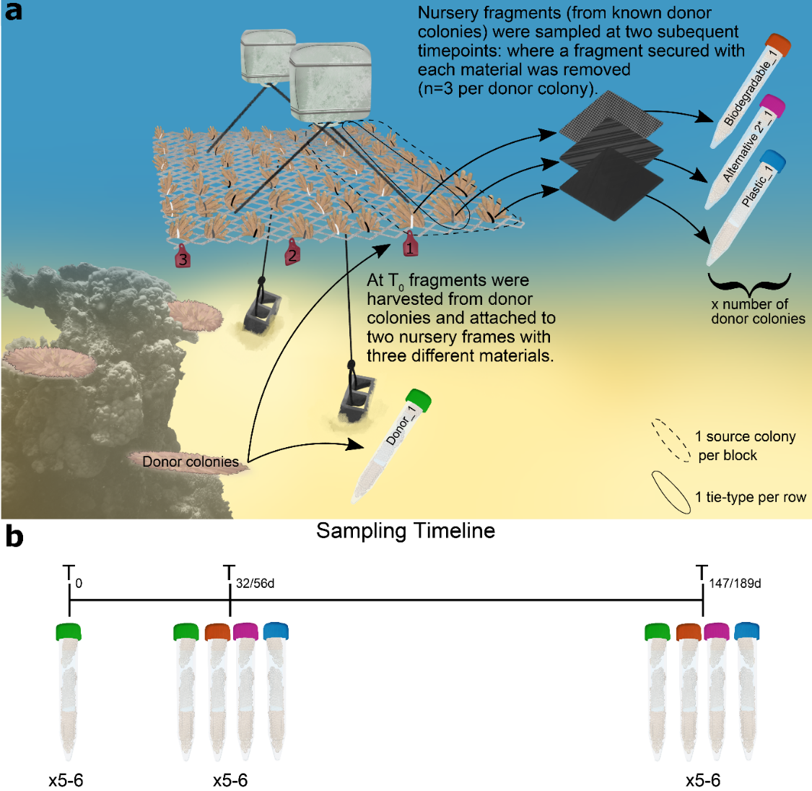
Fig. S3. Illustration of (a) the experimental design and nursery set up and (b) sampling timeline of the two experiments.
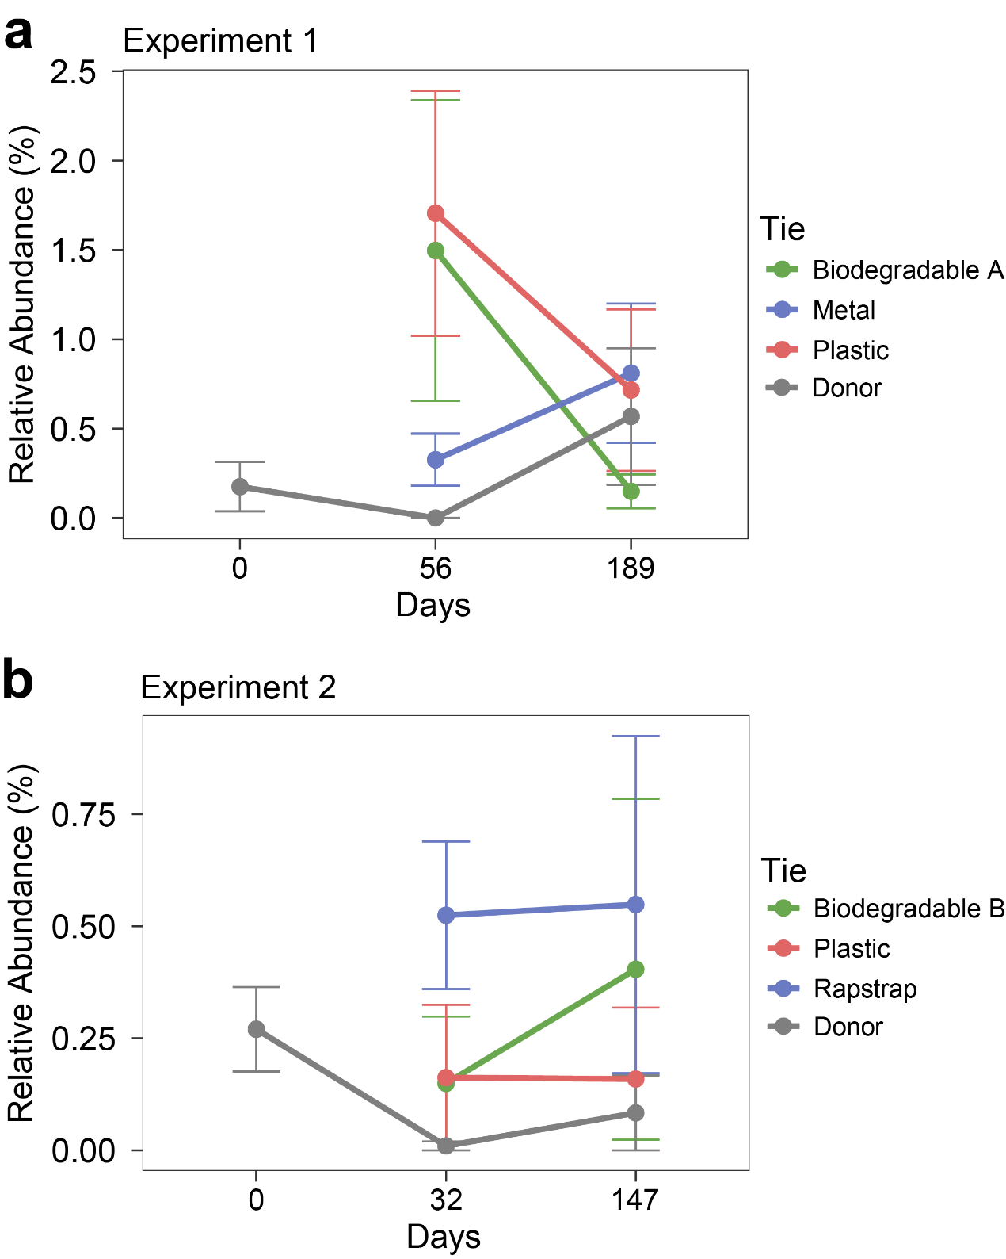
Fig S4. Relative abundance of bacteria within the Vibrio genus for Acropora millepora donor colonies and fragments within a coral nursery over time; in two studies assessing (a) biodegradable material A, plastic and metal zip-ties and (b) biodegradable material B, plastic and Rapstrap zip-ties to secure coral fragments (Source Data provided as Supplementary Data S2.).
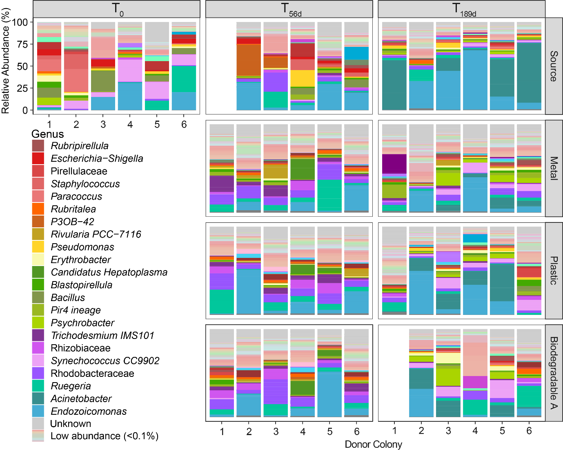
Fig S5. Bacterial community composition (relative abundances) by genus* of donor colonies at the start of the experiment (T₀) and fragments after 56 and 189 days (from August 2020 to February 2021) within a nursery secured with different materials; metal, plastic and biodegradable material A. Pastel colours represent genera with an average relative abundance of < 0.1 % in all samples, full legend provided as supplemental data (Supplementary Data S3a.) *non-italic text indicates family where – taxonomic resolution to genus level was unavailable.
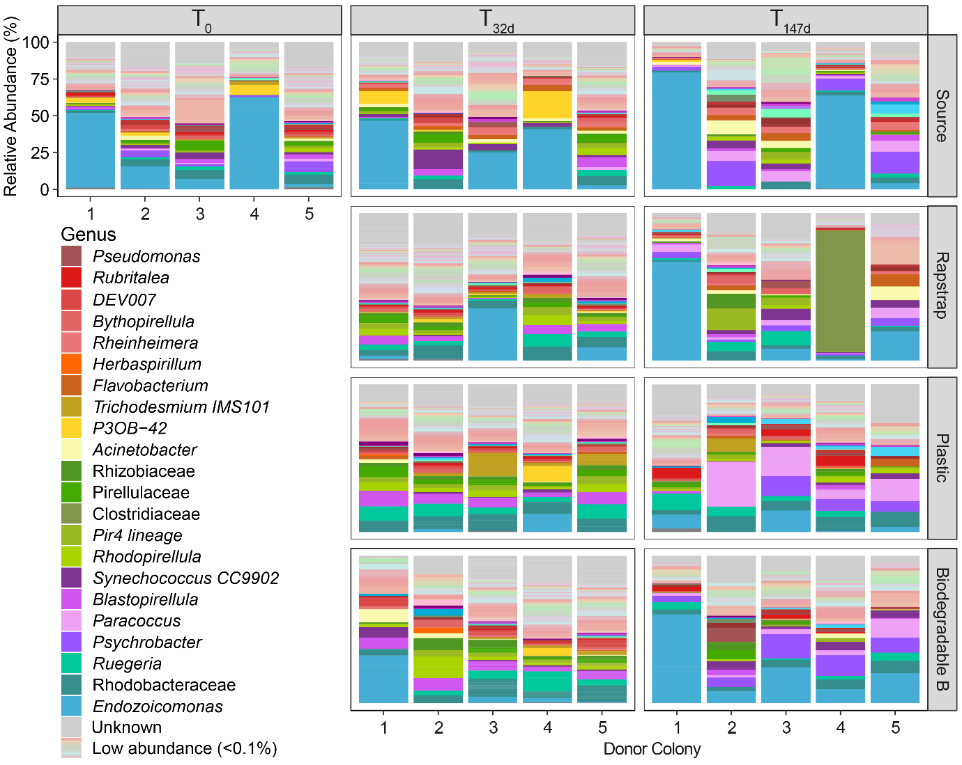
Fig S6. Bacterial community composition (relative abundances) by genus* of donor colonies at the start of the experiment (T₀) and fragments after 32 and 147 days (from February to August 2022) within a nursery secured with different materials; Rapstrap, plastic and biodegradable material B. Pastel colours represent genera with an average relative abundance of < 0.1 % in all samples, full legend provided as supplemental data (Supplementary Data S3b.) *non-italic text indicates family – where taxonomic resolution to genus level was unavailable.

Supplementary Tables
Experiment 1
Material Details
Biodegradable A  (gocableties.co.uk) | Metal | Plastic
SES-QUICK BIO biodegradable polyester (partially biobased of wheat or sugar cane).  Poly 1,4-butanediol Succinate – PBS.  300 mm x 7.6 mm | 316 Grade stainless steel.  200 mm x 4.6 mm | Nylon 66 – polyamide.  Black colour.  300 mm x 4.8 mm
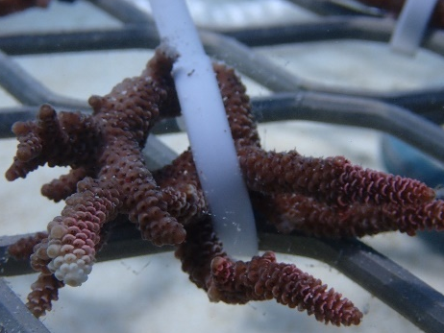 | 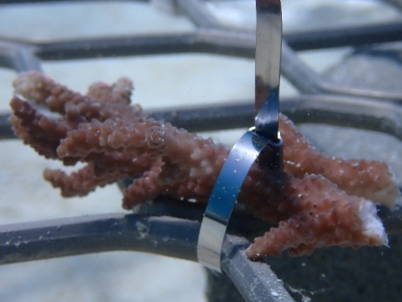 | 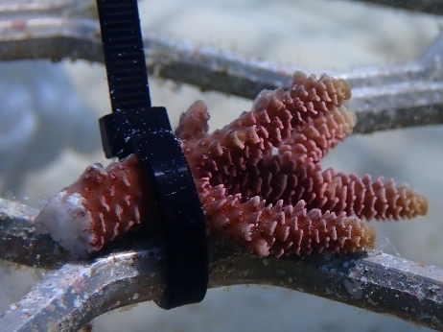
Experiment 2
Material Details
Biodegradable B  (rapstrap.com) | Rapstrap (i-Tie: 052-MPU)  (rapstrap.com) | Plastic
Polycaprolactone  300 mm x 8 mm | Polyurethane Elastomer.  300 mm x 4.8 mm | Nylon 66 – polyamide. “Natural” colour.  300 mm x 4.8 mm
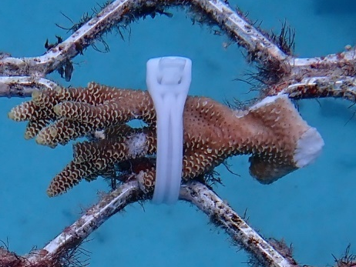 | 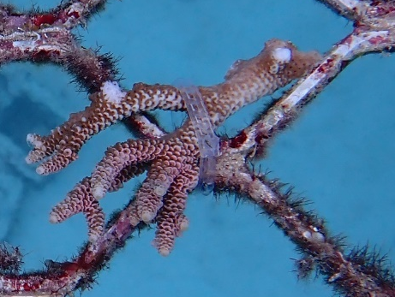 | 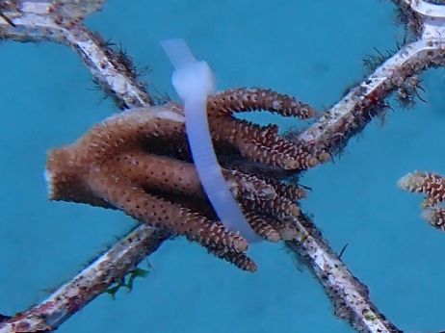
Table S1. Details of the attachment materials used in each experiment with photographs of corals attached to nursery frames.

Failure | Photograph, Experiment Number and Tie Details.
Missing coral fragment and tie. | 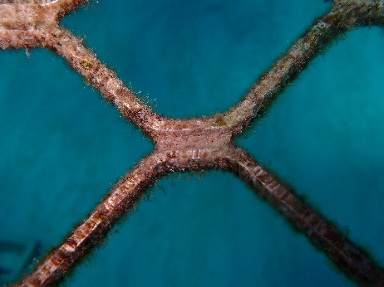  Experiment 1; Biodegradable (A).
Missing tie and coral fragment still present. | 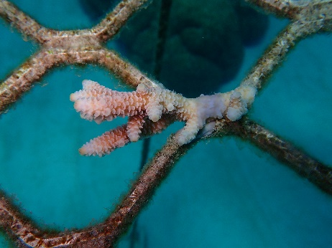  Experiment 1; Biodegradable (A). | 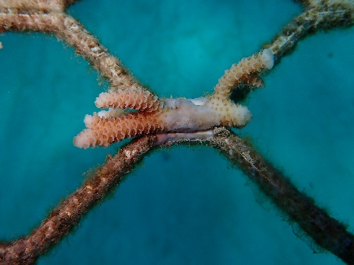  Experiment 1; Biodegradable (A).
Dead corals | 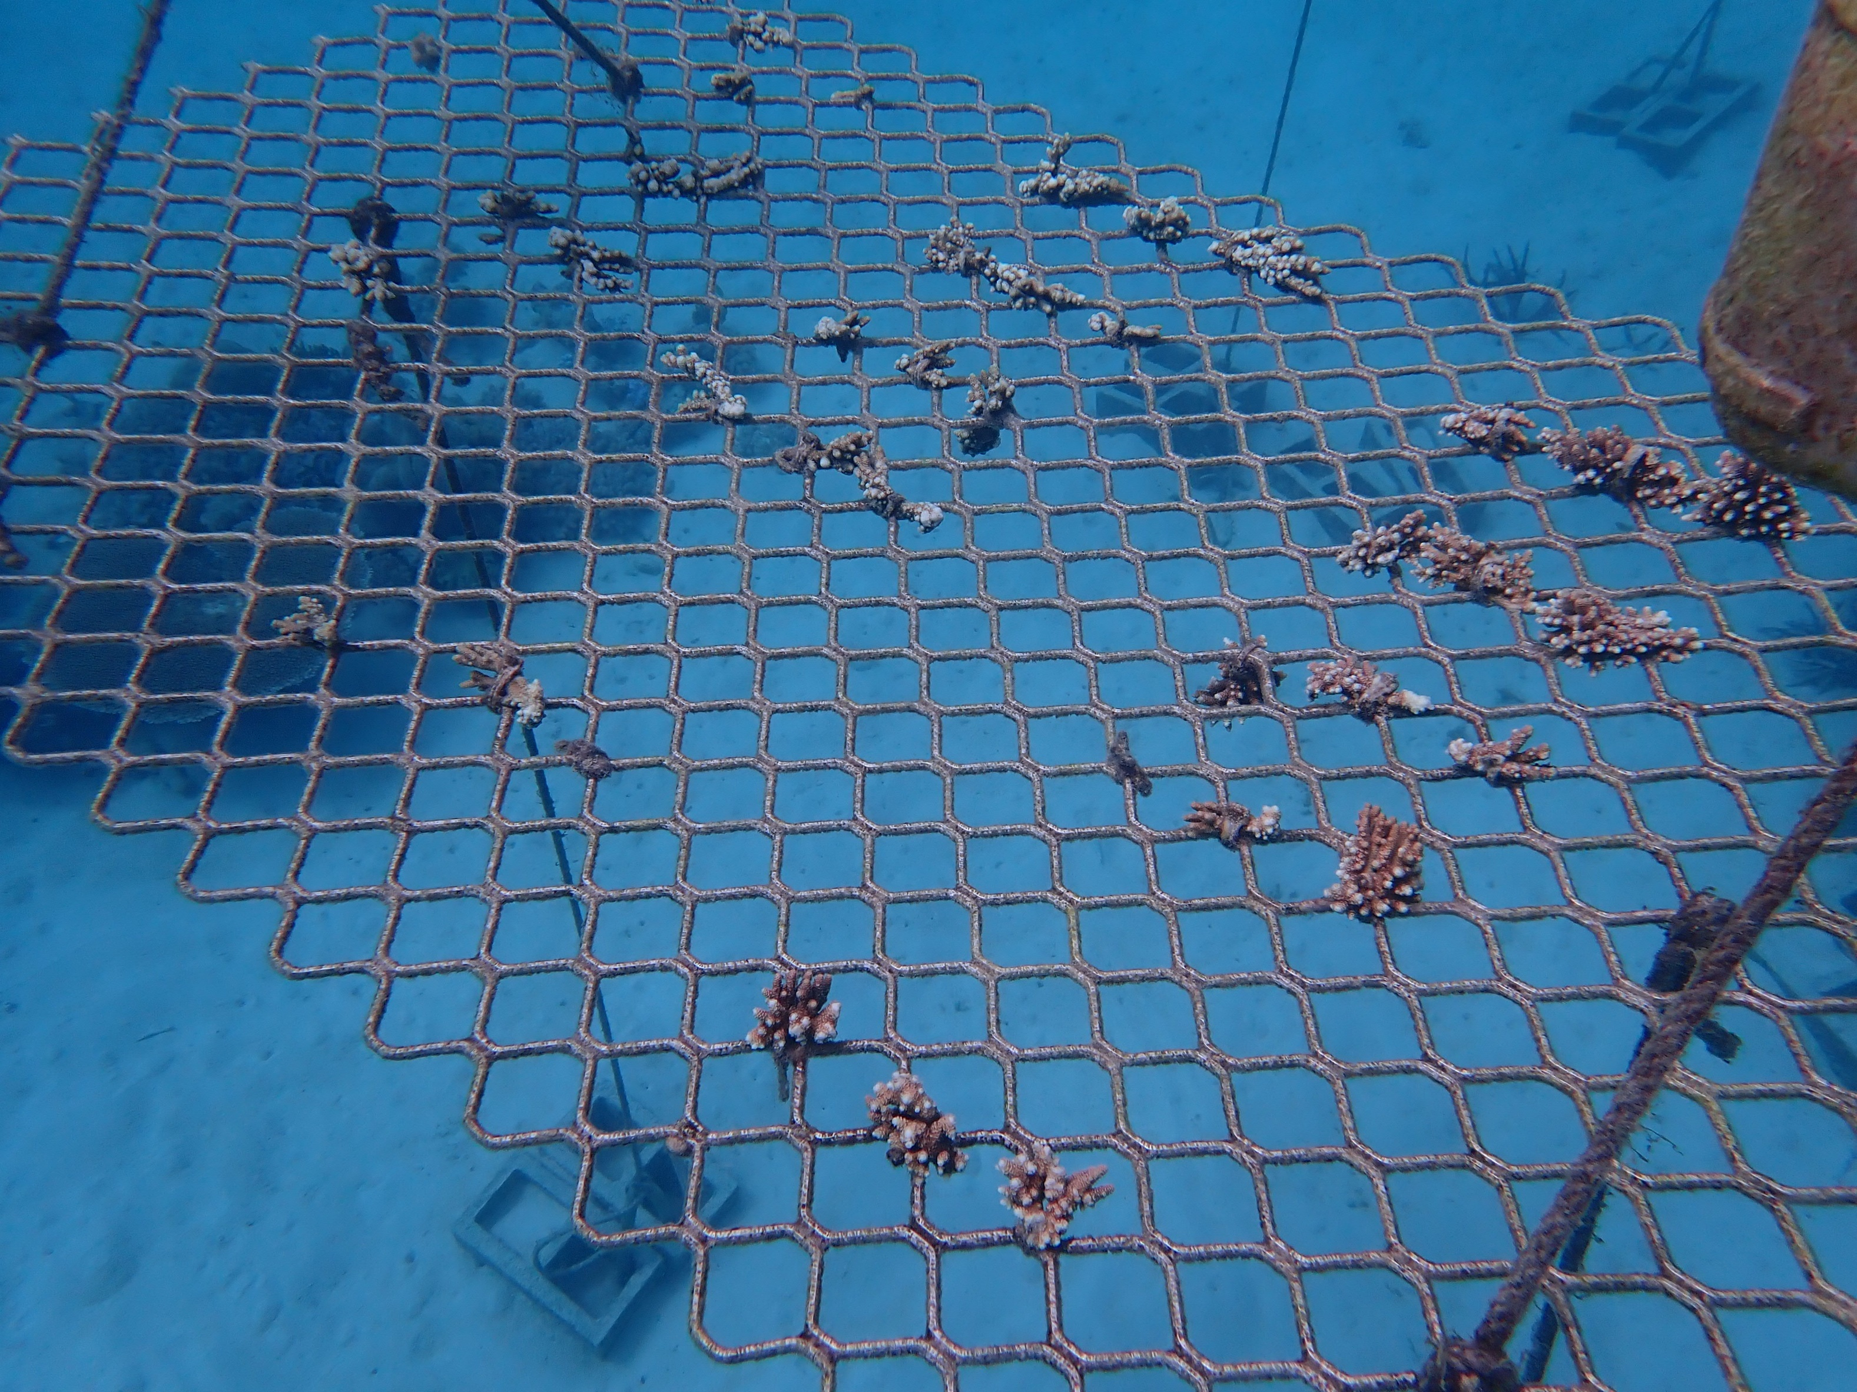  Experiment 2; Plastic tie. | Experiment 2; Rapstrap tie.
Table S2. Examples of tie failure and coral mortality.

Experiment 1
Timepoint | T₀ |  |  | T_{56d} |  |  | T_{189d}
 | Metal | Bio A | Plastic | Metal | Bio A | Plastic | Metal | Bio A | Plastic
attached with tie | 24 | 24 | 24 | 24 | 21 | 24 | 22 | 11 | 22
missing completely | 0 | 0 | 0 | 0 | 1 | 0 | 0 | 5 | 0
coral missing tie present | 0 | 0 | 0 | 0 | 0 | 0 | 1 | 0 | 1
coral present tie missing | 0 | 0 | 0 | 0 | 2 | 0 | 0 | 1 | 0
dead coral | 0 | 0 | 0 | 0 | 0 | 0 | 0 | 0 | 0
expected coral fragments | 24 | 24 | 24 | 24 | 24 | 24 | 23 | 18 | 23
 |  |  |  |  |  |  | Metal | Bio A | Plastic
 |  |  |  |  |  | total failure % | 4.166667 | 29.16667 | 4.166667
Experiment 2
Timepoint | T₀ |  |  | T_{32d} |  |  | T_{147d}
 | Rapstrap | Bio B | Plastic | Rapstrap | Bio B | Plastic | Rapstrap | Bio B | Plastic
attached with tie | 28 | 29 | 29 | 26 | 29 | 29 | 23 | 28 | 27
missing completely | 0 | 0 | 0 | 0 | 0 | 0 | 0 | 0 | 0
coral missing tie present | 0 | 0 | 0 | 0 | 0 | 0 | 0 | 0 | 0
coral present tie missing | 0 | 0 | 0 | 0 | 0 | 0 | 0 | 0 | 0
dead coral | 0 | 0 | 0 | 2 | 0 | 0 | 2 | 0 | 1
expected coral fragments | 28 | 29 | 29 | 28 | 29 | 29 | 25 | 28 | 28
 |  |  |  |  |  |  | Rapstrap | Bio B | Plastic
 |  |  |  |  |  | total failure % | 0 | 0 | 0
Table S3. Survivorship and failure counts for experiment 1 and 2 at sampling time points.

