Supplementary materials:

Table S1. Raw EAG response measurements (mV) from sexually immature female Bactrocera tryoni to Tenax® extracts from each bacterium (Control tryptone soya broth (TSB) media; CF: Citrobacter freundii; EC: Enterobacter cloacae; KO: Klebsiella oxytoca; PA: Enterobacter (sy. Pantoea) agglomerans).

Table S2. Mean relative proportions of microbial volatile organic compounds (MVOCs) identified for each bacterium grown at pH3, pH5, PH7, pH9, and pH12, and collected via 24 h headspace collection with solid phase micro-extraction (SPME) fibre. The MVOCs highlighted in grey were used in dual choice behavioural assays with individual compounds. (CF: Citrobacter freundii; EC: Enterobacter cloacae; KO: Klebsiella oxytoca; PA: Enterobacter (syn. Pantoea) agglomerans and tryptone soya broth (TSB) media).*KI: Kovats retention index; **RT: retention time (in min).

Table S3. Mean relative proportions (peak area) of microbial volatile organic compounds (MVOCs) identified for each bacterium grown on tryptone soya broth (TSB) and inoculated on three types of fruits; apple, kiwifruit, and orange. Volatiles were collected via Tenax® for 24 h, 3 days, and 5 days, and thermally desorbed. (CF: Citrobacter freundii; EC: Enterobacter cloacae; KO: Klebsiella oxytoca; PA: Enterobacter (syn. Pantoea) agglomerans and TSB media).

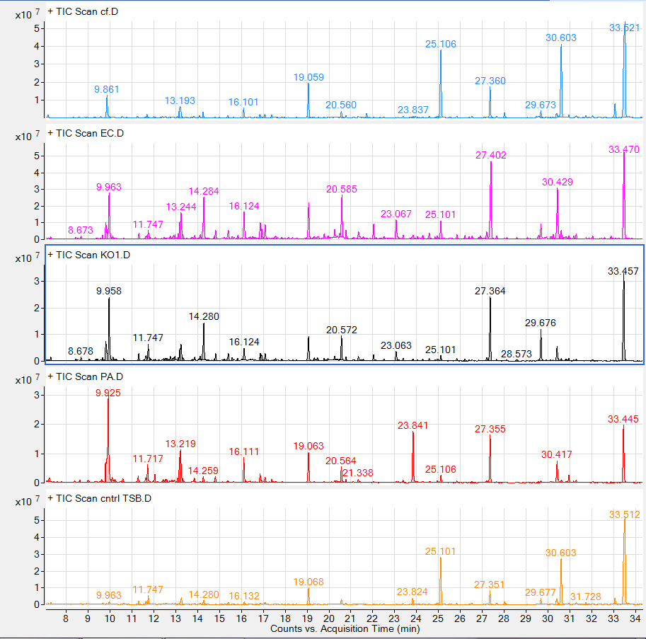
Figure S1. Representative chromatograph profiles of four bacterial species grown on tryptone soya broth (TSB), collected on Tenax® for 24 h and solvent-extracted. From top to bottom: CF-Citrobacter freundii; EC-Enterobacter cloacae; KO-Klebsiella oxytoca; PA- Enterobacter (sy. Pantoea) agglomerans and TSB media.

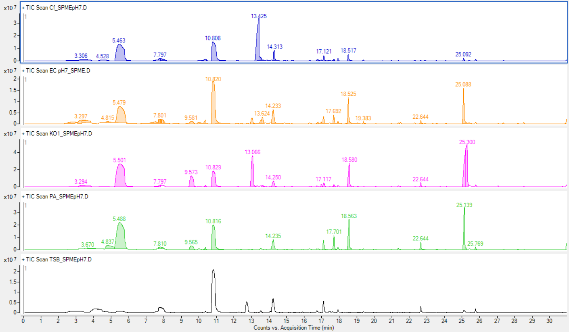
Figure S2. Representative chromatograph profiles of four bacterial species grown on tryptone soya broth (TSB), collected with solid phase micro-extraction (SPME) fibre for 1 h and thermally desorbed. From top to bottom: CF-Citrobacter freundii; EC-Enterobacter cloacae; KO-Klebsiella oxytoca; PA- Enterobacter (syn. Pantoea) agglomerans and TSB media.

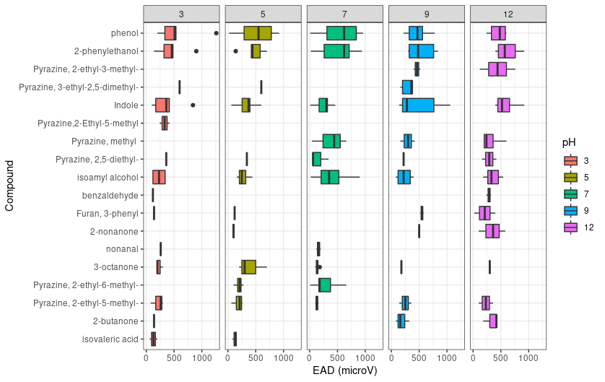
Figure S3. Olfactory responses from solid phase micro-extraction (SPME) - Gas-chromatograph coupled with electroantennographic detection (SPME-GC/EAD) of virgin females to microbial volatile organic compounds produced by a mix of four Enterobactericeae bacteria adjusted to pH 3,5,7,9 and 12.

