Supplementary Information

The Influence of Hydrothermal Fatigue on the Clinically Relevant Functional Properties of Conventional Glass-ionomer Cements

Magdalena Łępicka^{a*}, Agata Maria Niewczas^{b}, Magdalena Rodziewiczª, Konrad Pikuła^{b}, Paweł Kordos^{c}, Tomasz Gredes^{d,e}, Krzysztof Jan Kurzydłowskiª

ªInstitute of Mechanical Engineering, Faculty of Mechanical Engineering, Bialystok University of Technology, Wiejska 45C, 15-352, Bialystok, Poland

^{b}Medical University of Lublin, Department of Conservative Dentistry with Endodontics,
W. Chodźki 6, 20-093, Lublin, Poland

^{c}Lublin University of Technology, Institute of Transport, Combustion Engines and Ecology, Nadbystrzycka 36, 20-618, Lublin, Poland

^{d}Technische Universität Dresden, Department of Orthodontics, Carl Gustav Carus Campus,
Fetscherstr.74, 01307, Dresden, Germany

^{e}Poznan University of Medical Sciences, Department of Orthodontics and Temporomandibular Disorders, Bukowska 70, 60-812, Poznan, Poland

*corresponding author; e-mail: m.lepicka@pb.edu.pl

Table S1. Chemical compositions of the glass-ionomer cements included in the study [1-4]
Material Ingredient | Ketac Universal | Ketac Molar Easymix | Riva Self Cure
Liquid
Acrylic acid-maleic acid co-polymer | 30 – 50 % | 25 – 40 % | 20 – 30 %
Tartaric acid | 1 – 10 % | 5 – 10 % | 10 – 15 %
Powder
Oxide glass chemicals | > 95 % | 85 – 95 % | 90 – 95 %
Polyacrylic acid | - | 5 – 15 % | 5 – 10 %

References:
1. 3M ESPE Ketac Universal Safety Data Sheet. 2023 [cited 2023 6th Feb 2023]; Available from: https://multimedia.3m.com/mws/mediawebserver?mwsId=TTTTTV7o0_VyM9Apnyuw5ygCowvaldv_IwVAMYuEvTTTTTT--.
2. 3M ESPE Ketac Molar Easymix Safety Data Sheet. 2023 [cited 2023 6th Feb 2023]; Available from: https://multimedia.3m.com/mws/mediawebserver?mwsId=SSSSSuUn_zu8l9Ul4Yt9ox_9lvVsj17zHvu9lx_D7SSSSSS--.
3. Riva Self Cure (powder) Safety Data Sheet. 2023 [cited 2023 6th Feb 2023]; Available from: https://www.sdi.com.au/pdfs/sds/pl-pl/riva%20self%20cure%20powder_sdi_sds_pl-pl.pdf.
4. Riva Self Cure (liquid) Safety Data Sheet. 2023 [cited 2023 6th Feb 2023]; Available from: https://www.sdi.com.au/wp-content/uploads/SDS/SDS_Pol_PL/Riva_Self_Cure_Liquid_Pol.pdf.

Table S2. A summary of fabricated samples and conducted measurements, including number of replications; RSC – Riva Self Cure, KU – Ketac Universal, KME – Ketac Molar Easymix.
Series no. | Symbol | Sample type | Number of replications in each series
Series no. | Symbol | Sample type | Surface microhardness | Friction and wear | Surface roughness | Compression strength
1. | RSC | reference | 16 | 5 | 16 | 5
2. | KU
3. | KME
4. | RSC_TC | hydrothermal fatigue
5. | KU_TC
6. | KME_TC

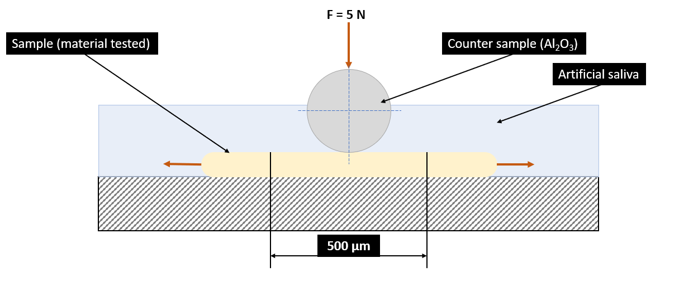
Figure S1. Schematic representation of the friction pair

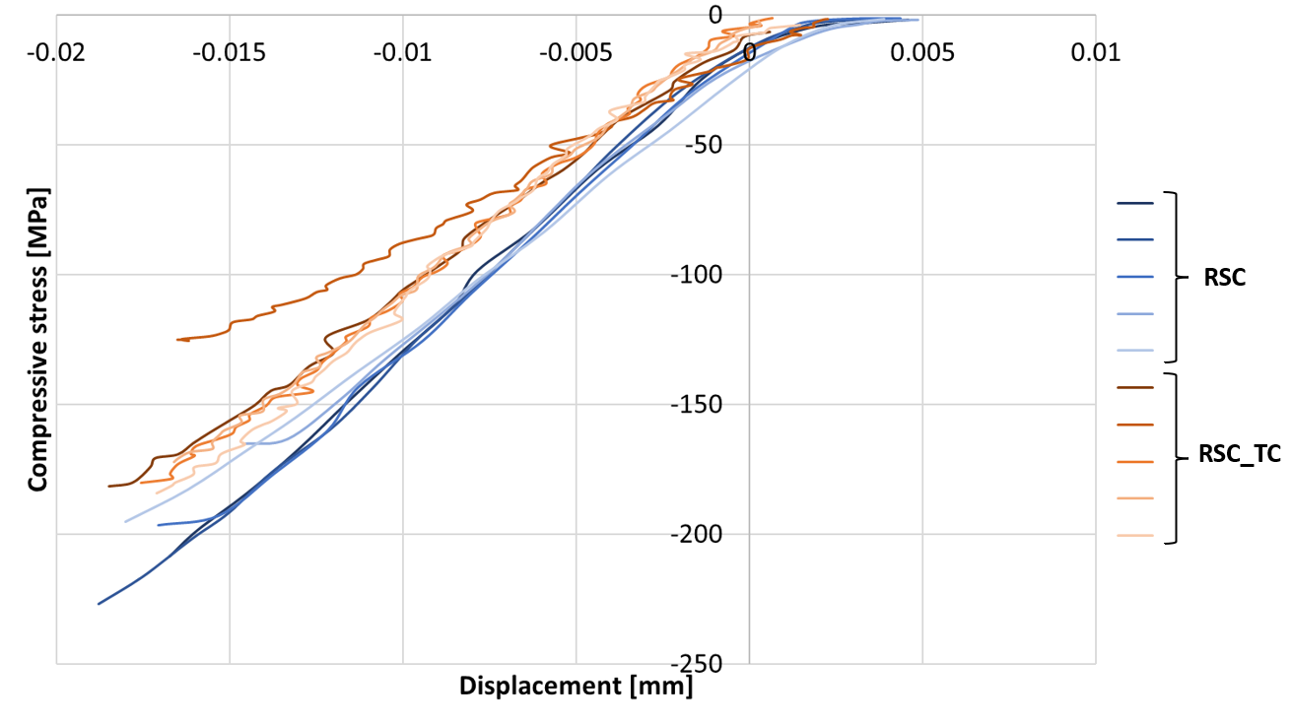
Figure S2. The compressive stress – displacement curves, acquired for the reference and fatigued RSC samples.

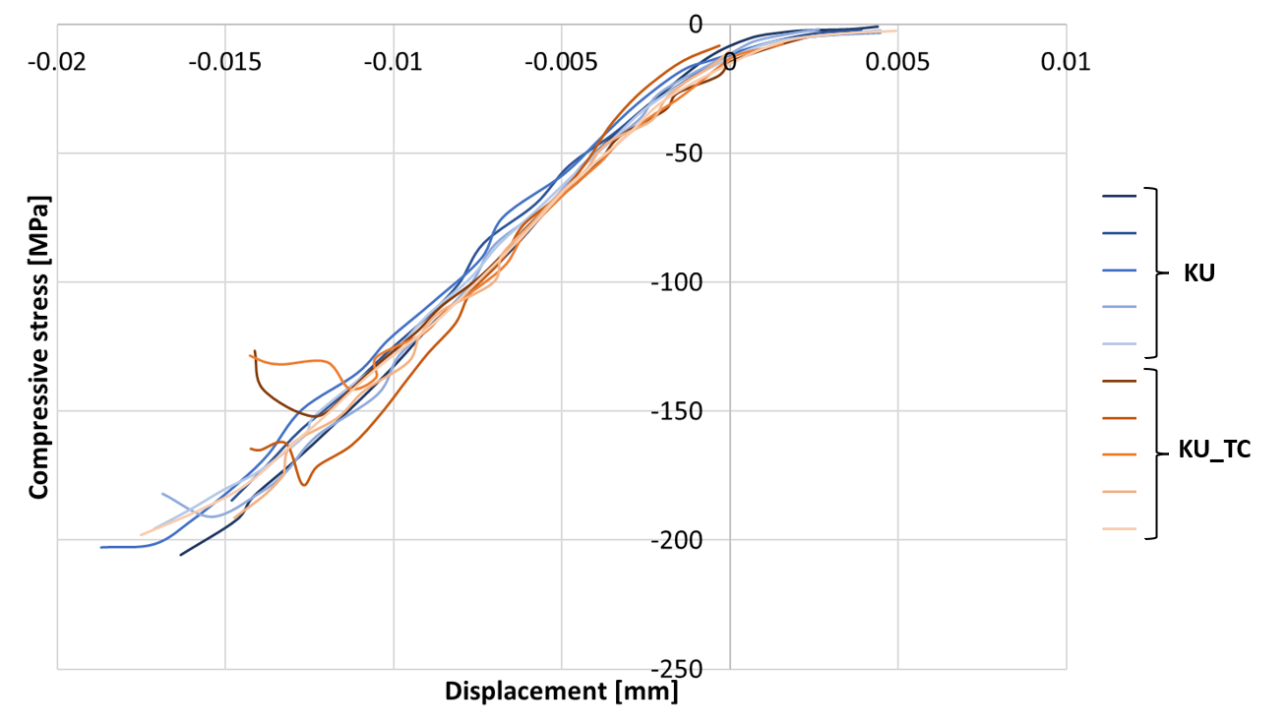
Figure S3. The compressive stress – displacement curves, acquired for the reference and fatigued KU samples.

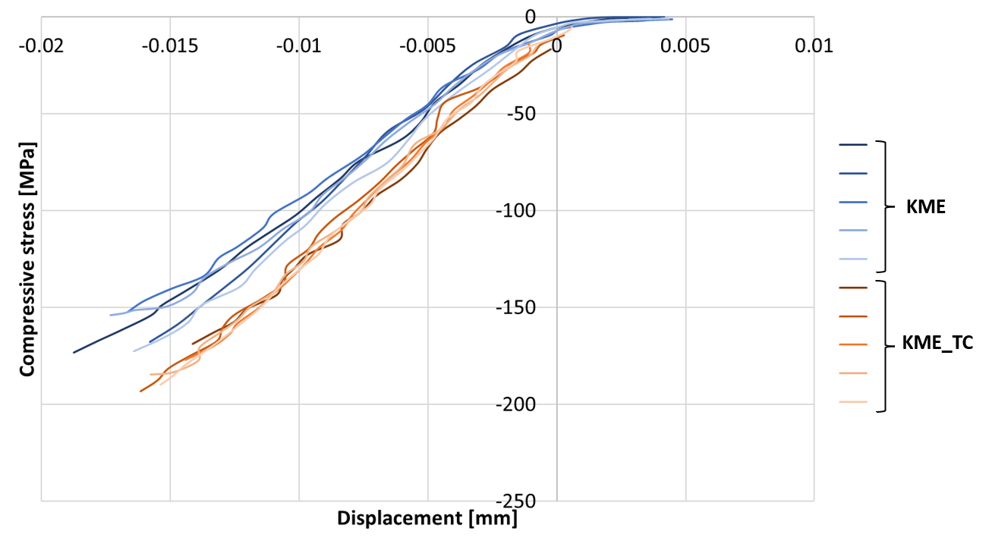
Figure S4. The compressive stress – displacement curves, acquired for the reference and fatigued KME samples.

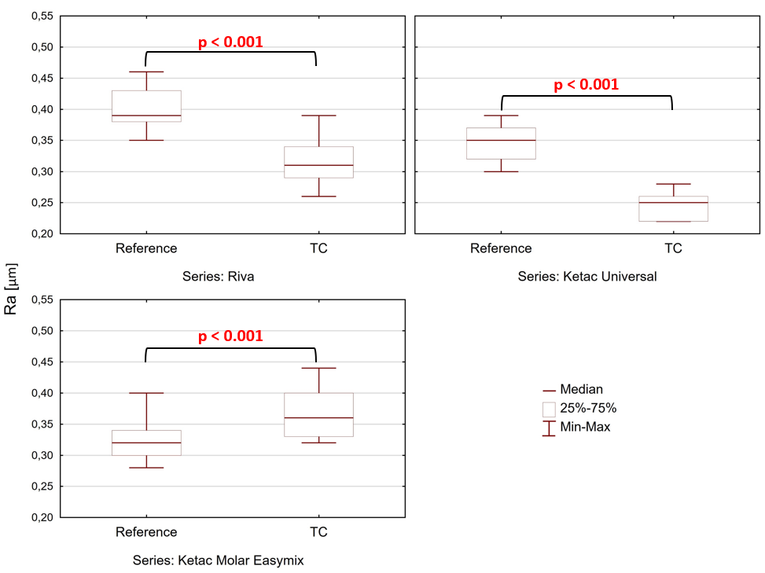
Figure S5. Results of surface roughness measurements: parameter Ra
(U Mann-Whitney, p < 0.05).

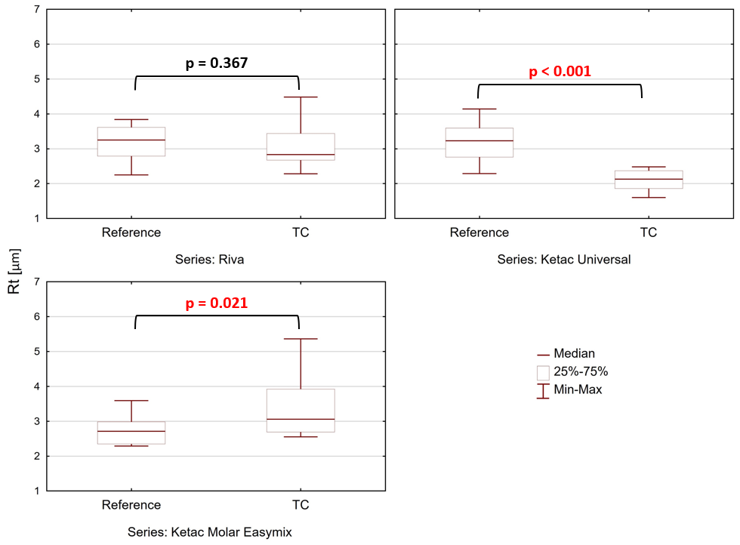
Figure S6. Results of surface roughness measurements: parameter Rt
(U Mann-Whitney, p < 0.05).

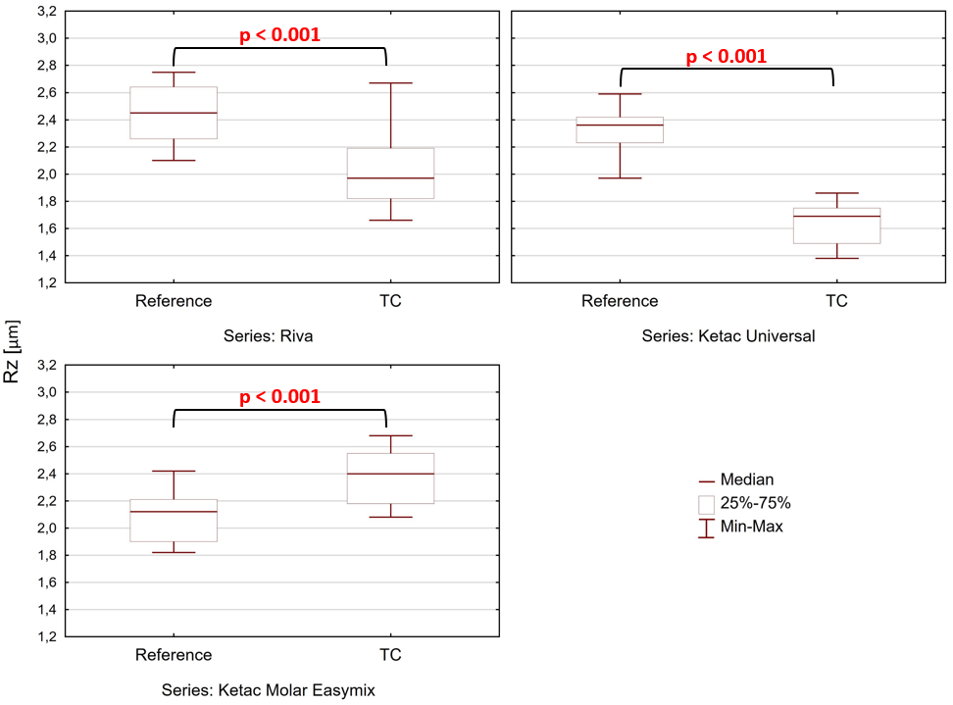

Figure S7. Results of surface roughness measurements: parameter Rz
(U Mann-Whitney, p < 0.05).

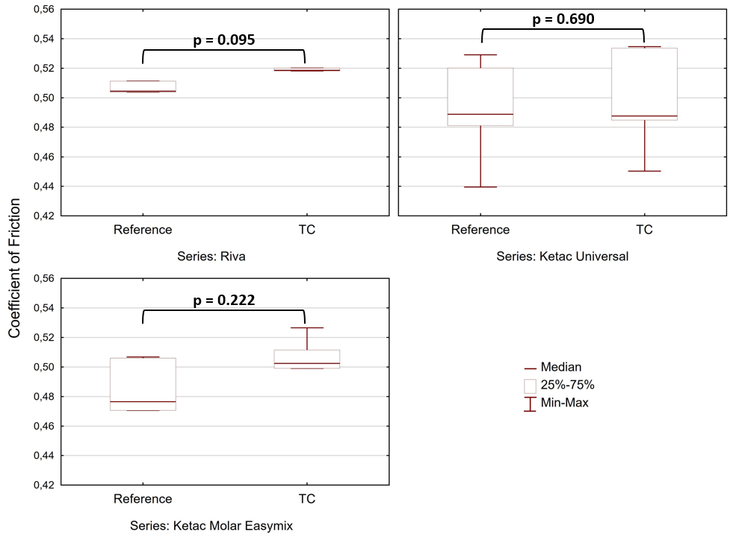
Figure S8. Average COF observed for both reference and thermocycled samples
(U Mann-Whitney, p < 0.05).

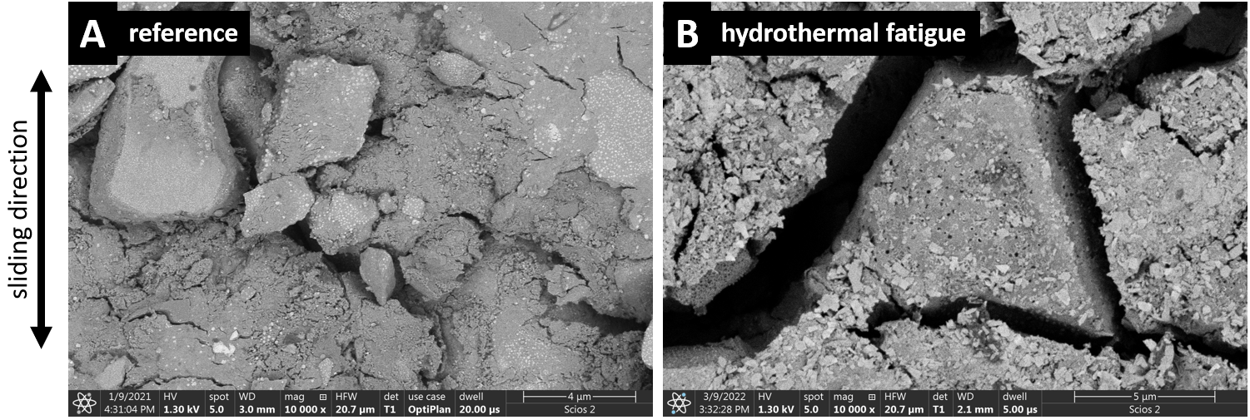
Figure S9. High magnification images of the wear tracks obtained for KME samples: (A) reference, and (B) sample subjected to hydrothermal fatigue. SEM BSE images.

