Biochar increased retention of ¹⁵NH₄⁺ in a tropical Acrisol under rain-fed maize crop
Munera-Echeverri J.L.^{ab*}, Martinsen V.ª, Talmo I.K. ^{ac}, Dörsch P.ª, Obia, A.^{d}, Mulder, J.ª
ªFaculty of Environmental Sciences and Natural Resource Management, Norwegian University of Life Sciences, P.O. Box 5003, 1432 Ås, Norway.
^{b}INRAE, Info&Sols, 45075, Orléans, France
^{c}Landbruksdirektoretatet, 0663, Oslo
^{d} Department of Agronomy, Faculty of Agriculture and Environment, Gulu University, P.O Box 166, Gulu, Uganda
*Corresponding author: jose-luis.munera-echeverri@inrae.fr

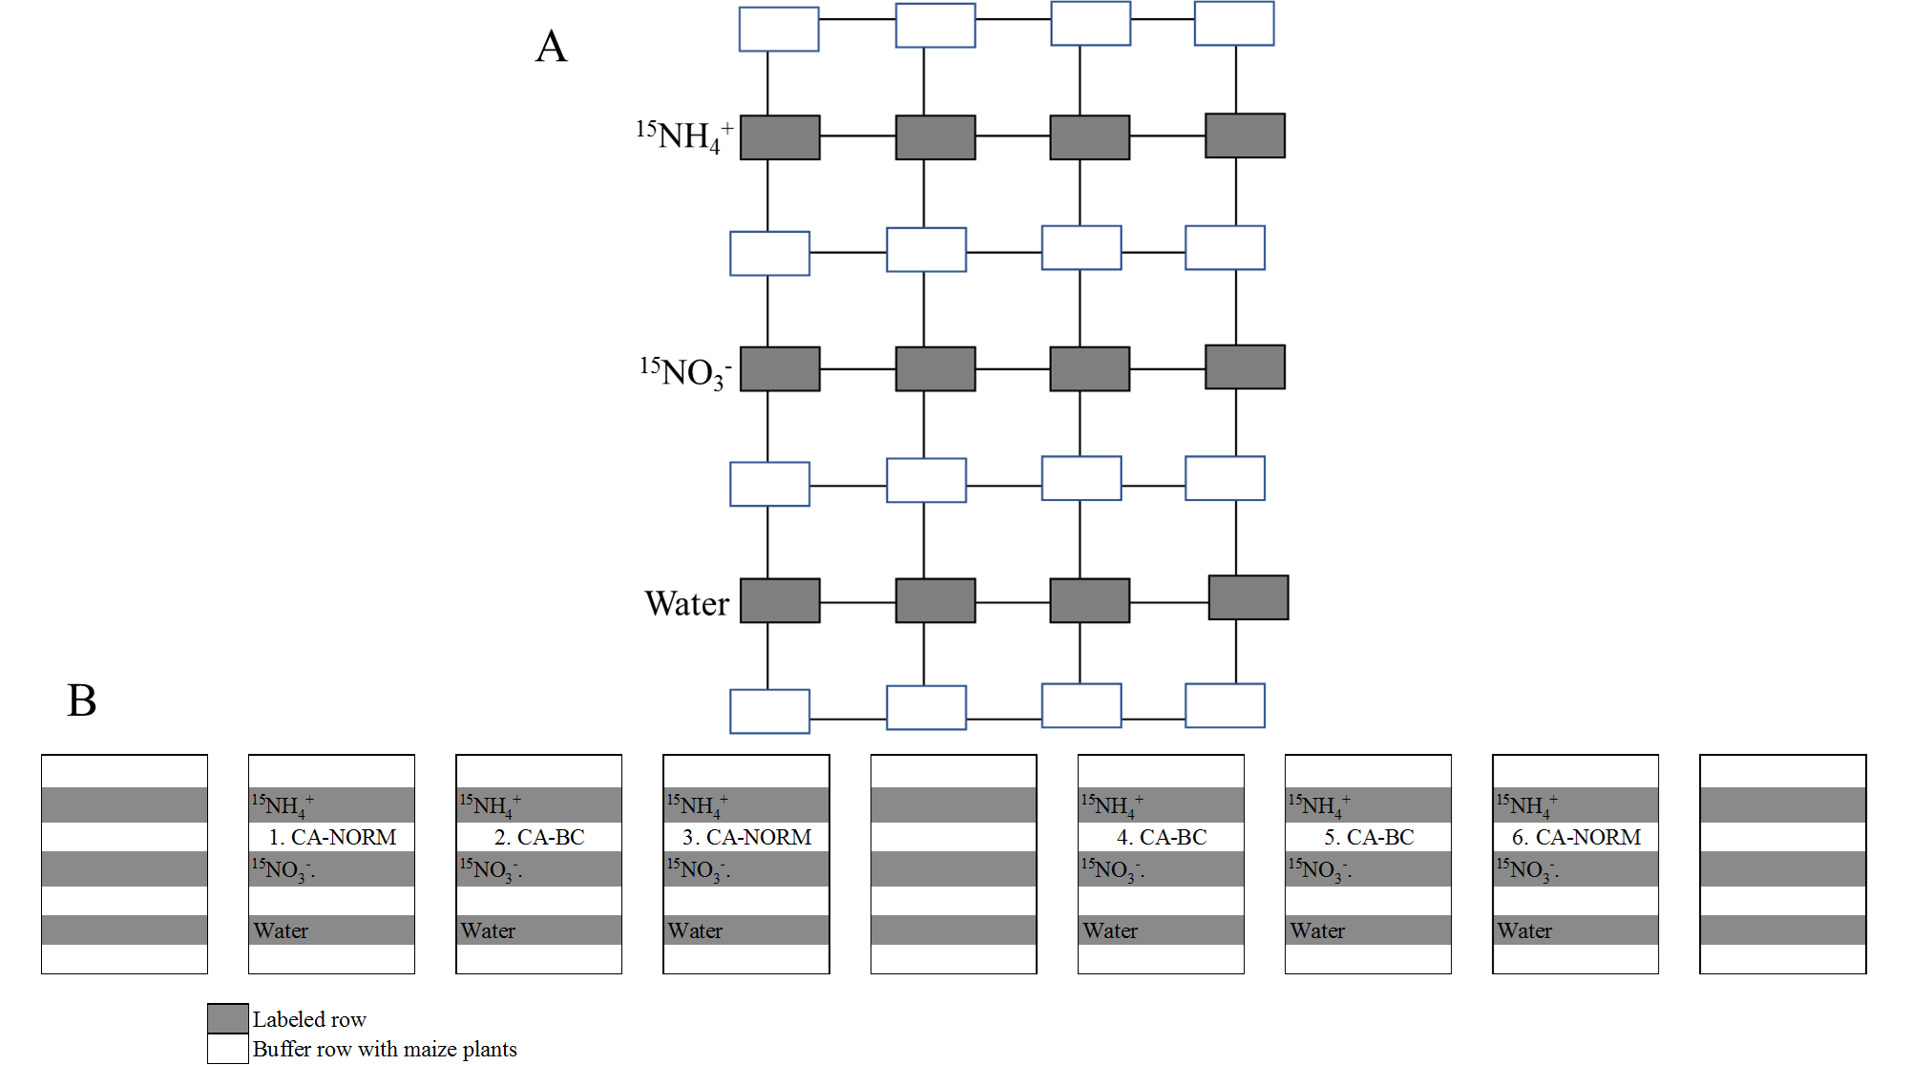
Fig. S1. A) Representation of a plot with seven rows of planting basins at 90 cm distance. Each row had four planting basins at 80 cm distance. The dimensions of each basin were 40 cm length x16.7cm width x20cm depth, each one with three maize plants. ¹⁵N addition was carried out in the four basins of each labeled row. B) Overall experimental set-up and detailed planting schemes used for conservation agriculture with (CA-BC) or without biochar (CA-NORM) in planting basins. CA-BC and CA-NORM had four planting basins per row and 3 maize plants per basin. Each plot had seven rows of maize plants, represented by the grey and white colors. ¹⁵N and the water control were added in the gray rows, while the white rows represent a buffer zone with maize plants present. The with no letters represent the adjacent conventionally tilled plots that were not included in the present study.
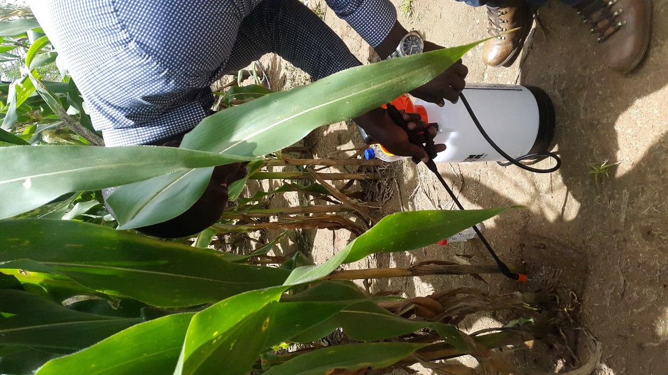
Fig. S2. Application of ¹⁵N with a hand sprayer in a planting basin.
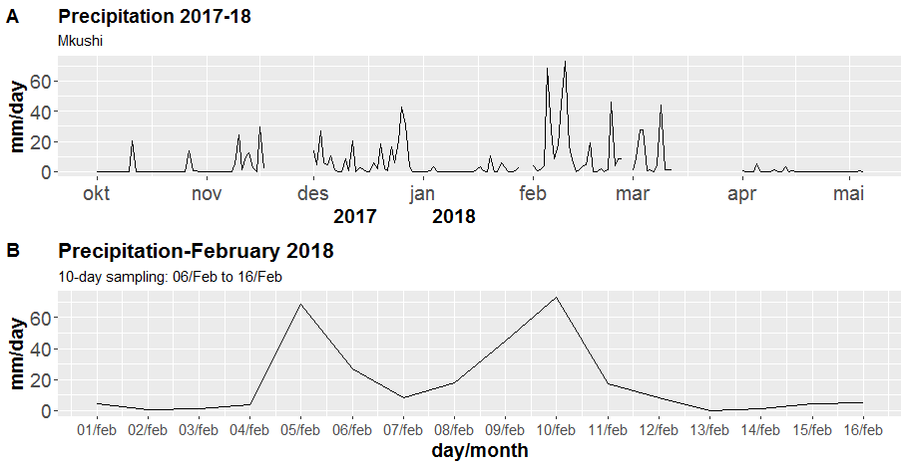
Fig S3. A) Precipitation during the growing season 2017-2018, from October 2017 to May 2018. B) precipitation from Feb 1 to Feb 16. The 10-days ¹⁵N tracer experiment started on February 6 and finished on February 16, 2018.

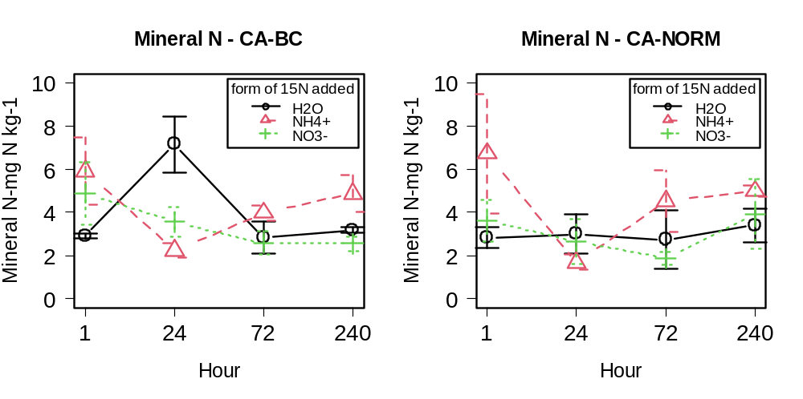
Fig. S4. Extractable mineral N (sum of extractable NO₃⁻ and extractable NH₄⁺ in mg N kg⁻¹) in conservation farming with biochar (CA-BC) and conservation farming without biochar (CA-NORM) with the addition of a small dose of ¹⁵NH₄⁺, ¹⁵NO₃⁻, and water as control. n=3 each day.

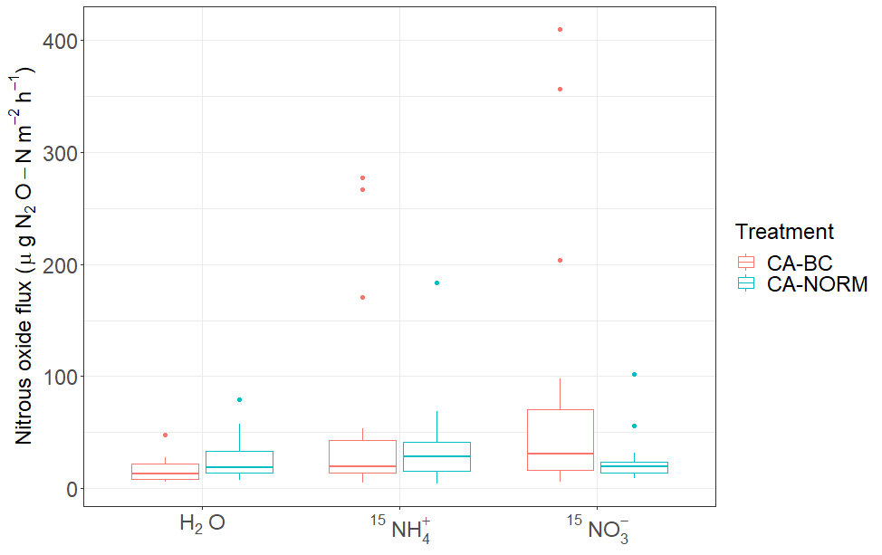
Fig. S5. Box-whisker plots of nitrous oxide emissions in conservation agriculture with (CA-BC) and without biochar (CA-NORM) in the treatments receiving ¹⁵NH₄⁺, ¹⁵NO₃⁻, and water as control. The box-whisker plots contain the fluxes measured at 1, 24, 48, 72, 120, 192, 216 and 240 hours after ¹⁵N addition. n= 24 for each of the treatments.

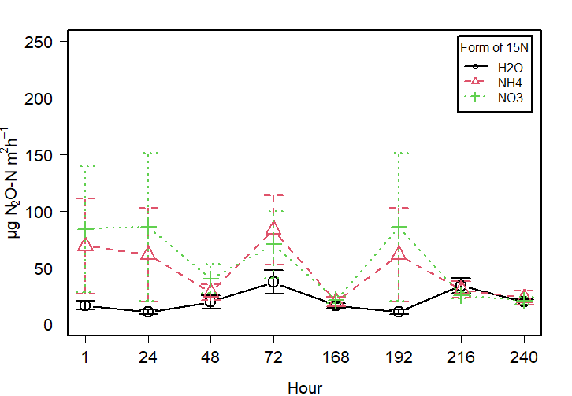
Fig. S6. Nitrous oxide fluxes in the treatments receiving ¹⁵NO₃⁻, ¹⁵NH₄⁺, and water as control. n= 3 each day.

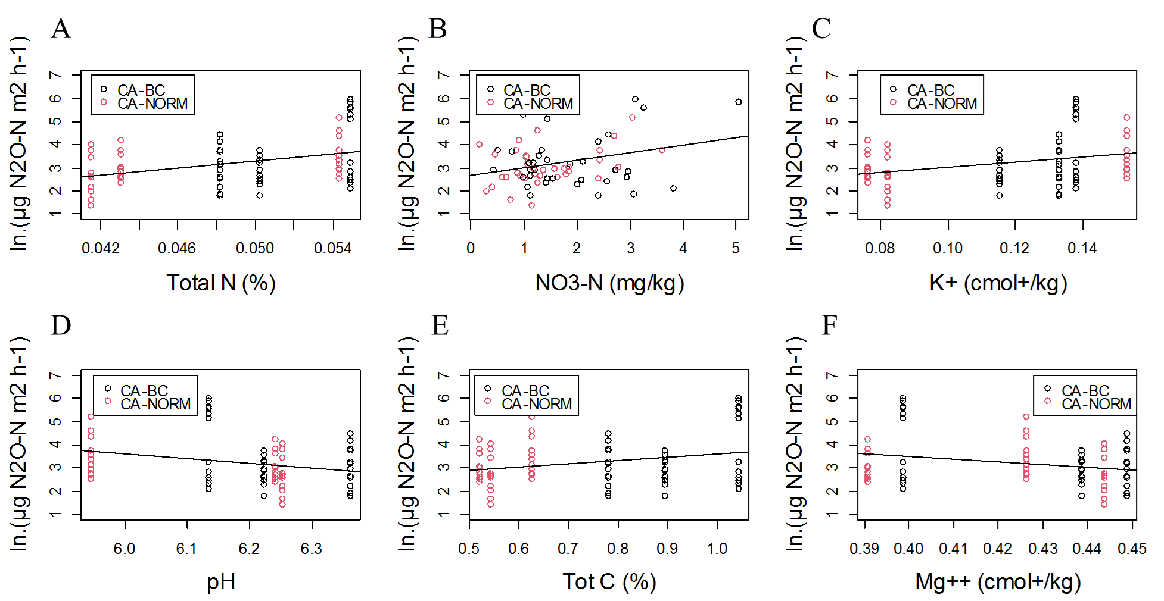
Fig. S7. Natural logarithm of N₂O fluxes as function of A) total N, B) extractable nitrate C) exchangeable K⁺ D) soil pH, E) total C, and F) exchangeable Mg²⁺.See equations in Table S4.

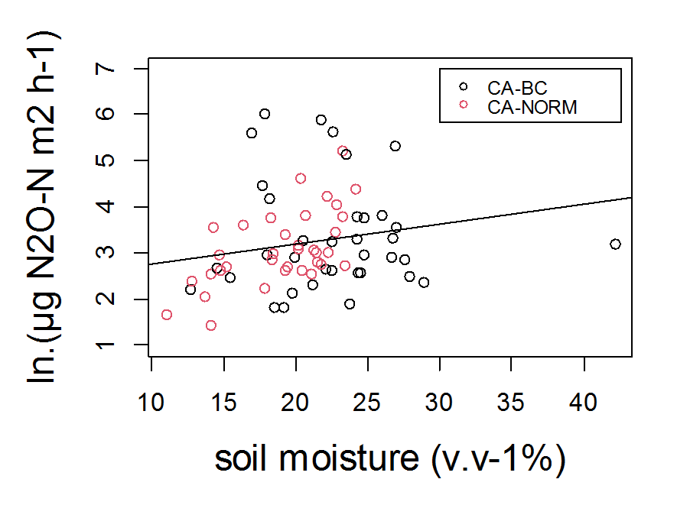
Fig. S8. Natural logarithm of N₂O fluxes as function of volumetric soil moisture content. See equations in Table S4.

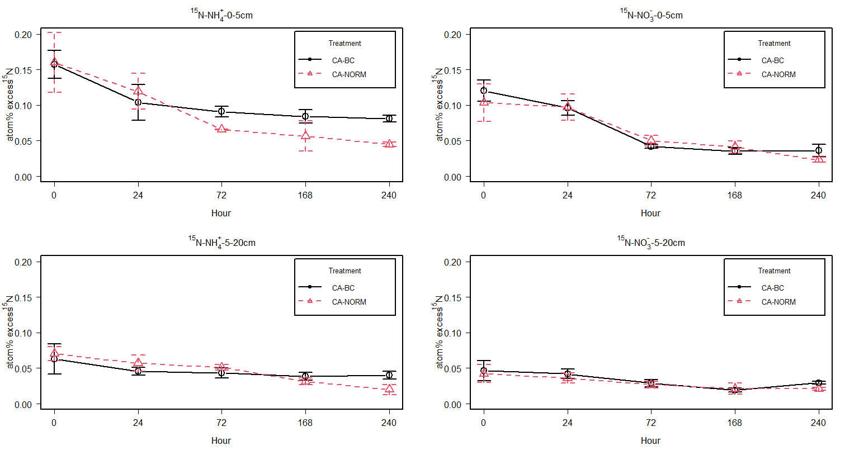
Fig. S9. Atom % ¹⁵N excess in bulk soil at 0 to 5 cm (upper side) and at 5 to 20 cm (lower side) in¹⁵NH₄⁺ and ¹⁵NO₃⁻ treatments (left and right, respectively).

Table S1. Pigeon pea biochar characteristics
Pigeon pea biochar

ªpH | 10.4
^{b}CEC (cmol₍₊₎kg⁻¹) | 6.6
^{c}EC (mS cm⁻¹) | 1.4
Elemental composition
^{d}Tot C (%) | 56.1
^{d} Org. C (%) | 55.7
^{e} N (%) | 0.69
^{e} H (%) | 1.1
C:N | 81
Molar H:C_{org} | 0.24
^{f} Ca (g kg⁻¹) | 12
^{g} K (g kg⁻¹) | 15
^{f} Mg (g kg⁻¹) | 8.3
^{g} Na (g kg⁻¹) | 0.30
^{f} P (g kg⁻¹) | 1.0
^{f} S (g kg⁻¹) | 0.14
^{g} Mn (mg kg⁻¹) | 930
^{f} Fe (mg kg⁻¹) | 12
ª Measured in 1:5 deionized water and raw biochar
^{b} (2018).
^{c} 1:20 deionized water and raw biochar
^{d} Dry combustion (EC12, C determinator, Leco Corporation) (Nelson and Sommers 1982). Organic carbon was determined on biochar washed five times with 2M HCl prior to dry combustion.
^{e} Total H and N was determined on untreated biochar samples by the Dumas method (TruSpec, CHN analyzer, Leco Corporation) (Bremner and Mulvaney 1982).
^{f} Decomposition with nitric acid (HNO₃) and analysis by inductively coupled plasma optical emission spectrometry (ICP-OES)
^{g} Decomposition with HNO₃ and hydrofluoric acid (HFl), and analysis by ICP-OES

Table S2. Estimated addition of N through addition of ¹⁵N as well as the amount of extractable mineral N (NO₃⁻ and NH₄⁺) in conservation agriculture without (CA-NORM) and with biochar (CA-BC) one hour after N label addition. Values represent mean with standard deviation (n=9). Values are based on the weighted average of the mineral N concentrations at 0 to 5 cm and 5 to 20 cm.
 | Depth | Added N  mg N kg⁻¹ | Added ¹⁵N  mg N kg⁻¹ | NO₃⁻  mg N kg⁻¹ | NH₄⁺  mg N kg⁻¹ | Mineral N  mg N kg⁻¹
CA-BC | 0-20 cm | 0.67 | 0.33 | 2.65±1.19 | 1.91±2.18 | 4.56±2.26
CA-NORM | 0-20 cm | 0.67 | 0.33 | 1.91±0.79 | 2.47±2.52 | 4.39±3.13

Table S3. Spearman rank correlation matrix of all variables ordered by the first principal component. Nitrous oxide fluxes and log transformed N₂O are included. Blue color denotes positive correlation, red denotes negative correlations, while white color shows insignificant correlations (p<0.05).
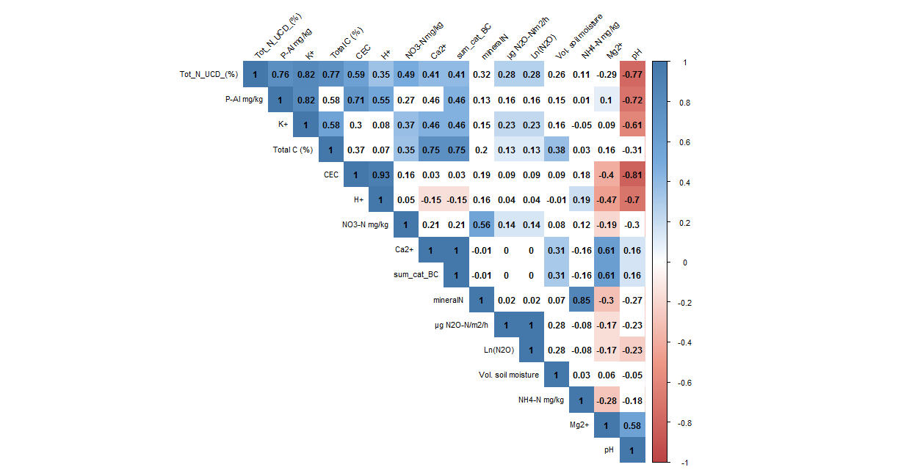

Table S4. Regressions between log transformed N₂O fluxes and the factors that significantly correlated with nitrous oxide emissions individually. R², p values, and model equations.
 | Factor | p | R² | Equation
 | Total N | 0.00178 | 0.1329 | -0.3584 + 73.35.13 x
 | NO₃⁻ | 0.0106 | 0.0908 | 2.6819 + 0.3260 x
 | K+ | 0.01255 | 0.08695 | 1.9827 + 10.6017 x
 | pH | 0.03497 | 0.06285 | 15.5056 – 1.9840 x
 | Total C | 0.02333 | 0.07234 | 2.1627 + 1.4242 x
 | Mg²⁺ | 0.02427 | 0.0714 | 8.407 – 12.224 x
 | Soil moisture (v v⁻¹; %) | 0.085 | 0.04238 | 2.30947 + 0.04368 x

Tab. S5. Mean +/- SE ¹⁵N recovery (%) in residual soil from 0 to 20 cm, KCl-extractable NO₃⁻ from 0 to 20, aboveground and root maize biomass, and in nitrous oxide in CA-BC and CA-NORM with applications of ¹⁵NH₄⁺ and ¹⁵NO₃⁻.
Treatment | Label | Hour | Soil_residual  0_20cm | Nitrate  0_20cm | Aboveground  biomass | Root  biomass | Total
CA-BC | ¹⁵N-NH₄⁺ | 1 | 110.78 ± 8.91 | 3.66 ± 0.94 | - | - | 114.43 ± 9.08
CA-BC | ¹⁵N-NH₄⁺ | 24 | 80.41 ± 16.89 | 1.07 ± 0.19 | 11.86 ± 3.8 | 7.83 ± 3.1 | 101.17 ± 14.61
CA-BC | ¹⁵N-NH₄⁺ | 72 | 73.26 ± 9.63 | 0.5 ± 0.2 | - | - | 73.76 ± 9.82
CA-BC | ¹⁵N-NH₄⁺ | 168 | 62.84 ± 8.58 | - | 15.59 ± 5.89 | 3.14 ± 1.63 | 81.56 ± 14.01
CA-BC | ¹⁵N-NH₄⁺ | 240 | 74.56 ± 11.13 | 0.67 ± 0.31 | 13.19 ± 2.47 | 3.16 ± 0.49 | 91.57 ± 10.51
CA-BC | ¹⁵N-NO₃⁻ | 1 | 76.7 ± 11.84 | 28.38 ± 6.37 | - | - | 105.09 ± 17.49
CA-BC | ¹⁵N-NO₃⁻ | 24 | 89.42 ± 15.96 | 8.97 ± 1.17 | 3.25 ± 1.4 | 7.66 ± 1.88 | 108.21 ± 16.7
CA-BC | ¹⁵N-NO₃⁻ | 72 | 42.89 ± 2.6 | 1.47 ± 0.68 | - | - | 44.36 ± 3.23
CA-BC | ¹⁵N-NO₃⁻ | 168 | 33.76 ± 3.27 | - | 3.11 ± 0.62 | 3.79 ± 0.34 | 40.66 ± 3.5
CA-BC | ¹⁵N-NO₃⁻ | 240 | 40.6 ± 0.51 | 0.69 ± 0.28 | 5.82 ± 0.68 | 5.62 ± 1.2 | 52.73 ± 1.64
CA-NORM | ¹⁵N-NH₄⁺ | 1 | 110.19 ± 14.4 | 18.25 ± 14.34 | - | - | 128.44 ± 23.84
CA-NORM | ¹⁵N-NH₄⁺ | 24 | 93.74 ± 19.97 | 1.83 ± 0.35 | 15 ± 4.84 | 2.84 ± 0.95 | 113.4 ± 25.58
CA-NORM | ¹⁵N-NH₄⁺ | 72 | 62.49 ± 2.05 | 0.64 ± 0.23 | - | - | 63.13 ± 2.26
CA-NORM | ¹⁵N-NH₄⁺ | 168 | 43.14 ± 9.15 | - | 15.34 ± 0.16 | 8.52 ± 3.87 | 67 ± 10.41
CA-NORM | ¹⁵N-NH₄⁺ | 240 | 28.18 ± 7.81 | 0.22 ± 0.04 | 15.61 ± 3.76 | 4.16 ± 0.98 | 48.16 ± 8.43
CA-NORM | ¹⁵N-NO₃⁻ | 1 | 65.65 ± 4.89 | 26.96 ± 6.54 | - | - | 92.61 ± 11.41
CA-NORM | ¹⁵N-NO₃⁻ | 24 | 69.44 ± 8.77 | 5.1 ± 2.41 | 3.71 ± 0.67 | 13.27 ± 3.6 | 91.52 ± 6.33
CA-NORM | ¹⁵N-NO₃⁻ | 72 | 43.48 ± 4.67 | 1.62 ± 0.63 | - | - | 45.1 ± 4.49
CA-NORM | ¹⁵N-NO₃⁻ | 168 | 31.23 ± 7.92 | - | 6.56 ± 3.99 | 6.05 ± 1.74 | 43.83 ± 11.4
CA-NORM | ¹⁵N-NO₃⁻ | 240 | 28.65 ± 1.45 | 0.37 ± 0.12 | 8.2 ± 0.47 | 6.24 ± 1.33 | 43.46 ± 1.2

Bremner JM, Mulvaney CS (1982) Nitrogen-Total. In: AL Page, RH Miller, DR Keeney (eds) Methods of soil analysis Part 2 Chemical and microbiological properties. American Society of Agronomy, Soil Science Society of America, Madison, Wisconsin.
Davidson EA, Hart SC, Shanks CA, Firestone MK (1991) Measuring gross nitrogen mineralization, immobilization, and nitrification by 15N isotopic pool dilution in intact soil cores. J Soil Sci 42: 335-349.
Munera-Echeverri JL, Martinsen V, Strand LT, Zivanovic V, Cornelissen G, Mulder J (2018) Cation exchange capacity of biochar: An urgent method modification. Sci Total Environ 642: 190-197. doi: 10.1016/j.scitotenv.2018.06.017.
Nelson DW, Sommers LE (1982) Total carbon, organic carbon and organic matter. In: AL Page, RH Miller, DR Keeney (eds) Methods of Soil Analysis Part 2 Agronomy 9. American Society of Agronomy, Madison, Wisconsin, USA.

