Supplementary Materials for
Metaproteomic analysis decodes the trophic basis of microbes in the dark ocean
Zihao Zhao^{1*}, Chie Amano¹, Thomas Reinthaler¹, Federico Baltar¹, Mónica V. Orellana^{2,3}, Gerhard J. Herndl^{1,4,5*}
¹ Department of Functional and Evolutionary Ecology, Bio-Oceanography and Marine Biology Unit, University of Vienna, Djerassiplatz 1, A-1030 Vienna, Austria
² Polar Science Center, Applied Physics Laboratory, University of Washington, Seattle, WA 98195, USA
³ Institute for Systems Biology, Seattle, WA 98109, USA
⁴ NIOZ, Department of Marine Microbiology and Biogeochemistry, Royal Netherlands Institute for Sea Research, Utrecht University, Den Burg, The Netherlands
⁵ Vienna Metabolomics Center, University of Vienna, Djerassiplatz 1, A-1030 Vienna, Austria
*Correspondence to: zihao.zhao@univie.ac.at, gerhard.herndl@univie.ac.at
This file includes:
Extended Data Figures 1 to 15
Extended Data Tables 1 to 2
Other Supplementary Material for this manuscript includes the following:
Supplementary dataset 1-9

Extended Data Table 1 Protein distribution in the different databases (DB).
 | Eukaryotic DB | Prokaryotic DB | Viral DB
Proteins | 75,783 | 156,883 | 1,884
Peptides | 174,414 | 367,452 | 3,407
Unique peptides | 108,966 | 232,340 | 2,212
Peptide-spectrum matches (PSMs) | 1872,594 | 3381,369 | 20,190

Extended Data Table 2 Protein classification at the super-kingdom level

 | Archaea | Bacteria | Eukaryota | Viruses | Unclassified
Proteins | 7,163 | 156,187 | 55,494 | 6,213 | 9,493
Peptides | 13,581 | 403,638 | 102,903 | 10,592 | 14,559
Unique peptides | 8,880 | 249,485 | 66,745 | 7,106 | 11,302
Peptide-spectrum matches (PSMs) | 84,156 | 397,2871 | 1021,299 | 71,614 | 124,213

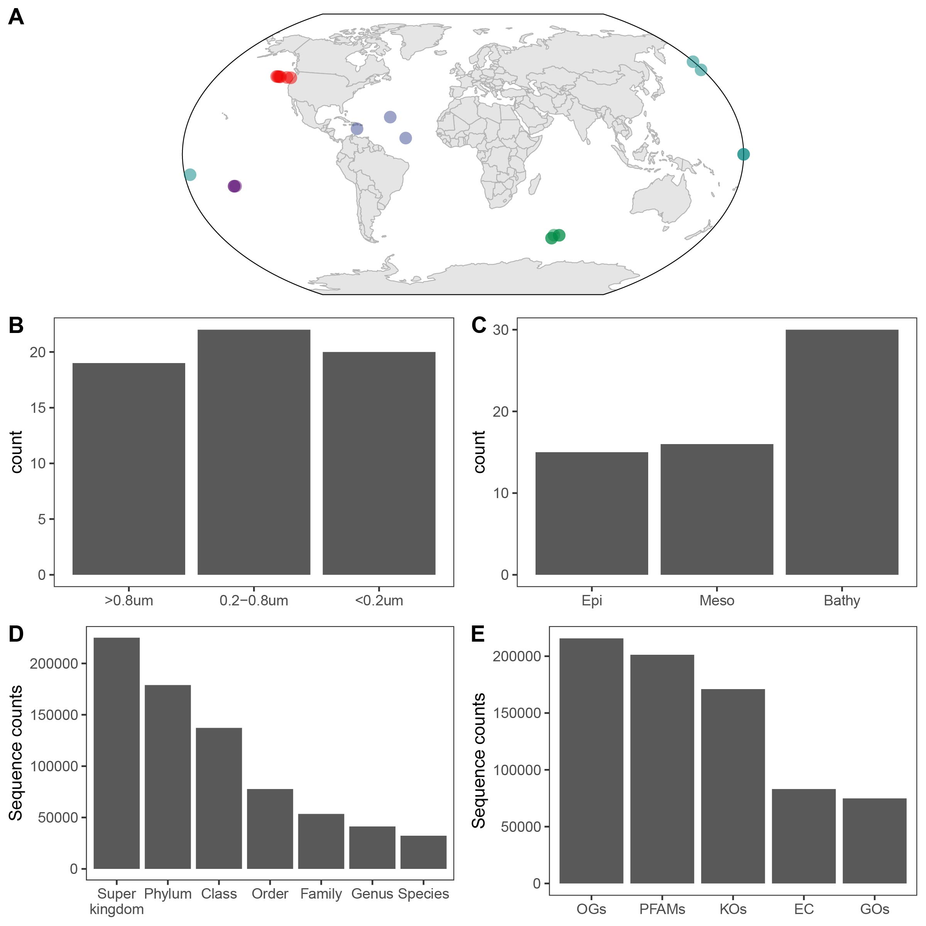

Extended Data Fig. 1 Overview of metaproteomic samples. (A) Sampling map, the color indicates different ocean basins. (B-C) Sample distribution in size-fractions and depth layers. (D-E) Taxonomic and functional classification of identified protein sequences. OGs – eggNOG orthology groups, PFAMs – protein families, KOs – KEGG-orthologues, EC – enzyme categories GOs – Gene Ontologies.

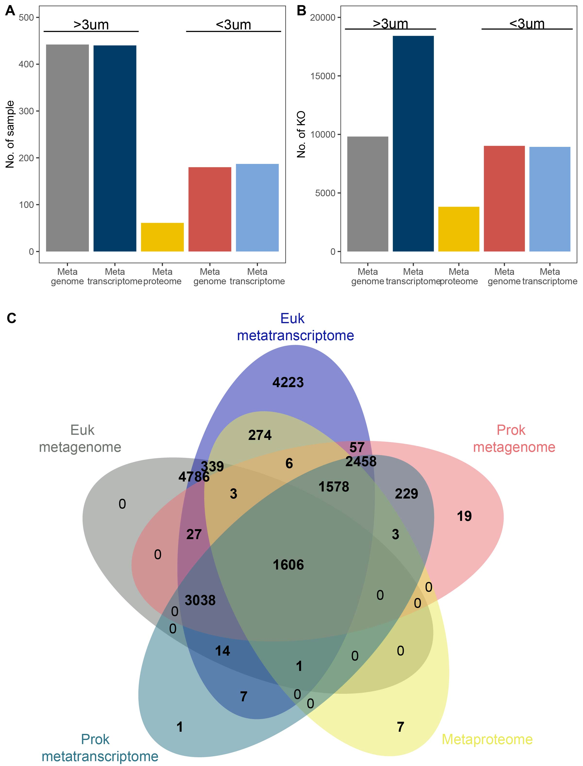
Extended Data Fig. 2 Profile of “omics” samples. (A) Number of omics samples used for comparison. (B) Number of KOs detected in each omics group. (C) Venn diagram showing the distribution of KOs (relative abundance >1%) in different omics samples.

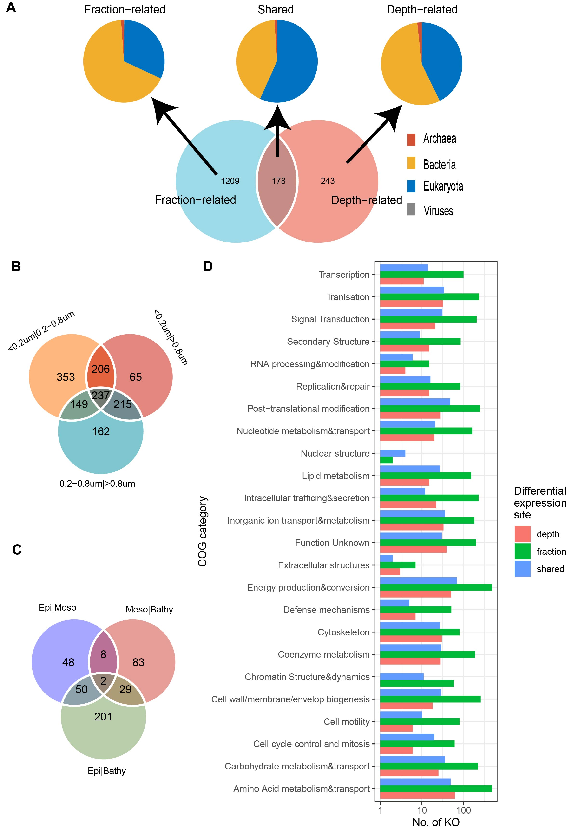

Extended Data Fig. 3 Profile of differentially expressed KOs in the metaproteome. (A) Comparison based on relative abundance of KO profiles of 1,630 identified KOs (Venn diagram) that may shape the clustering pattern of the metaproteome; the taxonomic origin of these KOs varied (pie chart). (B) Venn diagram showing the number of KOs differentially expressed between size fractions. (C) Venn diagram showing the number of KOs differentially expressed between depths. (D) Distribution of differentially expressed KOs in Clusters of Orthologous Genes (COG) category.
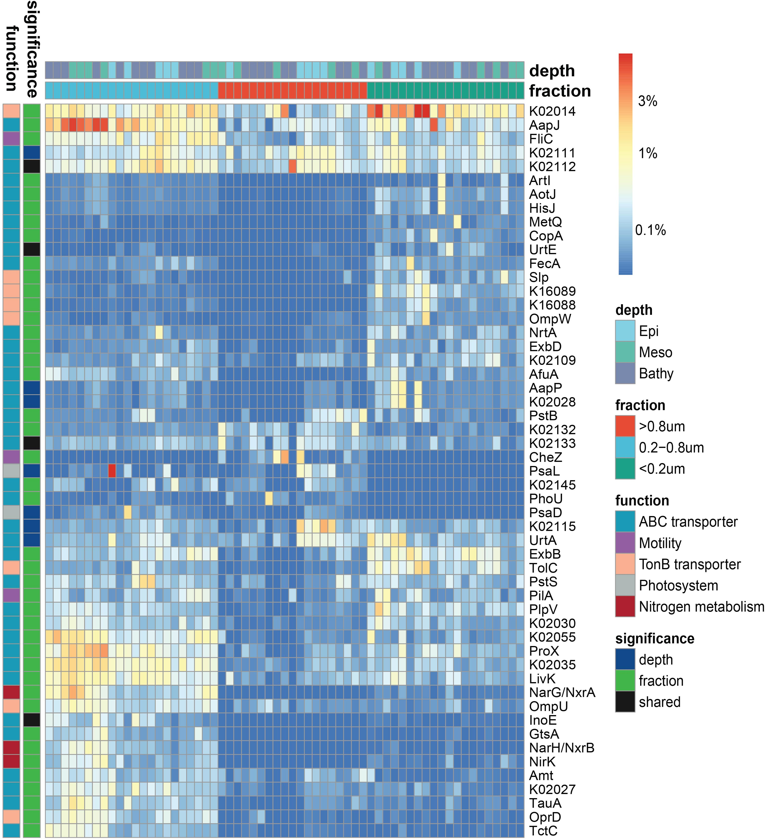
Extended Data Fig. 4 Heatmap of KOs (relative abundance >1%) differentially expressed between fractions and depths.
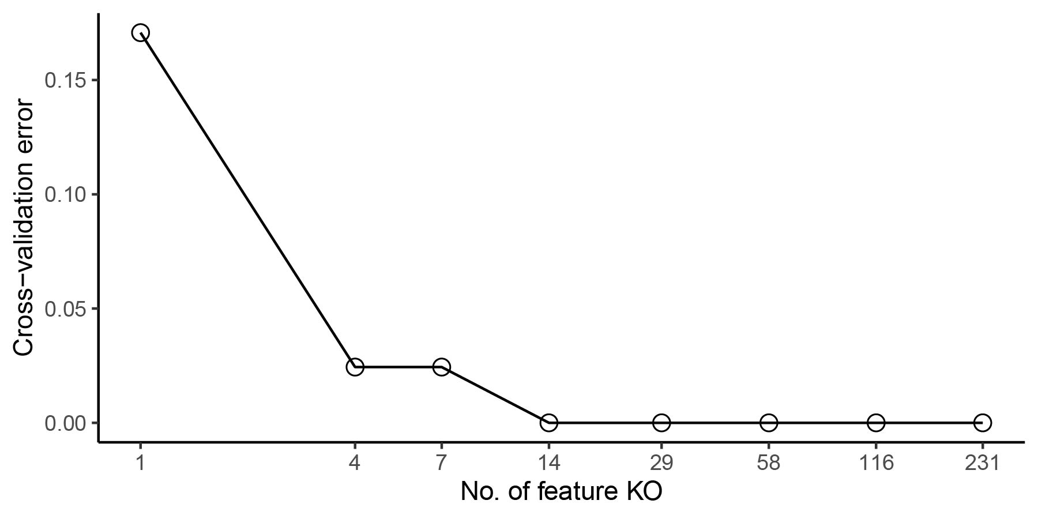
Extended Data Fig. 5 Ten-fold cross-validation error as a function of the number of input KOs used to regress against the size-fraction in the metaproteomic dataset in order of variable importance.

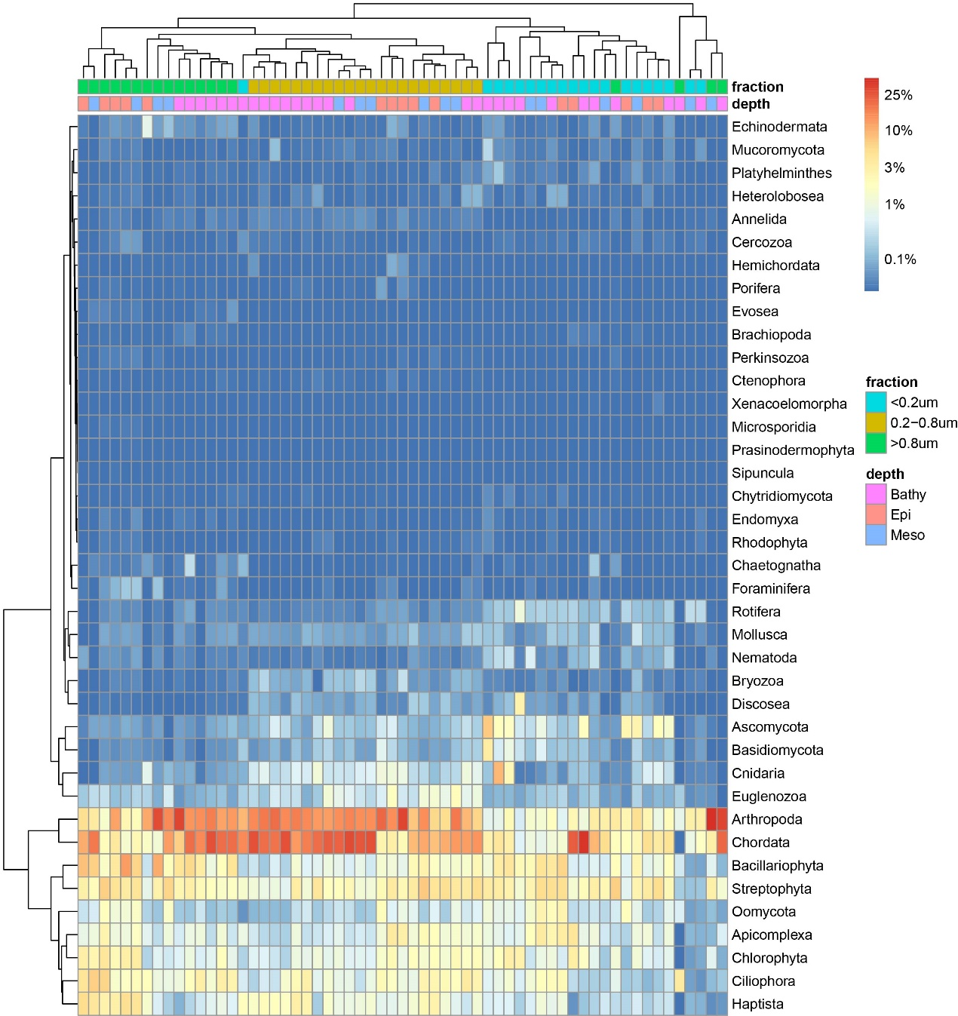
Extended Data Fig. 6 Heatmap of the eukaryotic community composition (at the phylum level) in the metaproteomics dataset.

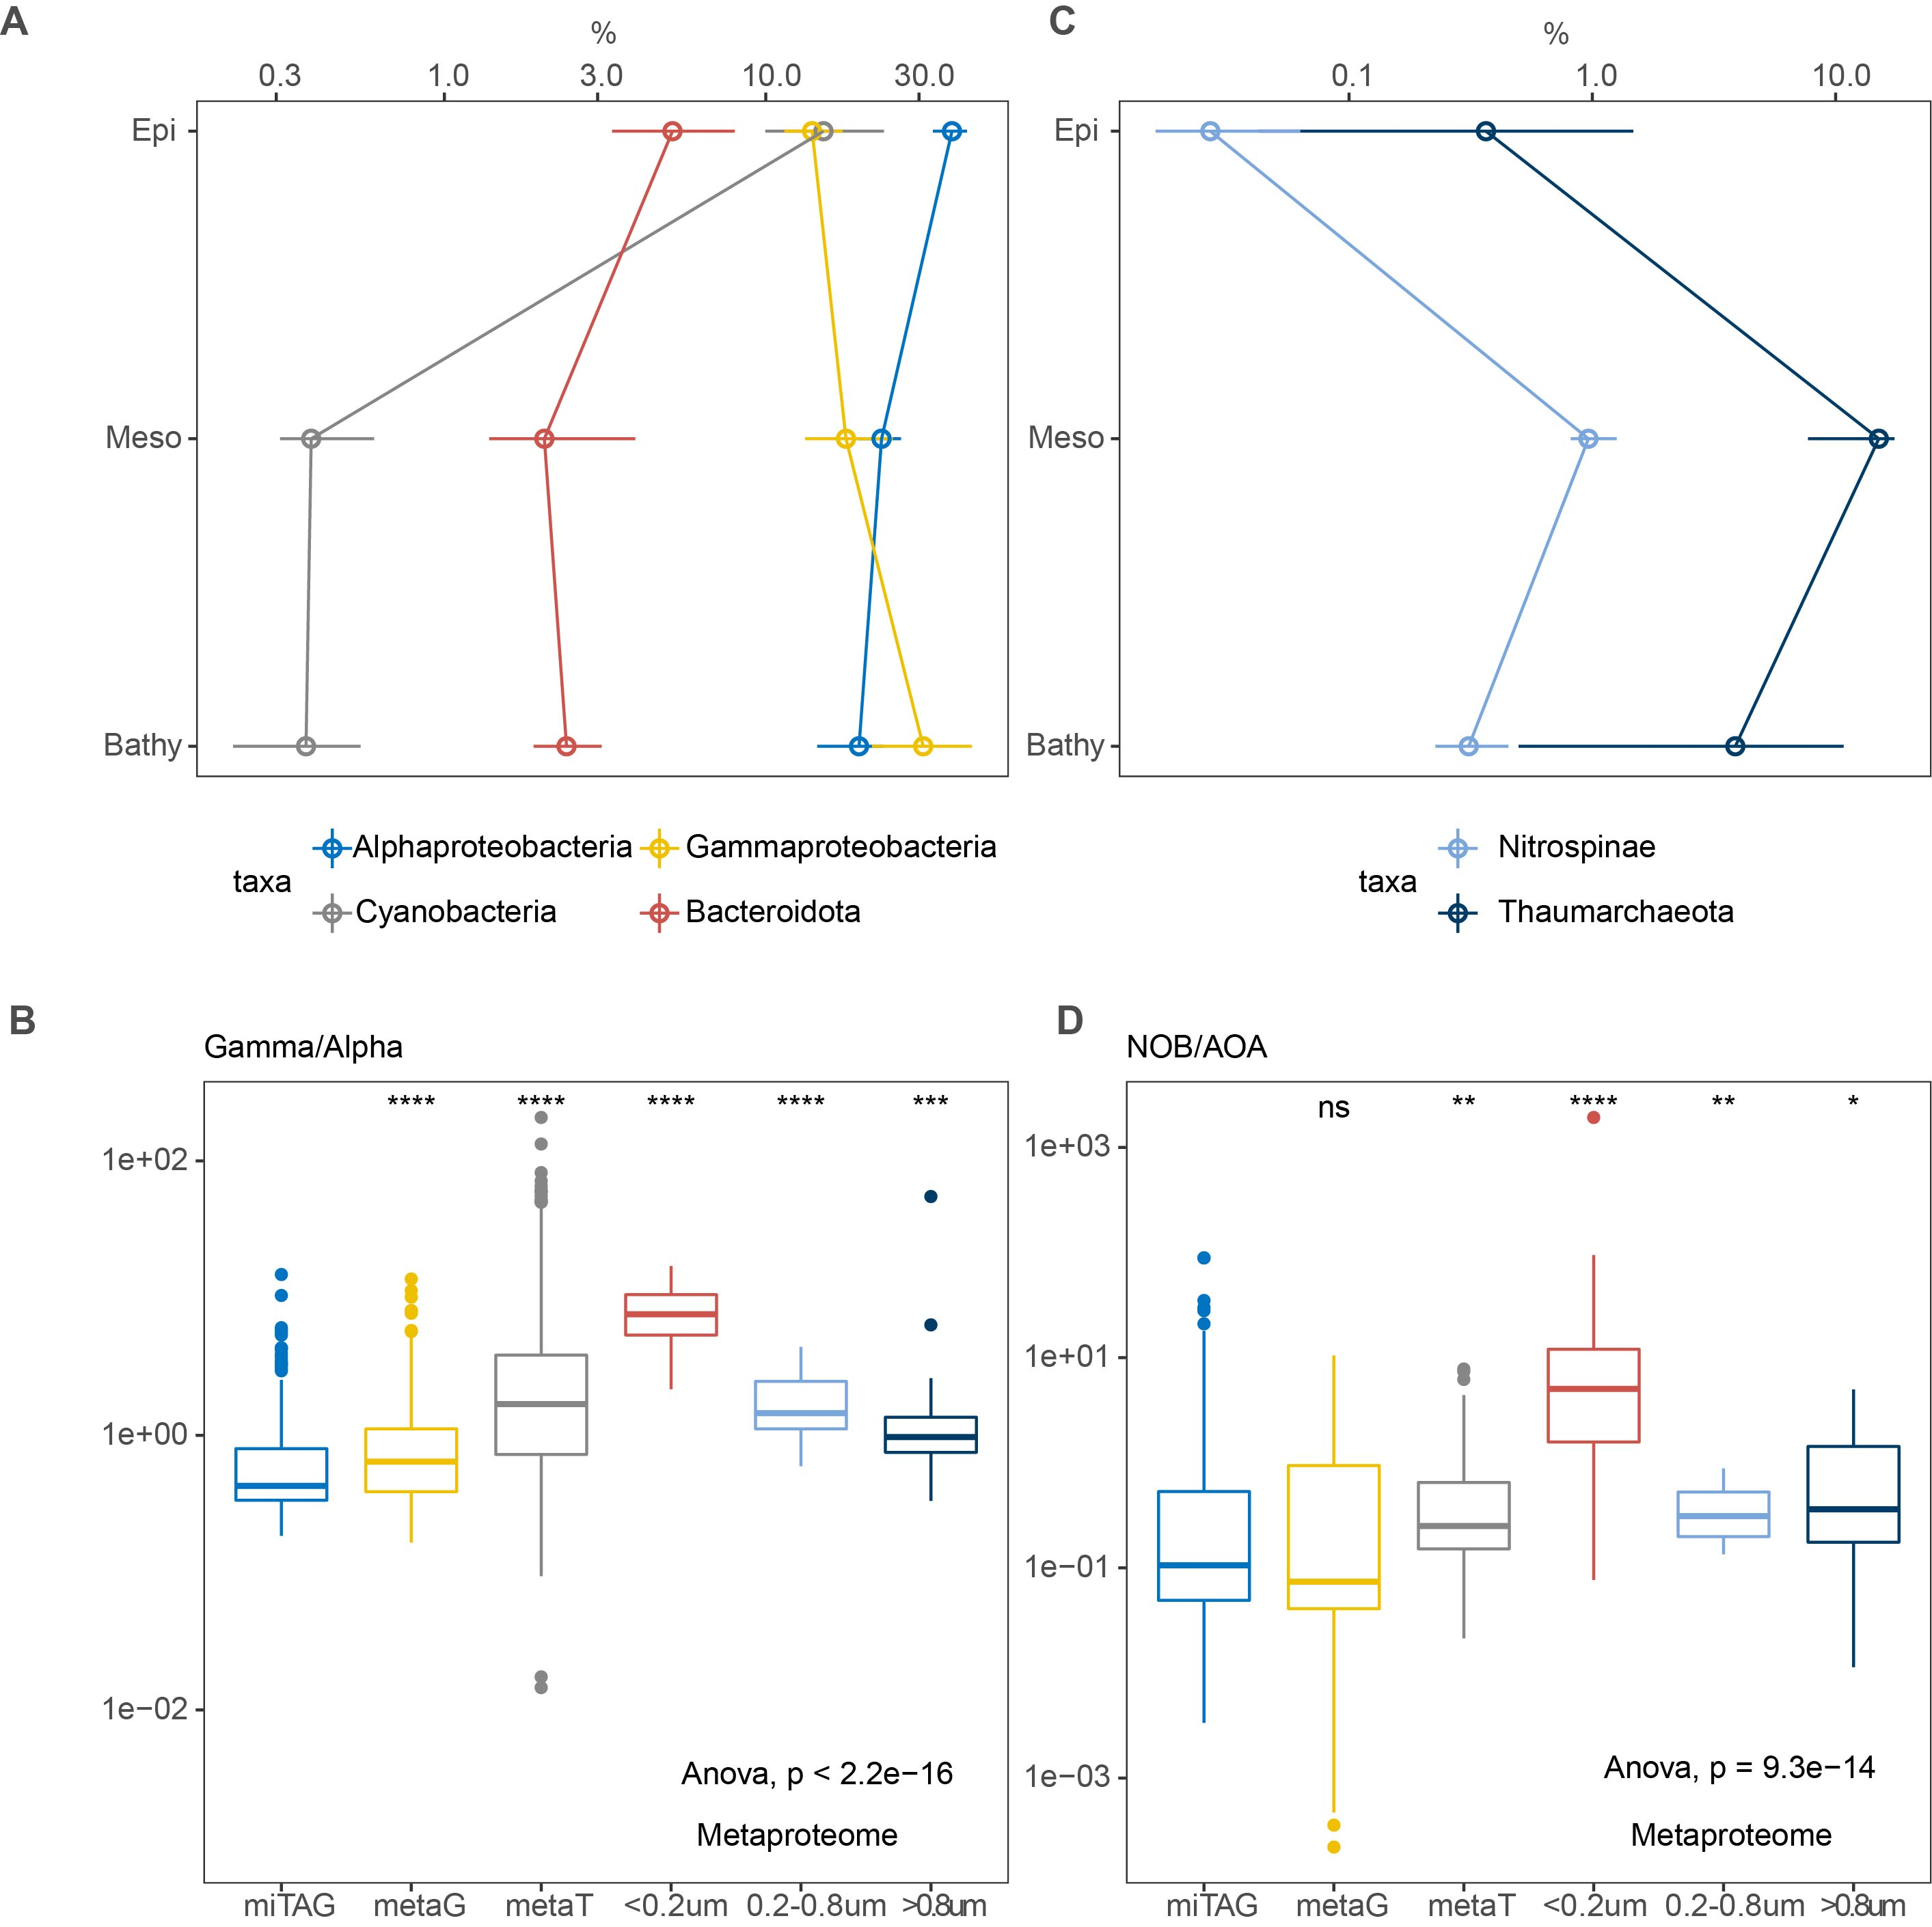
Extended Data Fig. 7 Comparison between 16S rRNA gene, metagenome, metatranscriptome and metaproteome. (A) Depth profile of 16S rRNA gene (miTAG) for major prokaryotic taxonomic groups. (B) Ratio of Gammaproteobacteria/Alphaproteobacteria in the different ‘omics’ datasets as well as different size-fractions. (C) Depth profile of 16S rRNA gene (miTAG) for nitrifiers. (D) Ratio of Nitrospinae/Thaumarchaea in the different ‘omics’ datasets as well as different size-fractions. Significance test (Wilcoxon test) was performed using 16S rRNA gene (miTAG) value as reference. *P<0.05, **P<0.01, ***P<0.001, ****P<0.0001, ns, not significant. metaG, mOTU data from metagenomes; metaT, mOTU data from metatranscriptomes. NOB, Nitrospina; AOA, Thaumarchaea.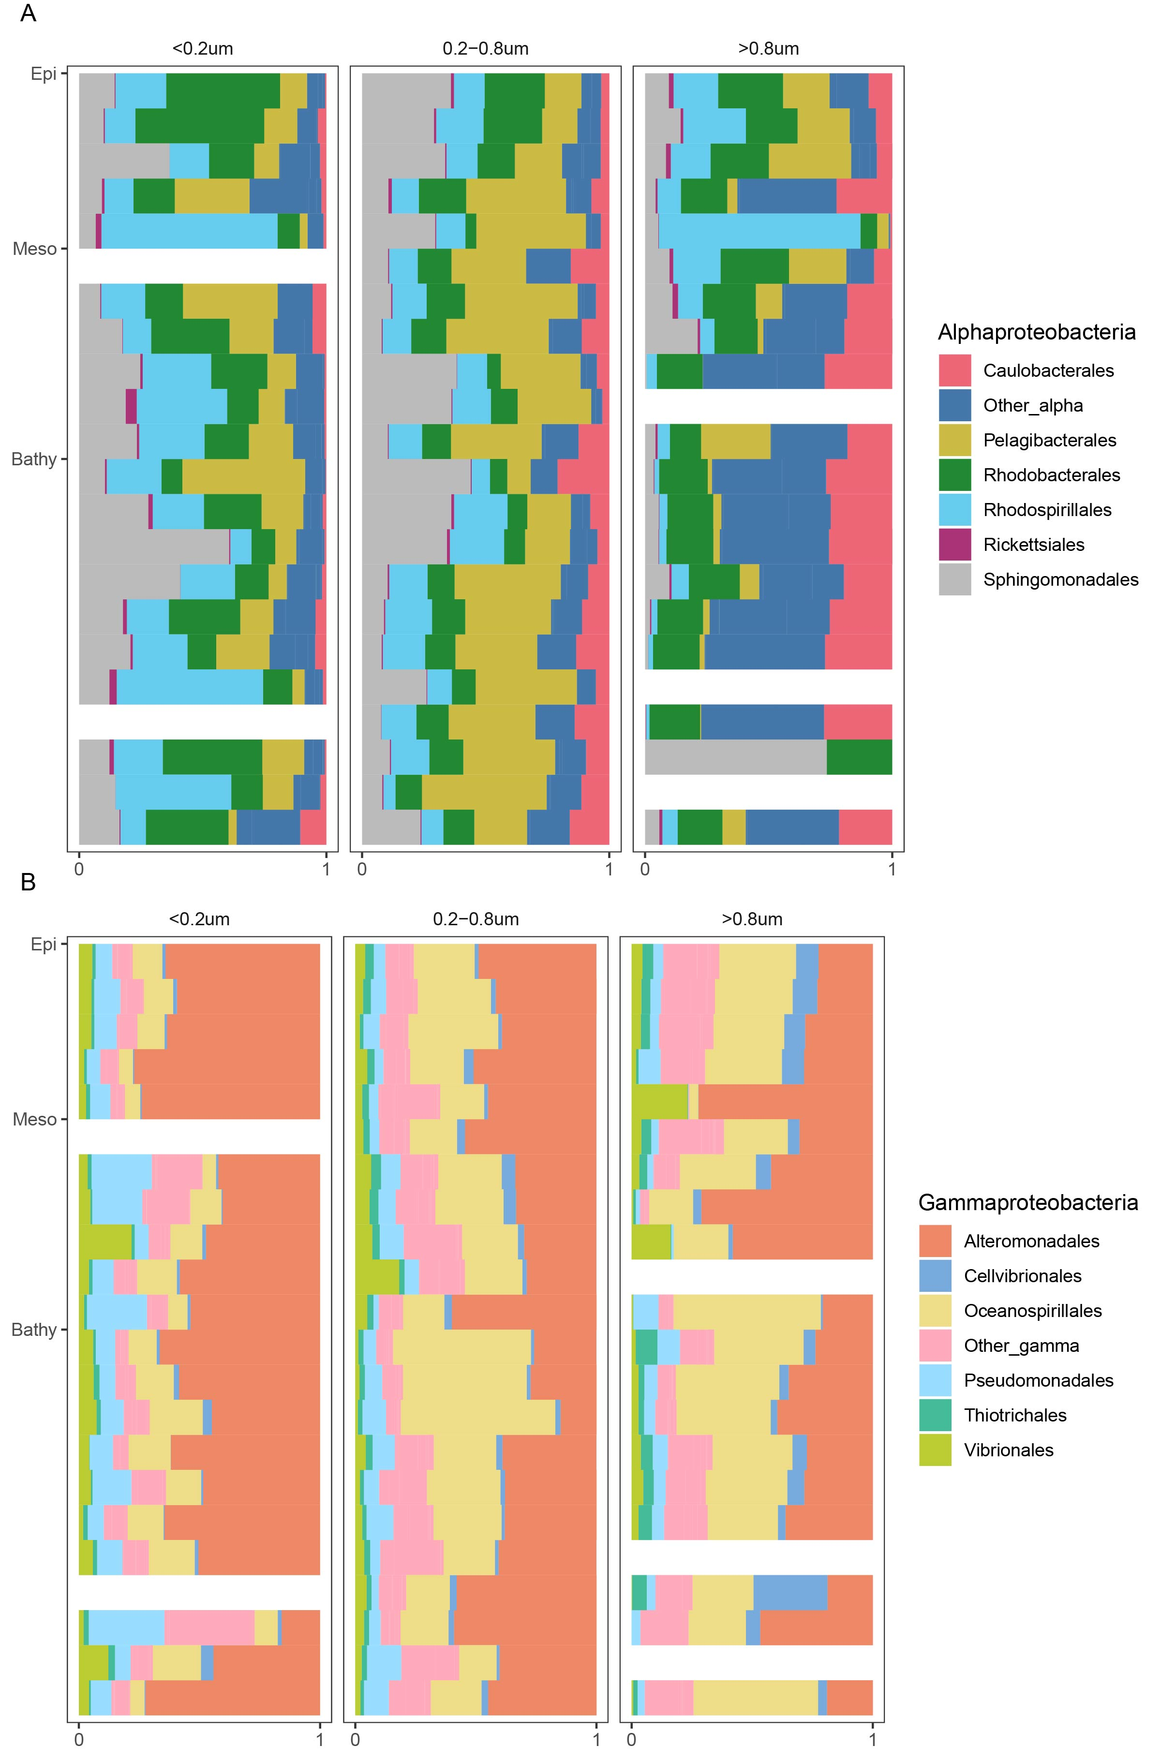
Extended Data Fig. 8 Taxonomic composition of Alphaproteobacteria (A) and Gammaproteobacteria (B) at the order level in the metaproteomic dataset.

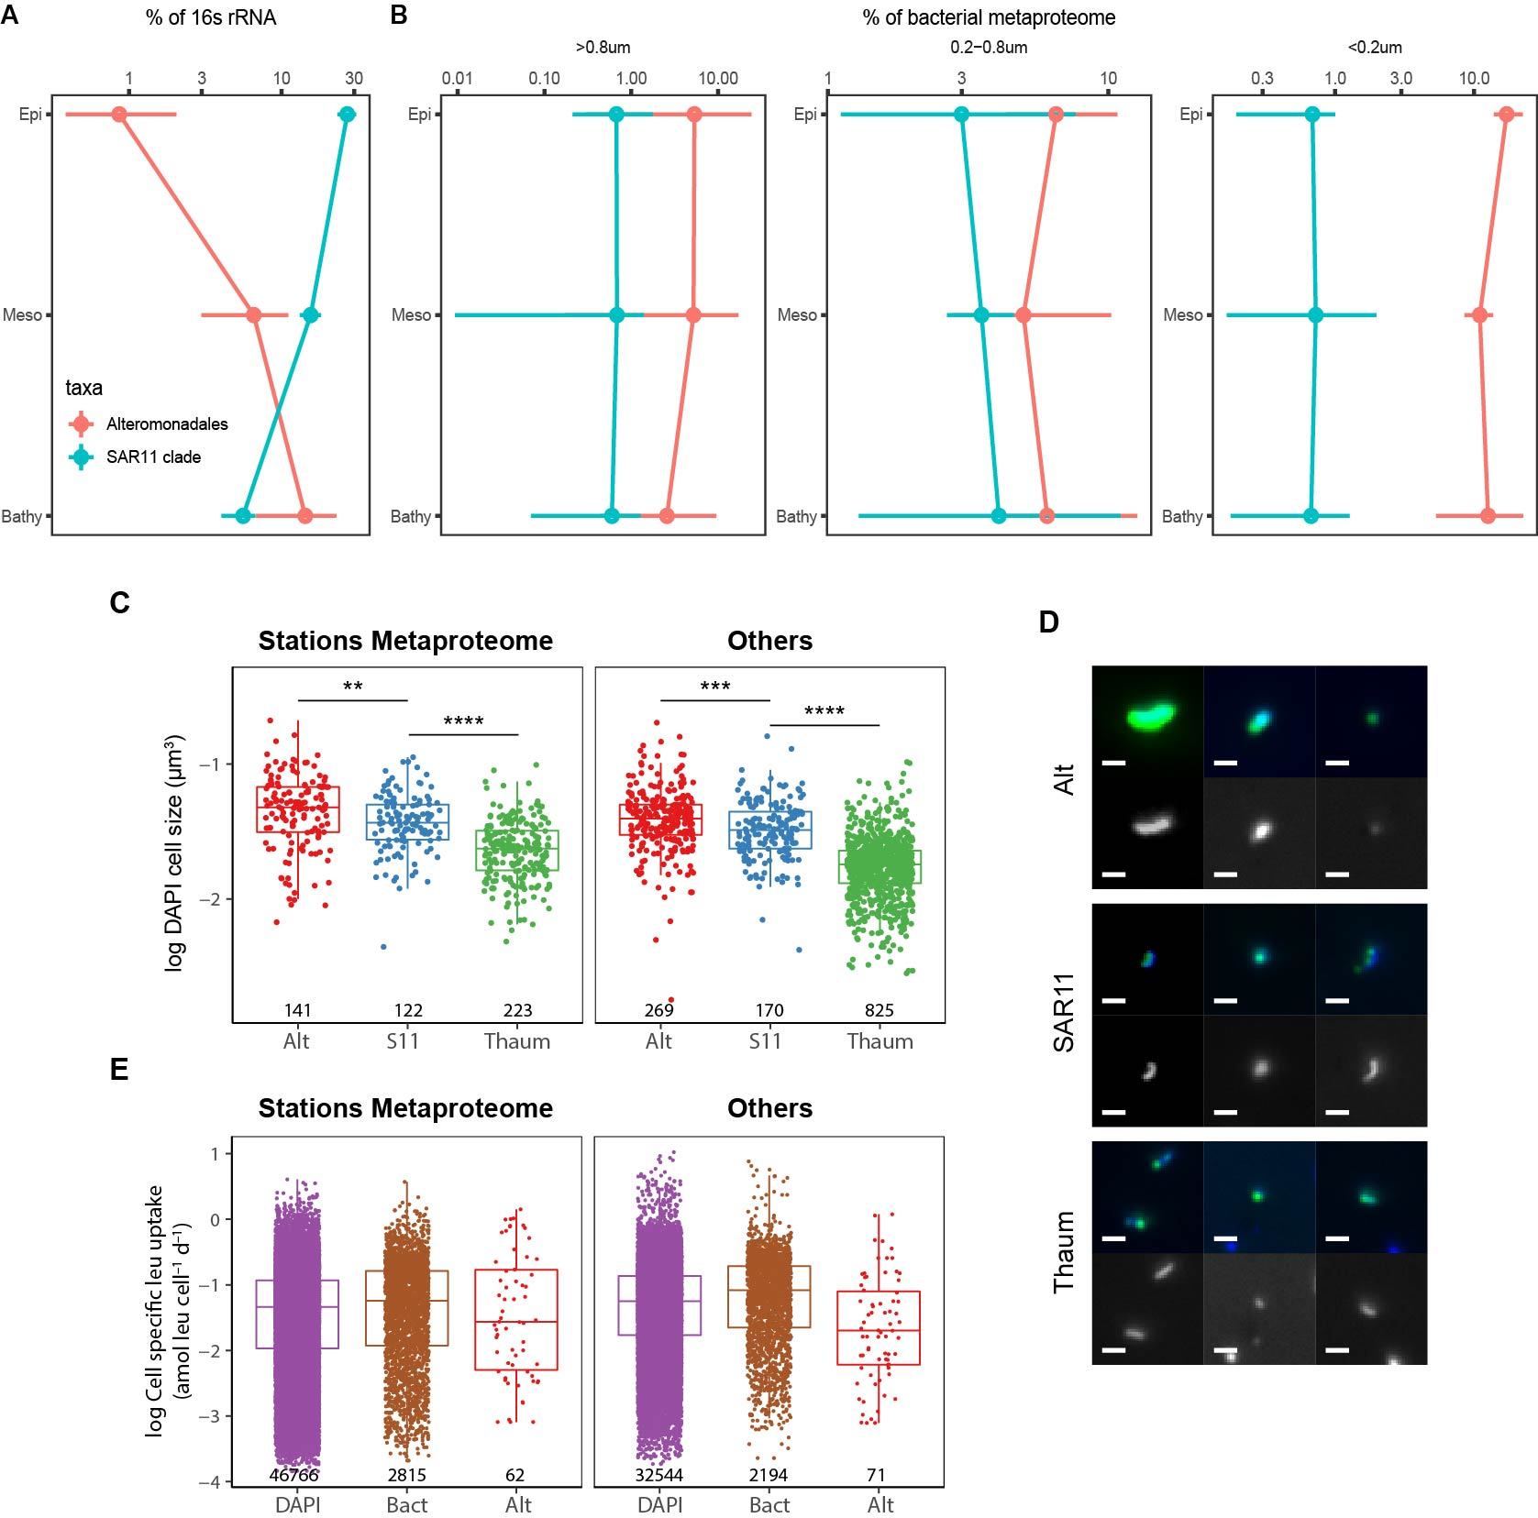

Extended Data Fig. 9 Profile of Alteromonadales and SAR11 in the 16S rRNA gene (A) and metaproteomic dataset (B), DAPI-based cell size (C) and representative morphology (D) of CARD-FISH positive target organisms, and cell-specific leucine uptake rate (E). Sampling stations where metaproteome samples were collected are shown in separate panels (C, E; left side). Alt: Alteromonas/Colwellia, S11: SAR11 clade, Thaum: Thaumarchaeota, Bact: Bacteria. Wilcoxon rank sum test was performed for each organism group; **P<0.01, ***P<0.001, ****P<0.0001. Numbers in the panels (C, E) indicate sample size of each boxplot. Upper panels of each target organism in the microscopic images (D) show merged images of DAPI (blue) and FISH (green) channels. Lower panels are gray scale images of DAPI channels. Scale bar: 1 μm.

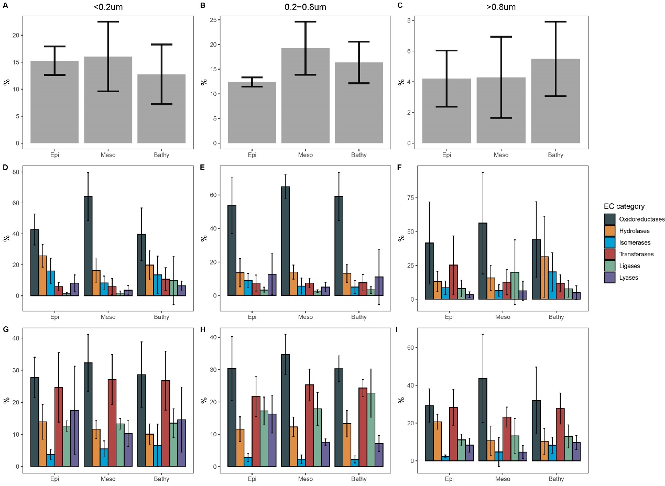
Extended Data Fig. 10 Patterns of microbial extracellular enzymes in the metaproteomics dataset. (A-C) Depth profiles of the relative abundance of extracellular enzymes in the different size-fractions. (D-F) Functional categorization of extracellular enzymes. (G-I), Functional categorization of intracellular enzymes.

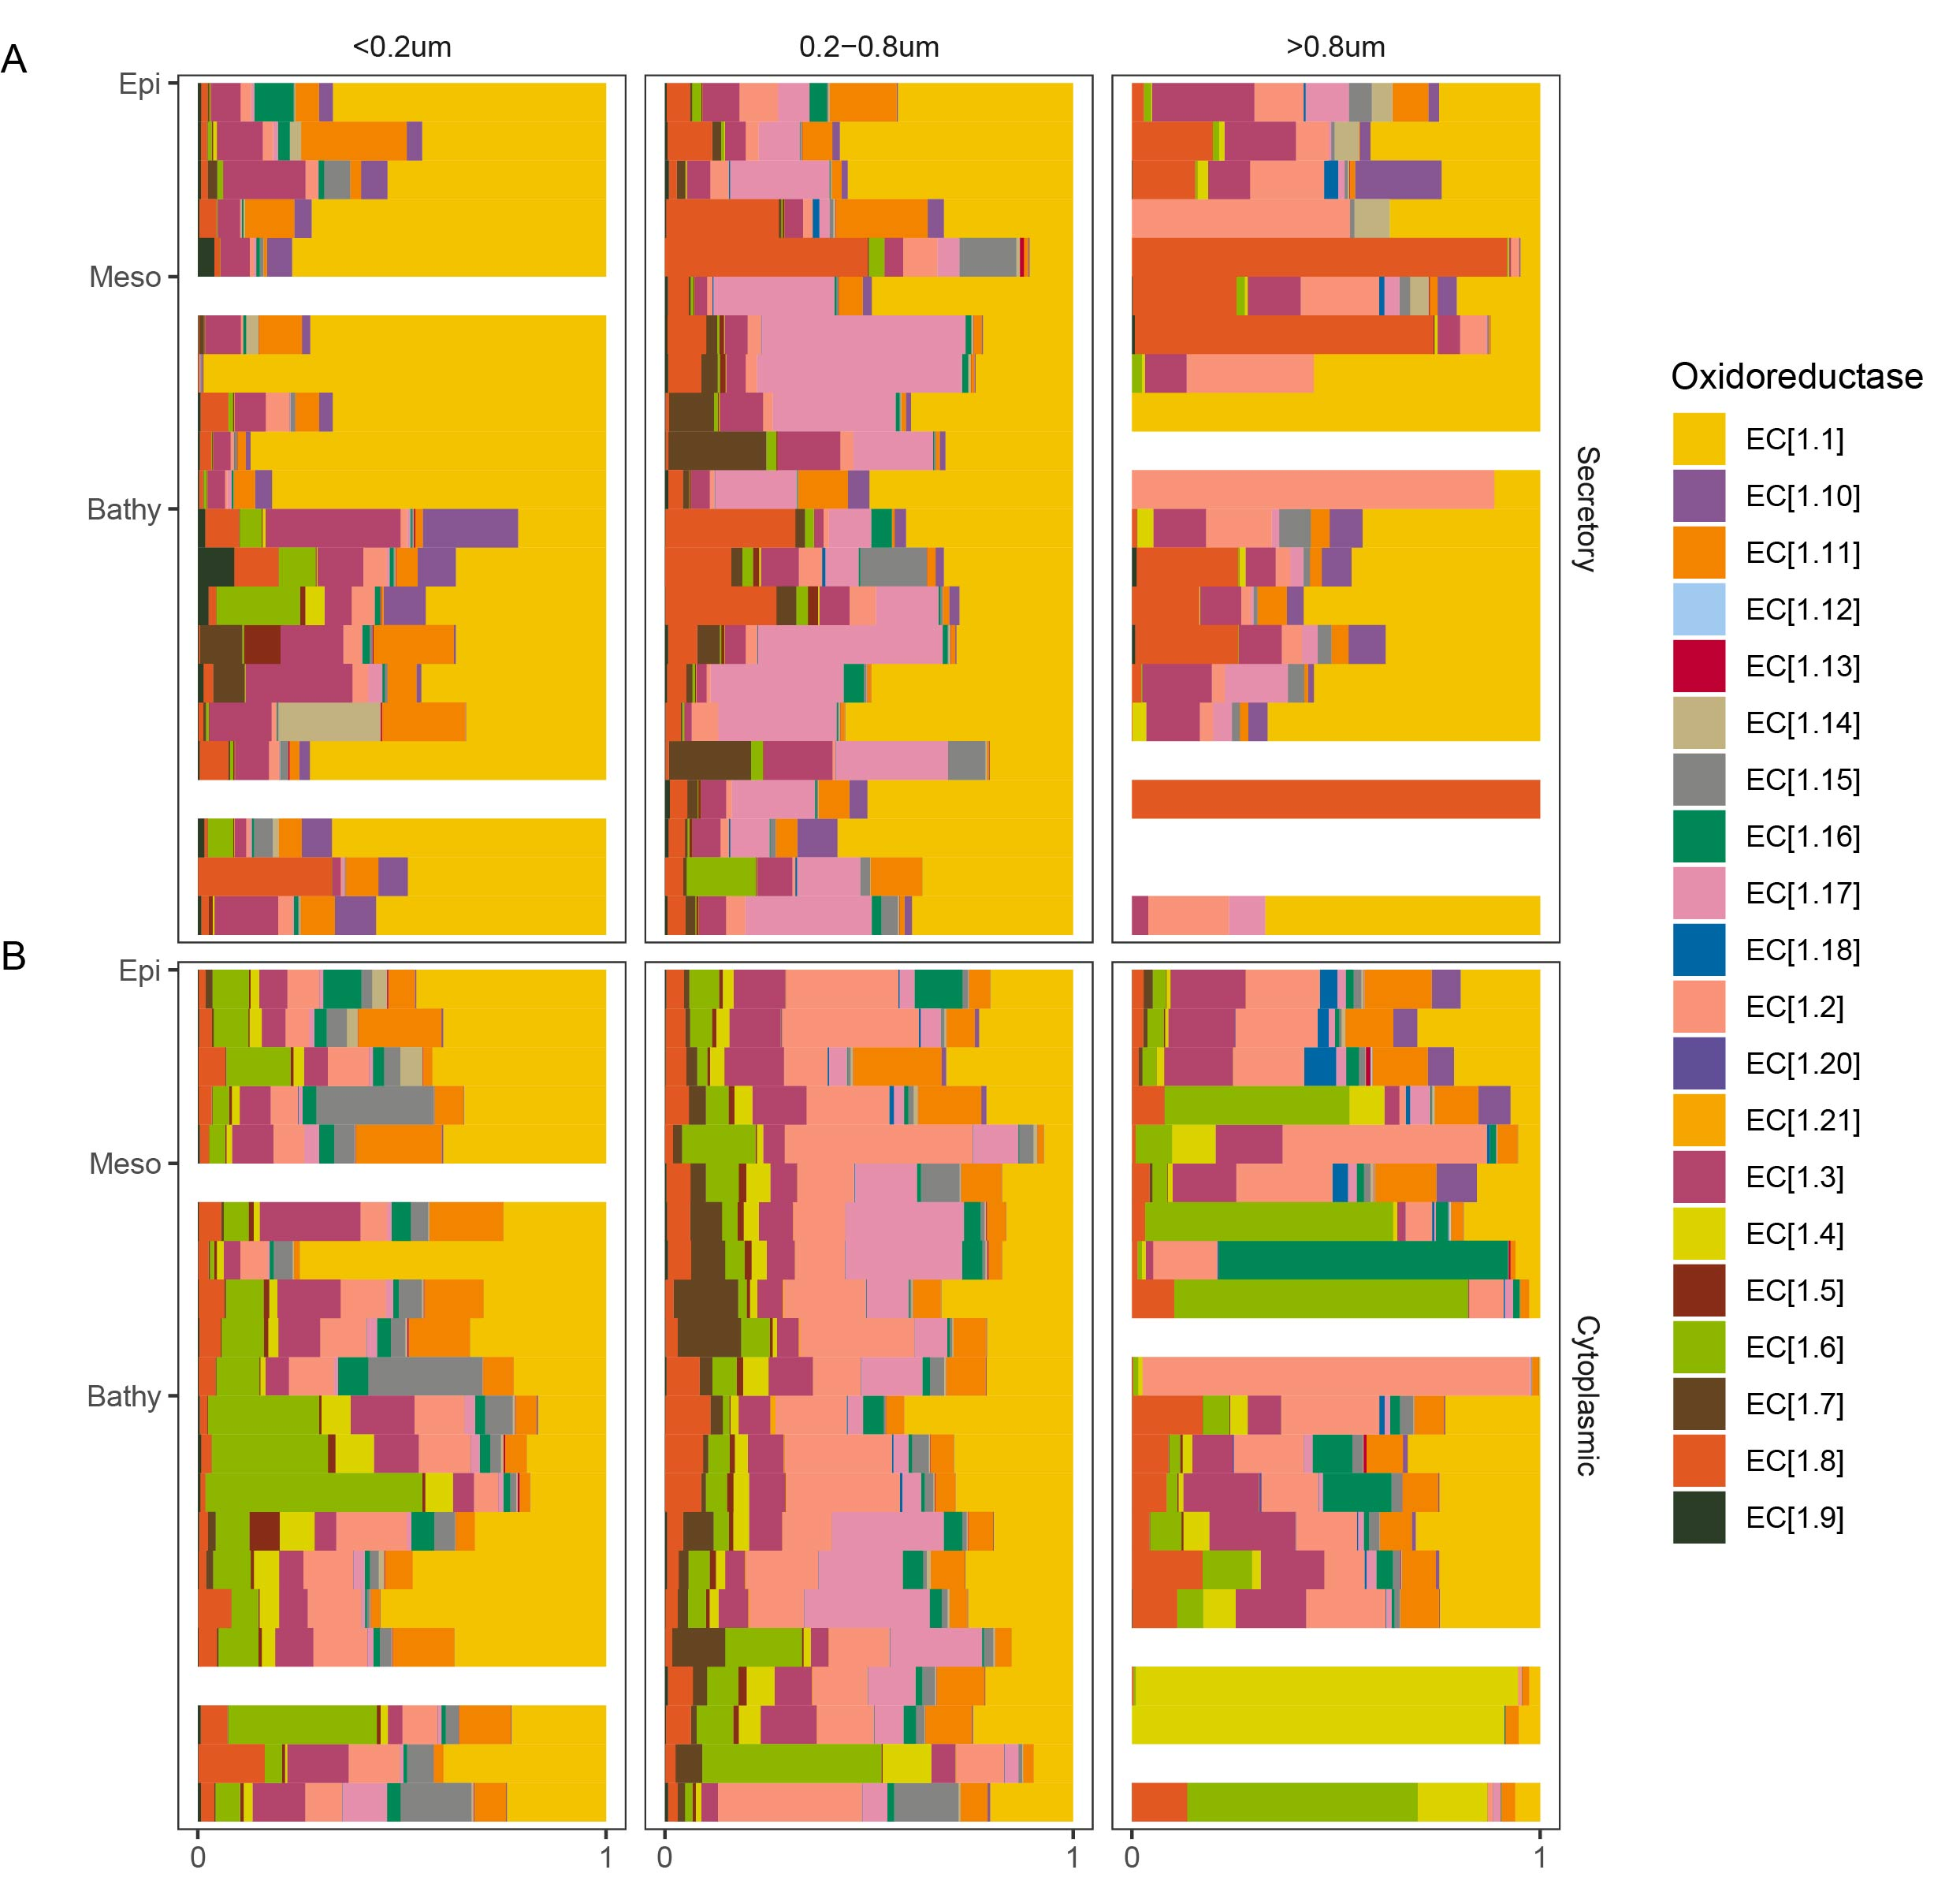

Extended Data Fig. 11 Composition of secretory (A) and cytoplasmic (B) oxidoreductase in the metaproteomic dataset.

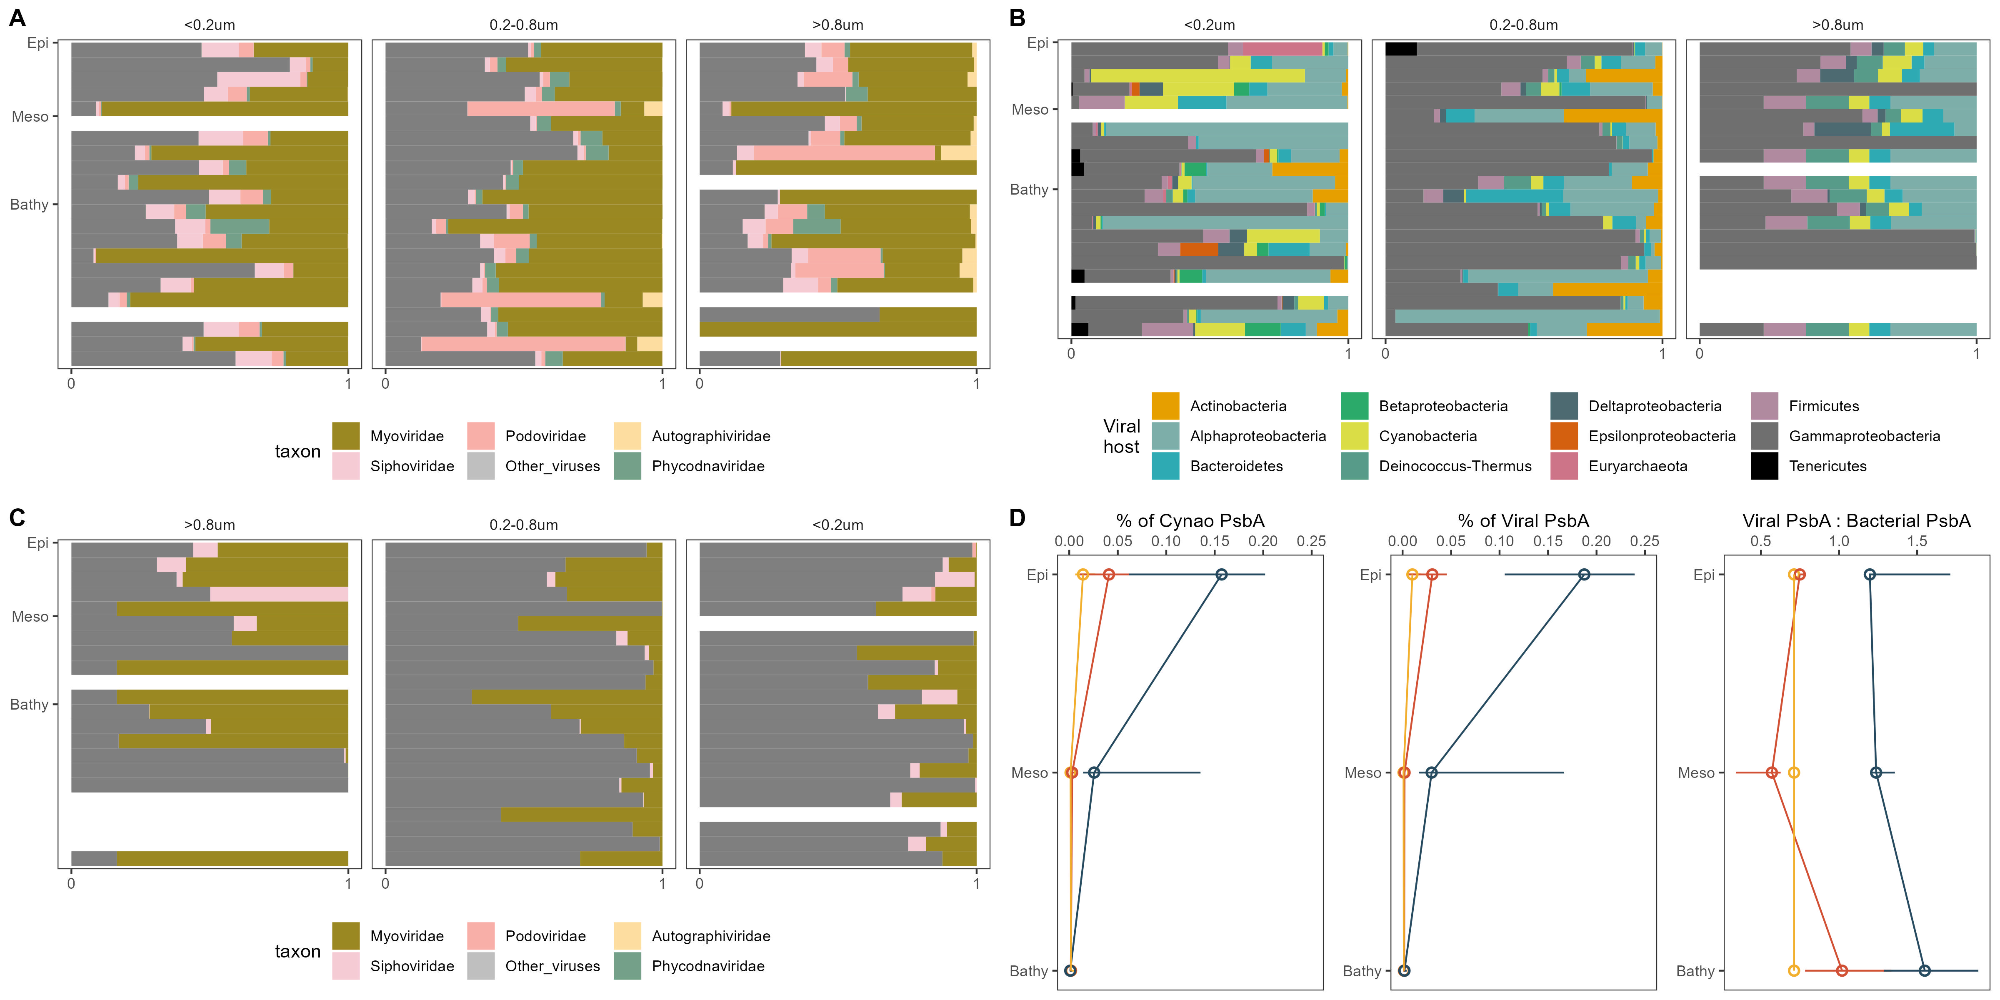

Extended Data Fig. 12 Composition profiles of viruses. (A) Taxonomic composition of viruses at the family level in the metaproteomic dataset. (B) Taxonomic composition of putative hosts of viruses in the metaproteomic dataset. (C) Taxonomic composition of viruses putatively infecting Gammaproteobacteria. (D) Expression profiles of viral psbA protein and its relationship with cyanobacterial psbA.

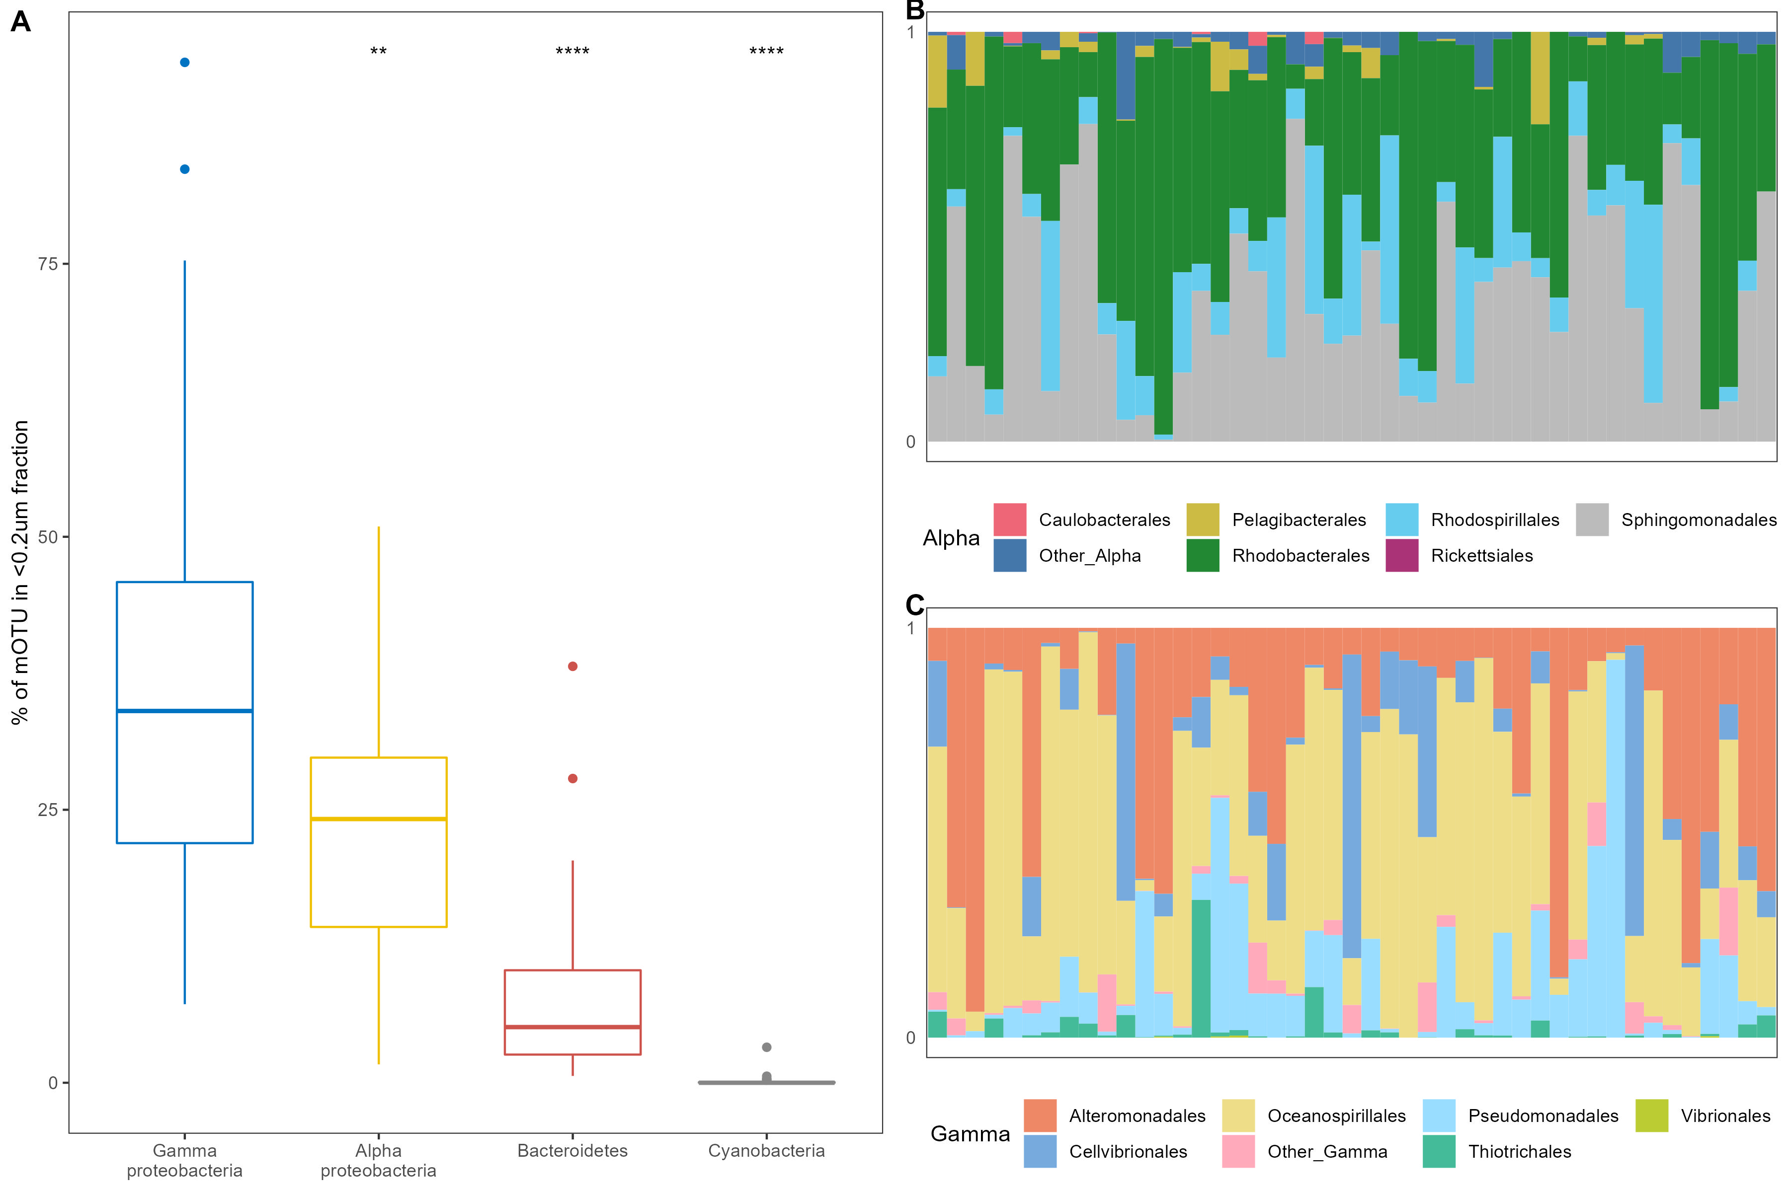
Extended Data Fig. 13 Taxonomic profile (phylogenetic marker gene-based operational taxonomic units, mOTU) of metagenomes (n=45) collected in the <0.2μm size fraction. (A) Relative abundance of major taxonomic groups in metagenomes collected from the <0.2μm fraction. (B-C) Taxonomic profile of Alpha- and Gamma-proteobacteria at the order level in the metagenomes collected in the <0.2μm fraction, the x-axis indicates samples. Significance test (Wilcoxon test) was performed using Gammaproteobacteria as reference. *P<0.05, **P<0.01, ***P<0.001, ****P<0.0001, ns, not significant.

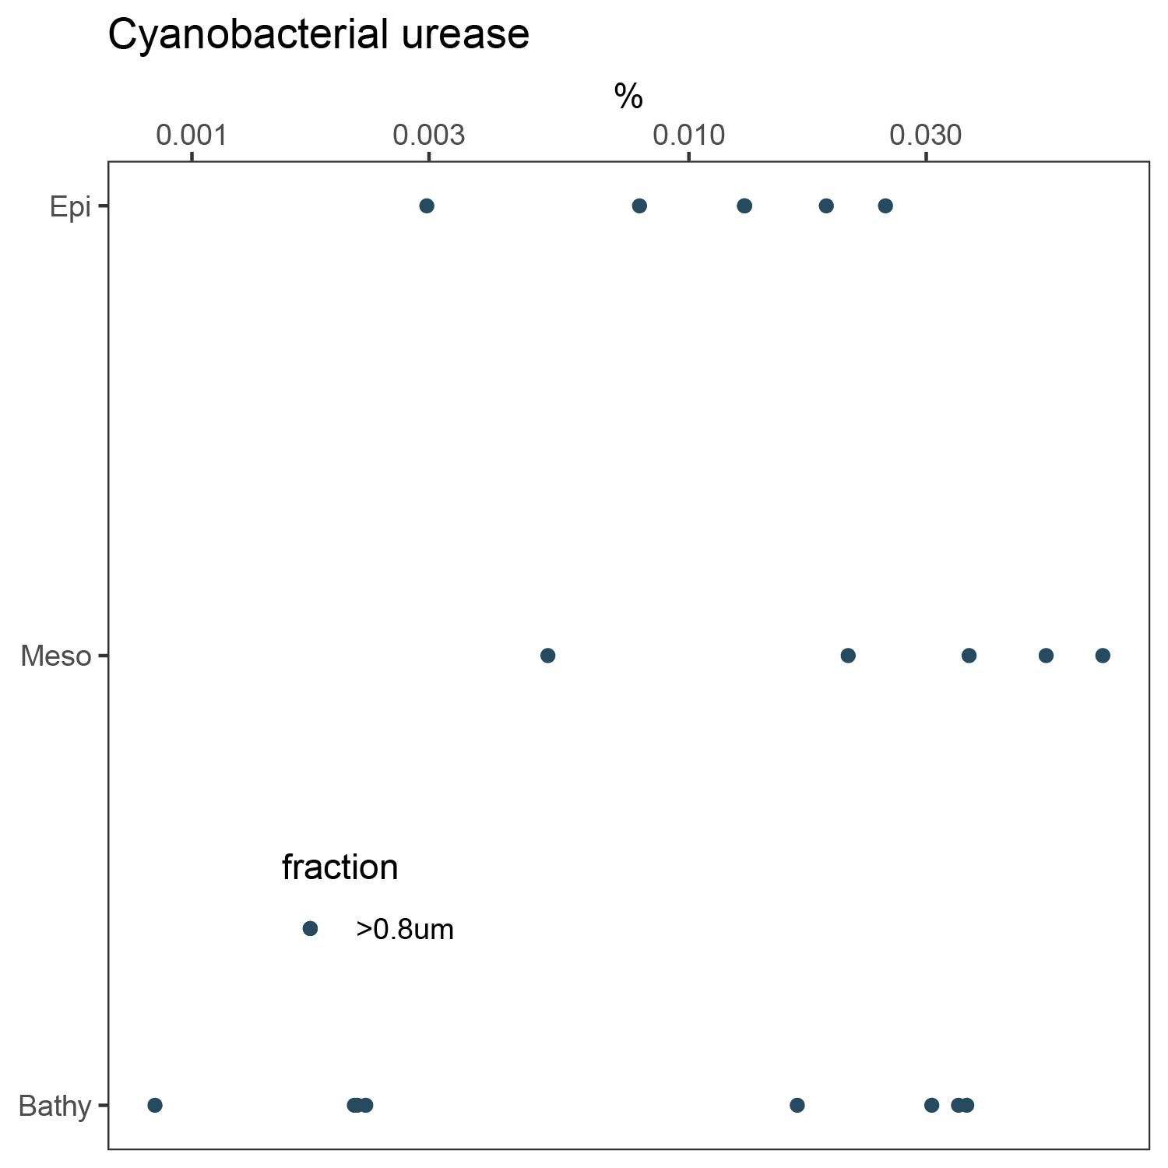
Extended Data Fig. 14 Depth profile of cyanobacterial urease in the metaproteomic dataset. Cyanobacterial urease was only found in the >0.8μm size fraction.

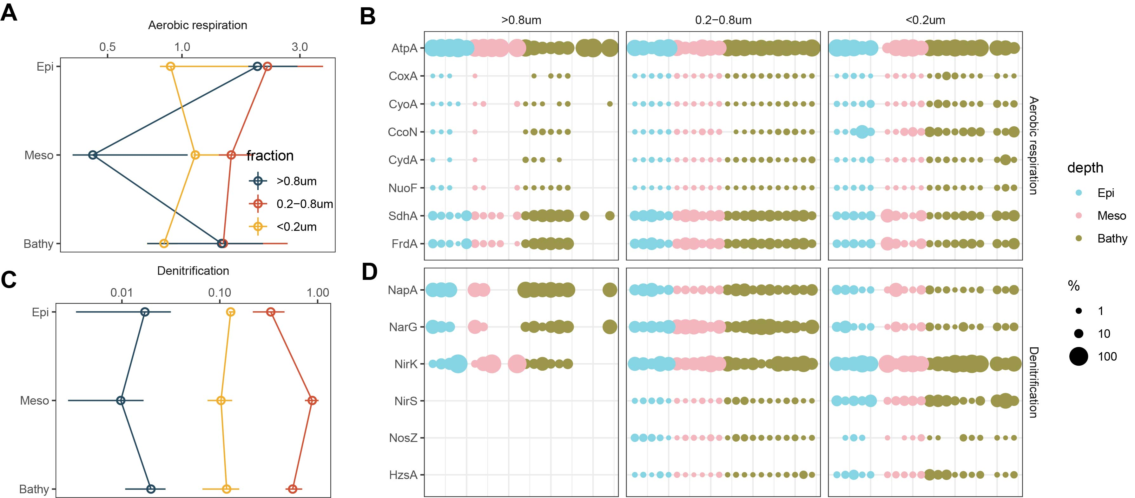
Extended Data Fig. 15 Expression level of enzymes involved in aerobic respiration and denitrification. (A-B) Depth profile of enzymes involved in aerobic respiration. (C-D) Depth profile of enzymes involved in denitrification. The relative abundance of each enzyme in B and D was normalized to the total enzyme pool in each process. AtpA, ATP synthase; CoxA/CyoA/CcoN/CydA, cytochrome oxidase; NuoF, NADH-quinone oxidoreductase subunit F; SdhA/FrdA, succinate dehydrogenase flavoprotein subunit; NapA/NarG, dissimilatory nitrate reductase; NirK/NirS, nitrite reductase; NosZ, nitrous-oxide reductase; HzsA, hydrazine synthase.

