Appendix 1. Effects of the calibration. Three graphs show the prediction results of the original model (a), the model with the class probability correction by applying a Gaussian filter of size 64 (b), and the model with the class probability correction by applying a Gaussian filter of size 128 (c). The X-axis represents the frames of the video. The Y-axis represents the model’s prediction, which classifies the location into the stomach (0), small intestine (1), and colon (2).
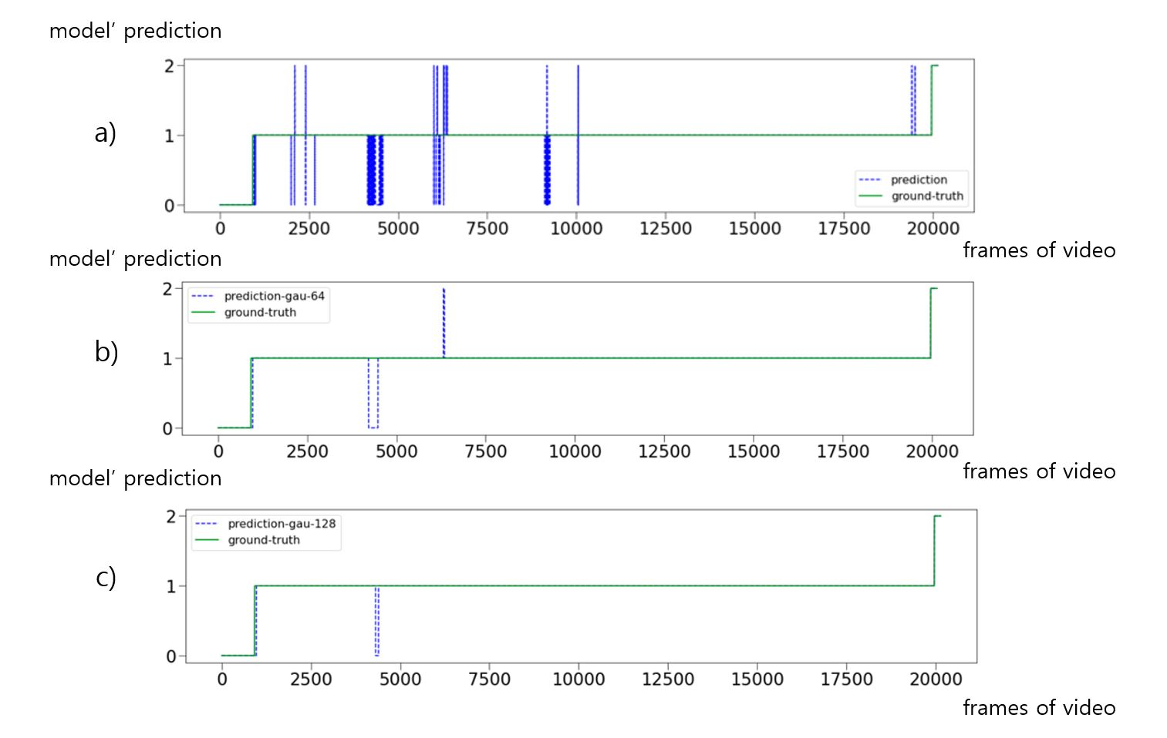
Appendix 2. Normal pylorus image from the duodenal side
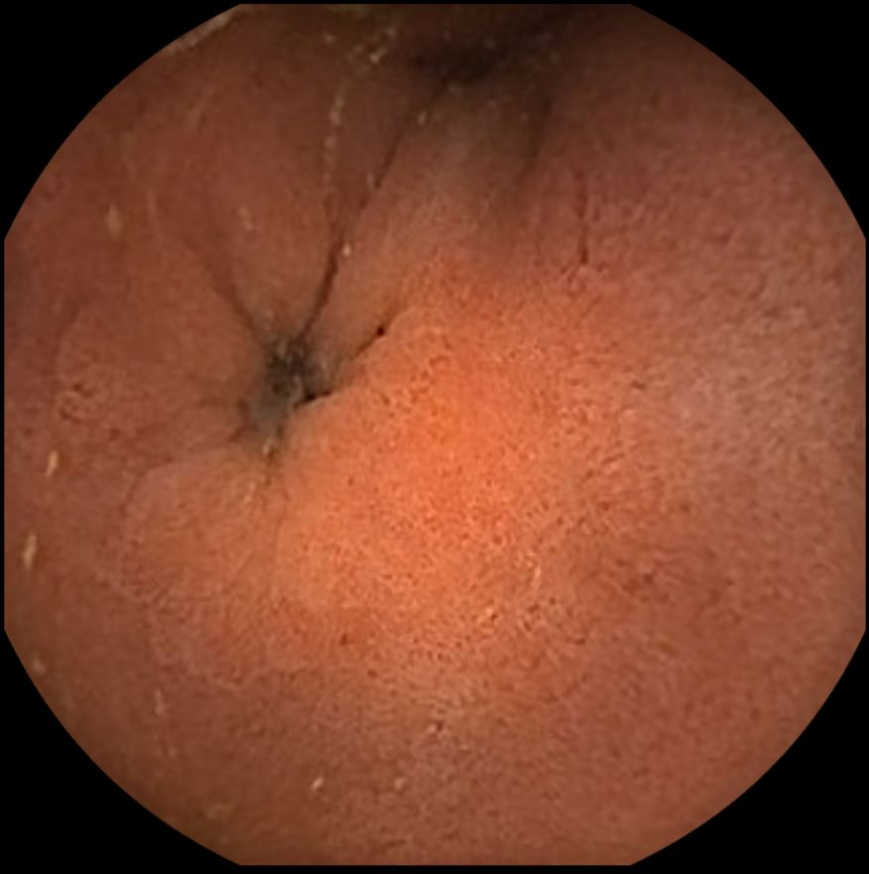
Appendix 3. Poor bowel preparation of small bowel due to fecal material (a) or blood clot (b). 