Supplementary Online Content

Ziwei Xie; Huizi Sun; Chunmiao Zhou; Chunying Fu; Qi Wang; Caiyun Dong; Wenting Hao; Xuemei Zhen; Dongshan Zhu.
Childhood, adulthood, and cumulative traumatic events experienced from childhood to adulthood and dementia risk: a population-based cohort study
eTable S1. The questionnaire of six types of traumatic experiences.
eTable S2. Characteristics of responders and non-responders to the questionnaire containing childhood and adulthood traumatic experiences.
eTable S3. Adjusted association of childhood traumatic events with dementia subtypes: VD and AD.
eTable S4. Adjusted association of adulthood traumatic events with dementia subtypes: VD and AD.
eFigure S1. The distributions of numbers of participants in each kind of traumatic events.
eFigure S2. The follow-up times in the analysis.

Table S1 The questionnaire of six types of traumatic experiences.
Period | Item | Field | Questions
Childhood | Physical abuse | Physically abused by family as a child | When I was growing up... People in my family hit me so hard that it left me with bruises or marks
Childhood | Emotional abuse | Felt loved as a child | When I was growing up... I felt loved
Childhood | Sexual abuse | Sexually molested as a child | When I was growing up... Someone molested me (sexually)
Adulthood | Physical violence | Physical violence by partner or ex-partner as an adult | Since I was sixteen... A partner or ex-partner deliberately hit me or used violence in any other way
Adulthood | Emotional violence | Been in a confiding relationship as an adult | Since I was sixteen... I have been in a confiding relationship
Adulthood | Sexual violence | Sexual interference by partner or ex-partner without consent as an adult | Since I was sixteen... A partner or ex-partner sexually interfered with me

* Response options included the following: “Never”, “Rarely”, “Sometimes”, “Often”, and “Very Often”.

Table S2 Characteristics of responders and non-responders to the questionnaire containing childhood and adulthood traumatic experiences.
Characteristics | No-responders | Responders
Characteristics | (n=319,650) | n=145,558)
Age, Mean(SD） | 56.7 (8.23) | 55.9 (7.73)
Sex:
Female | 170141 (53.2) | 81175 (55.8)
Male | 149509 (46.8) | 64383 (44.2)
Education level (years)
<=10 | 178416 (55.8) | 50793 (34.9)
(10,12] | 35618 (11.1) | 20154 (13.8)
＞12 | 105616 (33.0) | 74611 (51.3)
No. of leisure activities
No | 95410 (29.8) | 35971 (24.6)
One | 142685 (44.6) | 59992 (41.2)
Two or more | 81555 (25.5) | 49595 (34.2)
Physical activity level (MET)
Light (<600) | 71414 (22.3) | 34475 (23.7)
Moderate [600, 3000) | 126235 (39.5) | 60400 (41.5)
High (>=3000) | 122001 (38.2) | 50683 (34.8)
Income level (£)
<18000 | 84027 (26.3) | 20517 (14.1)
[18000, 31000) | 81247 (25.4) | 32803 (22.5)
[31000, 52000) | 79208 (24.8) | 41595 (28.6)
>=52000 | 75168 (23.5) | 50643 (34.9)
Body mass index (kg/m2)
Underweight (<18.5) | 1599 (0.50) | 802 (0.55)
Normal [18.5, 25.0) | 97334 (30.5) | 55851 (38.4)
Overweight [25.0, 30.0) | 138087 (43.2) | 60384 (41.5)
Obese (>=30.0) | 82630 (25.9) | 28521 (19.6)
Smoking status
Never | 171313 (53.6) | 83605 (57.4)
Past | 110846 (34.7) | 51481 (35.4)
Current | 37491 (11.7) | 10472 (7.19)
Diabetes
Yes | 224408 (70.2) | 111929 (76.9)
No | 95242 (29.8) | 33629 (23.1)
Hypertension
Yes | 298589 (93.4) | 140040 (96.2)
No | 21061 (6.59) | 5518 (3.80)
CVD
Yes | 298589 (93.4) | 140022 (96.2)
No | 21061 (6.59) | 5536 (3.80)
APOE
no apoE4 | 241887 (75.7) | 111135 (76.4)
one apoE4 | 71097 (22.2) | 31733 (21.8)
two apoE4 | 6666 (2.09) | 2690 (1.85)
Abbreviations: MET, metabolic equivalent; APOE, apolipoprotein E.
Numbers presented are n (%) unless otherwise specified.

Table S3 Adjusted association of childhood traumatic events with dementia subtypes: VD and AD.
Childhood traumatic events | Total | VD (n) | Hazard Ratio(95%CI) | P |  | AD (n) | Hazard Ratio(95%CI) | P
All
Emotional abuse
No | 131967 | 72 | Reference | - |  | 151 | Reference | -
Yes | 14809 | 8 | 1.71 (0.82, 3.56) | 0.15 |  | 21 | 2.04 (1.29, 3.23) | 0.002
Physical abuse
No | 139021 | 74 | Reference |  |  | 161 | Reference | -
Yes | 12755 | 6 | 1.22 (0.53, 2.82) | 0.63 |  | 11 | 1.05 (0.57, 1.93) | 0.876
Sexual abuse
No | 143797 | 75 | Reference |  |  | 164 | Reference | -
Yes | 7979 | 5 | 2.3 (0.93, 5.72) | 0.07 |  | 8 | 1.52 (0.74, 3.09) | 0.252
Female
Emotional abuse
No | 75435 | 26 | Reference | - |  | 66 | Reference | -
Yes | 10094 | 3 | 1.24 (0.38, 4.12) | 0.72 |  | 9 | 1.50 (0.75, 3.01) | 0.254
Physical abuse
No | 78410 | 27 | Reference | - |  | 70 | Reference | -
Yes | 7119 | 2 | 1.24 (0.29, 5.22) | 0.77 |  | 5 | 1.23 (0.50, 3.05) | 0.656
Sexual abuse
No | 79390 | 27 | Reference | - |  | 71 | Reference | -
Yes | 6139 | 2 | 1.54 (0.36, 6.47) | 0.56 |  | 4 | 1.15 (0.42, 3.15) | 0.790
Male
Emotional abuse
No | 61532 | 46 | Reference | - |  | 85 | Reference | -
Yes | 4715 | 5 | 2.16 (0.86, 5.44) | 0.10 |  | 12 | 2.71 (1.48, 4.96) | 0.001
Physical abuse
No | 60611 | 47 | Reference | - |  | 91 | Reference | -
Yes | 5636 | 4 | 1.20 (0.43, 3.34) | 0.721 |  | 6 | 0.94 (0.41, 2.15) | 0.883
Sexual abuse
No | 64407 | 48 | Reference | - |  | 93 | Reference | -
Yes | 1840 | 3 | 2.16 (0.86, 5.44) | 0.10 |  | 4 | 2.12 (0.78, 5.78) | 0.141
*All HRs were adjusted for age at first follow-up, sex and APOE.
Abbreviations: AD, Alzheimer’s disease; VD, vascular dementia.

Table S4 Adjusted association of adulthood traumatic events with dementia subtypes: VD and AD.
Adulthood traumatic events | Total | VD (n) | Hazard Ratio(95%CI) | P |  | AD (n) | Hazard Ratio(95%CI) | P
All
Emotional violence
No | 99335 | 50 | Reference | - |  | 104 | Reference | -
Yes | 46203 | 30 | 1.13 (0.71, 1.79) | 0.601 |  | 68 | 1.27 (0.93, 1.73) | 0.135
Physical violence
No | 136264 | 76 | Reference | - |  | 167 | Reference | -
Yes | 9294 | 4 | 0.83 (0.3, 2.31) | 0.72 |  | 5 | 0.46 (0.19, 1.14) | 0.094
Sexual violence
No | 141899 | 76 | Reference | - |  | 171 | Reference | -
Yes | 3659 | 4 | 2.24 (0.79, 6.37) | 0.129 |  | 1 | 0.23 (0.03, 1.64) | 0.141
Female
Emotional violence
No | 55016 | 19 | Reference | - |  | 40 | Reference | -
Yes | 26159 | 10 | 0.90 (0.41, 1.95) | 0.781 |  | 35 | 1.68 (1.06, 2.67) | 0.028
Physical violence
No | 73677 | 26 | Reference | - |  | 73 | Reference | -
Yes | 7498 | 3 | 1.03 (0.3, 3.53) | 0.958 |  | 2 | 0.28 (0.07, 1.18) | 0.084
Sexual violence
No | 77677 | 25 | Reference | - |  | 74 | Reference | -
Yes | 3498 | 4 | 3.74 (1.24, 11.27) | 0.019 |  | 1 | 0.33 (0.04, 2.37) | 0.268
Male
Emotional violence
No | 44339 | 31 | Reference | - |  | 64 | Reference | -
Yes | 20044 | 20 | 1.27 (0.72, 2.26) | 0.411 |  | 33 | 1.01 (0.66, 1.55) | 0.957
Physical violence
No | 62587 | 50 | Reference | - |  | 94 | Reference | -
Yes | 1796 | 1 | 0.68 (0.09, 5.06) | 0.71 |  | 3 | 1.23 (0.38, 3.93) | 0.73
*All HRs were adjusted for age at last follow-up, sex, educational years, income level, physical activity level, leisure activities, body mass index (BMI), smoking status, alcohol status, diabetes status, stroke status, hypertension status and APOE.
* No male participants who experience sexual violence developed dementia in this study.
Abbreviations: AD, Alzheimer’s disease; VD, vascular dementia.

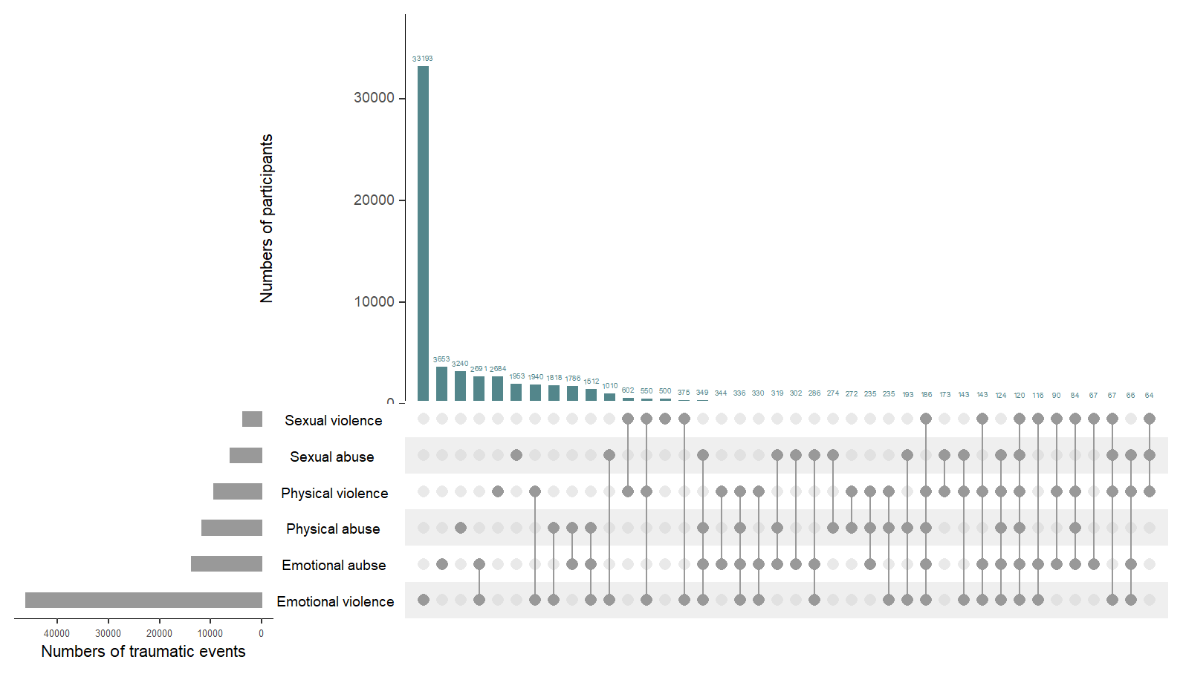
Fig. S1 The distributions of numbers of participants in each kind of traumatic events.
The bar chart above represents the number of participants contained in each type of group. The bar chart at the bottom left represents the number of traumatic events included in each type of traumatic events. the dotted line at the bottom right shows the types of events contained in the groups. The intersections mean the co-occurrence of six types of traumas.
* Responses of “sometimes”, “often” and “very often” to questions describing abuse were coded as 1 (Yes) and responses of “never” and “rarely” and were coded as 0 (No).

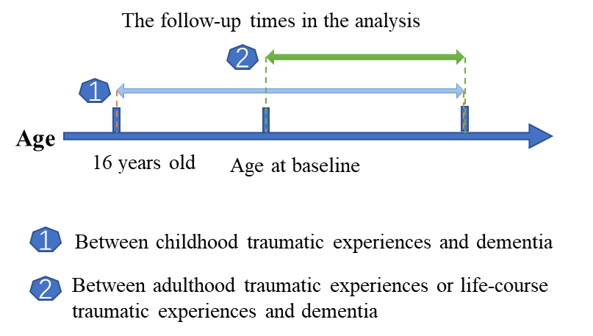
Fig.S2 The follow-up times in the analysis.

