An immunosensor for the detection of speckle-type POZ domain protein based on pioneering jasmine-like Cu@L-Asp hybrid nanoflowers and palladium-platinum nanoparticles.
Song Yue, Kexin Sun, Siyuan Li, Yi Liu, Qihao Zhu, Yiyu Chen, Dong Yuan, Tao Wen, Mingjian Ge* and Qiubo Yu*.

Institute of Life Science, Chongqing Medical University, Chongqing 400016, P.R. China.
Department of Ophthalmology, The First Affiliated Hospital of Chongqing Medical University, Chongqing Key Laboratory of Ophthalmology, Chongqing Eye Institute, Chongqing, 400016, P.R. China.
Department of thoracic surgery, The First Affiliated Hospital of Chongqing Medical University, Chongqing, 400016, P.R. China.

*Corresponding author: Prof. Qiubo Yu
Phone: (86)23 -68815186
Fax: (86) 23-68865186
E-mail: yqb76712@gmail.com

Full address: Institute of Life Science, Chongqing Medical University, 1 Yi Xue Yuan Road, Chongqing 400016, P. R. China.

S1. Synthesis of Pd NPs and Pt NPs
The synthetic methods of Pd NPs and Pt NPs is according to the literature¹.10 mL of NaBH4 solution was added into solution consists of 170 µl of 5% Na2PdCl4 and 10 mL of ultrapure water with stirring at 400 rpm for 1h. After that, use ultrapure water and ethanol for washing three times, respectively. Finally, the resulting preparation was dispersed in the 2 mL of ultrapure water for further use. Pt NPs were synthesized using a similar method except that 170 µl of Na₂PdCl₄(5%) was replaced with 300 µl of H₂PtCl₆(5%).

S2. XPS analysis of the Cu@L-Glu/Pd-Pt NPs
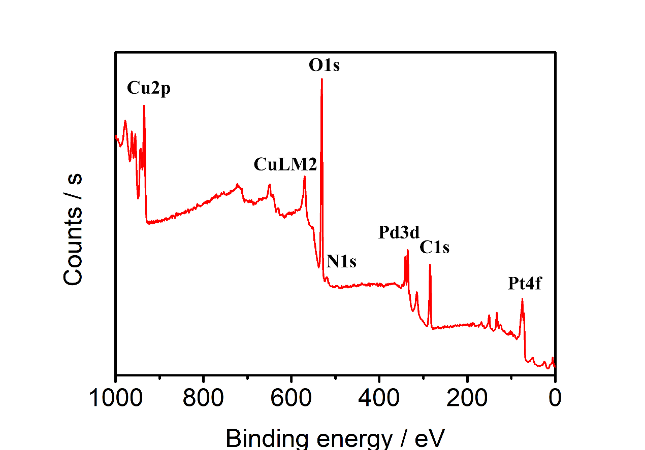

Fig. S1. XPS analysis of the Cu@L-Glu/Pd-Pt NPs

S3. The repeatability of the proposed immunosensor
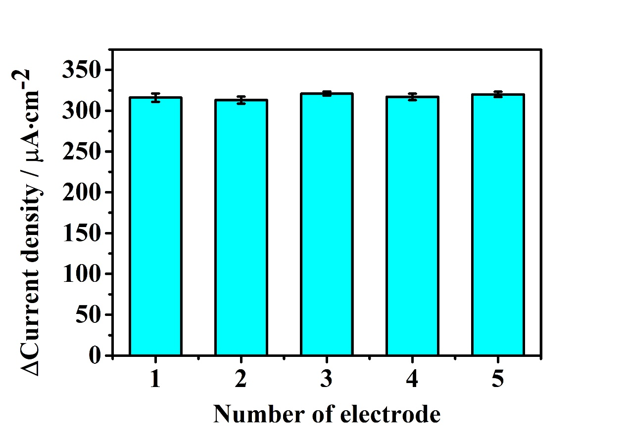
Fig. S2. Repeatability results for five groups of identical electrodes (n=3) incubated with the same concentration of SPOP (10 pg mL ⁻¹)

S4. The calibration plot of ELISA method and the whole detection procedure of this work
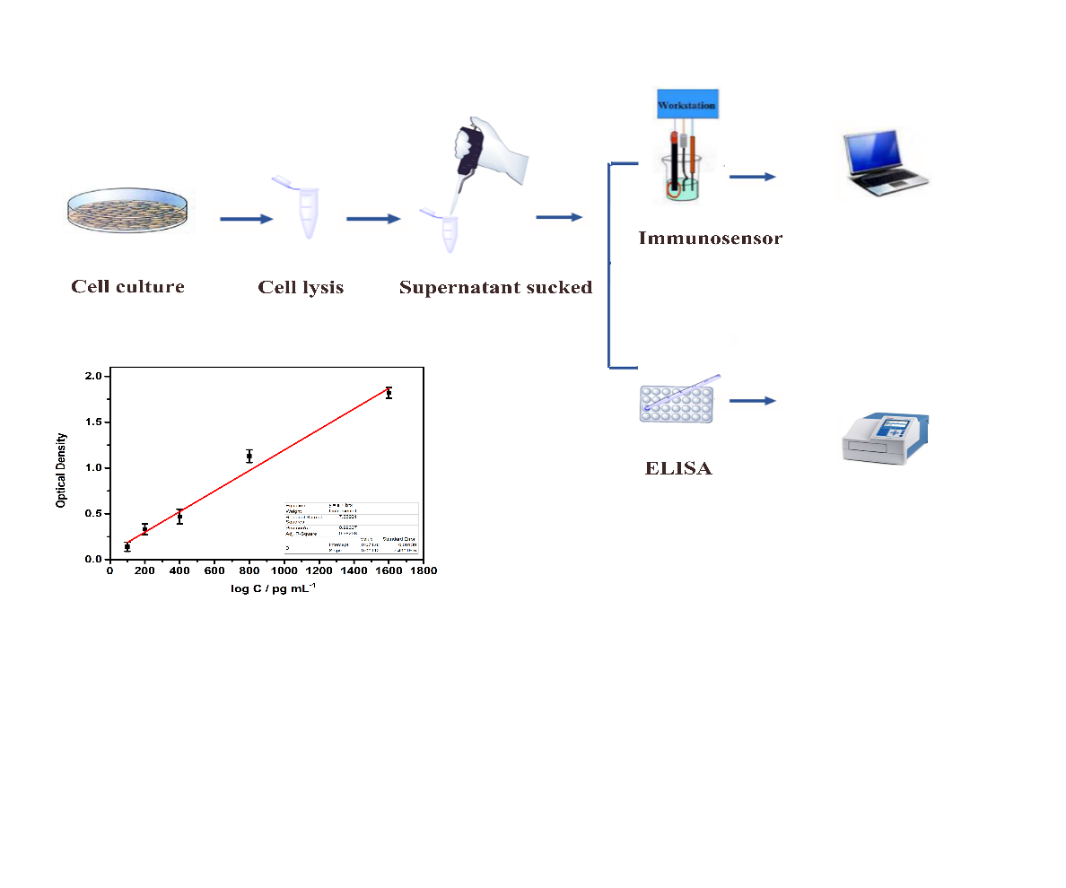
Fig. S3. The calibration plot of ELISA method and the whole detection procedure of this work
Table S1. EDS analysis of the Cu@L-Glu/Pd-Pt NPs
Element | Line Type | Apparent Concentration | k Ratio | Wt% | Wt% Sigma | Standard Label | Factory Standard
C | K series | 29.38 | 0.29383 | 80.77 | 1.16 | C Vit | Yes
Cu | K series | 2.47 | 0.02473 | 5.30 | 0.47 | Cu | Yes
Pd | L series | 3.85 | 0.03849 | 7.90 | 0.52 | Pd | Yes
Pt | M series | 3.12 | 0.03119 | 6.03 | 0.82 | Pt | Yes
Total: |  |  |  | 100.00

Table S2 Different methods used for detecting SPOP

Detection methods | Linear range | Detection limit | Reference
Western Blotting |  |  | ²
PRISMª-SRM^{b} | 0.1 - 1 fmol/μg of total protein |  | ³
ELISA^{c} | 100 pg/mL-1600 pg/mL | 47 pg/mL | This work
Label-free electrochemical method | 0.1 pg/mL-1000 pg/mL | 0.019 pg/mL | This work
ª High-pressure, high-resolution separations coupled with intelligent selection and multiplexing
^{b} Selected reaction monitoring
^{c} Enzyme linked immunosorbent assay

References
1 Ji, X. et al. Fabrication of pioneering 3D sakura-shaped metal-organic coordination polymers Cu@L-Glu phenomenal for signal amplification in highly sensitive detection of zearalenone. Biosensors & bioelectronics 129, 139-146 (2019).
2 Cuneo, M. J. & Mittag, T. The ubiquitin ligase adaptor SPOP in cancer. The FEBS journal 286, 3946-3958 (2019).
3 Wang, H. et al. Quantification of mutant SPOP proteins in prostate cancer using mass spectrometry-based targeted proteomics. Journal of Translational Medicine 15 (2017).

