Table 1. Baseline characteristics.
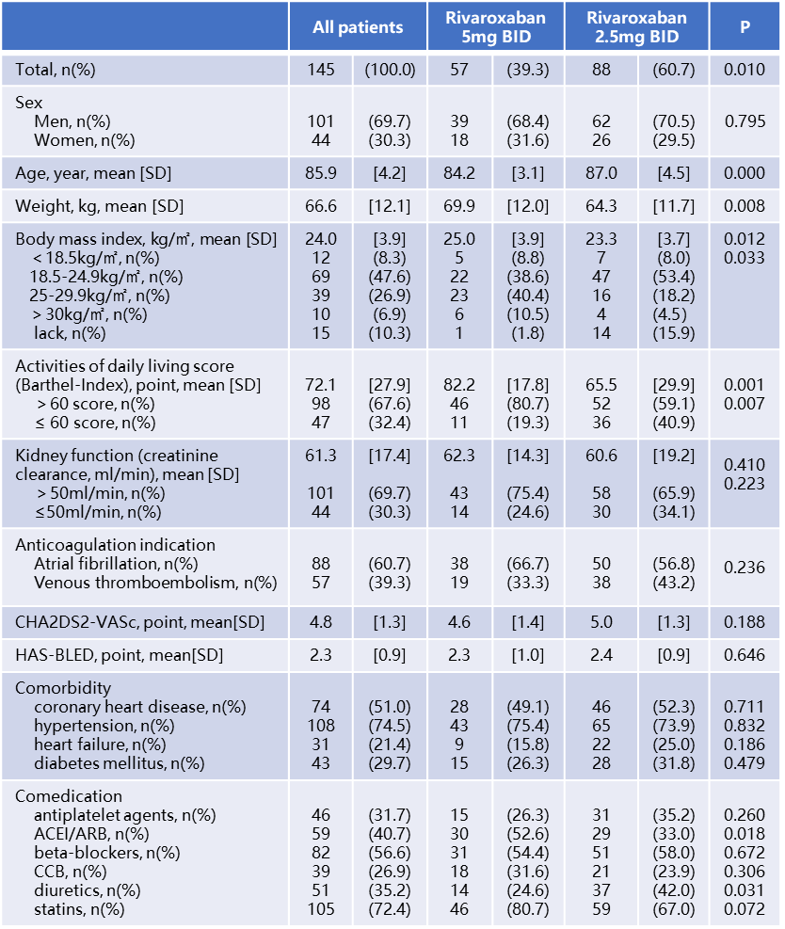
Abbreviations: SD, standard deviation; NA, not applicable; ACEI, angiotensin-converting enzyme inhibitors; ARB, angiotensin receptor blockers; CCB, calcium channel antagonists

Table 2. Average anti-factor Xa activity (AXA) trough and peak and the inter- individual variability at day 3 and day 30 stratified by rivaroxaban dose.

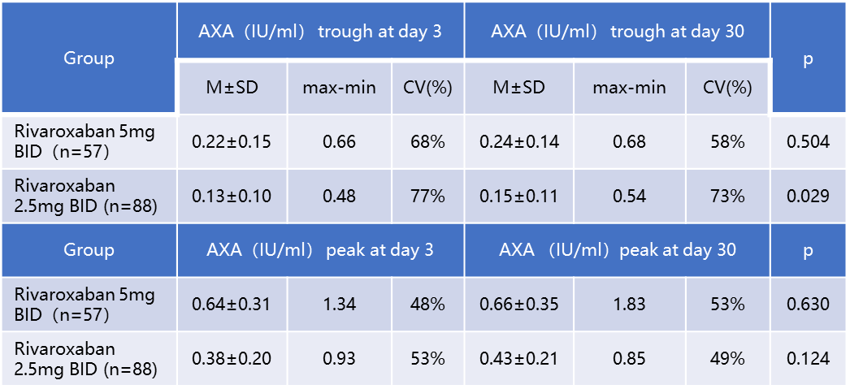
Abbreviations: CV, coefficient of variation; max, maximum; min, minimum; M, mean; SD, standard deviation

Table 3. Paired samples test of average anti-factor Xa activity (AXA) between at day 3 and day 30 stratified by rivaroxaban dose.

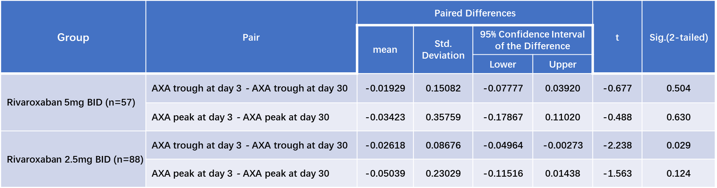

Abbreviations: Sig. (2-tailed), correlation is significant at the 0.05 level (2-tailed)

Table 4. Correlations between anti-factor Xa activity (AXA) and clinical characteristics at day 3 stratified by rivaroxaban dose.
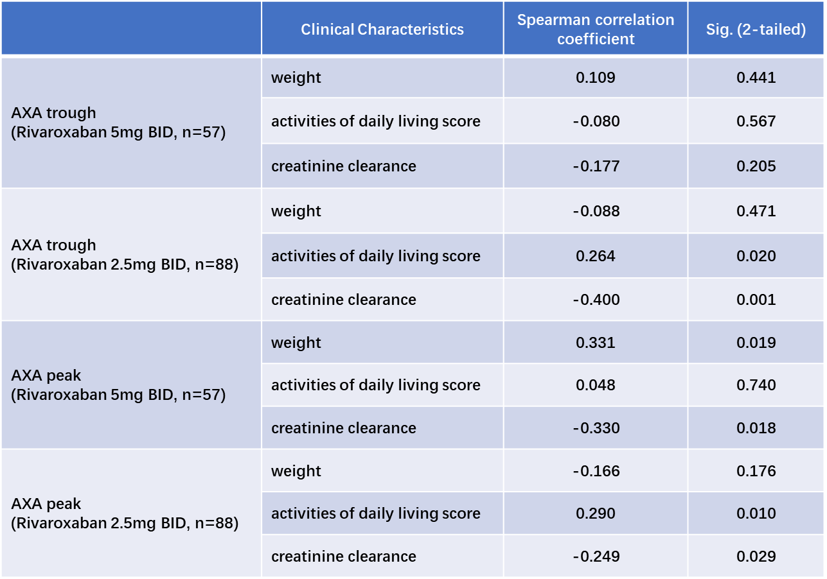
Abbreviations: Sig. (2-tailed), correlation is significant at the 0.05 level (2-tailed)

Table 5. Correlations between anti-factor Xa activity (AXA) and several coagulation indicators at day 3 stratified by rivaroxaban dose.
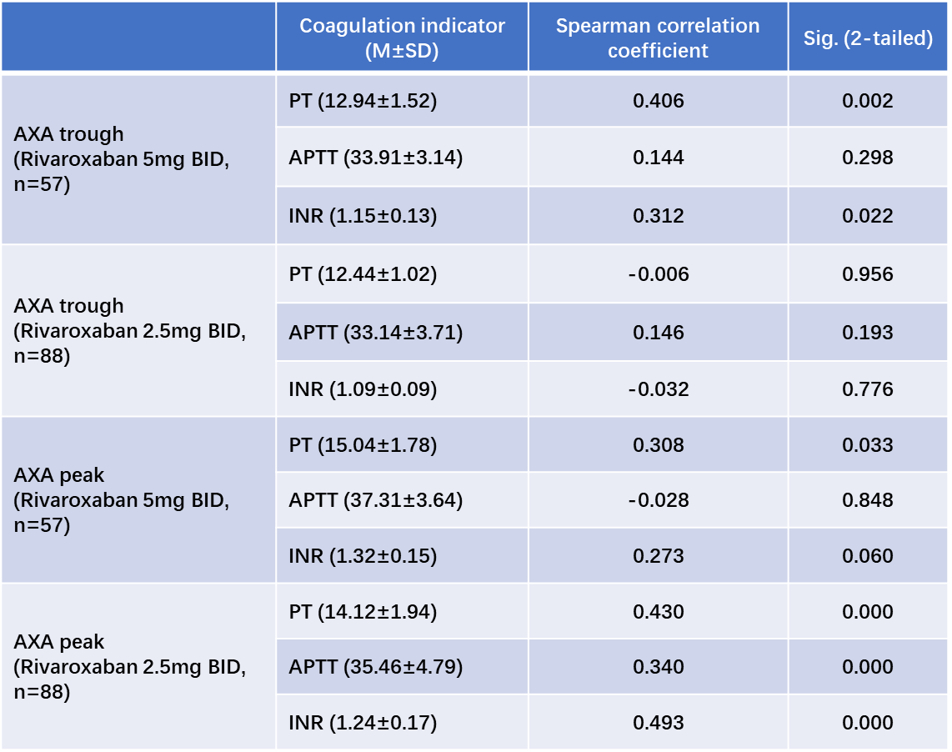
Abbreviations: Sig. (2-tailed), correlation is significant at the 0.05 level (2-tailed); PT, prothrombin time; APTT, activated partial thromboplastin time; INR, international normalized ratio

