Supplementary Figures

Supplementary Figure 1. Malaria positivity by month in each study site (August 2013 to March 2015)

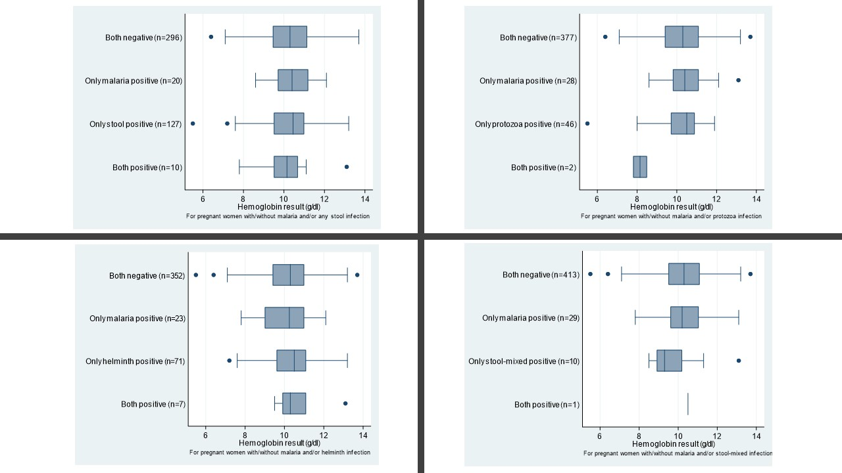
Fig 4b
Fig 4a
Fig 4c
Fig 4d
Supplementary Figure 2. Hemoglobin concentration in pregnant women with and without co-infections

