Immunoinformatic design of a COVID-19 subunit vaccine using entire structural immunogenic epitopes of SARS-CoV-2

Esmaeil Behmard,^{a,b} Bijan Soleymani,ª Ali Najafi,^{c} Ebrahim Barzegari ª

ª Medical Biology Research Center, Health Technology Institute, Kermanshah University of Medical Sciences, Kermanshah, Iran
^{b} Pharmaceutical Sciences Research Center, Shiraz University of Medical Sciences, Shiraz, Iran
^{c} Molecular Biology Research Center, Systems Biology and Poisonings Institute, Baqiyatallah University of Medical Sciences, Tehran, Iran

SUPPLEMENTARY INFORMATION

Table S1. Cytotoxic T Lymphocyte (CTL) epitopes of the spike protein (S) ª
Start | End | Length | Peptide | IC₅₀ | Rank | Antigenicity | Allergenicity
58 | 66 | 9 | FAMQMAYRF | 5.03 | 0.02 | 1.0278 | non-allergen
36 | 45 | 10 | KLNDLCFTNV | 6.22 | 0.1 | 2.6927 | non-allergen
19 | 27 | 9 | TTRTQLPPA | 8.31 | 0.05 | 1.254 | non-allergen
49 | 58 | 10 | FPNITNLCPF | 8.63 | 0.02 | 1.3964 | non-allergen
61 | 70 | 10 | FKIYSKHTPI | 9.13 | 0.18 | 1.016 | non-allergen
10 | 18 | 9 | VVFLHVTYV | 13.02 | 0.27 | 1.5122 | non-allergen
54 | 63 | 10 | LQYGSFCTQL | 13.44 | 0.06 | 1.4443 | non-allergen
27 | 35 | 9 | ITPCSFGGV | 20.32 | 0.2 | 1.3871 | non-allergen
17 | 26 | 10 | EQYIKWPWYI | 21.01 | 0.08 | 1.1122 | non-allergen
55 | 63 | 9 | YYVGYLQPR | 21.9 | 0.07 | 1.4692 | non-allergen
55 | 64 | 10 | QIPFAMQMAY | 23.9 | 0.1 | 1.2149 | non-allergen
19 | 28 | 10 | LPIGINITRF | 25.21 | 0.04 | 1.3027 | non-allergen
57 | 66 | 10 | PFAMQMAYRF | 28.72 | 0.1 | 1.1051 | non-allergen
54 | 64 | 11 | LQIPFAMQMAY | 29.34 | 0.12 | 1.0701 | non-allergen
17 | 25 | 9 | PYRVVVLSF | 30.39 | 0.11 | 1.0281 | non-allergen
22 | 30 | 9 | VLSFELLHA | 33.91 | 0.61 | 1.0776 | non-allergen
58 | 67 | 10 | RQIAPGQTGK | 38 | 0.15 | 1.7893 | non-allergen
6 | 15 | 10 | SLIDLQELGK | 38.67 | 0.25 | 1.0275 | non-allergen
49 | 57 | 9 | FPNITNLCP | 39.11 | 0.06 | 1.6218 | non-allergen
9 | 18 | 10 | GVVFLHVTYV | 39.32 | 0.69 | 1.4551 | non-allergen
14 | 23 | 10 | QTRAGCLIGA | 39.78 | 0.34 | 1.3933 | non-allergen
ª Epitopes selected to be used in vaccine polypeptide are shown in bold-italic font.

Table S2. Cytotoxic T Lymphocyte (CTL) epitopes of the envelope protein (E) ª
Start | End | Length | Peptide | IC₅₀ | Rank | Antigenicity | Allergenicity
61 | 69 | 9 | RVKNLNSSR | 4.68 | 0.02 | 0.8998 | non-allergen
20 | 28 | 9 | FLAFVVFLL | 5.26 | 0.04 | 0.5308 | non-allergen
18 | 26 | 9 | LLFLAFVVF | 8.32 | 0.03 | 0.8144 | non-allergen
20 | 29 | 10 | FLAFVVFLLV | 9.95 | 0.1 | 0.5651 | non-allergen
16 | 24 | 9 | SVLLFLAFV | 11.87 | 0.15 | 0.4765 | non-allergen
20 | 29 | 10 | FLAFVVFLLV | 12.57 | 0.26 | 0.5651 | non-allergen
20 | 28 | 9 | FLAFVVFLL | 14.54 | 0.3 | 0.5308 | non-allergen
57 | 65 | 9 | YVYSRVKNL | 15.74 | 0.31 | 0.702 | non-allergen
30 | 38 | 9 | TLAILTALR | 17.89 | 0.13 | 0.7223 | non-allergen
17 | 25 | 9 | VLLFLAFVV | 21.72 | 0.25 | 0.5677 | non-allergen
29 | 37 | 9 | VTLAILTAL | 22.24 | 0.27 | 0.614 | non-allergen
17 | 26 | 10 | VLLFLAFVVF | 22.52 | 0.12 | 0.5362 | non-allergen
60 | 69 | 10 | SRVKNLNSSR | 25.59 | 0.33 | 0.6612 | non-allergen
19 | 28 | 10 | LFLAFVVFLL | 26.16 | 0.3 | 0.5111 | non-allergen
29 | 38 | 10 | VTLAILTALR | 26.92 | 0.23 | 0.8404 | non-allergen
61 | 69 | 9 | RVKNLNSSR | 27.32 | 0.14 | 0.8998 | non-allergen
23 | 31 | 9 | FVVFLLVTL | 27.7 | 0.32 | 0.7403 | non-allergen
18 | 27 | 10 | LLFLAFVVFL | 32.72 | 0.37 | 0.6159 | non-allergen
26 | 34 | 9 | FLLVTLAIL | 39.95 | 0.43 | 0.9645 | non-allergen
15 | 24 | 10 | NSVLLFLAFV | 41.69 | 0.35 | 0.4551 | non-allergen
20 | 27 | 8 | FLAFVVFL | 42.25 | 0.45 | 0.4483 | non-allergen
45 | 53 | 9 | NIVNVSLVK | 46.43 | 0.4 | 0.931 | non-allergen
ª Epitopes selected to be used in vaccine polypeptide are shown in bold-italic font.

Table S3. Cytotoxic T Lymphocyte (CTL) epitopes of the membrane protein (M) ª
Start | End | Length | Peptide | IC₅₀ | Rank | Antigenicity | Allergenicity
61 | 70 | 10 | TLACFVLAAV | 3.82 | 0.04 | 1.2318 | non-allergen
61 | 69 | 9 | TLACFVLAA | 7.63 | 0.14 | 1.1932 | non-allergen
19 | 28 | 10 | QWNLVIGFLF | 12.03 | 0.04 | 1.2302 | non-allergen
12 | 20 | 9 | IAMACLVGL | 13.64 | 0.18 | 1.1306 | non-allergen
6 | 14 | 9 | GTITVEELK | 18.08 | 0.13 | 1.0976 | non-allergen
35 | 44 | 10 | RTRSMWSFNP | 18.67 | 0.09 | 1.591 | non-allergen
61 | 70 | 10 | TLACFVLAAV | 20.28 | 0.22 | 1.2318 | non-allergen
6 | 14 | 9 | GTITVEELK | 20.98 | 0.12 | 1.0976 | non-allergen
60 | 68 | 9 | VTLACFVLA | 24.2 | 0.29 | 1.4562 | non-allergen
51 | 60 | 10 | SGFAAYSRYR | 24.22 | 0.31 | 1.0034 | non-allergen
22 | 30 | 9 | LVIGFLFLT | 25.12 | 0.3 | 1.2619 | non-allergen
61 | 70 | 10 | TLACFVLAAV | 30.92 | 0.36 | 1.2318 | non-allergen
26 | 34 | 9 | FLFLTWICL | 32.26 | 0.36 | 1.4835 | non-allergen
61 | 69 | 9 | TLACFVLAA | 33.11 | 0.37 | 1.1932 | non-allergen
60 | 69 | 10 | VTLACFVLAA | 34.02 | 0.61 | 1.3176 | non-allergen
10 | 18 | 9 | IAIAMACLV | 34.16 | 0.39 | 1.1704 | non-allergen
60 | 70 | 11 | VTLACFVLAAV | 40.96 | 0.71 | 1.3368 | non-allergen
29 | 37 | 9 | SFRLFARTR | 41.19 | 0.17 | 0.7038 | non-allergen
ª Epitopes selected to be used in vaccine polypeptide are shown in bold-italic font.

Table S4. Cytotoxic T Lymphocyte (CTL) epitopes of the nucleocapsid phosphoprotein (N) ª
Start | End | Length | Peptide | IC₅₀ | Rank | Antigenicity | Allergenicity
305 | 314 | 10 | AQFAPSASAF | 3.58 | 0.02 | 0.5986 | non-allergen
361 | 369 | 9 | KTFPPTEPK | 6.28 | 0.02 | 0.7571 | non-allergen
105 | 113 | 9 | SPRWYFYYL | 6.32 | 0.02 | 0.734 | non-allergen
316 | 324 | 9 | GMSRIGMEV | 6.68 | 0.11 | 0.6287 | non-allergen
315 | 324 | 10 | FGMSRIGMEV | 7.16 | 0.13 | 0.88 | non-allergen
361 | 370 | 10 | KTFPPTEPKK | 11.43 | 0.02 | 0.7657 | non-allergen
360 | 369 | 10 | YKTFPPTEPK | 11.53 | 0.07 | 0.7633 | non-allergen
100 | 107 | 8 | KMKDLSPR | 13.15 | 0.15 | 1.7575 | non-allergen
305 | 315 | 11 | AQFAPSASAFF | 22.87 | 0.12 | 0.4775 | non-allergen
322 | 331 | 10 | MEVTPSGTWL | 28.62 | 0.09 | 0.6342 | non-allergen
359 | 369 | 11 | AYKTFPPTEPK | 32.64 | 0.2 | 0.6958 | non-allergen
193 | 201 | 9 | SSRNSTPGS | 32.96 | 0.16 | 1.2424 | non-allergen
78 | 87 | 10 | SSPDDQIGYY | 33.46 | 0.1 | 0.4533 | non-allergen
104 | 113 | 10 | LSPRWYFYYL | 37.51 | 0.11 | 1.3486 | non-allergen
ª Epitopes selected to be used in vaccine polypeptide are shown in bold-italic font.

Table S5. Final selected helper T lymphocyte epitopes for multi-epitope vaccine construction
Protein | Start | End | Length | Peptide | Core peptide | IC₅₀ (nM) | Rank | Antigenicity | IL-10 inducing | IL-4 inducing | IFN-γ inducing | Allergenicity
S | 511 | 525 | 15 | VVLSFELLHAPATVC | FELLHAPAT | 2.9 | 0.03 | 0.8618 | IL-10 inducer | IL-4 inducer | positive | non-allergen
S | 166 | 180 | 15 | CTFEYVSQPFLMDLE | EYVSQPFLM | 18.8 | 0.19 | 0.57 | IL-10 inducer | IL-4 inducer | positive | non-allergen
S | 750 | 764 | 15 | SNLLLQYGSFCTQLN | LLQYGSFCT | 10.5 | 0.27 | 0.8305 | IL-10 inducer | IL-4 inducer | positive | non-allergen
S | 168 | 182 | 15 | FEYVSQPFLMDLEGK | EYVSQPFLM | 21.4 | 0.29 | 0.8278 | IL-10 inducer | IL-4 inducer | positive | non-allergen
S | 751 | 765 | 15 | NLLLQYGSFCTQLNR | LLQYGSFCT | 12.1 | 0.36 | 0.8668 | IL-10 inducer | IL-4 inducer | positive | non-allergen
S | 142 | 156 | 15 | GVYYHKNNKSWMESE | YHKNNKSWM | 8.6 | 0.42 | 0.4684 | IL-10 inducer | IL-4 inducer | positive | non-allergen
S | 141 | 155 | 15 | LGVYYHKNNKSWMES | YHKNNKSWM | 9.2 | 0.48 | 0.4937 | IL-10 inducer | IL-4 inducer | positive | non-allergen
S | 1210 | 1224 | 15 | IKWPWYIWLGFIAGL | YIWLGFIAG | 26.9 | 0.69 | 0.9153 | IL-10 inducer | IL-4 inducer | positive | non-allergen
S | 140 | 154 | 15 | FLGVYYHKNNKSWME | YHKNNKSWM | 11.8 | 0.72 | 0.4793 | IL-10 inducer | IL-4 inducer | positive | non-allergen
S | 346 | 360 | 15 | RFASVYAWNRKRISN | FASVYAWNR | 8 | 0.74 | 0.4243 | IL-10 inducer | IL-4 inducer | positive | non-allergen
S | 55 | 69 | 15 | FLPFFSNVTWFHAIH | FSNVTWFHA | 28.8 | 0.81 | 0.4883 | IL-10 inducer | IL-4 inducer | positive | non-allergen
S | 166 | 180 | 15 | CTFEYVSQPFLMDLE | YVSQPFLMD | 32.3 | 0.97 | 0.57 | IL-10 inducer | IL-4 inducer | positive | non-allergen
N | 83 | 97 | 15 | QIGYYRRATRRIRGG | YRRATRRIR | 6.7 | 0.49 | 0.4614 | IL-10 inducer | IL-4 inducer | positive | non-allergen
N | 303 | 317 | 15 | QIAQFAPSASAFFGM | FAPSASAFF | 4.8 | 0.01 | 0.4032 | IL-10 inducer | IL-4 inducer | positive | non-allergen

Table S6. Final selected linear B lymphocyte epitope for multi-epitope vaccine construction
Protein | Start | End | Peptide | Score | Antigenicity | IL-10 inducing | IL-4 inducing | IFN-γ | Allergenicity
E | 48 | 63 | DVSLVKPSFYVYSRVK | 0.82 | 0.8767 | IL-10 inducer | IL-4 inducer | positive | non-allergen

Figure S1. Prediction and assessment of the secondary and 3D structure of the multi-epitope vaccine polypeptide. (A) The predicted results showed that among 694 amino acids in the final vaccine construct, 161 (23.20%), 213 (30.69%), 48(6.92%), and 272 (39.19%) amino acids are involved in α-helix, extended strand, β-turn, and random coil, respectively; (B) ProSA validation of 3D vaccine model showing Z-score (-4.33); (C) 3D structure of the vaccine protein; (D) Ramachandran plot analysis of refined structure showing 92.3%, 6.1% and 1.6% residues in favoured, allowed and disallowed regions, respectively.

Table S7. Linear and Discontinuous B cell epitopes of the final 3D structure of vaccine
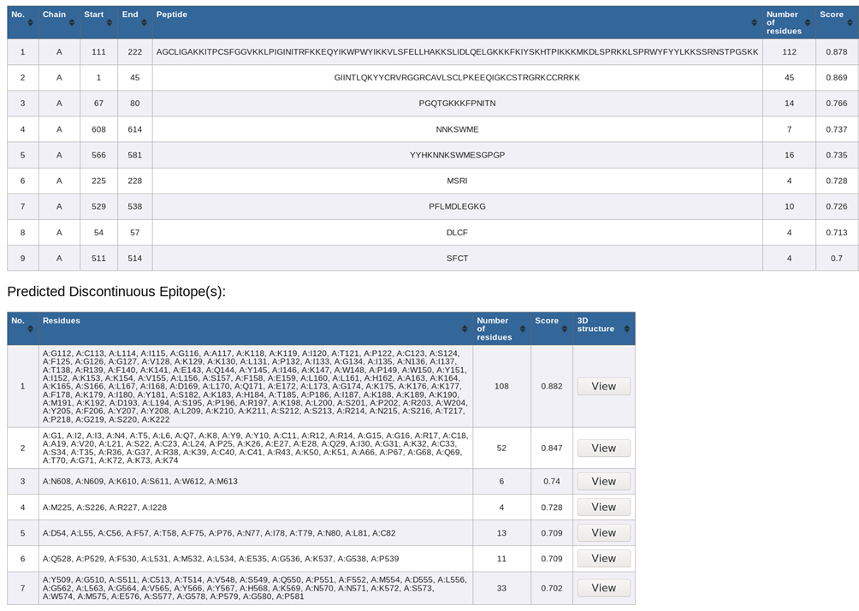

Figure S2. Illustration of the interaction between the designed vaccine polypeptide and the immune receptor Toll-like receptor-3 (TLR-3) as shown by molecular docking. (A) Docked complex of TLR-3 (PDB ID: 2A0Z) (chartreuse colour) with the multi-epitope vaccine (red colour); (B) Residues contributing in the vaccine polypeptide-receptor interaction.
Table S8. HLAs class I and class II which were used in the prediction of CTL and HTL epitopes
HLAs class I |  |  | HLAs class II
HLA-A*01:01,8  HLA-A*01:01,9  HLA-A*01:01,10  HLA-A*01:01,11  HLA-A*02:01,8  HLA-A*02:01,9  HLA-A*02:01,10  HLA-A*02:01,11  HLA-A*02:03,8  HLA-A*02:03,9  HLA-A*02:03,10  HLA-A*02:03,11  HLA-A*02:06,8  HLA-A*02:06,9  HLA-A*02:06,10  HLA-A*02:06,11  HLA-A*03:01,8  HLA-A*03:01,9  HLA-A*03:01,10  HLA-A*03:01,11  HLA-A*11:01,8  HLA-A*11:01,9  HLA-A*11:01,10  HLA-A*11:01,11  HLA-A*23:01,8  HLA-A*23:01,9  HLA-A*23:01,10  HLA-A*23:01,11  HLA-A*24:02,8  HLA-A*24:02,9  HLA-A*24:02,10  HLA-A*24:02,11  HLA-A*26:01,8  HLA-A*26:01,9  HLA-A*26:01,10  HLA-A*26:01,11  HLA-A*30:01,8  HLA-A*30:01,9  HLA-A*30:01,10 | HLA-A*30:01,11  HLA-A*30:02,8  HLA-A*30:02,9  HLA-A*30:02,10  HLA-A*30:02,11  HLA-A*31:01,8  HLA-A*31:01,9  HLA-A*31:01,10  HLA-A*31:01,11  HLA-A*32:01,8  HLA-A*32:01,9  HLA-B*58:01,8  HLA-B*58:01,9  HLA-B*58:01,10  HLA-B*58:01,11  HLA-A*32:01,10  HLA-A*32:01,11  HLA-A*33:01,8  HLA-A*33:01,9  HLA-A*33:01,10  HLA-A*33:01,11  HLA-A*68:01,8  HLA-A*68:01,9  HLA-A*68:01,10  HLA-A*68:01,11  HLA-A*68:02,8  HLA-A*68:02,9  HLA-A*68:02,10  HLA-A*68:02,11  HLA-B*07:02,8  HLA-B*07:02,9  HLA-B*07:02,10  HLA-B*07:02,11  HLA-B*08:01,8  HLA-B*08:01,9  HLA-B*08:01,10  HLA-B*08:01,11  HLA-B*15:01,8  HLA-B*15:01,9 | HLA-B*15:01,10  HLA-B*15:01,11  HLA-B*35:01,8  HLA-B*35:01,9  HLA-B*35:01,10  HLA-B*35:01,11  HLA-B*40:01,8  HLA-B*40:01,9  HLA-B*40:01,10  HLA-B*40:01,11  HLA-B*44:02,8  HLA-B*44:02,9  HLA-B*44:02,10  HLA-B*44:02,11  HLA-B*44:03,8  HLA-B*44:03,9  HLA-B*44:03,10  HLA-B*44:03,11  HLA-B*51:01,8  HLA-B*51:01,9  HLA-B*51:01,10  HLA-B*51:01,11  HLA-B*53:01,8  HLA-B*53:01,9  HLA-B*53:01,10  HLA-B*53:01,11  HLA-B*57:01,8  HLA-B*57:01,9  HLA-B*57:01,10  HLA-B*57:01,11 | HLA-DRB1*01:01  HLA-DRB1*03:01  HLA-DRB1*04:01  HLA-DRB1*04:05  HLA-DRB1*07:01  HLA-DRB1*08:02  HLA-DRB1*09:01  HLA-DRB1*11:01  HLA-DRB1*12:01  HLA-DRB1*13:02  HLA-DRB1*15:01  HLA-DRB3*01:01  HLA-DRB3*02:02  HLA-DRB4*01:01  HLA-DRB5*01:01  HLA-DQA1*05:01/DQB1*02:01  HLA-DQA1*05:01/DQB1*03:01  HLA-DQA1*03:01/DQB1*03:02  HLA-DQA1*04:01/DQB1*04:02  HLA-DQA1*01:01/DQB1*05:01  HLA-DQA1*01:02/DQB1*06:02  HLA-DPA1*02:01/DPB1*01:01  HLA-DPA1*01:03/DPB1*02:01  HLA-DPA1*01:03/DPB1*04:01  HLA-DPA1*03:01/DPB1*04:02  HLA-DPA1*02:01/DPB1*05:01  HLA-DPA1*02:01/DPB1*14:01

