Supplementary Information

Growth of Ultrafine Si embedded SiO₂ Nanowires by Pt catalyst

XibaoYang^{b}, Hang Lv^{*a}, Shuanglong Chenª, Qiushi Wangª, Linhai Jiang^{*c}
ªCollege of Physical Science and Technology, Bohai University, Jinzhou, Liaoning, China.
^{b}Laboratory Management Center, Bohai University, Jinzhou, Liaoning, China.
^{c}Instrumental Analysis Center, Shenzhen University, Shenzhen, Guangdong, China.
*Corresponding author’s email: lvhang@bhu.edu.cn;
Tel.: +86 416 3400145; fax: +86 416 3400145

Experimental Section
Chemicals.SiO powders (purity: 99.99%), N-type silicon wafer, N-type silicon wafer covered with Pt nanoparticles
Synthesis procedures and Characterization. In the experiment, a horizontal tube heating furnace is used, and the inner cavity of the furnace is a large quartz tube opening at both ends. The SiO (99.99% purity) of 0.4g is placed in the first end of the quartz boat. We use two kinds of silicon wafer as the substrate. One is a (111) oriented n-type silicon wafer with the phosphorus doping concentration of 10¹⁹ cm⁻¹ and the resistivity of 10⁻² Ωcm. Before the experiment, the dilute hydrochloric acid and acetone are used to remove the oxide layer and other impurities on the surface of the Si wafer for pretreatment. For another, the Pt metal particles were prepared via micelle nanolithography on the silicon wafer, with the thickness of 6 nm [1, 2]. A similar pretreatment process is done before depositing Pt. Then the silicon wafer and Pt plate is placed at about 3 mm above SiO to collect the product. The quartz tube was then placed into the open quartz tube at both ends, and the quartz tube was eventually placed counterclockwise into the high temperature heating area of the horizontal tube furnace. The horizontal tube furnace was heated up to the temperature of 1150 ºC. After growth and evaporation for 4 h at the rate of 90 ml/min under a constant argon flow, the system was reduced to room temperature and the white sample was found to be deposited on the substrate.
The as-synthesized SiO₂ nanostructures characteristics were investigated by several techniques. The surface morphology of deposited samples was examined using scanning SEM (HitachiS-4800) equipped. Structural of the samples were measured by X-Ray powder diffraction (XRD) on a Rigaku Ultima IV powder diffractometer (Rigaku Corporation) with Cu Ka radiation. Raman scattering spectra were characterized using a LabRAM HR Evolution Raman spectrometer with a laser excitation wavelength of 532 nm. PL spectrum was obtained by excitation at 532 nm at room temperature. The diffuse reflectance UV-Visible spectra were characterized by a lambda 2550 UV-Visible spectrophotometer (Shimadzu Corporation).
Supplementary Figures

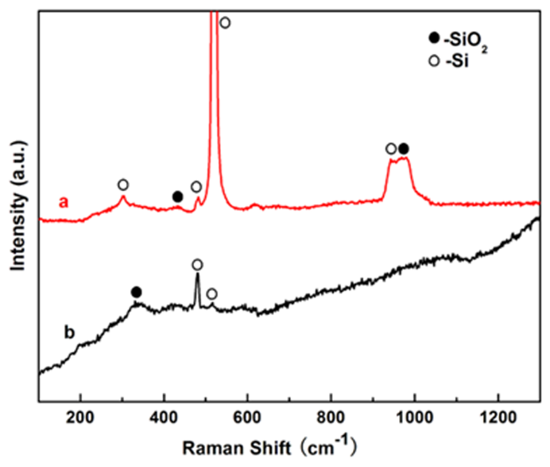
Figure S1. Raman spectra of the as-synthesized SiO₂ nanowires synthesized without catalyst (a), and with Pt catalyst (b), respectively.

[1] Mbenkum B N, Schneider A S, Schutz G, Xu C, Richter G, Aken P A, Majer G and Spatz J 2010 Acs Nano 4 1805
[2] Glass R, Arnold M, Cavalcanti-Adam E, Blummel J, Haferkemper C, Dodd C and Spatz J P 2004 New. J. Phys. 6 1

