Supplementary Information 1: AND or NAND gate operation via non-inverting or inverting comparator

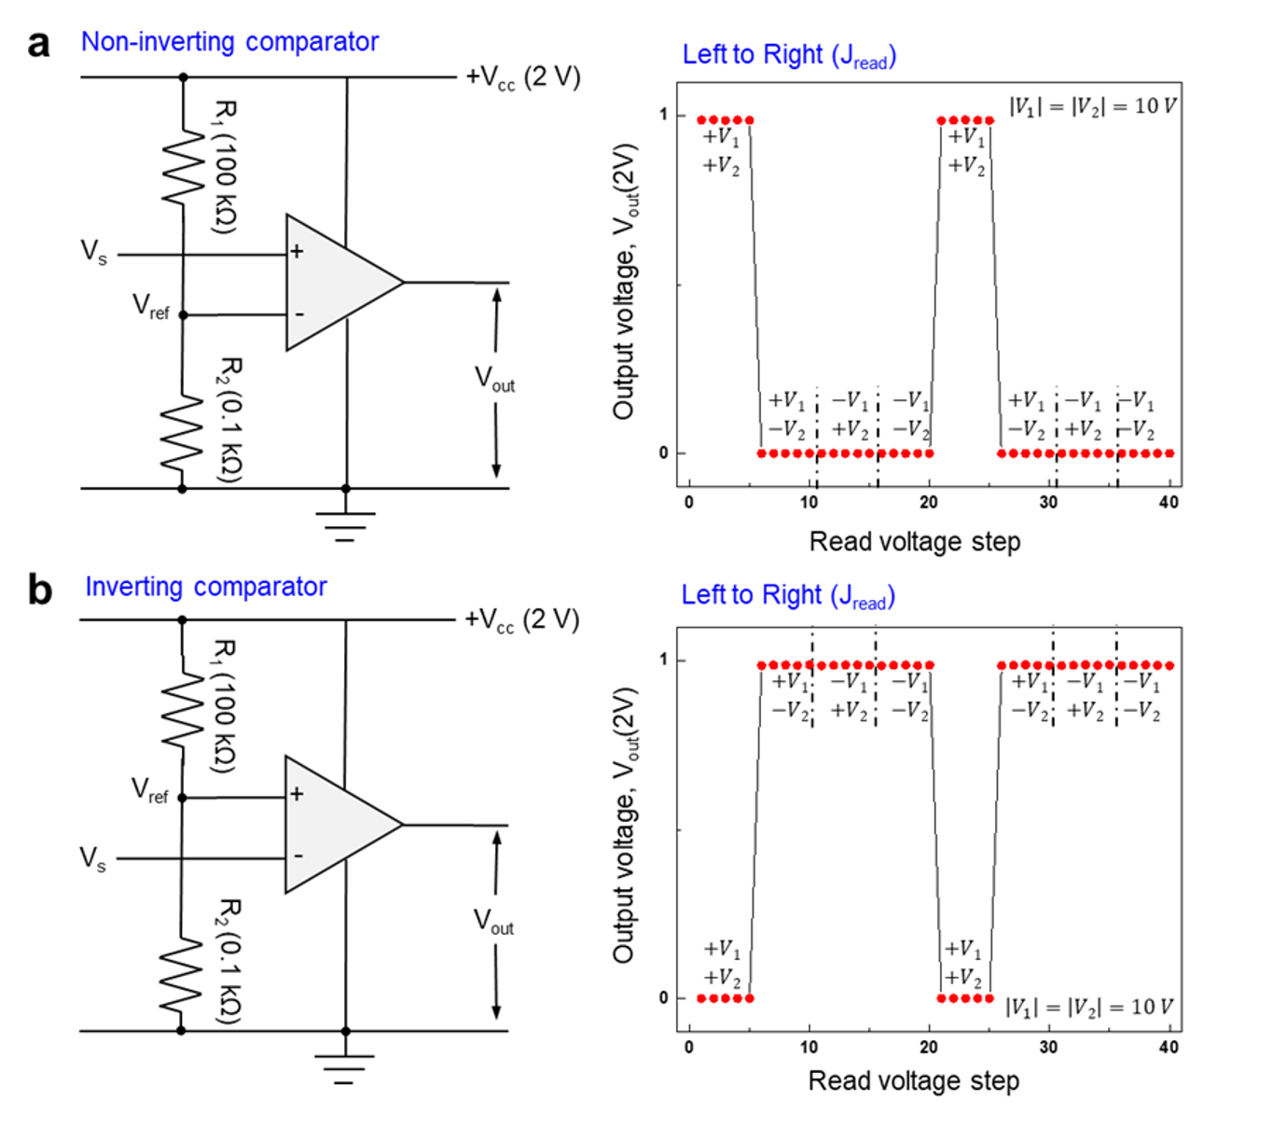
Figure S1 | Comparator circuit schematic and V_{out} curves by non-inverting or inverting comparator.
Op-amp comparator circuits with (a) non-inverting and (b) inverting configurations, where the circuit uses a comparison voltage V_{ref} of 2 mV to produce various logic outputs V_{out}. a, V_{out} in a non-inverting comparator circuit. b, V_{out} in inverted comparator circuit. The input voltages of both |𝑉₁| and |𝑉₂ | in each scheme have the same amplitude of 10 V and are used to switch the MD states. The positive and negative amplitudes of 𝑉₁ and 𝑉₂ correspond to the True and False, respectively. The read current, measured from left to right is proportional to the voltage difference between the two inputs.

Fig. S1 shows the implementation of logic gates through a non-inverting or inverting op-amp comparator circuit. The reference voltage (V_{ref}) is determined from the voltage drop as follows¹.
$$V_{ref}=\frac{R_{2}}{R_{1}+R_{2}}*V_{cc}=\frac{0.1k}{100k+0.1k}*2≅2 mV$$

Fig. S1a shows the non-inverting comparator circuit and the logic gate output. The circuit converts the output of the devices into logic gate results. When V_{s} is larger than V_{ref}, V_{out} is 2 V and represents a logic output of ‘True. ’ When V_{s} is 0 mV or -3 mV (depending on the state of MD), V_{out} is 0 V and represents a logic output of ‘False. ’ The right panel shows V_{out} through the noninverting comparator, with V_{s} measured as the read current flowing from left to right when V_{read} is applied, as shown in the main text of Fig. 3a. Input signals V₁ and V₂ were applied every five read-voltage steps. The absolute 10 V amplitudes of V₁ and V₂ in each scheme represent the voltages necessary to switch the MDs, and the positive and negative amplitudes correspond to True and False, respectively. Therefore, an AND gate can be implemented using a noninverting comparator. Fig. S1b shows the inverting comparator circuit and NAND gate operation. V_{s} is connected to the inverting input of the op amp and V_{ref} is connected to the positive input. When V_{s} is larger than V_{ref}, V_{out} is 0 V and represents a logic output of ‘False. ’ When V_{s} is 0 mV or -3 mV (depending on the state of MD), V_{out} is 2 V and represents a logic output of ‘True. ’ The inverting comparator converts V_{s} into a logic output, allowing the operation of a NAND gate.

Supplementary Information 2: Scaling of V_{s} with incremental read voltage amplitude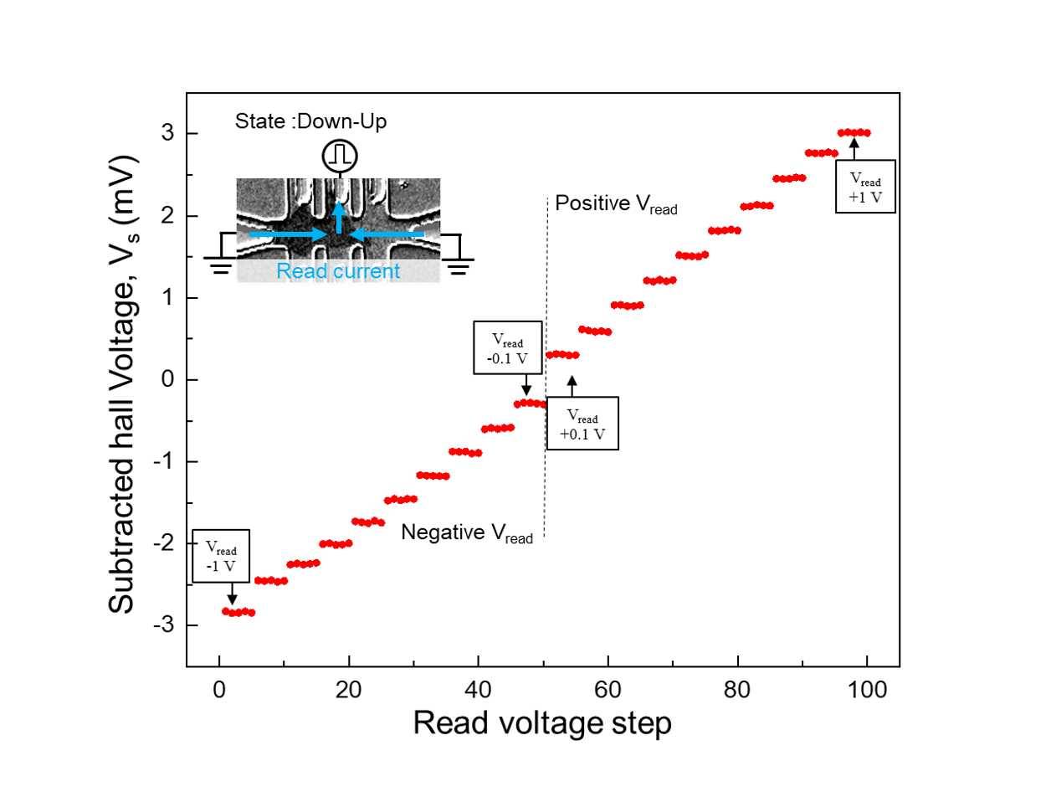
Figure S2 | Subtracted Hall voltage according to read voltage amplitude.
The V_{read} amplitude was varied from -1 to 1V in increments of 0.1 V for each set of five reading voltage steps. The corresponding V_{s} values were measured and plotted against V_{read} for each steps, with the voltage increasing by 0.3 mV per V_{read} increment. The results show a linear relationship between V_{s} and V_{read} with a positive slope for positive V_{read} values and a negative slope for negative V_{read} values; that is, the polarity of V_{s} changed according to the polarity of V_{read}

Supplementary Information 3: MOKE image of MD switched by all inputs in an initial state
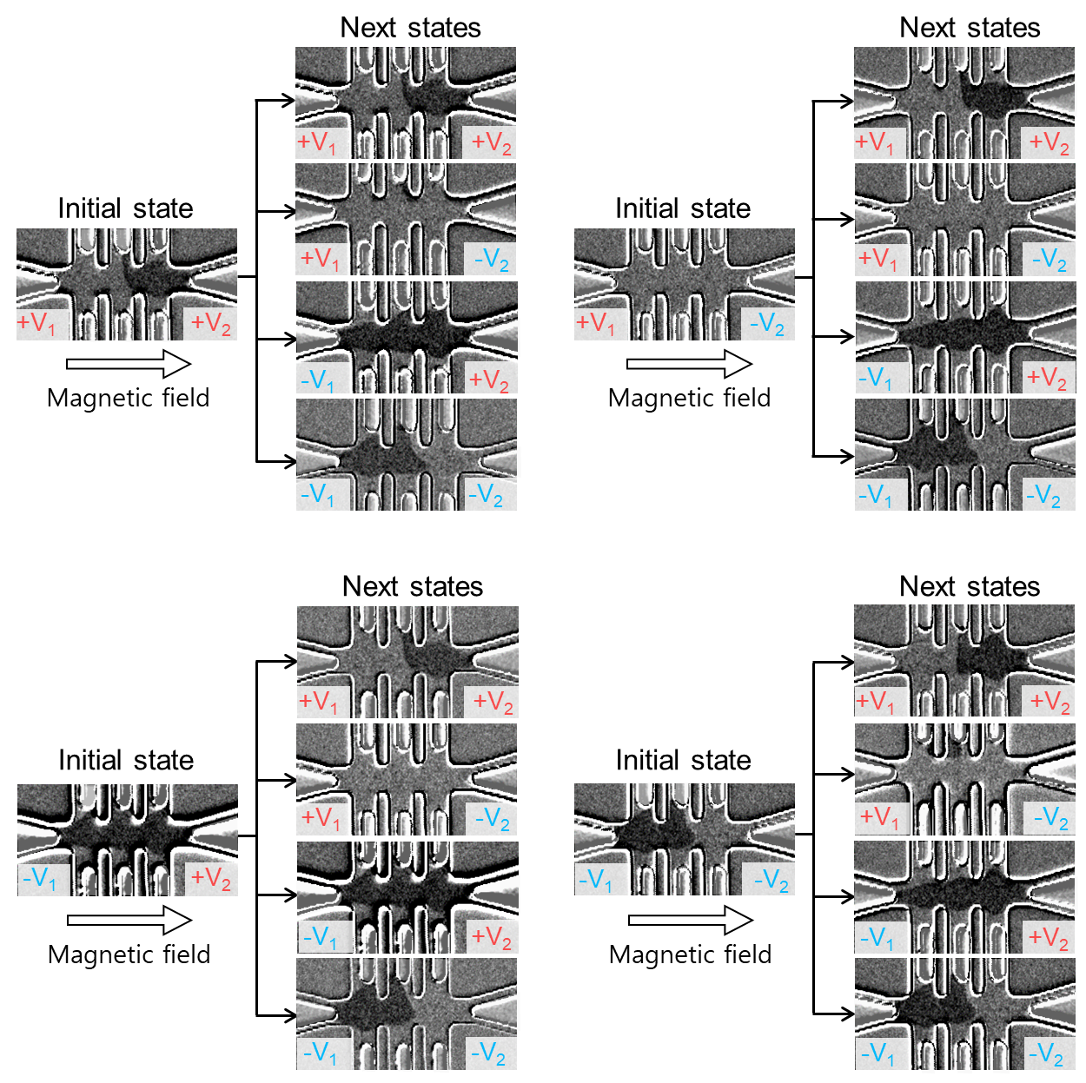
Figure S3 | MOKE image sequence from initial to the next consecutive states under V₁ and V₂ inputs.
Various MOKE image sequences for the (+V₁, +V₂), (+V₁, -V₂), (-V₁, +V₂), and (-V₁, -V₂) initial states (left) and their subsequent states (right). The positive (red) and negative (blue) inputs of V₁ and V₂ reflect True and False, respectively. The arrows in each black line indicate all the possibilities for magnetic domain switching from the initial state to the next state by V₁ and V₂. Magnetic domain switching occurred in the presence of an external magnetic field of H_{x} = 100 Oe.

Fig. 3b shows the MD switching results when the input voltages (+V1, +V2), (+V1, -V2), (-V1, +V2), and (-V1, -V2) are sequentially applied. Logic gate operations do not occur sequentially. Therefore, Fig. S3 illustrates the MD state-switching results from the initial states to all the different states. The initial state (up, down) on the left was set by applying inputs (+V1 and +V2). The other initial states are set up by applying inputs of (+V1, -V2), (-V1, +V2), and (-V1, -V2), respectively. The next states are switched by applying logic gate inputs (+V1, +V2), (+V1, -V2), (-V1, +V2), and (-V1, -V2). The MD switching results were confirmed using the MOKE image, and were sufficiently stable to operate the logic gates. Inputs with voltage amplitudes of 10V inducing a current density J_{read} = 1.0 x 10⁷ A/cm2 and a pulse duration of 100 ms were used at an external magnetic field of H_{x} = 100 Oe.

Supplementary Information 4: Logic gate behaviors with read current directions.

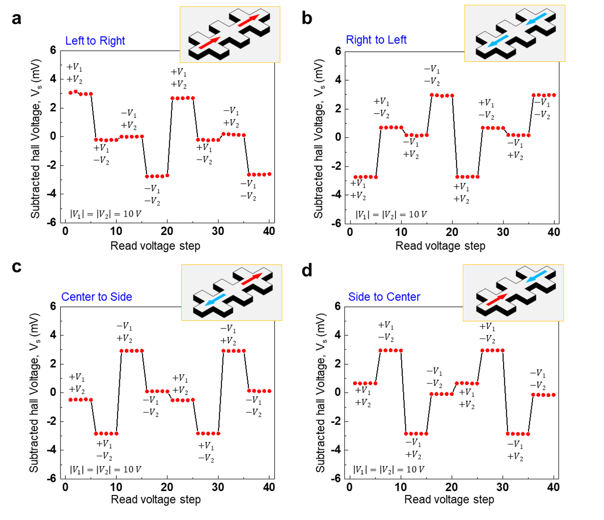
Figure S4 | Experimentally determined V_{s} curves under different read current directions.
The variation in V_{s} was monitored under different read-current directions, with schematic illustrations of the read-current directions given above each graph. a, V_{s} under right-right read currents in both channels. b, V_{s} under left-read current in both channels. c, V_{s} under left current in Channel 1 and right current in Channel 2. d, V_{s} under the right current in Channel 1 and left current in Channel 2. In each case, the same 10 V amplitudes of V₁ and V₂ were used, indicating the voltages necessary to switch the MD states, and the positive and negative amplitudes reflect the True and False states, respectively.

