Fig.S1 The SEM result for the solid products under the different precipitation temperature (a 60ºC, b 70ºC, c 80ºC, d 100ºC, e 120ºC, f 140ºC, g 160ºC, h 180ºC)
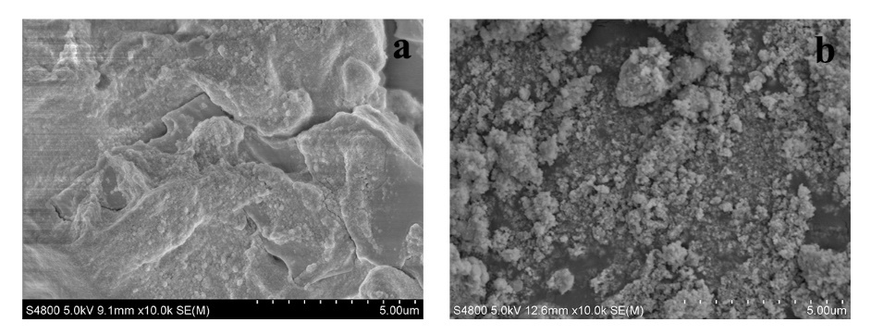
Fig.S2 The SEM result for the solid products under 120ºC (a) and 180ºC (b) with a measuring scale 5.0 um
Fig.S3 The ICP result of total quality of Ca+Na+Zn in the final products

